SKILL-7A
Code:
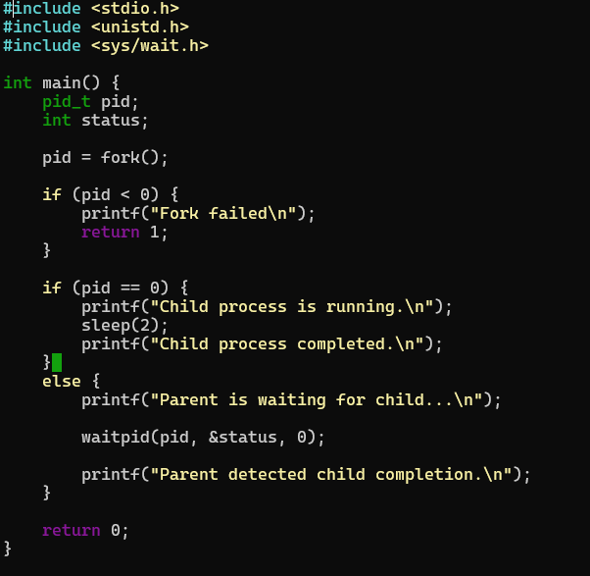

Output:
