SKILL-8A
Code:
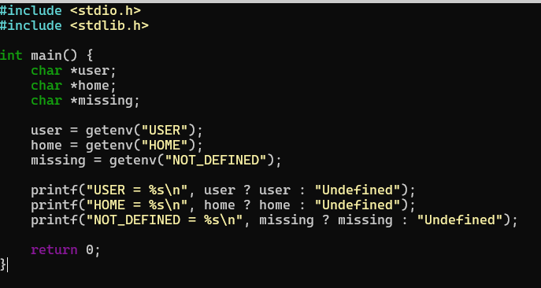

OUTPUT:
