SKILL-6B
Code:
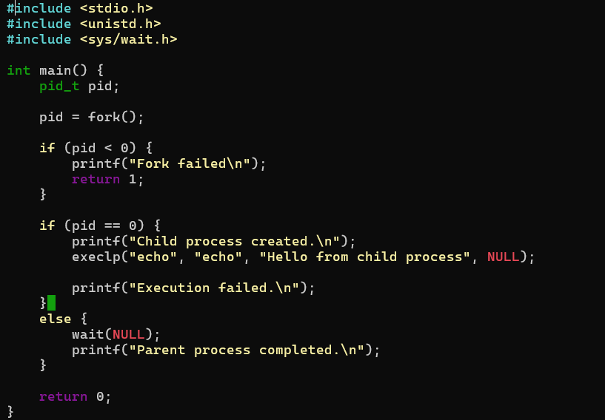
OUTPUT:
