Resume Parsing and Matching Project
Technical Report

Project Overview
This project automates the process of extracting relevant candidate information from resumes and matches them to job descriptions based on skills. It aims to streamline talent acquisition using Python, NLP, and a database-driven backend with a front-facing Streamlit application.

Technologies & Tools Used
- Language: Python
- Libraries:
- Core libraries: pandas, streamlit, pyodbc
- NLP and matching: spacy, nltk, sentence-transformers, rapidfuzz, fuzzywuzzy
- Document parsing: python-docx, PyMuPDF, pdfplumber
- Built-in utilities: re (regex), logging, os, sys
- Optional UI enhancement: streamlit-autorefresh
- Database: Azure SQL Server
- IDE: Visual Studio Code
- Platform: Streamlit Cloud (or localhost)
- Version Control: GitHub
Monitoring: Azure Budget & Anomaly Alerts

System Architecture / Workflow
Job Descriptions
(.docx/.pdf)

Extracted Skills/Data
Required Skills
Matcher Logic
Azure SQL Database
Resume Parser
Job Parser
Streamlit Web App
Resumes
(.docx/.pdf)

Execution Flow & Usage
This section outlines the internal execution flow of the program and provides instructions for running the application locally.

Internal Execution Flow
- The user runs the main script.
- Resumes and job descriptions are parsed and written to CSV.
- Resume and job matching is performed, and results are saved.
- The database tables are created if needed.
- All CSVs are loaded into the database.
- Metadata is updated and the database connection is closed.

Running the Program Locally
- Clone the repository from GitHub (Git Repo)
- Ensure Python and dependencies (requirements.txt) are installed.
- Configure database connection in main.py and app.py.*
- Run main.py to populate the database.
- Launch the app with: streamlit run app/app.py
- Run the translation script to support multilingual Power BI dashboards (optional)

Using the Streamlit Application
- Choose a job title from the dropdown.
- View matched resumes, scores, and candidate details.
- Filter or export results (optional).

Power BI Dashboard Connection**
- Open Power BI Desktop.
- Connect to the Azure SQL Database used in this project to access tables such as ParsedResumes, ParsedJobs, and ResumeMatches.
- Use the provided visuals or create custom ones to monitor resume-job matching metrics such as match scores, skill overlap, and candidate suitability.
- Use the additional translated columns from the translation module for multilingual reports. (Optional)
*Users also have the flexibility to configure and connect the solution to their own database by updating the connection strings in main.py and app.py, enabling them to maintain control over their infrastructure and reporting environment.
** Viewers accessing the Power BI Service report or streamlit app do not need to connect to the database, provided the report is shared and refresh is configured.

Sequence Diagram
This diagram illustrates the interaction between the user, frontend (Streamlit), backend modules, and database during resume-job matching.
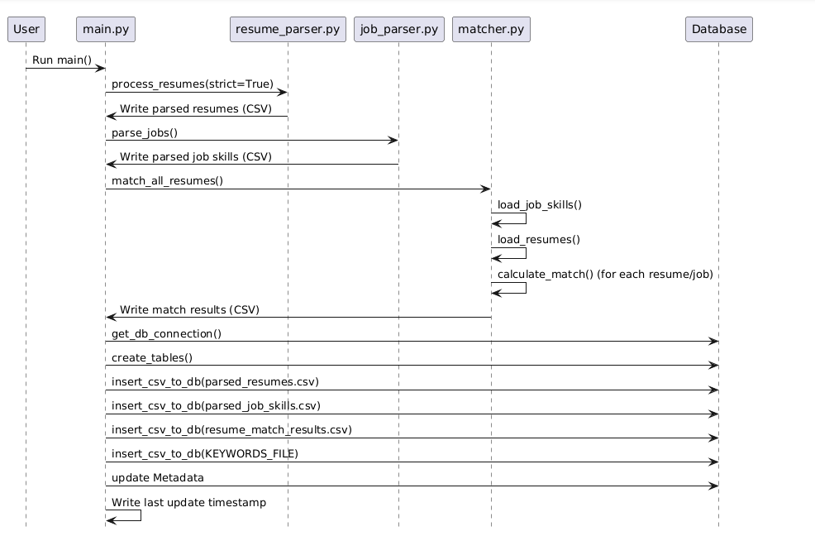

Module Descriptions
- resume_parser.py: Extracts: Name, Email, Phone, Education, Skills, Experience using spaCy, regex, and custom keyword extraction.
- job_parser.py: Parses job titles and required skills from structured job description data.
- matcher.py: Computes match scores using set intersection and fuzzy ratios (0–100 scale).
- main.py: Coordinates parsing and matching logic and writes output to SQL database.
- app.py (Streamlit): Interactive frontend for login, job filtering, and match score viewing.
- translate_powerbi.py: A standalone module to translate Power BI visuals and dashboard content into multiple languages using Azure Translator API. This enhances accessibility for non-English users and supports future multilingual reporting needs.

Database Design / Schema
This section outlines the structure of the database tables used to store parsed resumes, job descriptions, and their corresponding match results, along with relevant data types and constraints.
- ParsedResumes
Column Name | Data Type | Constraints
resume_id | VARCHAR(20) | Primary Key
name | VARCHAR(100) | NOT NULL
email | VARCHAR(100) | UNIQUE, NOT NULL
phone | VARCHAR(50) | NULL
skills | VARCHAR (MAX) | NULL
Job_title | VARCHAR(255) | NULL
experience | VARCHAR (MAX) | NULL
education | VARCHAR (MAX) | NULL

- ParsedJobs
Column Name | Data Type | Constraints
reference_number | VARCHAR(50) | Primary Key
Job_title | VARCHAR(255) | NOT NULL
skill | VARCHAR (MAX) | NULL
weight | FLOAT | NULL

- ResumeMatches
Column Name | Data Type | Constraints
resume_id | VARCHAR(20) | NOT NULL
name | VARCHAR(100) | NOT NULL
email | VARCHAR(100) | NOT NULL
phone | VARCHAR(50) | NULL
education | VARCHAR(MAX) | NULL
experience | VARCHAR(MAX) | NULL
job_title | VARCHAR(255) | NULL
skills | VARCHAR(MAX) | NULL

Integration Approach
- Azure SQL Server: Connected using pyodbc.
- Streamlit Cloud: Hosts frontend app or runs locally.
- Azure Budget Alerts: Set to manage compute usage and prevent overuse.

Challenges & Solutions
This section highlights key technical challenges encountered during development and the corresponding solutions implemented to ensure system reliability and performance.
Challenge | Solution
Varying resume formats | Used regex and NLP for flexible extraction
Skill mismatch in wording | Applied fuzzy string matching
Exceeded Azure free quota | Reduced min/max vCores and set budget alerts
UI filtering for job selection | Added dropdown in Streamlit with dynamic filtering

Future Technical Improvements
- Add multilingual NLP support
- Integrate resume upload directly in app
- Use machine learning for smarter matching
- Integrate language accessibility features into the Streamlit app to support multilingual user interfaces

