ASSIGNMENT – 87

SHIVA KUMAR NADICHERRA

1. IAM settings are region specific or NOT

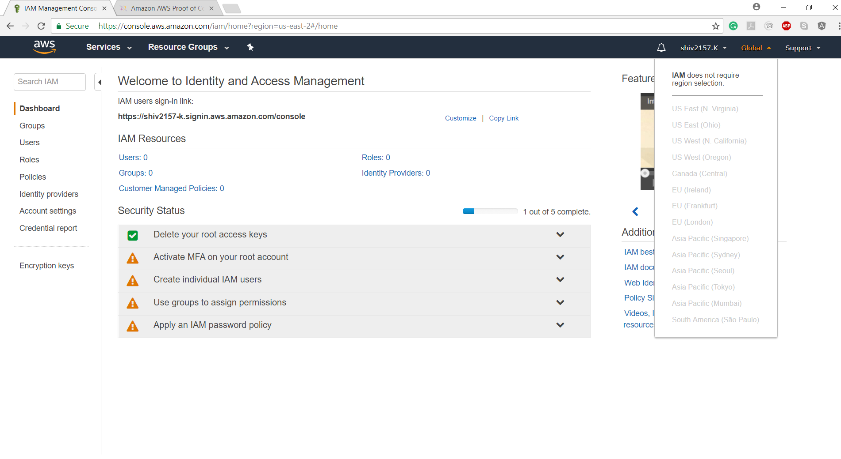

Ans: From the above top right corner of the snap we can prove that IAM settings are not region specific. IAM is Global.

1. By default, users have no permissions when first added.

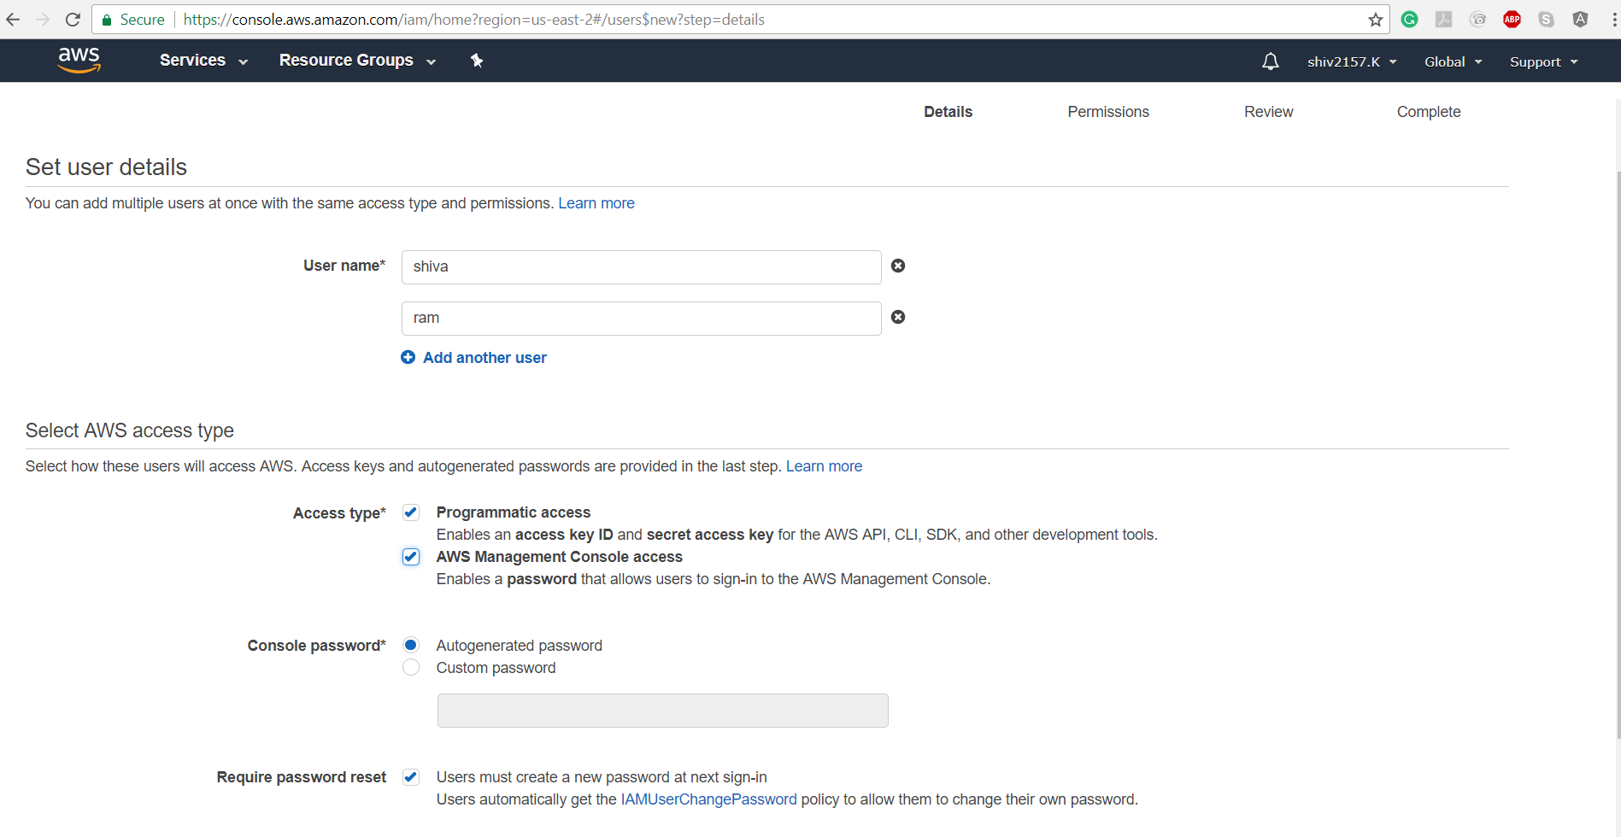

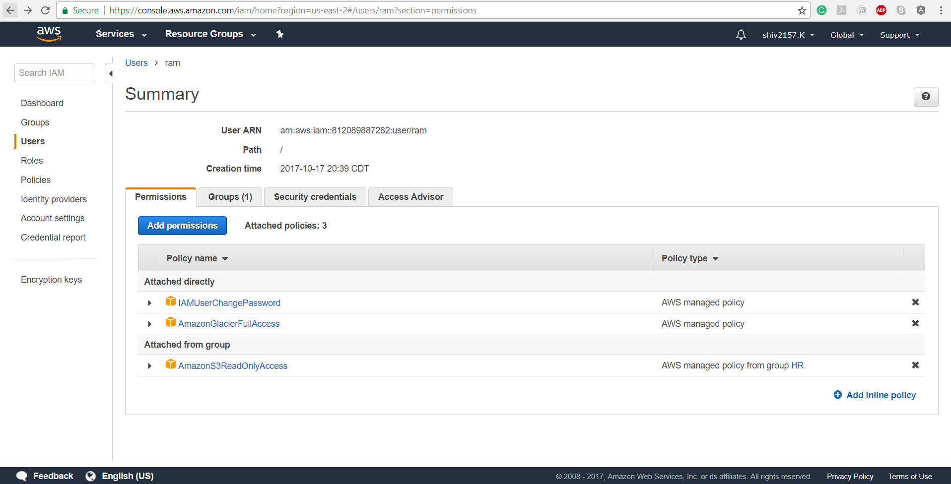

Ans. From the above two snaps we can conclude that by default users have no permissions we manually add permissions to them.

1. Active Directory Federation (AD) Can authenticate to AWS with AD using SAML

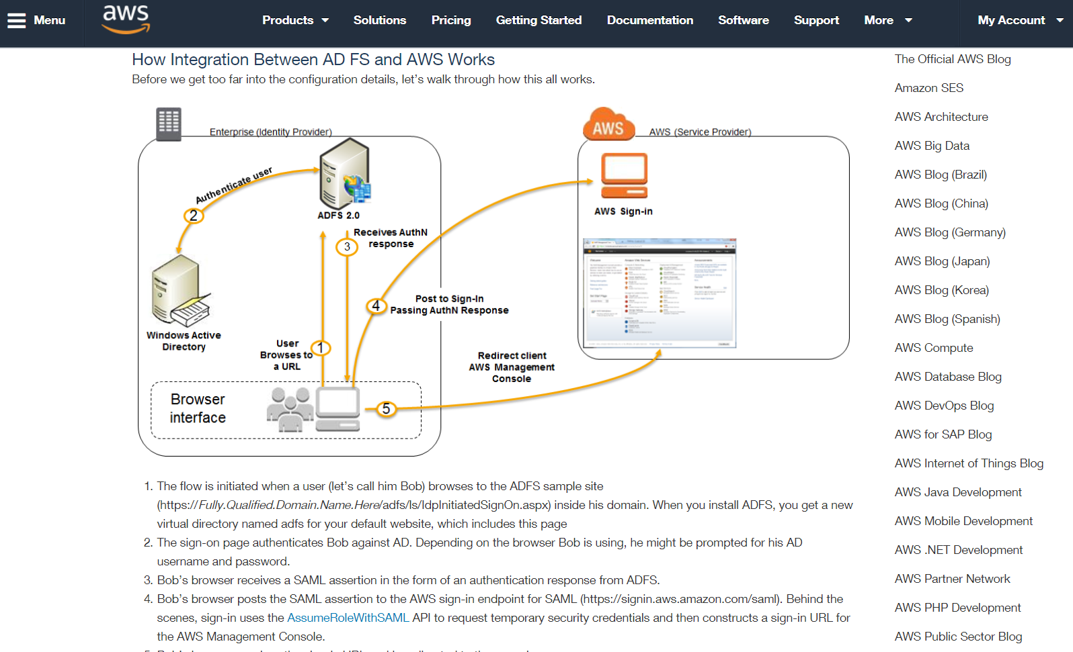

Ans: Yes, ADF can authenticate to AWS with AD using SAML (Security Assertion Markup Language).

Here we always authenticate against Active Directory first and then we would assign temporary security credential.

1. Web Identity Federation to AWS via Facebook or any other social sites

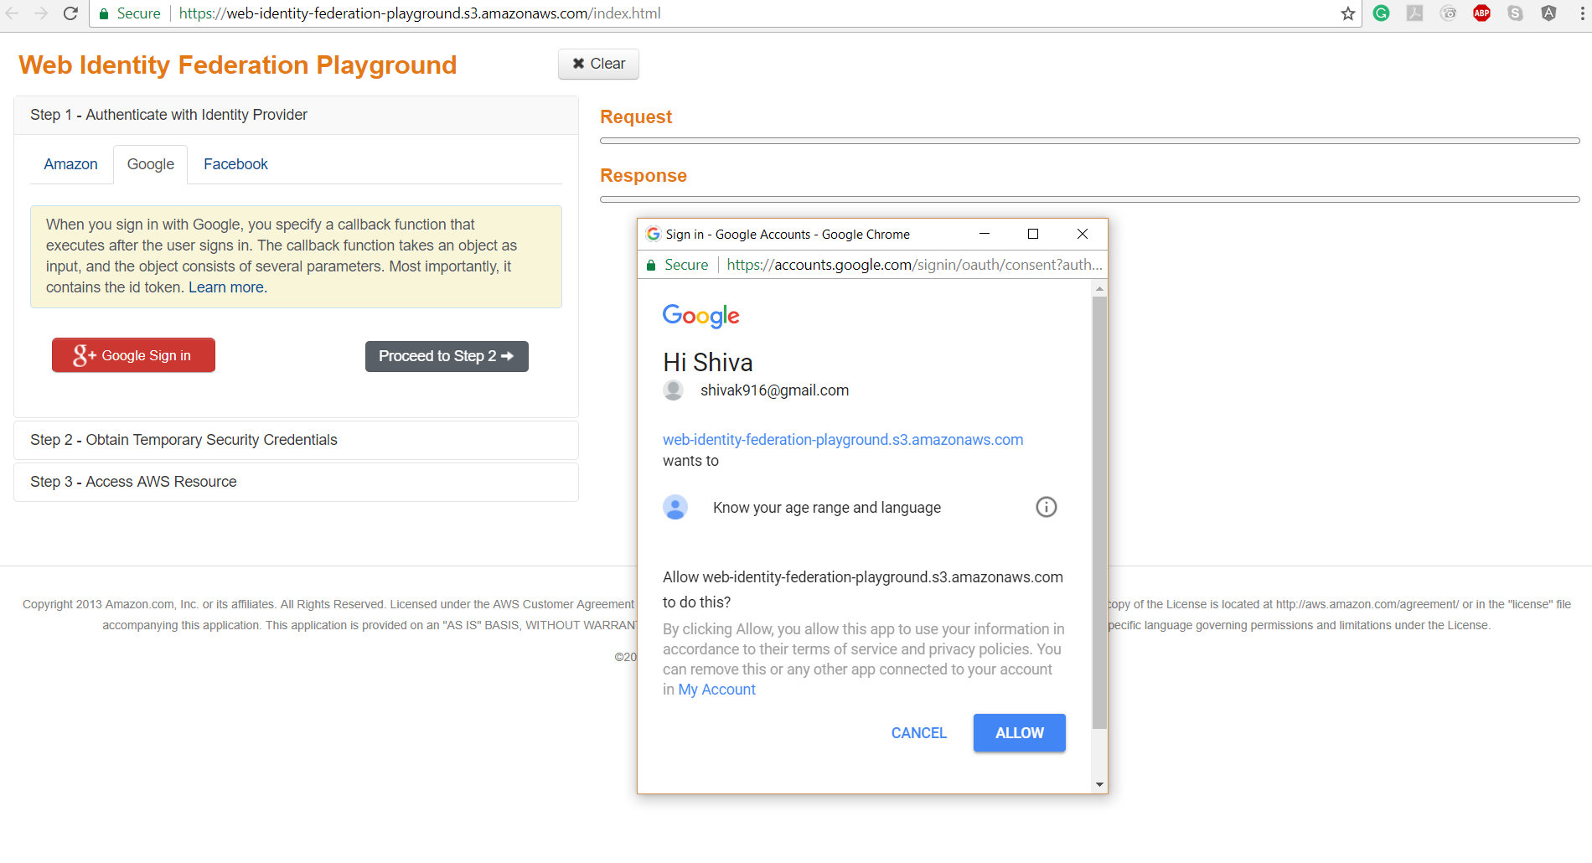

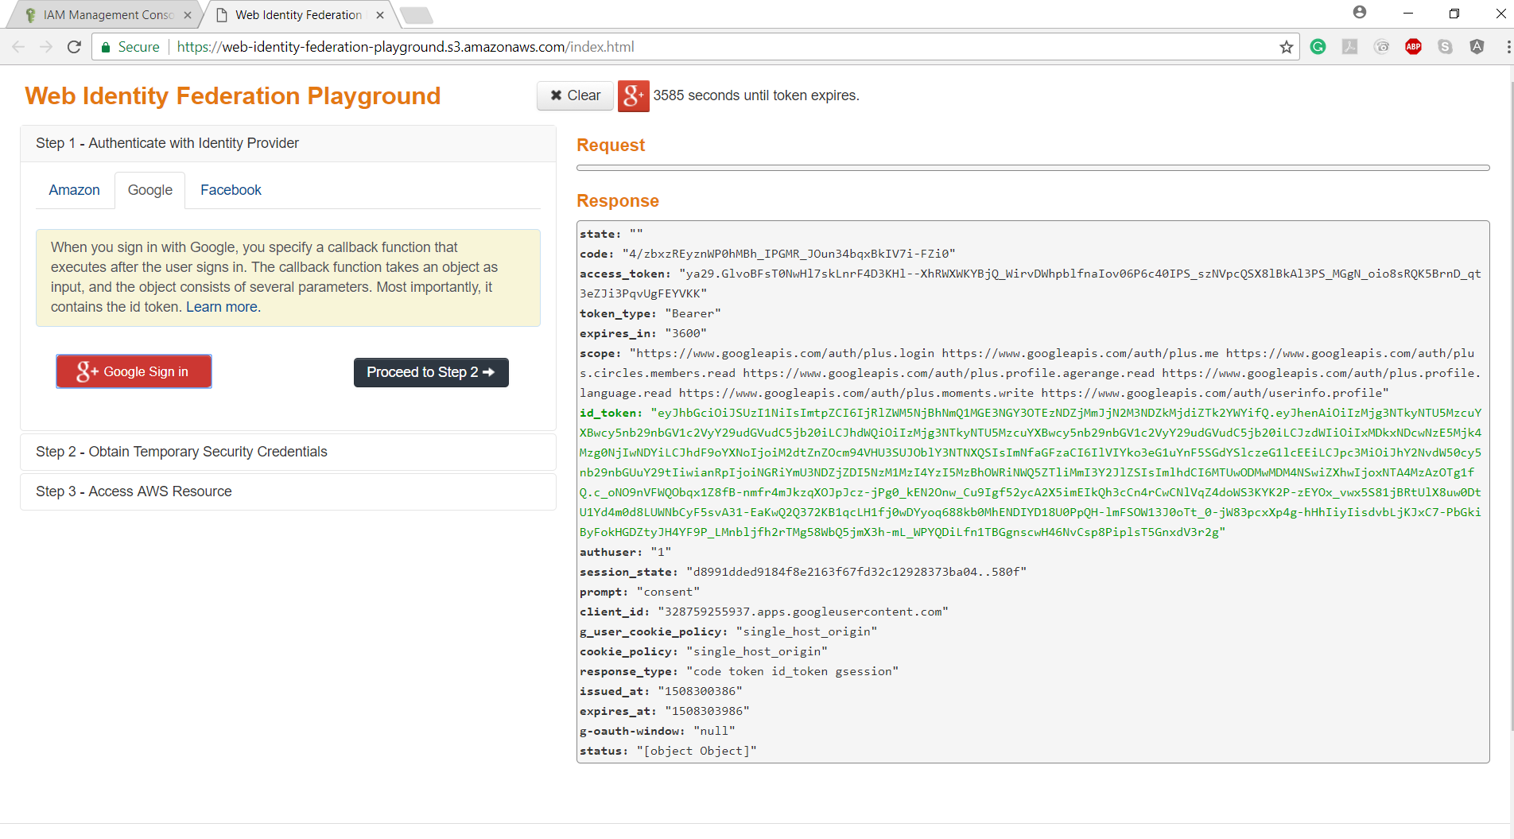

We can authenticate our applications using things like Facebook, Google, Linkedhin etc.

In the above snaps

We are Authenticating with Identity Provider

* We have gone to Google
* We verified our identity with google and we have been given an access token.
* Using this token, we then go into AWS

1. AssumeRoleWithWebIdentity API call used to obtain temporary security credentials when authenticating using Web Identity Federation? 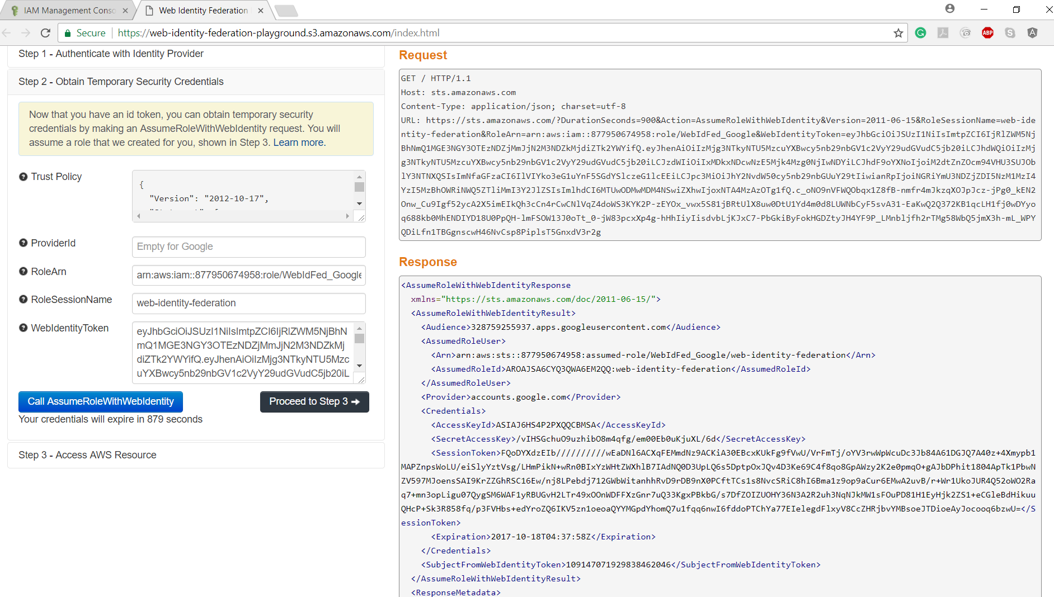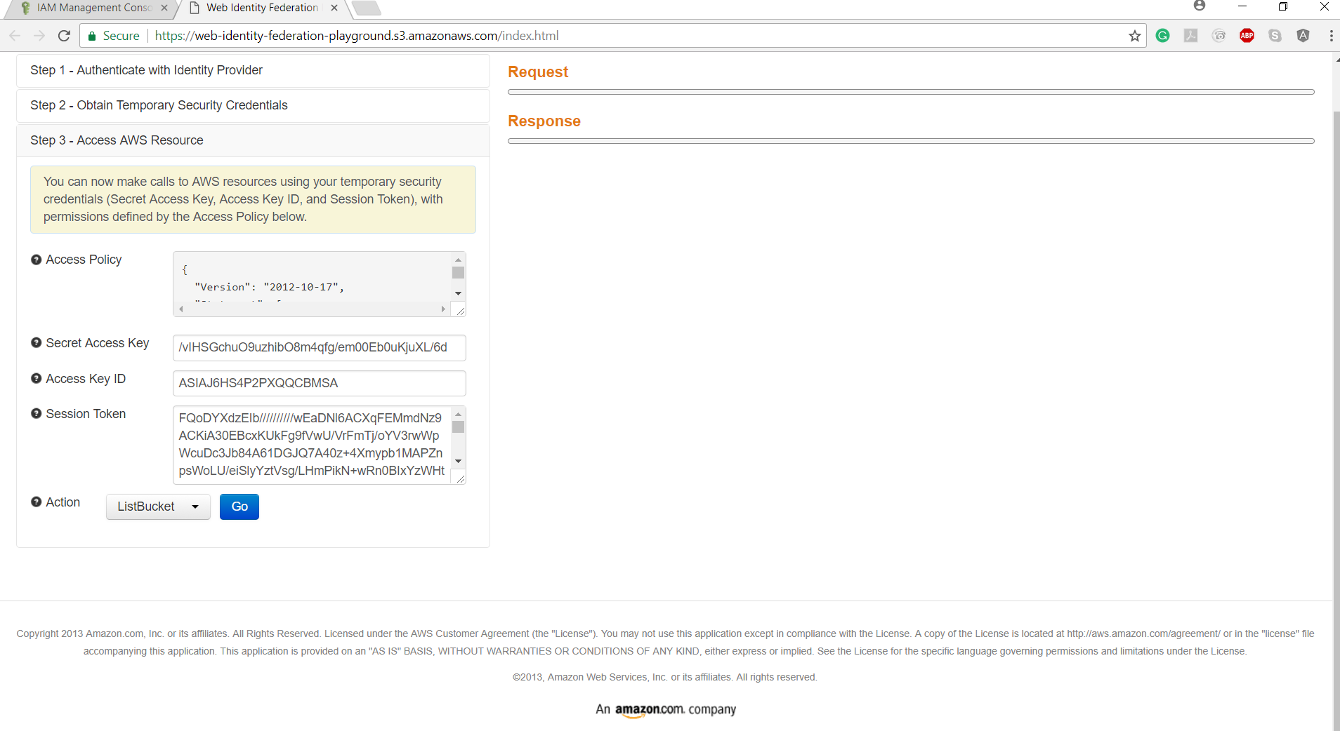

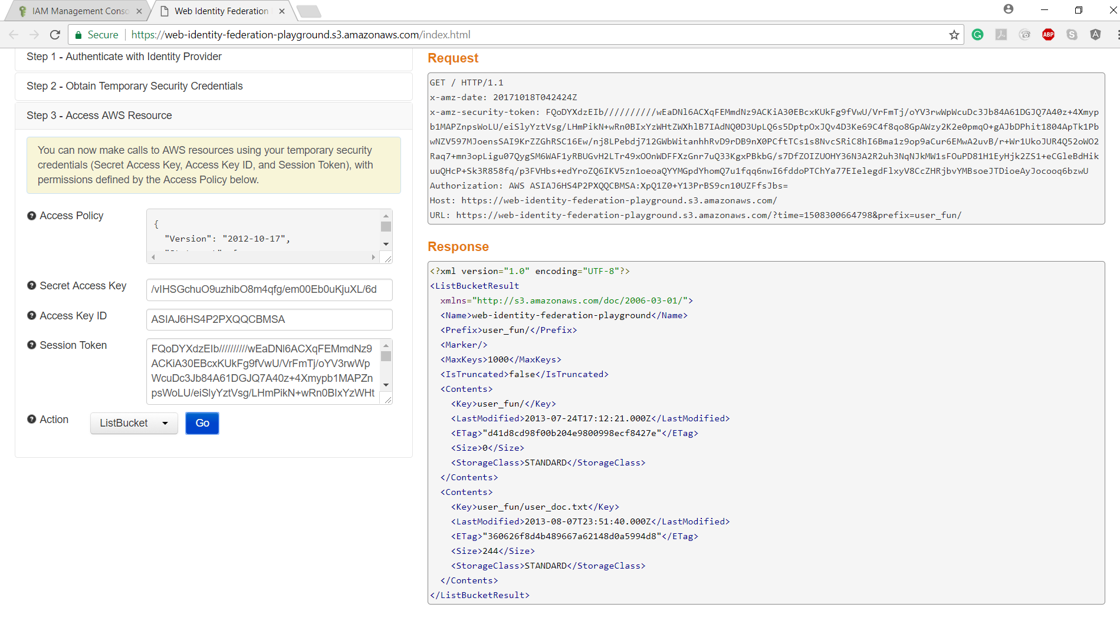

Ans.

Yes

Here after proceeding to Step 2:

* Here we are going to obtain temporary security credentials
* Using ID token, we can obtain our temporary security credentials by making an **AssumeRoleWithWebIdentity API.**

In Step 3:

* We are accessing the AWS Resource through setting the actions in the form of ListBucket/ GetObject.