# Project Report: ACME Sales Forecasting Model

Github Link: https://github.com/Shiva250503ss/Acme_Product_Analysis

## Executive Summary

ACME is focused on enhancing its ability to predict sales across various markets scientifically. This project involves the development of a sophisticated algorithm that can forecast sales under different scenarios, considering multiple constraints at various levels of the company’s hierarchy. This tool will aid in strategic decision-making, allowing ACME's leadership to set realistic growth targets based on data-driven insights.

## Problem Statement

ACME needs a robust predictive model that can accurately forecast sales across its diverse product lines and market segments. The challenge is to build a model that not only predicts these sales with high accuracy but also incorporates various internal constraints and market dynamics. These predictions must align with the hierarchical structure of ACME, ranging from individual segments up to the portfolio level.

## Objectives

1. Generate a Synthetic Dataset: Create a synthetic dataset that mimics the structure and constraints of ACME, providing a realistic foundation for algorithm testing.

2. Develop Sales Maximization Scenarios: Construct scenarios where the algorithm seeks to maximize sales within the set constraints.

3. Optimize for Margin: Adjust the model to also focus on maximizing profit margins, not just sales.

4. Target Achievement Modules: Create model outputs that show how set sales or margin targets can be achieved, while also optimizing for the other metric.

5. Long-term Forecasting: Enable the model to make projections over a five-year period, allowing for annual adjustments in constraints.

## Company Structure

ACME is organized into several hierarchical levels:

- Portfolio  
- Geography  
- Category  
- Brand  
- Segment

Each level has distinct units with specific data points such as sales, margin, trends, and contributions. The sum of the segment-level data aggregates up to the brand level and subsequently up through the higher levels to the portfolio.

## Definitions and Constraints

- Sales: Total sales for each unit.  
- Margin: Profit margin for each unit.  
- Trend: Expected growth rate for each unit, which can be positive or negative.  
- Contribution: Percentage contribution of each unit to its respective category.  
- Constraints: Minimum and maximum limits for trend growth and contributions within each segment.

## Methodology

1. Data Preparation:  
 - Generate a synthetic dataset reflecting the real structure and operational constraints of ACME.  
 - Include realistic sales and margin figures, along with varying constraints for different scenarios.

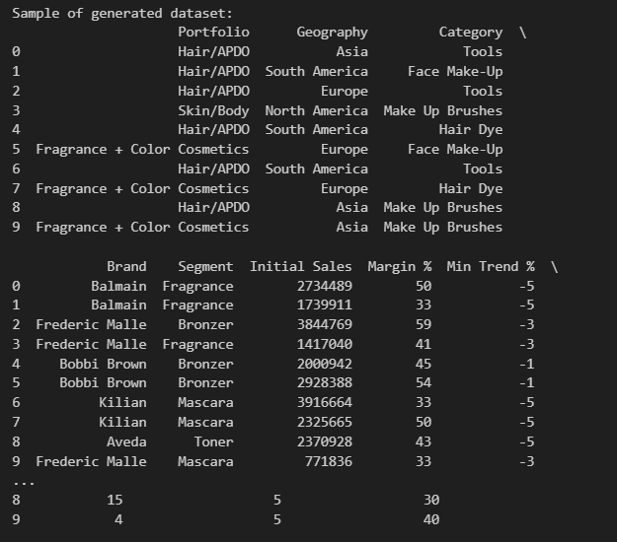

2. Model Development:  
 - Use statistical and machine learning techniques to develop a model that predicts sales and margin based on the input constraints.  
 - Ensure the model adheres to the hierarchical data aggregation structure of ACME.

3. Scenario Testing:  
 - Test the model across different predefined scenarios to evaluate its effectiveness in various operational settings.  
 - Adjust the model parameters based on the outputs to align with ACME’s strategic goals.

4. Optimization:  
 - Implement optimization algorithms to find the best mix of product sales and margins that maximize overall revenue or profit.  
 - Develop a user interface that allows executives to input different target scenarios and view the potential outcomes.

5. Projection and Adjustment:  
 - Enable the model to forecast sales and margins over a five-year period.  
 - Provide functionality to adjust constraints annually based on changing market conditions and internal strategy shifts.

## Output Screenshots:

Maximize Sales:

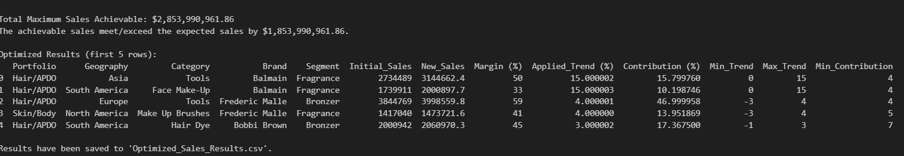

Maximize Origin:

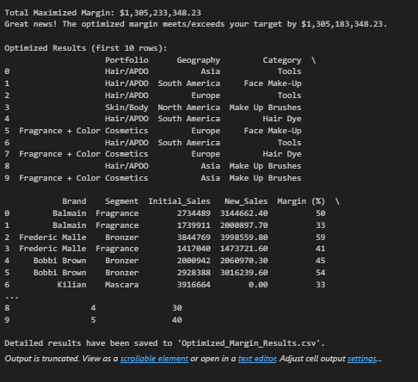

Hit A Sales Target While Maximizing Margin:

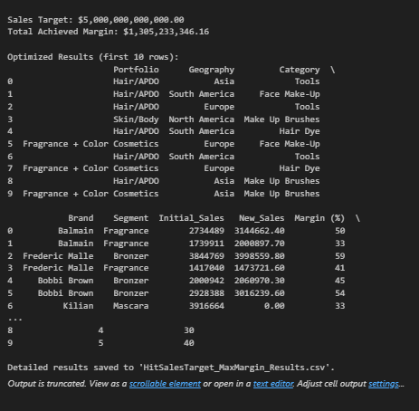

Hit A Margin Target While Maximizing Sales:

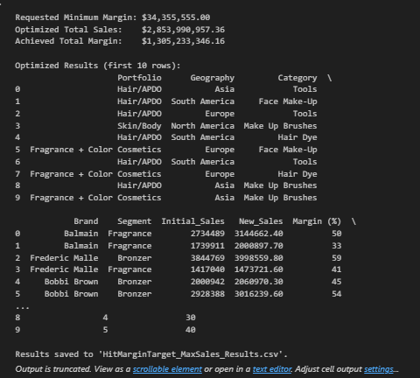

Projections for Each Year Over a 5 Year Period

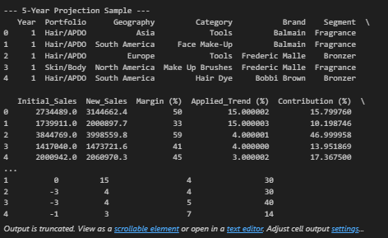

## Expected Deliverables

* A fully functional sales forecasting tool.
* Detailed documentation on model usage and scenario adjustments.
* A comprehensive report outlining model performance across various tests.
* All updated Values has been stored in a new CSV

## Conclusion

The ACME Sales Forecasting Model is designed to empower the leadership team with data-driven insights, facilitating more informed decision-making regarding future sales strategies and market positioning. By integrating detailed sales predictions aligned with strategic constraints, ACME can better navigate market dynamics and optimize for both growth and profitability.