Arduino Circuit Design Report
Wiring Diagrams • Circuit Images • Code & Explanations
Complete Beginner's Guide | Platform: TinkerCAD | Board: Arduino Uno R3

About This Report
This report documents four Arduino circuits created in TinkerCAD. Each section includes the actual circuit screenshot, a detailed wiring table, the complete code, and a beginner-friendly explanation of every line.

Circuit 1 | RGB LED Color Cycling — PWM color mixing with analogWrite()
Circuit 2 | HC-SR04 Ultrasonic Distance Sensor — measuring distance with sound
Circuit 3 | Traffic Light System — real traffic light sequence with digitalWrite()
Circuit 4 | Servo + Ultrasonic — automated servo response to detected objects

01 | RGB LED Color Cycling  Pins 9,10,11 (PWM) — analogWrite() — #define

1.1 Circuit Image
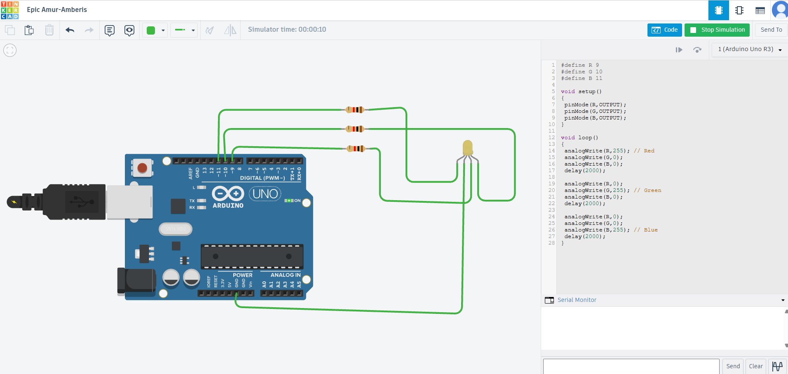
Circuit 1: RGB LED connected to Arduino Uno R3 (TinkerCAD simulation)

1.2 Overview
An RGB LED has three LEDs inside one package: Red, Green, Blue. By sending PWM values (0–255) through analogWrite(), each colour's brightness is controlled independently. This sketch cycles: Red → Green → Blue, each for 2 seconds.

1.3 Components
Arduino Uno R3 | Main microcontroller
RGB LED (Common Cathode) | 4-legged LED: R, GND, G, B
3 × 220 Ω Resistors | One per colour channel — protects LED from excess current
Wires | Connect Arduino pins to LED legs via resistors

1.4 Wiring Diagram
FROM (Component) | TO (Arduino) | Purpose
RGB Pin R (Red leg) | Pin 9 → 220Ω resistor | PWM output for Red brightness
RGB Common Cathode | GND | Return path for all three channels
RGB Pin G (Green leg) | Pin 10 → 220Ω resistor | PWM output for Green brightness
RGB Pin B (Blue leg) | Pin 11 → 220Ω resistor | PWM output for Blue brightness

⚠ Pins 9, 10, 11 are PWM-capable (marked ~ on the board). analogWrite() only works on PWM pins.

1.5 Complete Code
#define R 9 // Name pin 9 as R (Red)
#define G 10 // Name pin 10 as G (Green)
#define B 11 // Name pin 11 as B (Blue)

void setup()
{
pinMode(R, OUTPUT); // Pin 9 → send signals OUT
pinMode(G, OUTPUT); // Pin 10 → send signals OUT
pinMode(B, OUTPUT); // Pin 11 → send signals OUT
}

void loop()
{
// ── RED phase ──────────────────────────
analogWrite(R, 255); // Red = full brightness
analogWrite(G, 0); // Green = OFF
analogWrite(B, 0); // Blue = OFF
delay(2000); // Hold for 2 seconds

// ── GREEN phase ────────────────────────
analogWrite(R, 0); // Red = OFF
analogWrite(G, 255); // Green = full brightness
analogWrite(B, 0); // Blue = OFF
delay(2000);

// ── BLUE phase ─────────────────────────
analogWrite(R, 0); // Red = OFF
analogWrite(G, 0); // Green = OFF
analogWrite(B, 255); // Blue = full brightness
delay(2000);
} // loop() restarts automatically

1.6 Code Explanation (Line by Line)
#define R 9 | Creates a constant: anywhere we write R, Arduino reads 9. Makes code readable.
void setup() | Runs once at power-on. Used to configure pins.
pinMode(R, OUTPUT) | Declares pin 9 as an output — Arduino will send voltage on it.
void loop() | Runs forever in a cycle after setup() finishes.
analogWrite(R, 255) | PWM: sends ~5V (255/255) to Red pin → full brightness.
analogWrite(G, 0) | PWM: sends 0V to Green pin → completely off.
delay(2000) | Pauses execution for 2000 ms = 2 seconds.
// comment | Text after // is ignored by Arduino. Used to explain code to humans.

02 | HC-SR04 Ultrasonic Distance Sensor  Pins 9 (TRIG) & 10 (ECHO) — pulseIn() — Serial Monitor

2.1 Circuit Image
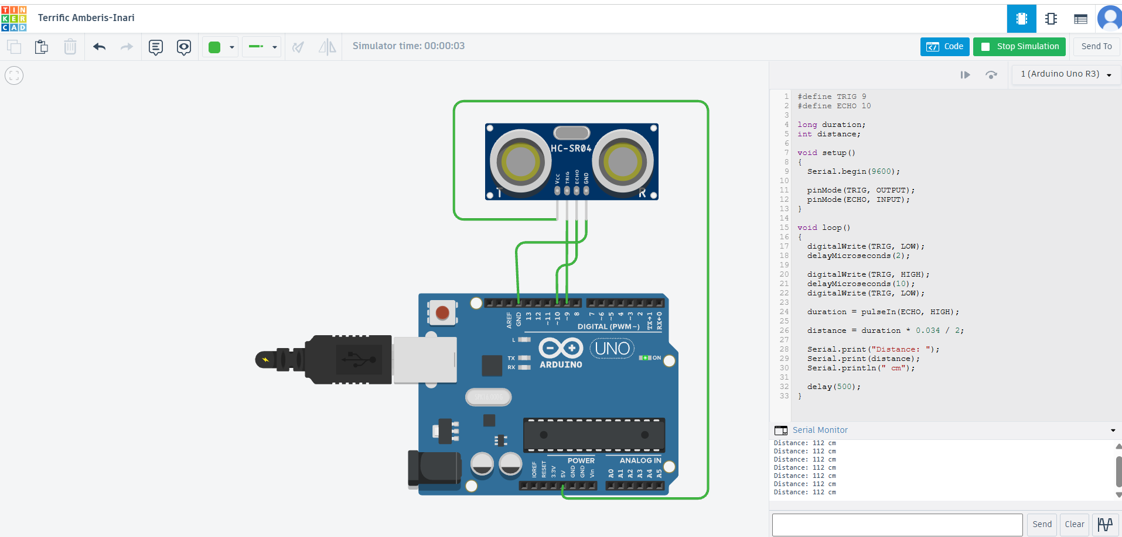
Circuit 2: HC-SR04 ultrasonic sensor wired to Arduino Uno R3

2.2 Overview
The HC-SR04 works like sonar. The TRIG pin fires a short ultrasonic burst; the sensor waits for the echo. pulseIn() measures how long the echo signal stays HIGH. Dividing by the speed of sound gives distance in centimetres. Results stream to the Serial Monitor every 500 ms.

2.3 Components
Arduino Uno R3 | Microcontroller
HC-SR04 Module | 4-pin ultrasonic sensor (VCC, TRIG, ECHO, GND)
4 Wires | VCC, GND, TRIG, ECHO connections

2.4 Wiring Diagram
FROM (Component) | TO (Arduino) | Purpose
HC-SR04 VCC | Arduino 5V | Power supply for the sensor
HC-SR04 GND | Arduino GND | Common ground
HC-SR04 TRIG | Arduino Pin 9 (OUTPUT) | Arduino triggers the ultrasonic pulse
HC-SR04 ECHO | Arduino Pin 10 (INPUT) | Sensor tells Arduino when echo returned

2.5 Complete Code
#define TRIG 9 // Trigger: sends ultrasonic pulse
#define ECHO 10 // Echo: receives reflected pulse

long duration; // Time (µs) for sound to travel and return
int distance; // Calculated distance in centimetres

void setup()
{
Serial.begin(9600); // Open serial at 9600 baud
pinMode(TRIG, OUTPUT); // TRIG → send pulse
pinMode(ECHO, INPUT); // ECHO → read echo
}

void loop()
{
// Step 1 – ensure TRIG is LOW before firing
digitalWrite(TRIG, LOW);
delayMicroseconds(2);

// Step 2 – send a 10-microsecond HIGH pulse
digitalWrite(TRIG, HIGH);
delayMicroseconds(10);
digitalWrite(TRIG, LOW);

// Step 3 – measure how long ECHO stays HIGH
duration = pulseIn(ECHO, HIGH);

// Step 4 – convert time to distance
// Speed of sound = 0.034 cm/µs
// Divide by 2: sound travels TO object AND back
distance = duration * 0.034 / 2;

// Step 5 – print result
Serial.print("Distance: ");
Serial.print(distance);
Serial.println(" cm");

delay(500); // read every 0.5 seconds
}

2.6 Code Explanation (Line by Line)
long duration | 'long' holds large integers. Echo time in µs can exceed int's max value.
int distance | 'int' is enough for distances 0–400 cm.
Serial.begin(9600) | Starts the serial connection at 9600 bits/sec so data appears in the Serial Monitor.
delayMicroseconds(2) | Waits 2 µs — far shorter than delay(). Keeps the TRIG LOW reset clean.
delayMicroseconds(10) | Holds TRIG HIGH for exactly 10 µs — the spec-required trigger pulse width.
pulseIn(ECHO, HIGH) | Waits for ECHO to go HIGH, measures duration, returns value in microseconds.
duration * 0.034 / 2 | 0.034 cm/µs × time = round-trip distance. Halved = one-way (object distance).
Serial.println() | Like print() but appends a newline so each reading appears on its own row.

03 | Traffic Light System  Pins 8,9,10 — digitalWrite() — Breadboard — Timing

3.1 Circuit Image
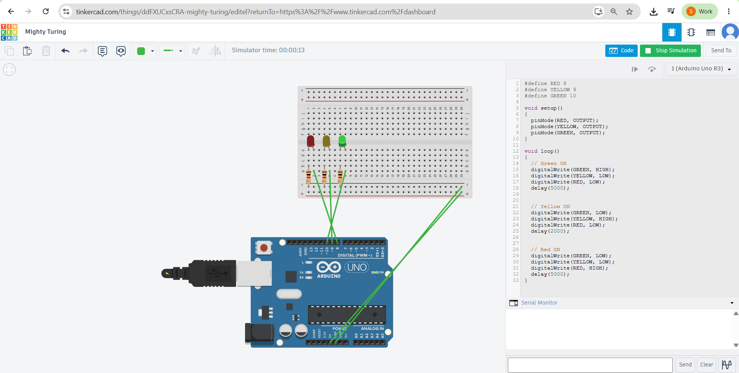
Circuit 3: Red/Yellow/Green LEDs on breadboard controlled by Arduino Uno R3

3.2 Overview
Three separate LEDs (Red, Yellow, Green) mounted on a breadboard simulate a real traffic light. Each LED has its own 220 Ω current-limiting resistor. The Arduino cycles through Green (5 s) → Yellow (2 s) → Red (5 s), exactly like a real intersection.

3.3 Components
Arduino Uno R3 | Microcontroller
Breadboard | Prototype board — rows share electrical connection; no soldering needed
Red LED | Stop signal
Yellow LED | Caution / prepare to stop
Green LED | Go signal
3 × 220 Ω Resistors | One per LED — limits current to safe ~20 mA
Wires | Arduino → breadboard connections

3.4 Wiring Diagram
FROM (Component) | TO (Arduino) | Purpose
Green LED anode (+) | Arduino Pin 10 via 220Ω resistor | digitalWrite HIGH = Green ON
Yellow LED anode (+) | Arduino Pin 9 via 220Ω resistor | digitalWrite HIGH = Yellow ON
Red LED anode (+) | Arduino Pin 8 via 220Ω resistor | digitalWrite HIGH = Red ON
All LED cathodes (−) | Arduino GND (via breadboard −ve rail) | Common ground return

Breadboard tip: long leg (anode +) faces the resistor; short leg (cathode −) goes to the GND rail.

3.5 Complete Code
#define RED 8
#define YELLOW 9
#define GREEN 10

void setup()
{
pinMode(RED, OUTPUT);
pinMode(YELLOW, OUTPUT);
pinMode(GREEN, OUTPUT);
}

void loop()
{
// ── Phase 1: GREEN ON (Go) ─────────────────────
digitalWrite(GREEN, HIGH); // Green ON
digitalWrite(YELLOW, LOW); // Yellow OFF
digitalWrite(RED, LOW); // Red OFF
delay(5000); // 5 seconds

// ── Phase 2: YELLOW ON (Caution) ──────────────
digitalWrite(GREEN, LOW); // Green OFF
digitalWrite(YELLOW, HIGH); // Yellow ON
digitalWrite(RED, LOW); // Red OFF
delay(2000); // 2 seconds

// ── Phase 3: RED ON (Stop) ────────────────────
digitalWrite(GREEN, LOW); // Green OFF
digitalWrite(YELLOW, LOW); // Yellow OFF
digitalWrite(RED, HIGH); // Red ON
delay(5000); // 5 seconds
}

3.6 Code Explanation (Line by Line)
#define RED 8 | Aliases pin 8 as RED. Using names instead of numbers prevents pin confusion.
3× pinMode OUTPUT | All three LED pins are configured as outputs in setup().
digitalWrite(GREEN, HIGH) | Sets pin 10 to 5V — current flows → Green LED lights up.
digitalWrite(YELLOW, LOW) | Sets pin 9 to 0V — no current → Yellow LED stays off.
delay(5000) | Freezes the program for 5 seconds. Loop resumes at next line after delay.
Why turn others LOW? | Best practice: explicitly turn off every other LED each phase to avoid accidental multi-LED states.
delay(2000) | Yellow is shorter (2 s) — mimics real traffic light warning duration.
Loop auto-repeats | After Red's delay(5000), loop() jumps back to top → Green turns on again.

04 | Servo Motor + Ultrasonic Sensor  Servo.h library — if/else — Object detection — Automated response

4.1 Circuit Image
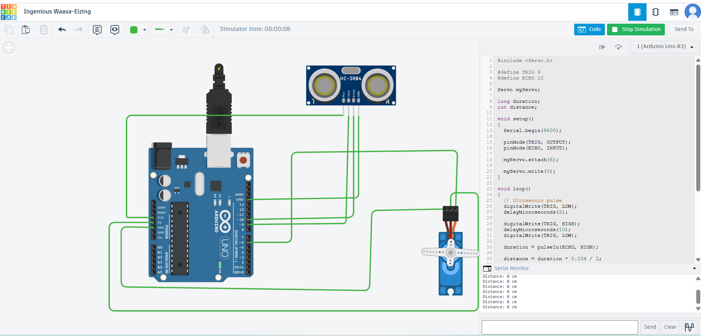
Circuit 4: HC-SR04 ultrasonic sensor + SG90 servo motor on Arduino Uno R3

4.2 Overview
This circuit combines the HC-SR04 sensor with a servo motor. When an object comes within 20 cm, the servo rotates to 90°. When the path clears, it returns to 0°. This is the core principle behind automatic doors, robot obstacle avoidance, and security barriers.

4.3 Components
Arduino Uno R3 | Microcontroller
HC-SR04 Module | Ultrasonic distance sensor
SG90 Servo Motor | 3-wire servo: Signal (orange), VCC (red), GND (brown)
Power Jack | External power — servo draws more current than USB alone can supply reliably
Wires | Multi-wire harness

4.4 Wiring Diagram
FROM (Component) | TO (Arduino) | Purpose
HC-SR04 VCC | Arduino 5V | Sensor power
HC-SR04 GND | Arduino GND | Sensor ground
HC-SR04 TRIG | Arduino Pin 9 (OUTPUT) | Sends ultrasonic burst
HC-SR04 ECHO | Arduino Pin 10 (INPUT) | Receives reflected echo
Servo Signal (orange) | Arduino Pin 6 (PWM ~) | myServo.write() angle commands
Servo VCC (red) | Arduino 5V (or ext. power) | Motor power
Servo GND (brown) | Arduino GND | Motor ground

⚠ Pin 6 must be a PWM pin (~). The Servo library sends a 50 Hz PWM signal to control angle.

4.5 Complete Code
#include <Servo.h> // Load Servo library

#define TRIG 9
#define ECHO 10

Servo myServo; // Create servo object
long duration;
int distance;

void setup()
{
Serial.begin(9600);
pinMode(TRIG, OUTPUT);
pinMode(ECHO, INPUT);
myServo.attach(6); // Servo on pin 6
myServo.write(0); // Start position = 0°
}

void loop()
{
// ── Measure distance (same as Circuit 2) ──────
digitalWrite(TRIG, LOW);
delayMicroseconds(2);
digitalWrite(TRIG, HIGH);
delayMicroseconds(10);
digitalWrite(TRIG, LOW);
duration = pulseIn(ECHO, HIGH);
distance = duration * 0.034 / 2;

// ── Servo decision based on distance ──────────
if (distance < 20) // Object closer than 20 cm?
{
myServo.write(90); // YES → rotate to 90°
}
else // Object far or none?
{
myServo.write(0); // NO → return to 0°
}

Serial.print("Distance: ");
Serial.print(distance);
Serial.println(" cm");
delay(100);
}

4.6 Code Explanation (Line by Line)
#include <Servo.h> | Imports the built-in Servo library. Without this, myServo commands won't compile.
Servo myServo | Declares a Servo object. Think of it as naming your servo 'myServo'.
myServo.attach(6) | Links myServo to pin 6. The library now sends PWM signals on that pin.
myServo.write(0) | Moves servo to 0 degrees. Range is 0–180. Call in setup() to set start position.
if (distance < 20) | Conditional check: is the measured distance less than 20 cm?
myServo.write(90) | If YES: rotate servo to 90° (barrier opens / door opens).
else { myServo.write(0) } | If NO: keep servo at 0° (closed position).
delay(100) | 100 ms pause stabilises sensor readings without making the servo feel sluggish.

4.7 if / else — How Decisions Work in Arduino
if ( condition ) // Is this true?
{
// Run this code when TRUE
}
else
{
// Run this code when FALSE
}

// Real example from this circuit:
if (distance < 20) // Is something within 20 cm?
{
myServo.write(90); // TRUE → open barrier
}
else
{
myServo.write(0); // FALSE → close barrier
}

Summary: All 4 Circuits at a Glance

# | Circuit | Pins | Key Function | New Concept | Output
01 | RGB LED | 9,10,11 (PWM) | Colour mixing | analogWrite() 0–255 | LED changes colour
02 | Ultrasonic | 9 TRIG, 10 ECHO | Distance measure | pulseIn(), Serial | Prints cm to monitor
03 | Traffic Light | 8,9,10 (Digital) | LED sequencing | digitalWrite() + timing | 3-phase light cycle
04 | Servo+Sensor | 6 Servo,9,10 | Object detection | Servo.h, if/else | Motor reacts to distance

Beginner Tips & Common Mistakes

Always add resistors to LEDs | Without a resistor, too much current flows — the LED burns out instantly.
Only PWM pins for analogWrite() | Pins marked ~ on Uno: 3,5,6,9,10,11. Plain digital pins will not work.
GND must be connected | Every component needs a GND wire back to Arduino or it won't function.
Serial.begin() before print() | Forgetting Serial.begin(9600) in setup() means nothing appears in the monitor.
delay() blocks everything | While waiting, Arduino ignores all other inputs. For complex timing use millis().
#include before any library call | Servo.h (or any library) must be #included at the top of the sketch.
Check pin numbers carefully | Swapping a pin number between code and wiring is the most common beginner mistake.
Long leg = anode (+) | On any LED, the longer leg is + (anode). Short leg is − (cathode) → GND.

— End of Report —

