Arduino Sensor Kit
Complete Beginner's Reference Guide
15 Sensors | Real Photos | Pinouts | Arduino Code | Real-World Examples
Prepared for Beginners — No Experience Needed

Introduction
This guide covers all 15 sensors in your kit. Each sensor gets its own page with a real photo, a plain-English explanation, a wiring table, complete Arduino code you can copy, and everyday examples of where that sensor is used.

WHAT YOU NEED:
- Arduino Uno (or Nano / Mega)
- USB cable to connect to your computer
- Jumper wires (male-to-male)
- Arduino IDE — free download at: arduino.cc/en/software
- Breadboard (optional but recommended)

HOW TO USE THIS GUIDE:
- Find your sensor by its number
- Read 'What Is This?' to understand it before wiring
- Follow the wiring table — connect each pin carefully
- Copy the code into Arduino IDE, then click Upload
- Open Serial Monitor: Tools > Serial Monitor, set baud to 9600
- Watch the sensor data appear live in the Serial Monitor!

#1 | TCS3200 — Color Sensor

📷 Photo  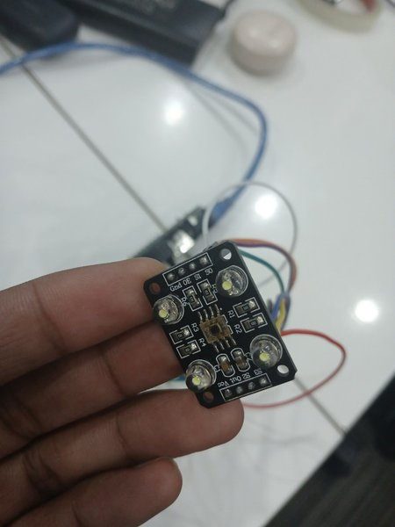 | What Is This?  Detects and identifies colors by shining white LEDs on an object and measuring the reflected red, green, and blue light — like eyes that can say 'this is red' or 'this is blue'. The 4 white LEDs around the center chip are the light sources.

🔌 Wiring (Pinout)
Sensor Pin | Arduino
VCC | 5V
GND | GND
S0 | Pin 4
S1 | Pin 5
S2 | Pin 6
S3 | Pin 7
OUT | Pin 8

💻 Arduino Code
Copy this into Arduino IDE, then click Upload:

// TCS3200 Color Sensor
#define S0 4
#define S1 5
#define S2 6
#define S3 7
#define OUT 8

void setup() {
Serial.begin(9600);
pinMode(S0,OUTPUT); pinMode(S1,OUTPUT);
pinMode(S2,OUTPUT); pinMode(S3,OUTPUT);
pinMode(OUT,INPUT);
digitalWrite(S0,HIGH); digitalWrite(S1,LOW);
}

int readColor(int s2val, int s3val) {
digitalWrite(S2,s2val); digitalWrite(S3,s3val);
delay(100);
return pulseIn(OUT,LOW); // lower = more of that color
}

void loop() {
int r = readColor(LOW,LOW); // Red
int g = readColor(HIGH,HIGH); // Green
int b = readColor(LOW,HIGH); // Blue
Serial.print("R:"); Serial.print(r);
Serial.print(" G:"); Serial.print(g);
Serial.print(" B:"); Serial.println(b);
delay(500);}

🌍 Real-World Uses
- Color sorting machines in factories
- Detecting fruit ripeness
- Line-following robots
- Smart paint mixing systems

#2 | HC-SR04 — Ultrasonic Distance Sensor

📷 Photo  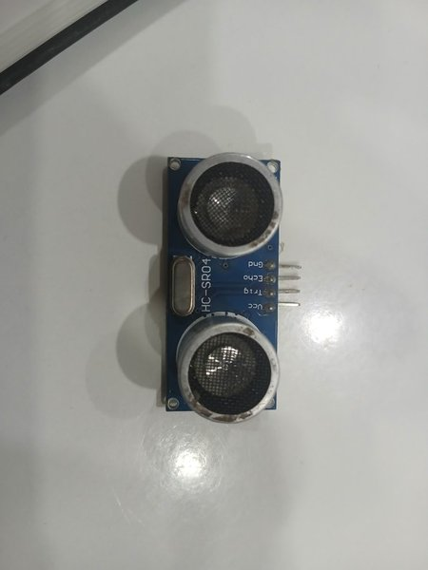 | What Is This?  Measures distance by sending an ultrasonic sound pulse and timing how long it takes to bounce back — just like a bat! The two silver circles are the transmitter (sends sound) and receiver (listens for echo). Range: 2 cm to 400 cm.

🔌 Wiring (Pinout)
Sensor Pin | Arduino
VCC | 5V
GND | GND
Trig | Pin 9
Echo | Pin 10

💻 Arduino Code
Copy this into Arduino IDE, then click Upload:

// HC-SR04 Ultrasonic Distance Sensor
#define TRIG 9
#define ECHO 10

void setup() {
Serial.begin(9600);
pinMode(TRIG, OUTPUT);
pinMode(ECHO, INPUT);}

void loop() {
digitalWrite(TRIG, LOW); delayMicroseconds(2);
digitalWrite(TRIG, HIGH); delayMicroseconds(10);
digitalWrite(TRIG, LOW);
long dur = pulseIn(ECHO, HIGH);
float cm = dur * 0.034 / 2;
Serial.print("Distance: ");
Serial.print(cm);
Serial.println(" cm");
delay(200);}

🌍 Real-World Uses
- Parking sensors in cars
- Robot obstacle avoidance
- Automatic hand sanitizer dispensers
- Water level measurement in tanks

#3 | KY-023 — Joystick Module

📷 Photo  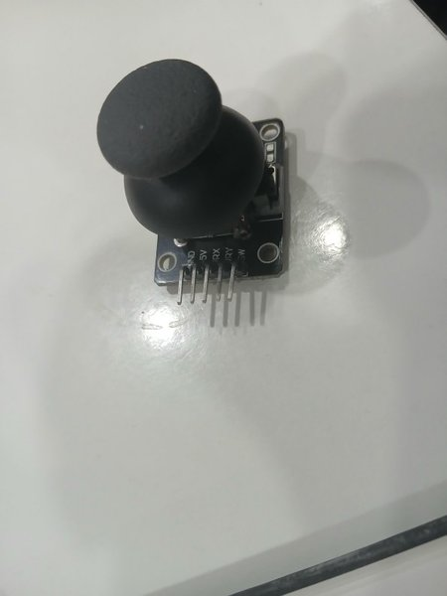 | What Is This?  Exactly like the thumbstick on a PS4/Xbox controller! Two potentiometers measure X (left/right) and Y (up/down) position, giving 0–1023. Pressing the stick down activates a push-button. The resting center position reads ~512 on both axes.

🔌 Wiring (Pinout)
Sensor Pin | Arduino
GND | GND
+5V | 5V
VRX | A0 (X axis)
VRY | A1 (Y axis)
SW | Pin 2 (button)

💻 Arduino Code
Copy this into Arduino IDE, then click Upload:

// KY-023 Joystick Module
#define VRX A0
#define VRY A1
#define SW 2

void setup() {
Serial.begin(9600);
pinMode(SW, INPUT_PULLUP);}

void loop() {
int x = analogRead(VRX); // 0=left, 512=center, 1023=right
int y = analogRead(VRY); // 0=up, 512=center, 1023=down
int btn = digitalRead(SW); // 0=pressed, 1=released
Serial.print("X:"); Serial.print(x);
Serial.print(" Y:"); Serial.print(y);
Serial.print(" BTN:"); Serial.println(btn);
delay(100);}

🌍 Real-World Uses
- DIY game controllers
- Controlling robot arms
- Pan-tilt camera systems
- RC car steering control

#4 | Digital Buzzer Module (Robomart ROBOMART-06)

📷 Photo  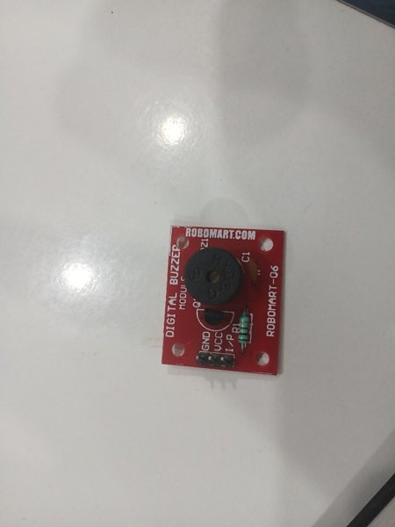 | What Is This?  An active buzzer — give it power and it beeps! The built-in oscillator generates the sound frequency automatically, so you just turn it ON or OFF. The black dome is the buzzer element. Red PCB with 3-pin connector (GND, VCC, I/P).

🔌 Wiring (Pinout)
Sensor Pin | Arduino
GND | GND
VCC | 5V
I/P | Pin 8 (signal)

💻 Arduino Code
Copy this into Arduino IDE, then click Upload:

// Digital Buzzer Module
#define BUZZER 8

void setup() {
pinMode(BUZZER, OUTPUT);}

void beep(int times, int ms) {
for(int i=0; i<times; i++) {
digitalWrite(BUZZER, HIGH); delay(ms);
digitalWrite(BUZZER, LOW); delay(ms);
}
}

void loop() {
beep(1, 500); // One long beep
delay(1000);
beep(3, 150); // Three short beeps
delay(1000);}

🌍 Real-World Uses
- Burglar alarm systems
- Doorbell projects
- Timer alerts (microwave, oven)
- Quiz game buzzers

#5 | MPU-6050 — 6-Axis Gyroscope + Accelerometer

📷 Photo  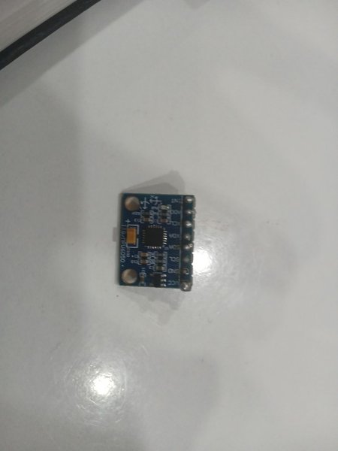 | What Is This?  Measures both acceleration (which way is down) and rotation speed in all 3 axes (X, Y, Z). The same chip used in smartphones for screen rotation and in drones to stay level. Communicates via I2C — only 2 data wires needed. The orange square is the I2C pull-up resistor.

🔌 Wiring (Pinout)
Sensor Pin | Arduino
VCC | 3.3V or 5V
GND | GND
SCL | A5 (I2C clock)
SDA | A4 (I2C data)
INT | Pin 2 (optional interrupt)

💻 Arduino Code
Copy this into Arduino IDE, then click Upload:

// MPU-6050 — install 'MPU6050 by Electronic Cats'
#include <Wire.h>
#include <MPU6050.h>
MPU6050 mpu;

void setup() {
Serial.begin(9600); Wire.begin();
mpu.initialize();
Serial.println(mpu.testConnection() ? "MPU OK" : "FAIL");}

void loop() {
int16_t ax,ay,az,gx,gy,gz;
mpu.getMotion6(&ax,&ay,&az,&gx,&gy,&gz);
Serial.print("Accel X:"); Serial.print(ax);
Serial.print(" Y:"); Serial.print(ay);
Serial.print(" Z:"); Serial.println(az);
delay(100);}

🌍 Real-World Uses
- Drone flight stabilization
- Phone screen auto-rotation
- Step counter / pedometer
- Self-balancing robots

#6 | KY-010 — Slotted Optical Sensor (Light Barrier)

📷 Photo  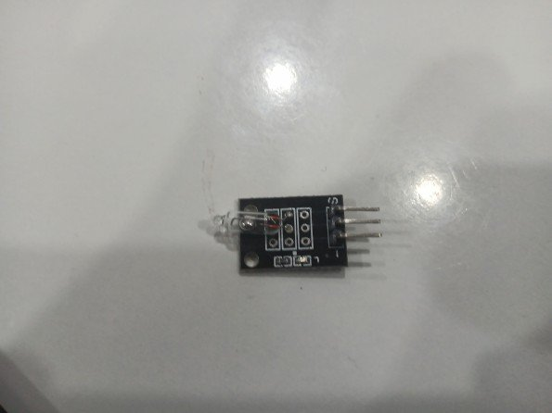 | What Is This?  An IR LED and a photodiode face each other across a small slot. When an object passes through the slot it breaks the light beam and triggers the output. Like a tiny light curtain. Very precise — can detect paper-thin objects.

🔌 Wiring (Pinout)
Sensor Pin | Arduino
- (GND) | GND
+ (VCC) | 5V
S (Signal) | Pin 7

💻 Arduino Code
Copy this into Arduino IDE, then click Upload:

// KY-010 Slotted Optical Sensor
#define SENSOR 7
int count = 0;
int lastState = HIGH;

void setup() {
Serial.begin(9600);
pinMode(SENSOR, INPUT);}

void loop() {
int state = digitalRead(SENSOR);
if(state == LOW && lastState == HIGH) {
count++;
Serial.print("Detected! Count: ");
Serial.println(count);
}
lastState = state;
delay(10);}

🌍 Real-World Uses
- Counting objects on a conveyor belt
- Encoder wheels for motor speed sensing
- Paper feed detection in printers
- Coin counting machines

#7 | KY-008 — Laser Transmitter + LDR Module

📷 Photo  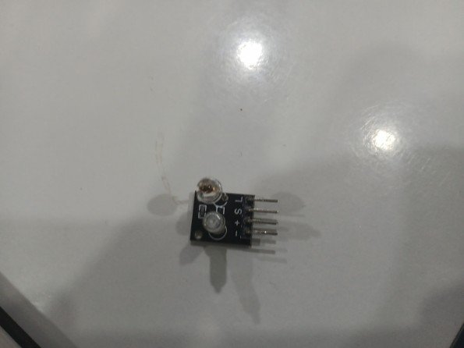 | What Is This?  A tiny laser diode shoots a red beam. Pair it with an LDR (light sensor) on the other side to create a tripwire — when something crosses the beam, the LDR reading drops sharply. The two components on the board are the laser (amber top) and an indicator LED (white dome).

🔌 Wiring (Pinout)
Sensor Pin | Arduino
- (GND) | GND
+ (VCC) | 5V
S (Signal) | Pin 13 (on/off control)

💻 Arduino Code
Copy this into Arduino IDE, then click Upload:

// KY-008 Laser tripwire (pair with LDR on A0)
#define LASER 13
#define LDR A0

void setup() {
Serial.begin(9600);
pinMode(LASER, OUTPUT);
digitalWrite(LASER, HIGH); // Turn laser ON
}

void loop() {
int val = analogRead(LDR);
// Laser hits LDR: ~900+ | Beam broken: <400
if(val < 400)
Serial.println("BEAM BROKEN! Alert!");
else
Serial.println("Beam clear");
delay(100);}

🌍 Real-World Uses
- Laser tripwire burglar alarm
- Detecting objects crossing a line
- Shooting gallery target
- Automatic door sensors

#8 | Dual IR Obstacle Avoidance Sensor

📷 Photo  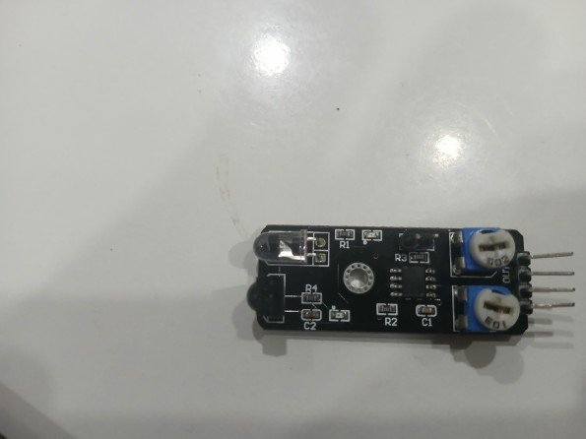 | What Is This?  Has an IR LED emitter and IR photodiode receiver with TWO blue trimpots for independent sensitivity tuning on each channel. The two adjustable knobs let you set detection range per zone. Two output channels let you sense obstacles on two sides simultaneously.

🔌 Wiring (Pinout)
Sensor Pin | Arduino
GND | GND
VCC | 5V
OUT1 | Pin 3
OUT2 | Pin 4

💻 Arduino Code
Copy this into Arduino IDE, then click Upload:

// Dual IR Obstacle Sensor
#define IR1 3
#define IR2 4

void setup() {
Serial.begin(9600);
pinMode(IR1, INPUT);
pinMode(IR2, INPUT);}

void loop() {
int L = digitalRead(IR1); // LOW = obstacle
int R = digitalRead(IR2);
if(L==LOW && R==LOW) Serial.println("STOP - both sides!");
else if(L==LOW) Serial.println("Obstacle LEFT - turn right");
else if(R==LOW) Serial.println("Obstacle RIGHT - turn left");
else Serial.println("Path clear - go forward");
delay(100);}

🌍 Real-World Uses
- Robot obstacle detection
- Smart vacuum cleaner navigation
- Table-edge detection for robots
- Automatic braking systems

#9 | IR Sensor Module (with Photodiode + Op-Amp)

📷 Photo  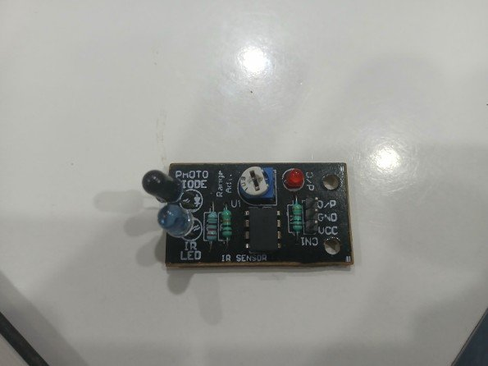 | What Is This?  A proximity sensor with a photodiode receiver, IR LED emitter, red status LED, and an op-amp comparator chip (the 8-pin IC). The blue trimpot adjusts detection range. When an object is close, output goes LOW and the red LED lights up. Labels: PHOTO DIODE, IR LED, IR SENSOR.

🔌 Wiring (Pinout)
Sensor Pin | Arduino
VCC | 5V
GND | GND
O/P | Pin 5 (output)

💻 Arduino Code
Copy this into Arduino IDE, then click Upload:

// IR Sensor Module with Photodiode
#define IR_PIN 5
#define LED 13

void setup() {
Serial.begin(9600);
pinMode(IR_PIN, INPUT);
pinMode(LED, OUTPUT);}

void loop() {
if(digitalRead(IR_PIN) == LOW) {
Serial.println("Object detected!");
digitalWrite(LED, HIGH);
} else {
Serial.println("Clear");
digitalWrite(LED, LOW);
}
delay(100);}

🌍 Real-World Uses
- Line-following robots
- Proximity sensing
- Object counting
- Obstacle avoidance

#10 | GY-271 / HMC5883L — Digital Compass (Magnetometer)

📷 Photo  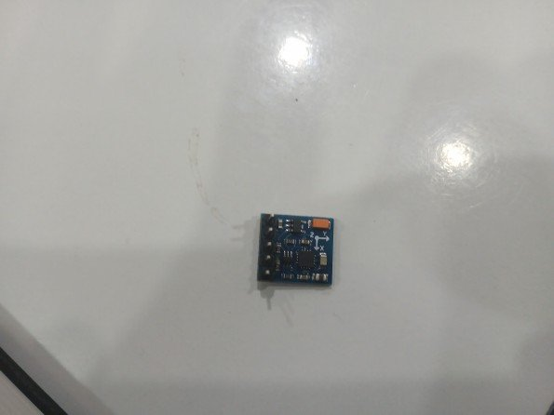 | What Is This?  A digital compass that detects the Earth's magnetic field in 3 axes (X, Y, Z) to tell which direction is North. Very small blue board with X/Y/Z axis arrows printed on it. The orange component is a decoupling capacitor. Uses I2C — shares the same pins as the MPU-6050.

🔌 Wiring (Pinout)
Sensor Pin | Arduino
VCC | 3.3V
GND | GND
SCL | A5
SDA | A4

💻 Arduino Code
Copy this into Arduino IDE, then click Upload:

// GY-271 Compass — install 'HMC5883L' library
#include <Wire.h>
#include <HMC5883L.h>
HMC5883L compass;

void setup() {
Serial.begin(9600); Wire.begin();
compass = HMC5883L();
compass.SetScale(1.3);
compass.SetMeasurementMode(Measurement_Continuous);}

void loop() {
MagnetometerScaled s = compass.ReadScaledAxis();
float heading = atan2(s.YAxis, s.XAxis) * (180.0/PI);
if(heading < 0) heading += 360;
Serial.print("Heading: "); Serial.print(heading);
Serial.println(" deg (0=North)");
delay(500);}

🌍 Real-World Uses
- Navigation compass for robots
- Drone heading control
- Geocaching / treasure hunt apps
- Electronic compass displays

#11 | HC-06 — Bluetooth Serial Module

📷 Photo  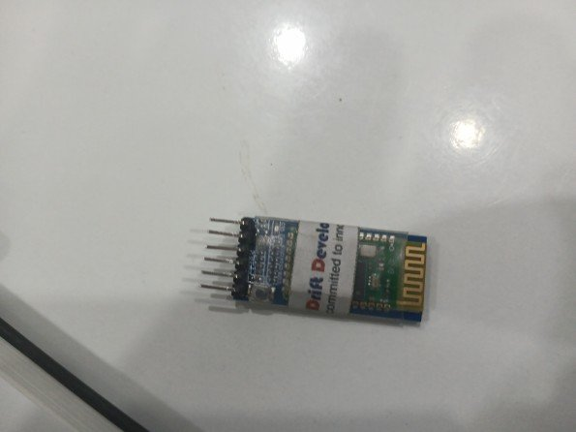 | What Is This?  Lets your Arduino talk wirelessly to a smartphone or PC over Bluetooth up to ~10 metres. It appears as a virtual serial port — just use Serial.print() as normal! The gold zig-zag pattern on the right is the Bluetooth antenna. The 'Drift Develo...' sticker is a reseller label.

🔌 Wiring (Pinout)
Sensor Pin | Arduino
VCC | 5V
GND | GND
TXD | Pin 0 RX
RXD | Pin 1 TX (use 1kΩ resistor)

💻 Arduino Code
Copy this into Arduino IDE, then click Upload:

// HC-06 Bluetooth — control LED from phone
// Download 'Arduino Bluetooth Controller' app
#define LED 13

void setup() {
Serial.begin(9600); // HC-06 default baud rate
pinMode(LED, OUTPUT);}

void loop() {
if(Serial.available()) {
char c = Serial.read();
if(c == '1') { digitalWrite(LED, HIGH); Serial.println("LED ON"); }
if(c == '0') { digitalWrite(LED, LOW); Serial.println("LED OFF"); }
}
}

🌍 Real-World Uses
- Control Arduino from your phone
- Wireless sensor data logging
- DIY smart home switches
- Bluetooth RC car

#12 | Single IR Obstacle Sensor (Compact, GND-VCC-OUT)

📷 Photo  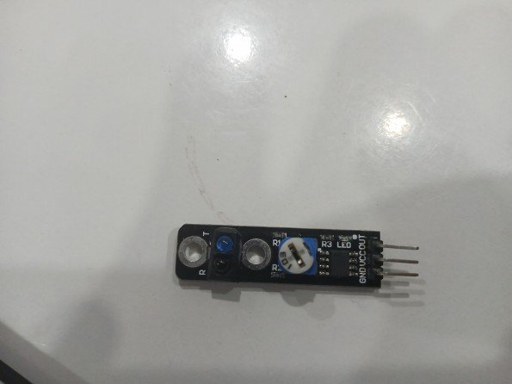 | What Is This?  The simplest IR sensor in the kit — just 3 pins (GND VCC OUT). Has an IR transmitter, IR receiver, a blue indicator LED, and a trimpot for range adjustment. The labels on the right clearly show: GND VCC OUT. Small onboard LED lights when obstacle detected.

🔌 Wiring (Pinout)
Sensor Pin | Arduino
GND | GND
VCC | 5V
OUT | Pin 6

💻 Arduino Code
Copy this into Arduino IDE, then click Upload:

// Compact IR Obstacle Sensor
#define IR_OUT 6

void setup() {
Serial.begin(9600);
pinMode(IR_OUT, INPUT);}

void loop() {
if(digitalRead(IR_OUT) == LOW)
Serial.println("Obstacle found!");
else
Serial.println("No obstacle");
delay(200);}

🌍 Real-World Uses
- Simple obstacle detection
- Robot bumper sensor
- Proximity switch replacement
- Conveyor item counting

#13 | IR-08H — Dual Output IR Sensor (V02.45.DC)

📷 Photo  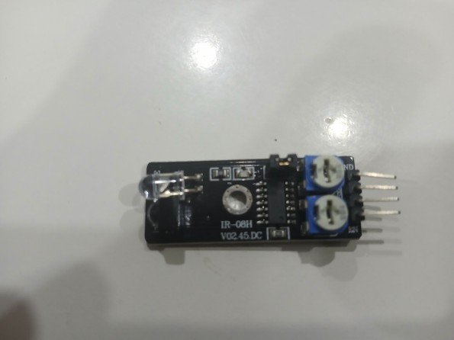 | What Is This?  Advanced IR obstacle sensor — model number IR-08H V02.45.DC printed on the board. Has two blue trimpots for independent sensitivity tuning and dual output channels. Better noise immunity than basic IR sensors. The clear dome is the IR LED and the dark dome is the IR receiver.

🔌 Wiring (Pinout)
Sensor Pin | Arduino
GND | GND
VCC | 5V
OUT1 | Pin 3
OUT2 | Pin 4

💻 Arduino Code
Copy this into Arduino IDE, then click Upload:

// IR-08H Dual IR Sensor
#define OUT1 3
#define OUT2 4

void setup() {
Serial.begin(9600);
pinMode(OUT1, INPUT);
pinMode(OUT2, INPUT);}

void loop() {
bool z1 = digitalRead(OUT1) == LOW;
bool z2 = digitalRead(OUT2) == LOW;
Serial.print("Zone1: "); Serial.print(z1 ? "DETECTED" : "clear");
Serial.print(" | Zone2: "); Serial.println(z2 ? "DETECTED" : "clear");
delay(200);}

🌍 Real-World Uses
- Two-zone proximity detection
- Robot edge detection
- Advanced obstacle avoidance
- Industrial presence sensing

#14 | D2018 — LDR Light Sensor Module

📷 Photo  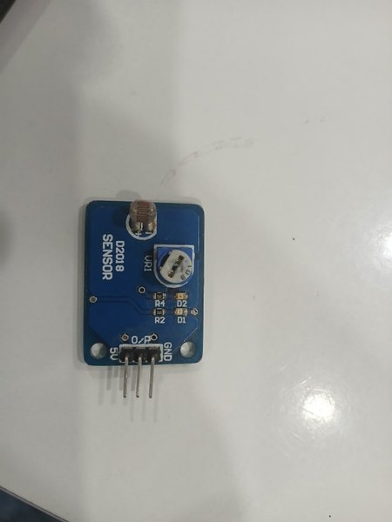 | What Is This?  Uses an LDR (Light Dependent Resistor) — the honey-colored component at the top. Its resistance changes with light level. The blue trimpot (VR1) sets the darkness threshold. Bright light → output HIGH. Darkness → output LOW. Board label: 'D2018 SENSOR'.

🔌 Wiring (Pinout)
Sensor Pin | Arduino
GND | GND
5V | 5V
D/O | Pin 7 (digital out)

💻 Arduino Code
Copy this into Arduino IDE, then click Upload:

// D2018 LDR Light Sensor
#define LDR_DO 7
#define LED 13

void setup() {
Serial.begin(9600);
pinMode(LDR_DO, INPUT);
pinMode(LED, OUTPUT);}

void loop() {
if(digitalRead(LDR_DO) == LOW) {
Serial.println("Dark - LED ON");
digitalWrite(LED, HIGH);
} else {
Serial.println("Bright - LED OFF");
digitalWrite(LED, LOW);
}
delay(300);}

🌍 Real-World Uses
- Automatic street lights
- Night light automation
- Solar charge controller
- Photography light meter

#15 | Reed Switch / Magnetic Sensor Module

📷 Photo  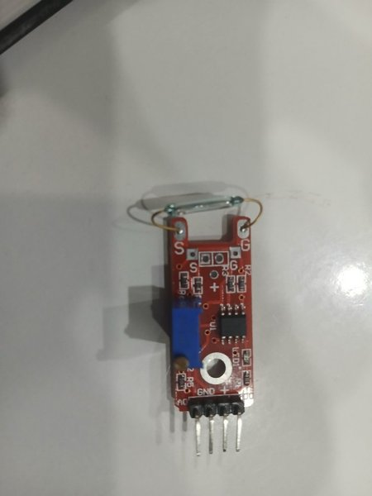 | What Is This?  A reed switch (the silver glass capsule at the top with gold wires) contains two metal reeds. When a magnet comes near, the reeds snap together — no physical contact needed! The red PCB adds an IC comparator, LEDs, and resistors. Labels S (signal), G (ground), + (power) visible on board.

🔌 Wiring (Pinout)
Sensor Pin | Arduino
GND | GND
+ | 5V
S (Signal) | Pin 2

💻 Arduino Code
Copy this into Arduino IDE, then click Upload:

// Reed Switch / Magnetic Sensor
#define REED 2
int lastState = HIGH;
int count = 0;

void setup() {
Serial.begin(9600);
pinMode(REED, INPUT_PULLUP);}

void loop() {
int state = digitalRead(REED);
if(state != lastState) {
if(state == LOW) {
Serial.println("Magnet DETECTED - circuit closed");
} else {
count++;
Serial.print("Magnet removed. Opens: ");
Serial.println(count);
}
lastState = state;
}
delay(50);}

🌍 Real-World Uses
- Door/window alarm (magnet on door, sensor on frame)
- Bike speedometer (magnet on wheel)
- Tamper detection in devices
- Flow meter counting in pipes

Quick Tips for Beginners

Common Mistakes to Avoid
- Check VCC — some sensors need 3.3V, most use 5V
- Don't swap TX and RX on the HC-06 Bluetooth module
- MPU-6050 and compass can share the same SDA/SCL pins (I2C)
- Adjust the blue trimpot knob on IR sensors if detection is unreliable
- Open Serial Monitor AFTER uploading code, not before
- Disconnect Bluetooth (HC-06) wires from Pin 0/1 when uploading code

Installing Libraries
Go to: Sketch > Include Library > Manage Libraries, then search:
- MPU-6050: search 'MPU6050 by Electronic Cats' and click Install
- Compass GY-271: search 'HMC5883L' and click Install

I2C Sensors — MPU-6050 & Compass
I2C needs only 2 data wires. On Arduino Uno: SDA = A4, SCL = A5. Multiple I2C sensors share the same 2 pins — each has a unique address, so Arduino knows which is which.

Reading the Serial Monitor
After uploading code: Tools > Serial Monitor. Set baud rate to 9600 in the bottom-right dropdown. Sensor readings will appear live.

