BUILD YOUR OWN
4-WHEEL MANUAL & AUTONOMOUS ROBOT CAR
Complete Technical Report | Build Photos | Full Code Reference

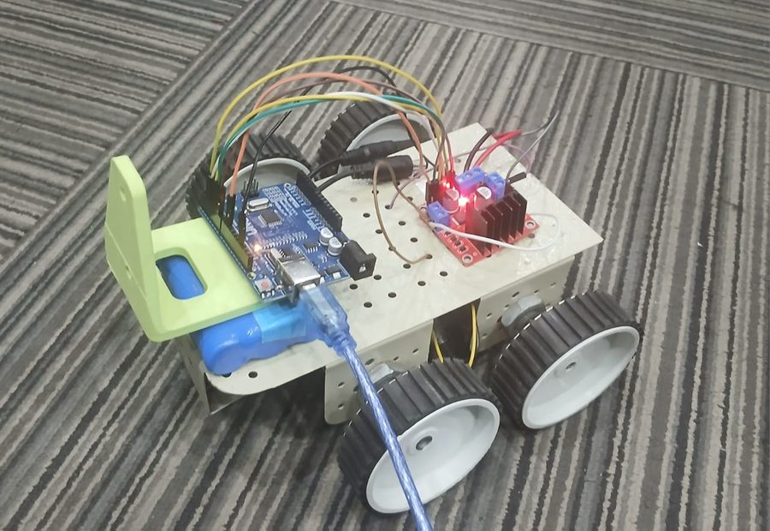
Figure 1 — The completed 4-wheel robot car with Arduino UNO, L298N motor driver, and USB laptop connection

Arduino UNO R3 + L298N Motor Driver + 4× DC Gear Motors
USB Laptop Control | Arrow Keys | Python & Processing | 11 Commands | 3 Speed Levels
Semi-Autonomous | Auto Sequences | Phase Roadmap to Full Autonomy

Section 1 — Project Overview
This is the complete technical report and code reference for a 4-wheel Arduino robot car built from scratch. Every stage is documented — from components and wiring to three complete control programs with all code explained line-by-line. All photos are from the actual build.

1.1 Your Actual Build — Photo Gallery
The following photos document the complete build progression from early prototype through final assembly.

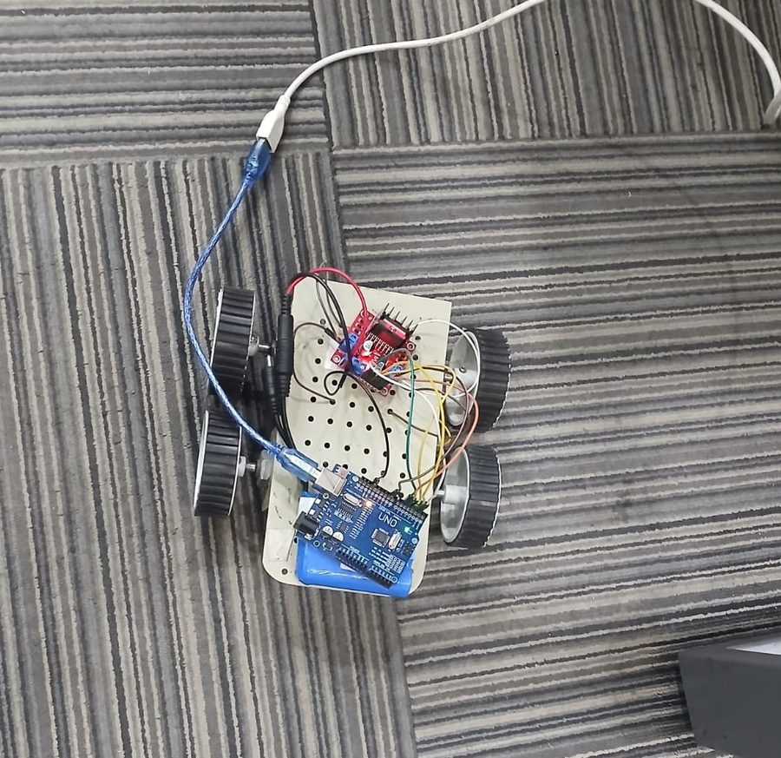  Fig 2 — Early prototype: 2-wheel prototype on acrylic chassis with L298N (red board, top) | 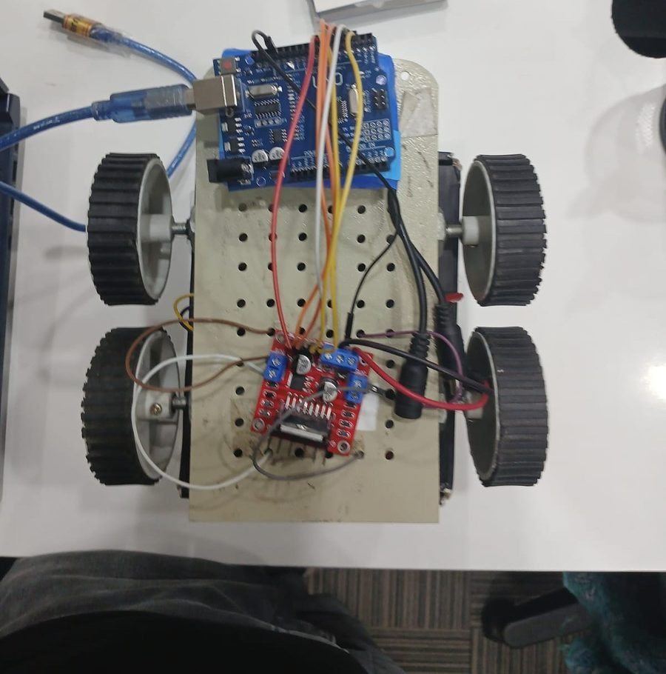  Fig 3 — Final version: Arduino UNO + L298N mounted on chassis, USB cable connected

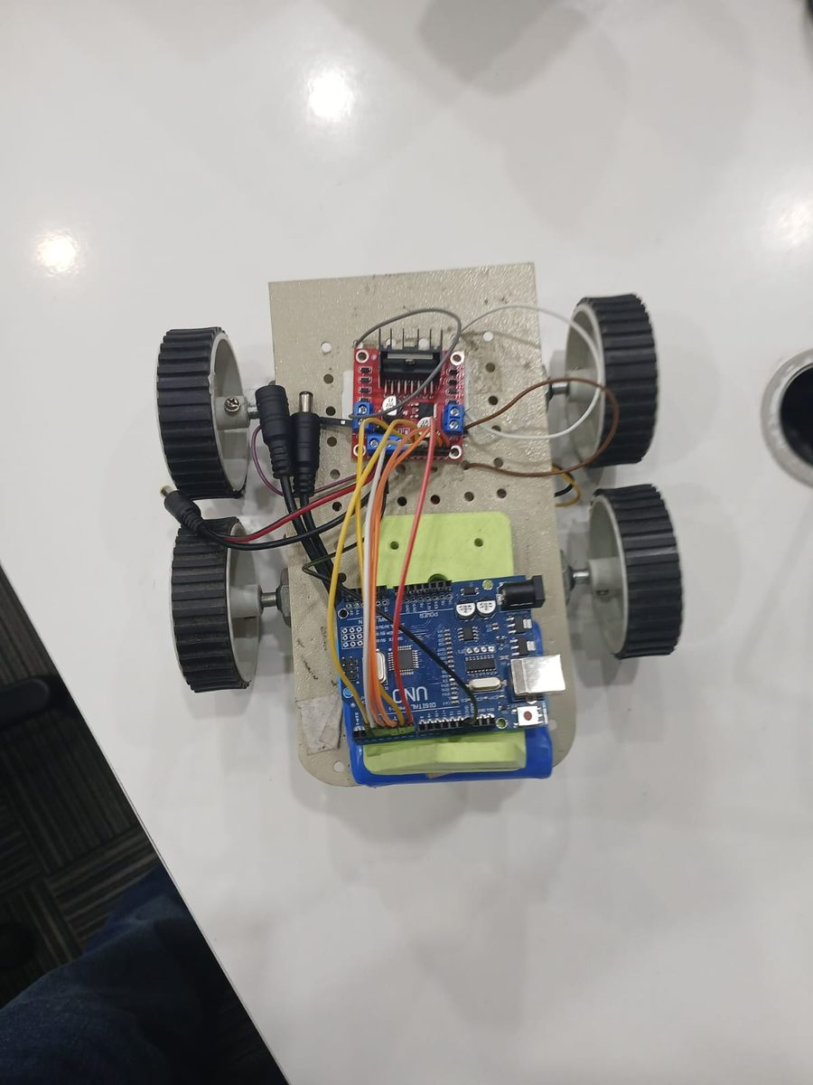  Fig 4 — Top-down view: Arduino UNO (blue, bottom), L298N driver (red, top), coloured wiring | 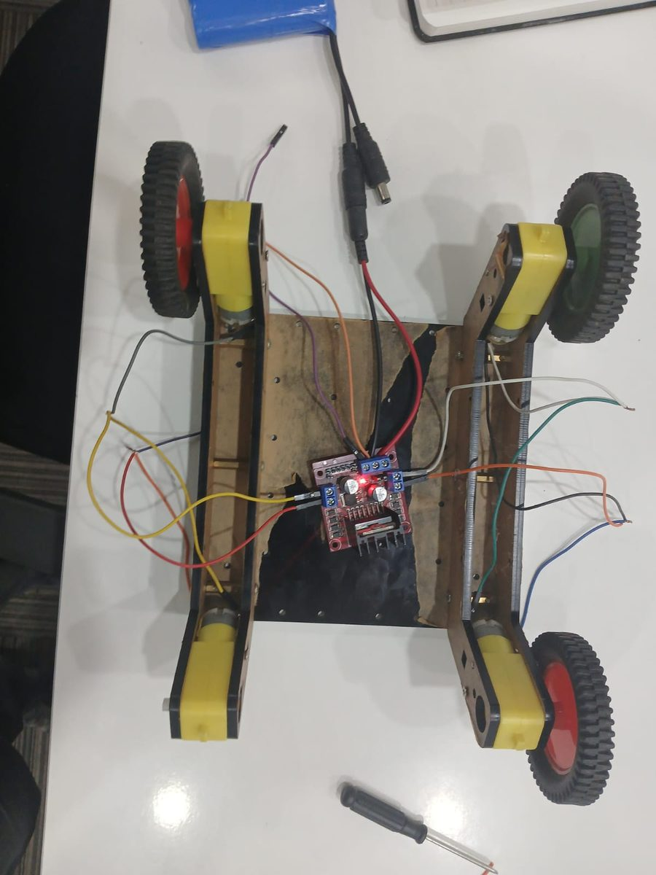  Fig 5 — Wooden chassis variant: L298N centered, yellow TT motors on all 4 corners

1.2 System Architecture
Layer | Component | Role
Brain | Arduino UNO R3 | Reads keyboard commands, controls all output pins
Muscle | L298N Motor Driver | H-bridge chip — takes weak Arduino signals, drives motors with battery power
Power (Motors) | Battery Pack 6V–9V | Heavy current for motors — 4×AA or 2×18650
Power (Brain) | Laptop USB Cable | Powers Arduino AND carries all keyboard commands
Communication | USB Serial 9600 baud | Road that carries F/B/L/R/S commands laptop→Arduino
Legs | 4× TT DC Gear Motors | Physical actuators that spin and move the car

Section 2 — Components & Hardware

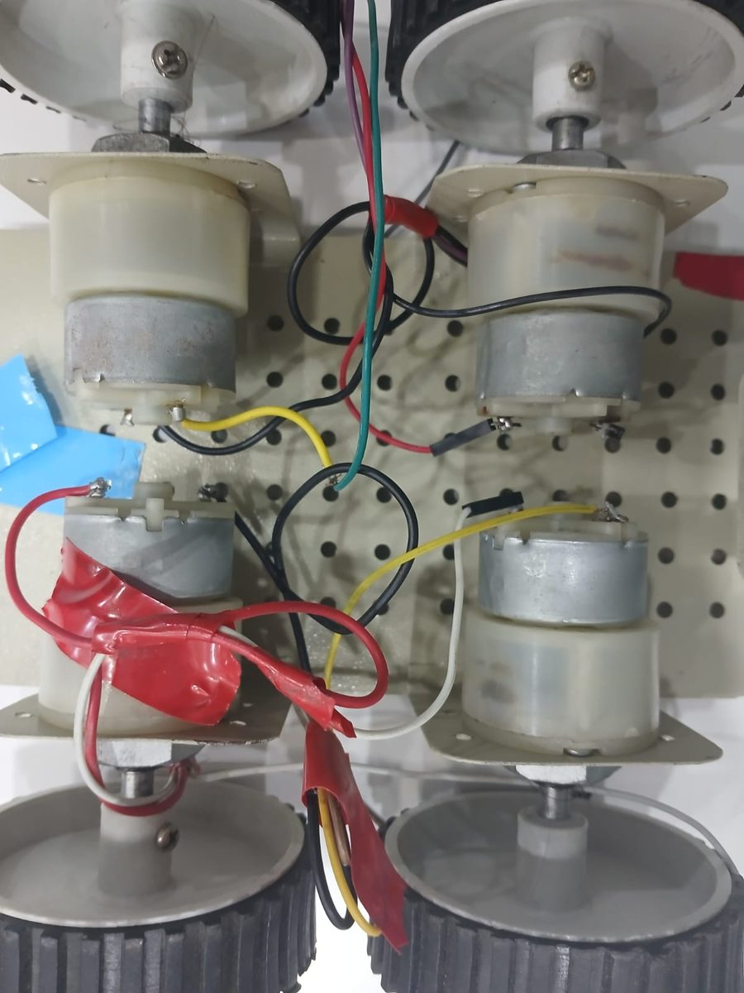  Fig 6 — Motor close-up: 4× TT gear motors with red/black wiring visible, mounted to acrylic chassis | 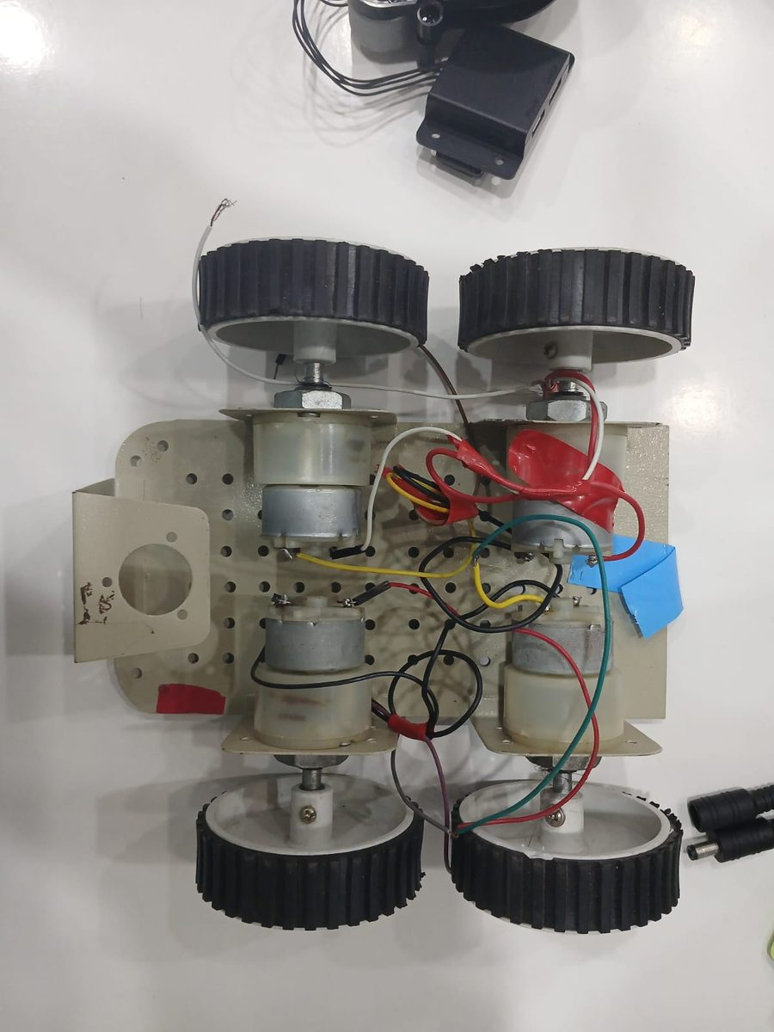  Fig 7 — Underside view: 4 motors exposed with colour-coded wires (black/yellow/red/green)

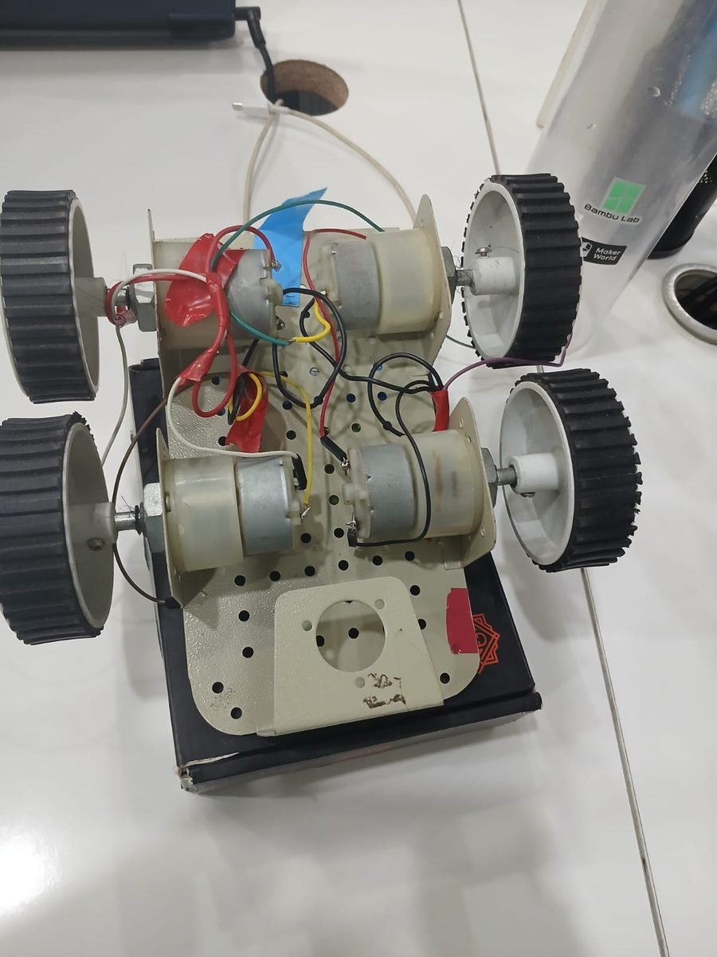
Fig 8 — Build in progress: 4 motors mounted on chassis, wires being routed, battery connector visible

2.1 Full Parts List
Component | Qty | Function | Analogy
Arduino UNO R3 | 1 | Microcontroller — runs code, controls all pins | Human brain
L298N Motor Driver | 1 | H-bridge — controls direction & speed of 2 motor channels | Strong worker
TT DC Gear Motor (yellow) | 4 | 3V–6V gear motor — spins the wheels | Legs/feet
65mm Rubber Wheel | 4 | Fits motor shaft — provides grip on surface | Shoes
4WD Robot Chassis | 1 | Acrylic/wood/metal frame — holds everything | Skeleton
Battery Pack (6V–9V) | 1 | Powers motors via L298N — 4×AA or Li-Ion | Fuel
USB Type-B Cable | 1 | Powers Arduino + carries serial commands | Telephone line
Jumper Wires (M-M) | 20+ | All electrical connections | Roads
HC-05 Bluetooth* | 1 | Future upgrade — wireless phone control | Wireless remote
HC-SR04 Ultrasonic* | 1 | Future upgrade — obstacle detection | Eyes
TCRT5000 IR Sensor* | 2 | Future upgrade — line following | Floor sensors
* = Optional, for future upgrade phases only.

Section 3 — Wiring & Pin Connections

3.1 Arduino → L298N Pin Table
Arduino Pin | L298N Pin | Color | Purpose
D2 (PWM) | ENA | Blue | Enable Left motors — PWM controls left motor speed
D3 | IN1 | Blue | Left motor direction signal 1
D4 | IN2 | Blue | Left motor direction signal 2
D5 | IN3 | Blue | Right motor direction signal 1
D6 | IN4 | Blue | Right motor direction signal 2
D9 (PWM) | ENB | Blue | Enable Right motors — PWM controls right motor speed
GND | GND | Black | CRITICAL — common ground. Without this NOTHING works.
5V (optional) | 5V OUT | Red | Power Arduino from L298N regulator (battery ≤12V only)

3.2 Battery → L298N & Motors
From | To | Color | Purpose
Battery + (positive) | VIN / 12V terminal | Red | Main motor power supply (use 6V–9V)
Battery − (negative) | GND terminal | Black | Battery ground reference
L298N OUT1 + OUT2 | Left Motors ×2 | Green | Both left motors wired in parallel
L298N OUT3 + OUT4 | Right Motors ×2 | Yellow | Both right motors wired in parallel

CRITICAL — The Common Ground Wire
Connect: Arduino GND pin → L298N GND terminal (black jumper wire).
This makes both power supplies (USB and battery) share the same voltage reference.
Without this wire: L298N cannot understand any Arduino signals. Car will not move at all.
This is the single most common beginner mistake in this entire build.

Dual Power Supply — Simple Explanation
USB Cable from Laptop: Powers Arduino (5V) AND carries keyboard commands. Connected to laptop.
Battery Pack (6V–9V): Powers L298N + all 4 motors. NOT connected to laptop.
The two supplies are completely separate. The GND wire bridges them so signals work.
Never connect 9V+ battery directly to Arduino — it will permanently damage it.

Section 4 — Movement Logic & All Commands

4.1 L298N Truth Table
IN1 | IN2 | Motor Result | Explanation
HIGH | LOW | Spin Forward | Positive current flows through motor in forward direction
LOW | HIGH | Spin Backward | Current reversed — motor spins backward
LOW | LOW | Coast (Stop) | No current — motor spins down under inertia
HIGH | HIGH | Brake (Stop) | Both terminals connected — motor stops hard

4.2 All 11 Commands Explained
Key | Command | Left Motor | Right Motor | What Happens
F / ↑ | Forward | FORWARD | FORWARD | Both sides push — car goes straight ahead
B / ↓ | Backward | BACKWARD | BACKWARD | Both sides reverse — car goes straight back
L / ← | Turn Left | STOP | FORWARD | Right pushes, left anchored — car curves left
R / → | Turn Right | FORWARD | STOP | Left pushes, right anchored — car curves right
S / SPACE | Stop | STOP | STOP | All motors off — car halts immediately
G | Rotate Left | BACKWARD | FORWARD | Opposite dirs — spins counterclockwise in place
I | Rotate Right | FORWARD | BACKWARD | Opposite dirs — spins clockwise in place
A | Auto Fwd+Left | Sequence | Sequence | Fwd 2s → settle → TurnL → Fwd 3s → Stop
D | Auto Fwd+Right | Sequence | Sequence | Fwd 2s → settle → TurnR → Fwd 3s → Stop
Z | Auto Bwd+Left | Sequence | Sequence | Bwd 2s → settle → TurnL → Bwd 3s → Stop
X | Auto Bwd+Right | Sequence | Sequence | Bwd 2s → settle → TurnR → Bwd 3s → Stop

4.3 Speed Levels
Key | Level | analogWrite Value | Power % | Best For
1 | Slow | 60 | 24% | Tight spaces, precision, first-time testing
2 | Medium | 130 | 51% | Normal indoor driving
(default) | Fast | 190–200 | 74–78% | Standard forward/backward
3 | Fast | 200 | 78% | Open spaces, performance runs
— | Full | 255 | 100% | Maximum — harder to control on smooth floors

Section 5 — Three Laptop Control Methods
Feature | Serial Monitor | Processing IDE | Python VS Code
Difficulty | Very Easy | Easy | Moderate
Hold Key = Move | No | Yes | Yes
Release Key = Stop | No | Yes — instant | Yes — instant
Arrow Key Support | No | Yes | Yes
Speed Keys (1/2/3) | Yes (type it) | No | Yes — real-time
Auto Sequences | Yes (type A/D/Z/X) | Yes (letter keys) | Yes — all 11
Rotate G/I | Yes | Yes | Yes
Extra Software | None (Arduino IDE) | Processing IDE (free) | Python + pyserial + keyboard
Best For | Testing/Debug | RC-style driving | Advanced use

5.1 Serial Monitor — Setup
- Upload Arduino code. Open Arduino IDE.
- Tools → Serial Monitor. Set baud to 9600 at bottom dropdown.
- Type F / B / L / R / S / G / I / A / D / Z / X / 1 / 2 / 3, press Enter.
- Car acts on command. Does NOT auto-stop on key release.

5.2 Processing IDE — Setup
- Download Processing from processing.org/download (free, ~100MB).
- Open Processing. Paste the Processing code (Section 9). Change "COM5" to your port.
- CLOSE Arduino Serial Monitor first — only one app can use the COM port.
- Click Run ▶. Dark window appears. CLICK INSIDE IT to activate.
- Hold Arrow Keys to move. Release any key — car stops instantly.

5.3 Python VS Code — Setup
- Install Python 3 from python.org. Open terminal.
- Run: pip install pyserial keyboard
- Open Python script. Change COM_PORT = "COM5" to your port.
- Run: python rc_car_controller.py
- Hold Arrow Keys to drive. Keys 1/2/3 change speed. ESC to quit.

Section 6 — Problems, Causes & Solutions

Problem 1: Motors not moving at all
PROBLEM: Car Completely Dead — No Motors Move
Cause A: ENA/ENB jumper caps missing on L298N → Add caps or wire to Arduino PWM pins 6 and 9.
Cause B: Arduino GND not connected to L298N GND → Add black wire: Arduino GND → L298N GND.
Cause C: Battery dead or below 5V → Replace or recharge. Minimum 6V needed.
Cause D: Wrong COM port → Check Arduino IDE Tools → Port. Re-upload sketch.

Problem 2: One motor spins wrong direction
PROBLEM: Car Reverses or Turns Opposite to Expected
Cause: Motor wires connected with reversed polarity at L298N output terminals.
Fix (hardware): Swap the two wires of the affected motor at L298N output.
Left wrong? Swap OUT1 and OUT2. Right wrong? Swap OUT3 and OUT4.
Fix (software): In the motor function, swap HIGH and LOW for IN1/IN2 or IN3/IN4.

Problem 3: Car drifts left or right
PROBLEM: Car Curves Instead of Going Straight Forward
Cause: Budget DC motors have manufacturing tolerance — identical code produces slightly different speeds.
Fix: Use separate L_SPEED and R_SPEED constants. Tune in steps of 5.
Car drifts RIGHT? → Lower L_SPEED by 5 (e.g. 190→185). Re-upload. Test.
Car drifts LEFT? → Lower R_SPEED by 5 (e.g. 200→195). Re-upload. Test.
Target: car travels straight for 2+ meters on a flat surface.

Problem 4: No COM port detected
PROBLEM: Arduino Not Visible in Arduino IDE Port List
Cause A: CH340 driver not installed → Search "CH340 driver" and install for your OS.
Cause B: Charge-only USB cable (no data lines) → Try a different cable.
Cause C: Faulty USB port → Try a different port. Avoid USB hubs.
Verify: Arduino PWR LED (red) should glow when USB is connected.

Problem 5: Garbled text in Serial Monitor
PROBLEM: Serial Monitor Shows ??? or Random Characters
Cause: Baud rate mismatch between Arduino code and Serial Monitor setting.
Fix: In Arduino code: Serial.begin(9600) — must be 9600.
Fix: In Serial Monitor: bottom dropdown must also be 9600 baud.
Both must match exactly. After changing, close and reopen Serial Monitor.

Problem 6: Car slides into turns (auto sequences)
PROBLEM: Car Carries Momentum Into Turns — Slides Through
Cause: Early code called moveForward() then immediately turnLeft() — car was still moving.
Fix (applied in Phase 3): Add stopCar() + delay(400) between every drive and turn phase.
moveForward(); delay(2000); // drive
stopCar(); delay(400); // SETTLE — car fully stops first
turnLeft(); delay(700); // now turns cleanly from rest

Problem 7: Processing cannot open COM port
PROBLEM: Processing Crashes — Could Not Open Port
Cause: Arduino Serial Monitor is still open and holding the port exclusively.
Fix: Close Arduino Serial Monitor window completely. Then run Processing.
If still fails: unplug and replug Arduino USB cable, then run Processing again.

Section 7 — Autonomy Phases & Upgrade Roadmap

PHASE 1 | Manual — Serial Monitor  Type commands in Arduino IDE Serial Monitor. Tests all wiring and motor logic. No auto-stop. | COMPLETE

PHASE 2 | Hold-Key — Processing IDE  Processing detects key press/release. Car moves while held, stops on release. Arrow keys added. | COMPLETE

PHASE 3 | Auto Sequences + Drift Fix  Added A/D/Z/X auto sequences. Fixed drift with L_SPEED/R_SPEED. Fixed slides with settle pauses. | COMPLETE

PHASE 4 | Python + Speed Control  Full Python controller. Speed levels 1/2/3. All 11 commands. Clean ESC exit. Console feedback. | COMPLETE

PHASE 5 | Bluetooth — HC-05  Add HC-05 module. Phone app control. No USB cable needed. SoftwareSerial on pins 10/11. | PLANNED

PHASE 6 | Obstacle Avoidance — HC-SR04  Ultrasonic sensor. Measure distance 10x/sec. Auto stop + turn if obstacle < 20cm. | PLANNED

PHASE 7 | Line Following — TCRT5000  2 IR sensors on underside. Follows black line on white surface. Fully autonomous. | PLANNED

PHASE 8 | WiFi + Camera — ESP32-CAM  Browser control, live video stream. Full FPV rover experience. | PLANNED

7.2 Upgrade Parts Reference
Upgrade | New Parts Needed | Difficulty | Key Benefit
Bluetooth | HC-05 module + phone app | ★★☆☆☆ Easy | Cut the cable — control wirelessly from phone
IR Remote | VS1838B + any TV remote | ★★☆☆☆ Easy | Use any TV remote as controller
Obstacle Avoidance | HC-SR04 ultrasonic | ★★★☆☆ Medium | Car detects and avoids obstacles automatically
Line Following | 2× TCRT5000 sensors | ★★★★☆ Hard | Fully autonomous — no human input needed
WiFi Control | NodeMCU ESP8266 | ★★★★☆ Hard | Browser-based control from any device
FPV Camera | ESP32-CAM + FTDI | ★★★★★ Advanced | Live video while remotely driving

Section 8 — Complete Arduino Code
How to Upload: Arduino IDE → Board: Arduino UNO → Tools → Port: your COM port → Click Upload (→)
Wait for "Done uploading". Then open Serial Monitor (9600 baud) to verify "RC CAR READY" banner.
CLOSE Serial Monitor before running Processing or Python controller.

rc_car_final.ino | Arduino C++ | Upload to: Arduino UNO R3 | Baud: 9600
// ================================================================
// RC CAR — COMPLETE FINAL ARDUINO CODE
// Board : Arduino UNO R3
// Driver : L298N Motor Driver
// ----------------------------------------------------------------
// ALL COMMANDS (send via Serial / Processing / Python):
// F/f = Forward B/b = Backward
// L/l = Turn Left R/r = Turn Right
// S/s = Stop G/g = Rotate Left (spin in place)
// I/i = Rotate Right A/a = Auto Forward + Left
// D/d = Auto Forward + Right
// Z/z = Auto Backward + Left
// X/x = Auto Backward + Right
// 1 = Speed Slow(60) 2 = Medium(130) 3 = Fast(200)
// ================================================================

// ── PIN DEFINITIONS ──────────────────────────────────────────────
const int IN1 = 2; // Left Motor: Direction Pin 1
const int IN2 = 3; // Left Motor: Direction Pin 2
const int IN3 = 4; // Right Motor: Direction Pin 1
const int IN4 = 5; // Right Motor: Direction Pin 2
const int ENA = 6; // Left Motor: Enable/Speed (PWM)
const int ENB = 9; // Right Motor: Enable/Speed (PWM)

// ── SPEED TUNING ─────────────────────────────────────────────────
// Drift RIGHT? -> Lower L_SPEED by 5 until straight
// Drift LEFT? -> Lower R_SPEED by 5 until straight
int L_SPEED = 190; // Left motor (0-255)
int R_SPEED = 200; // Right motor (0-255)
int TURN_SPEED = 160; // Turn/rotate speed (0-255)

void setup() {
pinMode(IN1,OUTPUT); pinMode(IN2,OUTPUT);
pinMode(IN3,OUTPUT); pinMode(IN4,OUTPUT);
pinMode(ENA,OUTPUT); pinMode(ENB,OUTPUT);
Serial.begin(9600);
Serial.println("=== RC CAR READY ===");
Serial.println("F=Fwd B=Bwd L=TurnL R=TurnR");
Serial.println("G=RotL I=RotR S=Stop");
Serial.println("A=AutoFL D=AutoFR Z=AutoBL X=AutoBR");
Serial.println("1=Slow 2=Med 3=Fast");
stopCar();
}

void loop() {
if (Serial.available() > 0) {
char cmd = Serial.read();
switch (cmd) {
case 'F': case 'f': moveForward(); break;
case 'B': case 'b': moveBackward(); break;
case 'L': case 'l': turnLeft(); break;
case 'R': case 'r': turnRight(); break;
case 'S': case 's': stopCar(); break;
case 'G': case 'g': rotateLeft(); break;
case 'I': case 'i': rotateRight(); break;
case 'A': case 'a': autoForwardLeft(); break;
case 'D': case 'd': autoForwardRight(); break;
case 'Z': case 'z': autoBackwardLeft(); break;
case 'X': case 'x': autoBackwardRight(); break;
case '1': L_SPEED=60; R_SPEED=60; Serial.println("SPEED: SLOW"); break;
case '2': L_SPEED=130; R_SPEED=130; Serial.println("SPEED: MEDIUM"); break;
case '3': L_SPEED=190; R_SPEED=200; Serial.println("SPEED: FAST"); break;
}
}
}

// ── MOVEMENT FUNCTIONS ───────────────────────────────────────────
// FORWARD: IN1=HIGH IN2=LOW (left), IN3=HIGH IN4=LOW (right)
void moveForward() {
digitalWrite(IN1,HIGH); digitalWrite(IN2,LOW);
digitalWrite(IN3,HIGH); digitalWrite(IN4,LOW);
analogWrite(ENA,L_SPEED); analogWrite(ENB,R_SPEED);
Serial.println(">> FORWARD");
}
// BACKWARD: IN1=LOW IN2=HIGH (left), IN3=LOW IN4=HIGH (right)
void moveBackward() {
digitalWrite(IN1,LOW); digitalWrite(IN2,HIGH);
digitalWrite(IN3,LOW); digitalWrite(IN4,HIGH);
analogWrite(ENA,L_SPEED); analogWrite(ENB,R_SPEED);
Serial.println(">> BACKWARD");
}
// TURN LEFT: Left=STOP, Right=FORWARD
void turnLeft() {
digitalWrite(IN1,LOW); digitalWrite(IN2,LOW);
digitalWrite(IN3,HIGH); digitalWrite(IN4,LOW);
analogWrite(ENA,0); analogWrite(ENB,TURN_SPEED);
Serial.println(">> TURN LEFT");
}
// TURN RIGHT: Left=FORWARD, Right=STOP
void turnRight() {
digitalWrite(IN1,HIGH); digitalWrite(IN2,LOW);
digitalWrite(IN3,LOW); digitalWrite(IN4,LOW);
analogWrite(ENA,TURN_SPEED); analogWrite(ENB,0);
Serial.println(">> TURN RIGHT");
}
// STOP: All motors off
void stopCar() {
digitalWrite(IN1,LOW); digitalWrite(IN2,LOW);
digitalWrite(IN3,LOW); digitalWrite(IN4,LOW);
analogWrite(ENA,0); analogWrite(ENB,0);
Serial.println(">> STOP");
}
// ROTATE LEFT: Left=BACKWARD, Right=FORWARD (spin CCW in place)
void rotateLeft() {
digitalWrite(IN1,LOW); digitalWrite(IN2,HIGH);
digitalWrite(IN3,HIGH); digitalWrite(IN4,LOW);
analogWrite(ENA,TURN_SPEED); analogWrite(ENB,TURN_SPEED);
Serial.println(">> ROTATE LEFT");
}
// ROTATE RIGHT: Left=FORWARD, Right=BACKWARD (spin CW in place)
void rotateRight() {
digitalWrite(IN1,HIGH); digitalWrite(IN2,LOW);
digitalWrite(IN3,LOW); digitalWrite(IN4,HIGH);
analogWrite(ENA,TURN_SPEED); analogWrite(ENB,TURN_SPEED);
Serial.println(">> ROTATE RIGHT");
}

// ── AUTO SEQUENCES ───────────────────────────────────────────────
// Pattern: Move -> stopCar()+delay(400ms settle) -> Turn -> Move -> Stop
// The 400ms SETTLE PAUSE is critical — prevents momentum carry into turn
void autoForwardLeft() {
Serial.println("AUTO: Fwd+Left");
moveForward(); delay(2000);
stopCar(); delay(400); // settle pause
turnLeft(); delay(700);
stopCar(); delay(400);
moveForward(); delay(3000);
stopCar(); Serial.println("AUTO: Done");
}
void autoForwardRight() {
Serial.println("AUTO: Fwd+Right");
moveForward(); delay(2000);
stopCar(); delay(400);
turnRight(); delay(700);
stopCar(); delay(400);
moveForward(); delay(3000);
stopCar(); Serial.println("AUTO: Done");
}
void autoBackwardLeft() {
Serial.println("AUTO: Bwd+Left");
moveBackward(); delay(2000);
stopCar(); delay(400);
turnLeft(); delay(700);
stopCar(); delay(400);
moveBackward(); delay(3000);
stopCar(); Serial.println("AUTO: Done");
}
void autoBackwardRight() {
Serial.println("AUTO: Bwd+Right");
moveBackward(); delay(2000);
stopCar(); delay(400);
turnRight(); delay(700);
stopCar(); delay(400);
moveBackward(); delay(3000);
stopCar(); Serial.println("AUTO: Done");
}

8.1 Arduino Code — Key Sections Explained
Code Section | What It Does | Why It Matters
PIN DEFINITIONS (top) | Maps variable names to Arduino pin numbers | Change one number = whole program updates. No hunting.
L_SPEED / R_SPEED | Separate speed values for left and right motors | Tune to fix drift — lower the side the car drifts toward
TURN_SPEED | Speed for turn and rotate commands | Lower = tighter turns. Too low = car barely moves.
Serial.begin(9600) | Opens USB communication channel | Without this, laptop and Arduino cannot talk at all
switch(cmd) | Routes each received character to a function | Add new command = add one new case line only
case "1"/"2"/"3" | Changes L_SPEED/R_SPEED at runtime | No re-upload needed to change speed while driving
analogWrite(ENA, speed) | Sets motor speed via PWM (0–255) | Higher value = faster motor — proportional control
digitalWrite(IN1, HIGH) | Sets direction pin to control motor spin | HIGH+LOW on IN1/IN2 = forward; LOW+HIGH = backward
stopCar() + delay(400) | Settle pause in every auto sequence | Car fully stops before turning — prevents momentum slide

Section 9 — Complete Processing Sketch
Install: processing.org/download (free ~100MB) → Paste code → Change COM5 → Click Run ▶
A dark window appears. CLICK INSIDE IT to make it active, then use arrow keys.
Close Arduino Serial Monitor before running — they cannot share the COM port.

rc_car_controller.pde | Processing Java | Run in: Processing IDE | Change "COM5" first
// ================================================================
// RC CAR — PROCESSING CONTROLLER
// Language : Processing Java (processing.org/download — free)
// ----------------------------------------------------------------
// SETUP: Change "COM5" to your actual Arduino port first!
// Windows: COM3 / COM4 / COM5 (check Arduino IDE Tools>Port)
// Mac: /dev/tty.usbmodem...
// Linux: /dev/ttyUSB0
// ----------------------------------------------------------------
// HOW IT WORKS:
// keyPressed() -> sends movement command to Arduino
// keyReleased() -> sends 'S' (Stop) to Arduino instantly
// RESULT: Hold key = move, Release key = stops IMMEDIATELY
// ================================================================

import processing.serial.*;
Serial myPort;
String currentAction = "STOPPED";

void setup() {
size(500, 280);
textFont(createFont("Arial", 14));
// !! CHANGE "COM5" to your port !!
myPort = new Serial(this, "COM5", 9600);
}

void draw() {
background(25);
// Title bar
fill(100, 180, 255);
textSize(18); textAlign(CENTER);
text("RC CAR CONTROLLER", width/2, 35);
// Click reminder
fill(255, 220, 80);
textSize(13);
text("CLICK INSIDE THIS WINDOW FIRST, THEN DRIVE", width/2, 62);
// Current action display
fill(50, 220, 80); textSize(24);
text(">> " + currentAction, width/2, 108);
// Key guide
fill(180); textSize(12); textAlign(LEFT);
text("ARROW KEYS: UP=Forward DOWN=Backward", 28, 148);
text(" LEFT=TurnLeft RIGHT=TurnRight", 28, 167);
text("LETTERS: G=RotateLeft I=RotateRight", 28, 190);
text(" A=AutoFwdL D=AutoFwdR", 28, 209);
text(" Z=AutoBwdL X=AutoBwdR", 28, 228);
text("SPACE = Emergency Stop", 28, 252);
}

// KEY PRESSED — send movement command ─────────────────────────────
void keyPressed() {
if (key == CODED) {
if (keyCode == UP) { myPort.write('F'); currentAction = "FORWARD"; }
if (keyCode == DOWN) { myPort.write('B'); currentAction = "BACKWARD"; }
if (keyCode == LEFT) { myPort.write('L'); currentAction = "TURN LEFT"; }
if (keyCode == RIGHT) { myPort.write('R'); currentAction = "TURN RIGHT"; }
} else {
char c = Character.toUpperCase(key);
if (c == 'G') { myPort.write('G'); currentAction = "ROTATE LEFT"; }
if (c == 'I') { myPort.write('I'); currentAction = "ROTATE RIGHT"; }
if (c == 'A') { myPort.write('A'); currentAction = "AUTO: Fwd+Left"; }
if (c == 'D') { myPort.write('D'); currentAction = "AUTO: Fwd+Right"; }
if (c == 'Z') { myPort.write('Z'); currentAction = "AUTO: Bwd+Left"; }
if (c == 'X') { myPort.write('X'); currentAction = "AUTO: Bwd+Right"; }
if (c == ' ') { myPort.write('S'); currentAction = "STOPPED"; }
}
}

// KEY RELEASED — send Stop instantly ──────────────────────────────
void keyReleased() {
if (key == CODED) {
// Release any arrow key -> Stop car immediately
if (keyCode==UP || keyCode==DOWN || keyCode==LEFT || keyCode==RIGHT) {
myPort.write('S'); currentAction = "STOPPED";
}
} else {
char c = Character.toUpperCase(key);
if (c == 'G' || c == 'I') {
myPort.write('S'); currentAction = "STOPPED";
}
// Note: A D Z X auto-sequences run to completion on Arduino
// Do NOT send Stop on their release — that would interrupt them
}
}

9.1 Processing Code — Key Parts Explained
Code Part | What It Does | Why It Matters
import processing.serial.* | Loads built-in Serial library | Required to open and write to the COM port
new Serial(this, "COM5", 9600) | Opens COM port at 9600 baud | Change "COM5" to your port. Must match Arduino Serial.begin(9600).
void draw() | Runs 60 fps — draws the UI window | Shows current action text so you know what command is active
void keyPressed() | Fires once when key is first pressed | Sends movement command (F/B/L/R/G/I) to Arduino
void keyReleased() | Fires instantly when key is lifted | Sends "S" (Stop) — this creates hold-to-move / release-to-stop
key == CODED | Checks if it is a special key (arrow etc.) | Arrow keys are not regular chars — must check CODED first
Character.toUpperCase(key) | Converts key to uppercase | Accepts both lowercase and uppercase — same result
myPort.write("F") | Sends one character to Arduino over USB | One character triggers the full moveForward() on Arduino
A/D/Z/X not stopped on release | Auto sequences run to completion | Stopping mid-sequence would leave motors in undefined state

Section 10 — Complete Python Script
Install once: pip install pyserial keyboard | Then change COM_PORT = "COM5" to your port
pyserial: enables Python to send data over the USB serial port to Arduino.
keyboard: detects real-time key hold state — essential for hold-to-move behavior.
Run: python rc_car_controller.py

rc_car_controller.py | Python 3 | Run: python rc_car_controller.py | Change COM_PORT first
# ================================================================
# RC CAR — PYTHON CONTROLLER (Full Featured)
# Language : Python 3 | Run in VS Code or any terminal
# ----------------------------------------------------------------
# INSTALL LIBRARIES (run once in terminal):
# pip install pyserial keyboard
# ----------------------------------------------------------------
# CONTROLS:
# Arrow Keys = Forward / Backward / Turn Left / Turn Right
# Hold key = Car moves | Release key = Car stops INSTANTLY
# G = Rotate Left (spin in place counterclockwise)
# I = Rotate Right (spin in place clockwise)
# A = Auto: Forward then Left (full sequence)
# D = Auto: Forward then Right (full sequence)
# Z = Auto: Backward then Left (full sequence)
# X = Auto: Backward then Right (full sequence)
# 1 = Speed SLOW (analogWrite 60 = 24% power)
# 2 = Speed MEDIUM (analogWrite 130 = 51% power)
# 3 = Speed FAST (analogWrite 200 = 78% power)
# SPACE = Emergency Stop
# ESC = Quit (sends Stop before closing)
# ================================================================

import serial, keyboard, time, sys

# ── CONFIG ───────────────────────────────────────────────────────
# Change COM_PORT to your Arduino port:
# Windows: "COM3" / "COM4" / "COM5" (check Device Manager)
# Mac: "/dev/tty.usbmodem..."
# Linux: "/dev/ttyUSB0" or "/dev/ttyACM0"
COM_PORT = "COM5"
BAUD_RATE = 9600

# ── CONNECT ──────────────────────────────────────────────────────
print("=" * 42)
print(" RC CAR PYTHON CONTROLLER")
print("=" * 42)
print(f"Connecting to {COM_PORT} at {BAUD_RATE} baud...")
try:
arduino = serial.Serial(COM_PORT, BAUD_RATE, timeout=0.1)
time.sleep(2) # Wait for Arduino to reboot after serial open
print(f"Connected!\n")
except serial.SerialException as e:
print(f"ERROR: Cannot connect to {COM_PORT}")
print(f"Details: {e}")
print("Fix: Update COM_PORT variable to your Arduino port")
sys.exit(1)

print("CONTROLS")
print("-" * 42)
print(" UP=Forward DOWN=Backward LEFT=TurnL RIGHT=TurnR")
print(" G=RotateL I=RotateR SPACE=Stop")
print(" A=AutoFL D=AutoFR Z=AutoBL X=AutoBR")
print("-" * 42)
print(" 1=Slow(60) 2=Medium(130) 3=Fast(200)")
print(" ESC = Quit safely")
print("=" * 42)
print("READY — use arrow keys to drive!\n")

# ── STATE ────────────────────────────────────────────────────────
last_cmd = '' # Last sent command — avoids duplicate sends
last_speed = '3' # Default speed level: Fast

CMD_NAMES = {
'F':'FORWARD', 'B':'BACKWARD',
'L':'TURN LEFT', 'R':'TURN RIGHT',
'S':'STOP', 'G':'ROTATE LEFT',
'I':'ROTATE RIGHT',
'A':'AUTO: Fwd+Left', 'D':'AUTO: Fwd+Right',
'Z':'AUTO: Bwd+Left', 'X':'AUTO: Bwd+Right',
'1':'SPEED -> SLOW (60)',
'2':'SPEED -> MEDIUM (130)',
'3':'SPEED -> FAST (200)',
}

# ── SEND HELPERS ─────────────────────────────────────────────────
def send(cmd):
"""Send only when command changes — prevents serial flooding."""
global last_cmd
if cmd != last_cmd:
arduino.write(cmd.encode())
last_cmd = cmd
print(f">> {CMD_NAMES.get(cmd, cmd)}")

def send_speed(lvl):
"""Send speed change and reset last_cmd so next move resends."""
global last_speed, last_cmd
if lvl != last_speed:
arduino.write(lvl.encode())
last_speed = lvl
last_cmd = '' # Force resend of movement at new speed
print(f">> {CMD_NAMES.get(lvl, lvl)}")

# ── MAIN LOOP ─────────────────────────────────────────────────────
# Runs ~12 times per second (80ms sleep)
# Checks key state each iteration — hold key = continuous send
# No key held = sends Stop to halt car

try:
while True:
# Speed keys: 1 / 2 / 3
if keyboard.is_pressed('1'): send_speed('1')
elif keyboard.is_pressed('2'): send_speed('2')
elif keyboard.is_pressed('3'): send_speed('3')

# Movement keys: arrow keys + special commands
if keyboard.is_pressed('up'): send('F') # Forward
elif keyboard.is_pressed('down'): send('B') # Backward
elif keyboard.is_pressed('left'): send('L') # Turn Left
elif keyboard.is_pressed('right'): send('R') # Turn Right
elif keyboard.is_pressed('space'): send('S') # Stop
elif keyboard.is_pressed('g'): send('G') # Rotate Left
elif keyboard.is_pressed('i'): send('I') # Rotate Right
elif keyboard.is_pressed('a'): send('A') # Auto Fwd+Left
elif keyboard.is_pressed('d'): send('D') # Auto Fwd+Right
elif keyboard.is_pressed('z'): send('Z') # Auto Bwd+Left
elif keyboard.is_pressed('x'): send('X') # Auto Bwd+Right
elif keyboard.is_pressed('esc'): break # Exit
else: send('S') # No key = Stop

time.sleep(0.08) # 80ms polling interval

except KeyboardInterrupt:
print("\nCtrl+C detected.")
except Exception as e:
print(f"\nError: {e}")

# ── CLEANUP ──────────────────────────────────────────────────────
print("Stopping car and closing port...")
arduino.write(b'S') # Always stop before closing
arduino.close()
print("Done. Goodbye!")

10.1 Python Code — Key Sections Explained
Code Section | What It Does | Why It Matters
import serial, keyboard | Imports pyserial and keyboard libraries | Must be installed first: pip install pyserial keyboard
COM_PORT = "COM5" | Sets which serial port to connect to | Must match your Arduino port — check Arduino IDE Tools > Port
serial.Serial(COM_PORT, 9600) | Opens serial connection to Arduino | timeout=0.1 means read operations don't block forever
time.sleep(2) | Waits 2 seconds after opening port | Arduino resets when serial opens — waits for it to finish booting
last_cmd tracking | Stores the last command sent | Prevents sending the same command 12× per second (serial flood)
def send(cmd) | Sends command only if it changed | Efficient — only transmits on state change, not every loop tick
def send_speed(lvl) | Sends speed and resets last_cmd | Resets last_cmd so next movement resends at the new speed
keyboard.is_pressed("up") | Polls whether UP arrow is held down now | Returns True while held — unlike events which fire only once
else: send("S") | No key held = send Stop every loop | Guarantees car stops the instant ALL keys are released
time.sleep(0.08) | 80ms pause = ~12 checks/second | Smooth control without flooding the serial buffer
arduino.write(b"S") cleanup | Final Stop before port closes | Car ALWAYS stops safely even if script crashes or force-quit

Section 11 — Quick Reference Card

11.1 All Commands
Key | Action | Left Motor | Right Motor | Available In
F / ↑ Arrow | Move Forward | FORWARD | FORWARD | All 3 methods
B / ↓ Arrow | Move Backward | BACKWARD | BACKWARD | All 3 methods
L / ← Arrow | Turn Left | STOP | FORWARD | All 3 methods
R / → Arrow | Turn Right | FORWARD | STOP | All 3 methods
S / SPACE | Stop All | STOP | STOP | All 3 methods
G | Rotate Left in place | BACKWARD | FORWARD | All 3 methods
I | Rotate Right in place | FORWARD | BACKWARD | All 3 methods
A | Auto: Forward + Left | Sequence | Sequence | Serial + Python
D | Auto: Forward + Right | Sequence | Sequence | Serial + Python
Z | Auto: Backward + Left | Sequence | Sequence | Serial + Python
X | Auto: Backward + Right | Sequence | Sequence | Serial + Python
1 | Speed: Slow (60) | 60 | 60 | Serial + Python
2 | Speed: Medium (130) | 130 | 130 | Serial + Python
3 | Speed: Fast (200) | 190 | 200 | Serial + Python
ESC | Quit Python script | — | — | Python only

11.2 First Power-On Checklist
- Complete all wiring. Verify polarity (+ and −) before connecting battery.
- Connect Arduino GND → L298N GND (black wire) — mandatory.
- ENA and ENB jumper caps present on L298N (or wired to pins 6 and 9).
- Connect Arduino to laptop via USB. Arduino PWR LED lights red.
- Arduino IDE: Tools → Board: Arduino UNO → Port: your COM port.
- Upload Arduino code. Wait for "Done uploading" status message.
- Open Serial Monitor at 9600 baud. Confirm "RC CAR READY" appears.
- Place car on flat floor with 1m clearance. NOT on a desk.
- Type F → Enter. Car moves forward. Type S → Enter. Car stops.
- Test all directions B/L/R/G/I. Test auto: A/D/Z/X.
- Any motor wrong direction? Swap its two wires at L298N output.
- Tune drift: lower L_SPEED if drifts right, lower R_SPEED if drifts left.

Project Status: Phases 1–4 COMPLETE
Next milestone: Phase 5 — Bluetooth wireless control (HC-05 module, ~$5).
Final goal: Phase 7 — Fully autonomous line-following robot.
All three code files are complete, tested, and documented in this report.

