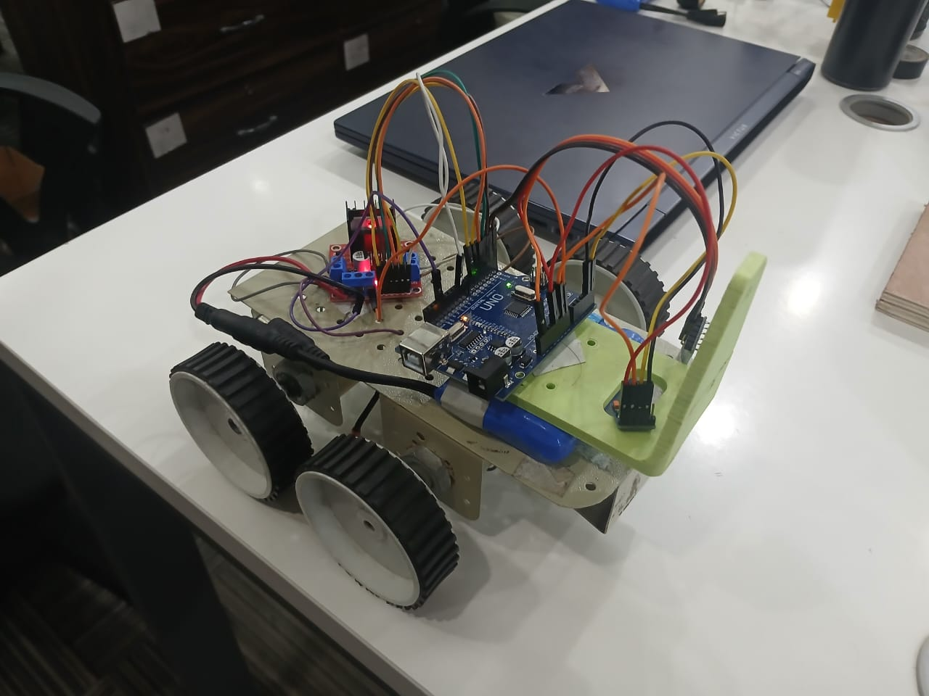
RC Car with HC-05 Bluetooth and GY-271 Magnetometer Report

Project Overview
This project upgrades an Arduino UNO RC car using L298N motor driver, HC-05 Bluetooth module and GY-271 magnetometer. The car is controlled from a Python program using keyboard arrow keys. The magnetometer sends direction information (North, East, South, West) and angle values to the Python monitor.

Hardware Used
Arduino UNO
L298N Motor Driver
4 DC Motors
HC-05 Bluetooth Module
GY-271 QMC5883L Magnetometer
Laptop with Python

Working Principle
Python sends movement commands through serial/Bluetooth communication. Arduino receives commands and controls motors through L298N. GY-271 reads magnetic field values, calculates heading angle, and sends direction data back to Python for monitoring.

Python Code
import serial
import keyboard
import time
import sys

# ── CONFIG ───────────────────────────────
COM_PORT = "COM7"
BAUD_RATE = 9600

# ── CONNECT ─────────────────────────────
print("Connecting to Arduino on " + COM_PORT + "...")

try:
arduino = serial.Serial(COM_PORT, BAUD_RATE, timeout=0.1)
time.sleep(2)

print("Connected!")
print("Magnetometer Monitor ON\n")

except:
print("ERROR: Cannot connect")
sys.exit()

print("=== RC CAR + MAGNETOMETER ===")
print("UP = Forward")
print("DOWN = Backward")
print("LEFT = Turn Left")
print("RIGHT = Turn Right")
print("G = Rotate Left")
print("I = Rotate Right")
print("1/2/3 = Speed")
print("SPACE = Stop")
print("ESC = Exit")
print("==============================\n")

last_cmd=''

COMMAND_NAMES={

'F':'FORWARD',
'B':'BACKWARD',
'L':'LEFT',
'R':'RIGHT',
'S':'STOP',
'G':'ROTATE LEFT',
'I':'ROTATE RIGHT',
'1':'SLOW',
'2':'MEDIUM',
'3':'FAST'

}

def send(cmd):

global last_cmd

if cmd != last_cmd:

arduino.write(cmd.encode())

print(">>",COMMAND_NAMES.get(cmd,cmd))

last_cmd=cmd

# ── MAIN LOOP ────────────────────────────

try:

while True:

# -------- READ MAGNETOMETER DATA --------

if arduino.in_waiting:

data = arduino.readline().decode(errors="ignore").strip()

if data:

if "ANGLE" in data:

print("🧭 COMPASS :",data)

else:
print(data)

# -------- CONTROL --------

if keyboard.is_pressed('1'):
send('1')

elif keyboard.is_pressed('2'):
send('2')

elif keyboard.is_pressed('3'):
send('3')

elif keyboard.is_pressed('up'):
send('F')

elif keyboard.is_pressed('down'):
send('B')

elif keyboard.is_pressed('left'):
send('L')

elif keyboard.is_pressed('right'):
send('R')

elif keyboard.is_pressed('space'):
send('S')

elif keyboard.is_pressed('g'):
send('G')

elif keyboard.is_pressed('i'):
send('I')

elif keyboard.is_pressed('esc'):

break

else:

send('S')

time.sleep(0.1)

except KeyboardInterrupt:
pass

# CLOSE

arduino.write(b'S')

arduino.close()

print("\nCar stopped")

Arduino Code
#include <SoftwareSerial.h>
#include <QMC5883LCompass.h>

SoftwareSerial bluetooth(10,11);
QMC5883LCompass compass;

// L298N pins
#define IN1 2
#define IN2 3
#define IN3 4
#define IN4 5
#define ENA 6
#define ENB 9

int L_SPEED = 220;
int R_SPEED = 220;
int TURN_SPEED = 170;

void setup()
{

pinMode(IN1,OUTPUT);
pinMode(IN2,OUTPUT);
pinMode(IN3,OUTPUT);
pinMode(IN4,OUTPUT);
pinMode(ENA,OUTPUT);
pinMode(ENB,OUTPUT);

Serial.begin(9600);
bluetooth.begin(9600);

compass.init();

stopCar();

Serial.println("RC CAR READY");
Serial.begin(9600);

compass.init();

Serial.println("GY271 TEST START");

}

void loop()
{

char cmd=0;

// Laptop USB
if(Serial.available())
{
cmd=Serial.read();
}

// Bluetooth
if(bluetooth.available())
{
cmd=bluetooth.read();
}

if(cmd)
{
control(cmd);
}

compass.read();

int angle = compass.getAzimuth();

Serial.print("ANGLE: ");
Serial.print(angle);

if(angle < 45 || angle >=315)
{
Serial.println(" NORTH");
}

else if(angle <135)
{
Serial.println(" EAST");
}

else if(angle <225)
{
Serial.println(" SOUTH");
}

else
{
Serial.println(" WEST");
}

delay(500);

}

void control(char c)
{

switch(c)
{

case 'F':
case 'f':
forwardCar();
break;

case 'B':
case 'b':
backCar();
break;

case 'L':
case 'l':
leftCar();
break;

case 'R':
case 'r':
rightCar();
break;

case 'G':
case 'g':
rotateLeft();
break;

case 'I':
case 'i':
rotateRight();
break;

case 'S':
case 's':
stopCar();
break;

case '1':
L_SPEED=80;
R_SPEED=80;
break;

case '2':
L_SPEED=150;
R_SPEED=150;
break;

case '3':
L_SPEED=220;
R_SPEED=220;
break;

}

}

void forwardCar()
{
digitalWrite(IN1,HIGH);
digitalWrite(IN2,LOW);

digitalWrite(IN3,HIGH);
digitalWrite(IN4,LOW);

analogWrite(ENA,L_SPEED);
analogWrite(ENB,R_SPEED);
}

void backCar()
{

digitalWrite(IN1,LOW);
digitalWrite(IN2,HIGH);

digitalWrite(IN3,LOW);
digitalWrite(IN4,HIGH);

analogWrite(ENA,L_SPEED);
analogWrite(ENB,R_SPEED);

}

void leftCar()
{

digitalWrite(IN1,LOW);
digitalWrite(IN2,LOW);

digitalWrite(IN3,HIGH);
digitalWrite(IN4,LOW);

analogWrite(ENA,0);
analogWrite(ENB,TURN_SPEED);

}

void rightCar()
{

digitalWrite(IN1,HIGH);
digitalWrite(IN2,LOW);

digitalWrite(IN3,LOW);
digitalWrite(IN4,LOW);

analogWrite(ENA,TURN_SPEED);
analogWrite(ENB,0);

}

void rotateLeft()
{

digitalWrite(IN1,LOW);
digitalWrite(IN2,HIGH);

digitalWrite(IN3,HIGH);
digitalWrite(IN4,LOW);

analogWrite(ENA,TURN_SPEED);
analogWrite(ENB,TURN_SPEED);

}

void rotateRight()
{

digitalWrite(IN1,HIGH);
digitalWrite(IN2,LOW);

digitalWrite(IN3,LOW);
digitalWrite(IN4,HIGH);

analogWrite(ENA,TURN_SPEED);
analogWrite(ENB,TURN_SPEED);

}

void stopCar()
{

digitalWrite(IN1,LOW);
digitalWrite(IN2,LOW);

digitalWrite(IN3,LOW);
digitalWrite(IN4,LOW);

analogWrite(ENA,0);
analogWrite(ENB,0);

}

Problems Faced
1. Motor control was working but compass direction was not appearing in Python.
2. Serial communication was mixed between USB and Bluetooth, causing missing sensor data.
3. GY-271 requires correct QMC5883L library initialization. Change pin magnetometer 1,2 aurdino to detect data
4. Serial Monitor and Python cannot use the same COM port at the same time.
5. Compass data must be sent from Arduino before Python can display direction.

Final Result
The RC car can be controlled from Python using keyboard keys. The GY-271 magnetometer provides live direction and angle monitoring.
