Arduino Robot Navigation
GY-271 (QMC5883L) Compass + MPU-6050 Gyroscope + L298N Motor Driver
16-Point Compass | Gyro Angle Tracking | R45 / L45 Auto-Stop
Arduino Uno | QMC5883LCompass Library | 9600 baud | This is Your Working Code

Your Robot
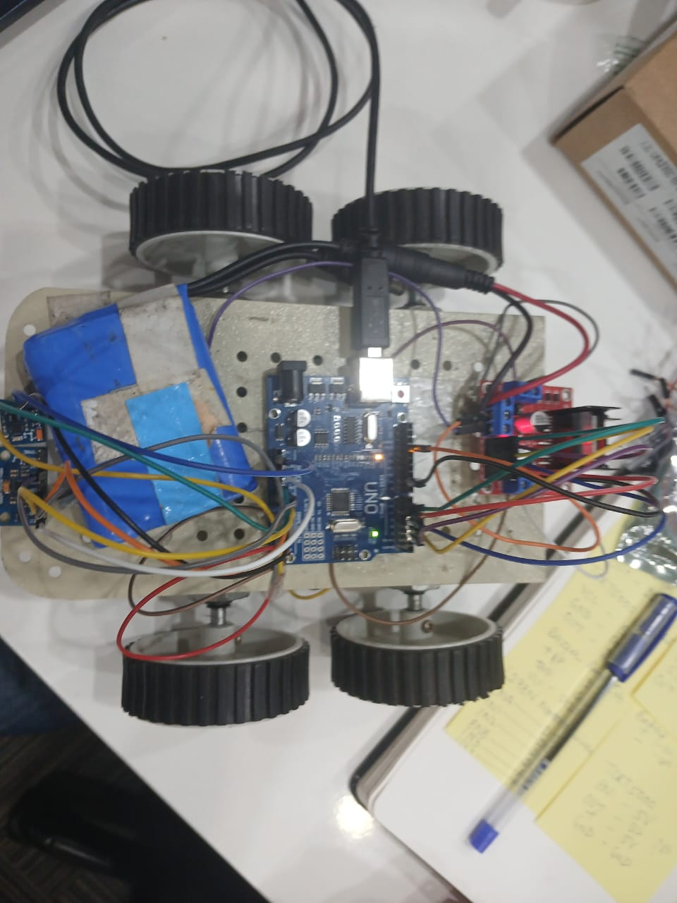 | 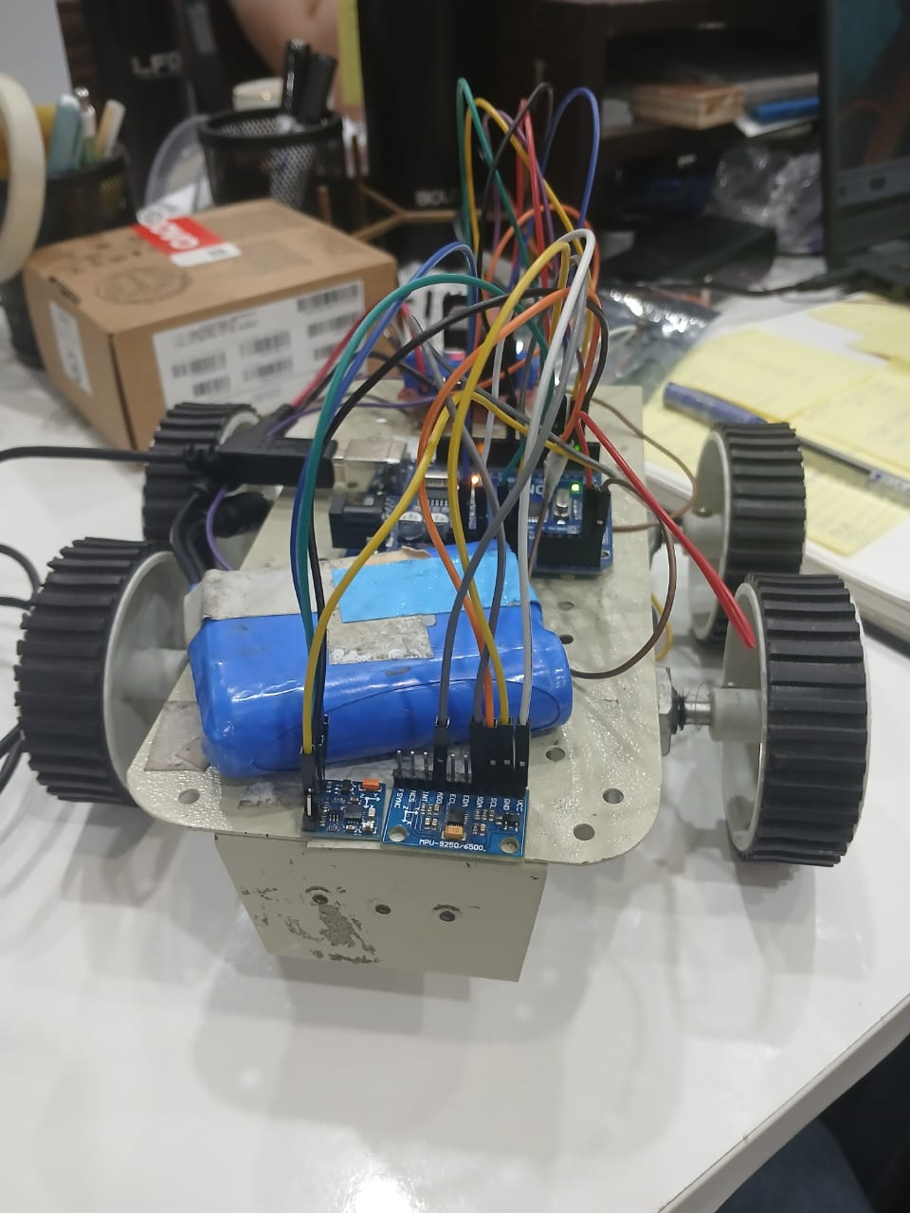
Top view (left) | Front view showing MPU-6050 mounted at front (right)

1. System Overview
This is your working robot navigation sketch. It uses two sensors wired on the same I2C bus to give the robot both precise gyro-based turning and real compass heading feedback after every move.

GY-271 — QMC5883L Compass
The QMC5883L inside the GY-271 module reads Earth's magnetic field and returns an absolute azimuth from 0 to 360 degrees. Your code calls compass.getAzimuth() and compass.getDirection() after every turn and prints the result. The direction uses 8 points (N NE E SE S SW W NW). Section 2 of this report extends this to all 16 compass points.

MPU-6050 — Gyroscope
The MPU-6050 Z-axis gyro is read from I2C register 0x47. Your code divides the raw value by 131 (sensitivity for the default +/-250 dps full-scale range) and multiplies by elapsed time dt to get degrees turned. This counts continuously in the yaw variable. On a turn command, the while loop runs until abs(yaw-start) reaches the target angle, then stops.

NOTE: Both sensors share A4 (SDA) and A5 (SCL). I2C supports multiple devices on the same wires as long as they have different addresses — MPU-6050 is 0x68, QMC5883L is 0x0D.

2. 16-Point Compass Directions
The compass circle is 360 degrees divided into 16 equal sectors of 22.5 degrees each. Your QMC5883L library returns 8-point directions. The table below shows all 16 — you can upgrade to these by replacing the library call with the get16Direction() function shown at the end of this section.

Code | Full Name | Centre° | Range | Meaning
N | North | 0° | 348° – 11° | Facing magnetic North
NNE | North-North-East | 22.5° | 12° – 33° | Mostly North, slightly East
NE | North-East | 45° | 34° – 56° | Equal North and East
ENE | East-North-East | 67.5° | 57° – 78° | Mostly East, slightly North
E | East | 90° | 79° – 101° | Facing magnetic East
ESE | East-South-East | 112.5° | 102° – 123° | Mostly East, slightly South
SE | South-East | 135° | 124° – 146° | Equal East and South
SSE | South-South-East | 157.5° | 147° – 168° | Mostly South, slightly East
S | South | 180° | 169° – 191° | Facing magnetic South
SSW | South-South-West | 202.5° | 192° – 213° | Mostly South, slightly West
SW | South-West | 225° | 214° – 236° | Equal South and West
WSW | West-South-West | 247.5° | 237° – 258° | Mostly West, slightly South
W | West | 270° | 259° – 281° | Facing magnetic West
WNW | West-North-West | 292.5° | 282° – 303° | Mostly West, slightly North
NW | North-West | 315° | 304° – 326° | Equal West and North
NNW | North-North-West | 337.5° | 327° – 347° | Mostly North, slightly West

Colour key: Blue = North Green = NE Yellow = East/SE Pink = South/West Purple = NW

2.1 How to Read the Letters
N = North, S = South, E = East, W = West. Two or three letters combined mean:
- NE = North-East — equal mix, 45 degrees
- NNE = North-North-East — mostly North, slightly East, 22.5 degrees
- ENE = East-North-East — mostly East, slightly North, 67.5 degrees
- SSW = South-South-West — mostly South, slightly West, 202.5 degrees
- WNW = West-North-West — mostly West, slightly North, 292.5 degrees

2.2 Reading Your Serial Monitor Output

MAG ANGLE: 83 deg DIR: E
Robot is facing almost exactly East (79 to 101 degrees)

MAG ANGLE: 45 deg DIR: NE
Robot is facing North-East exactly

MAG ANGLE: 203 deg DIR: S
Library returns S — with 16-dir would show SSW

2.3 Optional: Upgrade to 16 Directions
Add this function to your code and call get16Direction(angle) instead of compass.getDirection():

const char* get16Direction(int az) {
az = ((az % 360) + 360) % 360;
if(az< 12) return "N"; if(az< 34) return "NNE";
if(az< 57) return "NE"; if(az< 79) return "ENE";
if(az<102) return "E"; if(az<124) return "ESE";
if(az<147) return "SE"; if(az<169) return "SSE";
if(az<192) return "S"; if(az<214) return "SSW";
if(az<237) return "SW"; if(az<259) return "WSW";
if(az<282) return "W"; if(az<304) return "WNW";
if(az<327) return "NW"; if(az<349) return "NNW";
return "N";
}

Then in showCompass(), replace:
compass.getDirection(dir, angle);
Serial.println(dir);
with:
Serial.println(get16Direction(angle));

3. Wiring

3.1 GY-271 (QMC5883L Compass) to Arduino Uno

GY-271 Pin | Arduino Uno | Wire | Notes
VCC | 3.3V | Red | 3.3V logic — check your breakout board
GND | GND | Black | Common ground with MPU + L298N
SCL | A5 | Yellow | I2C clock — shared bus with MPU-6050
SDA | A4 | Blue | I2C data — shared bus with MPU-6050
DRDY | NC | — | Not used

3.2 MPU-6050 (Gyroscope) to Arduino Uno

MPU-6050 Pin | Arduino Uno | Wire | Notes
VCC | 3.3V | Red | DO NOT use 5V — destroys chip
GND | GND | Black | Common ground
SCL | A5 | Yellow | Same A5 pin as GY-271
SDA | A4 | Blue | Same A4 pin as GY-271
AD0 | GND | Black | Sets address to 0x68
INT | NC | — | Not used

WARNING: The MPU-6050 is a 3.3V device. Your photos show the MPU-6050 board mounted at the front of the robot. Make sure its VCC wire goes to the Arduino 3.3V pin and NOT 5V. Connecting to 5V will permanently destroy the chip.

3.3 L298N Motor Driver to Arduino Uno

L298N Pin | Arduino | Wire | Function
IN1 | D2 | Orange | Motor A direction
IN2 | D3 | Orange | Motor A direction
ENA | D6 (PWM) | Purple | Motor A speed
IN3 | D4 | Green | Motor B direction
IN4 | D5 | Green | Motor B direction
ENB | D9 (PWM) | Purple | Motor B speed
12V | Battery + | Red | 7–12V motor supply
GND | Battery- & Arduino GND | Black | All grounds linked

TIP: Both sensors plug into A4 and A5 in parallel. Wire both SDA pins to A4 and both SCL pins to A5. The I2C bus handles them both at the same time.

3.4 I2C Address Map

Device | I2C Address | Notes
MPU-6050 Gyroscope | 0x68 | AD0 pin tied to GND in code
GY-271 QMC5883L Compass | 0x0D | Fixed — no config needed

4. How Your Code Works
This section explains every function in your sketch.

Function | What It Does | Key Detail
readGyroZ() | Reads raw Z-axis gyro from MPU-6050 reg 0x47 | Returns signed 16-bit int
calibrateGyro() | Averages 300 readings to find zero-rate offset | Robot must be still for 1.5s
updateGyro() | Integrates angular rate into running yaw total | Call as fast as possible
motor() | Sets IN1-IN4 + PWM speed on ENA/ENB | Base function all moves use
stopCar() | All pins LOW, speed 0 | Called after every turn
forwardCar() | IN1=H IN2=L IN3=H IN4=L speed 180 | Both motors forward
rightMotor() | IN1=L IN2=H IN3=H IN4=L speed 150 | Spins robot right
leftMotor() | IN1=H IN2=L IN3=L IN4=H speed 150 | Spins robot left
showCompass() | Reads QMC5883L, prints azimuth + direction | Called after every turn
turnRight(t) | Gyro loop until delta >= target, then stop+show | abs() catches both signs
turnLeft(t) | Same as turnRight but leftMotor() | Uses same abs() logic

4.1 Gyro Integration Detail
Your updateGyro() function is the core of the angle tracking. It runs at the top of loop() and inside every turn while-loop:

void updateGyro() {
unsigned long now = millis();
float dt = (now - lastTime) / 1000.0; // seconds since last call
lastTime = now;
float rate = (readGyroZ() - gyroOffset) / 131.0; // deg/sec
yaw += rate * dt; // accumulate
}

The 131.0 divisor is the MPU-6050 sensitivity for the default +/-250 dps range. Every LSB of raw reading equals 1/131 degrees per second.

4.2 Turn Loop
Your while loop in turnRight uses abs() which catches both positive and negative gyro readings:

rightMotor();
while(abs(yaw-start) < target)
{
updateGyro();
Serial.print("GYRO: ");
Serial.println(yaw-start);
delay(10);
}
stopCar();

NOTE: The delay(10) and Serial.print inside the loop slow it down slightly and can cause the robot to overshoot at high speeds. If you see overshoot, lower TURN_SPEED to 120 or remove the delay.

5. Serial Monitor Output
Open Serial Monitor at 9600 baud, set line ending to Newline. Example output for R45:

RIGHT TURN
GYRO: 5.21
GYRO: 12.44
GYRO: 24.87
GYRO: 35.12
GYRO: 44.98
TURN COMPLETE
GYRO ANGLE: 45.10
MAG ANGLE: 47 deg DIR: NE

For the H command:

GYRO YAW: 45.10
MAG ANGLE: 47 deg DIR: NE

5.1 Command Reference

Command | Example | What Happens | Serial Output
F | F | Motors forward | FORWARD
S | S | All motors stop | STOP
R45 | R45 | Right 45 deg gyro auto-stop | TURN COMPLETE + GYRO ANGLE + MAG ANGLE DIR
L45 | L45 | Left 45 deg gyro auto-stop | TURN COMPLETE + GYRO ANGLE + MAG ANGLE DIR
R<n> | R90 | Right n degrees | Same output
L<n> | L180 | Left n degrees | Same output
H | H | Live heading | GYRO YAW + MAG ANGLE DIR

6. Complete Code
This is your exact code as submitted — unchanged. It works.

#include <Wire.h>
#include <QMC5883LCompass.h>

QMC5883LCompass compass;

// L298N pins
#define IN1 2
#define IN2 3
#define IN3 4
#define IN4 5
#define ENA 6
#define ENB 9

float yaw = 0;
float gyroOffset = 0;

unsigned long lastTime;

// ---------------- GYRO ----------------

int16_t readGyroZ()
{
Wire.beginTransmission(0x68);
Wire.write(0x47);
Wire.endTransmission(false);

Wire.requestFrom(0x68,2);

return (Wire.read()<<8) | Wire.read();
}

void calibrateGyro()
{

long sum=0;

Serial.println("Gyro calibration keep still");

for(int i=0;i<300;i++)
{
sum += readGyroZ();
delay(5);
}

gyroOffset=sum/300;

Serial.println("Gyro ready");

}

void updateGyro()
{

unsigned long now=millis();

float dt=(now-lastTime)/1000.0;

lastTime=now;

float rate=(readGyroZ()-gyroOffset)/131.0;

yaw += rate*dt;

}

// ---------------- MOTOR ----------------

void motor(int a,int b,int c,int d,int speed)
{

digitalWrite(IN1,a);
digitalWrite(IN2,b);

digitalWrite(IN3,c);
digitalWrite(IN4,d);

analogWrite(ENA,speed);
analogWrite(ENB,speed);

}

void stopCar()
{
motor(LOW,LOW,LOW,LOW,0);
}

void forwardCar()
{
motor(HIGH,LOW,HIGH,LOW,180);
}

void rightMotor()
{
motor(LOW,HIGH,HIGH,LOW,150);
}

void leftMotor()
{
motor(HIGH,LOW,LOW,HIGH,150);
}

// ---------------- COMPASS ----------------

void showCompass()
{

compass.read();

int angle=compass.getAzimuth();

char dir[3];

compass.getDirection(dir,angle);

Serial.print("MAG ANGLE: ");

Serial.print(angle);

Serial.print(" deg DIR: ");

Serial.println(dir);

}

// ---------------- TURN ----------------

void turnRight(float target)
{

float start=yaw;

Serial.println("RIGHT TURN");

rightMotor();

while(abs(yaw-start)<target)
{

updateGyro();

Serial.print("GYRO: ");

Serial.println(yaw-start);

delay(10);

}

stopCar();

Serial.println("TURN COMPLETE");

Serial.print("GYRO ANGLE: ");

Serial.println(yaw-start);

showCompass();

}

void turnLeft(float target)
{

float start=yaw;

Serial.println("LEFT TURN");

leftMotor();

while(abs(yaw-start)<target)
{

updateGyro();

Serial.print("GYRO: ");

Serial.println(yaw-start);

delay(10);

}

stopCar();

Serial.println("TURN COMPLETE");

Serial.print("GYRO ANGLE: ");

Serial.println(yaw-start);

showCompass();

}

// ---------------- SETUP ----------------

void setup()
{

Serial.begin(9600);

Wire.begin();

// MPU wake
Wire.beginTransmission(0x68);
Wire.write(0x6B);
Wire.write(0);
Wire.endTransmission();

pinMode(IN1,OUTPUT);
pinMode(IN2,OUTPUT);

pinMode(IN3,OUTPUT);
pinMode(IN4,OUTPUT);

pinMode(ENA,OUTPUT);
pinMode(ENB,OUTPUT);

stopCar();

// QMC5883L

compass.init();

compass.setSmoothing(10,true);

calibrateGyro();

lastTime=millis();

Serial.println("----------------");
Serial.println("READY");
Serial.println("F Forward");
Serial.println("S Stop");
Serial.println("R45 Right 45");
Serial.println("L45 Left 45");
Serial.println("H Heading");
Serial.println("----------------");

}

// ---------------- LOOP ----------------

void loop()
{

updateGyro();

if(Serial.available())
{

String cmd=Serial.readStringUntil('\n');

cmd.trim();

if(cmd=="F")
{
forwardCar();

Serial.println("FORWARD");
}

else if(cmd=="S")
{

stopCar();

Serial.println("STOP");

}

else if(cmd=="H")
{

Serial.print("GYRO YAW: ");

Serial.println(yaw);

showCompass();

}

else if(cmd.startsWith("R"))
{

float a=cmd.substring(1).toFloat();

turnRight(a);

}

else if(cmd.startsWith("L"))
{

float a=cmd.substring(1).toFloat();

turnLeft(a);

}

}

}
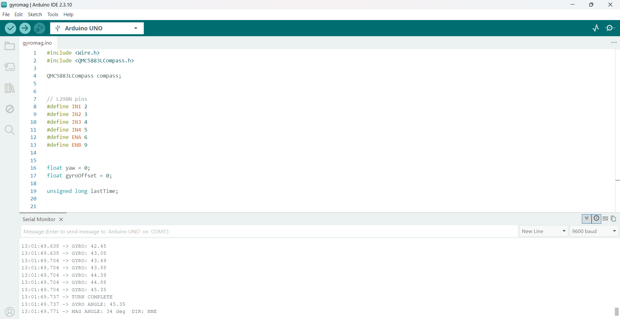

7. Troubleshooting

Turn overshoots 45 degrees
- Lower TURN_SPEED from 150 to 120 or 100.
- The delay(10) inside the while loop adds 10ms per iteration — remove it for tighter control.
- The Serial.print inside the loop also slows it — move prints to after stopCar().

Compass always reads 0 or wrong direction
- Run the magneto_test sketch to confirm GY-271 found at address 0x0D.
- Move the GY-271 board as far from motors and battery as the wires allow.
- Motors create magnetic interference — this is the most common cause of wrong readings.

Gyro drifts when robot is still
- Keep the robot perfectly still for the full 1.5 seconds during calibrateGyro() at startup.
- Increase samples from 300 to 500 for a more accurate offset.

Robot spins wrong direction on R or L
- Swap IN1 and IN2 (or IN3 and IN4) for the motor spinning the wrong way.
- Your rightMotor() uses IN1=L IN2=H IN3=H IN4=L — verify this matches your motor wiring.

Arduino Robot Navigation | GY-271 QMC5883L + MPU-6050 Gyro + L298N | Your Working Code | 16-Dir Compass Reference

