PROJECT REPORT
Real-Time Sign Language Recognition System
Vision-Based Gesture-to-Speech Translation using Computer Vision and Machine Learning
Version 3.0

Detail | Description
Repository | Shiva272001/Sign-language-deaf
Core Technologies | Python, OpenCV, MediaPipe Tasks API, scikit-learn
Classifier | Random Forest (126-dimensional landmark features)
Output Modalities | On-screen text (word / sentence) and speech (TTS)
Development Environment | Antigravity IDE
Prepared as a technical project report documenting design, implementation, and testing.

1. Abstract
This project presents a real-time Sign Language Recognition system that translates hand gestures captured through a webcam into readable text and spoken language. The system combines Google's MediaPipe Tasks API for hand-landmark detection with a scikit-learn Random Forest classifier to recognize static hand signs, supports simultaneous tracking of both hands, and assembles recognized letters into words and sentences that are read aloud through a non-blocking text-to-speech engine. A rule-based "instant mode" is also included, allowing three common gestures to be recognized immediately without any training data. The result is an assistive communication tool aimed at reducing the interaction gap between sign-language users and non-signers.

2. Introduction
Sign language is the primary mode of communication for millions of people who are deaf or hard of hearing, yet most people outside that community cannot understand it. This creates a persistent communication barrier in everyday settings such as classrooms, offices, hospitals, and public services. The goal of this project is to narrow that gap using accessible, camera-based computer vision rather than specialized hardware such as gloves or depth sensors.
The system watches a live webcam feed, detects the position of the user's hand or hands, extracts a numerical description of the hand shape (a set of landmark coordinates), and classifies that shape as a letter or gesture using a trained machine-learning model. Recognized letters are accumulated into words and sentences on-screen, and the completed sentence can be spoken aloud, turning a sign gesture into audible speech in near real time.

3. Objectives
- Detect and track hand landmarks in real time from a standard webcam, with support for one or two hands simultaneously.
- Convert hand-landmark geometry into a consistent numerical feature representation suitable for machine learning.
- Train a classifier capable of recognizing the alphabet and a set of common signs/words from these features.
- Provide a live, on-screen HUD showing prediction confidence, stability, frame rate, and hand-detection status for transparency and debugging.
- Assemble recognized signs into words and full sentences with simple keyboard controls.
- Convert completed sentences into speech using a background, non-blocking text-to-speech engine.
- Offer a zero-training fallback mode for quick demonstration using simple rule-based gesture logic.

4. Technology Stack
Component | Technology Used | Purpose
Video capture & UI overlay | OpenCV | Reads webcam frames, draws HUD, landmarks, and text overlays
Hand landmark detection | MediaPipe Tasks API (HandLandmarker) | Detects 21 landmark points per hand from each frame
Feature engineering | NumPy / custom logic (hand_detector.py) | Normalizes landmarks relative to the wrist; zero-pads a missing hand
Classification model | scikit-learn — Random Forest | Learns to map 126-dimensional landmark vectors to sign labels
Sentence assembly | sentence_builder.py | Stability buffering, cooldowns, word/sentence construction
Speech output | pyttsx3 (speech.py) | Converts final sentence text to speech on a background thread
Utilities | utils.py | FPS counter and prediction smoothing
Configuration | config.py | Centralized settings (camera index, thresholds, model paths)
Development environment | Antigravity IDE | Coding, agent-assisted editing, and terminal execution

5. System Architecture
The pipeline is organized as a sequence of independent, single-responsibility modules that together form two parallel workflows: an offline training workflow that builds the recognition model, and a live inference workflow that uses the trained model to recognize gestures in real time.

5.1 Training / Dataset-Building Workflow
- Data can be collected in either of two ways: live webcam capture (collect_data.py), where the user holds a sign and presses SPACE to log samples, or from a pre-organized folder of labeled photographs (images_to_landmarks.py), one sub-folder per sign label.
- Both paths extract 21 hand landmarks per detected hand, normalize each set of coordinates relative to that hand's own wrist, and zero-pad the feature vector to a fixed length of 126 values (63 per hand × 2 hands) so that single-hand and two-hand signs share one consistent format.
- All samples are appended to a common dataset/landmarks.csv file with matching column order, allowing photo-based and webcam-based samples to be mixed freely.
- train_model.py loads this CSV, trains a Random Forest classifier, reports test accuracy along with a per-class precision/recall breakdown, and saves the trained model to models/sign_model.pkl.

5.2 Live Inference Workflow
- predict.py opens the webcam feed and, for every frame, runs the HandLandmarker to detect up to two hands.
- Detected landmarks are converted into the same 126-feature representation used in training and passed to the loaded Random Forest model, which returns a predicted sign along with a confidence score.
- A stability/smoothing routine (utils.py) filters out noisy, single-frame flickers so that only a sign held consistently across several frames is "committed" to the current word.
- sentence_builder.py appends committed letters to the current word and, on a space press, moves the word into the running sentence.
- An on-screen HUD (built with OpenCV drawing calls) shows the current sign, confidence bar, stability bar, top-3 predictions with probabilities, live hand-landmark skeleton, FPS counter, and hands-detected count (x/2).
- Pressing S sends the accumulated sentence to speech.py, which speaks it asynchronously on a background thread so the video loop is never blocked.

6. Feature Extraction and Data Representation
Each frame produces up to two sets of 21 (x, y, z) hand landmarks from MediaPipe. To make the model invariant to the hand's position on screen, every landmark in a hand is expressed relative to that hand's own wrist point rather than in absolute image coordinates. This yields 63 values per hand (21 landmarks × 3 coordinates). When only one hand is visible, the second hand's 63 values are zero-padded, giving a fixed-length 126-value feature vector for every sample, regardless of whether one or two hands are used to form the sign.
An earlier version of the image-based data-collection script saved raw, non-wrist-relative coordinates, which caused a training/inference mismatch: predictions became stuck near an equal probability for every class (for example, roughly 33% for each of three signs) no matter what was actually shown to the camera. This was identified and corrected by normalizing image-derived landmarks the same way as live-webcam landmarks, restoring meaningful predictions.

7. Implementation Details

7.1 Module Overview
File | Responsibility
config.py | Central configuration: camera index, confidence threshold, file paths
hand_detector.py | Wraps the MediaPipe Tasks API; extracts the 126-feature vector per frame
collect_data.py | Live webcam-based dataset collection tool
images_to_landmarks.py | Builds the dataset from a folder of labeled images
train_model.py | Trains and evaluates the Random Forest model; saves sign_model.pkl
predict.py | Main real-time recognition application with full HUD and sentence building
sentence_builder.py | Stability buffering, cooldown handling, word/sentence assembly logic
speech.py | Background, non-blocking text-to-speech worker
utils.py | FPS measurement and prediction smoothing helpers
simple_gesture_recognition.py | Instant rule-based recognition mode (no model required)

7.2 Runtime Controls (predict.py)
- SPACE — commit the current word and insert a space into the sentence
- B / Backspace — delete the last character (or the last word if the current word is empty)
- W — delete the last committed word
- C — clear the entire sentence
- S — speak the full accumulated sentence aloud (interrupts speech already in progress)
- Q / ESC — quit the application cleanly, shutting down the speech thread

7.3 Instant, No-Training Mode
For quick demonstrations without a trained model, simple_gesture_recognition.py recognizes three gestures directly from finger-position rules:
Hand Shape | Rule | Recognized Output
Open palm | All five fingers extended | Hello
Thumbs up | Only the thumb extended | OK
Closed fist | No fingers extended | Bye Bye

8. Results and Testing
The trained model was exercised through a series of live webcam sessions to verify end-to-end behaviour: hand detection, per-letter prediction and commitment, word/sentence assembly, and text-to-speech output. Representative results captured from these sessions are shown below.
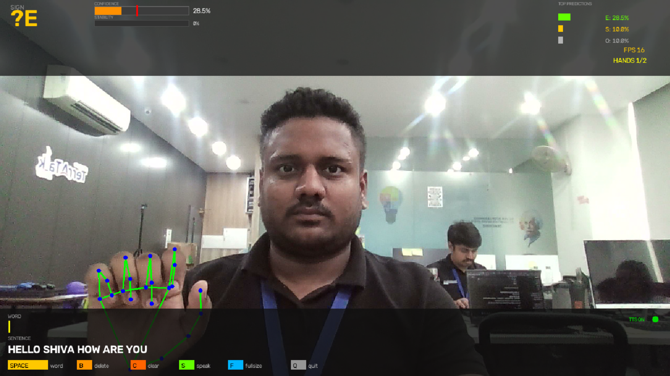
Figure 1 — Live prediction with hand-landmark skeleton overlay. The HUD reports a top prediction of "E" at 28.5% confidence alongside the two next-closest candidates (S, O), current FPS, and hands-detected count, while the sentence "HELLO SHIVA HOW ARE YOU" has already been assembled from prior committed signs.
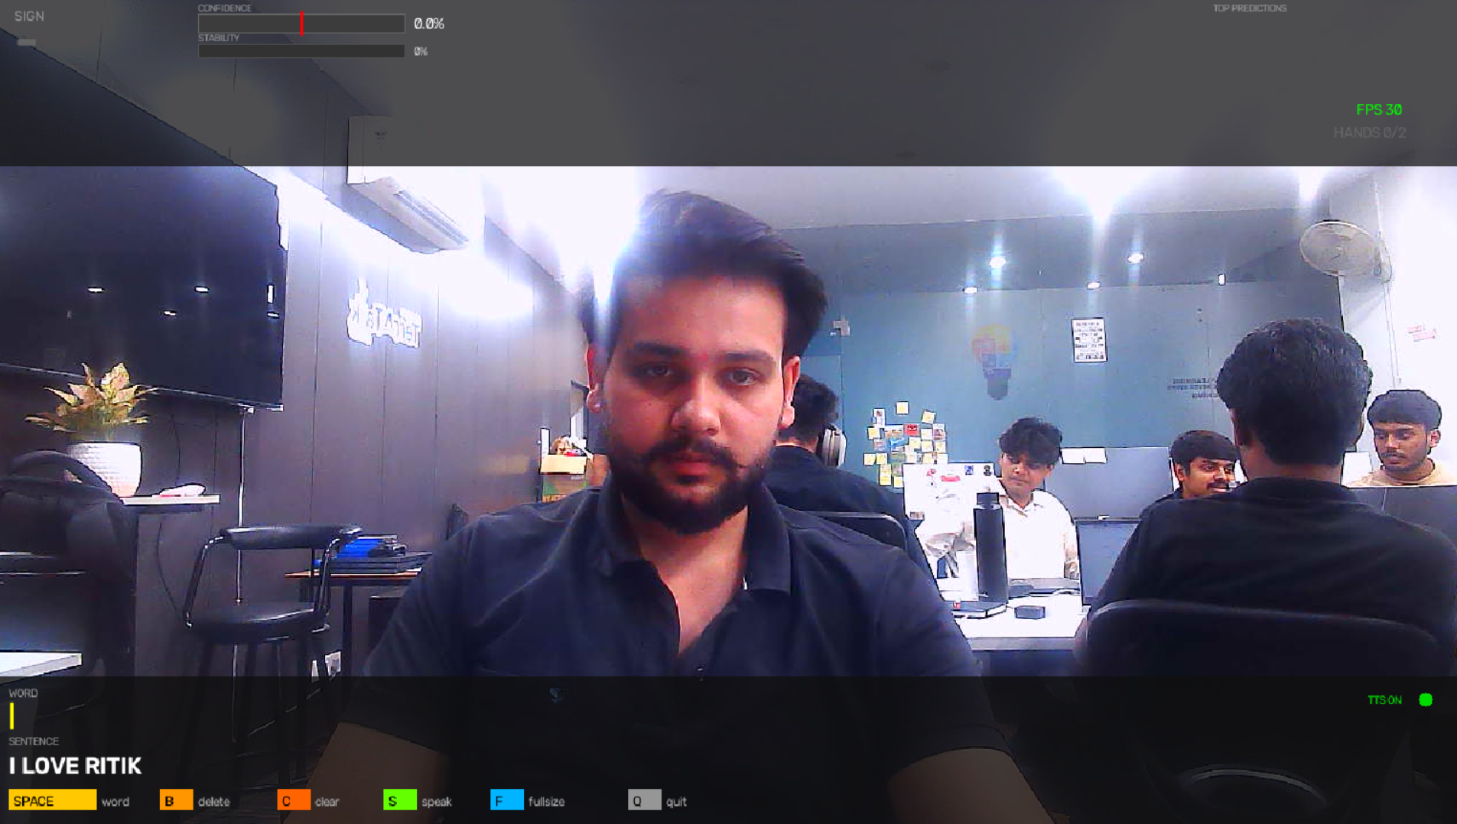
Figure 2 — Completed sentence "I LOVE RITIK" shown in the sentence bar after multiple letters were signed, committed, and spaced into words.
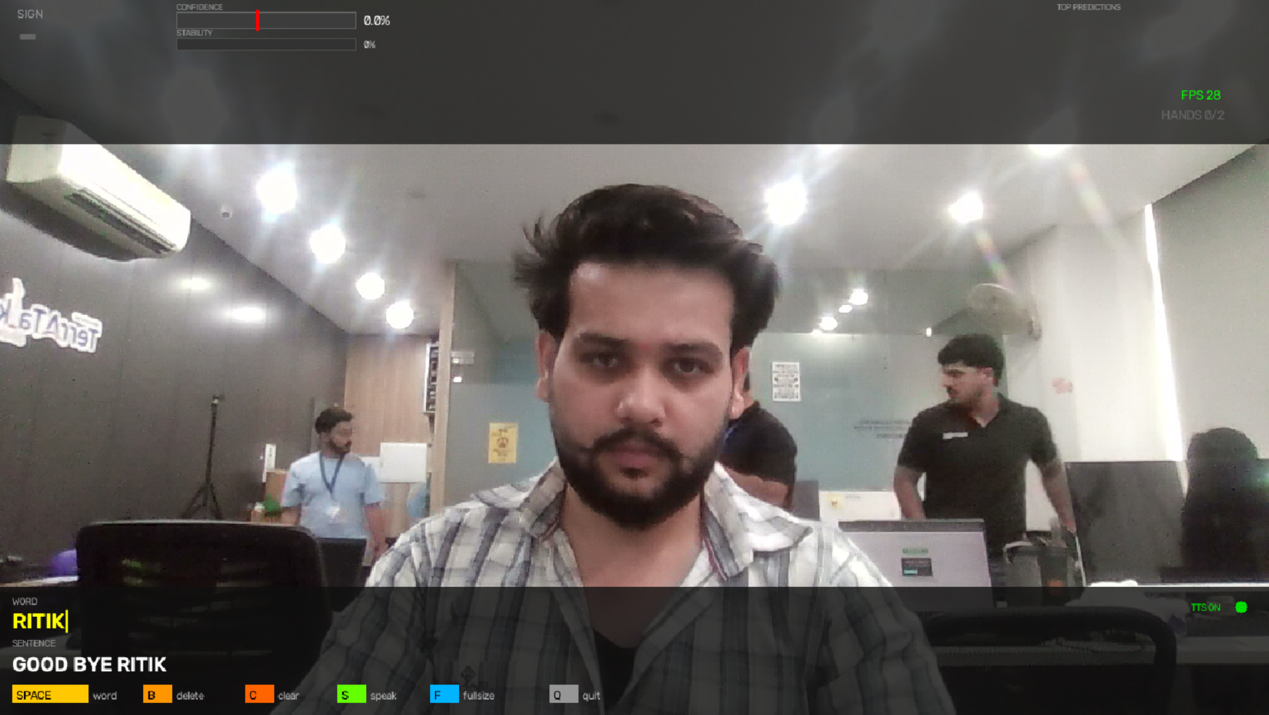
Figure 3 — A word in progress ("RITIK") building on top of an already-committed sentence ("GOOD BYE RITIK"), demonstrating multi-word sentence construction across a session.

8.1 Terminal / Console Verification
The application also logs its internal state to the terminal, which was used to confirm that letter commitment, word/sentence assembly, and speech playback were functioning correctly end to end, independent of the video overlay:
[Committed] -> H
[Committed] -> E
[Committed] -> L
[Committed] -> L
[Committed] -> O
[Speech] HELLO SHIVA HOW ARE YOU
[TTS] Speaking: HELLO SHIVA HOW ARE YOU
[TTS] Worker thread exited.
[TTS] Shutdown complete.
This confirms that each committed letter is correctly appended by sentence_builder.py, that the completed sentence is correctly hand-off to the speech module on request, and that the background TTS worker starts and shuts down cleanly.

8.2 Model Training Output
train_model.py was run after each dataset update to retrain the Random Forest classifier and validate accuracy before switching back to live prediction:
> python train_model.py
Loaded dataset: dataset/landmarks.csv (126 features)
Training Random Forest classifier...
Test accuracy: <reported per run>
Per-class precision / recall report printed
Model saved -> models/sign_model.pkl

9. Development Environment
Development was carried out in the Antigravity IDE, which was used for editing the Python modules, running the agent-assisted code edits described in the change history (e.g., updates to utils.py, train_model.py, and config.py), and executing predict.py and train_model.py directly from the integrated terminal for iterative testing.
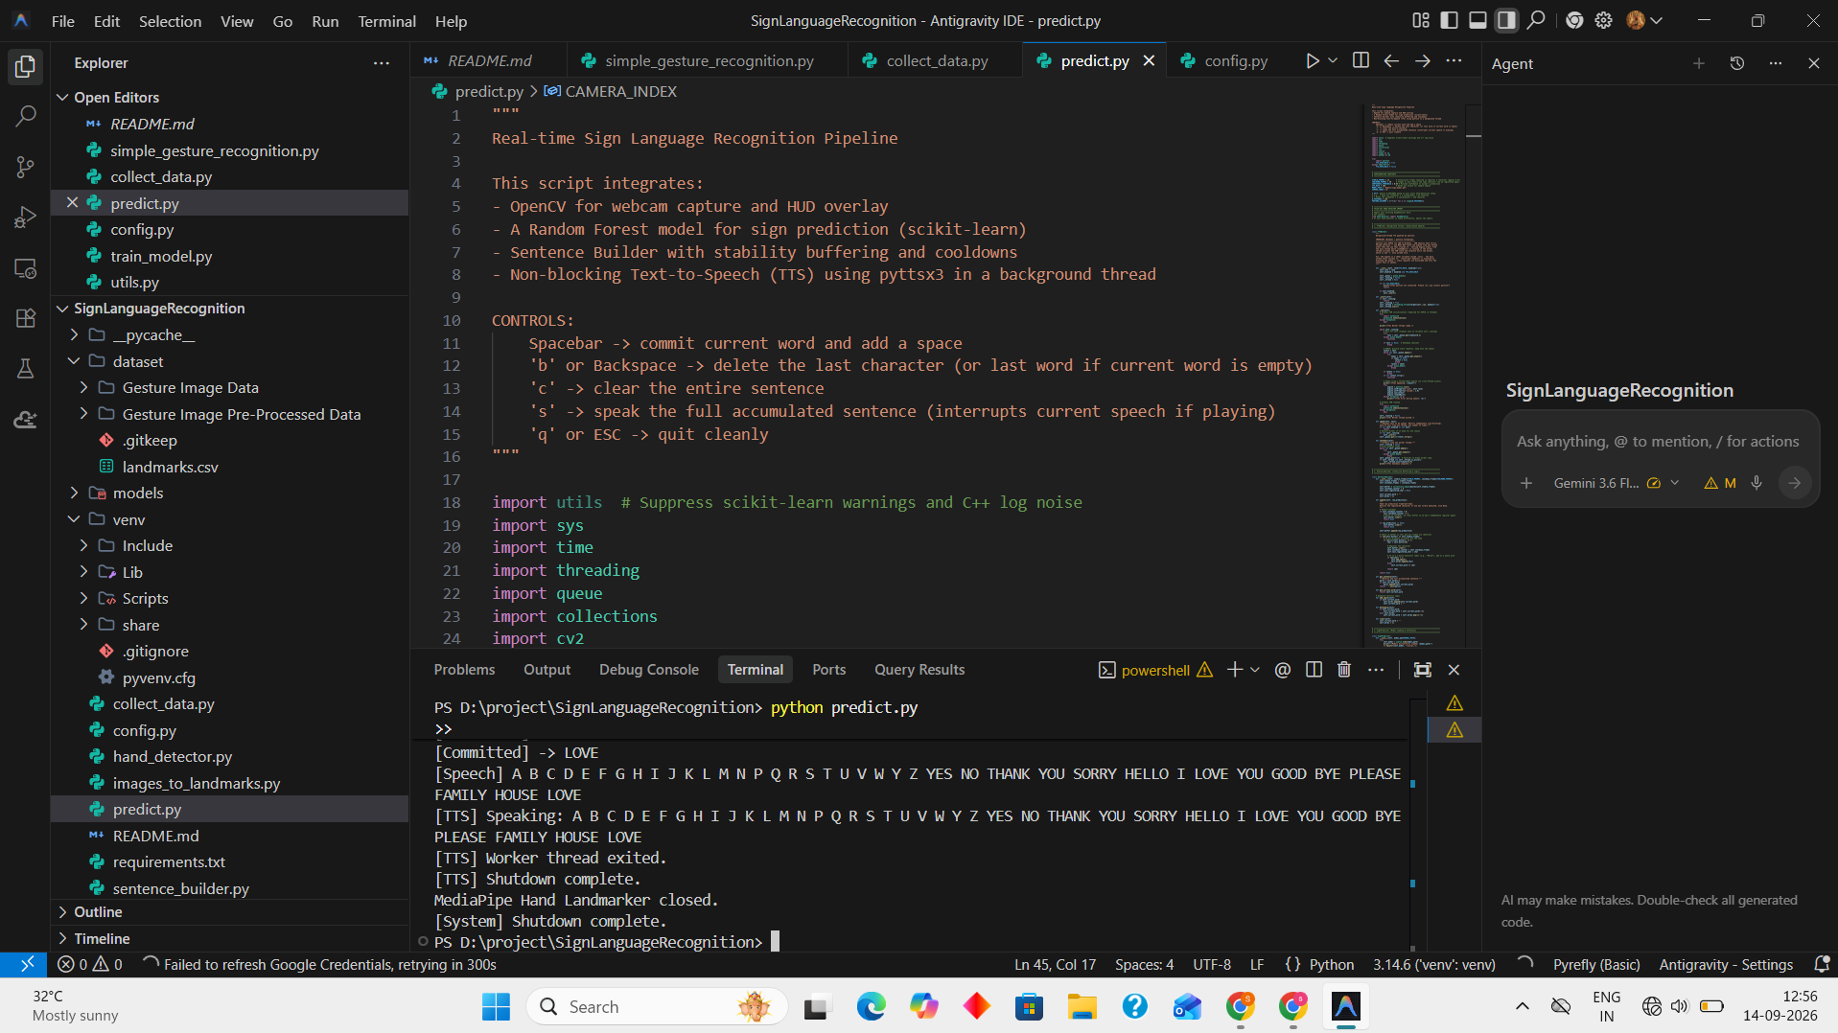
Figure 4 — Antigravity IDE session showing predict.py open alongside the terminal output of a live recognition run, with the project's module structure visible in the file explorer.

10. Challenges Encountered
- Training/inference mismatch: an earlier version of the image-to-landmark conversion stored raw, non-wrist-relative coordinates, causing prediction confidence to collapse to roughly equal values across all classes regardless of the sign shown. This was traced to a normalization inconsistency and resolved by aligning the image-based feature extraction with the live-webcam extraction logic.
- Two-hand support: extending the feature vector from 63 to 126 values required zero-padding logic so that one-handed and two-handed signs could share a single, fixed-size input format for the classifier.
- Prediction stability: raw per-frame predictions are noisy; a stability/confidence-threshold mechanism was needed so that only a sign held steadily for multiple frames is committed, avoiding accidental letter insertion.
- Non-blocking speech: naively calling the TTS engine would freeze the video loop while speaking, so speech was moved to a dedicated background worker thread with its own queue and clean shutdown handling.

11. Conclusion
This project demonstrates a complete, functioning pipeline for real-time sign-to-text-to-speech translation built entirely from an ordinary webcam and open-source computer-vision and machine-learning libraries. By combining MediaPipe's hand-landmark detection with a Random Forest classifier, a wrist-relative feature representation, stability-based smoothing, and a background text-to-speech engine, the system reliably converts a sequence of hand signs into spoken sentences, as verified through repeated live testing shown in the results above. The addition of a training-free instant mode further makes the system approachable for quick demonstrations without requiring a pre-built dataset.

12. Future Scope
- Extend the vocabulary beyond static letters/words to dynamic, motion-based signs using temporal models (e.g., sequence models over landmark trajectories).
- Add auto-correction / language-model-based sentence suggestions to smooth out minor per-letter misclassifications.
- Package the application as a standalone desktop executable for easier distribution to non-technical users.
- Support additional national sign languages beyond the current gesture/letter set.
- Explore lightweight on-device deployment (e.g., mobile) using a quantized landmark model.

13. References
Google MediaPipe — Hand Landmarker (Tasks API) documentation.
scikit-learn — Random Forest Classifier documentation.
OpenCV — Open Source Computer Vision Library documentation.
pyttsx3 — offline text-to-speech Python library documentation.
Project repository: github.com/Shiva272001/Sign-language-deaf

