**PROJECT – 2 STATIC HOSTING WEBSITE**

**on AWS**

Creating a static website and deploy it using **AWS** services. A static website is a site that consists of **HTML**, **CSS**, and **JavaScript** files, and it doesn't require server-side processing or a database.

* Log-in to AWS Management Console.
* Set your location to your nearest area “Mumbai”.
* Search “S3”.
* Go to the “Buckets” section and click “Create bucket”.

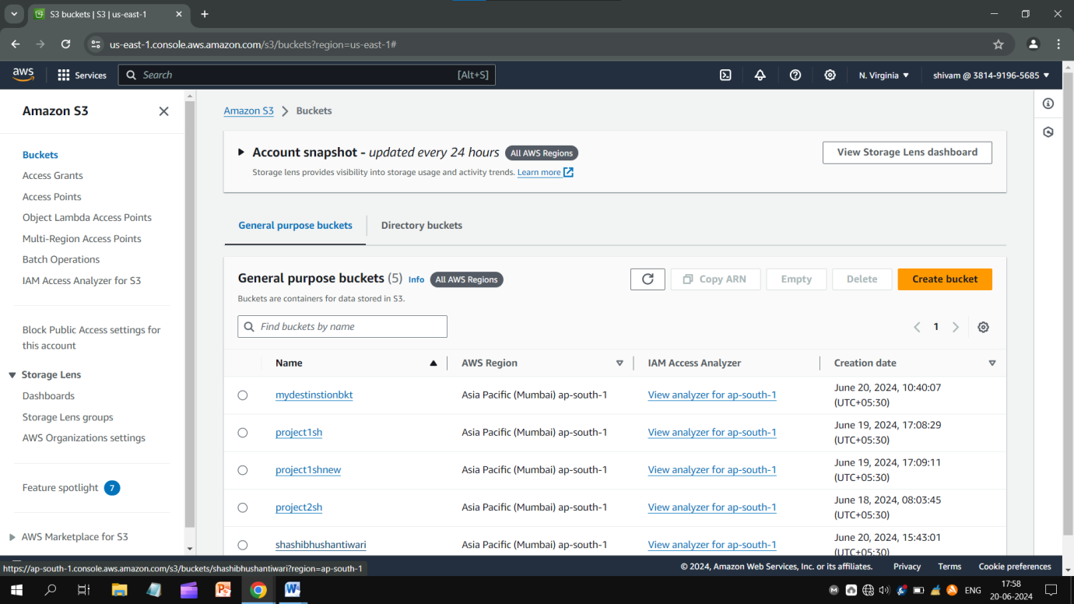

* Type a unique bucket name, unblock “all public access”
* Enable “ACLs” and accept the “I acknowledge that…….public” notice.
* Let other settings be as they are.
* Just click on “Create bucket” and go ahead.....

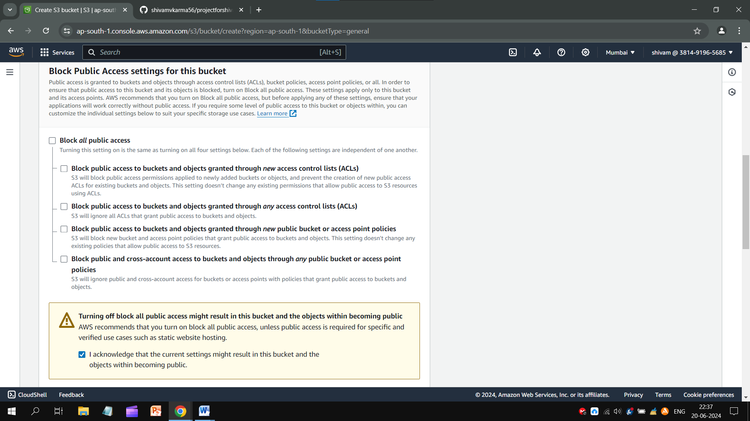

**Creating An HTML File:-**

<!DOCTYPE html>

<html>

<body>

<h1>Type Your Title Here</h1>

<p>Type Your Content Here</p>

</body>

</html>

* Copy the above code and paste to the Notepad.
* Save the text on Notepad with *.htm* extension. Extension should be HTML type.

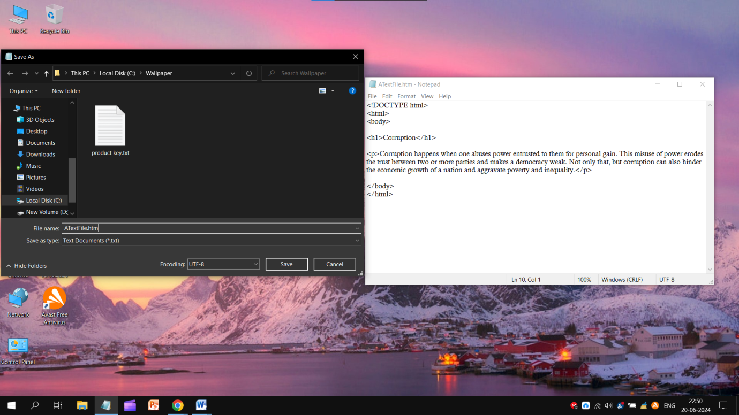

* Open the bucket you created recently.
* Click on bucket’s name, click **Upload** and **Add files**.
* Select that “HTML file”and click **Upload** bottom given below. **Close** it.

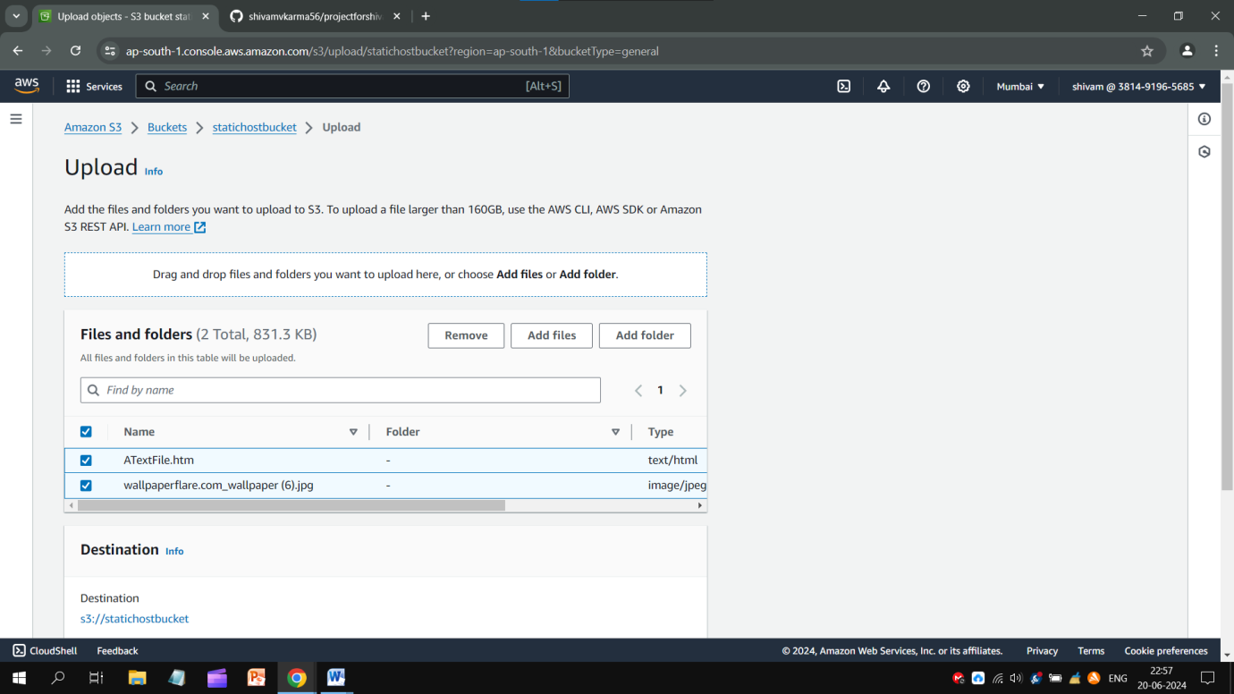

Follow these steps:-

* In “Permission” section, *all* public access should be unblocked.
* In “Object Ownership”, ACLs should be enabled.

If they are correct, go into Object tab, select all files and open “*Actions*”script. Click on “*Make public using ACLs*”.

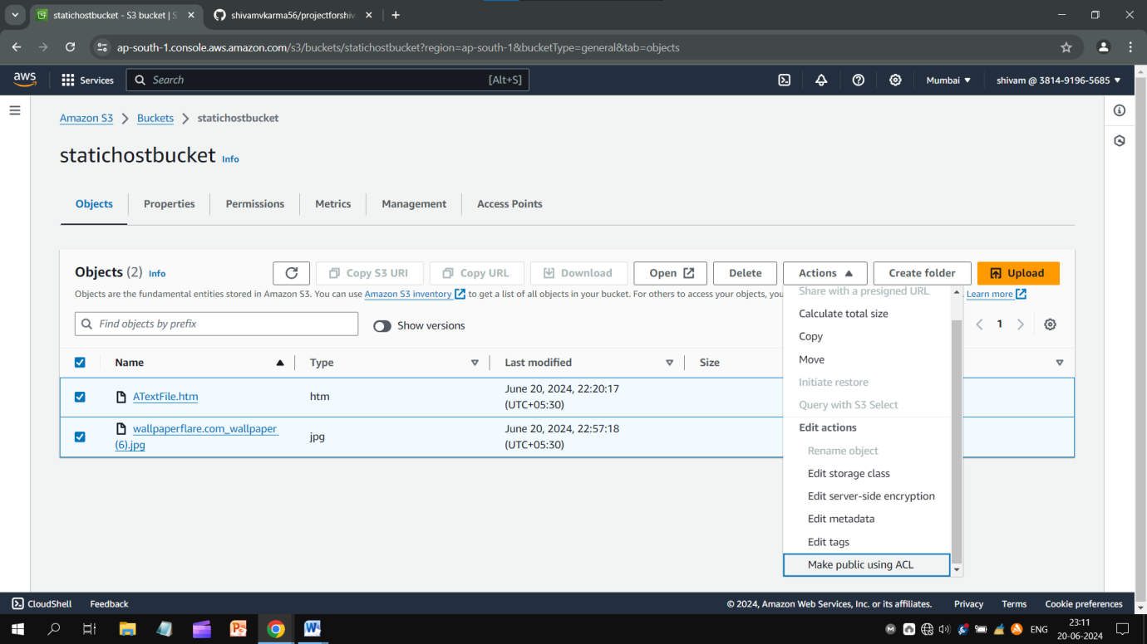

* Click on your file name and open its *Properties* tab.
* Copy *Object URL* and check it out by pasting it on browser.

Your Website will be available in public and you could successfully host your site by **AWS Management Console**.

Conclusion**:** Static sites enable you to decouple your content repository and front-end interface, giving you greater flexibility in how your content is served. Cost-efficiency is another reason companies migrate to a static site because static files are lightweight and often faster and cheaper to serve.

~Thank You!