Haarlem Festival
Technical Documentation
Ticketing website for The Festival (Inholland, 2.3)
Plain PHP MVC · MySQL · Docker

1. Introduction
The Haarlem Festival website lets visitors browse six festival events, build a personal program, buy tickets and passes, make restaurant reservations, donate to pay-as-you-like events, and pay online (or within 24 hours). Staff scan tickets at the entrance and administrators manage the catalogue, content and orders.
It is built in plain PHP (no framework) following an MVC structure with a Controller -> Service -> Repository layering. It runs in Docker (nginx, PHP-FPM, MySQL 8, phpMyAdmin, MailHog) and uses Stripe (test mode) for payment.

2. Architecture
Requests are routed (FastRoute) to a Controller, which validates input and delegates to a Service. Services hold the business rules and depend on Repositories for data access; every Service and Repository is consumed through an interface, so behaviour is programmed against abstractions, not concrete classes. Repositories extend a base Repository that wraps PDO with prepared statements.
Cross-cutting concerns: AuthMiddleware (authentication, role checks, CSRF), a small Container for wiring, View for rendering templates, and Flash for one-shot messages. The diagram below shows the pattern for the Orders slice.
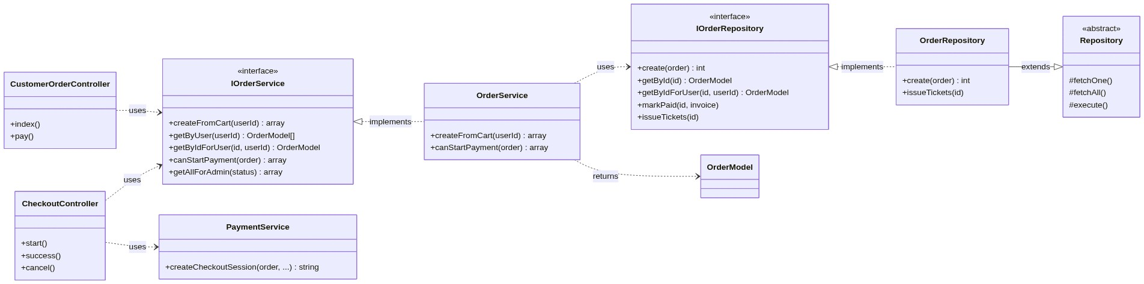
Figure 1 — Layered MVC with interface-based services and repositories (Orders slice).

3. Database design
The schema is created and evolved through numbered, forward-only SQL migrations run by database/migrate.php. Money is stored as DECIMAL; prices are VAT-inclusive and the VAT portion is derived per line. The entity-relationship diagram below reflects the live schema.
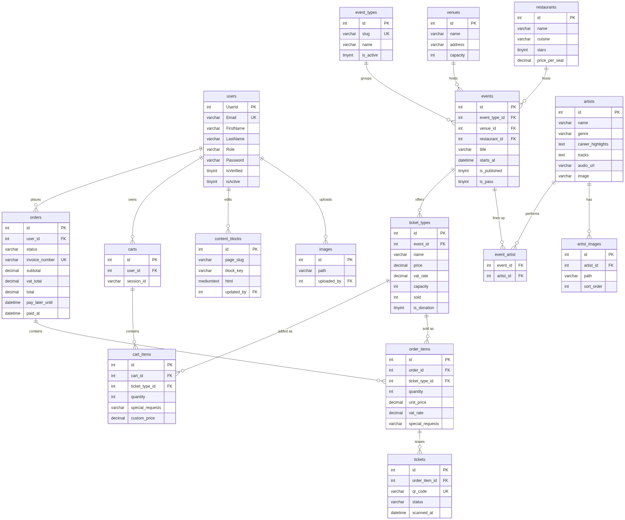
Figure 2 — Entity-Relationship Diagram (generated from the live database).

3.1 Key entities
Entity | Purpose
users | Accounts with a role (customer/employee/admin).
event_types | The six festival events (Jazz, DANCE!, Yummy, History, Magic, Stories).
events | A session/performance under a type, at a venue or restaurant; may be a pass.
ticket_types | What can be bought for an event: price, VAT, capacity, donation flag.
venues / restaurants / artists | Catalogue entities; artists link to events many-to-many and have detail content.
artist_images | Gallery images for an artist's detail page.
carts / cart_items | A guest or user cart; lines hold quantity, requests and custom price.
orders / order_items | A placed order and its priced lines; status drives pay-later.
tickets | Issued per order-item with a unique QR code; scanned at the entrance.
content_blocks / images | CMS content (WYSIWYG HTML) and uploaded images.

4. Domain model
The domain classes mirror the schema and carry small behaviours. For example TicketTypeModel::available() derives remaining stock, CartItemModel::effectivePrice() applies a donation amount or HaarlemPas discount, and OrderModel::canPayLater() encodes the 24-hour pay-later rule.
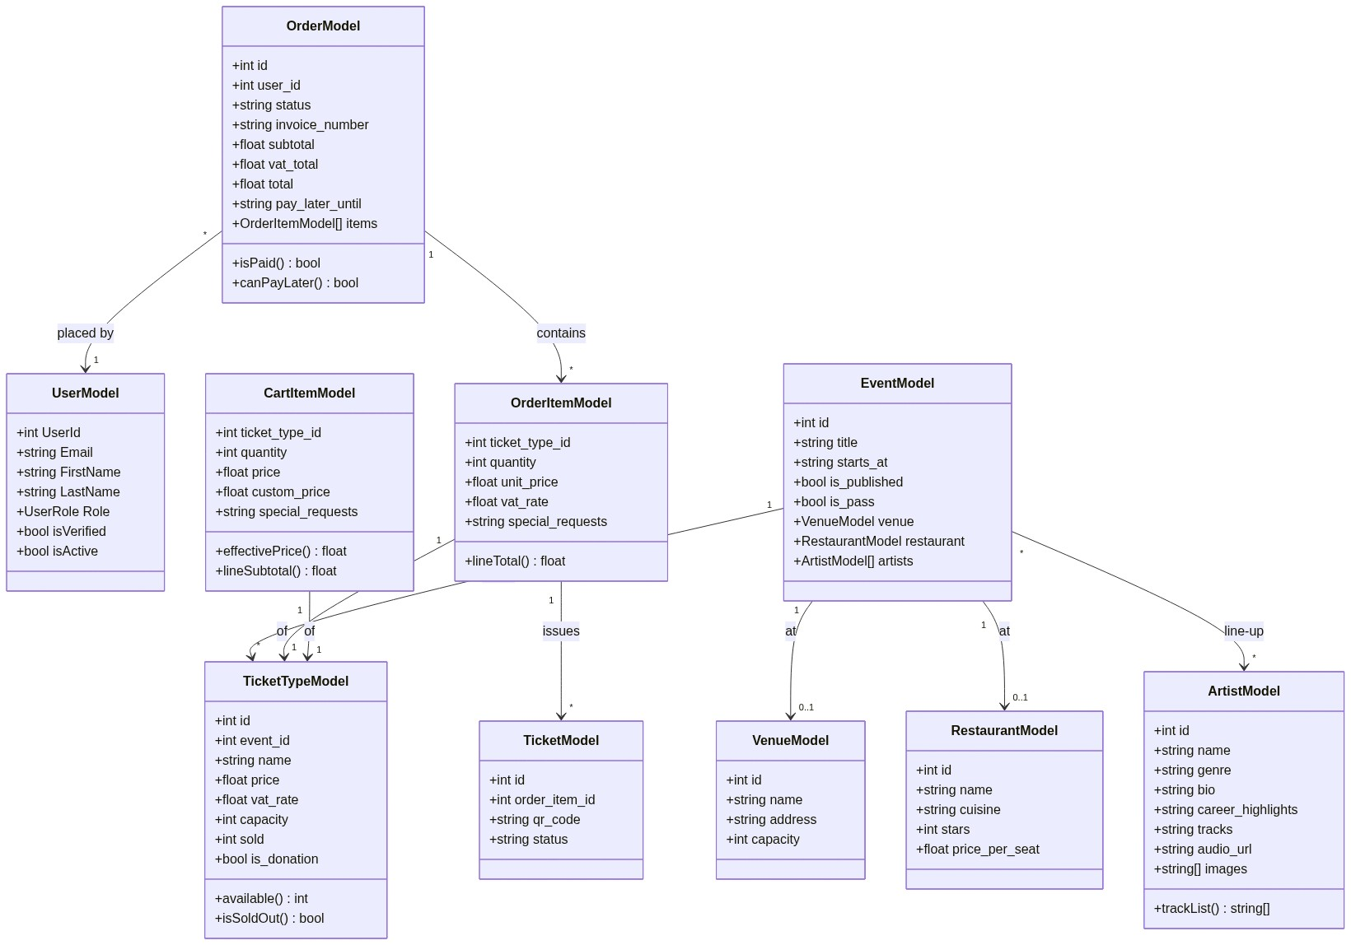
Figure 3 — Domain model UML class diagram.

5. Key design decisions
Program against interfaces. Each Service/Repository has an interface (e.g. IOrderService, IOrderRepository). Controllers and Services depend on the interface, which keeps layers swappable and testable.
Migrations. Schema changes are append-only SQL files applied in order and tracked in a migrations table, so every environment converges to the same state.
Passes as ticket types. All-access passes are modelled as ticket types on a flagged 'pass event' (events.is_pass), so they reuse the cart, checkout, ticket and personal-program flow unchanged.
Effective price. Donations (pay-what-you-like) and the HaarlemPas 25% reduction both resolve to a per-line effective price (cart_items.custom_price), which becomes the order line's unit_price.
Reservations. Restaurant reservations charge a EUR 10 per-person fee and capture special requests (allergies) on the order line, visible to admins on the order detail page.
Pay later. Orders are created pending with pay_later_until = now + 24h; retry re-validates the deadline and stock before re-opening Stripe.
Security & GDPR. Passwords are hashed; all POST requests carry a CSRF token; queries use prepared statements; the session cookie is HttpOnly/SameSite. Users can export or erase their data; erasure anonymises the row to preserve invoice integrity.

