Optimizing Skin Cancer Detection Using the MobileNet Deep Learning Model: A Lightweight and Efficient Approach

T. Balaji1, N. Komal Kumar2, C. Revanth3, Dandam Siva Kumar Goud4, G. Sai Haritha5,

B. Praveen6

1,2,3,4,*5,6Department of Computer Science & Engineering (Data Science),*

*Madanapalle Institute of Technology & Science,*

Madanapalle, Andhra Pradesh, India.

1baalaji24@gmail.com, 2komalkumarnapa@gmail.com, 3chennamreddyrevanth2003@gmail.com,

4shiva995999@gmail.com, 5gsharitha9644@gmail.com, 6bachupraveen26@gmail.com

*Abstract -* Early and precise diagnosis of skin cancer is essential for successful treatment and enhanced patient survival. Automated skin cancer classification, however, is still a challenging task because of the variability in lesion appearance and the requirement for high diagnostic accuracy. In this work, we investigate the possibility of using deep learning to improve skin cancer detection. We apply the MobileNet model, a light and fast convolutional neural network (CNN), to classify skin lesions based on the HAM10000 dataset, which contains 10,000 labeled dermoscopic images. MobileNet is designed for low-resource settings and is therefore ideal for real-time medical applications, such as mobile and edge devices. Our experimental results show that MobileNet has high classification accuracy 92.86% and validation accuracy 98.56%, while greatly lowering computational costs and inference time relative to larger deep-learning models. This research brings out the effectiveness of MobileNet in detecting skin cancer as a feasible scalable and cheap diagnosis device. Increased effectiveness in machine detection results in overall advancement of AI-driven healthcare, promoting early dermatologist diagnosis and better patient care.

*Keywords—* ***Skin Cancer, Deep Learning, MobileNet, Convolutional Neural Networks, Medical Imaging, Classification, AI in Healthcare.***

1. INTRODUCTION

In medical imaging, skin cancer detection is still quite difficult. which is one of the most common tumors worldwide. Since early identification allows for more effective therapeutic interventions, early detection is of utmost importance in order to boost survival rates. In the past, dermatologists have used eye examination [1] of dermoscopic pictures to spot potentially cancerous tumors, but this method is typically laborious, subjective, and prone to human error. With the complex nature and variability of skin cancer images, the demand for computerized diagnostic systems. Breakthroughs in DL have revolutionized many medical fields, especially image analysis. CNN in particular have been extremely successful [2] in automated medical image analysis, including skin cancer detection. Traditional CNNs, however, are generally afflicted by the shortcomings of modeling long-range dependencies and complex global patterns, which are vital for distinguishing benign from malignant lesions. To alleviate these shortcomings, attention mechanisms specifically those in Mobile Net model have received significant interest in recent years. Originally designed for natural language processing tasks, are especially well-suited to extract long-range dependencies in data and showed promising performance in analysis tasks. while ignoring unnecessary information makes This are potential gem for medical imaging tasks, where subtle patterns in images can make all the difference in diagnostic accuracy.

The dataset employed in this research, the HAM10000 dataset, is a well-established standard in the field of dermatological image analysis. It has 10,000 annotated images [5] capture a diverse characteristics. The dataset comprises different types of images , which makes it easier to test the competency of the models in differentiating between different types. The high diversity inherent in the dataset makes it challenging for the models to detect complex patterns in images that can have different dimensions, shape, and color. Such diversity makes the HAM10000 dataset an ideal source for training and testing.

These performance metrics are necessary to comprehend the models' various advantages and disadvantages, [6] medical applications where diagnosis speed and accuracy are crucial. While high accuracy is a crucial important because they are directly related to the model's ability to reliably detect benign and malignant lesions, which is crucial for patient safety. Additionally, as the models must produce findings in clinical situations in real-time or very real-time, computational performance is a crucial factor. Insightful information about the effectiveness of Mobile Net models in the context of diagnosing skin cancer. This study aims to speed up the development of effective, precise, and trustworthy automated diagnostic tools that could help medical professionals diagnose skin cancer quickly by describing [7]. In order to ultimately help the patient, shorten diagnostic times, support more thoughtful treatment decisions.

1. LITERATURE SURVEY

Diagnostic systems have been transformed by the use DL techniques in Medicine, especially in of skin cancer. The capacity of deep neural networks to automatically learn complex from unprocessed picture has the outperformed conventional techniques, which depended on manually created features and shallow learning models. The most successful skin cancer classification methods are based on CNN, which automatically learn hierarchical features from dermoscopic images to produce correct findings. There are still issues in applying models generally to various patient populations and datasets. Over the past few years, the necessity to integrate data from multiple modalities for skin cancer detection has become a prominent trend in research studies. Multimodal learning leverages complementary [8] information from multiple data sources, for instance, clinical images and patient demographics, to improve classification performance. The concept is to enhance model by incorporating extra contextual information, potentially better performence. Although promising, challenges remain to integrate these data sources effectively without introducing noise or causing model overfitting. Medical professionals need transparency in the decision-making process of these models so that they can trust their predictions. Methods like saliency maps, class activation maps, and attention mechanisms have been investigated to explain deep learning models. These methods try to identify the [9] most significant features in an image that affect a model's prediction, thereby making the model's reasoning more transparent.

Because it can enhance model performance, particularly in situations when labeled data is limited, transfer learning [10] has gained a lot of traction in the identification of skin cancer. Large dataset collection is a time- and money-intensive process in the majority of medical imaging applications. Smaller, domain-specific datasets, such as those used to diagnose skin cancer, can be used to refine models trained on big datasets thanks to transfer learning. This preserves high classification accuracy while lowering the requirement for substantial volumes of labeled data. But while fine-tuning, there is still a chance of overfitting, thus the model needs to be handled carefully [11]. The challenge of GAN in has enabled new methods of dataset augmentation. [12] the augmentation of datasets without requiring additional clinical images. Notwithstanding the possible benefits of using this technique, questions concerning the veracity of artificial images and their possible influence on model performance still exist.[13] to an imbalanced bias in the predictions of models. This is done to reduce overfitting, especially when training data is limited. However, some research has shown that over-reliance on augmentation can create unrealistic data transformations, potentially compromising model performance. [14] information, ensuring data security and patient confidentiality. This approach promotes the development of stronger models by combining knowledge from heterogeneous datasets in accordance with stringent data protection policies. Few-shot learning has been a new method. This approach enables models to classify new, unseen classes of images using [15] a few labeled samples. Few-shot learning uses meta-learning techniques, where models are trained to learn patterns across multiple tasks and learn new ones quickly. While it has tremendous potential, few-shot learning in medical imaging remains an active research area, with challenges in ensuring models learn effectively from a few samples without sacrificing accuracy or generalization. The role of [16] ensemble methods in improving the classification of skin cancer has gained increasing academic attention. The principle of "model fusion" has been promising to enhance the effectiveness of classification through the minimization of bias and variance.The principle of multi-task learning (MTL) has been applied to skin cancer diagnosis, where a single model is trained to execute several related tasks concurrently. One model, for example, could execute the task of classifying skin lesions [17] and segmenting relevant areas in an image at the same time. By facilitating the sharing of knowledge among various tasks, multi-task learning encourages effective utilization of data and enables better generalization in the model. The use of DRL in medical image analysis is a novel field with great potential for to detect [18] cancer. The development of hybrid models that incorporate multiple DL for classification has been [19] a common theme of recent studies. Hybrid models integrate the advantages of various approaches, like CNNs for feature extraction and transformers for understanding global context, to obtain better performance. These models seek to exploit both local and global information from medical images, which is essential for correct identification of skin cancer. The difficulty is in integrating these various pieces together in an efficient manner while keeping the hybrid models computationally efficient and deployable in the clinical environment. The application of 3D imaging and volumetric data for identification of skin cancer has been investigated as a means to enhance diagnostic correctness. Conventional 2D dermoscopic images, though useful [20], may not capture the depth of a lesion, which can be a significant factor in the diagnosis of skin cancer. Improved 3D imaging modalities, like optical coherence tomography (OCT), offer a better visualization of the skin layers, potentially providing more information for classification. The processing of 3D data, however, needs more sophisticated algorithms and additional computational power, which is difficult for use in real-time in the clinical environment.

1. METHODOLOGY

Medical practitioners have benefited from the integration of automated skin cancer screening with deep learning models made possible by the advancement of medical image analysis. Despite technological advancements, diagnosing skin cancer with great computation efficiency and accuracy remains a difficulty. The effectiveness of many cutting-edge DL architectures, such as MobileNet-based and, in automating the is examined in this work. The main theme is to assess the model diagnostic efficacy using the HAM10000 data set.

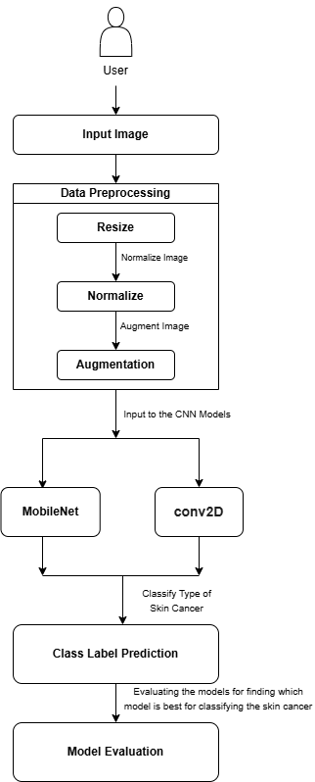

Fig. 1. Architecture Diagram

*A. Data Collection*

The study uses HAM10000 dataset , which consists of labeled skin reports, including seven categories. The images are derived from a wide demographic sample of patients, thus presenting a sufficient sample of skin diseases. The dataset is publicly available and is widely used as a benchmark for skin cancer classification research.

*B. Data Preprocessing*

Preprocessing is conducted to make the dataset ready for incorporation in DL resizing the images into 125x100, which is a common size used in most CNN. Normalization techniques are used to normalize pixel values between 0 and 1, thus making it easy for the models to learn efficiently. Augment the size of the dataset and prevent overfitting, thus increasing the performance of the models new samples. These preprocessing steps lead to the provision of high-quality inputs for training.

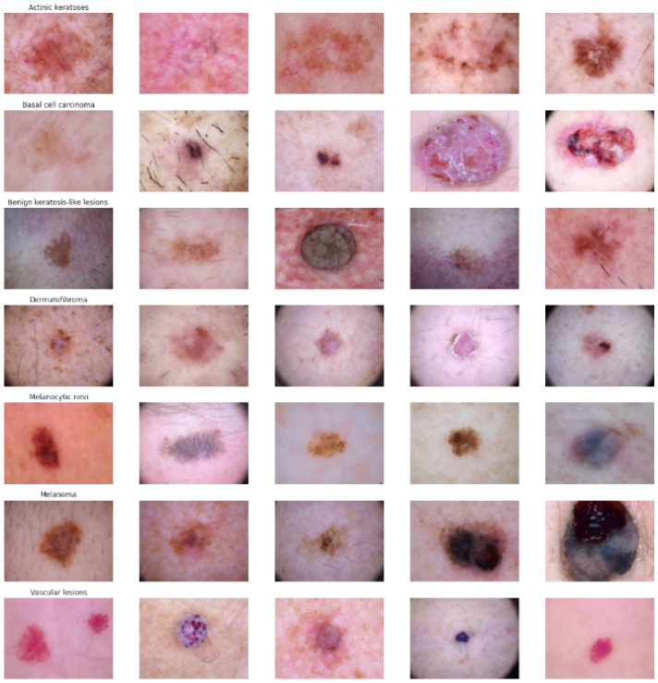

Fig. 2. Data Collection

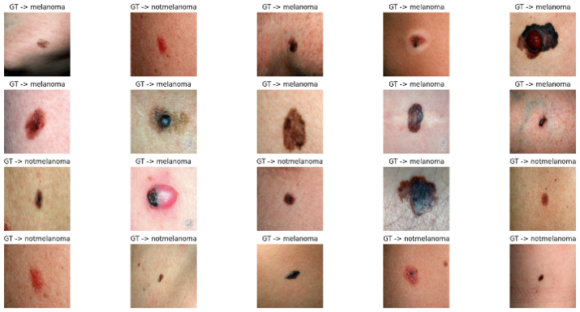

Fig. 3. Preprocessed images

Important insights into the characteristics of skin cancer are obtained by dataset analysis. Most lesions are of the "nv" (nevus) type, with less common melanoma (mel) and other types following, indicating a class imbalance. In order to maintain the objectivity of model training, gender distribution approaches equality. The back, lower limbs, and upper limbs are where lesions are most common. Middle aged individuals are at higher risk, with the majority of cases occurring in those over 50. These results aid in improving model construction and data preparation for accurate skin cancer detection.

*C. Model Selection*

The research between MobileNet and a standard Sequential CNN model is conducted to compare their effectiveness in detecting skin cancer. MobileNet is selected for its depthwise separable convolutions, which have high accuracy with considerably reduced computational complexity, thus ideal for mobile and edge-device deployment. A standard Sequential CNN model takes a basic convolutional layer stacking method, with flexibility but tending to demand higher computational resources and parameters for comparable accuracy.

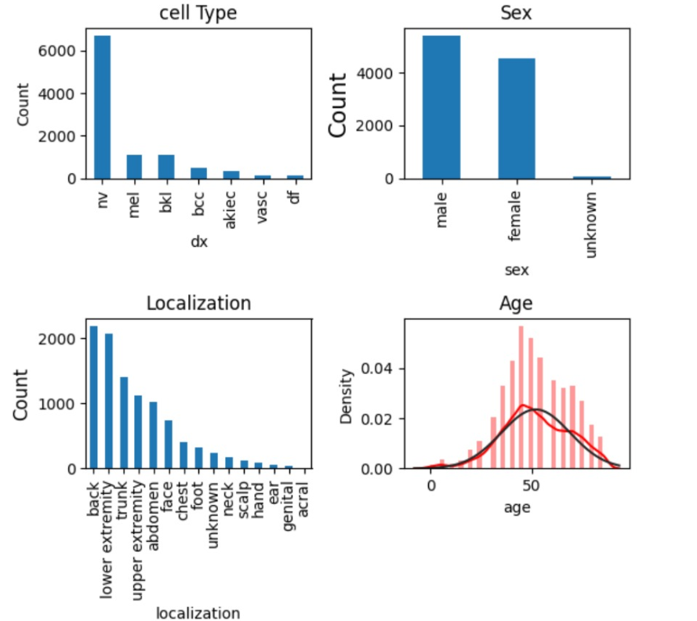

Fig. 4. About Dataset

*D. Model Training*

Both models are trained on the HAM10000 dataset, a popular skin lesion classification dataset. The dataset is divided into training, validation, and test sets through inbuilt functions. Training features include:

MobileNet:

Employs depthwise separable convolutions to the minimize parameters. Needs to lower batch sizes to avoid overfitting. Pretrained weights (ImageNet) can be employed for transfer learning to improve feature extraction. Learning rate scheduling is used for optimal convergence.

Sequential CNN Model:

Sequentially stacked standard convolutional layers. Increased computational expense with full convolutions in every layer. Needs data augmentation to generalize the effectively. Needs manual hyperparameter adjustment to achieve optimal training. Cross-entropy loss as the objective function, and optimization is done using Adam for effective learning.

*E. Model Evaluation*

Both models are tested in terms of classification accuracy, precision, recall, and F1-score. Moreover, the computational efficiency is also taken into consideration:

MobileNet:

Increased accuracy owing to its light feature extraction. Improved training and inference speed due to its lean architecture. Reduced memory usage, which makes it fit for real-world applications (e.g., mobile and embedded devices).

Sequential CNN Model:

Middle-of-the-road accuracy, sometimes needing extra layers for improved feature learning. Increased computational cost due to conventional convolutions. Larger model size, which poses difficulties in deploying resource-scarce environments.

*F. Comparative Analysis*

MobileNet, employing depthwise separable convolutions, is computationally lightweight and suitable for mobile deployment. It has high accuracy, particularly with transfer learning, but at a smaller model size. The Sequential CNN model, employing standard convolutions, needs more parameters and computational resources to deliver similar performance. MobileNet provides quicker training and inference times, making it suitable for real-time use. The Sequential CNN model, though flexible, is more memory- and processing-intensive. MobileNet performs well in skin lesion classification effectively, which makes it more suitable for real-world medical diagnosis. Its light-weight structure provides feasibility for mobile and edge AI use cases. While the Sequential CNN model is more suitable for high-end computing scenarios.

1. RESULT AND DISCUSSION

In skin cancer diagnosis, finding a suitable deep learning model is critical to achieving accuracy without sacrificing efficiency. MobileNet is a light-weight CNN that is optimized for mobile and embedded platforms through the use of depthwise separable convolutions. This minimizes the computational complexity while preserving high classificatory accuracy, making it well suited for real-time medical diagnosis. It is deployable on mobile and edge devices due to its reduced model size and effective processing. On the other hand, a Sequential model, constructed using typical convolutional layers, can perform deeper feature extraction and possibly greater accuracy. However, more computationally intensive and memory-hungry, thus less suitable for mobile deployment. While the Sequential model is more accurate in fine-grained classification, picking up on finer lesion patterns more easily, it is less resource-effective and slower than MobileNet. This provides a best compromise, achieving decent generalization with minimal overfitting but still enabling fast inference. MobileNet can be used in real-time diagnosis where the performance needs to be quick. The Sequential model is better suited for high-performance environments where computational efficiency has to take a backseat to precision. In summary, MobileNet is preferable in real-world practical real-time skin cancer diagnosis, whereas a Sequential CNN would be better applied in precision-oriented applications in a controlled environment.

After 50 epochs, the plot displays the accuracy of training and validation. Both accuracy levels gradually increase, indicating appropriate learning. There appears to be minimal overfitting because the validation accuracy and training accuracy are so similar. The model's over 97% accuracy at the most recent epochs indicates that it is steadily becoming better.

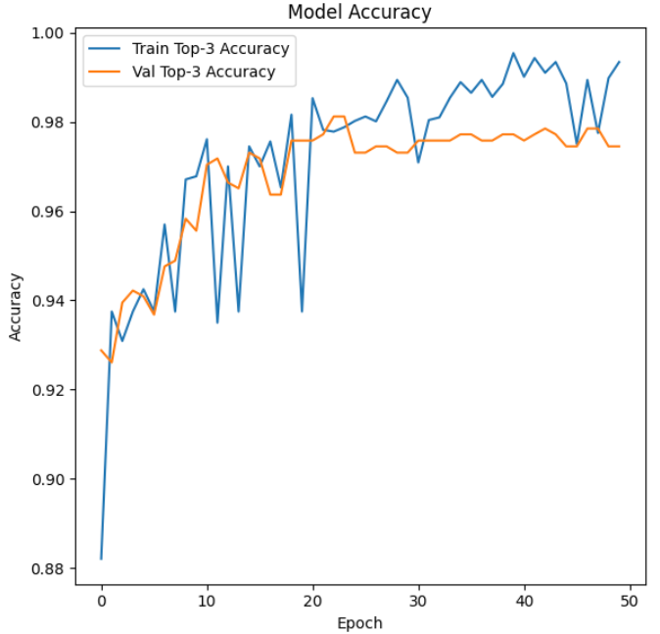

Fig. 5. Training and Validation Accuracy

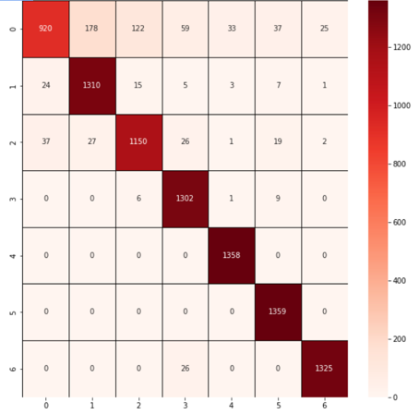

Fig. 6. Confusion matrix

Successful model learning is demonstrated by the plot, which shows the loss total 50 epochs with steady decline in both. The earliest epochs saw a significant decline in the loss, which starts out high. With minimal overfitting, the training and validation loss are constantly monitored. By the last epochs, the loss stabilizes, indicating improved generalization and convergence of the model.

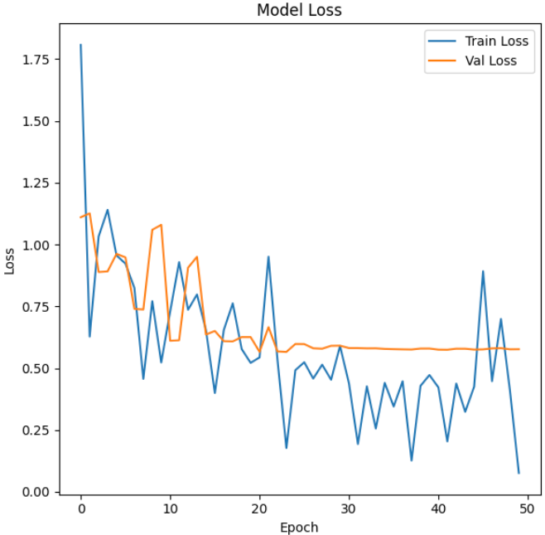

Fig. 7. Training and Validation Accuracy

The MobileNet model is a lightweight and energy-efficient deep learning architecture for mobile and edge devices. In contrast to a regular Sequential model where layers are linearly added one after another in a linear way, MobileNet utilizes depthwise separable convolutions to significantly cut down parameters and computational requirements. This puts it in a perfect position to be used for real-time use cases where computation and memory are constrained.

In contrast, a Sequential model, with explicit layer-by-layer computation, will be computationally expensive and probably not as efficient. Standard deep learning networks are extremely large in parameters, making them slower and making them useless for deployment on mobile hardware. MobileNet, however, substitutes standard convolutions with depthwise and pointwise convolutions, cutting computation by a large margin without sacrificing accuracy.

This method keeps the model lightweight without sacrificing much performance and is suitable for real-time skin cancer detection. In terms of accuracy, MobileNet is adequately suited for classification operations where the compromise is between speed and accuracy. While deeper models like ResNet or Vision Transformers may have improved accuracy, they use more computation, thus not feasible for mobile-based applications. In contrast, the Sequential model is customizable with larger filter sizes and more sophisticated layers but results in increased training and inference times. The architectural efficiency of MobileNet positions it ideally in healthcare usage where executing AI models on mobile devices is required to ensure accessibility and scalability.

Overall, MobileNet's compact size, quick inference time, and good accuracy make it highly suitable for real-world skin cancer detection applications. Compared to a Sequential model, MobileNet achieves a balance between computationally efficiency and diagnostic accuracy, making it a viable candidate for mobile healthcare applications.

1. CONCLUSION AND FUTURE DIRECTIONS

In this work, we investigate the effectiveness of MobileNet compared to the standard Sequential model for skin cancer diagnosis. Lightweight deep learning architecture MobileNet is customized for mobile and embedded applications through the application of depthwise separable convolutions. This significantly minimizes computational complexity without compromising high classification accuracy. MobileNet's strength is its capability to extract deep features at an efficient rate, and it is very well suited for real-time medical diagnosis, especially in environments of limited resources such as mobile healthcare applications. Its depthwise separable convolutions enable it to perform better than conventional convolutional models in speed and efficiency without significantly sacrificing accuracy.

On the other hand, an ordinary Sequential model, built from traditional convolutional neural networks (CNNs), employs a layer-by-layer architecture with each layer stacked linearly. Though such a design makes it simple to implement, it often does not provide efficiency in computing and memory use. Sequential models, due to their depth and number of parameters, can gain stronger learning capabilities on complex patterns but are often slower and more resource-intensive. This makes them less ideal for mobile deployment or applications where fast inference is critical. MobileNet's efficiency makes it highly desirable for tasks in skin cancer detection, especially where immediate and precise prediction is required.

While Sequential models offer architectural design flexibility, computational cost can act as a limiting factor for real-time applications. The findings reveal that MobileNet is a good option for mobile and edge computing applications, ensuring rapid diagnosis and facilitating early skin cancer detection in real-world environments. MobileNet thus provides a powerful alternative to the conventional Sequential models, providing accuracy and efficiency while making automated skin cancer detection technology more accessible.

REFERENCES

1. K. Mridha, M. M. Uddin, J. Shin, S. Khadka and M. F. Mridha, "An Interpretable Skin Cancer Classification Using Optimized Convolutional Neural Network for a Smart Healthcare System," in IEEE Access, vol. 11, pp. 41003-41018, 2023, doi: 10.1109/ACCESS.2023.3269694.
2. A. Imran, A. Nasir, M. Bilal, G. Sun, A. Alzahrani and A. Almuhaimeed, "Skin Cancer Detection Using Combined Decision of Deep Learners," in IEEE Access, vol. 10, pp. 118198-118212, 2022, doi: 10.1109/ACCESS.2022.3220329.
3. R. Schiavoni, G. Maietta, E. Filieri, A. Masciullo and A. Cataldo, "Microwave Reflectometry Sensing System for Low-Cost in-vivo Skin Cancer Diagnostics," in IEEE Access, vol. 11, pp. 13918-13928, 2023, doi: 10.1109/ACCESS.2023.3243843.
4. M. N. Hamza, M. Tariqul Islam, S. Lavadiya, S. Koziel, I. Ud Din and B. Cavalcante de Souza Sanches, "Designing a High-Sensitivity Dual-Band Nano-Biosensor Based on Petahertz MTMs to Provide a Perfect Absorber for Early-Stage Nonmelanoma Skin Cancer Diagnostic," in IEEE Sensors Journal, vol. 24, no. 11, pp. 18418-18427, 1 June1, 2024, doi: 10.1109/JSEN.2024.3391347.
5. N. Shafi et al., "A Portable Non-Invasive Electromagnetic Lesion-Optimized Sensing Device for the Diagnosis of Skin Cancer (SkanMD)," in IEEE Transactions on Biomedical Circuits and Systems, vol. 17, no. 3, pp. 558-573, June 2023, doi: 10.1109/TBCAS.2023.3260581.
6. M. N. Hamza et al., "Designing a High-Sensitivity Microscale Triple-Band Biosensor Based on Terahertz MTMs to Provide a Perfect Absorber for Non-Melanoma Skin Cancer Diagnostic," in IEEE Photonics Journal, vol. 16, no. 2, pp. 1-13, April 2024, Art no. 5900113, doi: 10.1109/JPHOT.2024.3381649.
7. R. Karthik, R. Menaka, S. Atre, J. Cho and S. Veerappampalayam Easwaramoorthy, "A Hybrid Deep Learning Approach for Skin Cancer Classification Using Swin Transformer and Dense Group Shuffle Non-Local Attention Network," in IEEE Access, vol. 12, pp. 158040-158051, 2024, doi: 10.1109/ACCESS.2024.3485507.
8. A. R. Chishti et al., "Advances in Antenna-Based Techniques for Detection and Monitoring of Critical Chronic Diseases: A Comprehensive Review," in IEEE Access, vol. 11, pp. 104463-104484, 2023, doi: 10.1109/ACCESS.2023.3316149.
9. L. Riaz et al., "A Comprehensive Joint Learning System to Detect Skin Cancer," in IEEE Access, vol. 11, pp. 79434-79444, 2023, doi: 10.1109/ACCESS.2023.3297644.
10. M. Saeed, A. Naseer, H. Masood, S. U. Rehman and V. Gruhn, "The Power of Generative AI to Augment for Enhanced Skin Cancer Classification: A Deep Learning Approach," in IEEE Access, vol. 11, pp. 130330-130344, 2023, doi: 10.1109/ACCESS.2023.3332628.
11. W. Di, F. Xin, L. Yu, Z. Hui, H. Ping and S. Hui, "ECRNet: Hybrid Network for Skin Cancer Identification," in IEEE Access, vol. 12, pp. 67880-67888, 2024, doi: 10.1109/ACCESS.2024.3397197.
12. Z. Ji, X. Wang, C. Liu, Z. Wang, N. Yuan and I. Ganchev, "EFAM-Net: A Multi-Class Skin Lesion Classification Model Utilizing EnhaFeature Fusion and Attention Mechanisms," in IEEE Access, vol. 12, pp. 143029-143041, 2024, doi: 10.1109/ACCESS.2024.3468612.
13. M. N. Hamza and M. T. Islam, "Designing an Extremely Tiny Dual-Band Biosensor Based on MTMs in the Terahertz Region as a Perfect Absorber for Non-Melanoma Skin Cancer Diagnostics," in IEEE Access, vol. 11, pp. 136770-136781, 2023, doi: 10.1109/ACCESS.2023.3339562.
14. P. A. Lyakhov, U. A. Lyakhova and D. I. Kalita, "Multimodal Analysis of Unbalanced Dermatological Data for Skin Cancer Recognition," in IEEE Access, vol. 11, pp. 131487-131507, 2023, doi: 10.1109/ACCESS.2023.3336289.
15. Y. Olmez, G. O. Koca, A. Sengür, U. R. Acharya and H. Mir, "Improved PSO With Visit Table and Multiple Direction Search Strategies for Skin Cancer Image Segmentation," in IEEE Access, vol. 12, pp. 840-867, 2024, doi: 10.1109/ACCESS.2023.3347587.
16. X. Qian et al., "SPCB-Net: A Multi-Scale Skin Cancer Image Identification Network Using Self-Interactive Attention Pyramid and Cross-Layer Bilinear-Trilinear Pooling," in IEEE Access, vol. 12, pp. 2272-2287, 2024, doi: 10.1109/ACCESS.2023.3347424.
17. H. He et al., "Machine Learning Analysis of Human Skin by Optoacoustic Mesoscopy for Automated Extraction of Psoriasis and Aging Biomarkers," in IEEE Transactions on Medical Imaging, vol. 43, no. 6, pp. 2074-2085, June 2024, doi: 10.1109/TMI.2024.3356180.
18. K. M. Hosny, D. Elshoura, E. R. Mohamed, E. Vrochidou and G. A. Papakostas, "Deep Learning and Optimization-Based Methods for Skin Lesions Segmentation: A Review," in IEEE Access, vol. 11, pp. 85467-85488, 2023, doi: 10.1109/ACCESS.2023.3303961.
19. B. Xu and F. Zhou, "The Roles of Cloud-Based Systems on the Cancer-Related Studies: A Systematic Literature Review," in IEEE Access, vol. 10, pp. 64126-64145, 2022, doi: 10.1109/ACCESS.2022.3181147.
20. H. L. Gururaj, N. Manju, A. Nagarjun, V. N. M. Aradhya and F. Flammini, "DeepSkin: A Deep Learning Approach for Skin Cancer Classification," in IEEE Access, vol. 11, pp. 50205-50214, 2023, doi: 10.1109/ACCESS.2023.3274848.