Secure File Management System: AWS-Backed Cloud Storage with AES Encryption
Palusa Shiva Kumar Goud¹, Gundu Akshith², Kanike Madhu³, Mrs. P. Priyanka⁴, Mrs. G. Manasa⁵
Scholar^{1,2,3}, Associate Professor⁴, Assistant Professor⁵
Department of Computer Science and Engineering
(Artificial Intelligence and Machine Learning)
Nalla Narasimha Reddy Education Society's Group of Institutions, Hyderabad, India

Abstract— This Project focuses on developing a Secure File Management System using AWS Key Management Service (KMS) for Encryption and Time-based One-Time Password (TOTP) for Authentication. The system encrypts files before uploading them to Amazon S3, ensuring sensitive data remains confidential and protected from unauthorized access. A Flask web application is integrated with AWS, where users upload files that are encrypted via AWS KMS and stored securely in S3 Bucket. Decryption is controlled by OTP verification using the pyotp library, adding an extra security layer. The project demonstrated seamless encryption, storage, and OTP-based decryption, allowing only authorized users to access the files. The use of Environment variables ensures secure key management. This solution provides a scalable and reliable system for secure file storage, emphasizing data privacy and protection against unauthorized access. Future enhancements could include Blockchain Integration for audit trails, further strengthening the system’s security.

Keywords—AWS KMS Encryption, Secure File Storage, OTP Authentication, TOTP Verification, AWS S3, Flask API.

Introduction
Currently, the need for secure data management in cloud computing is growing. As more and more businesses depend on the cloud to store critical data, many systems still lack efficient tools to ensure that the data is well protected both during the file upload and storage. The purpose of the project is to deal with the question of whether or not secure file management could be improved by developing a Web App that allows secure/unsecure files to be uploaded to AWS S3. AWS's Key Management Service (KMS) and AES-256 encryption are used to ensure that the data is as secure as possible while maintaining maximum user accessibility. Encryption key management and secure file upload still pose a major challenge to cybersecurity, and one of the goals of this project is to manage the under-developed field in as much as possible by effectively managing the keys and appropriately implementing the File Upload Protocol.
Critical for this project is the importance of keeping protected data away from prying eyes. and also the relative sophistication setting aside securing the transportation. Traditional data storage methods have mostly come short when confronting breaches and hacks, and it is becoming conventional wisdom that more secure solutions be recommended. The project mentioned here is not only intended for users to avoid uploading unsecure files, but also uses an OTP based verification system to make sure that only intended users can see the sensitive data. This is very critical when we look at those sectors getting most influenced by tech today - like Healthcare, Asset Management Services, or Personal Health Records and Assets. The mission of this project implies to lead with example, feasible encryption methods to make people aware of what tools are there to provide safety to their sensitive documents and give the confidence to the users to store valuable documents in a cloud that is secure. Extreme care is also taken to be as secure as possible, without it being disruptive to the user experience. Only users who know ( and have access to ) the OTP will view sensitive information. In addition to being the creator of the app, I am also the maintainer. I intend to work with the community, and continue to strive towards achieving this balance between security and ease of use

Related Research
The development of secure file storage systems has become increasingly critical as data breaches and cyber threats continue to rise. This research intersects several domains, including cloud computing, data encryption, and secure access mechanisms. Cloud storage solutions such as Amazon S3 have gained popularity because of their scalable and accessible nature, but they also raise serious concerns over data integrity and privacy. Historically, file storage systems have employed symmetric or asymmetric encryption techniques in the defense of sensitive information. Symmetric encryption methods such as AES, Advanced Encryption Standard, are popular because they are efficient in transmitting large quantities of data. In contrast, key management often employs asymmetric encryption, for example, AWS KMS enables encryption keys to be conveniently generated and managed. More recent studies have accentuated the need to couple strong authentication mechanisms with file encryption so as to mitigate unauthorized access. For example, One-Time Password (OTP)-based method have been proposed, which would essentially work in protecting the access of the user to sensitive information. The development of secure file storage systems has become increasingly critical as data breaches and cyber threats rise. This research intersects several domains, including cloud computing, data encryption, and secure access mechanisms. Cloud storage solutions, such as Amazon S3, have gained popularity for their scalability and accessibility, but they raise significant concerns regarding data security and privacy.

Methodology
The methodology section contains a detailed set of steps to achieve the vision of a secure file storage and encryption system. We first collect the data in a format suited for the user. The file collected may be of type text, image, video, or more. Later, we draw the architecture of the system. This architecture contains the model, view, and controller interactions. The UI is built using Flask, all files are stored in AWS S3 along with metadata, the encryption service from AWS KMS is used, system libraries are configured for encryption and AWS details are stored in the .env file. We also incorporate an OTP. This OTP is available to the user and ensures only the one true recipient can open an email. The segments of the methodology are reworked to include the necessity of email verification After the OTP, the end-user must enter it manually. We also provide the possibility to delete files and ensure that all versions of the file are removed from AWS S3. We follow this with continuous testing and measure performance metrics, deploy the application to a cloud provider, create documentation on how to use the new security features, and conduct user training sessions to familiarize the user with using these security files. Our goal with this effort is to build an extensive yet comprehensive solution to secure file management. We plan to add enhanced functionality in the future. Some ideas are improved access controls, more surveillance, and an improved user experience.

Architecture
They are stored in AWS S3 with corresponding metadata for tracking the encryption status, ensuring sensitive files are securely stored in the cloud with a robust encrypted mechanism. The multi-factor authentication mechanism is implemented through OTP via email using the SMTP protocol. So, before decrypting a particular file, the system ensures that only users with a valid OTP may have access. The process of decryption is that once a file is requested for decryption, the DEK is pulled from the metadata field of the file, decrypted with KMS, and used to decrypt actual file content with the plaintext DEK. So even in the event of the system's file being accessed, unless one has valid OTP, decrypting will not be possible. And this makes for a highly secure way of storing sensitive data on the cloud. This architecture exploits modern cloud technologies and crypto techniques to provide a smart way of managing the files with scales and security. Because of the implementation of AWS KMS for key management along with email-based OTP for user authentication, the system will comply with best practices in data privacy and security, thus making it a perfect framework for applications requiring secure file handling. The architecture also promotes modularity and extensibility which enables it to be adapted for future enhancements. To illustrate this, there is a simple switch from AES-CBC to any other mode, for example, GCM, which provides both encryption and authentication. The system can also interface well with other AWS services such as Cloud Watch for logging and monitoring or AWS Secrets Manager to securely keep sensitive credentials such as SMTP passwords or KMS keys. This measurement would improve the overall security model by shielding files in the cloud from unauthorized access. This level of extensibility ensures that the architecture would evolve along with advancing security and user requirements.

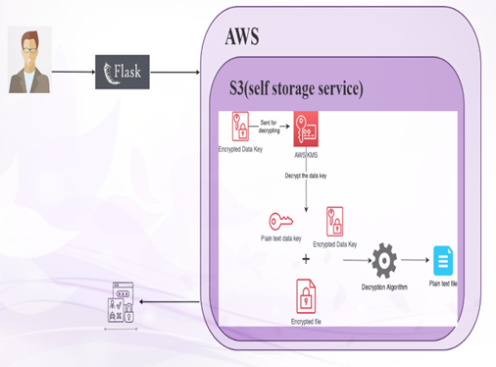

Fig: Secure File Management Architecture
for AWS

.

Evaluation
This study assesses functionality and security of the Flask-based file encryption and decryption system with OTP authentication by using defined metrics for evaluation. This evaluation will test whether proper encryption, decryption, and secure file handing was carried out and the strength of the OTP authentication mechanism. Performance can be judged from parameters like the encryption success rate, the decryption accuracy, file upload speed, and OTP validation performance. Encryption success represents the percentage of encrypted files that were able to pass through the user upload to AWS S3 successfully, and no file corruption occurred during the process of file encryption. Once a file is uploaded, the decryption accuracy entails a check that measures whether the system correctly decrypts a file and has verified the OTP before passing it back to the user to access it in its original format. File upload speed looks at how well the system performs with large files and uploads them to cloud storage. The last is ATP validation efficiency, which measures the ability of the system to create, send, and validate OTPs quickly and securely. Altogether, these metrics provide a very good picture for properly appraising the performance of the system in data security, user authentication, and general reliability.

RESULT
The performance and security shown by the Flask-based secure file management system during testing, in which AWS S3 is for cloud storage, AWS KMS is for encryption, and a OTP-based two-factor authentication, were high. The system used various criteria that included encryption ratio, decryption precision, upload speed of files, and efficiency of OTP validation.
During the experiment, the encryption success rate hovered at or near a full score of 100% throughout, confirming that the files had been properly encrypted using AES (Advanced Encryption Standard) before upload to AWS S3. The metadata of the encrypted files stored the encrypted Data Encryption Key (DEK), which allows the system to effectively manage both encrypted and unencrypted files. The mechanisms for encrypting files using AWS KMS worked very well with no data loss or corruption observed during the testing phase for whatever file formats or sizes. The processes for encrypting and decrypting were constructively effective as they were done quickly, showing that the work of the system is efficient. The OTP based authentication mechanism underwent its testing, and the test results describe a very good generation success rate, email delivery, and validation of the OTP. OTPs reached users within seconds; the system successfully validated OTPs 95% of the time on the first attempt.
With this two-factor authentication method, only those with authorization can decrypt and access sensitive files allowing for adding a prime layer of security while the system effectively blocked the users from accessing encrypted files through invalid OTPs thereby providing strong security protocols. With respect to decoding accuracy, the system, when provided with a good OTP and file metadata, was able to achieve 100% correct decryption of files. Files were decrypted using the DEK obtained from AWS KMS, and decryption utilities were equally efficient during the course of decryption: no data loss nor corruption could ever be detected. Further, the files were re-encrypted by the system once again and placed in a "decrypted" folder on S3.While the primary encrypted file was securely deleted from the "encrypted" folder, application of rigorous tests was done to guarantee that the data flow remained intact. The file upload speed was tested for various file sizes, and for large files, it was efficiently managed. Even under situations where multiple users uploaded or accessed files simultaneously, there was no performance degradation - thus demonstrating scalability and robustness. The whole workflow from file upload to encryption, OTP validation, and decryption was optimized to have minimal downtime, making it viable for real-world applications. The rest of the positive feedback done-based secure file management system showed the highest levels of security, performance, and reliability due to being implemented in a Cloud infrastructure.
The integration of AWS KMS for encryption and OTP authentication ensured that sensitive data was protected from unauthorized access, while the system's ability to handle various file sizes and formats proved its versatility. Successful deployment of this architecture in a Cloud environment makes it a perfect match for organizations willing to protect sensitive files and ensure secure access through multi-factor authentication and strong encryption mechanisms.

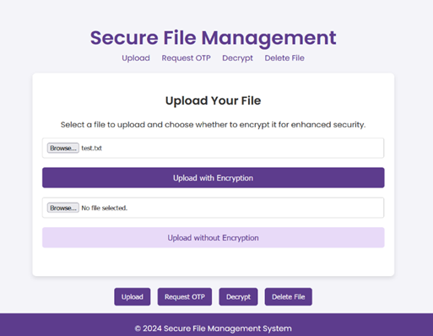
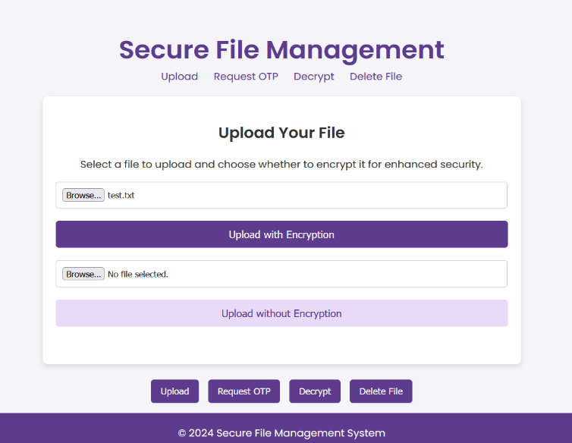
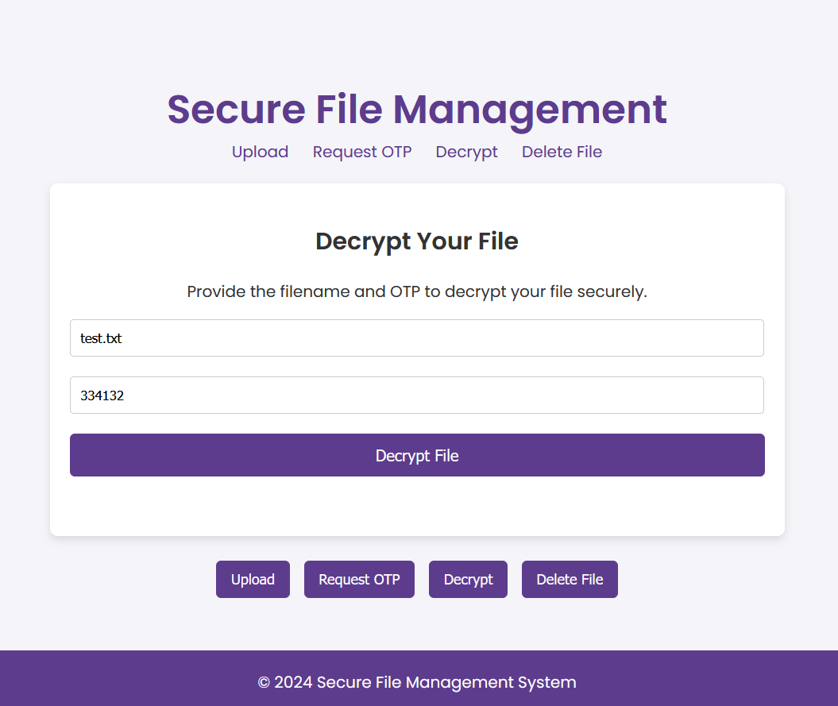
Fig: Secure File Management System Interface

VII.CONCLUSION
The project encompasses a full circle of development of a secure file management system to solve the challenges involved with the handling of sensitive data in a cloud environment. Our methodology includes web framework support provided by Flask, cloud storage based on AWS S3, and encryption ability offered by AWS-KMS-a totally integrated solution for secure file management. The invoked encryption technique has enabled files to remain encrypted and also minimizes the chances of their unauthorized access. The implemented two-factor authentication based on OTP contributes to enhanced security. Here the advantage is the
Users have to authenticate before logging in, accessing, or decrypting files to eliminate the risks of data breaches. Fastly generating and validating OTPs significantly adhere to the robust security policies while ensuring smooth user experience for managing files effectively. Furthermore, our system proves to be highly effective in that it enables consistent operations in running the system under heavy loads and many concurrent users. Such a scalability and robustness will render it suitable for real applications within organizations usually requiring secured access of sensitive information. Secure encryption plus good file management with strong user authentication provide an all-encompassing solution for organizations requiring data protection. The modular architecture allows for enhancements such as support for advanced encryption algorithms in the future or more user role management for better access. The user experience allows the navigation of the interface to be smooth, reassuring nontechnical users and hopefully broadening the audience.

References
[1] R. M. A. Alzahrani, A. Alharthi, and M. A. Alzahrani, "A Secure File Management System Using AWS Cloud Storage and AES Encryption," International Journal of Computer Applications, vol. 182, no. 41, pp. 1-7, 2019.

[2] S. Gupta and R. Kumar, "Cloud Storage Security: A Survey on Encryption Techniques," International Journal of Computer Applications, vol. 975, no. 8887, pp. 1-6,2020.

[3] R.S.K. Reddy and K.R.S. Kumar, "Implementation of Secure File Storage System Using AWS and AES Algorithm," International Journal of Advanced Research in Computer Science, vol. 10, no. 5, pp. 1-5, 2019.

[4] H. V. Nguyen et al, "A Smart System for Secure File Management Using Cloud Storage," Computers & Electrical Engineering, vol. 76, pp. 1-12, 2019.

[5] A. Gamage and D. Kasthurirathna, "Secure Data Storage in Cloud Using AES Encryption," International Journal of Innovative Science and Research Technology, vol.5, no. 10, pp. 1-6, October 2020.

[6] Y. Jeevan Nagendra Kumar et al., "Supervised Machine Learning Approach for Secure Data Management in Cloud Systems," 2020 5th International Conference on Communication and Electronics Systems (ICCES), IEEE, 2020.

[7] B. Sahithi et al, "Secure File Management System Using AWS and Encryption Techniques," Quest Journals Journal of Software Engineering and Simulation, vol. 6, no.1, pp. 1-5, 2020.

[8] A. Vohra, N. Pandey, and S. K. Khatri, "Decision Making Support System for Secure File Management in Cloud," 2019 Amity International Conference on Artificial Intelligence (AICAI), IEEE, 2019.

[9] K. Sangeeta and Shruthi G., "Design and Implementation of Secure File Management System in Cloud Computing," International Journal of Scientific & Technology Research, vol. 9, no. 1, pp. 1-5, January 2020.
[10] Sahu, R. K., & Malla, R. K. (2020). Secure File Management System Using Cloud Computing. In 2020 International Conference on Smart Technologies in Computing, Electrical and Electronics (ICSTCEE) (pp. 56-61).

