1. Created a basic bash script with file name called text.bash to get output as

Free -m

Ps -ef

Df

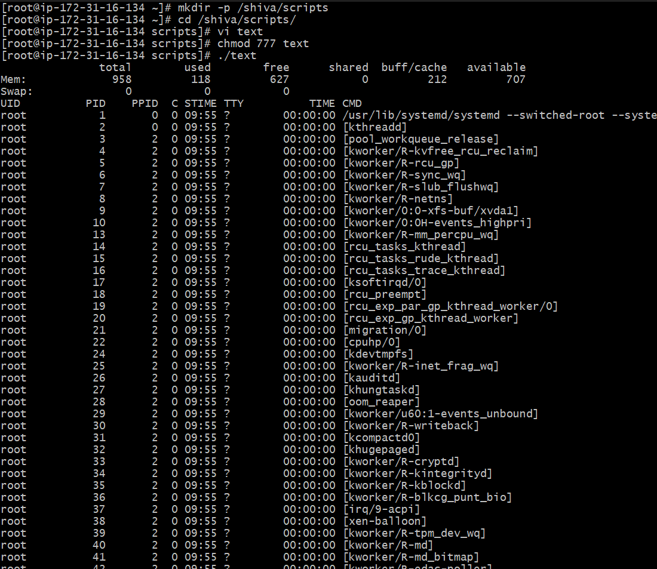

1. Create a Basic Hello world script.

1. To check about the Permissions.

We have 2 types to get the output.

./abc.bash - -> The Permission gets denied

Bash abc.bash - -> This Usually accepts the permissions ang gets the output.

1. Creating a script using variables.

1. Creating basic second script using commands in that.

1. Creating Administration Tasks

1. Creating and running variables and commands.

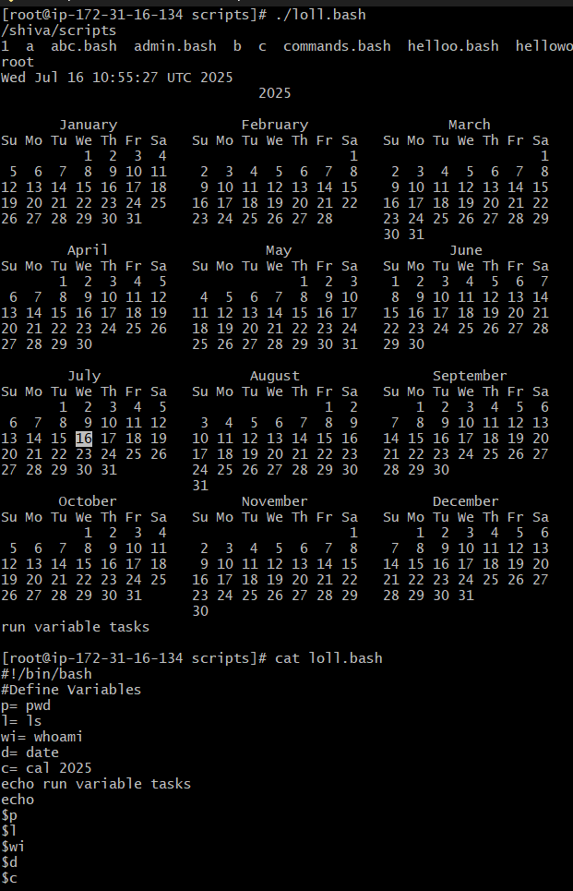

1. Creating Input/Output Script

1. Case scripting.

1. Scripts to run command

1. Read Input Command

1. Creating a script using variable command

1. Defining Tasks.

1. Performing The task

1. Script to run for a number of times.

1. Script to run for number of seconds.

1. Create a simple for loop script.

1. Specify days in for a loop

1. List all users one by one from /etc/passwd file

1. Chck the response and then output.

