1. Install Jenkins and run Jenkins on port number 8081.

sudo wget -O /etc/yum.repos.d/jenkins.repo https://pkg.jenkins.io/redhat-stable/jenkins.repo   
   
sudo rpm --import https://pkg.jenkins.io/redhat-stable/jenkins.io-2023.key   
sudo dnf install java-17-amazon-corretto-devel   
sudo yum install jenkins -y   
sudo systemctl start jenkins.service   
sudo systemctl status jenkins   
Step2: vi /usr/lib/systemd/system/jenkins.service   
replace 8080 with :8081 and save it   
systemctl daemon-reload   
systemctl restart jenkins.service

2) Secure Jenkins server

We have to remove that InitialAdminPassword from the PC

and in Jenkins go to security and edit the   
password and change it. Then we can login we the  
edited password.  
Now the Jenkins is Secure.

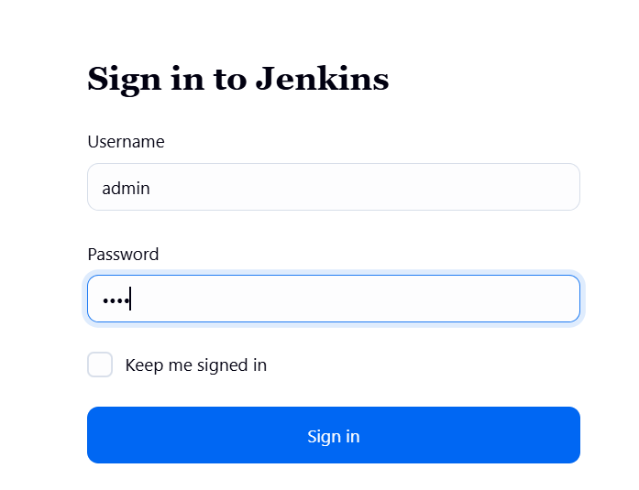

1. Create users called DevOps, testing in Jenkins with Limited access.

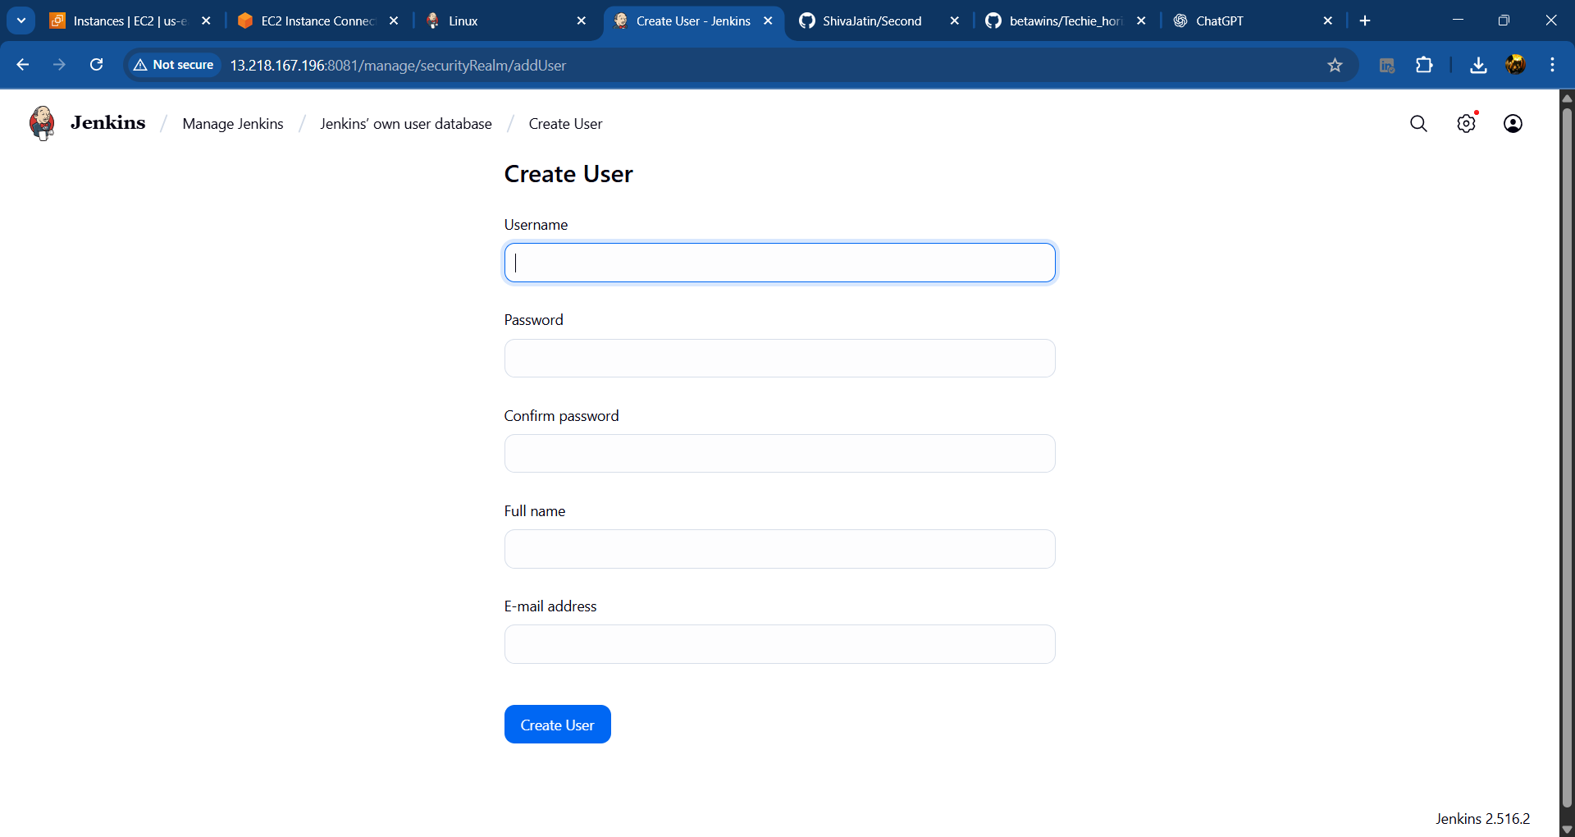

Go to plugins and install role-based strategy in plugins.  
Then go to manage and then security and then credentials

After creating the user, we can’t able to see the create job in this because we have given only the read access to this user.  
4) Configure labels and restrict the jobs to execute based on label only.

In the above job I have given the label and in one more job we don’t have to assign the label only have to attach the Git repo url.  
So the console output will be

5) Create Three sample jobs using the below URL.  
   <https://github.com/betawins/Techie_horizon_Login_app.git>

6) Create one Jenkins job using git hub Private repository.

For the Private Repo I need to give credentials as it is not accepting credentials I have given PAT number as password and gave ID as 123 and then I can copy the private repo to my Jenkins.

