1) Create one jenkins job using the below code and create three stages.

stage1: Git clone to download the source code.

https://github.com/betawins/VProfile-1.git

stage2: Sonarqube Integration to check the quality of code

stage3: Slack Integration to send the alerts to slack.

* Open Jenkins Dashboard  
  Go to your Jenkins URL → http://<>:8080/
* Create a New Job name as – Vprofile -> Select Freestyle project ->Click OK.
* Configure Git Repository  
  In Source Code Management -> Select -> enter your Git repo link:  
  <https://github.com/betawins/VProfile-1.git>

* Save and Build -> Check the Console Output → It should show Jenkins cloning the repository.  
  Now successfully we have created the VProfile job and cloned the source code from git hub using the url.

We can check by login to your ssh as cd /var/lib/Jenkins/workspace  
in workspace we’ll see the Vprofile

Step-by-Step SonarQube Installation on EC2  
Launch EC2 Instance -> Instance type: t2.large -> Storage: 20 GB  
Install java 1.8 version -> yum install java-1.8*

Install & Configure MySQL  
wget https://dev.mysql.com/get/mysql57-community-release-el7-11.noarch.rpm  
yum localinstall -y mysql57-community-release-el7-11.noarch.rpm  
rpm --import https://repo.mysql.com/RPM-GPG-KEY-mysql-2022  
yum install -y mysql-community-server

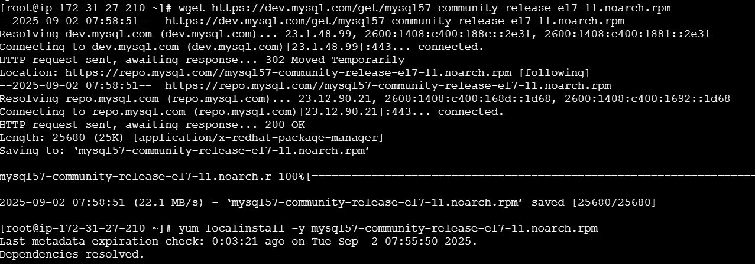

systemctl start mysqld.service

systemctl status mysqld.service  
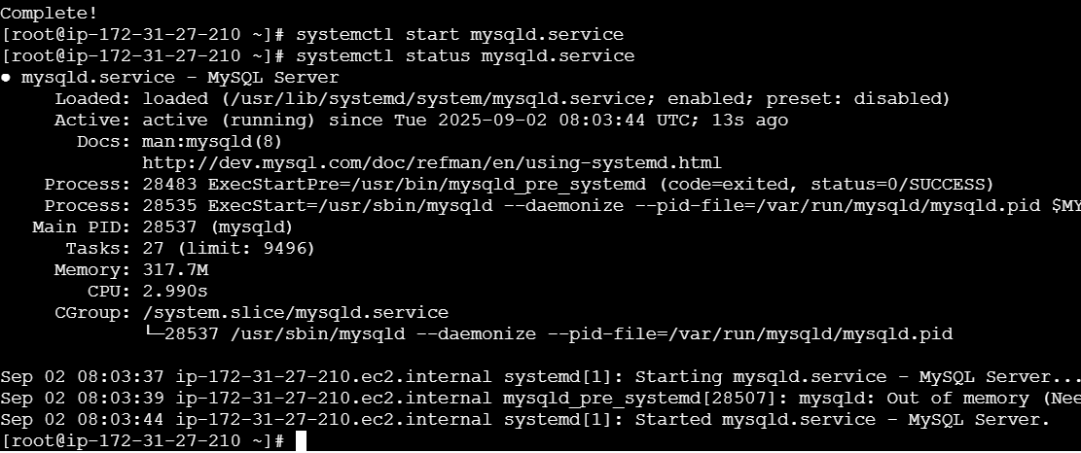

Configure the MySQL Root Password  
grep 'temporary' /var/log/mysqld.log

By typing the above, we get temporary mysql password  
 Login to mysql using mysql -u root -p  
 Now replace the default password with a new and strong password  
ALTER USER 'root'@'localhost' IDENTIFIED BY 'Admin@123';  
flush privileges;

Test Using new password  
mysql -u root -p

Exit  
And Download the sonarqube using the below commands  
5. Install SonarQube  
Download & unzip SonarQube 6.0  
cd /opt/ - Always Download anything in opt file  
wget https://binaries.sonarsource.com/Distribution/sonarqube/sonarqube-6.6.zip  
unzip sonarqube-6.6.zip  
mv /opt/sonarqube-6.6 /opt/sonar

After Downloading and unzipping I have changed the name of Sonarqube-6.6 to sonar.  
Login to mysql ---- mysql -u root -p  
Show databases

6.Create SonarQube Database & User  
Create a new sonar database  
CREATE DATABASE sonar CHARACTER SET utf8 COLLATE utf8_general_ci;  
Create a local and a remote user  
CREATE USER sonar@localhost IDENTIFIED BY 'Sonar@123';  
CREATE USER sonar@'%' IDENTIFIED BY 'Sonar@123';  
Grant database access permissions to users  
GRANT ALL ON sonar.* TO sonar@localhost;  
GRANT ALL ON sonar.* TO sonar@'%';  
show databases;

SELECT User FROM mysql.user;  
FLUSH PRIVILEGES;

Configure SonarQube with MySQL  
So for you have configured required database information on mysql. Let’s  
Jump back to your EC2 instance and enable SonarQube properties file to   
connect his Database.  
ON EC2 Instance edit sonar properties file to uncomment and provide required information for below properties.

- File Name: /opt/sonar/conf/sonar.properties  
- File Name: /opt/sonar/conf/sonar.properties  
Edit properties file:  
Vi sonar .properties  
Uncomment and update:  
- sonar.jdbc.username=`sonar`  
 - sonar.jdbc.password=`Sonar@123`  
 - sonar.jdbc.url=jdbc:mysql://`localhost:3306`/sonar?  
useUnicode=true&characterEncoding=utf8&rewriteBatchedStatements  
=true&useConfigs=maxPerformance&useSSL=false  
 - sonar.web.host=`0.0.0.0`  
 - sonar.web.context=`/sonar`

8. Start SonarQube

Start SonarQube service  
cd /opt/sonar/bin/linux-x86-64/  
./sonar.sh start  
While starting the Sonarqube it failed to start

use this command to give permissions and the start again

These Permissions should be given in /opt file.  
sudo chown -R ec2-user:ec2-user sonar

9. Access SonarQube UI

SonarQube application uses port 9000. access SonarQube from browser  
 http:// 54.89.167.184:9000/Sonar

Default credentials for sonarqube.  
Username : admin  
Password: admin

**Jenkins + SonarQube Integration**  
Install SonarQube Scanner Plugin in Jenkins  
Login to Jenkins GUI console and install " SonarQube   
scanner" plugin  
 - `Manage Jenkins` > `Manage Plugins` > `Avalable` >   
`SonarQube scanner`

Configure SonarQube Server in Jenkins Go to:  
Manage Jenkins → Configure System.  
 Scroll down to SonarQube servers → Add SonarQube.  
Name: SonarQube  
Server URL: http://<Sonarqube_server>:9000/sonar  
.Generate Token from SonarQube:  
•Login to SonarQube → Top-right corner My Account → Security →  
Generate Tokens.

4.Login to Jenkins server and install sonarqube scanner.  
wget https://binaries.sonarsource.com/Distribution/sonar-scanner-cli/sonar-scanner-cli-4.6.2.2472-linux.zip  
unzip sonar-scanner-cli-4.6.2.2472-linux.zip

# mv sonar-scanner-4.6.2.2472-linux /opt/sonar_scanner  
Set SonarQube server details in sonar-scanner property file- Sonar properties file: /opt/sonar_scanner/conf/sonar-scanner.properties -sonar.host.url=http://`<SONAR_SERVER_IP>`:9000  
Configure SonarQube Scanner in Jenkins  
- `Manage Jenkins` > `Global Tool Configuration` > `SonarQube Scanner`  
 Name : sonar_scanner  
 SONAR_RUNNER_HOME : /opt/sonar_scanner/bin

6.Create a Jenkins Job to Test SonarQube  
Alredy we have created a VProfile Job  
Configure that job  
Create a job to test SonarQube. Provide below sonar properties details in  
the job under build-SCM:  
 https://github.com/betawins/VProfile-1.git  
   
 `Execute SonarQube Scanner` > `Analysis properties` (it is   
mandatary).

sonar.projectKey=Shivajatin

sonar.projectName=Shivajatin  
sonar.projectVersion=1.0  
sonar.sources=/var/lib/jenkins/workspace/$JOB_NAME/src/  
sonar.binaries=target/classes/com/visualpathit/account/controller/  
sonar.junit.reportsPath=target/surefire-reports  
sonar.jacoco.reportPath=target/jacoco.exec  
sonar.java.binaries=src/main/java/com/visualpathit/account/  
Execute job to get analysis report.

Run the Jenkins Job

Verify in SonarQube  
Goto sonarqube and refresh

stage3: Slack Integration to send the alerts to slack.  
1. jenkins + Slack Integration  
Goto slack open apps  
Select Jenkins cli  
Click on Add to slack

Goto slack open apps

Select Jenkins cli

Click on Add to slack

**Select the channel #jenkins-integration**

**And add**

**2. Install Slack Plugin in Jenkins**

1. Go to Jenkins GUI:  
   **Manage Jenkins → Manage Plugins → Available → Search “Slack Notification” → Install without restart**.
2. Once installed, go to:  
   **Manage Jenkins → Configure System → Slack**.

**3. Configure Slack in Jenkins**

* **Workspace:** your Slack team domain
* **Integration Token Credential ID:** Add a new credential → Kind = “Secret Text” → Paste URL.
* **Default Channel:** #jenkins-integration
* Save.

**4. Add Slack Notifications to Jenkins Job**

Open your existing **SonarQube Jenkins job** → **Post-build Actions**:

1. Select **Add post-build action** → **Slack Notifications**.
2. Choose when to notify:
   * Notify Success
   * Notify Failure
   * Notify Build start
   * Notify Back to Normal
3. Save job.

Now when you build, Jenkins will push notifications to Slack

2) 1) Create one jenkins job using the below code and create three stages.

stage1: Git clone to download the source code.

stage2: Sonarqube Integration to check the quality of code

stage3: Slack Integration to send the alerts to slack.

URL: <https://github.com/betawins/hiring-app.git>

Create a job called Hiring-app -> clone the URL from Git.

After Creating and build is done. Check if the Git repo is successfully cloned or not in cli.

Create a Jenkins Job to Test SonarQube  
Already we have created a Hiring-app Job  
Configure that job  
Create a job to test SonarQube. Provide below sonar properties details in  
the job under build-SCM:  
 https://github.com/betawins/hiring-app.git  
   
 `Execute SonarQube Scanner` > `Analysis properties` (it is   
mandatary).

sonar.projectKey=Shivajatin

sonar.projectName=Shivajatin  
sonar.projectVersion=1.0  
sonar.sources=/var/lib/jenkins/workspace/$JOB_NAME/src/  
sonar.binaries=target/classes/com/visualpathit/account/controller/  
sonar.junit.reportsPath=target/surefire-reports  
sonar.jacoco.reportPath=target/jacoco.exec  
sonar.java.binaries=src/main/java/com/visualpathit/account/  
Execute job to get analysis report.

Run the Jenkins Job

Verify in SonarQube  
Goto sonarqube and refresh

1. Select **Add post-build action** → **Slack Notifications**.
2. Choose when to notify:
   * Notify Success
   * Notify Failure
   * Notify Build start
   * Notify Back to Normal
3. Save job.

Now when you build, Jenkins will push notifications to Slack.

