1)Configure 2 slave machines in Jenkins master.

Jenkins Master–Slave Configuration  
**Steps to be done on slave**

Create an ec2 –slave-01  
Login to slave machine.  
switch to root user  
dnf install -y java-17-amazon-corretto  
Create ssh-keygen  
cat id_rsa.pub > authorized_keys  
chmod 700 authorized_keys

**Steps to be done on master machine:**

Login to Master machine  
switch to root user.  
Prepare Jenkins SSH directory  
mkdir -p /var/lib/jenkins/.ssh  
cd /var/lib/jenkins/.ssh  
Add slave’s SSH key to known_hosts  
ssh-keyscan -H   
SLAVE-NODE-IP-OR-HOSTNAME>>/var/lib/jenkins/.ssh/known_hosts  
# ssh-keyscan -H 13.220.118.249 >>/var/lib/jenkins/.ssh/known_hosts  
Fix permissions  
chown jenkins:jenkins known_hosts  
#we need to change the owner as we ran ssh-keyscan command using “root”  
user.  
# default user of Jenkins will be “jenkins”  
chmod 700 known_hosts

# Done!!

**Steps on Jenkins GUI**

1. Go to Manage Jenkins → Manage Nodes and Clouds → New   
Node  
Give it a name (e.g., slave-1)  
Select Permanent Agent

1. Configure Node  
   Remote root directory: /home/ec2-user   
   Labels: Java  
   Launch method: Launch agent via SSH  
   Host: Public IP of Slave  
   Add Credentials  
   Kind: SSH Username with private key  
   Username: ec2-user  
   Private key: Paste your. pem key (from AWS)  
   Save

1. Save & Test Connection  
Jenkins master should now connect to the slave machine via   
SSH.  
If successful, the node status will show as online.

Your slave-01 agent is offline  
•This means the /tmp partition on the slave machine is almost full. Jenkins   
automatically puts the node offline when it detects free space is lower than the   
threshold.  
.

Lower Jenkins Disk Threshold  
1. Uncheck Disk Space Monitoring Thresholds, OR  
2. Set:  
Free Disk Space Threshold = 200MiB  
Free Temp Space Threshold = 200MiB

Click Save → Then Bring this node back online

Let’s test it with a job tied to the label java   
1. Create a New Freestyle Job and Check  
1. Go to Jenkins → New Item.  
2. Enter a job name   
3. Select Freestyle project → Click OK.  
2. Configure Job to Run on Slave

1. In job configuration:  
   Scroll to General section.  
   Check Restrict where this project can be run.  
   In Label Expression, enter: java  
   (This ensures the job runs only on nodes with the label java →   
   your slave-01).  
   4. Save & Build  
   •Save the job.  
   •Click Build Now.

2) Configure webhooks to Jenkins job.

First, we need to configure webhooks in Git. Then we will get as

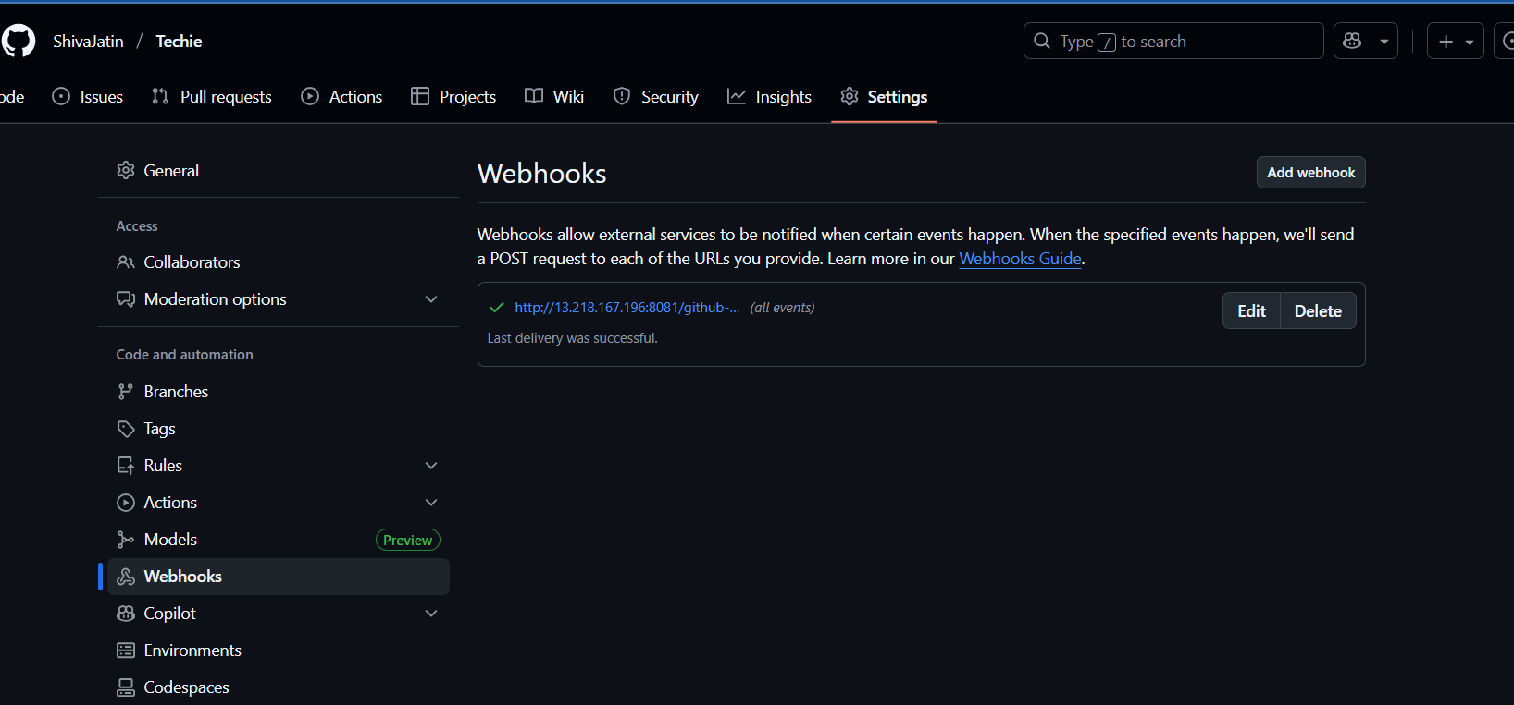

Create a Job and configure with Git URL.

3) Configure poll scm and build periodical options in Jenkins job.

To configure Poll SCM

In Jenkins server I am creating a job

1st job -> selected Git Repo -> Build Triggers -> Select Poll SCM

Configure Poll SCM as * * * * * as it executes every minute, hour, date, month, year as follows

After Configuring and creating a job it builds and done.

Poll SCM will only get triggered when there is any change in the commit in repository.

If there is no change in the repo then Poll SCM will not get triggered.

Here, I have made few changes in the repository and committed the changes. So, Now I will get triggered by Poll SCM and it asks to build again.

Build Periodically:

While creating the job after you select the repository then in Build Triggers, we have another option called Build Periodically.

It also works the same way as Poll SCM as we give * * * * *. But it will build all the time even if we made changes or not it gets build.

Now, my 2nd job gets executed for every minute.

4) Take backup of Jenkins server by using bash script.

To Create a backup file, I have written bash script as follows:

File name as backup.sh

Then I have given the permissions as

Chmod 700 backup.sh

Executed the bash script as ./backup.sh

5) Take backup of Jenkins using rethin backup plugin.

Go to Manage Jenkins → Manage Plugins-> Available plugins -> ThinBackup -> Install without restart



Configure ThinBackup  
Go to Manage Jenkins → System -> Click Configure -> Backup directory -> Click Save.

Take Manual Backup ->Manage Jenkins → ThinBackup -> Backup Now -> The backup is created.

Navigate to the backup folder.

  
6) Setup a new Jenkins server and dump the backup taken in task4.

I have Launched new Ec2 instance as backup-jenkins



->Install Java (required for Jenkins)  
dnf install -y java-17-amazon-corretto  
->Add Jenkins Repository  
sudo wget -O /etc/yum.repos.d/jenkins.repo https://pkg.jenkins.io/redhat-stable/jenkins.repo  
sudo rpm --import https://pkg.jenkins.io/redhat-stable/jenkins.io-2023.key  
-> Install Jenkins  
sudo yum install jenkins –y  
systemctl start Jenkins  
systemctl status Jenkins

-> Copy Your Backup to New Server  
Login into your old main server you took backup

-> Create an ssh-keygen and copy your pem key to new pem key  
Create an test.pem file  
scp -i test.pem jenkins-backups/backup1.tar.gz ec2-user@54.234.112.228:/tmp/  
test.pem is your new server pemkey  
jenkins-backups - is the folder containing the backup tar file  
backup.tar -backup file  
ec2-user@ 54.234.112.228 - public ip of new server  
/tmp – is the location in new server where you send your backup tar file

Login in to new server and check the file in /tmp  
backup.tar  
Copy the file from tmp to /var/lib/  
cp /tmp/backup.tar/var/lib/

  
then extracts  
cd /var/lib/  
tar -xvf backup.tar

After Extracting the tar file restart the Jenkins

We can do in 2 ways

1. systemctl restart Jenkins
2. http://< 54.234.112.228 >:8080/restart

Verify in browser  
http://< 54.234.112.228 >:8080  
new server by default running on port no-: 8080

Old server running on port no:- 8081

