PERFORMANCE ASSESSMENT OF ADDITIVE BASED VEGETABLE OILS AS CUTTING FLUIDS IN MACHINING
Project report submitted in partial fulfilment of the requirements for the award of degree
BACHELOR OF TECHNOLOGY
IN
MECHANICAL ENGINEERING
Submitted by
P.SHIVA KUMAR 1210813247
T.SAI MAHITH 1210813256
N.SAI KIRAN 1210813238
T.SITA RAMA RAJU 1210813257
Under the guidance of
DR.PADMINI.R
ASSISTANT PROFESSOR
INDUSTRIAL ENGINEERING

DEPARTMENT OF MECHANICAL ENGINEERING
GITAM UNIVERSITY-530045
2013-2017
DEPARTMENT OF MECHANICAL ENGINEERING
GITAM UNIVERSITY
(Declared as deemed to be university u/s3 of the UGC Act 1956)
VISAKHAPATNAM (INDIA)

CERTIFICATE

This is to certify that the project work entitled “Performance assessment of additive based vegetable oils as cutting fluids in machining”, is a bonafide work submitted in partial fulfilment of the requirement for the award of degree of “BACHELOR OF TECHNOLOGY” in mechanical engineering submitted to the Department of “MECHANICAL ENGINEERING” from GITAM University, Visakhapatnam. The results embodied in this have not been submitted to any other university or institute earlier for the award of any Degree/Diploma.
P.SHIVA KUMAR 1210813247
T.SAI MAHITH 1210813256
N.SAI KIRAN 1210813238
T.SITA RAMA RAJU 1210813257

Signature of Guide Signature of HOD
Dr.R.Padmini Dr. M. R.Satyanarayana
(Assistant Professor) (Professor and HOD)

EVALUATION SHEET
Title of the Project: Performance assessment of additive based vegetable oils as cutting fluids in machining

1. Year of Submission : 2016-2017
2. Name of the Degree : B. Tech (Mechanical Engineering)
3. Date of Examination : 13-04-2017
4. Student Names : P.SHIVA KUMAR 1210813247
T.SAI MAHITH 1210813256
N.SAI KIRAN 1210813238
T.SITA RAMA RAJU 1210813257
5. Name of the Guide : Dr.Padmini.R
6. Result : Approved/ Rejected



DECLARATION

We hereby declare that the work presented in the report entitled “Performance assessment of additive based vegetable oils as cutting fluids in machining” is a record of our original work done under Asst. prof.Dr.R.Padmini, GITAM Institute of technology, GITAM University. This project report is being submitted in partial fulfilment of the requirements for the award of degree of Bachelor of Technology in mechanical engineering at GITAM Institute of technology, Visakhapatnam for the academic session 2013-2017. We have not submitted the matter embodied in this report for the award of any degree or diploma.

P.SHIVA KUMAR 1210813247
T.SAI MAHITH 1210813256
N.SAI KIRAN 1210813238
T.SITA RAMA RAJU 1210813257

ACKNOWLEDGEMENT

With deep sense of gratitude, we acknowledge the guidance, help and active cooperation rendered by our internal guide DR.Padmini.R, Assistant Professor, Department of Industrial Engineering, GITAM University, Visakhapatnam, who has guided us with his generous suggestions and encouragement throughout the execution of all the stages of the project work.
We are thankful to Dr. M. R. S. SATYANARAYANA, Head of the Department, Mechanical Engineering, GITAM Institute of Technology, for giving us this opportunity to undergo academic project in GITAM University.
We are also grateful to Prof. K. LAKSHMI PRASAD, Principal, GITAM Institute of Technology for giving me a noble opportunity to enhance my knowledge through inclusion of academic project in our curriculum.
We are also thankful to everyone in the teaching staff who has supported us directly or indirectly in making the project a successful one with their valuable suggestions.
Finally we take the opportunity to express our gratitude to our parents and friends who helped us with their constant encouragement.
ABSTRACT

Due to the development of new engineering materials and high-speed cutting, cutting fluid plays an important role in machining. Commonly, the use of cutting fluid can decrease cutting temperature, reduce the friction between tool and workpiece, extend tool life, and improve machining efficiency and surface quality. These effects of cutting fluid were mainly obtained from its basic functions including cooling, lubrication, corrosion protection, and cleaning. This report also suggests that the effect of cutting fluid on machined surface quality and performance will become an important research direction.

The present work focuses on formulation of additive based bio-degradable cutting fluids followed by their application during machining of EN8 through minimum quantity lubrication technique. Different samples of cutting fluids are formulated using dispersions of maize starch in coconut (CC) and sunflower(SF) oils at varying inclusions and examined for basic properties. Machining parameters are measured during machining. Performance of bio-degradable cutting fluids with maize starch additive is compared with dry machining, pure oil assisted machining initially at constant cutting conditions and with 0.1gm,0.5gm,1.0gm additive by measuring cutting temperatures, tool wear and surface roughness. It is observed that the basic properties are all improved for additive based compared to pure oils. By examination, it is observed that coconut oil mixed with additive of 0.1gm per 100 ml resulted in best machining performance by reducing tool wear, improved surface roughness and decreasing in cutting temperatures.

CONTENTS
1.INTRODUCTION 9
1.1 Basic function of cutting fluid 10
2. Review of literature 12
2.1 Solid Lubricants in machining 12
2.2 Vegetable oils as cutting fluids in machining 13
2.3 Nanofluids in machining 13
2.4 MQL 15
3. GAPS in Literature and Motivation 16
4. Experimentation 17
4.1. Materials used 17
4.2. Vegetable oils 18
4.3. Formulation of cutting fluids 18
4.4. Machining 20
5. Results and discussion 22
5.1. Basic properties 22
5.1.1. Thermal Conductivity 22
5.2. Machining Performance 23
5.2.1. Cutting Temperature 23
5.2.2. Tool Wear 26
5.2.3. Surface Roughness 28
6. Conclusion 30
7. References 31

List of Figures
Figure.1 Basic functioning of cutting fluid and zones. 10
Figure.2. PSG-124 lathe machine 19
Figure.3. Nozzle 20
Figure.4. Digital temperature indicator with K-type thermocouple 20
Figure.5: Surface roughness test setup 21
Figure.6: Optical Microscope 21
Figure.7: P.A.Hilton Apparatus 21
Figure.8: UV Spectrometer 21
Figure.9: Pictures representing tool wear in µm of different oils. 27

- INTRODUCTION

Metal cutting is the main processing method in mechanical engineering. During the cutting process especially high-speed machining, plastic deformation of the material near cutting edge is very large, with high temperature and complex mechanical and thermal stresses. Because of excellent cooling and lubricating properties, cutting fluid (or metalworking fluid) plays an important role in machining. Due to the development of advanced manufacturing technology and strengthening of awareness of environmental protection, higher requirements were proposed for cutting fluid technology, and new environmentally friendly cutting fluid is continuously being under research and development. Since then, the classification, composition, recycling, and disposal of the cutting fluids were studied widely.

The main purpose of using cutting fluid is to decrease cutting temperature, reduce friction between tool and workpiece, extend tool life, and improve machining efficiency and surface quality. These effects of cutting fluid were obtained from its chief functions of cooling and lubrication, and additional features of corrosion protection and cleaning. In addition to these functions, the physical and chemical interactions between the surface of the material and cutting fluid during processing will directly affect the quality and service performances of the machined surface, especially for the precision parts in extremely harsh environments with long life and high stability requirements.

In spite of cooling and lubricating functions, conventional cutting fluids when applied as lubricants during machining result in various techno-environmental problems. Though conventional cutting fluids are widely used by industries in several applications, they do create problems which cause skin related ailments to operators exposed to such an environment [1,2]. They also pose a check to ecological balance owing to their non-biodegradable characteristics [3,4]. By way of quantity of cutting fluids used by manufacturing companies approximately 38 million metric tonnes of lubricants were utilized globally with an estimated raise of 1.2% for every ten years [5]. Thus, in order to reduce the bulk usage of conventional cutting fluids and also to minimise their adverse effects on environment and operators, alternatives to these fluids are being rigorously explored by research community. Dry machining, cryogenic cooling, solid lubricant based machining, minimum quantity lubrication (MQL) technique followed by application of vegetable oils and nanofluids are some of the alternatives being explored in the attempt to replace conventional cutting fluids.
Solid lubricant assisted machining has emerged to be an effective way to improve machining performance when compared to traditional cutting fluids. Solid lubricants like graphite, calcium fluoride, boric acid and MoS₂ are endowed with good tribological characteristics. One of the significant phenomena which char acterises these materials is the presence of weak atomic interactions between their layered lattice structures, leading to low-strength shearing. In the present modern manufacturing era, nano integrated manufacturing has gained ample impetus to render sustainability and result in ecologically harmless engineering processes. Nanofluids have high thermal conductivity, heat transfer coefficient, viscosity; flash and fire points when compared to base fluids [6]. Nanoparticles when added to base fluid in small proportions that is 5% by volume or even less can enhance the thermal conductivity of the base fluid to a greater extent. Another important aspect is the environmental effects of the application of nano fluids due to their toxic nature especially when they are used as cutting fluids in machining. Researchers across the globe have worked from this perspective and revealed interesting facts. Nanofluids obtained by dispersing very small quantities of nano-particles in base fluids can be applied at machining zone through MQL technique. This would result in very small mist which does not show any impact on human health. The remains of nano cutting fluid applied through MQL are too low to be disposed ahead unlike flood supply [7]. Nanoparticles possess enhanced thermo-physical properties owing to their large surface to volume ratio, which when dispersed in small proportions by volume in base fluids like biodegradable fluids (vegetable oils), result in formulations which imbibe the eco-friendly and user friendly aspects of the base fluid which are not harmful to the environment like conventional cutting fluids.
Vegetable oils which are operator friendly possess various other advantages like biodegradability, ease of availability and afford-ability. Coconut oil, sunflower oil, canola oil, sesame oil etc., are being explored by researchers in various machining applications as cutting fluids. Coconut oil for instance has high oxidative stability and more than 90% of fatty acids of coconut oil are saturated. Viscosity index of coconut oil is 130 while its flash point is 294 °C [8]. Thus, in view of these properties vegetable oils are being researched exclusively in the process of search for eco-friendly alternatives to conventional cutting fluids in machining applications. The usage of new formulations of cutting fluids when applied through MQL technique offers economical and operational advantage. Thus in order to assimilate the positive aspects of vegetable oils, nano solid lubricants, and MQL technique additive based vegetable oil are experimented in the present work.

1.1 Basic function of cutting fluid

According to the principle of metal cutting, there are three deformation zones during material removal process: shear deformation zone, contact zone of tool–chip, and contact zone of tool–work piece. They are also the areas where the heat generates. Cutting fluid directly affects on these three areas, as shown in Figure 1. A, B, and C are the main paths where the cutting fluid affects the cutting area. Cooling is the most important effect, especially for water-based cutting fluid used in high-speed machining. Cutting fluid will transfer heat away from the cutting areas and decrease the temperature of tool and workpiece, particularly at the cutting edge and tool tip. The cooling effect is achieved through a variety of heat exchange processes, such as conduction, convection, evaporation (or vaporization), and very little radiation.

Cooling effect can reduce chemical reaction, heat damage, and material adhesion of the tool and extend its life; it also inhibits thermal expansion of machining system, which will reduce thermal deformation of workpiece and improve its dimension precision.

Lubrication effect of the cutting fluid occurs mainly in these two regions, and it is believed that liquid films cannot be sustained along these interfaces in most cutting operations especially in high-speed machining. In typical cutting process, they are believed to approach boundary lubrication. At the interface of tool–chip, the lubricant absorbs onto the chip and restricts the adhesion of chip to the rake face. Besides, a chemical combination of film of lower shear strength reaction product of the cutting fluid with the fresh metal surface of generated chip will also reduce friction force and temperature. A combination of extreme pressure and lubricity additives plays a significant role in reducing friction. Lubrication of the cutting fluid is a comprehensive physical and chemical property, and it is relevant to the structure and property of the boundary lubrication films formed on the frictional surface. Lubrication effect can reduce the friction and thereby change the cutting force and temperature. It will also reduce the wear of the tool and inhibit the growth of built up edge (BUE) and improve the quality of the machined surface. Pure metals are unstable, especially for the fresh machined metal surface, and corrosion is a natural trend to change into stable compound, caused by chemical or electrochemical effect.

Generally, oil-based cutting fluids have good corrosion resistance, which will form a physical barrier on surface to prevent the chemical reaction. But if the cutting fluid contains organic acids, acidic oxide, or sulfide, chemical corrosion will be caused for some reactive metals. These fluids are commonly alkaline to prevent metal from corrosion damage, as well as semi-synthetic fluids. Water-based cutting fluid is an electrolyte solution and easily cause electrochemical corrosion. Adding suitable anti-corrosion additives can improve the corrosion resistance of the cutting fluid. These water-soluble antirust agents are mainly grouped as anode type, cathode type, and hybrid-type rust preventive.

2.Review of literature

2.1 Solid Lubricants in machining

- Extensive research has been initiated to counter the harmful effects due to the application of conventional cutting fluids as coolants/lubricants in machining operations. Several alternatives are being explored by researchers globally to serve this purpose. Researchers have pinpointed the good frictional behaviour of MoS₂ is due to the physical and chemical properties of its surface layers [9].

- Performance of boric acid was assessed by applying it at machining zone in turning experiments and it was observed that cutting forces, cutting temperatures and tool flank wear got reduced while surface finish improved with reduced particle size when compared to other lubricating conditions as reported by Krishna and Rao [10].

- Improvement in surface finish was found to be approximately 7% by using solid lubricants when compared to dry machining during hard turning of bearing steel at varying cutting conditions and varying tool geometry using mixed ceramic inserts [11].

- Venu Gopal and P V Rao [12] attempted to experimentally study the significance of applying graphite as a solid lubricant during grinding silicon carbide material with diamond wheel. When compared to dry grinding it was observed that graphite assisted grinding resulted in low grinding force components under various grinding conditions and by using different grinding wheels.

- Shaji and Radhakrishna [13] reported that it was possible to obtain improvement in grinding process performance by way of reduction in tangential force and surface roughness when compared to conventional grinding. Graphite and MoS₂ were exclusively tested for their lubricity during end milling of AISI 1045 steel by using milling tools of varying geometry by Reddy and Rao [14]. They noted that MoS₂ assisted milling outperformed graphite and wet milling by, reducing specific energy consumption to an extent of 28%, reduction in cutting forces, lowering friction generated at tool-work interface, improving surface quality.

2.2 Vegetable oils as cutting fluids in machining

- Due to ease of availability, low cost and bio-degradable nature vegetable oils are one of the preferred alternatives for conventional cutting fluids. As reported by Susan woods [15] the application of vegetable oils as cutting fluids can be attributed to the consistent alignment of oil’s lubricity to the specimen or workpiece being machined.

- Improvement in tool life, reduction in tool wear and cutting forces was reported by Belluco and De Chiffire [16] during the application of new formulations of vegetable oils while investigating the effect of the same on surface integrity as well as part accuracy during reaming and tapping of AISI 316L steel.

- Alves and de Olivera [17] experimented with castor oil in grinding operation and found that wheel wear, grinding forces and surface roughness reduced and the new vegetable based cutting fluid (VBCF) was biodegradable as well. Similar improvement in machining performance using rapeseed oil was reported by Ion et al. [18]. Researchers examined the influential role of vegetable oil based cutting fluids on carbide tool’s flank wear and surface roughness of AISI 304 grade austenitic stainless steel by the application of different types of cutting fluids including coconut oil in turning operations and reported reduction in tool flank wear and surface roughness using VBCFs when compared to other environments [19].

- The significance of extreme pressure (EP) additives in two types of vegetable oils namely sunflower and canola in the turning of AISI 304L steel on cutting and feed forces was examined by Cetin et al. [20]. It was inferred that VBCFs are potential cutting fluids which are capable of replacing conventional cutting fluids in turning operations.

2.3 Nanofluids in machining

- Nanofluids possess enhanced thermo physical properties due to higher surface to volume ratio. Investigators developed empirical models to estimate the thermal conductivity and heat transfer rate of nanofluids [21, 22]. Putra et al. [23] reported that thermal conductivity and heat transfer capacity of nanofluids are high which lead to reduction of cutting tool temperatures.

- Krajnik et al. [24] inferred that through proper priming nanofluids can perform better than conventional cutting fluids with higher thermal conductivity, convective heat transfer coefficient, critical heat flux and viscosity. Yimin Xuan and Qiang Li [25] inferred through their experimental work that nanofluids show great potential in enhancing the heat transfer process owing to increase in thermal conductivity due to suspended ultrafine particles. The volume fraction, shape, dimensions and properties of nanoparticles affect their thermal conductivity.

- Shaikh et al. [26] evaluated the effective thermal conductivity of carbon nano tubes (CNTs) heat-treated nanofibers (HTTs), and exfoliated graphite (EXG) powder dispersed in poly-alpha-olefin (PAO) oil and they found that, percent enhancement in the thermal conductivity of the three nanofluids over the PAO oil was maximum for the CNT-based nanoparticle suspension followed by the EXG and HTT.

- Srikant et al [27] examined the application of nano fluids using copper oxide (CuO) particle suspensions in water miscible fluids in turning and found substantial reduction in cutting temperatures due to enhanced thermal properties of nano fluids.

2.4 MQL

- Researchers have attempted to assess machining performance by using MQL technique as an alternative to flood supply in various machining operations for different workpiece materials to avoid bulk usage of cutting fluids and minimize environmental perturbances.

- Varadarajan et al. [28] reported that MQL technique lead to improvement in machining performance by reduction in cutting forces, temperature, cutting ratio, tool-chip contact length and substantial improvement in surface finish and increase in tool life when compared to dry and conventional lubricant supply environments while turning hardened steel. Attanasio et al. [29] signified that MQL lead to reduction in induced thermal shock and aided in enhancement of surface integrity of workpiece under high tool pressure during turning.

- Diniz et al. [30] carried out experimental investigations to examine the effect of MQL mode on tool flank wear and surface roughness during turning of SAE 52100 hardened steel and noted that reduction in these parameters was possible by using dry and MQL machining when compared to wet environment.
- Shen et al. [31] carried out extensive research to estimate the influence of nanofluids prepared from Al₂O₃, ZnO and nano diamond particles in MQL grinding operation and reported encouraging results in terms of reduction in grinding forces and improvement in surface finish through MQL technique.
- Khan and Dhar [32] reported significant reduction in tool wear, dimensional inaccuracy and surface roughness through MQL due to reduction in the cutting temperature along with positive change in the chip–tool and work–tool interactions, during turning of AISI 1060 steel using vegetable oil supplied using MQL technique at varying cutting conditions.

3. GAPS in Literature & Motivation
- Though certain works are reported encompassing the application of MQL and nanofluids, it is found that they have not included eco friendly oils and more over these techniques have dealt with drilling and milling operations and not turning operation.

- The influence of thermo-physical properties on cutting forces, cutting tool temperatures, tool flank wear and surface roughness is not discussed at length in the works reported.

- Influence of different types of oils with of variation in percentage of additives at varying cutting conditions has not been reported in machining.

- Thus research works pertaining to the application of additive based cutting fluids through MQL technique have not been exclusively dealt with and the present work finds its way owing to this factor.

- The present work is motivated by these aspects and additive based bio-degradable cutting fluids are formulated and experimented with.

4. Experimentation

4.1 Materials used

The materials used in carrying out this work included 13 pieces of EN8 grade steel round bar of 35mm diameter and 45cm length. EN8 is a medium carbon steel usually supplied untreated. It has good tensile strength and is often used in applications such as: shafts, gears, stressed pins, studs, bolts, keys etc. It is a very popular grade and is readily machinable in any condition. It can be further surface-hardened to produce components with enhanced wear resistance, typically in the range 50-55 HRC through induction processes.

EN8 (080M40) Specification
Table 1. Chemical Composition
Carbon | 0.36-0.44%
Silicon | 0.10-0.40%
Manganese | 0.60-1.00%
Sulphur | 0.050 Max
Phosphorus | 0.050 Max
Chromium | –
Molybdenum | –
Nickel | –

Table 2. EN8 (080M40) – mechanical properties in “R” condition
Max Stress | 700-850 n/mm2
Yield Stress | 465 n/mm2 Min
0.2% Proof Stress | 450 n/mm2 Min
Elongation | 16% Min
Impact KCV | 28 Joules Min
Hardness | 201-255 Brinell

4.2 Vegetable oils

The chemical composition and fatty acid profiles of vegetable oils (VO) are the primary reasons behind their performance as cutting fluid. The percentage of saturated fatty acids (SFA), unsaturated fatty acids (U-SFA) and their profiles of VO considered in the present work are shown in Table 3(a) and(b)respectively . Molecular structures of vegetable oils are termed as triacylglicerides. The y contain long chain and medium chain of fatty acids (LCFA and MCFA) which are joined at the hydroxyl groups (OH) through ester linkages. The length of the chain of these fatty acids ranges from 14 to 22 (long chain) carbons and 6 to 12 (medium chain) carbons.

Table3
Composition of vegetable oils.
(a) % of saturated and unsaturated acids in vegetable oils
Vegetable oils | % Saturated | % Mono-unsaturated % | % Poly-unsaturated
CC | 91 | 6 | 3
SF | 11 | 30 | 59

(b) Fatty acids profiles of three types of vegetable oils
Vegetable Oil | Linoleic acid  (U-SFA) | Oleic acid  (U-SFA) | Palmatic acid  (SFA) | Stearic acid  (SFA) | Fatty acids  (length)
CC | 2 | 8 | 11 | 3 | MCFA [8–12  carbons]
SF | 71 | 15 |  | 5 | LCFA [14–22  carbons]

4.3 Formulation of cutting fluids
Maize Starch (additive) is procured from stores and vegetable oils are obtained from local market. Cutting fluids are formulated by using maize starch powder suspensions in CC ans SF at 0.1%, 0.5% and 1% of base fluid. At first pre-measured quantity of maize starch is taken in a beaker and the required quantity of VO (100 ml) is slowly added while manually mixing both to obtain a uniform suspension. The additive suspensions thus obtained are subjected to thorough sonication for a period of one hour. The suspensions thus prepared are placed in a bath type ultra sonicator for 60 min. After soni-cation it is observed that the particles are uniformly distributed without any agglomeration. The cutting fluids thus prepared are tested for basic properties prior to their application as cutting fluids in turning operation.
4.4 Machining
Experiments are carried out on PSG-124 lathe machine (Fig.2), at varying cutting conditions and at 3 percentages of additive inclusions. Machining conditions are selected to suit the tool– workpiece combination and MQL flow rate of 10 ml/min. EN8 steel workpiece under different types of cutting lubricant environments is subjected to turning operation. Table.4 reflects the details of machining operation carried out as a part of the present work.
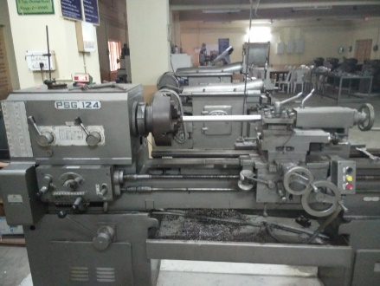

Figure.2: PSG-124 lathe machine
Machine tool | PSG-124 lathe
Machining operation | Turning
Material of workpiece | EN8 (European Norms)
Tool holder | PSLNR 2020 K12
Cutting tool | CNMG120408NC6110 coated carbide
Cutting speed (rpm) | 560
Feed (mm/rev) | 0.17
Depth of cut (mm) | 0.5 (Constant)
Lubricant environment | Dry, CCF, Pure oils, CC + %additive;  SF + %additive
Supply mode | MQL
Flow rate | 10 ml/min
Duration of machining | 12 min
% of Additive | 0, 0.1, 0.250.5,1

The cutting fluid is taken in a container, located collinear to the axis of machining. Due to self-weight and atmospheric pressure the cutting fluid flows in the downward direction. A nozzle shown in Fig.3 is used to control the flow rate of cutting fluid. Flow rate of cutting fluid is measured and set to 10 ml/min.
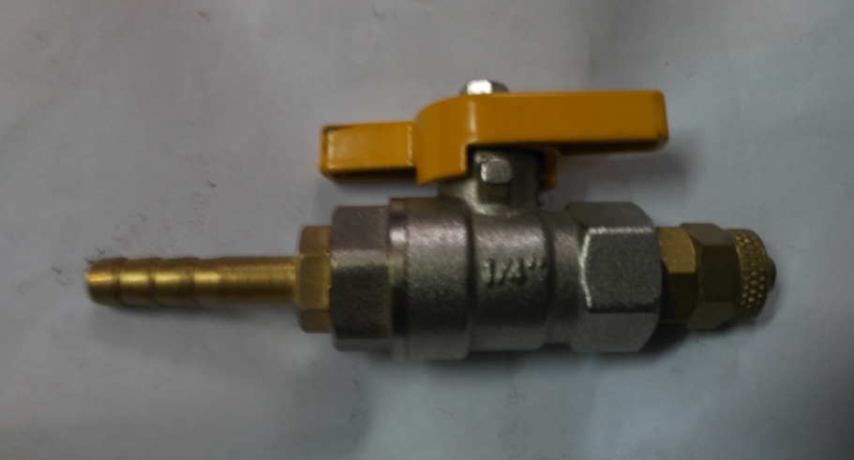
Figure.3: Nozzle

An Embedded thermocouple (chromelalumel, K-type shielded; range: 0–1200 °C) which is calibrated is used to measure the cutting tool temperatures at a nodal point 5 mm from the tool tip. Digital temperature indicator is used for recording and displaying the temperature of the hot junction of thermocouple.
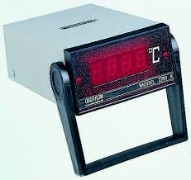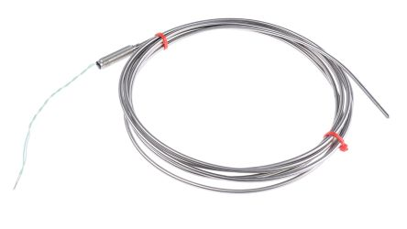
Figure.4: Digital temperature indicator with K-type thermocouple

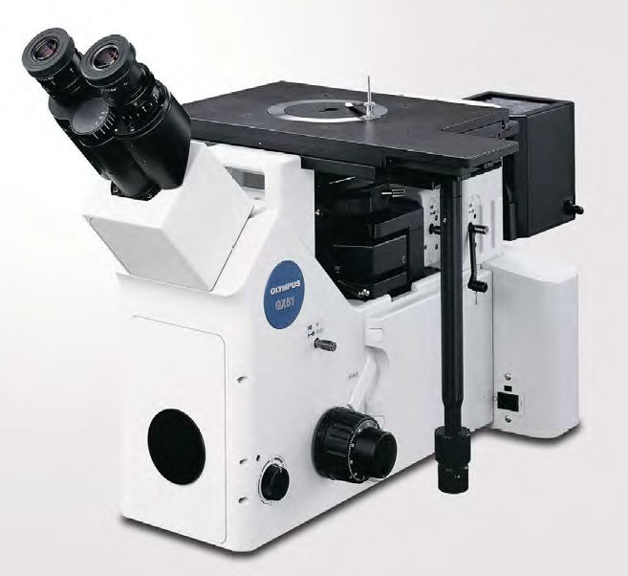
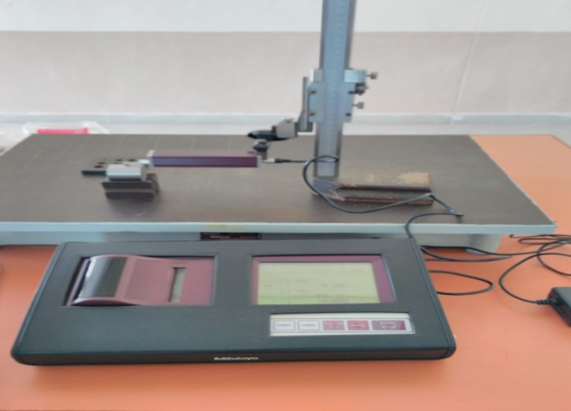
Surf test SJ-301 (stylus material: diamond; tip radius: 5 mm) Fig.5 is employed for measurement of average surface roughness (R_{a}). Tool wear is measured by using SC30 optical microscope fig.6 and the readings are recorded by using Olympus analysis software. Tool wear and surface roughness are measured offline for each turn, 3 readings for each lubricant condition are measured and the average is considered to avoid discrepancies in measurement.
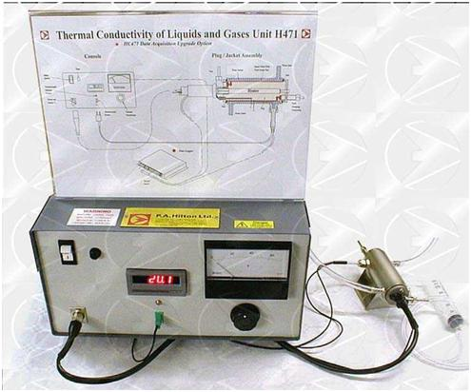
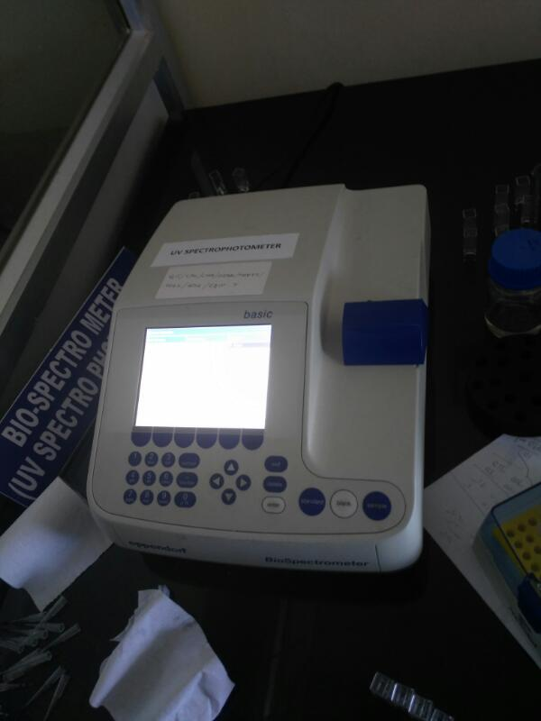
Figure.5: Surface roughness test setup Figure.6: optical microscope

Figure.7: P.A.Hilton Apparatus Figure.8: UV Spectrometer
Thermal conductivity test is done to find thermal conductivities of the prepared additive based cutting fluids on P.A.Hilton thermal conductivity apparatus (fig.7). In the present work absorbance is tested to assess whether the additive get dispersed uniformly to give rise to a stable formulation or not at higher percent. Thus stability assessment is done using a double beam UV-spectrophotometer (fig.8).

5. Results and discussion
5.1 Basic properties
5.1.1.Thermal Conductivity:
In physics, thermal conductivity (often denoted k, λ, or κ) is the property of a material to conduct heat. It is evaluated primarily in terms of Fourier's Law for heat conduction. Heat transfer occurs at a lower rate across materials of low thermal conductivity than across materials of high thermal conductivity. Apart from lubrication, cooling is another prime objective of cutting fluid. Thermal conductivity of the fluids is estimated at different temperatures as given in Table.5.

Base fluids | Thermal Conductivity(W/m-K)
CC PURE | 0.121
CC + 0.1g MSA/100ml | 0.26
CC + 0.5g MSA/100ml | 0.245
CC + 1.0g MSA/100ml | 0.213
SF PURE | 0.168
SF + 0.1g MSA/100ml | 0.232
SF + 0.25g MSA/100ml | 0.241
SF + 0.5g MSA/100ml | 0.249

Table .5: Thermal properties of cutting fluids
Results indicate rise in thermal conductivity with increase in inclusion levels. Unlike most liquids, which show a fall in thermal conductivity with rise in temperature, the sunflower oil with maize starch additive show a consistent increase in the thermal conductivity with temperature. This property may be inherited from water, which is a major constituent of the fluids. Thermal conductivity is found to rise with increase in content of inclusion in sunflower, fluids with higher inclusion levels content can apparently be used for machining that produces higher temperatures. The results shows that higher value of thermal conductivity of CC with 1gm MSA/100ml when compared to other %additive inclusions of CC and SF.

Graph.1: Bar graph showing thermal conductivities of % MSA of different base fluids

5.2 Machining performance
5.2.1. Cutting temperature
The cooling ability of bio-degradable cutting fluids is presented through variation in cutting temperatures with respect to percentage of additive based base fluids. Cutting temperatures have increased along with increase in speed and feed. Among all lubricating conditions, CC resulted in low cutting temperatures. CC with 0.1gm/100ml of starch additive, at higher temperatures enables formation of a high strength layer of lubricant which separates the surfaces in contact. Because oils with MCFA having shorter hydrocarbon chain lengths Table 3(b). exhibit better wettability than long chain fatty acids. Thus their interfacial properties are enhanced, which play vital role in lubricant application. The phenomenon of formation of VO film on the metallic surface is more significant in case of vegetable oils like CC which have MCFA unlike SS and CAN which possess LCFA.

Table.6. Cutting temperatures
6 (a).Cutting temperatures of various % inclusions of MSA of coconut oil
TIME (min) | Cutting Temperatures (in °C)
TIME (min) | CC+0.1gm/100ml | CC+0.25gm/100ml | CC+0.5gm/100ml | CC+1gm/100ml
0 | 30 | 41 | 30 | 43
1 | 87 | 115 | 102 | 101
2 | 97 | 123 | 106 | 105
3 | 104 | 128 | 108 | 109
4 | 112 | 128 | 110 | 125

6 (b). ).Cutting temperatures of various % inclusions of MSA of sunflower oil
TIME (min) | Cutting Temperatures (in °C)
TIME (min) | SF+0.1gm/100ml | SF+0.25gm/100ml | SF+0.5gm/100ml
0 | 43 | 43 | 42
1 | 95 | 110 | 98
2 | 104 | 118 | 124
3 | 126 | 120 | 137
4 | 128 | 122 | 139

Increase in thermal conductivity of cutting fluids, thus reducing cutting temperatures at machining zone. As discussed earlier in thermal properties of cutting fluids (Table.5.), thermal conductivity of CC + 0.1gm MSA/100ml are high when compared to other % inclusions of MSA of CC and SF. In variations of SF 0.25gmof MSA /100ml resulted in low temperatures during turning. Maize starch additive with base oils tends to reduce cutting temperatures. It is found that this phenomenon is not very commanding in reducing the cutting temperatures at higher inclusions (specifically beyond 0.5%). Heat dissipation capacity of the VO fluids may reduce due to increase in density and viscosity with increase in %additive. Coefficient of friction at the machining zone increases as a result and also the cutting fluid may not reach the surfaces in contact. On the total CC + 0.1gm MSA/100ml is found to reduce cutting temperatures better than other cases due to conjunctive effect of chemical structure of CC, improved thermal conductivity.

Graph 2(a). Variation of cutting temperatures under varying % inclusions of MSA of coconut oil

Graph 2(a). Variation of cutting temperatures under varying % inclusions of MSA of coconut oil

5.2.2. Tool wear
Tool wear describes the gradual failure of cutting tools due to regular operation. It is a term often associated with tipped tools, tool bits, or drill bits that are used with machine tools.
Types of wear include:
- Flank wear in which the portion of the tool in contact with the finished part erodes. Can be described using the Tool Life Expectancy equation.
- Crater wear in which contact with chips erodes the rake face. This is somewhat normal for tool wear, and does not seriously degrade the use of a tool until it becomes serious enough to cause a cutting edge failure.
Effects of tool wear include increased cutting forces, increased cutting temperatures, poor surface finish, decreased accuracy of finished part, may lead to tool breakage, causes change in tool geometry
Base fluids | Tool Wear (µm)
CC + 0.1g MSA/100ml | 144.64
CC + 0.5g MSA/100ml | 81.92
CC + 1.0g MSA/100ml | 230.4
SF + 0.1g MSA/100ml | 136.96
SF + 0.25g MSA/100ml | 152.32
SF + 0.5g MSA/100ml | 127.35

Table.7. Tool wear rate in micro meters of all the cutting fluids used

Variation of tool wear with varying percentage of additive. Tool wear is found to be better at 0.5% additive of MSA among the both CC and SF oils used, CC on 0.5gm MSA/100ml is found to be effective in reduction of tool wear when compared to other cases at same machining conditions(speed:560rpm,feed:0.17mm/rev,D.O.C:0.5mm) as seen in the table.7


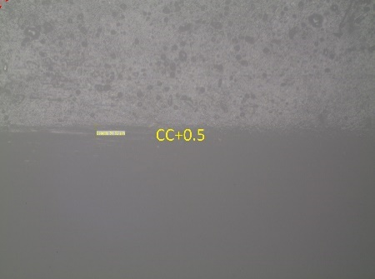
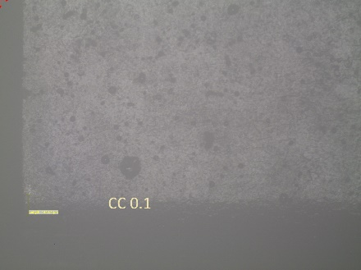
Graph.3. Variation of tool wear under varying %MSA in corresponding oils (CC, SF) (speed: 560 rpm; feed: 0.17 mm/rev,D.O.C:0.5 mm).
(CC+0.1gm/100mlMSA) CC+0.5gm/100mlMSA CC+1.0gm/100mlMSA




SF+0.1gm/100mlMSA SF+0.25gm/100mlMSA SF+1.0gm/100mlMSA
Figure .9. Pictures representing tool wear in µm of different oils.
5.2.3. SURFACE ROUGHNESS:
- Surface Roughness is a component of surface texture. It is quantified by the deviations in the direction of the normal vector of a real surface from its ideal form.

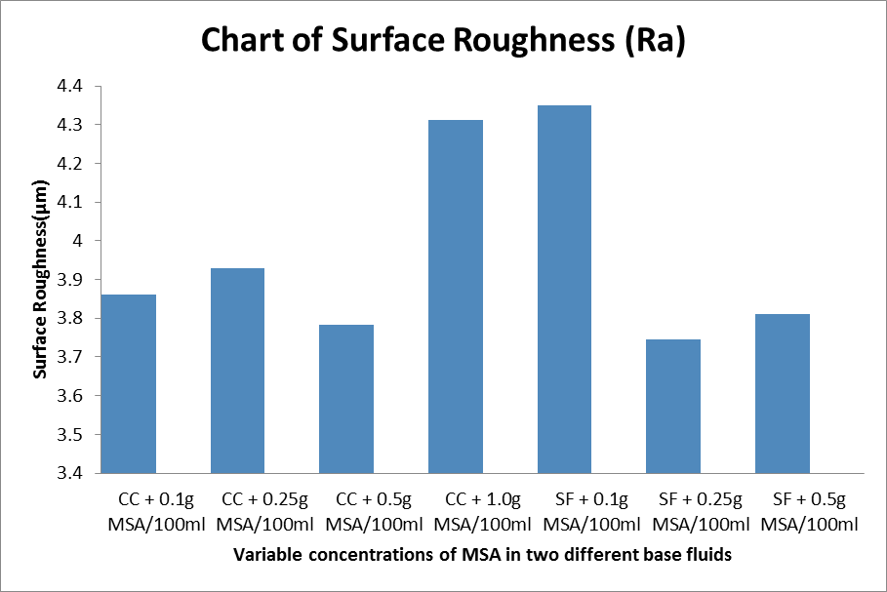
Graph.4. Bar graph representing surface roughness values in µm of different cutting fluids used.
Quality of machined surface is judged by surface roughness. It can be noticed from Graph.4 that surface roughness has increased with % inclusions of additive for CC at constant cutting conditions but in SF, with the percentage increase in additive, it is observed that the surface roughness becomes better. Variation of surface roughness with varying percentage additive is shown above. In coconut 0.5%MSA has shown better reduction of surface roughness when compared to other variants. Lubricating action of SF is found to be better when compared to CC . Due to low coefficient of friction of starch in collation with the improved cooling and lubrication of vegetable oil, imparts better surface quality to the workpiece by reducing cutting temperature and tool wear. Presently, 0.5%MSA on CC is noticed to improve surface finish.

Graph.5. variation of cutting temperatures under varying % MSA in base fluids coconut and sunflower (speed 560 RPM, Feed 0.17mm/rev, DOC 0.5mm):

6. Conclusion
- Experimental investigations to examine the performance of Maize Starch based additive in coconut and Sunflower oils are carried out.
- Basic properties of additive based cutting fluids increased with amount of additive. Consistent increase in the basic properties with varying amount of additive does not mean that the same behavior should be exhibited by additive based cutting fluids during machining.
- It is observed that 0.1gm MSA/100ml in CC performed better than other lubrication conditions.
- Infact all the Bio-degradable cutting fluids exhibited better machining than the dry, CCF and pure oil assisted turning.

7.References
- Passman FJ, Roossmoore HW. Reassessing the health risks associatedwith employee exposure of metalworking fluid microbes. Lubr Eng 2002;58:30–8.
- Korde VM, Phelps TJ, Bienkowski PR, White DC. Biodegradationof chlorinated aliphatics and aromatic compounds in total-recycle expanded-bed reactors. Appl Biochem Biotechnol 1993;45–46:731–40.

- Zeman A, Sprengel A, Niedermeier D, Spath M. Biodegradablelubricants-studies on thermo oxidation of metal—working fluids by differential scan-ning calorimetry(DSC). Thermochim Acta 1995;268:9–15.
- Howes TD, Toenshoff HK, Heuer W. Environmental aspects of grinding fluids. Ann CIRP 1991;40(2):623–9.
- Kline & Company, Inc.. Competitive intelligence for the global lubricants industry. Kline & Company.; 2006. p. 2004–14.
- Hwang Y, Park HS, Lee JK, Jung WH. Thermal conductivity and lubrication characteristics ofnanofluids. Curr Appl Phys 2001;61:67–71.
- Nam Jung Soo, Lee Pil-Ho, Lee Sang Won. A Study on machining and envir-onmental characteristics of micro-drilling process using nanofluid minimum quantity lubrication. In: Proceedings of the ASME 2011 international manu-facturing science and engineering conference, vol. 2, Corvallis, Oregon, USA, June 13–17; 2011.
- Jayadas NH, Prabhakaran Nair K. Coconut oil as base oil for industriallu-bricantsevaluation and modification of thermal, oxidative and low-temperature properties. Tribol Int 2006;39:873–8.
- Bartz W J, Muller K. Investigations on the lubricating effectiveness of molybdenum disulfide Wear 1972; 20:371-379.
- Vamsi Krishna P, Rao D N. The influence of solid lubricant particle size on machining parameters in Turning, International Journal of Machine Tools and Manufacture 2008; 48(1): 07-111.
- Singh D, Rao P V. Performance improvement of hard turning with solid lubricants. International Journal of Advanced Manufacturing Technology 2007; 32:170-177.
- Venugopal A, Rao P V. Performance improvement of grinding of SiC using graphite as a solid lubricant, Materials and Manufacturing processes, 2004; 177-186.
- Shaji S, Radhakrishnan V. Analysis of process parameters in surface grinding with graphite as lubricant based on Taguchi method, Journal of Materials Processing Technology 2003; 141:51-59.
- Kumar Reddy N S, Rao P V. Experimental investigation to study effect of solid lubricants on cutting forces & surface quality in end milling, International Journal of machine tools & manufacture 2006; 46:189-198.
- Susan W. Vegetable oil-based metalworking fluids can provide better performance and environmental results than mineral oil-based fluids. Cutting tool magazine 2005; 57(2):1-3.
- Belluco W, De Chiffre, L. Surface integrity and part accuracy in reaming and tapping stainless steel with new vegetable based cutting oils, Tribology International 2002; 35:865–870.
- Ion I S, Camelia C,George C. On the future of biodegradable vegetable lubricants used for industrial tribosystems, The Annals of University “Dunarea De Jos”, of Galati Fascicle 2002; 8:1221-4590.
- Alves S M, Oliveria J F G. Vegetable based cutting fluids-an environmental alternative to grinding process In: 15th CIRP international conference on life cycle engineering. Elsevier 2008; 664-668.
- Xavior M A, Adithan M. Determining the influence of cutting fluids on tool wear and surface roughness during turning of AISI 304 austenitic stainless steel. J.Mater.Process.Technology 2009; 209:900-909.
- Cetin M H, Ozcelik B, Kuram E, Demirbas E. Evaluation of vegetable based cutting fluids with extreme pressure and cutting parameters in turning of AISI 304L by Taguchi method. J Clean Prod 2011;19:2049–2056.
- Moghadassi, A R, Hosseini, S M, Henneke D, Elkamel, A. A model of nanofluid effective thermal conductivity based on dimensionless groups, Journal of Thermal Analysis and Calorimetry, 2001;96:1,81–84.
- Devdatta P. K., Praveen K., Namburu , Debendra Das K., Comparison of Heat Transfer Rates of Different Nanofluids on The Basis of The Mouromtseff Number, Electronics Cooling, 13(3), 28-32, 2007.
- Nandy Putra, Wilfried Roetzel, Sarit K. Das. Natural convection of nano-fluids.Heat and Mass Transfer 2003; 39:775–784.
- Yimin Xuan, Qiang Li. Heat transfer enhancement of nanofluids. International Journal of Heat and Fluid Flow 2000; 21: 58-64.
- Krajnik P, Pusavec F, Rashid A. Nanofluids: Properties, Applications and Sustainability Aspects in Materials Processing Advances in Sustainable Manufacturing, Springer link, 2011; 107-113.
- Shaikh S, Lafdi K and Ponnappan R. Thermal conductivity improvement in carbon nanoparticle doped PAO oil: an experimental study. J Appl Phys 2007;101: 064302.
- Srikant R R, Rao D N,Subrahmanyam M S, P Vamsi Krishna. Applicability of cutting fluids with nanoparticles inclusion as coolants in machining. Proc. IMechE Part J: J. Engineering Tribology 2009; 223: 221-226.
- Varadarajan A S, Philip P K, Ramamoorthy B (2002) Investigations on hard turning with minimal cutting fluid application (HTMF) and its comparison with dry and wet turning. Int J Mach Tools Manuf 2002; 42:193–200.
- Attanasio A, Gelfi M, Giardini C, Remino C. Minimum Quantity Lubrication in Turning. Wear 2006; 260:333-338.
- Diniz A E, Ferreira J R, Filho F T. Influence of refrigeration/lubrication condition on SAE 52100 hardened steel turning at several cutting speeds. Int J Mach Tools Manuf 2003; 43:317–326.
- Shen B, Shih A, Tung S C. Application of nanofluids in mql grinding. Tribology & Lubrication Technology 2008; 51: 730-737.
- Khan M M A, Dhar N R. Performance evaluation of minimum quantity lubrication by vegetable oil in terms of cutting force, cutting zone temperature, tool wear, job dimension and surface finish in turning AISI-1060 steel. J Zhejiang Univ Sci A 2006; 7(11): 1790–1799.

