**LAB-04**

**Html**

<!DOCTYPE html>

<html lang="en">

<head>

<meta charset="UTF-8">

<meta name="viewport" content="width=device-width, initial-scale=1.0">

<link rel="stylesheet" href="stylin.css">

<title>Document</title>

</head>

<body style="background-color:#CCCCCC;">

<div id="main">

<div>

<h1 style="font-family: Georgia, 'Times New Roman', Times, serif; text-align: center;padding-bottom: 20px;">Registration Form</h1>

</div>

<form id="registrationForm" align="center" onsubmit="return validate()">

<label for="firstName" class="side">First Name:</label>

<br>

<input type="text" id="firstName" name="firstName" class="inpBox"><br><br>

<label for="lastName" class="side">Last Name:</label>

<br>

<input type="text" id="lastName" name="lastName" class="inpBox"><br><br>

<label for="username" class="side">Username:</label>

<br>

<input type="text" id="username" name="username" class="inpBox"><br><br>

<label for="password" class="side">Password:</label>

<br>

<input type="password" id="password" name="password" class="inpBox"><br><br>

<label for="email" class="side">Email:</label>

<br>

<input type="email" id="email" name="email" class="inpBox"><br><br>

<label for="phoneNumber" class="side">Phone Number:</label>

<br>

<input type="tel" id="phone" name="phoneNumber" class="inpBox"><br><br>

<!-- Styled submit button -->

<div align="center">

<input type="submit" id="Submit" value="Submit">

</div>

</form>

</div>

<script defer src="lab.js"></script>

</body>

</html>

**CSS**

*{

padding:0px;

margin:0;

}

#main{

width:40%;

height: 700px;

border-left: 200px;

background-color:#E5E5E5 ;

border:solid 1px black;

border-radius:10px;

padding:10px;

margin-left: 35%;

margin-top: 20px;

color: #000000;

box-shadow: 10px 10px 5px rgba(0, 0, 0, 0.5);

}

#Submit{

background-color: #4CAF50; /* Green */

border: none;

color: white;

padding: 10px 26px;

text-align: center;

text-decoration: none;

display: inline-block;

font-size: 16px;

margin: 4px 2px;

cursor: pointer;

border-radius: 4px;

}

#text{

border-radius: 5px;

}

#registrationform{

font-family: Arial, Helvetica, sans-serif;

font-size: 20px;

}

.side{

font-size: 20px;

font-weight: bold;

}

.inpBox{

background-color:white;

/* background-color:#CCCCCC; */

width: 90%;

height:40px;

margin-top:8px;

margin-left:20px ;

font-size: 16px;

}

.inpBox:hover{

background-color: #BBBBBB;

}

.login1{

width:50%;

height: 500px;

border-left: 200px;

background-color:#E5E5E5 ;

border:solid 1px black;

border-radius:10px;

padding:10px;

margin-left: 27%;

margin-top: 180px;

color: #000000;

box-shadow: 10px 10px 5px rgba(0, 0, 0, 0.5);

}

.inp{

background-color:white;

width: 90%;

height:40px;

margin-top:20px;

margin-left:8px;

margin-bottom: 5px;

font-size: 16px;

}

.inp:hover{

background-color: #BBBBBB;

}

**JS**

function validate() {

var firstName = document.getElementById("firstName").value;

var lastName = document.getElementById("lastName").value;

var username = document.getElementById("username").value;

var password = document.getElementById("password").value;

var email = document.getElementById("email").value;

var phone = document.getElementById("phone").value;

// Regular expressions for validation

var nameRegex = /^[a-zA-Z]+$/;

var usernameLength = username.length;

var passwordRegex = /^(?=.*[a-z])(?=.*[A-Z])(?=.*\d)(?=.*[@$!%*?&])[A-Za-z\d@$!%*?&]{6,}$/;

var emailRegex = /^[^\s@]+@[^\s@]+\.[^\s@]+$/;

var phoneRegex = /^\d{10}$/;

// Validation

if (!nameRegex.test(firstName) || !nameRegex.test(lastName)) {

alert('First name and last name should contain only characters.');

return false;

}

if (usernameLength < 6 || usernameLength > 15) {

alert('Username length should be between 6 and 15 characters.');

return false;

}

if (!password.match(passwordRegex)) {

alert('Password must be at least 6 characters long and contain at least one uppercase letter, one lowercase letter, one digit, one special character, and should start with an alphabet.');

return false;

}

if (!email.match(emailRegex)) {

alert('Email id should be in proper format.');

return false;

}

if (!phone.match(phoneRegex)) {

alert('Phone number should contain only 10 numbers.');

return false;

}

return true;

}

Output

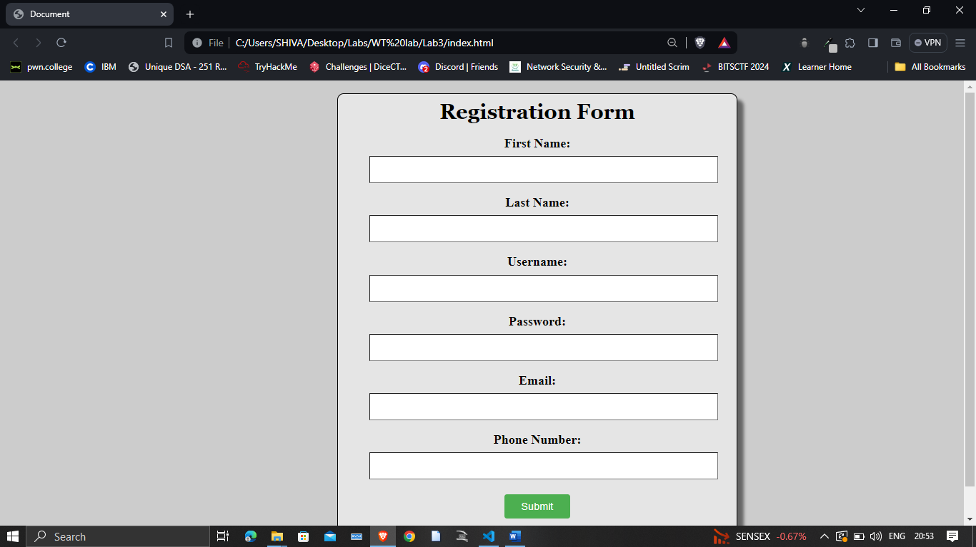

Alert

