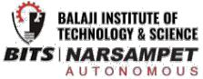

**Industrial Internship Report on**

**” Password Manager”**

**Prepared by**

**Chindam Shiva Kumar**



*Executive Summary*

This report provides details of the Industrial Internship provided by upskill Campus and The IoT Academy in collaboration with Industrial Partner UniConverge Technologies Pvt Ltd (UCT).

This internship was focused on a project/problem statement provided by UCT. We had to finish the project including the report in 6 weeks’ time.

My project was **PASSWORD MANAGER** which is based on Python designed to securely manage user passwords. It offers a comprehensive solution by incorporating encryption algorithms to ensure the confidentiality of stored passwords. The “Password Manager” provides a reliable and user-friendly platform for securely storing, generating and accessing passwords.

This internship gave me a very good opportunity to get exposure to Industrial problems and design/implement solution for that. It was an overall great experience to have this internship.



Industrial Internship Report Page 1



**TABLE OF CONTENTS**

1 Preface 3

2 Introduction 4

2.1 About UniConverge Technologies Pvt Ltd 4

2.2 About upskill Campus 8

2.3 Objective 10

2.4 Reference 10

2.5 Glossary 11

3 Problem Statement 11

4 Existing and Proposed solution 12

5 Proposed Design/ Model 14

5.1 High Level Diagram (if applicable) 14

5.2 Low Level Diagram (if applicable) 14

6 Performance Test 15

6.1 Test Plan/ Test Cases 15

6.2 Test Procedure 15

6.3 Performance Outcome 16

7 My learnings 17

8 Future work scope 18



Industrial Internship Report Page 2



**1 Preface**

Summary of the whole 6 weeks’ work.

About need of relevant Internship in career development.

Brief about Your project/problem statement.

Opportunity given by USC/UCT.

How Program was planned

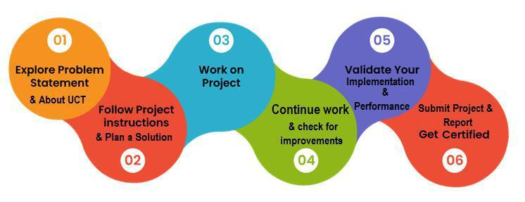

Your Learnings and overall experience.

Thanks to all (with names), who have helped you directly or indirectly.

Your message to your juniors and peers.



Industrial Internship Report Page 3



**2 Introduction**

**2.1** **About UniConverge Technologies Pvt Ltd**

A company established in 2013 and working in Digital Transformation domain and providing Industrial solutions with prime focus on sustainability and RoI.

For developing its products and solutions it is leveraging various **Cutting Edge Technologies e.g. Internet**

**of Things (IoT), Cyber Security, Cloud computing (AWS, Azure), Machine Learning, Communication Technologies (4G/5G/LoRaWAN), Java Full Stack, Python, Front end** etc.

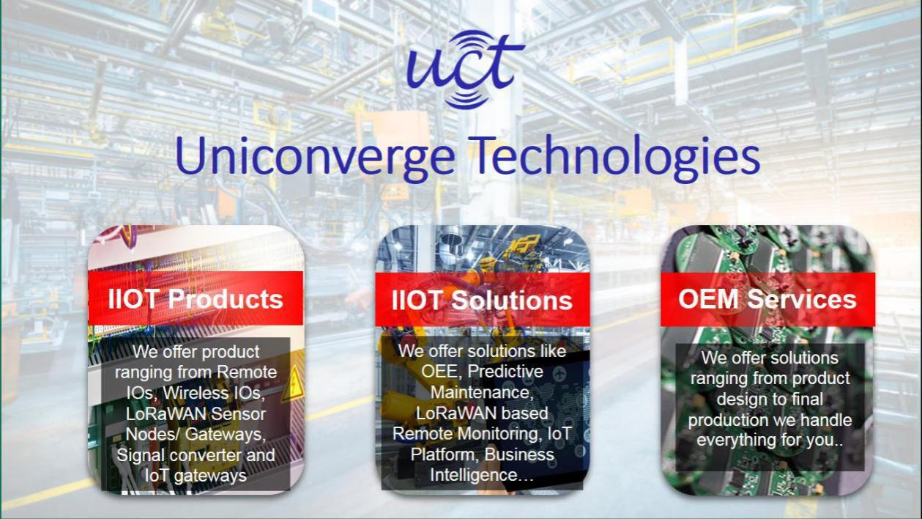

1. **UCT IoT Platform ()**

**UCT Insight** is an IOT platform designed for quick deployment of IOT applications on the same time providing valuable “insight” for your process/business. It has been built in Java for backend and ReactJS for Front end. It has support for MySQL and various NoSql Databases.

* It enables device connectivity via industry standard IoT protocols - MQTT, CoAP, HTTP, Modbus

TCP, OPC UA

* It supports both cloud and on-premises deployments.



Industrial Internship Report Page 4



It has features to

* Build Your own dashboard
* Analytics and Reporting
* Alert and Notification
* Integration with third party application(Power BI, SAP, ERP)
* Rule Engine

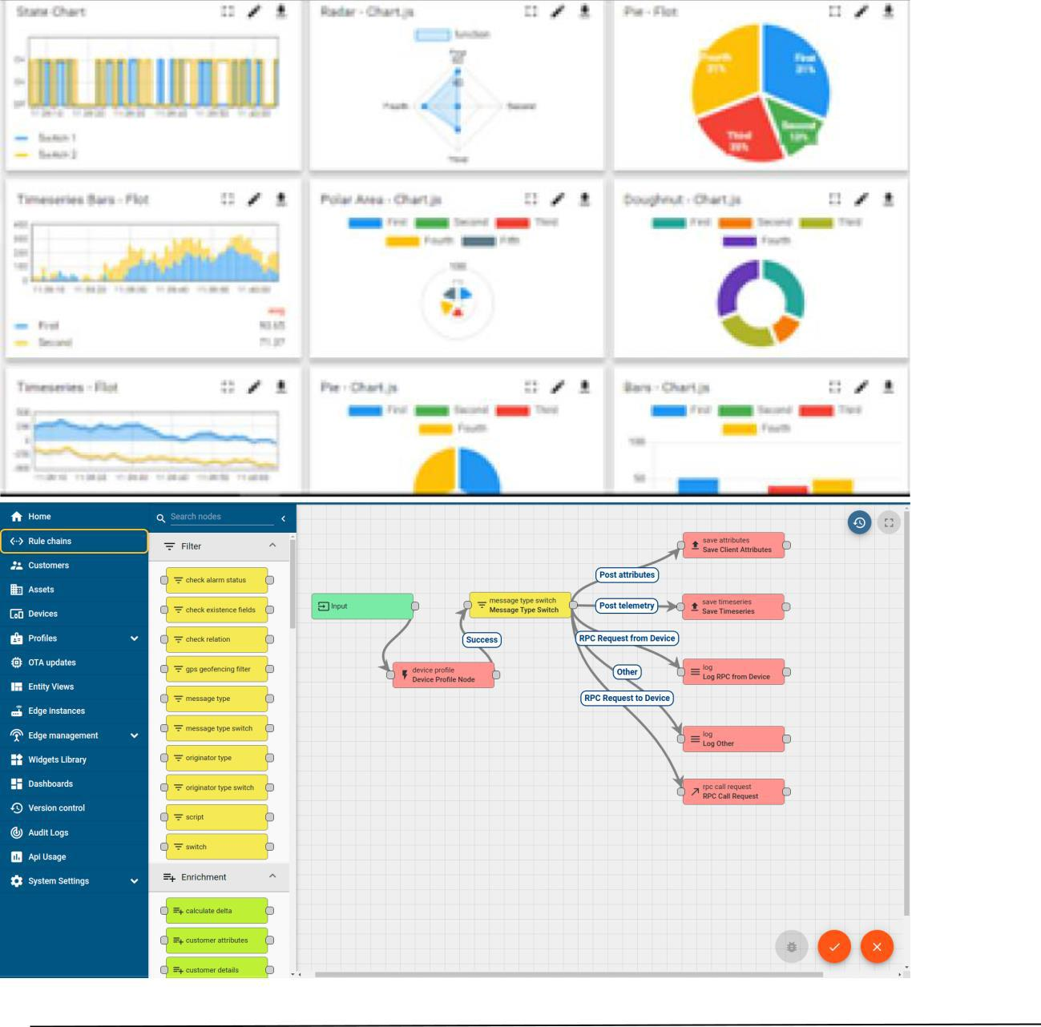

Industrial Internship Report Page 5



ii. **Smart Factory Platform (** **)**

Factory watch is a platform for smart factory needs.

It provides Users/ Factory

* with a scalable solution for their Production and asset monitoring
* OEE and predictive maintenance solution scaling up to digital twin for your assets.
* to unleased the true potential of the data that their machines are generating and helps to identify the KPIs and also improve them.
* A modular architecture that allows users to choose the service that they what to start and then can scale to more complex solutions as per their demands.

Its unique SaaS model helps users to save time, cost and money.



Industrial Internship Report Page 6

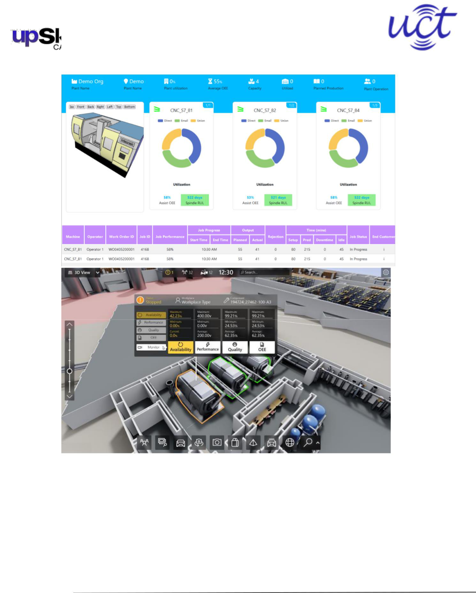

Industrial Internship Report Page 7



1. based Solution

UCT is one of the early adopters of LoRAWAN teschnology and providing solution in Agritech, Smart cities, Industrial Monitoring, Smart Street Light, Smart Water/ Gas/ Electricity metering solutions etc.

1. Predictive Maintenance

UCT is providing Industrial Machine health monitoring and Predictive maintenance solution leveraging Embedded system, Industrial IoT and Machine Learning Technologies by finding Remaining useful life time of various Machines used in production process.

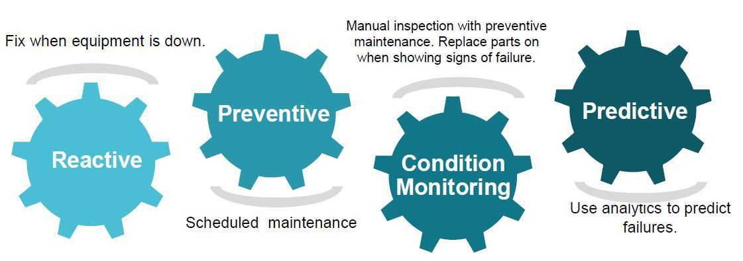

**2.2** **About upskill Campus (USC)**

upskill Campus along with The IoT Academy and in association with Uniconverge technologies has facilitated the smooth execution of the complete internship process.

USC is a career development platform that delivers **personalized executive coaching** in a more affordable, scalable and measurable way.



Industrial Internship Report Page 8

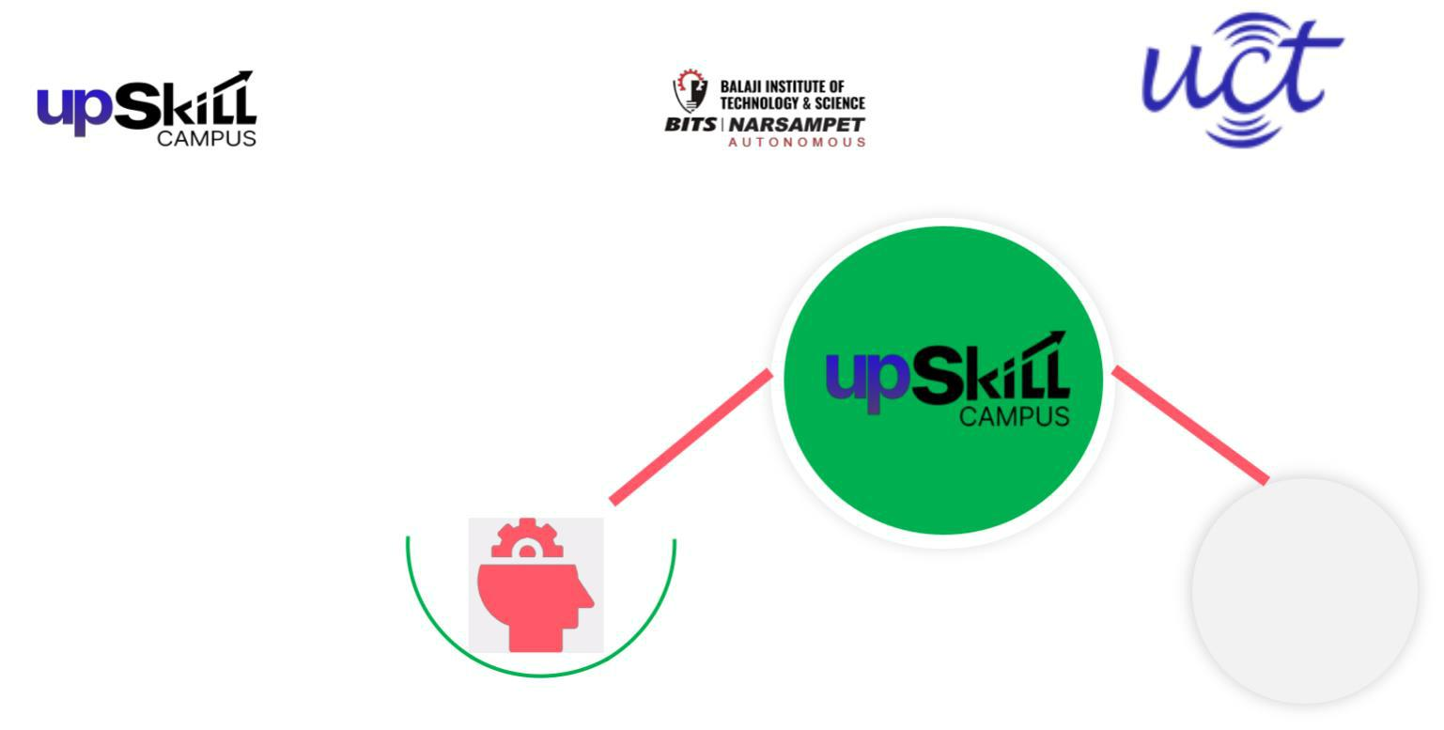

Seeing need of upskilling in self

upSkill Campus aiming

paced manner along-with

to upskill 1 million

additional support services e.g.

learners in next 5 year

Internship, projects, interaction

with Industry experts, Career

growth Services

<https://www.upskillcampus.com/>



|  |
| --- |
| Career growth/upskilling |

Interview Preparation

and skill building

upskilling Courses

Skill Assessment

Profile building

|  |  |  |  |
| --- | --- | --- | --- |
| Professionalnetworking | Alumni | Collaborationplatform | Project |
|  |  |
|  | Connections |  | collaboration |
|  | Mentorship |  | Discussion forum |
|  | Discussion/QA |  | Tech updates |
|  | forum |  |
|  |  |  |



Industrial Internship Report

|  |
| --- |
| Job/internship platform |

Job portal

Internship portal

Freelancing

projects

Page 9



**2.3** **The IoT Academy**

The IoT academy is EdTech Division of UCT that is running long executive certification programs in collaboration with EICT Academy, IITK, IITR and IITG in multiple domains.

**2.4** **Objectives of this Internship program**

The objective for this internship program was to

* get practical experience of working in the industry.
* to solve real world problems.
* to have improved job prospects.
* to have Improved understanding of our field and its applications.
* to have Personal growth like better communication and problem solving.

**2.5** **Reference**

1. <https://readthedocs.org/projects/cryptography/>
2. <https://www.sqlite.org/docs.html>
3. <https://docs.python.org/3/library/tk.html>
4. <https://thepythoncode.com/article/build-a-password-manager-in-python>
5. <https://www.freecodecamp.org/news/tag/mysql/>



Industrial Internship Report Page 10



**2.6** **Glossary**

|  |  |
| --- | --- |
| Terms | Acronym |
|  |  |
| SQL | Structured Query Language |
|  |  |
| IOT | Internet of Things |
|  |  |
| DB | Database |
|  |  |
| UCT | Uniconverge Technologies |
|  |  |
| USC | UpSkill campus |
|  |  |

**3 Problem Statement**

In the assigned problem statement

* Password Manager:

Description: The password manager is a Python project that securely stores and manages user passwords. It allows users to store their passwords for various accounts, generate strong passwords, and retrieve passwords when needed.

Scope: The scope of this project involves implementing encryption algorithms to secure password storage, designing a user interface to input and retrieve passwords, and developing functions to generate strong passwords and store/retrieve them from a database.



Industrial Internship Report Page 11



**4 Existing and Proposed solution**

**Existing Solutions:**

Browser-integrateed password managers

Cloud-based password managers

Open-source password managers

**Proposed Solution:**

**ENHANCED PYTHON PASSWORD MANAGER**

Focused more on security

User-Friendly interface

potential for open source contribution

Value addition on balancing security and convenience.

**4.1** **Code submission (Github link)**

**https://github.com/ShivaKumarChindam/Upskill-Campus/blob/main/PasswordManager.py**

**4.2** **Report submission (Github link) :**

**https://github.com/ShivaKumarChindam/Upskill-Campus/blob/main/PasswordManager_ShivaKumarChindam_USC_UCT.pdf**



Industrial Internship Report Page 12



Industrial Internship Report Page 13



**5 Proposed Design/ Model**

Given more details about design flow of your solution. This is applicable for all domains. DS/ML Students can cover it after they have their algorithm implementation. There is always a start, intermediate stages and then final outcome.

**5.1** **High Level Diagram (if applicable)**

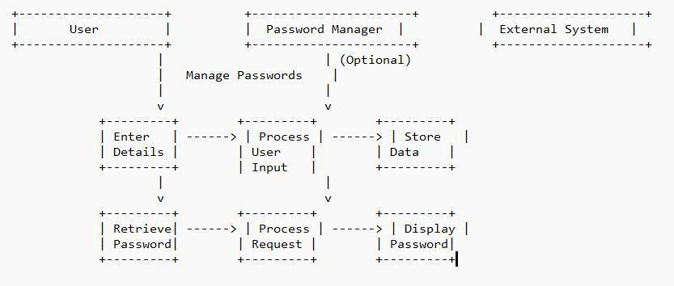

**Figure 1: HIGH LEVEL DIAGRAM OF THE SYSTEM**

**5.2** **Low Level Diagram (if applicable)**



Industrial Internship Report Page 14

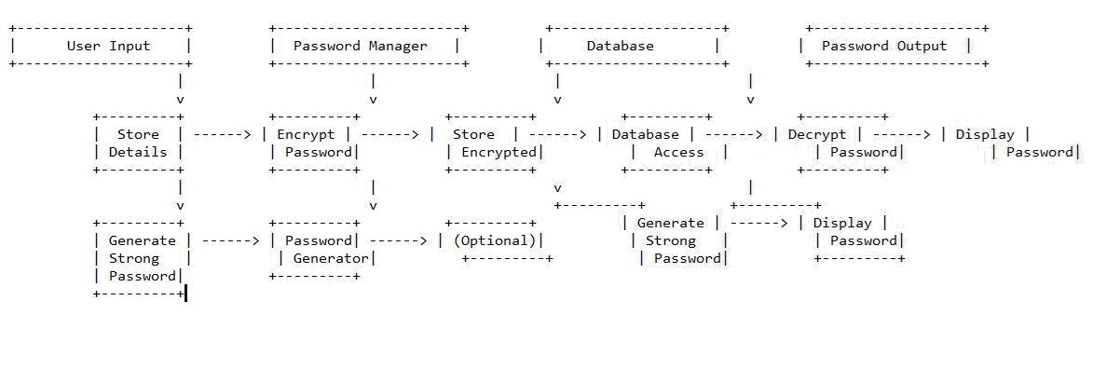

**6 Performance Test**

As Performance testing is crucial for real world applications ensuring the project functions effectively under expected user loads. While this project might be an academic exercise at present, considering performance constraints from beginning lays a strong foundation for future scalability.

**6.1** **Test Plan/ Test Cases**

This test plan outlines the strategy for evaluating performance and functionality of a python. This primary goal is to ensure application meets user requirements and performs efficiently under various loads.

Each test case will be executed manually or through automated scripts. Using manual testing or functional testing. Test results will be documented including pass/fail status and observed issues.

**6.2** **Test Procedure**

Firstly we ensure python development environment is set up as specified for performing tasks.

Next we setup the database with sample data for testing.

Next we perform testing procedures such as

Manual Testing and Automated testing, Performance testing for memory management.



Industrial Internship Report Page 15



**6.3** **Performance Outcome**

As performance testing was not good as expected therefore, we cannot provide accurate results.

But the observed patterns are

If not optimized memory consumption could increase with a growing number of stored passwords. This might become an issue for users with limited system resources.

Encryption/Decryption algortihms can add overhead especially for large datasets.

Database performance having a great impact responsiveness, especially with frequent password retrievals and updations.

Afterall the actual performance may vary based on the hardware specifications and chosen algorithms and the number of stored passwords.

Hence by this project Performance of the Password manager was satisfactory.



Industrial Internship Report Page 16



**7 My learnings**

**From the Password Manager Project:**

**SECURITY:**

I explored the importance of encryption and its importance to secure password storage and how cryptography safeguards information.

**DATABASE MANAGEMENT:**

I explored the options for storing passwords likely in a database which involves the working with libraries like MYSQL or connecting to remote database.

**APPLYING PYTHON CONCEPTS:**

As developing involves applying various concepts from Python which strengthened my Python Programming skills.

**Project Management:**

As the project involved many manageable parts like building UI, implementing encryption and integrating with database. This experience provides valuable insights to my learning and experience.

These learnings highlight the valuable technical and practical skills gained through developing this project this further increased my knowledge as will help as foundation for my future projects.



Industrial Internship Report Page 17



**8 Future work scope**

**Enhanced Security Features:**

To implement Two-Factor Authentication for added security.

Allow secure password sharing with other users through encrypted channels.

**Advanced Functionality:**

Automatic Password filling.

Increase scalability and user experience.

**Further Exploration:**

Integration with cloud platforms for secure data storage.

Exploring other options for authentication.



Industrial Internship Report Page 18