Smart Rewrite Chatbot
Introduction to Artificial Intelligence Mini Project Report
Student name: Shiva Lamsal
Student number: 2413800
Date: 13/05/2026
Link to git project repo:
Link to project video recording:
Word count: Approx 1700 words

Introduction
Smart Rewrite Chatbot is a local natural language processing tool that aims at helping students, non-native English speakers and casual users to improve their short written English pieces. Initially, the project was a chatbot based on rules that operated through a terminal, but it was later enhanced and transformed into a more user-friendly writing assistant, including grammar correction, paraphrasing, formal rewriting, stronger input validation, a Tkinter graphical interface and optional local LLM rewriting. However, the main goal of the tool is not to be on par with large commercial systems. Rather, it aims at presenting the main ideas of artificial intelligence in a simple and understandable manner: user input is interpreted, processed through rules and patterns, then returned as improved written output.
The project has arisen from an actual communication issue. Sometimes students need to write emails, report sentences and project explanations very quickly, and little errors in grammar, punctuation or word choice can significantly diminish the effectiveness of the message. Web-based writing aids like Grammarly and QuillBot do offer excellent writing assistance, but they are online and, consequently, probably, not very convenient for assignments that require local code and visibly accessible NLP logic [2, 8]. That's why Smart Rewrite Chatbot relies on simple and comprehensible Python rules, which are the primary basis for delivering dependable outputs and it also includes an optional offline Llama 3.2 component for very elaborate rewriting.

Background
The project is deeply rooted in early chatbot research, particularly the ELIZA chatbot that illustrated how one can use pattern matching and substitution rules leading to meaningful interactions even if the machine didn't actually understand the language [9]. This matters quite a bit because Smart Rewrite Chatbot, to some extent, also relies on rule-based processing; however, the goal here is the practical improvement of the text rather than engaging in an open-ended conversation. Besides that, there have been pointers to NLP libraries and model sources, such as NLTK, Scikit-Learn, Transformers and Hugging Face in the course materials, which ultimately influenced the decision to keep the main prototype as lightweight as possible while still outlining a model-based extension that one could potentially pursue. The optional extension uses a lightweight local LLM approach through Ollama and Llama 3.2, rather than relying on cloud API calls [3, 4].
Other commercial writing tools served as great referential points. Grammarly positions itself as an AI writing assistant, whereas QuillBot equates paraphrasing to come up with text expressions in a way that the original meaning remains intact [2, 8]. Simply put, paraphrasing is the act of changing the wording but not the meaning of a text . Both of these tools are a testament to the importance of grammar correction and paraphrasing. However, they also throw light on the reasons why the student prototype should be a lot tighter, more self-explanatory and hence one that can be run locally. For creating a simple user interface, Python's tkinter package is greatly suited here as it is the standard Python interface to Tk and is available on all major desktop systems [6]. For the task of grammar and phrase replacement, Python's re module will come in handy since it is meant for regular-expression matching [6]. Coming to the optional upgrade part, Meta's Llama 3.2 family comprises, among others, 1B and 3B text models, and Ollama is providing a very handy local option for running llama3.2:3b [4, 5].

Implementation details for interactive application
The whole software application revolves around an object-oriented programming concept. The class SmartRewriteChatbot, which is declared in the file smart_rewrite_chatbot.py, inherits the ChatbotBase class and customises the processing and response mechanisms of the chatbot. By default, the run file, run_chatbot.py, starts the graphical user interface, while the --cli option maintains a command line version for assessment testing purposes. This architecture meets the template stipulation that the project should revolve around the base class provided, while also permitting extra functions for exhibiting advanced behaviour.
The series of processing stages is as follows: raw user input -> validation -> mode selection -> rewrite generation -> final output. Validation starts with stripping out superfluous whitespace, checking for no input, limiting extremely long text to 1200 characters or 220 words, warning about sentences over 45 words and finally removing unusual symbols. This is in line with the feedback about long or complex input by not only avoiding crashes but also by giving the user a direct message instead of silently failing.
Figure 1: Smart Rewrite Chatbot processing flow.
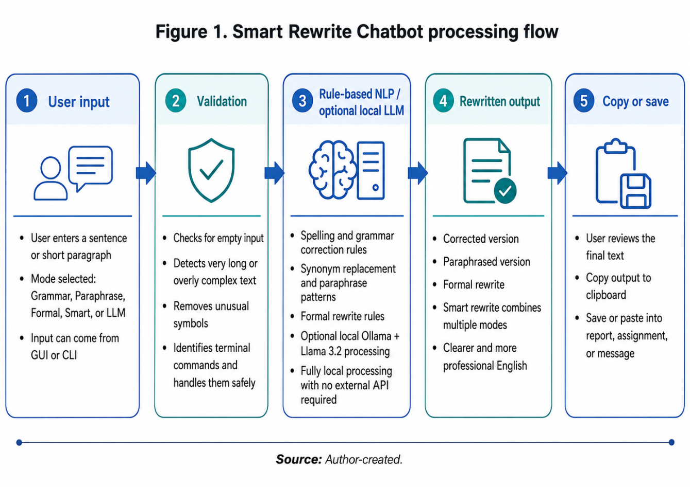
The grammar mode uses local spelling and phrase rules. This encompasses changes like don't to do not, can't to cannot, teh to the and becouse to because. Besides that, it works on the grammar patterns (I has to I have, he go to he goes) and it replaces should of with should have. Then, capitalisation and sentence punctuation get normalised. The paraphrase mode is the one that makes use of bigger synonym dictionaries and more structural patterns to rewrite the original prototype. For example, a sentence starting with because may be rewritten as two connected sentences or using with, as, or while the meaning stays the same. The formal mode is the one that expands contractions and changes casual terms into professional ones, e.g. want to into would like to and lots of into a significant amount of. Smart rewrite mode is the one that mixes all three results and lets the users check correction, paraphrase and formal tone changes.
GUI present in gui_app.py is a Tkinter GUI, which includes a text area for input, a mode selector, buttons for rewriting, clearing, copying output, and saving output, an output area and a status bar. The layout is kept deliberately simple because the feedback called for a lightweight GUI rather than a complex web interface. The optional local LLM mode uses subprocess to call Ollama and attempts llama3.2:3b first. If the model is not present, then the program displays an installation message guiding the user and falls back to rule-based formal rewrite, so the app remains functional.
Along with the report, a brief processing-flow diagram was presented as it is more effective to show the system in video demo and it is more visually clear. The diagram breaks down the application into input, validation, rule- based NLP processing, optional local LLM processing, and final output.
It was quite useful while doing the actual job, as it provided a clear correlation between each enhancement to a feedback point: validation takes care of the difficult input, the synonym and pattern bank for paraphrasing and repetition, and the GUI for user accessibility.
Because of the modular design, one can add new functionalities at any time without redoing the entire app. One can add a spell-checking library or a transformer pipeline after validation, for instance, and do not have to change the GUI and response formatting.

Details of additional experimentation
Simple grammar examples, spelling and punctuation checked, paraphrase examples tested for variety, and formal rewrite examples tested for tone. A sample testing file, test_smart_rewrite.py, executes representative inputs and verifies that all the modes produce some output. For instance, "i want to visit europe because i have lots of money" is the example input which gives three outputs: a corrected version, a paraphrased version, and a formal version. This is in line with the project objective, as it allows the users not to see a single repetitive answer but various rewriting options.
The decision of which model to use was very carefully considered. GLM-OCR is a very strong model for lightweight OCR, but the project is a rewriting chatbot, so it was not the main extension chosen. Qwen3.5-0.8B is very small and is good for quick experiments, but would require setting up a separate Transformers or local runtime environment. Llama 3.2 through Ollama was, therefore, selected because it fits the tutor's small-model direction and gives the ability to make simple local calls from Python. So, this demo remains student-laptop-friendly, yet it is still a step towards modern lightweight LLM workflows.
Another experiment involved a comparison of interface options. Terminal menu was quite straightforward to implement, but for presentation purpose, it was not user-friendly because users would have to memorise command words. Tkinter interface made the modes visible and also added copy and save buttons, which greatly enhanced efficiency [6]. Besides that, it was the third experiment that worked on the aspect of optional LLM use. Hugging Face direct integration will need additional and larger dependencies and model downloads, so Ollama was picked as a lighter demonstration way [3, 5]. So, the code supports Llama 3.2 locally but it is not dependent on the model for the main assessment demo.

Critical reflection
The best aspect of the work is that it explicitly responds to the feedback. One of the main improvements is paraphrasing variety, which was achieved by using a larger dictionary of synonyms and restructuring sentences. Changing from terminal-only to GUI is a major upgrade to the interface. Application of input validation was also deepened so that now the app handles long or symbol-heavy text much more safely. The optional LLM route also appears to be cognizant of recent small model options while preserving the submitted app's stability.
Rules-based NLP is the major bottleneck here as it simply can't comprehend the semantic layer in depth. For instance, a word could be replaced by another one that looks fine syntactically but fails to carry the exact meaning. Besides, it mainly targets short and straightforward sentences while being less efficient with lengthy and complex ones. Turning on the LLM as an additional aid would mean getting more graceful rephrasings, but that will depend on the user having enough quota and agreeing to the model license terms. If changing the project was still within my power, I would pick a small test set to distinguish between rule and LLM outputs and to supplement with a confidence scale for risky changes.
The chatbot should be ethically spoken of as a help in writing rather than a very ready tool that you submit without checking. The ACM Code of Ethics prioritises helping society and not doing harm, so the app shouldn't lead users into thinking that it always produces the right answer [1]. It doesn't send text to external APIs by default, which is good from a privacy perspective. They should still always check the completions, especially in cases of academic work.

LLM disclaimer
To help with project planning, writing, debugging, and improving files and report, Large language model methods to some extent were employed. The final code was double checked to make sure it met the assessment guidelines, and the project presented is still readable as the main logic is based on rules and very clearly visible in the Python files. The Llama 3.2 optional feature implementation is explained as an extra-installation other than hiding it in the default system.

References
[1] Association for Computing Machinery (2018) ACM Code of Ethics and Professional Conduct. Available at: https://www.acm.org/code-of-ethics (Accessed: 13 May 2026).
[2] Grammarly (2026) Grammarly: Free AI Writing Assistance. Available at: https://www.grammarly.com/ (Accessed: 13 May 2026).
[3] Hugging Face (2026) Pipelines. Available at: https://huggingface.co/docs/transformers/main_classes/pipelines (Accessed: 13 May 2026).
[4] Meta (2024) Llama 3.2 3B model card. Available at: https://huggingface.co/meta-llama/Llama-3.2-3B (Accessed: 13 May 2026).
[5] Ollama (2026) llama3.2 model library. Available at: https://ollama.com/library/llama3.2 (Accessed: 13 May 2026).
[6] Python Software Foundation (2026a) tkinter - Python interface to Tcl/Tk. Available at: https://docs.python.org/3/library/tkinter.html (Accessed: 13 May 2026).
[7] Python Software Foundation (2026b) re - Regular expression operations. Available at: https://docs.python.org/3/library/re.html (Accessed: 13 May 2026).
[8] QuillBot (2026) Paraphrasing Tool. Available at: https://quillbot.com/paraphrasing-tool (Accessed: 13 May 2026).
[9] Weizenbaum, J. (1966) ‘ELIZA - a computer program for the study of natural language communication between man and machine’, Communications of the ACM, 9(1), pp. 36–45. Available at: https://doi.org/10.1145/365153.365168 (Accessed: 13 May 2026).

