*A*

*Report*

*Submitted in partial fulfilment of the Requirements for the award of the Degree of*

***BACHELOR OF TECHNOLOGY***

***IN***

### INFORMATION TECHNOLOGY

By

**SHIVA PALLAVI R<1602-22-737-165>**

**SHARATH CHANDRA B<1602-22-737-175>**

#### Under the Guidance of

****Dr. S. Aruna****



**Department of Information Technology Vasavi College of Engineering (Autonomous) (Affiliated to Osmania University) Ibrahimbagh, Hyderabad-31**

**2023-24**

BONAFIDE CERTIFICATE

This is to certify that this project report titled

‘**CROP DATA MANAGEMENT SYSTEM**’ is a

## project work of SHIVA PALLAVI R and SHARATH CHANDRA B bearing roll no. 1602-22-737-165 and 1602-22-737-175 who carried out this project under my supervision in the III semester for the academic year 2023-24.

Signature

Internal Examiner

Signature

External Examiner

**CROP DATA MANAGEMENT SYSTEM**

### ABSTRACT

The Crop Data Management System (CDMS) is a comprehensive software solution designed to streamline the management of crop-related information for farmers and agricultural professionals. By leveraging modern technologies and database management systems, CDMS offers a user-friendly interface for efficiently storing, organizing, and analyzing crucial data related to crops. It facilitates the seamless integration of various data sources, including farmer details, farm information, pesticide usage, equipment inventory, crop details, profit and loss records, and farmer contacts. With CDMS, users can access real-time data insights, make informed decisions, optimize resource allocation, and enhance overall productivity in the agricultural sector. Whether it's tracking crop growth, monitoring pesticide usage, evaluating equipment performance, or analyzing profitability, CDMS provides a centralized platform to effectively manage and leverage crop data, ultimately contributing to sustainable farming practices and agricultural success.

#### Requirements Analysis:

**List of Tables:**

1. Farmers
2. Farm
3. Pesticides
4. Pesticides_Farm
5. Equipment
6. Equipment_Farmer
7. Crop
8. Profit_Loss
9. Farmer_F_Contact

**Attributes list and domain types:**

**Farmers:**

F_ID NUMBER(38)

F_FIRSTNAME VARCHAR2(50)

F_SURNAME VARCHAR2(50)

F_DOB DATE

F_DOORNO VARCHAR2(20)

F_STREETNAME VARCHAR2(50)

F_VILLAGE VARCHAR2(50)

F_TYPE VARCHAR2(50)

**Farm:**

FARM_ID NUMBER(38)

FARM_AREA NUMBER(38)

FARM_VILLAGE VARCHAR2(50)

FARM_MANDAL VARCHAR2(50)

FARM_SOILTYPE VARCHAR2(50)

F_ID NUMBER(38)

**Pesticides:**

P_ID NUMBER(38)

P_NAME VARCHAR2(60)

P_MANUFACTURE DATE

P_EXPIRY DATE

P_USE VARCHAR2(60)

**Pesticides_Farm:**

P_ID NUMBER(38)

FARM_ID NUMBER(38)

**Equipment:**

EQUIPMENT_ID NUMBER(38)

EQUIPMENT_TYPE VARCHAR2(60)

EQUIPMENT_COST NUMBER(38)

EQUIPMENT_USE VARCHAR2(60)

**Equipment_Farmers:**

EQUIPMENT_ID NUMBER(38)

F_ID NUMBER(38)

**Crop:**

C_ID NUMBER(38)

FARM_ID NUMBER(38)

C_NAME VARCHAR2(60)

DURATION NUMBER(38)

SEASON_MONTH VARCHAR2(60)

INVESTMENT NUMBER(38)

**Profit_Loss:**

F_ID NUMBER(38)

P_L_VALUE NUMBER(10,2)

**Farmer_F_Contact:**

F_ID NUMBER(38)

F_CONTACT VARCHAR2(12)

# AIM AND PRIORITY OF THE PROJECT

The aim of this project is to develop a comprehensive Crop Data Management System (CDMS) using Java. The system will provide a user-friendly interface to manage and analyze various aspects of crop-related data, including farmer details, farm information, pesticide usage, equipment inventory, crop details, profit/loss records, and farmer contact information.

# ARCHITECTURE AND TECHNOLOGY

**Software Used:**

**Java**: Java will be used for developing the GUI-based desktop application. It offers rich libraries and tools for creating interactive user interfaces.

**MySQL Database**: MySQL will serve as the backend database for storing student information and other relevant data. It provides robust data management capabilities and ensures data integrity.

**Java SE Version 14**: Java Standard Edition (SE) version 14 will be utilized for developing the application. It offers the latest features and enhancements available in the Java platform.

**JDBC (Java Database Connectivity):** JDBC will be used to establish a connection between the Java application and the MySQL database. This will allow seamless interaction between the frontend and backend components of the application.

**Run SQL**: Run SQL is a tool that provides a convenient environment for executing SQL queries and managing the MySQL database.

**Java SWING:**

Java SWING is a GUI widget toolkit for Java. It is part of Oracle's Java Foundation Classes (JFC) - an API for providing a graphical user interface (GUI) for Java programs.

Swing was developed to provide a more sophisticated set of GUI components than the earlier AWT. Swing provides a look and feel that emulates the look and feel of several platforms, and also supports a pluggable look and feel that allows applications to have a look and feel unrelated to the underlying platform. It has more powerful and flexible components than AWT. In addition to familiar components such as buttons, check boxes and labels, Swing provides several advanced components such as tabbed panel, scroll panes, trees, tables, and lists

**SQL:**

Structure Query Language(SQL) is a database query language used for storing and managing data in Relational DBMS. SQL was the first commercial language introduced for E.F Codd's Relational model of database. Today almost all RDBMS (MySql, Oracle, Infomix, Sybase, MS Access) use SQL as the standard database query language. SQL is used to perform all types of data operations in RDBMS

### ER MODELLING:

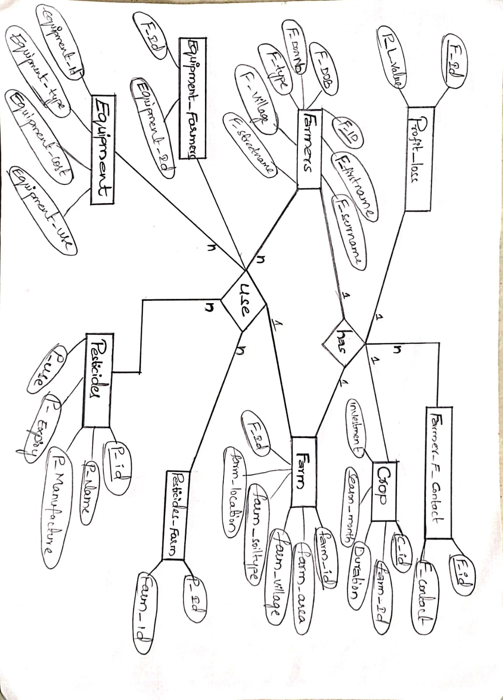

**Key Constraints:**

**Farmers:**

Primary Key: F_ID

**Farm:**

Primary Key: FARM_ID

Foreign Key: F_ID (references Farmers(F_ID))

**Pesticides:**

Primary Key: P_ID

**Pesticides_Farm**:

Composite Primary Key: (P_ID, FARM_ID)

Foreign Key: P_ID (references Pesticides(P_ID))

Foreign Key: FARM_ID (references Farm(FARM_ID))

**Equipment:**

Primary Key: EQUIPMENT_ID

**Equipment_Farmers:**

Composite Primary Key: (EQUIPMENT_ID, F_ID)

Foreign Key: EQUIPMENT_ID (references Equipment(EQUIPMENT_ID))

Foreign Key: F_ID (references Farmers(F_ID))

**Crop:**

Primary Key: C_ID

Foreign Key: FARM_ID (references Farm(FARM_ID))

**Profit_Loss:**

Composite Primary Key: (F_ID, P_L_VALUE)

Foreign Key: F_ID (references Farmers(F_ID))

**Farmer_F_Contact:**

Composite Primary Key: (F_ID, F_CONTACT)

Foreign Key: F_ID (references Farmers(F_ID))

### DDL & DML OPERATIONS:

### Farmers:

### CREATE TABLE Farmers

### (

### F_Id INT NOT NULL,

### F_FirstName VARCHAR(50) NOT NULL,

### F_SurName VARCHAR(50) NOT NULL,

### F_DOB DATE NOT NULL,

### F_DoorNo VARCHAR(20) NOT NULL,

### F_StreetName VARCHAR(50) NOT NULL,

### F_Village VARCHAR(50) NOT NULL,

### F_Type VARCHAR(50) NOT NULL,

### PRIMARY KEY (F_Id)

### );

### INSERT INTO Farmers (F_ID, F_FIRSTNAME, F_SURNAME, F_DOB, F_DOORNO, F_STREETNAME, F_VILLAGE, F_TYPE)

### SELECT 7451, 'Veerayya', 'Kasturi', '1962-05-21', '1/7-6F', 'Surya Nagar', 'Chepurapalli', 'Owner'

### UNION ALL SELECT 1524, 'Saidulu', 'Kadiyala', '1989-08-30', '2/5/9F', 'Ashok Nagar', 'Lakkavarapu Kota', 'Tenant'

### UNION ALL SELECT 4963, 'Subbayya', 'Gangavarapu', '1967-02-11', '91-4/A', 'Pransanth Nagar', 'Sabbavaram', 'Owner'

### UNION ALL SELECT 2582, 'Bharat', 'Ogirala', '1965-06-09', '1-2/5B', 'Chanukya Nagar', 'Srungavarapu Kota', 'Owner'

### UNION ALL SELECT 6428, 'Srinu', 'Vadlamani', '1958-03-12', '1-54/A', 'Prasanthi Nagar', 'CM Wada', 'Tenant'

### UNION ALL SELECT 6745, 'Swamy', 'Ivaturi', '1973-12-11', '8-4/1C', 'Rama Rao Colony', 'Pendurthi', 'Owner'

### UNION ALL SELECT 2983, 'Sasidhar', 'Manchiraju', '1992-05-20', '9-8-/A', 'Prakash Nagar', 'Devarapalli', 'Tenant';

### Farm Table:

### REATE TABLE Farm (

### Farm_Id INT NOT NULL,

### Farm_Area INT NOT NULL,

### Farm_Village VARCHAR(50) NOT NULL,

### Farm_Mandal VARCHAR(50) NOT NULL,

### Farm_SoilType VARCHAR(50) NOT NULL,

### F_Id INT NOT NULL,

### PRIMARY KEY (Farm_Id),

### CONSTRAINT fk_fid FOREIGN KEY (F_Id) REFERENCES Farmers(F_Id)

### );

### INSERT INTO Farm (Farm_Id, Farm_Area, Farm_Village, Farm_Mandal, Farm_SoilType, F_Id, farm_latitude, farm_longitude)

### VALUES

### (97482, 3, 'Sabbavaram', 'Sangivalasa', 'Red Soil', 4963, POINT(83.2185, 17.6868)),

### (48642, 2, 'Devarapalli', 'Mangalapalem', 'Black Soil', 2983, POINT(82.9831, 17.4483)),

### (34811, 4, 'Pendurthi', 'Anakapalli', 'Black Soil', 6745, POINT(82.8973, 17.8589)),

### (67418, 1, 'Lakkavarapu Kota', 'Jami', 'Red Soil', 1524, POINT(82.8284, 17.5845)),

### (87522, 1, 'CM Wada', 'Gopalapatnam', 'Black Soil', 6428, POINT(83.2908, 17.6894)),

### (75671, 2, 'Srungavarapu Kota', 'Kothavalasa', 'Red Soil', 2582, POINT(83.1461, 18.0975)),

### (73196, 1, 'Chepurapalli', 'Veera Bhadra Puram', 'Black Soil', 7451, POINT(83.0872, 18.1390));

### Pesticides Table:

### CREATE TABLE Pesticides

### (

### P_Id INT NOT NULL,

### P_Name VARCHAR(60) NOT NULL,

### P_Manufacture DATE NOT NULL,

### P_Expiry DATE NOT NULL,

### P_Use VARCHAR(60) NOT NULL,

### PRIMARY KEY (P_Id)

### );

### INSERT INTO Pesticides (P_Id, P_Name, P_Manufacture, P_Expiry, P_Use)

### VALUES

### (7857, 'Sodium Arsenite', '2020-01-11', '2022-03-10', 'Purpose for Plants'),

### (9745, 'Streptomycin', '2020-03-23', '2022-02-20', 'Purpose for Bacteria'),

### (1486, 'Warfarin', '2021-02-13', '2023-05-16', 'Purpose for Rats'),

### (6068, 'Folpet', '2021-07-25', '2024-02-09', 'Purpose for Fungi'),

### (9743, 'Bactivec', '2021-09-17', '2024-03-21', 'Purpose for Larvae'),

### (1525, 'Green Beauveria', '2022-05-09', '2025-03-14', 'Purpose for Insects');

### Pesticides_Farm Table:

### CREATE TABLE Pesticides_Farm

### (

### P_Id INT NOT NULL,

### Farm_Id INT NOT NULL,

### PRIMARY KEY (P_Id, Farm_Id),

### FOREIGN KEY (P_Id) REFERENCES Pesticides(P_Id),

### FOREIGN KEY (Farm_Id) REFERENCES Farm(Farm_Id)

### );

### INSERT INTO Pesticides_Farm VALUES

### (7857, 97482),

### (7857, 67418),

### (7857, 87522),

### (9745, 34811),

### (9745, 67418),

### (9745, 73196),

### (1486, 48642),

### (1486, 87522),

### (6068, 97482),

### (6068, 34811),

### (6068, 73196),

### (9743, 34811),

### (9743, 75671),

### (1525, 97482),

### (1525, 67418),

### (1525, 87522);

### Equipment Table:

### CREATE TABLE Equipment

### (

### Equipment_Id INT NOT NULL,

### Equipment_Type VARCHAR(60) NOT NULL,

### Equipment_Cost INT NOT NULL,

### Equipment_Use VARCHAR(60) NOT NULL,

### PRIMARY KEY (Equipment_Id)

### );

### INSERT INTO Equipment VALUES

### (75, 'Water Filter Pressure', 17000, 'Watering for Crops'),

### (41, 'Turner Tool Attachment', 15000, 'Trimming Purpose'),

### (61, 'Aeronex Blower', 20000, 'Creating Airflow'),

### (93, 'Disc Harrow', 22000, 'Digging Purpose'),

### (18, 'Plough', 5000, 'Sowing Purpose'),

### (54, 'Hand Push Brush Cutter', 13000, 'Cutting Purpose'),

### (85, 'Tractor', 10000, 'Tilling Purpose');

### Equipment _Farmers Table:

### CREATE TABLE Equipment_Farmers

### (

### Equipment_Id INT NOT NULL,

### F_Id INT NOT NULL,

### PRIMARY KEY (Equipment_Id, F_Id),

### FOREIGN KEY (Equipment_Id) REFERENCES Equipment(Equipment_Id),

### FOREIGN KEY (F_Id) REFERENCES Farmers(F_Id)

### );

### INSERT INTO Equipment_Farmers VALUES

### (75, 7451),

### (75, 2983),

### (41, 1524),

### (41, 2983),

### (61, 7451),

### (61, 2983),

### (93, 2582),

### (93, 2983),

### (18, 7451),

### (18, 2983),

### (54, 6428),

### (54, 2983),

### (85, 2582),

### (85, 2983);

### Crop Table:

### CREATE TABLE Crop

### (

### C_Id INT NOT NULL,

### Farm_Id INT NOT NULL,

### C_Name VARCHAR(60) NOT NULL,

### Duration INT NOT NULL,

### Season_Month VARCHAR(60) NOT NULL,

### Investment INT NOT NULL,

### PRIMARY KEY (C_Id)

### );

### INSERT INTO Crop VALUES

### (1, 97482, 'Kharif Crops', 5, 'June', 10000),

### (2, 48642, 'Rabi Crops', 6, 'October', 10000),

### (3, 34811, 'Rice', 3, 'July', 15000),

### (4, 67418, 'Zaid Crops', 4, 'March', 12000),

### (5, 87522, 'Wheat', 5, 'November', 16000),

### (6, 75671, 'Cotton', 7, 'August', 20000),

### (7, 73196, 'Sugarcane', 10, 'September', 25000);

### Profit_Loss Table:

### CREATE TABLE Profit_Loss

### (

### F_Id INT NOT NULL,

### P_L_Value DECIMAL(10, 2) NOT NULL,

### PRIMARY KEY (F_Id),

### FOREIGN KEY (F_Id) REFERENCES Farmers(F_Id)

### );

### INSERT INTO Profit_Loss (F_Id, P_L_Value) VALUES

### (7451, 1500.50),

### (1524, -250.75),

### (4963, 1000.00),

### (2582, -1250.25),

### (6428, -458.20),

### (6745, 2000.00),

### (2983, 0.00);

### Farmer_F_Contact Table:

### CREATE TABLE Farmer_F_Contact

### (

### F_Id INT NOT NULL,

### F_Contact VARCHAR(12) NOT NULL,

### PRIMARY KEY (F_Contact, F_Id),

### FOREIGN KEY (F_Id) REFERENCES Farmers(F_Id)

### );

### INSERT INTO Farmer_F_Contact VALUES

### (7451, '7093369035'),

### (1524, '9347429568'),

### (4963, '9059144881'),

### (2582, '9348101001'),

### (6428, '9110312523'),

### (6745, '9492590911'),

### (2983, '9542765317'),

### (6745, '6303341833'),

### (6745, '8332822678'),

### (2582, '7396661751'),

### (2983, '9705563225');

### Tables:

### Farmers:

### C:\Users\MICROCHIP\Pictures\Screenshots\Screenshot (55).png

### Farm:

### C:\Users\MICROCHIP\Pictures\Screenshots\Screenshot (55).png

### Pesticides:

### C:\Users\MICROCHIP\Pictures\Screenshots\Screenshot (55).png

### Pesticides_Farm:

### C:\Users\MICROCHIP\Pictures\Screenshots\Screenshot (55).png

### Equipment:

### C:\Users\MICROCHIP\Pictures\Screenshots\Screenshot (55).png

### Equipment_Farmers:

### C:\Users\MICROCHIP\Pictures\Screenshots\Screenshot (55).png

**Crop:**

### C:\Users\MICROCHIP\Pictures\Screenshots\Screenshot (55).png

### Profit_Loss:

### C:\Users\MICROCHIP\Pictures\Screenshots\Screenshot (55).png

### Farmer_F_Contact:

### C:\Users\MICROCHIP\Pictures\Screenshots\Screenshot (55).png

# IMPLEMENTATION

#### JAVA-SQL Connectivity using JDBC:

Java Database Connectivity (JDBC) is an application programming interface (API) for the programming language Java, which defines how a client may access a database. It is a Java-based data access technology used for Java database connectivity. It is part of the Java Standard Edition platform, from Oracle Corporation. It provides methods to query and update data in a database and is oriented towards relational databases.

The connection to the database can be established using Java programming (JDBC API) as follows:

try (

Connection conn = DriverManager.getConnection(

"jdbc:mysql://localhost:3306/CDMS?allowPublicKeyRetrieval=true&useSSL=false&serverTimezone=UTC","sharath", "sharath");

Statement stmt = conn.createStatement();

**NOTE:** We have merged frontend and JDBC program into one program for each individual table.

**HomePage.java**

import javax.swing.*;

import java.awt.*;

import java.awt.event.ActionEvent;

import java.awt.event.ActionListener;

import java.io.IOException;

public class HomePage extends JFrame implements ActionListener {

public HomePage() {

setTitle("CROP DATA MANAGEMENT SYSTEM");

setSize(800, 600);

setDefaultCloseOperation(JFrame.EXIT_ON_CLOSE);

setLocationRelativeTo(null);

// Maximize the frame

setExtendedState(JFrame.MAXIMIZED_BOTH);

// Create a panel for the heading and buttons using GridBagLayout

JPanel panel = new JPanel(new GridBagLayout());

panel.setOpaque(false); // Make panel transparent

GridBagConstraints gbc = new GridBagConstraints();

gbc.fill = GridBagConstraints.HORIZONTAL;

gbc.insets = new Insets(10, 10, 10, 10);

JLabel headingLabel = new JLabel("CROP DATA MANAGEMENT SYSTEM");

headingLabel.setFont(new Font("Arial", Font.BOLD, 24));

headingLabel.setHorizontalAlignment(SwingConstants.CENTER);

gbc.gridx = 0;

gbc.gridy = 0;

gbc.gridwidth = 5; // Span across 5 columns

panel.add(headingLabel, gbc);

// Set up background image

ImageIcon backgroundImage = new ImageIcon("F:\\Team-06(1602-22-737-165 & 175)\\project\\images\\cFarm.jpg"); // Replace with your image file path

JLabel backgroundLabel = new JLabel(backgroundImage);

backgroundLabel.setLayout(new BorderLayout());

// Add panel to the background label

backgroundLabel.add(panel, BorderLayout.CENTER);

// Set background label as content pane

setContentPane(backgroundLabel);

// Add buttons

JButton[] buttons = new JButton[10];

String[] buttonLabels = {"FARMERS", "FARM", "PESTICIDES", "PESTICIDES_FARM", "EQUIPMENT", "EQUIPMENT_FARMERS", "CROP", "PROFIT_LOSS", "CONTACTS", "GET FARMER'S DATA"};

String[] filePaths = {

"C:\\MyWebProjects\\FarmersManagement.java",

"C:\\MyWebProjects\\FarmManagement.java",

"C:\\MyWebProjects\\PesticidesManagement.java",

"C:\\MyWebProjects\\Pesticides_FarmManagement.java",

"C:\\MyWebProjects\\EquipmentManagement.java",

"C:\\MyWebProjects\\Equipment_FarmersManagement.java",

"C:\\MyWebProjects\\CropManagement.java",

"C:\\MyWebProjects\\Profit_LossManagement.java",

"C:\\MyWebProjects\\Farmer_F_ContactManagement.java",

"C:\\MyWebProjects\\FarmerDataForm.java"

};

gbc.gridwidth = 1; // Reset to 1 for buttons

gbc.gridy = 1; // Start from second row

for (int i = 0; i < 10; i++) {

buttons[i] = new JButton(buttonLabels[i]);

buttons[i].setPreferredSize(new Dimension(200, 100)); // Adjusted button size

buttons[i].setActionCommand(filePaths[i]);

buttons[i].addActionListener(this);

gbc.gridx = i % 5;

if (i % 5 == 0 && i != 0) {

gbc.gridy++;

}

panel.add(buttons[i], gbc);

}

setVisible(true);

}

@Override

public void actionPerformed(ActionEvent e) {

String filePath = e.getActionCommand();

openFile(filePath);

}

private void openFile(String filePath) {

try {

ProcessBuilder pb = new ProcessBuilder("javac", "-cp", ".;C:\\MyWebProjects\\mysql-connector-j-8.4.0\\mysql-connector-j-8.4.0\\mysql-connector-j-8.4.0.jar", filePath);

Process process = pb.start();

int exitCode = process.waitFor();

if (exitCode == 0) {

String className = filePath.substring(filePath.lastIndexOf("\\") + 1, filePath.lastIndexOf("."));

pb = new ProcessBuilder("java", "-cp", ".;C:\\MyWebProjects\\mysql-connector-j-8.4.0\\mysql-connector-j-8.4.0\\mysql-connector-j-8.4.0.jar", className);

process = pb.start();

} else {

System.out.println("Compilation failed for file: " + filePath);

}

} catch (IOException | InterruptedException ex) {

ex.printStackTrace();

}

}

public static void main(String[] args) {

SwingUtilities.invokeLater(() -> new HomePage());

}

}

**FarmersManagement.java**

import javax.swing.*;

import javax.swing.table.DefaultTableModel;

import java.awt.*;

import java.awt.event.ActionEvent;

import java.awt.event.ActionListener;

import java.sql.*;

import java.util.Vector;

public class FarmersManagement extends JFrame {

private Connection connection;

private DefaultTableModel tableModel;

private JTable table;

public FarmersManagement() {

try {

// Establish connection

Class.forName("com.mysql.cj.jdbc.Driver");

connection = DriverManager.getConnection("jdbc:mysql://localhost:3306/CDMS?allowPublicKeyRetrieval=true&useSSL=false&serverTimezone=UTC", "sharath", "sharath");

// Create UI

setTitle("Farmers Management");

setSize(800, 600);

setDefaultCloseOperation(JFrame.EXIT_ON_CLOSE);

setLocationRelativeTo(null);

JPanel panel = new JPanel(new BorderLayout());

getContentPane().add(panel);

tableModel = new DefaultTableModel();

table = new JTable(tableModel);

JScrollPane scrollPane = new JScrollPane(table);

panel.add(scrollPane, BorderLayout.CENTER);

JPanel buttonPanel = new JPanel();

JButton addButton = new JButton("Add Farmer");

JButton deleteButton = new JButton("Delete Farmer");

JButton updateButton = new JButton("Update Farmer");

JButton refreshButton = new JButton("Refresh");

buttonPanel.add(addButton);

buttonPanel.add(deleteButton);

buttonPanel.add(updateButton);

buttonPanel.add(refreshButton);

panel.add(buttonPanel, BorderLayout.SOUTH);

addButton.addActionListener(new ActionListener() {

public void actionPerformed(ActionEvent e) {

addFarmer();

}

});

deleteButton.addActionListener(new ActionListener() {

public void actionPerformed(ActionEvent e) {

deleteFarmer();

}

});

updateButton.addActionListener(new ActionListener() {

public void actionPerformed(ActionEvent e) {

updateFarmer();

}

});

refreshButton.addActionListener(new ActionListener() {

public void actionPerformed(ActionEvent e) {

refreshTable();

}

});

// Display table

refreshTable();

setVisible(true);

} catch (Exception ex) {

ex.printStackTrace();

}

}

private void refreshTable() {

try {

// Clear table

tableModel.setRowCount(0);

// Fetch data from database

Statement statement = connection.createStatement();

ResultSet resultSet = statement.executeQuery("SELECT * FROM Farmers");

ResultSetMetaData metaData = resultSet.getMetaData();

int columns = metaData.getColumnCount();

// Add column names

Vector<String> columnNames = new Vector<String>();

for (int i = 1; i <= columns; i++) {

columnNames.add(metaData.getColumnName(i));

}

tableModel.setColumnIdentifiers(columnNames);

// Add data rows

while (resultSet.next()) {

Vector<String> rowData = new Vector<String>();

for (int i = 1; i <= columns; i++) {

rowData.add(resultSet.getString(i));

}

tableModel.addRow(rowData);

}

resultSet.close();

statement.close();

} catch (Exception e) {

e.printStackTrace();

}

}

private int getNextFarmerID() {

int nextID = 0;

try {

Statement stmt = connection.createStatement();

ResultSet rs = stmt.executeQuery("SELECT MAX(F_ID) FROM Farmers");

if (rs.next()) {

nextID = rs.getInt(1) + 1;

} else {

nextID = 1; // If there are no existing farmers, start with ID 1

}

rs.close();

stmt.close();

} catch (SQLException e) {

e.printStackTrace();

}

return nextID;

}

private void addFarmer() {

try {

String firstName = JOptionPane.showInputDialog("Enter First Name:");

String surname = JOptionPane.showInputDialog("Enter Surname:");

String dob = JOptionPane.showInputDialog("Enter Date of Birth (YYYY-MM-DD):");

String doorNo = JOptionPane.showInputDialog("Enter Door Number:");

String streetName = JOptionPane.showInputDialog("Enter Street Name:");

String village = JOptionPane.showInputDialog("Enter Village:");

String type = JOptionPane.showInputDialog("Enter Type:");

// Insert the new farmer into the database

PreparedStatement pstmt = connection.prepareStatement("INSERT INTO Farmers (F_ID, F_FIRSTNAME, F_SURNAME, F_DOB, F_DOORNO, F_STREETNAME, F_VILLAGE, F_TYPE) VALUES (?, ?, ?, ?, ?, ?, ?, ?)");

pstmt.setInt(1, getNextFarmerID());

pstmt.setString(2, firstName);

pstmt.setString(3, surname);

pstmt.setDate(4, Date.valueOf(dob));

pstmt.setString(5, doorNo);

pstmt.setString(6, streetName);

pstmt.setString(7, village);

pstmt.setString(8, type);

pstmt.executeUpdate();

pstmt.close();

refreshTable();

} catch (Exception e) {

e.printStackTrace();

}

}

private void deleteFarmer() {

try {

String farmerID = JOptionPane.showInputDialog("Enter Farmer ID to delete:");

// Delete the farmer from the database

PreparedStatement pstmt = connection.prepareStatement("DELETE FROM Farmers WHERE F_ID = ?");

pstmt.setInt(1, Integer.parseInt(farmerID));

int rowsAffected = pstmt.executeUpdate();

pstmt.close();

if (rowsAffected > 0) {

JOptionPane.showMessageDialog(null, "Farmer deleted successfully!");

} else {

JOptionPane.showMessageDialog(null, "Farmer deletion failed. Farmer ID not found.");

}

refreshTable();

} catch (Exception e) {

e.printStackTrace();

}

}

private void updateFarmer() {

try {

String farmerID = JOptionPane.showInputDialog("Enter Farmer ID to update:");

String field = JOptionPane.showInputDialog("Enter field to update (F_FIRSTNAME, F_SURNAME, F_DOB, F_DOORNO, F_STREETNAME, F_VILLAGE, F_TYPE):");

String newValue = JOptionPane.showInputDialog("Enter new value:");

// Update the farmer in the database

PreparedStatement pstmt = connection.prepareStatement("UPDATE Farmers SET " + field + " = ? WHERE F_ID = ?");

pstmt.setString(1, newValue);

pstmt.setInt(2, Integer.parseInt(farmerID));

int rowsAffected = pstmt.executeUpdate();

pstmt.close();

if (rowsAffected > 0) {

JOptionPane.showMessageDialog(null, "Farmer updated successfully!");

} else {

JOptionPane.showMessageDialog(null, "Farmer update failed. Farmer ID not found.");

}

refreshTable();

} catch (Exception e) {

e.printStackTrace();

}

}

public static void main(String[] args) {

FarmersManagement farmersManagement = new FarmersManagement();

}

}

**FarmManagement.java**

import javax.swing.*;

import javax.swing.table.DefaultTableModel;

import java.awt.*;

import java.awt.event.ActionEvent;

import java.awt.event.ActionListener;

import java.sql.*;

import java.util.Vector;

public class FarmManagement extends JFrame {

private Connection connection;

private DefaultTableModel tableModel;

private JTable table;

public FarmManagement() {

try {

// Establish connection

Class.forName("com.mysql.cj.jdbc.Driver");

connection = DriverManager.getConnection("jdbc:mysql://localhost:3306/CDMS?allowPublicKeyRetrieval=true&useSSL=false&serverTimezone=UTC", "sharath", "sharath");

// Create UI

setTitle("Farm Management");

setSize(800, 600);

setDefaultCloseOperation(JFrame.EXIT_ON_CLOSE);

setLocationRelativeTo(null);

JPanel panel = new JPanel(new BorderLayout());

getContentPane().add(panel);

tableModel = new DefaultTableModel();

table = new JTable(tableModel);

JScrollPane scrollPane = new JScrollPane(table);

panel.add(scrollPane, BorderLayout.CENTER);

JPanel buttonPanel = new JPanel();

JButton addButton = new JButton("Add Farm");

JButton deleteButton = new JButton("Delete Farm");

JButton updateButton = new JButton("Update Farm");

JButton refreshButton = new JButton("Refresh");

buttonPanel.add(addButton);

buttonPanel.add(deleteButton);

buttonPanel.add(updateButton);

buttonPanel.add(refreshButton);

panel.add(buttonPanel, BorderLayout.SOUTH);

addButton.addActionListener(new ActionListener() {

public void actionPerformed(ActionEvent e) {

addFarm();

}

});

deleteButton.addActionListener(new ActionListener() {

public void actionPerformed(ActionEvent e) {

deleteFarm();

}

});

updateButton.addActionListener(new ActionListener() {

public void actionPerformed(ActionEvent e) {

updateFarm();

}

});

refreshButton.addActionListener(new ActionListener() {

public void actionPerformed(ActionEvent e) {

refreshTable();

}

});

// Display table

refreshTable();

setVisible(true);

} catch (Exception ex) {

ex.printStackTrace();

}

}

private void refreshTable() {

try {

// Clear table

tableModel.setRowCount(0);

// Fetch data from database

Statement statement = connection.createStatement();

ResultSet resultSet = statement.executeQuery("SELECT * FROM Farm");

ResultSetMetaData metaData = resultSet.getMetaData();

int columns = metaData.getColumnCount();

// Add column names

Vector<String> columnNames = new Vector<String>();

for (int i = 1; i <= columns; i++) {

columnNames.add(metaData.getColumnName(i));

}

tableModel.setColumnIdentifiers(columnNames);

// Add data rows

while (resultSet.next()) {

Vector<String> rowData = new Vector<String>();

for (int i = 1; i <= columns; i++) {

rowData.add(resultSet.getString(i));

}

tableModel.addRow(rowData);

}

resultSet.close();

statement.close();

} catch (Exception e) {

e.printStackTrace();

}

}

private int getNextFarmID() {

int nextID = 0;

try {

Statement stmt = connection.createStatement();

ResultSet rs = stmt.executeQuery("SELECT MAX(FARM_ID) FROM Farm");

if (rs.next()) {

nextID = rs.getInt(1) + 1;

} else {

nextID = 1; // If there are no existing farms, start with ID 1

}

rs.close();

stmt.close();

} catch (SQLException e) {

e.printStackTrace();

}

return nextID;

}

private void addFarm() {

try {

String area = JOptionPane.showInputDialog("Enter Area:");

String village = JOptionPane.showInputDialog("Enter Village:");

String mandal = JOptionPane.showInputDialog("Enter Mandal:");

String soilType = JOptionPane.showInputDialog("Enter Soil Type:");

String farmerID = JOptionPane.showInputDialog("Enter Farmer ID:");

// Insert the new farm into the database

PreparedStatement pstmt = connection.prepareStatement("INSERT INTO Farm (Farm_Id, Farm_Area, Farm_Village, Farm_Mandal, Farm_SoilType, F_Id) VALUES (?, ?, ?, ?, ?, ?)");

pstmt.setInt(1, getNextFarmID());

pstmt.setString(2, area);

pstmt.setString(3, village);

pstmt.setString(4, mandal);

pstmt.setString(5, soilType);

pstmt.setInt(6, Integer.parseInt(farmerID));

pstmt.executeUpdate();

pstmt.close();

refreshTable();

} catch (Exception e) {

e.printStackTrace();

}

}

private void deleteFarm() {

try {

String farmID = JOptionPane.showInputDialog("Enter Farm ID to delete:");

// Delete the farm from the database

PreparedStatement pstmt = connection.prepareStatement("DELETE FROM Farm WHERE FARM_ID = ?");

pstmt.setInt(1, Integer.parseInt(farmID));

int rowsAffected = pstmt.executeUpdate();

pstmt.close();

if (rowsAffected > 0) {

JOptionPane.showMessageDialog(null, "Farm deleted successfully!");

} else {

JOptionPane.showMessageDialog(null, "Farm deletion failed. Farm ID not found.");

}

refreshTable();

} catch (Exception e) {

e.printStackTrace();

}

}

private void updateFarm() {

try {

String farmID = JOptionPane.showInputDialog("Enter Farm ID to update:");

String field = JOptionPane.showInputDialog("Enter field to update (FARM_AREA, FARM_VILLAGE, FARM_MANDAL, FARM_SOILTYPE, F_ID):");

String newValue = JOptionPane.showInputDialog("Enter new value:");

// Update the farm in the database

PreparedStatement pstmt = connection.prepareStatement("UPDATE Farm SET " + field + " = ? WHERE FARM_ID = ?");

pstmt.setString(1, newValue);

pstmt.setInt(2, Integer.parseInt(farmID));

int rowsAffected = pstmt.executeUpdate();

pstmt.close();

if (rowsAffected > 0) {

JOptionPane.showMessageDialog(null, "Farm updated successfully!");

} else {

JOptionPane.showMessageDialog(null, "Farm update failed. Farm ID not found.");

}

refreshTable();

} catch (Exception e) {

e.printStackTrace();

}

}

public static void main(String[] args) {

FarmManagement farmManagement = new FarmManagement();

}

}

**PesticidesManagement.java**

import javax.swing.*;

import javax.swing.table.DefaultTableModel;

import java.awt.*;

import java.awt.event.ActionEvent;

import java.awt.event.ActionListener;

import java.sql.*;

import java.util.Vector;

public class PesticidesManagement extends JFrame {

private Connection connection;

private DefaultTableModel tableModel;

private JTable table;

public PesticidesManagement() {

try {

// Establish connection

Class.forName("com.mysql.cj.jdbc.Driver");

connection = DriverManager.getConnection("jdbc:mysql://localhost:3306/CDMS?allowPublicKeyRetrieval=true&useSSL=false&serverTimezone=UTC", "sharath", "sharath");

// Create UI

setTitle("Pesticides Management");

setSize(800, 600);

setDefaultCloseOperation(JFrame.EXIT_ON_CLOSE);

setLocationRelativeTo(null);

JPanel panel = new JPanel(new BorderLayout());

getContentPane().add(panel);

tableModel = new DefaultTableModel();

table = new JTable(tableModel);

JScrollPane scrollPane = new JScrollPane(table);

panel.add(scrollPane, BorderLayout.CENTER);

JPanel buttonPanel = new JPanel();

JButton addButton = new JButton("Add Pesticide");

JButton deleteButton = new JButton("Delete Pesticide");

JButton updateButton = new JButton("Update Pesticide");

JButton refreshButton = new JButton("Refresh");

buttonPanel.add(addButton);

buttonPanel.add(deleteButton);

buttonPanel.add(updateButton);

buttonPanel.add(refreshButton);

panel.add(buttonPanel, BorderLayout.SOUTH);

addButton.addActionListener(new ActionListener() {

public void actionPerformed(ActionEvent e) {

addPesticide();

}

});

deleteButton.addActionListener(new ActionListener() {

public void actionPerformed(ActionEvent e) {

deletePesticide();

}

});

updateButton.addActionListener(new ActionListener() {

public void actionPerformed(ActionEvent e) {

updatePesticide();

}

});

refreshButton.addActionListener(new ActionListener() {

public void actionPerformed(ActionEvent e) {

refreshTable();

}

});

// Display table

refreshTable();

setVisible(true);

} catch (Exception ex) {

ex.printStackTrace();

}

}

private void refreshTable() {

try {

// Clear table

tableModel.setRowCount(0);

// Fetch data from database

Statement statement = connection.createStatement();

ResultSet resultSet = statement.executeQuery("SELECT * FROM Pesticides");

ResultSetMetaData metaData = resultSet.getMetaData();

int columns = metaData.getColumnCount();

// Add column names

Vector<String> columnNames = new Vector<String>();

for (int i = 1; i <= columns; i++) {

columnNames.add(metaData.getColumnName(i));

}

tableModel.setColumnIdentifiers(columnNames);

// Add data rows

while (resultSet.next()) {

Vector<String> rowData = new Vector<String>();

for (int i = 1; i <= columns; i++) {

rowData.add(resultSet.getString(i));

}

tableModel.addRow(rowData);

}

resultSet.close();

statement.close();

} catch (Exception e) {

e.printStackTrace();

}

}

private int getNextPesticideID() {

int nextID = 0;

try {

Statement stmt = connection.createStatement();

ResultSet rs = stmt.executeQuery("SELECT MAX(P_Id) FROM Pesticides");

if (rs.next()) {

nextID = rs.getInt(1) + 1;

} else {

nextID = 1; // If there are no existing pesticides, start with ID 1

}

rs.close();

stmt.close();

} catch (SQLException e) {

e.printStackTrace();

}

return nextID;

}

private void addPesticide() {

try {

String name = JOptionPane.showInputDialog("Enter Pesticide Name:");

String manufactureDate = JOptionPane.showInputDialog("Enter Manufacture Date (YYYY-MM-DD):");

String expiryDate = JOptionPane.showInputDialog("Enter Expiry Date (YYYY-MM-DD):");

String use = JOptionPane.showInputDialog("Enter Use:");

// Insert the new pesticide into the database

PreparedStatement pstmt = connection.prepareStatement("INSERT INTO Pesticides (P_Id, P_Name, P_Manufacture, P_Expiry, P_Use) VALUES (?, ?, ?, ?, ?)");

pstmt.setInt(1, getNextPesticideID());

pstmt.setString(2, name);

pstmt.setDate(3, Date.valueOf(manufactureDate));

pstmt.setDate(4, Date.valueOf(expiryDate));

pstmt.setString(5, use);

pstmt.executeUpdate();

pstmt.close();

refreshTable();

} catch (Exception e) {

e.printStackTrace();

}

}

private void deletePesticide() {

try {

String pesticideID = JOptionPane.showInputDialog("Enter Pesticide ID to delete:");

// Delete the pesticide from the database

PreparedStatement pstmt = connection.prepareStatement("DELETE FROM Pesticides WHERE P_Id = ?");

pstmt.setInt(1, Integer.parseInt(pesticideID));

int rowsAffected = pstmt.executeUpdate();

pstmt.close();

if (rowsAffected > 0) {

JOptionPane.showMessageDialog(null, "Pesticide deleted successfully!");

} else {

JOptionPane.showMessageDialog(null, "Pesticide deletion failed. Pesticide ID not found.");

}

refreshTable();

} catch (Exception e) {

e.printStackTrace();

}

}

private void updatePesticide() {

try {

String pesticideID = JOptionPane.showInputDialog("Enter Pesticide ID to update:");

String field = JOptionPane.showInputDialog("Enter field to update (P_Name, P_Manufacture, P_Expiry, P_Use):");

String newValue = JOptionPane.showInputDialog("Enter new value:");

// Update the pesticide in the database

PreparedStatement pstmt = connection.prepareStatement("UPDATE Pesticides SET " + field + " = ? WHERE P_Id = ?");

pstmt.setString(1, newValue);

pstmt.setInt(2, Integer.parseInt(pesticideID));

int rowsAffected = pstmt.executeUpdate();

pstmt.close();

if (rowsAffected > 0) {

JOptionPane.showMessageDialog(null, "Pesticide updated successfully!");

} else {

JOptionPane.showMessageDialog(null, "Pesticide update failed. Pesticide ID not found.");

}

refreshTable();

} catch (Exception e) {

e.printStackTrace();

}

}

public static void main(String[] args) {

PesticidesManagement pesticidesManagement = new PesticidesManagement();

}

}

**Pesticides_FarmManagement.java**

import javax.swing.*;

import javax.swing.table.DefaultTableModel;

import java.awt.*;

import java.awt.event.ActionEvent;

import java.awt.event.ActionListener;

import java.sql.*;

import java.util.Vector;

public class Pesticides_FarmManagement extends JFrame {

private Connection connection;

private DefaultTableModel tableModel;

private JTable table;

public Pesticides_FarmManagement() {

try {

// Establish connection

Class.forName("com.mysql.cj.jdbc.Driver");

connection = DriverManager.getConnection("jdbc:mysql://localhost:3306/CDMS?allowPublicKeyRetrieval=true&useSSL=false&serverTimezone=UTC", "sharath", "sharath");

// Create UI

setTitle("Pesticides Farm Management");

setSize(800, 600);

setDefaultCloseOperation(JFrame.EXIT_ON_CLOSE);

setLocationRelativeTo(null);

JPanel panel = new JPanel(new BorderLayout());

getContentPane().add(panel);

tableModel = new DefaultTableModel();

table = new JTable(tableModel);

JScrollPane scrollPane = new JScrollPane(table);

panel.add(scrollPane, BorderLayout.CENTER);

JPanel buttonPanel = new JPanel();

JButton addButton = new JButton("Add Pesticide");

JButton deleteButton = new JButton("Delete Pesticide");

JButton updateButton = new JButton("Update Pesticide");

JButton refreshButton = new JButton("Refresh");

buttonPanel.add(addButton);

buttonPanel.add(deleteButton);

buttonPanel.add(updateButton);

buttonPanel.add(refreshButton);

panel.add(buttonPanel, BorderLayout.SOUTH);

addButton.addActionListener(new ActionListener() {

public void actionPerformed(ActionEvent e) {

addPesticide();

}

});

deleteButton.addActionListener(new ActionListener() {

public void actionPerformed(ActionEvent e) {

deletePesticide();

}

});

updateButton.addActionListener(new ActionListener() {

public void actionPerformed(ActionEvent e) {

updatePesticide();

}

});

refreshButton.addActionListener(new ActionListener() {

public void actionPerformed(ActionEvent e) {

refreshTable();

}

});

// Display table

refreshTable();

setVisible(true);

} catch (Exception ex) {

ex.printStackTrace();

}

}

private void refreshTable() {

try {

// Clear table

tableModel.setRowCount(0);

// Fetch data from database

Statement statement = connection.createStatement();

ResultSet resultSet = statement.executeQuery("SELECT * FROM Pesticides_Farm");

ResultSetMetaData metaData = resultSet.getMetaData();

int columns = metaData.getColumnCount();

// Add column names

Vector<String> columnNames = new Vector<String>();

for (int i = 1; i <= columns; i++) {

columnNames.add(metaData.getColumnName(i));

}

tableModel.setColumnIdentifiers(columnNames);

// Add data rows

while (resultSet.next()) {

Vector<String> rowData = new Vector<String>();

for (int i = 1; i <= columns; i++) {

rowData.add(resultSet.getString(i));

}

tableModel.addRow(rowData);

}

resultSet.close();

statement.close();

} catch (Exception e) {

e.printStackTrace();

}

}

private int getNextPesticideID() {

int nextID = 0;

try {

Statement stmt = connection.createStatement();

ResultSet rs = stmt.executeQuery("SELECT MAX(P_Id) FROM Pesticides_Farm");

if (rs.next()) {

nextID = rs.getInt(1) + 1;

} else {

nextID = 1; // If there are no existing pesticides, start with ID 1

}

rs.close();

stmt.close();

} catch (SQLException e) {

e.printStackTrace();

}

return nextID;

}

private void addPesticide() {

try {

String PId = JOptionPane.showInputDialog("Enter P_Id:");

String FarmId = JOptionPane.showInputDialog("Enter Farm_Id:");

// Convert FarmId to integer

int farmIdInt = Integer.parseInt(FarmId);

// Insert the new pesticide into the database

PreparedStatement pstmt = connection.prepareStatement("INSERT INTO Pesticides_Farm (P_Id, Farm_Id) VALUES (?, ?)");

pstmt.setInt(1, getNextPesticideID());

pstmt.setInt(2, farmIdInt); // Use the integer value

pstmt.executeUpdate();

pstmt.close();

refreshTable();

} catch (Exception e) {

e.printStackTrace();

}

}

private void deletePesticide() {

try {

String pesticideID = JOptionPane.showInputDialog("Enter Pesticide ID to delete:");

// Delete the pesticide from the database

PreparedStatement pstmt = connection.prepareStatement("DELETE FROM Pesticides_Farm WHERE P_Id = ?");

pstmt.setInt(1, Integer.parseInt(pesticideID));

int rowsAffected = pstmt.executeUpdate();

pstmt.close();

if (rowsAffected > 0) {

JOptionPane.showMessageDialog(null, "Pesticide deleted successfully!");

} else {

JOptionPane.showMessageDialog(null, "Pesticide deletion failed. Pesticide ID not found.");

}

refreshTable();

} catch (Exception e) {

e.printStackTrace();

}

}

private void updatePesticide() {

try {

String pesticideID = JOptionPane.showInputDialog("Enter Pesticide ID to update:");

String field = JOptionPane.showInputDialog("Enter field to update (P_Name, P_Manufacture, P_Expiry, P_Use):");

String newValue = JOptionPane.showInputDialog("Enter new value:");

// Update the pesticide in the database

PreparedStatement pstmt = connection.prepareStatement("UPDATE Pesticides_Farm SET " + field + " = ? WHERE P_Id = ?");

pstmt.setString(1, newValue);

pstmt.setInt(2, Integer.parseInt(pesticideID));

int rowsAffected = pstmt.executeUpdate();

pstmt.close();

if (rowsAffected > 0) {

JOptionPane.showMessageDialog(null, "Pesticide updated successfully!");

} else {

JOptionPane.showMessageDialog(null, "Pesticide update failed. Pesticide ID not found.");

}

refreshTable();

} catch (Exception e) {

e.printStackTrace();

}

}

public static void main(String[] args) {

Pesticides_FarmManagement pesticidesFarmManagement = new Pesticides_FarmManagement();

}

}

**EquipmentManagement.java**

import javax.swing.*;

import javax.swing.table.DefaultTableModel;

import java.awt.*;

import java.awt.event.ActionEvent;

import java.awt.event.ActionListener;

import java.sql.*;

import java.util.Vector;

public class EquipmentManagement extends JFrame {

private Connection connection;

private DefaultTableModel tableModel;

private JTable table;

public EquipmentManagement() {

try {

// Establish connection

Class.forName("com.mysql.cj.jdbc.Driver");

connection = DriverManager.getConnection("jdbc:mysql://localhost:3306/CDMS?allowPublicKeyRetrieval=true&useSSL=false&serverTimezone=UTC", "sharath", "sharath");

// Create UI

setTitle("Equipment Management");

setSize(800, 600);

setDefaultCloseOperation(JFrame.EXIT_ON_CLOSE);

setLocationRelativeTo(null);

JPanel panel = new JPanel(new BorderLayout());

getContentPane().add(panel);

tableModel = new DefaultTableModel();

table = new JTable(tableModel);

JScrollPane scrollPane = new JScrollPane(table);

panel.add(scrollPane, BorderLayout.CENTER);

JPanel buttonPanel = new JPanel();

JButton addButton = new JButton("Add Equipment");

JButton deleteButton = new JButton("Delete Equipment");

JButton updateButton = new JButton("Update Equipment");

JButton refreshButton = new JButton("Refresh");

buttonPanel.add(addButton);

buttonPanel.add(deleteButton);

buttonPanel.add(updateButton);

buttonPanel.add(refreshButton);

panel.add(buttonPanel, BorderLayout.SOUTH);

addButton.addActionListener(new ActionListener() {

public void actionPerformed(ActionEvent e) {

addEquipment();

}

});

deleteButton.addActionListener(new ActionListener() {

public void actionPerformed(ActionEvent e) {

deleteEquipment();

}

});

updateButton.addActionListener(new ActionListener() {

public void actionPerformed(ActionEvent e) {

updateEquipment();

}

});

refreshButton.addActionListener(new ActionListener() {

public void actionPerformed(ActionEvent e) {

refreshTable();

}

});

// Display table

refreshTable();

setVisible(true);

} catch (Exception ex) {

ex.printStackTrace();

}

}

private void refreshTable() {

try {

// Clear table

tableModel.setRowCount(0);

// Fetch data from database

Statement statement = connection.createStatement();

ResultSet resultSet = statement.executeQuery("SELECT * FROM Equipment");

ResultSetMetaData metaData = resultSet.getMetaData();

int columns = metaData.getColumnCount();

// Add column names

Vector<String> columnNames = new Vector<String>();

for (int i = 1; i <= columns; i++) {

columnNames.add(metaData.getColumnName(i));

}

tableModel.setColumnIdentifiers(columnNames);

// Add data rows

while (resultSet.next()) {

Vector<String> rowData = new Vector<String>();

for (int i = 1; i <= columns; i++) {

rowData.add(resultSet.getString(i));

}

tableModel.addRow(rowData);

}

resultSet.close();

statement.close();

} catch (Exception e) {

e.printStackTrace();

}

}

private int getNextEquipmentID() {

int nextID = 0;

try {

Statement stmt = connection.createStatement();

ResultSet rs = stmt.executeQuery("SELECT MAX(Equipment_Id) FROM Equipment");

if (rs.next()) {

nextID = rs.getInt(1) + 1;

} else {

nextID = 1; // If there are no existing equipment, start with ID 1

}

rs.close();

stmt.close();

} catch (SQLException e) {

e.printStackTrace();

}

return nextID;

}

private void addEquipment() {

try {

String type = JOptionPane.showInputDialog("Enter Equipment Type:");

String cost = JOptionPane.showInputDialog("Enter Equipment Cost:");

String use = JOptionPane.showInputDialog("Enter Equipment Use:");

// Insert the new equipment into the database

PreparedStatement pstmt = connection.prepareStatement("INSERT INTO Equipment (Equipment_Id, Equipment_Type, Equipment_Cost, Equipment_Use) VALUES (?, ?, ?, ?)");

pstmt.setInt(1, getNextEquipmentID());

pstmt.setString(2, type);

pstmt.setInt(3, Integer.parseInt(cost));

pstmt.setString(4, use);

pstmt.executeUpdate();

pstmt.close();

refreshTable();

} catch (Exception e) {

e.printStackTrace();

}

}

private void deleteEquipment() {

try {

String equipmentID = JOptionPane.showInputDialog("Enter Equipment ID to delete:");

// Delete the equipment from the database

PreparedStatement pstmt = connection.prepareStatement("DELETE FROM Equipment WHERE Equipment_Id = ?");

pstmt.setInt(1, Integer.parseInt(equipmentID));

int rowsAffected = pstmt.executeUpdate();

pstmt.close();

if (rowsAffected > 0) {

JOptionPane.showMessageDialog(null, "Equipment deleted successfully!");

} else {

JOptionPane.showMessageDialog(null, "Equipment deletion failed. Equipment ID not found.");

}

refreshTable();

} catch (Exception e) {

e.printStackTrace();

}

}

private void updateEquipment() {

try {

String equipmentID = JOptionPane.showInputDialog("Enter Equipment ID to update:");

String field = JOptionPane.showInputDialog("Enter field to update (Equipment_Type, Equipment_Cost, Equipment_Use):");

String newValue = JOptionPane.showInputDialog("Enter new value:");

// Update the equipment in the database

PreparedStatement pstmt = connection.prepareStatement("UPDATE Equipment SET " + field + " = ? WHERE Equipment_Id = ?");

if (field.equals("Equipment_Cost")) {

pstmt.setInt(1, Integer.parseInt(newValue));

} else {

pstmt.setString(1, newValue);

}

pstmt.setInt(2, Integer.parseInt(equipmentID));

int rowsAffected = pstmt.executeUpdate();

pstmt.close();

if (rowsAffected > 0) {

JOptionPane.showMessageDialog(null, "Equipment updated successfully!");

} else {

JOptionPane.showMessageDialog(null, "Equipment update failed. Equipment ID not found.");

}

refreshTable();

} catch (Exception e) {

e.printStackTrace();

}

}

public static void main(String[] args) {

EquipmentManagement equipmentManagement = new EquipmentManagement();

}

}

**Equipment_FarmersManagemen.java**

import javax.swing.*;

import javax.swing.table.DefaultTableModel;

import java.awt.*;

import java.awt.event.ActionEvent;

import java.awt.event.ActionListener;

import java.sql.*;

import java.util.Vector;

public class Equipment_FarmersManagement extends JFrame {

private Connection connection;

private DefaultTableModel tableModel;

private JTable table;

public Equipment_FarmersManagement() {

try {

// Establish connection

Class.forName("com.mysql.cj.jdbc.Driver");

connection = DriverManager.getConnection("jdbc:mysql://localhost:3306/CDMS?allowPublicKeyRetrieval=true&useSSL=false&serverTimezone=UTC", "sharath", "sharath");

// Create UI

setTitle("Equipment Farmers Management");

setSize(800, 600);

setDefaultCloseOperation(JFrame.EXIT_ON_CLOSE);

setLocationRelativeTo(null);

JPanel panel = new JPanel(new BorderLayout());

getContentPane().add(panel);

tableModel = new DefaultTableModel();

table = new JTable(tableModel);

JScrollPane scrollPane = new JScrollPane(table);

panel.add(scrollPane, BorderLayout.CENTER);

JPanel buttonPanel = new JPanel();

JButton addButton = new JButton("Add Equipment");

JButton deleteButton = new JButton("Delete Equipment");

JButton updateButton = new JButton("Update Equipment");

JButton refreshButton = new JButton("Refresh");

buttonPanel.add(addButton);

buttonPanel.add(deleteButton);

buttonPanel.add(updateButton);

buttonPanel.add(refreshButton);

panel.add(buttonPanel, BorderLayout.SOUTH);

addButton.addActionListener(new ActionListener() {

public void actionPerformed(ActionEvent e) {

addEquipment();

}

});

deleteButton.addActionListener(new ActionListener() {

public void actionPerformed(ActionEvent e) {

deleteEquipment();

}

});

updateButton.addActionListener(new ActionListener() {

public void actionPerformed(ActionEvent e) {

updateEquipment();

}

});

refreshButton.addActionListener(new ActionListener() {

public void actionPerformed(ActionEvent e) {

refreshTable();

}

});

// Display table

refreshTable();

setVisible(true);

} catch (Exception ex) {

ex.printStackTrace();

}

}

private void refreshTable() {

try {

// Clear table

tableModel.setRowCount(0);

// Fetch data from database

Statement statement = connection.createStatement();

ResultSet resultSet = statement.executeQuery("SELECT * FROM Equipment_Farmers");

ResultSetMetaData metaData = resultSet.getMetaData();

int columns = metaData.getColumnCount();

// Add column names

Vector<String> columnNames = new Vector<String>();

for (int i = 1; i <= columns; i++) {

columnNames.add(metaData.getColumnName(i));

}

tableModel.setColumnIdentifiers(columnNames);

// Add data rows

while (resultSet.next()) {

Vector<String> rowData = new Vector<String>();

for (int i = 1; i <= columns; i++) {

rowData.add(resultSet.getString(i));

}

tableModel.addRow(rowData);

}

resultSet.close();

statement.close();

} catch (Exception e) {

e.printStackTrace();

}

}

private int getNextEquipmentID() {

int nextID = 0;

try {

Statement stmt = connection.createStatement();

ResultSet rs = stmt.executeQuery("SELECT MAX(Equipment_Id) FROM Equipment_Farmers");

if (rs.next()) {

nextID = rs.getInt(1) + 1;

} else {

nextID = 1; // If there are no existing equipment, start with ID 1

}

rs.close();

stmt.close();

} catch (SQLException e) {

e.printStackTrace();

}

return nextID;

}

private void addEquipment() {

try {

String equipmentId = JOptionPane.showInputDialog("Enter Equipment ID:");

String farmerId = JOptionPane.showInputDialog("Enter Farmer ID:");

// Insert the new equipment into the database

PreparedStatement pstmt = connection.prepareStatement("INSERT INTO Equipment_Farmers (Equipment_Id, F_Id) VALUES (?, ?)");

pstmt.setInt(1, getNextEquipmentID());

pstmt.setInt(2, Integer.parseInt(farmerId));

pstmt.executeUpdate();

pstmt.close();

refreshTable();

} catch (Exception e) {

e.printStackTrace();

}

}

private void deleteEquipment() {

try {

String equipmentID = JOptionPane.showInputDialog("Enter Equipment ID to delete:");

// Delete the equipment from the database

PreparedStatement pstmt = connection.prepareStatement("DELETE FROM Equipment_Farmers WHERE Equipment_Id = ?");

pstmt.setInt(1, Integer.parseInt(equipmentID));

int rowsAffected = pstmt.executeUpdate();

pstmt.close();

if (rowsAffected > 0) {

JOptionPane.showMessageDialog(null, "Equipment deleted successfully!");

} else {

JOptionPane.showMessageDialog(null, "Equipment deletion failed. Equipment ID not found.");

}

refreshTable();

} catch (Exception e) {

e.printStackTrace();

}

}

private void updateEquipment() {

try {

String equipmentID = JOptionPane.showInputDialog("Enter Equipment ID to update:");

String field = JOptionPane.showInputDialog("Enter field to update (F_Id):");

String newValue = JOptionPane.showInputDialog("Enter new value:");

// Update the equipment in the database

PreparedStatement pstmt = connection.prepareStatement("UPDATE Equipment_Farmers SET " + field + " = ? WHERE Equipment_Id = ?");

pstmt.setString(1, newValue);

pstmt.setInt(2, Integer.parseInt(equipmentID));

int rowsAffected = pstmt.executeUpdate();

pstmt.close();

if (rowsAffected > 0) {

JOptionPane.showMessageDialog(null, "Equipment updated successfully!");

} else {

JOptionPane.showMessageDialog(null, "Equipment update failed. Equipment ID not found.");

}

refreshTable();

} catch (Exception e) {

e.printStackTrace();

}

}

public static void main(String[] args) {

Equipment_FarmersManagement equipmentFarmersManagement = new Equipment_FarmersManagement();

}

}

**CropManagement.java**

import javax.swing.*;

import javax.swing.table.DefaultTableModel;

import java.awt.*;

import java.awt.event.ActionEvent;

import java.awt.event.ActionListener;

import java.sql.*;

import java.util.Vector;

public class CropManagement extends JFrame {

private Connection connection;

private DefaultTableModel tableModel;

private JTable table;

public CropManagement() {

try {

// Establish connection

Class.forName("com.mysql.cj.jdbc.Driver");

connection = DriverManager.getConnection("jdbc:mysql://localhost:3306/CDMS?allowPublicKeyRetrieval=true&useSSL=false&serverTimezone=UTC", "sharath", "sharath");

// Create UI

setTitle("Crop Management");

setSize(800, 600);

setDefaultCloseOperation(JFrame.EXIT_ON_CLOSE);

setLocationRelativeTo(null);

JPanel panel = new JPanel(new BorderLayout());

getContentPane().add(panel);

tableModel = new DefaultTableModel();

table = new JTable(tableModel);

JScrollPane scrollPane = new JScrollPane(table);

panel.add(scrollPane, BorderLayout.CENTER);

JPanel buttonPanel = new JPanel();

JButton addButton = new JButton("Add Crop");

JButton deleteButton = new JButton("Delete Crop");

JButton updateButton = new JButton("Update Crop");

JButton refreshButton = new JButton("Refresh");

buttonPanel.add(addButton);

buttonPanel.add(deleteButton);

buttonPanel.add(updateButton);

buttonPanel.add(refreshButton);

panel.add(buttonPanel, BorderLayout.SOUTH);

addButton.addActionListener(new ActionListener() {

public void actionPerformed(ActionEvent e) {

addCrop();

}

});

deleteButton.addActionListener(new ActionListener() {

public void actionPerformed(ActionEvent e) {

deleteCrop();

}

});

updateButton.addActionListener(new ActionListener() {

public void actionPerformed(ActionEvent e) {

updateCrop();

}

});

refreshButton.addActionListener(new ActionListener() {

public void actionPerformed(ActionEvent e) {

refreshTable();

}

});

// Display table

refreshTable();

setVisible(true);

} catch (Exception ex) {

ex.printStackTrace();

}

}

private void refreshTable() {

try {

// Clear table

tableModel.setRowCount(0);

// Fetch data from database

Statement statement = connection.createStatement();

ResultSet resultSet = statement.executeQuery("SELECT * FROM crop");

ResultSetMetaData metaData = resultSet.getMetaData();

int columns = metaData.getColumnCount();

// Add column names

Vector<String> columnNames = new Vector<String>();

for (int i = 1; i <= columns; i++) {

columnNames.add(metaData.getColumnName(i));

}

tableModel.setColumnIdentifiers(columnNames);

// Add data rows

while (resultSet.next()) {

Vector<String> rowData = new Vector<String>();

for (int i = 1; i <= columns; i++) {

rowData.add(resultSet.getString(i));

}

tableModel.addRow(rowData);

}

resultSet.close();

statement.close();

} catch (Exception e) {

e.printStackTrace();

}

}

private int getNextCropID() {

int nextID = 0;

try {

Statement stmt = connection.createStatement();

ResultSet rs = stmt.executeQuery("SELECT MAX(C_Id) FROM crop");

if (rs.next()) {

nextID = rs.getInt(1) + 1;

} else {

nextID = 1; // If there are no existing crops, start with ID 1

}

rs.close();

stmt.close();

} catch (SQLException e) {

e.printStackTrace();

}

return nextID;

}

private void addCrop() {

try {

String farmId = JOptionPane.showInputDialog("Enter Farm ID:");

String name = JOptionPane.showInputDialog("Enter Crop Name:");

String duration = JOptionPane.showInputDialog("Enter Duration:");

String seasonMonth = JOptionPane.showInputDialog("Enter Season Month:");

String investment = JOptionPane.showInputDialog("Enter Investment:");

// Insert the new crop into the database

PreparedStatement pstmt = connection.prepareStatement("INSERT INTO crop (C_Id, Farm_Id, C_Name, Duration, Season_Month, Investment) VALUES (?, ?, ?, ?, ?, ?)");

pstmt.setInt(1, getNextCropID());

pstmt.setInt(2, Integer.parseInt(farmId));

pstmt.setString(3, name);

pstmt.setInt(4, Integer.parseInt(duration));

pstmt.setString(5, seasonMonth);

pstmt.setInt(6, Integer.parseInt(investment));

pstmt.executeUpdate();

pstmt.close();

refreshTable();

} catch (Exception e) {

e.printStackTrace();

}

}

private void deleteCrop() {

try {

String cropID = JOptionPane.showInputDialog("Enter Crop ID to delete:");

// Delete the crop from the database

PreparedStatement pstmt = connection.prepareStatement("DELETE FROM crop WHERE C_Id = ?");

pstmt.setInt(1, Integer.parseInt(cropID));

int rowsAffected = pstmt.executeUpdate();

pstmt.close();

if (rowsAffected > 0) {

JOptionPane.showMessageDialog(null, "Crop deleted successfully!");

} else {

JOptionPane.showMessageDialog(null, "Crop deletion failed. Crop ID not found.");

}

refreshTable();

} catch (Exception e) {

e.printStackTrace();

}

}

private void updateCrop() {

try {

String cropID = JOptionPane.showInputDialog("Enter Crop ID to update:");

String field = JOptionPane.showInputDialog("Enter field to update (Farm_Id, C_Name, Duration, Season_Month, Investment):");

String newValue = JOptionPane.showInputDialog("Enter new value:");

// Update the crop in the database

PreparedStatement pstmt = connection.prepareStatement("UPDATE crop SET " + field + " = ? WHERE C_Id = ?");

pstmt.setString(1, newValue);

pstmt.setInt(2, Integer.parseInt(cropID));

int rowsAffected = pstmt.executeUpdate();

pstmt.close();

if (rowsAffected > 0) {

JOptionPane.showMessageDialog(null, "Crop updated successfully!");

} else {

JOptionPane.showMessageDialog(null, "Crop update failed. Crop ID not found.");

}

refreshTable();

} catch (Exception e) {

e.printStackTrace();

}

}

public static void main(String[] args) {

CropManagement cropManagement = new CropManagement();

}

}

**Profit_LossManagement.java**

import javax.swing.*;

import javax.swing.table.DefaultTableModel;

import java.awt.*;

import java.awt.event.ActionEvent;

import java.awt.event.ActionListener;

import java.math.BigDecimal;

import java.sql.*;

import java.util.Vector;

public class Profit_LossManagement extends JFrame {

private Connection connection;

private DefaultTableModel tableModel;

private JTable table;

public Profit_LossManagement() {

try {

// Establish connection

Class.forName("com.mysql.cj.jdbc.Driver");

connection = DriverManager.getConnection("jdbc:mysql://localhost:3306/CDMS?allowPublicKeyRetrieval=true&useSSL=false&serverTimezone=UTC", "sharath", "sharath");

// Create UI

setTitle("Profit Loss Management");

setSize(800, 600);

setDefaultCloseOperation(JFrame.EXIT_ON_CLOSE);

setLocationRelativeTo(null);

JPanel panel = new JPanel(new BorderLayout());

getContentPane().add(panel);

tableModel = new DefaultTableModel();

table = new JTable(tableModel);

JScrollPane scrollPane = new JScrollPane(table);

panel.add(scrollPane, BorderLayout.CENTER);

JPanel buttonPanel = new JPanel();

JButton addButton = new JButton("Add Profit/Loss");

JButton deleteButton = new JButton("Delete Profit/Loss");

JButton updateButton = new JButton("Update Profit/Loss");

JButton refreshButton = new JButton("Refresh");

buttonPanel.add(addButton);

buttonPanel.add(deleteButton);

buttonPanel.add(updateButton);

buttonPanel.add(refreshButton);

panel.add(buttonPanel, BorderLayout.SOUTH);

addButton.addActionListener(new ActionListener() {

public void actionPerformed(ActionEvent e) {

addProfitLoss();

}

});

deleteButton.addActionListener(new ActionListener() {

public void actionPerformed(ActionEvent e) {

deleteProfitLoss();

}

});

updateButton.addActionListener(new ActionListener() {

public void actionPerformed(ActionEvent e) {

updateProfitLoss();

}

});

refreshButton.addActionListener(new ActionListener() {

public void actionPerformed(ActionEvent e) {

refreshTable();

}

});

// Display table

refreshTable();

setVisible(true);

} catch (Exception ex) {

ex.printStackTrace();

}

}

private void refreshTable() {

try {

// Clear table

tableModel.setRowCount(0);

// Fetch data from database

Statement statement = connection.createStatement();

ResultSet resultSet = statement.executeQuery("SELECT * FROM Profit_Loss");

ResultSetMetaData metaData = resultSet.getMetaData();

int columns = metaData.getColumnCount();

// Add column names

Vector<String> columnNames = new Vector<>();

for (int i = 1; i <= columns; i++) {

columnNames.add(metaData.getColumnName(i));

}

tableModel.setColumnIdentifiers(columnNames);

// Add data rows

while (resultSet.next()) {

Vector<String> rowData = new Vector<>();

for (int i = 1; i <= columns; i++) {

rowData.add(resultSet.getString(i));

}

tableModel.addRow(rowData);

}

resultSet.close();

statement.close();

} catch (Exception e) {

e.printStackTrace();

}

}

private void addProfitLoss() {

try {

String farmerId = JOptionPane.showInputDialog("Enter Farmer ID:");

String profitLossValue = JOptionPane.showInputDialog("Enter Profit/Loss Value:");

// Insert the new profit/loss into the database

PreparedStatement pstmt = connection.prepareStatement("INSERT INTO Profit_Loss (F_Id, P_L_Value) VALUES (?, ?)");

pstmt.setInt(1, Integer.parseInt(farmerId));

pstmt.setBigDecimal(2, new BigDecimal(profitLossValue));

pstmt.executeUpdate();

pstmt.close();

refreshTable();

} catch (Exception e) {

e.printStackTrace();

}

}

private void deleteProfitLoss() {

try {

String farmerId = JOptionPane.showInputDialog("Enter Farmer ID to delete:");

// Delete the profit/loss from the database

PreparedStatement pstmt = connection.prepareStatement("DELETE FROM Profit_Loss WHERE F_Id = ?");

pstmt.setInt(1, Integer.parseInt(farmerId));

int rowsAffected = pstmt.executeUpdate();

pstmt.close();

if (rowsAffected > 0) {

JOptionPane.showMessageDialog(null, "Profit/Loss deleted successfully!");

} else {

JOptionPane.showMessageDialog(null, "Profit/Loss deletion failed. Farmer ID not found.");

}

refreshTable();

} catch (Exception e) {

e.printStackTrace();

}

}

private void updateProfitLoss() {

try {

String farmerId = JOptionPane.showInputDialog("Enter Farmer ID to update:");

String newValue = JOptionPane.showInputDialog("Enter new Profit/Loss Value:");

// Update the profit/loss in the database

PreparedStatement pstmt = connection.prepareStatement("UPDATE Profit_Loss SET P_L_Value = ? WHERE F_Id = ?");

pstmt.setBigDecimal(1, new BigDecimal(newValue));

pstmt.setInt(2, Integer.parseInt(farmerId));

int rowsAffected = pstmt.executeUpdate();

pstmt.close();

if (rowsAffected > 0) {

JOptionPane.showMessageDialog(null, "Profit/Loss updated successfully!");

} else {

JOptionPane.showMessageDialog(null, "Profit/Loss update failed. Farmer ID not found.");

}

refreshTable();

} catch (Exception e) {

e.printStackTrace();

}

}

public static void main(String[] args) {

Profit_LossManagement profitLossManagement = new Profit_LossManagement();

}

}

**Farmer_F_ContactManagement.java**

import javax.swing.*;

import javax.swing.table.DefaultTableModel;

import java.awt.*;

import java.awt.event.ActionEvent;

import java.awt.event.ActionListener;

import java.sql.*;

import java.util.Vector;

public class Farmer_F_ContactManagement extends JFrame {

private Connection connection;

private DefaultTableModel tableModel;

private JTable table;

public Farmer_F_ContactManagement() {

try {

// Establish connection

Class.forName("com.mysql.cj.jdbc.Driver");

connection = DriverManager.getConnection("jdbc:mysql://localhost:3306/CDMS?allowPublicKeyRetrieval=true&useSSL=false&serverTimezone=UTC", "sharath", "sharath");

// Create UI

setTitle("Farmer Contact Management");

setSize(800, 600);

setDefaultCloseOperation(JFrame.EXIT_ON_CLOSE);

setLocationRelativeTo(null);

JPanel panel = new JPanel(new BorderLayout());

getContentPane().add(panel);

tableModel = new DefaultTableModel();

table = new JTable(tableModel);

JScrollPane scrollPane = new JScrollPane(table);

panel.add(scrollPane, BorderLayout.CENTER);

JPanel buttonPanel = new JPanel();

JButton addButton = new JButton("Add Contact");

JButton deleteButton = new JButton("Delete Contact");

JButton updateButton = new JButton("Update Contact");

JButton refreshButton = new JButton("Refresh");

buttonPanel.add(addButton);

buttonPanel.add(deleteButton);

buttonPanel.add(updateButton);

buttonPanel.add(refreshButton);

panel.add(buttonPanel, BorderLayout.SOUTH);

addButton.addActionListener(new ActionListener() {

public void actionPerformed(ActionEvent e) {

addContact();

}

});

deleteButton.addActionListener(new ActionListener() {

public void actionPerformed(ActionEvent e) {

deleteContact();

}

});

updateButton.addActionListener(new ActionListener() {

public void actionPerformed(ActionEvent e) {

updateContact();

}

});

refreshButton.addActionListener(new ActionListener() {

public void actionPerformed(ActionEvent e) {

refreshTable();

}

});

// Display table

refreshTable();

setVisible(true);

} catch (Exception ex) {

ex.printStackTrace();

}

}

private void refreshTable() {

try {

// Clear table

tableModel.setRowCount(0);

// Fetch data from database

Statement statement = connection.createStatement();

ResultSet resultSet = statement.executeQuery("SELECT * FROM Farmer_F_Contact");

ResultSetMetaData metaData = resultSet.getMetaData();

int columns = metaData.getColumnCount();

// Add column names

Vector<String> columnNames = new Vector<String>();

for (int i = 1; i <= columns; i++) {

columnNames.add(metaData.getColumnName(i));

}

tableModel.setColumnIdentifiers(columnNames);

// Add data rows

while (resultSet.next()) {

Vector<String> rowData = new Vector<String>();

for (int i = 1; i <= columns; i++) {

rowData.add(resultSet.getString(i));

}

tableModel.addRow(rowData);

}

resultSet.close();

statement.close();

} catch (Exception e) {

e.printStackTrace();

}

}

private int getNextContactID() {

int nextID = 0;

try {

Statement stmt = connection.createStatement();

ResultSet rs = stmt.executeQuery("SELECT MAX(F_Id) FROM Farmer_F_Contact");

if (rs.next()) {

nextID = rs.getInt(1) + 1;

} else {

nextID = 1; // If there are no existing contacts, start with ID 1

}

rs.close();

stmt.close();

} catch (SQLException e) {

e.printStackTrace();

}

return nextID;

}

private void addContact() {

try {

String farmerId = JOptionPane.showInputDialog("Enter Farmer ID:");

String contact = JOptionPane.showInputDialog("Enter Contact Number:");

// Insert the new contact into the database

PreparedStatement pstmt = connection.prepareStatement("INSERT INTO Farmer_F_Contact (F_ID, F_CONTACT) VALUES (?, ?)");

pstmt.setInt(1, Integer.parseInt(farmerId));

pstmt.setString(2, contact);

pstmt.executeUpdate();

pstmt.close();

refreshTable();

} catch (Exception e) {

e.printStackTrace();

}

}

private void deleteContact() {

try {

String contactID = JOptionPane.showInputDialog("Enter Contact ID to delete:");

// Delete the contact from the database

PreparedStatement pstmt = connection.prepareStatement("DELETE FROM Farmer_F_Contact WHERE F_ID = ?");

pstmt.setInt(1, Integer.parseInt(contactID));

int rowsAffected = pstmt.executeUpdate();

pstmt.close();

if (rowsAffected > 0) {

JOptionPane.showMessageDialog(null, "Contact deleted successfully!");

} else {

JOptionPane.showMessageDialog(null, "Contact deletion failed. Contact ID not found.");

}

refreshTable();

} catch (Exception e) {

e.printStackTrace();

}

}

private void updateContact() {

try {

String contactID = JOptionPane.showInputDialog("Enter Farmer ID to update:");

String newContact = JOptionPane.showInputDialog("Enter new contact number:");

// Update the contact in the database

PreparedStatement pstmt = connection.prepareStatement("UPDATE Farmer_F_Contact SET F_CONTACT = ? WHERE F_ID = ?");

pstmt.setString(1, newContact);

pstmt.setInt(2, Integer.parseInt(contactID));

int rowsAffected = pstmt.executeUpdate();

pstmt.close();

if (rowsAffected > 0) {

JOptionPane.showMessageDialog(null, "Contact updated successfully!");

} else {

JOptionPane.showMessageDialog(null, "Contact update failed. Contact ID not found.");

}

refreshTable();

} catch (Exception e) {

e.printStackTrace();

}

}

public static void main(String[] args) {

Farmer_F_ContactManagement contactManagement = new Farmer_F_ContactManagement();

}

}

**FarmerDataForm.java**

import javax.swing.*;

import javax.swing.table.DefaultTableModel;

import java.awt.*;

import java.awt.event.ActionEvent;

import java.awt.event.ActionListener;

import java.sql.*;

public class FarmerDataForm extends JFrame {

private JTextField farmerIdField;

private JTable resultTable;

private Connection connection;

public FarmerDataForm() {

// Set up the frame

setTitle("Farmer Data Form");

setSize(800, 600);

setDefaultCloseOperation(JFrame.EXIT_ON_CLOSE);

setLocationRelativeTo(null);

// Initialize UI components

JPanel panel = new JPanel(new BorderLayout());

JPanel inputPanel = new JPanel(new FlowLayout());

JLabel farmerIdLabel = new JLabel("Enter Farmer ID: ");

farmerIdField = new JTextField(10);

JButton fetchButton = new JButton("Fetch Data");

JButton printButton = new JButton("Print Data");

inputPanel.add(farmerIdLabel);

inputPanel.add(farmerIdField);

inputPanel.add(fetchButton);

inputPanel.add(printButton);

// Table to display results

resultTable = new JTable();

JScrollPane scrollPane = new JScrollPane(resultTable);

panel.add(inputPanel, BorderLayout.NORTH);

panel.add(scrollPane, BorderLayout.CENTER);

getContentPane().add(panel);

// Add action listener to the button

fetchButton.addActionListener(new ActionListener() {

@Override

public void actionPerformed(ActionEvent e) {

fetchFarmerData();

}

});

// Add action listener to the print button

printButton.addActionListener(new ActionListener() {

@Override

public void actionPerformed(ActionEvent e) {

printTableData();

}

});

// Establish database connection

connectToDatabase();

}

private void connectToDatabase() {

try {

Class.forName("com.mysql.cj.jdbc.Driver");

connection = DriverManager.getConnection(

"jdbc:mysql://localhost:3306/CDMS?allowPublicKeyRetrieval=true&useSSL=false&serverTimezone=UTC",

"sharath", "sharath");

} catch (Exception ex) {

ex.printStackTrace();

}

}

private void fetchFarmerData() {

String farmerId = farmerIdField.getText().trim();

if (farmerId.isEmpty()) {

JOptionPane.showMessageDialog(this, "Please enter a Farmer ID.", "Error", JOptionPane.ERROR_MESSAGE);

return;

}

try {

String query = "SELECT F.F_ID, F.F_FIRSTNAME, F.F_SURNAME, F.F_DOB, F.F_DOORNO, F.F_STREETNAME, F.F_VILLAGE, F.F_TYPE, " +

"FA.FARM_AREA, FA.FARM_VILLAGE, FA.FARM_MANDAL, FA.FARM_SOILTYPE, " +

"P.P_NAME, P.P_MANUFACTURE, P.P_EXPIRY, P.P_USE, " +

"E.EQUIPMENT_TYPE, E.EQUIPMENT_COST, E.EQUIPMENT_USE, " +

"C.C_NAME, C.DURATION, C.SEASON_MONTH, C.INVESTMENT, " +

"PL.P_L_VALUE, " +

"FFC.F_CONTACT " +

"FROM Farmers F " +

"LEFT JOIN Farm FA ON F.F_ID = FA.F_ID " +

"LEFT JOIN Pesticides_Farm PF ON FA.FARM_ID = PF.FARM_ID " +

"LEFT JOIN Pesticides P ON PF.P_ID = P.P_ID " +

"LEFT JOIN Equipment_Farmers EF ON F.F_ID = EF.F_ID " +

"LEFT JOIN Equipment E ON EF.EQUIPMENT_ID = E.EQUIPMENT_ID " +

"LEFT JOIN Crop C ON FA.FARM_ID = C.FARM_ID " +

"LEFT JOIN Profit_Loss PL ON F.F_ID = PL.F_ID " +

"LEFT JOIN Farmer_F_Contact FFC ON F.F_ID = FFC.F_ID " +

"WHERE F.F_ID = ?";

PreparedStatement pstmt = connection.prepareStatement(query);

pstmt.setInt(1, Integer.parseInt(farmerId));

ResultSet resultSet = pstmt.executeQuery();

// Clear previous results

resultTable.setModel(new DefaultTableModel());

// If there is data, display it

if (resultSet.next()) {

String[] columnNames = {

"Field", "Value"

};

Object[][] data = {

{"Farmer ID", resultSet.getInt("F_ID")},

{"First Name", resultSet.getString("F_FIRSTNAME")},

{"Surname", resultSet.getString("F_SURNAME")},

{"Date of Birth", resultSet.getDate("F_DOB")},

{"Door Number", resultSet.getString("F_DOORNO")},

{"Street Name", resultSet.getString("F_STREETNAME")},

{"Village", resultSet.getString("F_VILLAGE")},

{"Type", resultSet.getString("F_TYPE")},

{"Farm Area", resultSet.getDouble("FARM_AREA")},

{"Farm Village", resultSet.getString("FARM_VILLAGE")},

{"Farm Mandal", resultSet.getString("FARM_MANDAL")},

{"Farm Soil Type", resultSet.getString("FARM_SOILTYPE")},

{"Pesticide Name", resultSet.getString("P_NAME")},

{"Pesticide Manufacture Date", resultSet.getDate("P_MANUFACTURE")},

{"Pesticide Expiry Date", resultSet.getDate("P_EXPIRY")},

{"Pesticide Use", resultSet.getString("P_USE")},

{"Equipment Type", resultSet.getString("EQUIPMENT_TYPE")},

{"Equipment Cost", resultSet.getDouble("EQUIPMENT_COST")},

{"Equipment Use", resultSet.getString("EQUIPMENT_USE")},

{"Crop Name", resultSet.getString("C_NAME")},

{"Duration", resultSet.getInt("DURATION")},

{"Season Month", resultSet.getString("SEASON_MONTH")},

{"Investment", resultSet.getDouble("INVESTMENT")},

{"Profit/Loss Value", resultSet.getDouble("P_L_VALUE")},

{"Contact", resultSet.getString("F_CONTACT")},

};

DefaultTableModel model = new DefaultTableModel(data, columnNames);

resultTable.setModel(model);

} else {

JOptionPane.showMessageDialog(this, "No data found for Farmer ID: " + farmerId);

}

resultSet.close();

pstmt.close();

} catch (SQLException e) {

e.printStackTrace();

}

}

private void printTableData() {

try {

if (!resultTable.print()) {

System.err.println("User cancelled printing");

}

} catch (Exception e) {

e.printStackTrace();

}

}

public static void main(String[] args) {

SwingUtilities.invokeLater(() -> new FarmerDataForm().setVisible(true));

}

}

# GITHUB LINK AND FOLDER STRUCTURE

**Link:** <https://github.com/SharathBommera/CDMS>

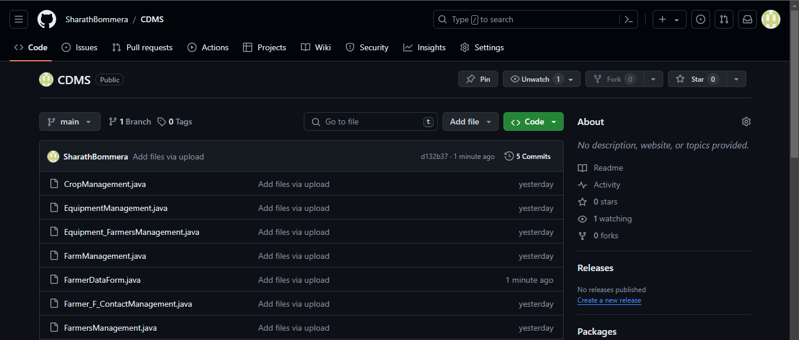

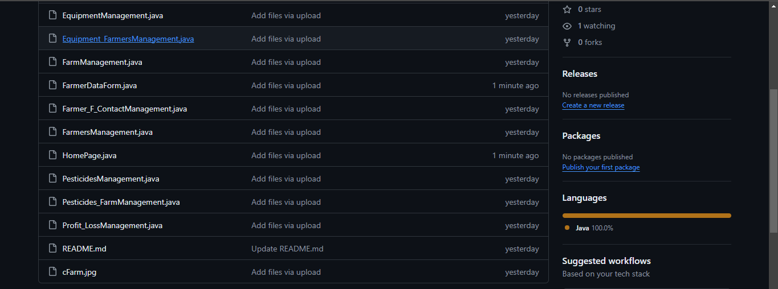

# TESTING

**Starting MySqld server:**

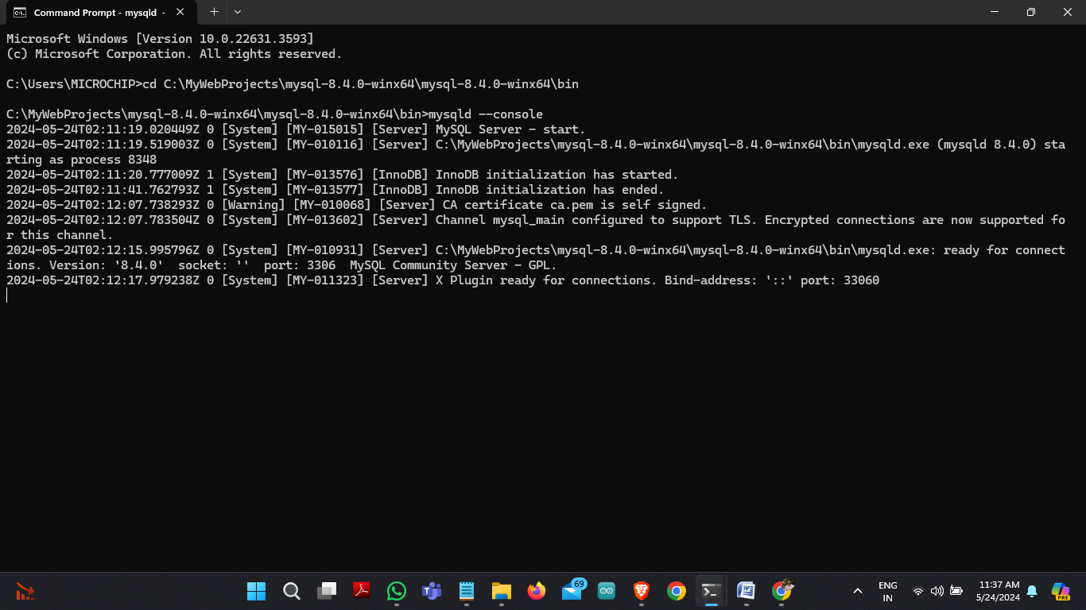

**Running MySql Monitor:**



**HomePage:**

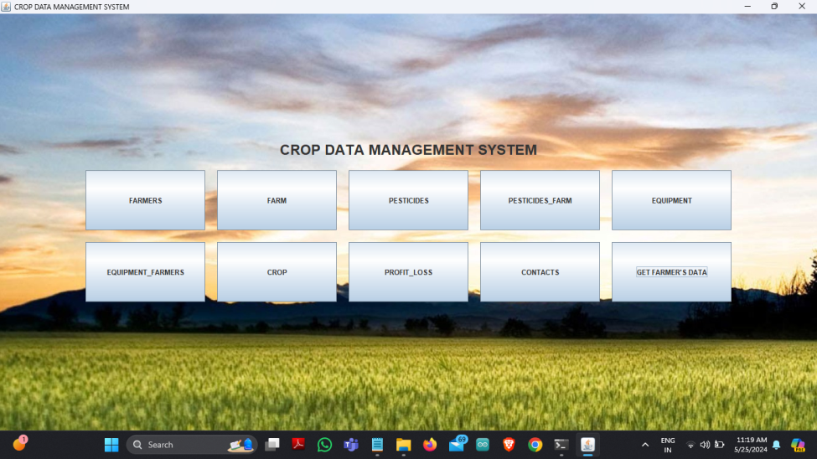

**Farmers:**

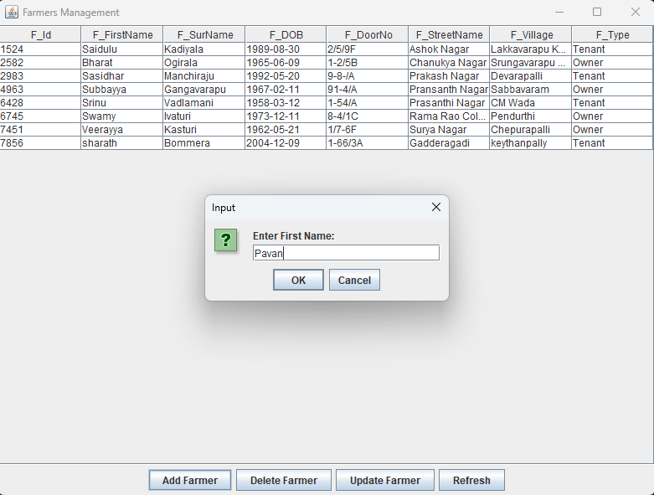

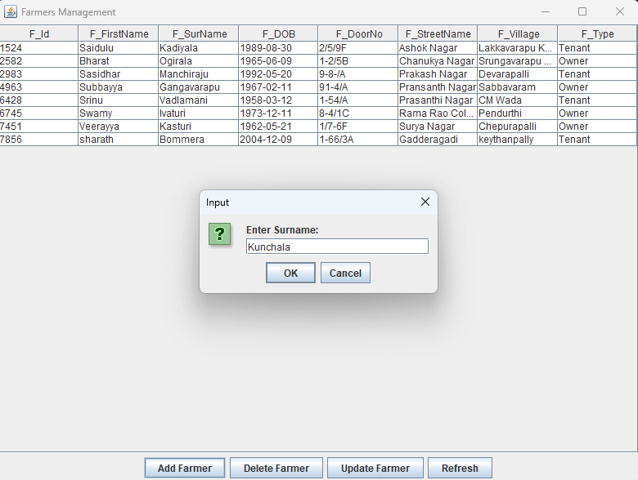

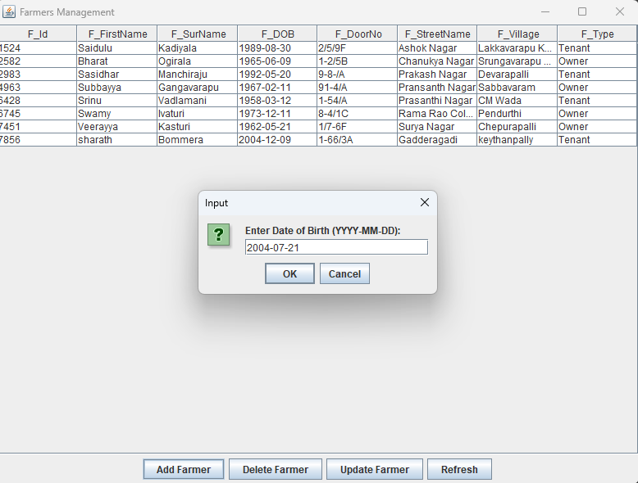

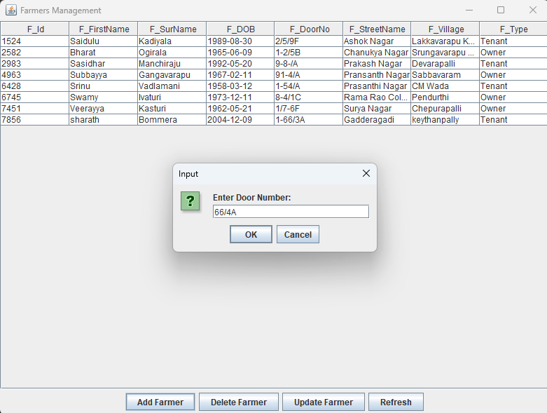

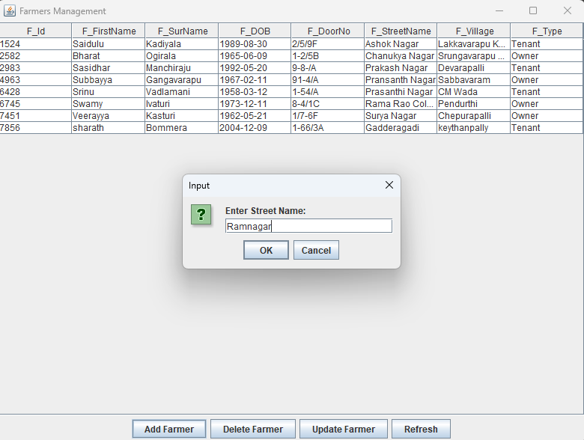

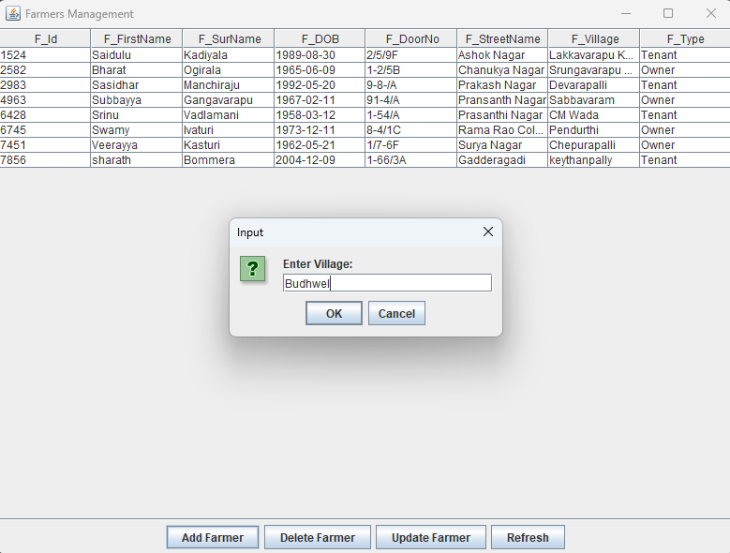

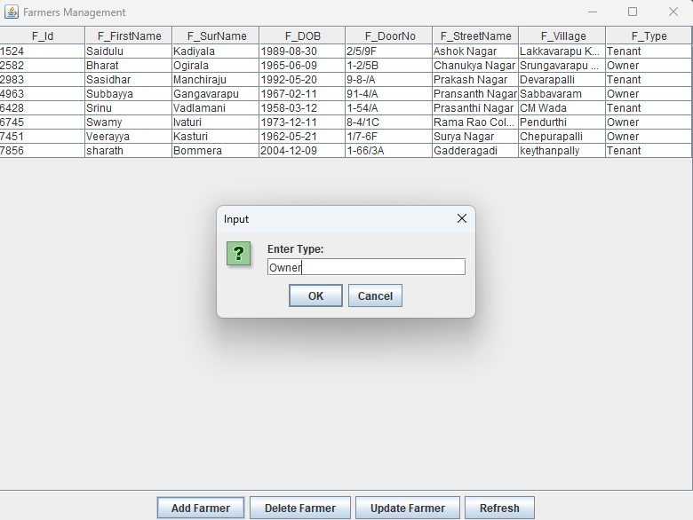

**Farm;**

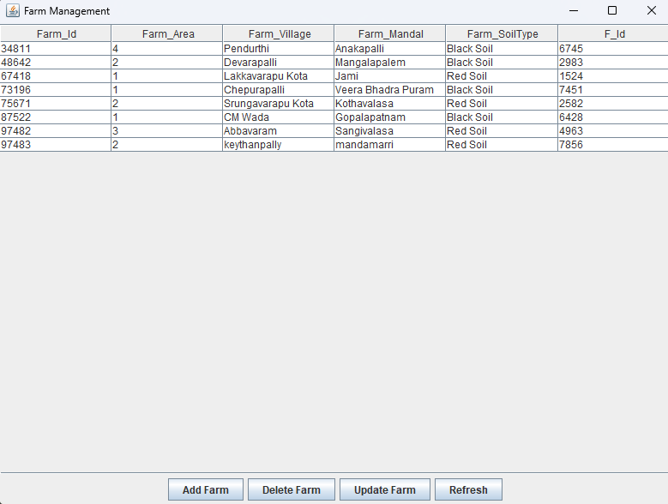

**Pesticides:**

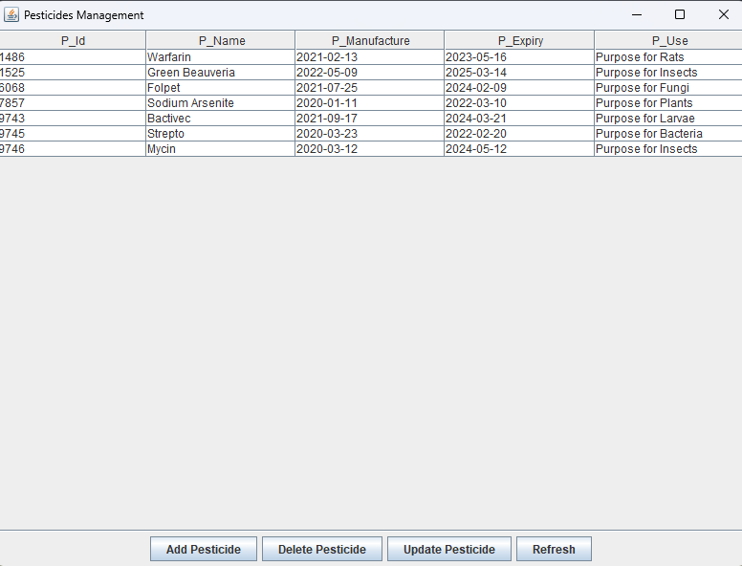

**Pesticides_Farm:**

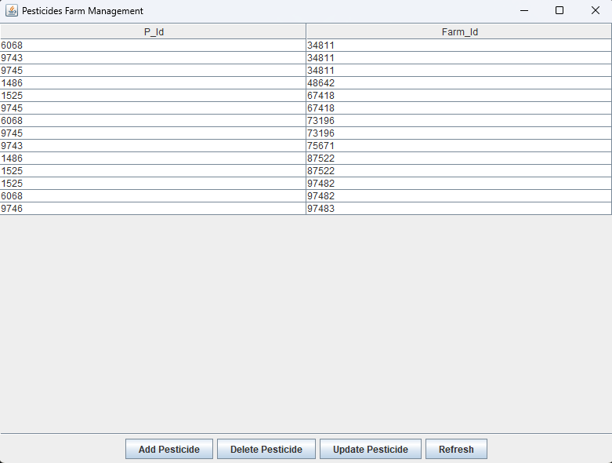

**Equipment:**

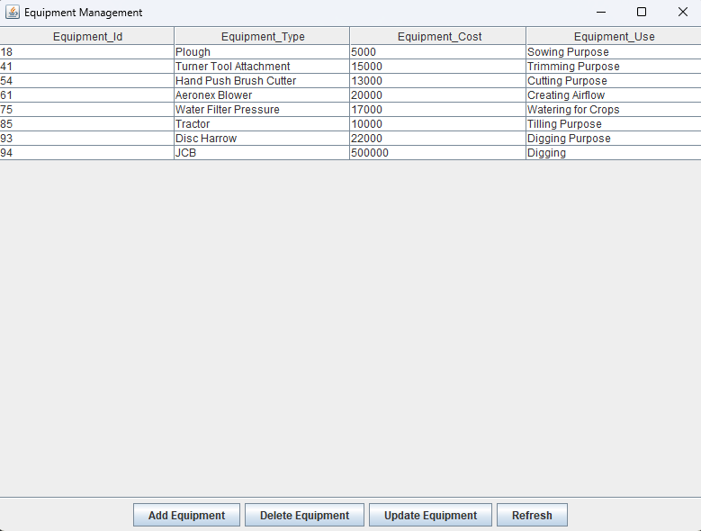

**Equipment_Farmers:**

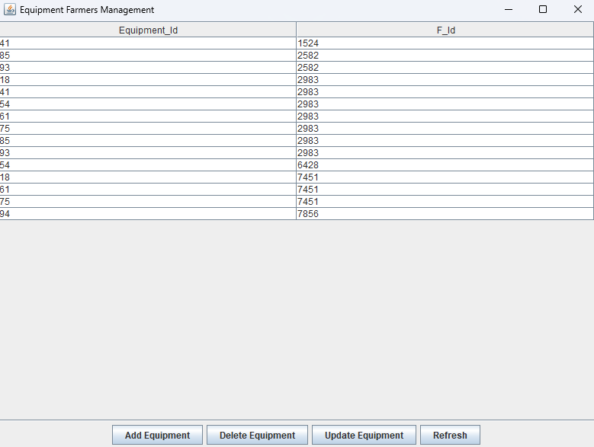

**Crop:**

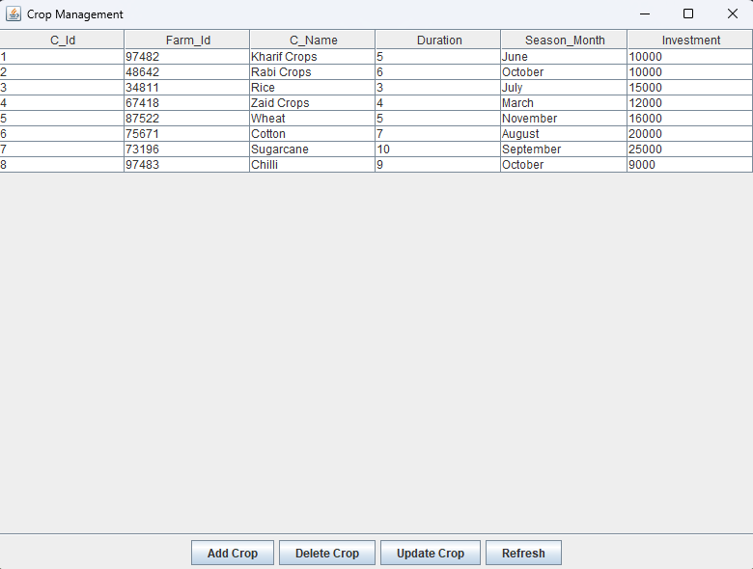

**Profit_Loss:**

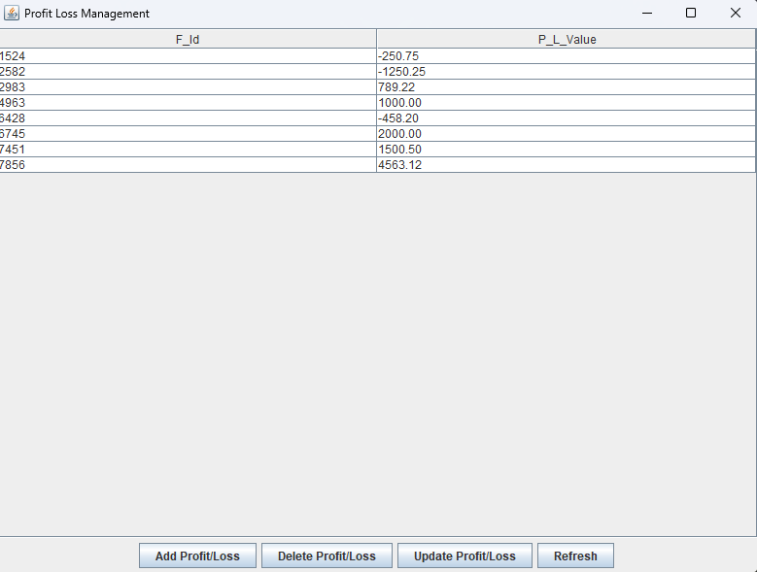

**Contacts:**

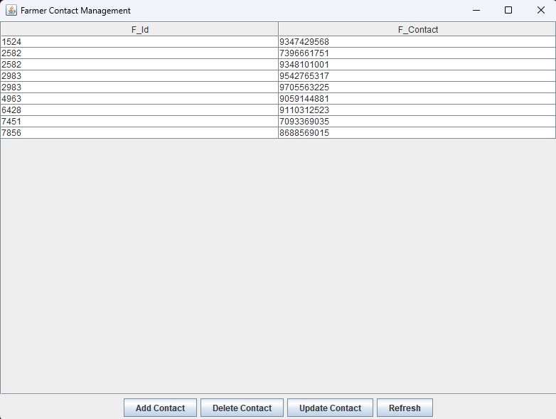

**GET FARMER’S DATA:**

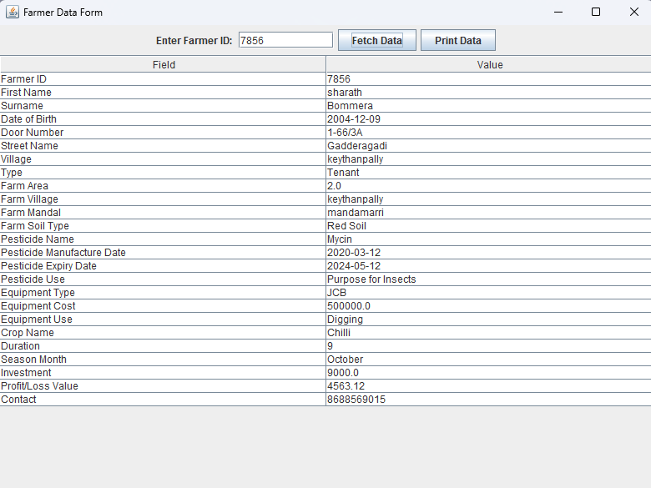

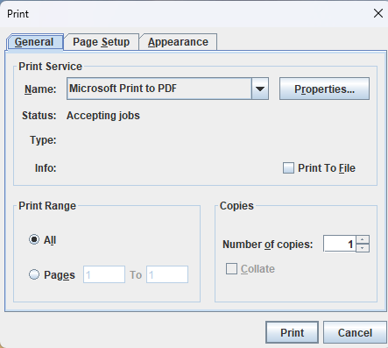

# RESULTS

I have successfully completed the mini project “**CROP DATA MANAGEMENT SYSTEM**”

# DISCUSSION AND FUTURE WORK

In the future, the Crop Data Management System (CDMS) could see improvements in various areas. Enhancements might include a more user-friendly interface for easier navigation and customization options, empowering users to tailor their experience. Integrating data analysis tools and predictive analytics could offer valuable insights into crop trends and yield forecasts. Mobile app development could extend accessibility, while IoT integration could automate data collection from sensors, enhancing real-time monitoring capabilities. Strengthening security measures and optimizing performance for scalability would ensure data integrity and smooth operation. Moreover, compliance with agricultural standards and ongoing user support would guarantee the CDMS's reliability and usefulness in modern agriculture..

# REFERENCES

* <https://www3.ntu.edu.sg/home/ehchua/programming/java/JDBC_Basic.html>
* <https://www3.ntu.edu.sg/home/ehchua/programming/sql/MySQL_HowTo.html/>
* <https://www.mysql.com/>