Diabetes Prediction
Using Neural Network, ADABoost, And XGBoost Algorithms
Shiva Ramezani, Vedant Vartak
California State University Northridge

Abstract
As a chronic disease, Diabetes is one of the most prevalent, opportunistic complications that has caused major public health concerns. Although this disease has almost reached epidemic proportions globally, humankind has been unable to find a cure for it. Therefore, the most crucial issue is to make very accurate predictions. One of these techniques is to employ machine learning algorithms. As a result, we used artificial neural networks, XGBoost, and AdaBoost to predict whether a person is diabetic in this paper. Our goal is to utilize these three algorithms that have been less studied in previous articles and get accuracy level better or at least equal to the result of the other algorithms used in the other investigations. By training data, we could achieve accuracy of 81% in both Neural Network and XGB algorithms and 96% in AdaBoost.

1. Introduction
Diabetes mellitus, or diabetes as we all know it, is a collection of metabolic illnesses characterized by a constant rise in blood sugar levels over time. According to the International Diabetes Federation, 8.8% of the world's population (approximately 415 million individuals worldwide) have diabetes [1]. This is a very critical problem as the data above suggests that in about 20 years, there will be a 15% increase in diabetes patients from what there are today. Thus, it has become necessary to immediately detect and cure this disease to stop this exponential growth in the number of patients. For this purpose, machine learning has been used extensively by many people who have come up with prediction models using various algorithms. They have detected if a patient has diabetes or not with the help of his medical data, family history and similar other factors. [2] The dataset of patients is obtained from hospitals who conduct physical examinations on patients from time to time. The Pima Indian Diabetes database provided by the National Institute of Diabetes and Digestive Kidney Diseases database has been used in many papers. Both supervised and unsupervised algorithms were found to be employed in our study, while supervised learning techniques such as Random Forest, K - Nearest Neighbor (KNN), and Decision Tree were used more frequently. [3] These algorithms have worked well to predict whether a person has diabetes or not as they have given an accuracy around and above 90%. [4]
Now, we will explain these algorithms briefly.

1.1. KNN
The k-Nearest-Neighbors (KNN) method is a simple and effective classification technique. The inefficiency and dependency on the selection of k are its key drawbacks [5].

1.2. Random Forest
Random Forest is a new Machine Learning Algorithm. Random Forest is a classification algorithm that combines several different tree structure classification algorithms. Random Forest features a diverse cast of characters. Random Forest is a classification and prediction system with regression capabilities. In comparison to typical algorithms, Random Forest has several advantages. As a result, Random Forest can be used in a variety of situations [6].

1.3. Decision Tree
The decision tree consists of several nodes and branches in which it sorts the specimens in such a way that it grows from the root downwards and eventually reaches the leaf nodes. Each internal or non-leaf node is identified by a property. This feature raises questions about the input example. In each internal node there are as many branches as possible with the answer to this question, each with the value of that answer. The leaves of this tree are identified by a class or a class of answers [7].

2. Dataset
Pima Indians Diabetes Database (also known as PID) was used for this investigation. The original data for this dataset came from the National Institute of Diabetes and Digestive and Kidney Diseases. The purpose of the dataset is to use diagnostic parameters to determine if a patient has diabetes. Many constraints were applied to the selection of these examples from a larger database. This dataset only consists of the data of Pima Indian women who are above 21 years old. The file of this dataset is available on “Kaggle.com” website [8]. This dataset has 2000 instances or rows. There are 8 descriptive features on this dataset which are: pregnancies (number of times pregnant), glucose (plasma glucose concentration a 2 hours in an oral glucose tolerance test), blood pressure (diastolic blood pressure; mm Hg), skin thickness (triceps skin fold thickness; mm), Insulin (2-hour serum insulin; U/ml), BMI (body mass index; weight in kg; height in m), diabetes pedigree function, and age (in years). [9]
The target feature is called outcome which has binary value. One indicates diabetes and zero indicates no diabetes.

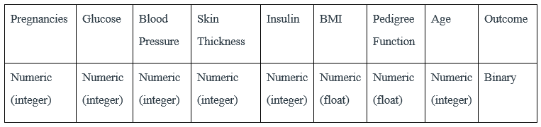
Table 1. Dataset features

The pedigree function is calculated using the below formula, where i and j are the relatives with diabetes and without diabetes. K is the fraction of shared genes, and ADMi and ACLj represent the age of relatives [8].
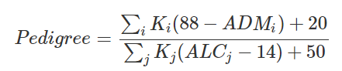 [8]

3. Methodology
In this project, three algorithms have been utilized: Neural Network, XGBoost, and AdaBoost. In the continuation of this section, we will describe these three types of machine learning models.

3.1. Neural network
Artificial Neural Network (also known as ANN) is perfect for predicting illness occurrence in individuals, It accomplishes this by fitting a nonlinear correlation between input and output variables until a high level of accuracy is reached. [10]
ANN’s are mathematical models that try to replicate the function of the human intelligence, as well as the interconnections between them. They're usually made up of layers of simple, tightly connected neurons. In ANNs, there are many alternative architectures.[11] Multilayer perceptron neural networks are the most basic and widely used neural network topologies. There are three layers in a MLPNN: an input layer, an output layer, and a few hidden layers. The input layer neurons simply act as buffers, distributing input impulses to the hidden layer neurons. Each hidden layer neuron sums its input signals after weighting them according to the strengths of the relevant input layer connections, then computes its output as a function of the sum. The function can be a Sigmoid or hyperbolic tangent function. The output of neurons in the output layer is computed in the same way. The process of training a network comprises employing a learning algorithm to change the network's weights.[12] Here is the formula:
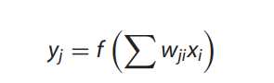[12]

3.2. XGBoost (Extreme Gradient-Boosted Tree Model)
Gradient tree boosting is a machine learning approach that succeeds in a range of applications. Tree boosting has been found to deliver good performance on a variety of common classification benchmarks. [13]
XGB is a very efficient supervised learning algorithm that has been demonstrated to produce precise results in a wide range of classification challenges. It's known for its resistance to outliers, ability to cope with small datasets, and ability to handle feature selection automatically. As a result, it was a good fit for the goal of this project. [14]
A tree ensemble model utilizes K additive functions to forecast the output for a data set with n examples and m features [14]. Here is the formula:
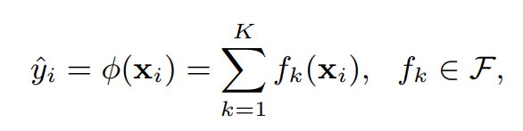[14]

“The space of regression trees is F = f(x) = wq(x)(q: R m T, w R T). Each tree's structure that maps an example to the relevant leaf index is represented by q. The number of leaves on the tree is indicated by the letter T. Each f_{k} is associated with a unique tree structure q and leaf weights w. We use w_{i} to indicate the score on the i-th leaf, unlike decision trees, which include a continuous score on each of the leaves.” [14]

3.3. AdaBoost
AdaBoost is a relatively new machine learning classification algorithm. It is a group algorithm that combines many weak learners (decision trees) and turns them into a strong learner. AdaBoost is like random forests, meaning that predictions are made from many decision trees. However, there are three main differences that make AdaBoost unique:
First, AdaBoost creates a forest of tree trunks instead of a tree. It is a tree stump that consists of only one node and two leaves (as in the picture above).
Second, the stumps that are created do not have equal weight in the final decision. Stumps that make more mistakes will play a lesser role in the final decision.
Ultimately, the order in which the stump is created is important because each stump intends to reduce the errors made by the previous stump.

3.4. Data Preprocessing
In machine learning initiatives, data pre-processing is critical. It's because the data's quality, as well as the relevant information that can be derived from it, has a direct bearing on our model's learning ability. As a result, preprocessing our data before importing it into our model is critical. [15]
Handling null values, handling categorical variables, standardization, and one-hot encoding are the most important and efficient ways to preprocess the data before training it with the model. For this project, we checked the whole dataset for zero, null, and missing values. Imputation helps a lot to handle these values. Taking care of zero values helps the programmer to get the correct result. For example, the mean, mode, and std values for each feature will be incorrect if there are zero values among all values of a feature. Moreover, standardization and scaling help to normalize the data into a particular interval. We performed MinMaxScaler to scale our data for the neural network modeling and Normalizer for the XGBoost modeling.

3.5. Data visualization
Utilizing matplotlib helps to visualize the correlation matrix which we can see in the below figure. We can see that age is the most correlated feature to diabetes.
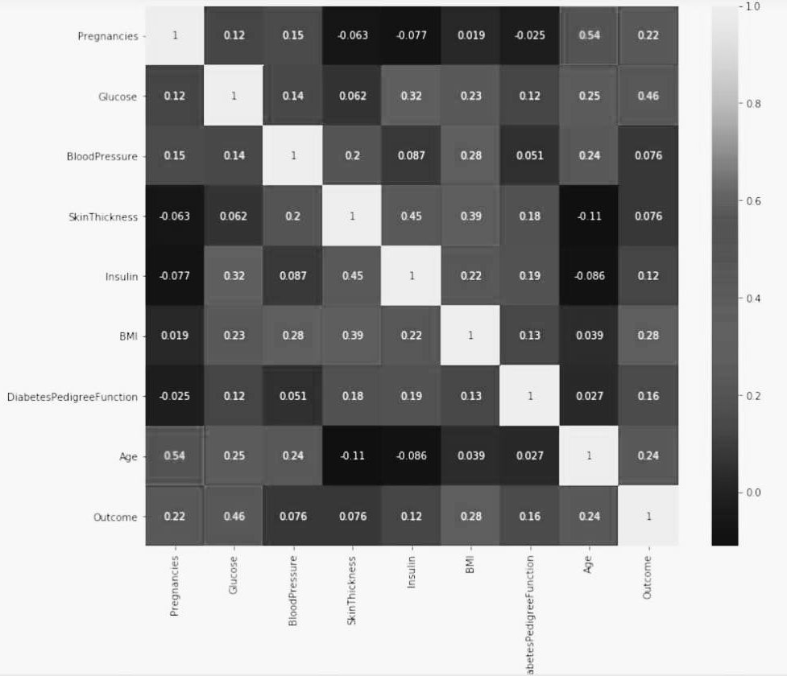
Fig.1 - Correlation between all the features

3.6. Tools
In this project, Python programming language has been utilized to develop machine learning models for prediction, data imputation, augmentation, and feature ranking. Python and its fundamental libraries make machine learning possible. We have manipulated arrays of numbers with the NumPy library, then have dealt with tabular data with the Pandas library. Then, to visualize data, we utilized the matplotlib software, which is beneficial because it allows you to plot a variety of charts to readily see your data. Jupyter Notebook, on the other hand, is a web-based editor for working with Python projects. It allows the user to run each line of code and examine the results independently. [16]
In addition, Anaconda’s package manager, is utilized for installing, updating, and managing libraries and packages. To work with Jupyter Notebook, you can use Anaconda to install different languages, packages, and libraries.
In addition, Conda, Anaconda's own package manager, is also used to update and manage Anaconda and its packages. Users can install different packages, libraries, and languages (such as Python, R, JavaScript, Julia, and so on) to work in a Jupyter Notebook using Anaconda.

4. Results
4.1. Neural Network algorithm
The appropriate number of layers for creating a model with a neural network algorithm depends on the project type and its difficulty level. For the diabetes prediction project, we found out that a 2-layer model will work the best. We utilized two activation functions: rectified linear activation function (also known as ReLU) and sigmoid. Our choice of optimization algorithm for the neural network model is Adam optimization algorithm. For deep learning model training, Adam is an alternative for stochastic gradient descent. Adam can enhance the performance of a deep and wide neural network. [17]
The very first result we got from the neural network algorithm was as it is shown on the figure below:
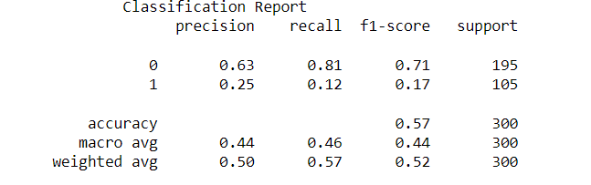
Fig.2 - Results of first diagnosis for Neural Networks algorithm

The result was not as we expected. By changing the number of layers and the test and train ratio, the result improved significantly. The final result of the neural network is shown in the below figure:
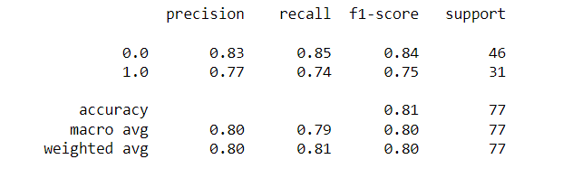
Fig.3 - Results of second diagnosis for Neural Networks algorithm
The accuracy is 81% which is very good. Moreover, we also measured the performance of the final model using cross_val_score, which takes an average over cross-validation fields, it turned out 78.3%. This is a satisfying result.

4.2. XGBoost
By training the data into the XGBoost algorithm a very good result showed up. Which is shown in the figure below:
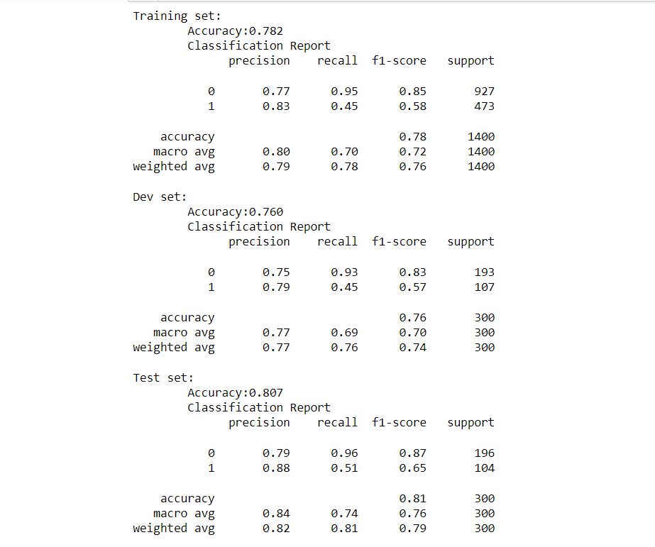
Fig.4 - Results of diagnosis for XGBoosting algorithm
The characteristics of the XGB model is as follows: objective ='reg:linear', colsample_bytree = 0.3, learning_rate = 0.1, max_depth = 5, alpha = 10, and n_estimators = 10.

4.3. AdaBoost
By training the data into our AdaBoost model, we could achieve a very high accuracy. The accuracy is 96%, R² score is 0.80, and mean square error is 0.043. The classification report of the model is shown in the following figure:
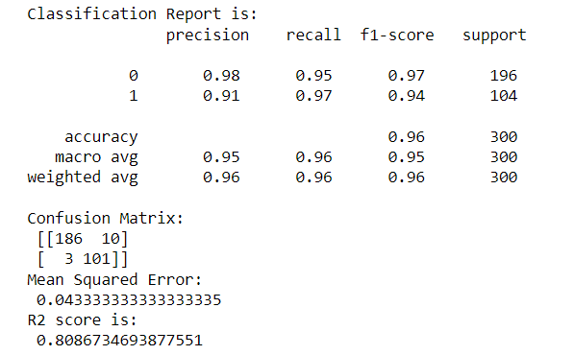
Fig.5 - Results of diagnosis for adaBoost algorithm

The result for this algorithm is very satisfying.

5. Discussion
Many of the research papers we studied had the diabetes prediction model done using algorithms such as Decision Tree, Random Forest, Linear Regression, etc. which are comparatively simple to implement. Therefore, we decided to implement the model using neural networks. Our main goal was to try applying more complicated algorithms to the dataset. We chose to go ahead with neural networks. Our expectation was that the accuracy would be up to the 90% mark if not more. But after running the tests we found that we were getting only 57% accuracy which is very low. We changed the structure of the model and the number of layers and ratio of the test and train. After this we got the accuracy at 81% which is on par with what we were expecting. Yet, we decided that we should try another algorithm to support our findings as well as getting another perspective. We chose XGBoosting. The 81% accuracy we got is a good score. We didn’t face any surprising results. We also trained our data into a simpler algorithm, AdaBoost, to be able to compare the result. We could get 96% accuracy for it. Our assumption for this paper was that we could get way higher accuracy levels than previous works as they were all using simple algorithms. In the end, we concluded that on simple datasets and prediction problems, it is not guaranteed to get higher scores with more complicated algorithms. Our result showed that AdaBoost had a very better result compared to the neural network algorithm.

6. Limitations / Future Work
The major factor in carrying out this work is obtaining data of patients from medical facilities. This can sometimes be difficult as most of the major hospitals and healthcare units prefer to keep the data of their patients confidential on the ground of integrity. This could be a major hurdle if we are to make machine learning models for prediction of diabetes more prominent. Another point of contention is that datasets used for the model can be old and may miss out on a recent trend causing diabetes. For example, the threshold of blood pressure for having a negative outcome on this model may have gone down in recent which may not be reflected in older datasets. Therefore, it is imperative that recent datasets should be used for these models to obtain a higher accuracy on the prediction models.
We hope that in future, our work can be developed further by other peers and colleagues to build a prediction model having even better results and higher accuracies using complicated algorithms.

7. Conclusion
As diabetes is exponentially on the rise day by day, it is vital that it is detected and cured at an early stage. For this reason, diabetes prediction using machine learning can be an effectively way to bring curb to this issue. After studying various research papers, we found out that lot of papers have tried to build their prediction model using random forest, decision tree and KNN which are relatively simple to implement. Thus, we decided to build our model using complicated algorithms and our aim was to obtain a higher accuracy than the previous algorithms. In our work, we tried to work on a dataset by using three different algorithms, namely – neural networks, XGBoost, and Adaboost. We obtained 81% accuracy for neural networks and XGBoost while we got 96% accuracy when we tried implementing the model with AdaBoost. Thus using complicated algorithms reduced the accuracy significantly which opposed our hypothesis. Nevertheless, the results are satisfactory enough to say that we have successfully built a prediction model.

8. Reference list

- Thomas R. Einarson, Annabel Acs, Craig Ludwig, Ulrik H. Panton, Prevalence of cardiovascular disease in type 2 diabetes: a systematic literature review of scientific evidence from across the world in 2007–2017
- Aishwarya Mujumdar, V Vaidehi, Diabetes Prediction using Machine Learning Algorithms, Procedia Computer Science, Volume 165, 2019, Pages 292-299
- Analysis and prediction of diabetes diseases using machine learning algorithm: Ensemble approach - IRJET Journal (Volume: 04 Issue: 10 | Oct -2017
- S. Dewangan.et.al. Int. Journal of Engineering Research and Application ISSN: 2248-9622, Vol. 8, Issue 1, (Part -II) January 2018, pp.-09-13
- Guo, Gongde, et al. "KNN model-based approach in classification." OTM Confederated International Conferences" On the Move to Meaningful Internet Systems". Springer, Berlin, Heidelberg, 2003
- Liu, Yanli, Yourong Wang, and Jian Zhang. "New machine learning algorithm: Random forest." International Conference on Information Computing and Applications. Springer, Berlin, Heidelberg, 2012
- A. Navada, A. N. Ansari, S. Patil and B. A. Sonkamble, "Overview of use of decision tree algorithms in machine learning," 2011 IEEE Control and System Graduate Research Colloquium, 2011, pp. 37-42
- M. K. Hasan, M. A. Alam, D. Das, E. Hossain and M. Hasan, "Diabetes Prediction Using Ensembling of Different Machine Learning Classifiers," in IEEE Access, vol. 8, pp. 76516-76531, 2020, doi: 10.1109/ACCESS.2020.2989857
- Kaur, H. and Kumari, V. (2022), "Predictive modeling and analytics for diabetes using a machine learning approach", Applied Computing and Informatics, Vol. 18 No. 1/2, pp. 90-100. https://doi.org/10.1016/j.aci.2018.12.004
- Li, Huixia PhD; Luo, Miyang MD; Zheng, Jianfei MD; Luo, Jiayou PhD; Zeng, Rong MPH; Feng, Na MPH; Du, Qiyun MD; Fang, Junqun MPH An artificial neural network prediction model of congenital heart disease based on risk factors, Medicine: February 2017 - Volume 96 - Issue 6 - p e6090
- Maren A, Harston C and Pap R, Handbook of Neural Computing Applications. Academic Press, London (1990)
- GÜCLÜ, Dunyamin, et al. “Application of Neural Network Prediction Model to Full-Scale Anaerobic Sludge Digestion.” Journal of Chemical Technology and Biotechnology (1986), vol. 86, no. 5, John Wiley & Sons, Ltd, 2011, pp. 691–98
- Chen, T.; Guestrin, C. XGBoost: A scalable tree boosting system. In Proceedings of the 22nd ACM SIGDD Int Conf on Knowledge Discovery, San Francisco, CA, USA, August 2016; pp. 13–17
- Cappon, G., Facchinetti, A., Sparacino, G., Georgiou, P., & Herrero, P. (2019). Classification of postprandial glycemic status with application to insulin dosing in type 1 Diabetes—An in silico proof-of-concept. Sensors, 19(14)
- Chmielewski, Michal R., and Jerzy W. Grzymala-Busse. "Global discretization of continuous attributes as preprocessing for machine learning." International journal of approximate reasoning 15.4
- Lee, Wei-Meng. Python Machine Learning. 1st edition, Wiley, 2019.
- Jais, Imran Khan Mohd, Amelia Ritahani Ismail, and Syed Qamrun Nisa. "Adam optimization algorithm for wide and deep neural network." Knowledge Engineering and Data Science 2.1 (2019): 41-46

