**Name**: Shiva Ramezani

**Batch code:** [LISUM21](https://canvas.instructure.com/courses/6781462)

**Submission Date:** 05/31/2023

**Submitted to:** <https://github.com/ShivaRamezani/FlaskDeplymentIRIS>

App.py file:

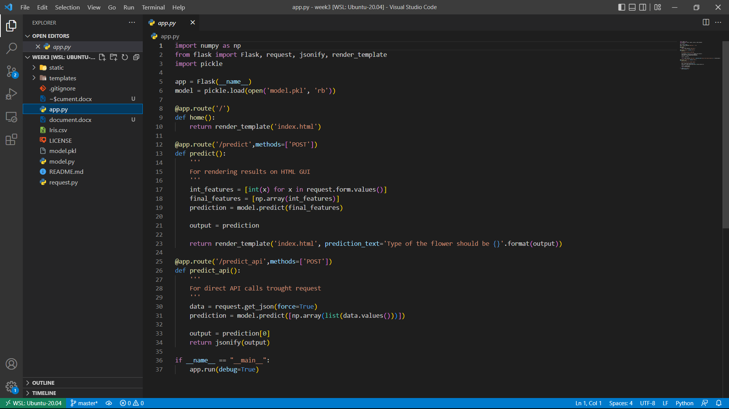

Model.py file:

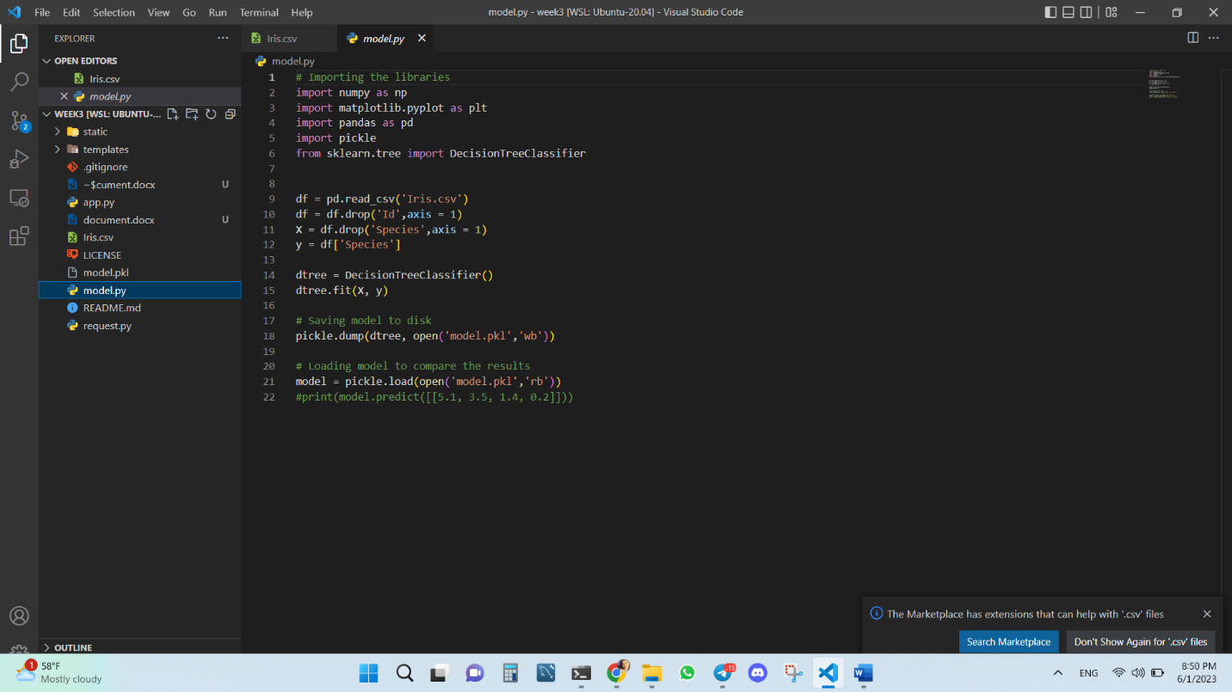

Request.py file:

Command line prompts:

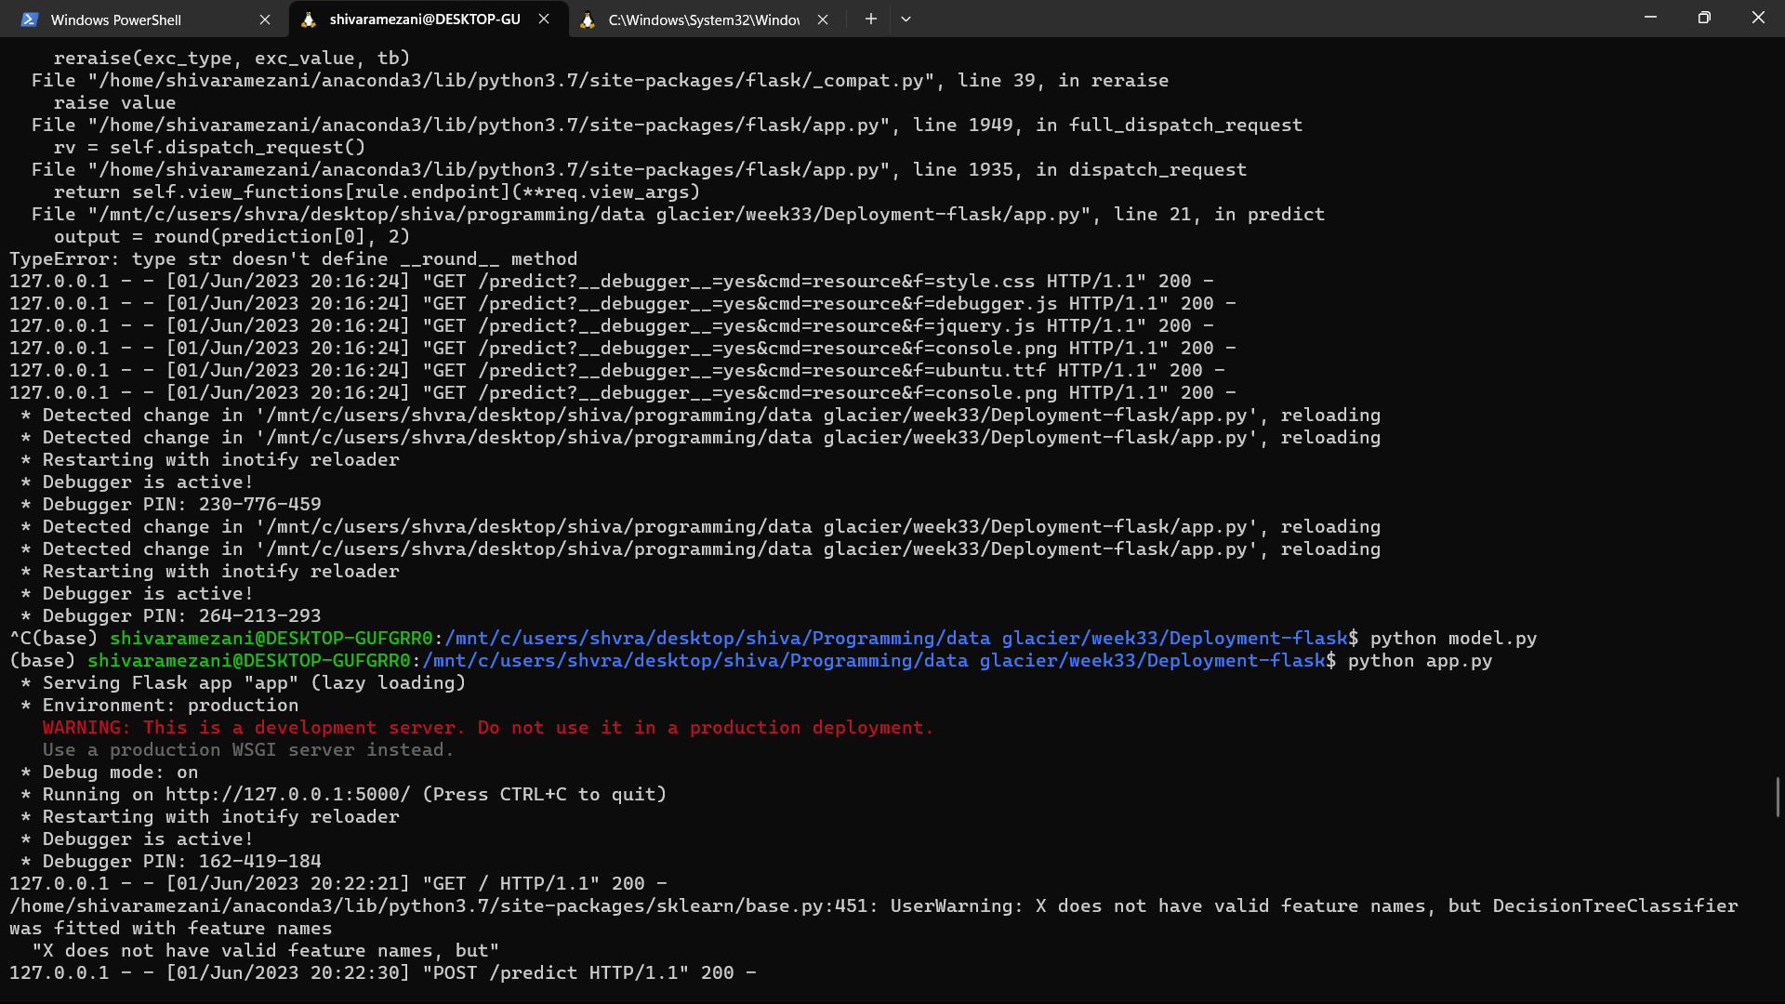

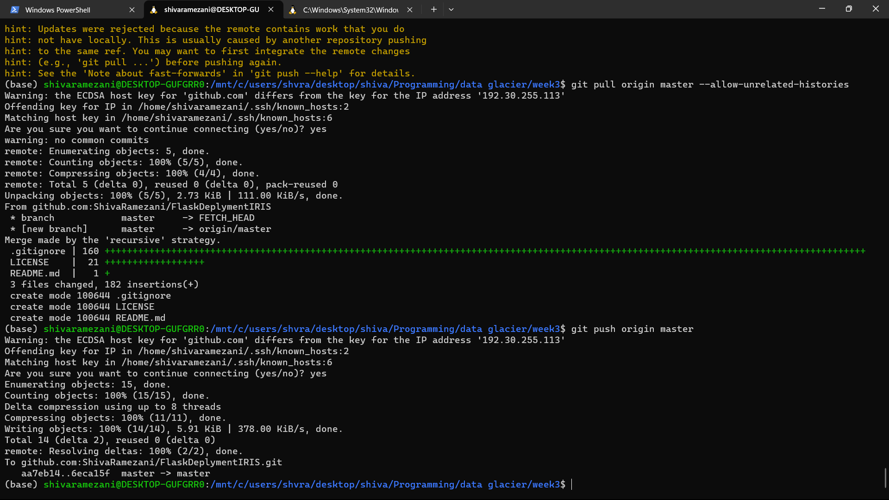

Web App:

