**Name**: Shiva Ramezani

**Batch code:** [LISUM21](https://canvas.instructure.com/courses/6781462)

**Submission Date:** 06/03/2023

**Submitted to:** [**https://github.com/ShivaRamezani/HerokuIris**](https://github.com/ShivaRamezani/HerokuIris)

**Creating app on Heroku after signing up:**

**Connecting to GitHub:**

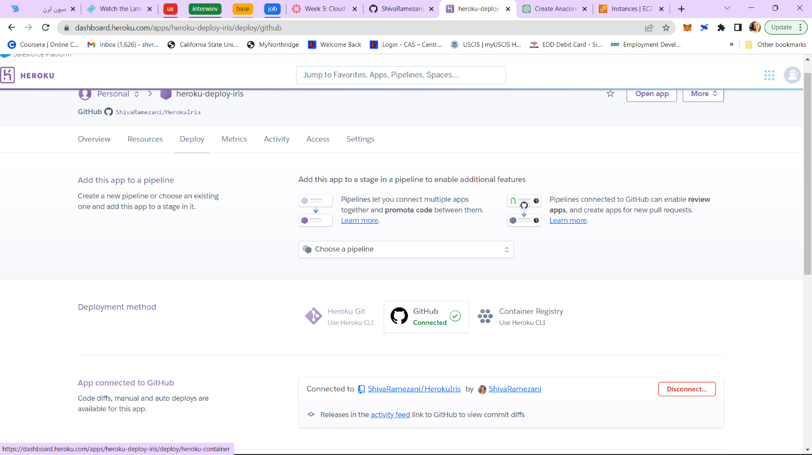

**Deploy the branch manually:**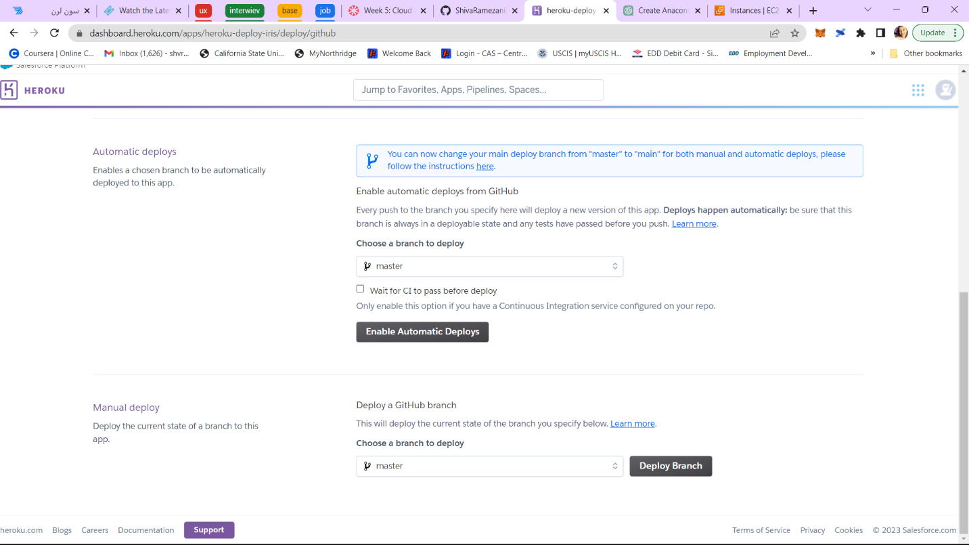

**App was successfully deployed:**

**After checking the deployed app, I saw this error and couldn’t fix it in anyway!****-Procfile:** 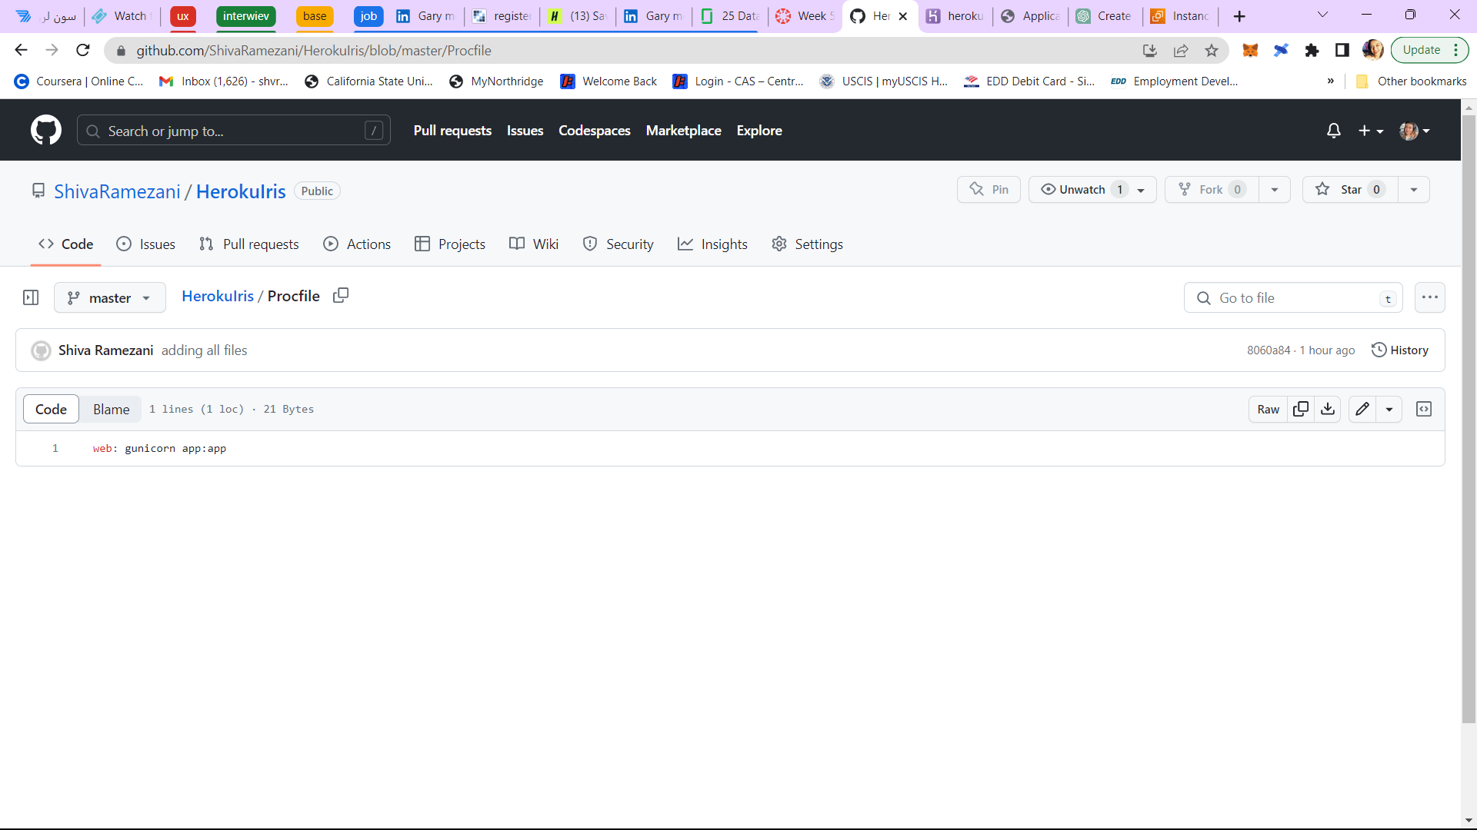

**Requirements.txt file that was created by this command: pip list --format=freeze > requirements.txt**

