SENSORS

1. **Temperature:** TE NTC thermistor sensors are used for temperature measurement and are qualified for extended space flight applications per the NASA GSFC S-311-P-18 specification. The thermistors are small, with high sensitivity and include operational temperatures from -55°C to 150°C with dimensions ranging from 2.4 mm to 2.8mm.

**LM35**

1. **Moisture:** The optimal range of soil moisture content for crops depends on the specific plant species, but the range for most crops is between 20% and 60%.

Volumetric moisture sensors for soil determine the water-to-soil volume percentage. Two common varieties of volumetric sensors are neutron probes and electromagnetic sensors.

Electromagnetic sensors have been alternatives to neutron probes since the late 1980s. Let’s consider the most typical examples of electromagnetic sensors:

* 1. Capacitance or frequency-domain refractometry (FDR) sensors generate an electromagnetic signal and analyze the frequency shift between the outgoing and reflected waves.
  2. Time-domain reflectometry (TDR) soil moisture sensors use voltage on parallel rods to cause pulses, which are then reflected to the device for analysis.
  3. Transmissometry sensors in the time domain (TDT) share the same principle as TDRs but utilize a closed circuit with the rods connected in a loop. Similar to time-domain reflectometers, the speed of the returned pulse will be lower in damp ground than in dry ground.

Thus, FDR sensors shall be used.

1. **Light:**

Sunlight Detection Option: [Grove – Sunlight Sensor](https://www.seeedstudio.com/Grove-Sunlight-Sensor.html?utm_source=blog&utm_medium=blog)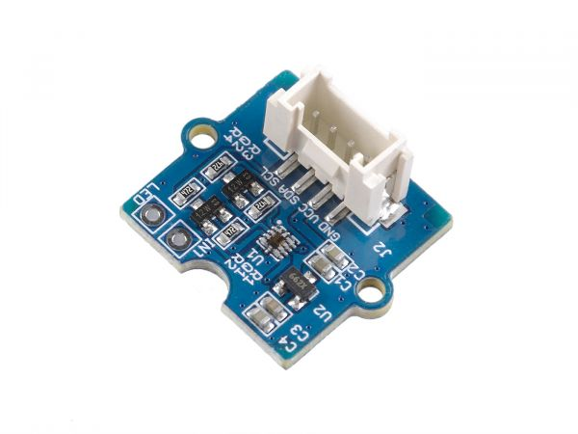

This sunlight sensor is based on the SI1145, a low-powered, reflectance-based, infrared proximity, UV index, and ambient light sensor with an I2C digital interface and programmable-event interrupt output.

**Features:**

* Variety of use (UV, visible, and infrared light)
* Wide spectrum detection range (280 – 950 nm)
* Programmable configuration
* Low power consumption (3.3/5V supply)
* Detect sunlight directly
* Onboard Grove port, I2C Interface (7-bit) for easy interfacing

1. **Gas/Smoke:** MQ2 Gas Sensor: The MQ2 sensor is one of the most widely used in the MQ sensor series. It is a MOS (Metal Oxide Semiconductor) sensor. Metal oxide sensors are also known as **Chemiresistors**because sensing is based on the change in resistance of the sensing material when exposed to gasses.