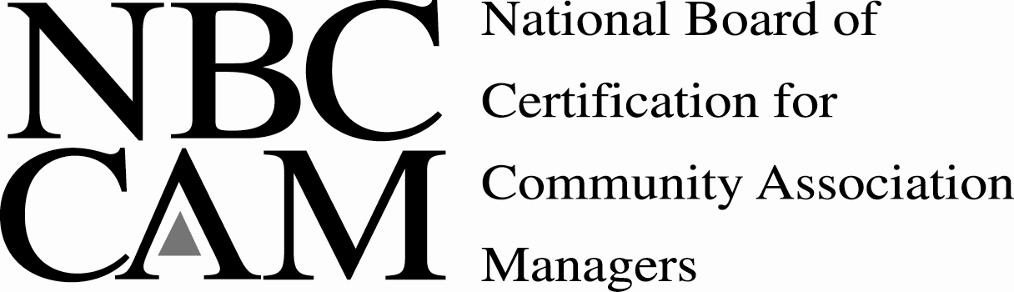
CMCA® Re-Certification
CONTINUING EDUCATION ACTIVITY WORKSHEET

IL Chapter - CAI
Educational Institution or Organization
Capital Improvements – This course offered a step by step explanation of managing the capital improvements process. 3
Title and Description of Program # of Hours
Northwestern Law School, Chicago, IL 6/13/08
Location Date

Levenfeld Pearlstein, LLC
Educational Institution or Organization
IL Condominium Act (The “Plain English Version”) – This presentation was a section by section explanation of the IL Condo Act. 4
Title and Description of Program # of Hours
Levenfeld Pearlstein Conference Room, Chicago, IL 1/16/08
Location Date

Gordon & Pikarski
Educational Institution or Organization
Training on Tax Appeals – This presentation was an explanation of the tax appeal process. 1.5
Title and Description of Program # of Hours
Riverbend Conference Room, 333 N. Canal Street, Chi, IL 11/13/08
Location Date

Elliot & Associates
Educational Institution or Organization
Additional training on the triennial tax assessment appeals
process. 2.5
Title and Description of Program # of Hours
123 Wacker Drive 1/7/09
Location Date

Alexia Besbekos – Riddle, ARM
Educational Institution or Organization
Managing a Condominium in the City of Chicago – This training explained each and every inspection & permit unique to Chicago, handouts included all forms required. 2.5
Title and Description of Program # of Hours
3440 N. Lake Shore Drive Conference Room 2/30/09
Location Date

City of Chicago – Department of Buildings
Educational Institution or Organization
New Requirements of the Chicago Façade Inspection Ordinance – 2008 –
Detailed presentation about changes to the Façade inspection ordinance, classification of buildings, way critical and ongoing inspections can be performed, legal ramifications of the ordinance. 4
Title and Description of Program # of Hours
The Thompson Center 3/20/08
Location Date

Levenfeld Pearlstein, LLC
Educational Institution or Organization
The Collections Process – This training explained the collections process with special emphasis on changes (6 months from 3rd party). 1
Title and Description of Program # of Hours
Teleconference – Kerry Walsh 2/2/09
Location Date

