1. python –version

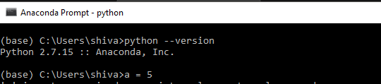

1. jupyter tests pages done in the in class notes including the matplotlib

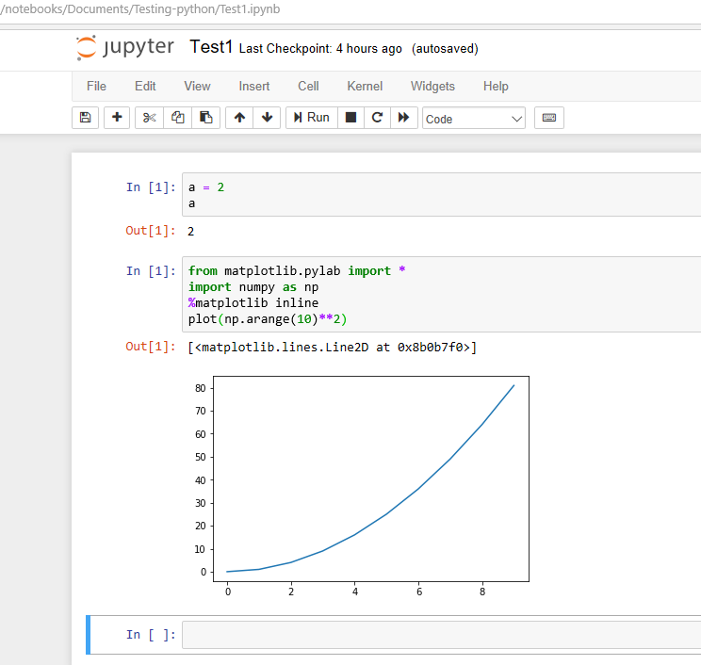

1. Spyder test

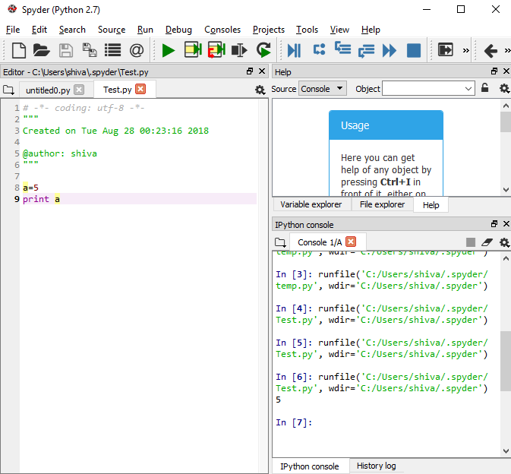

1. Generate the first 10 Fibonacci sequence numbers using a python program ( use a **while** or **for** loop ):

Using VScode 

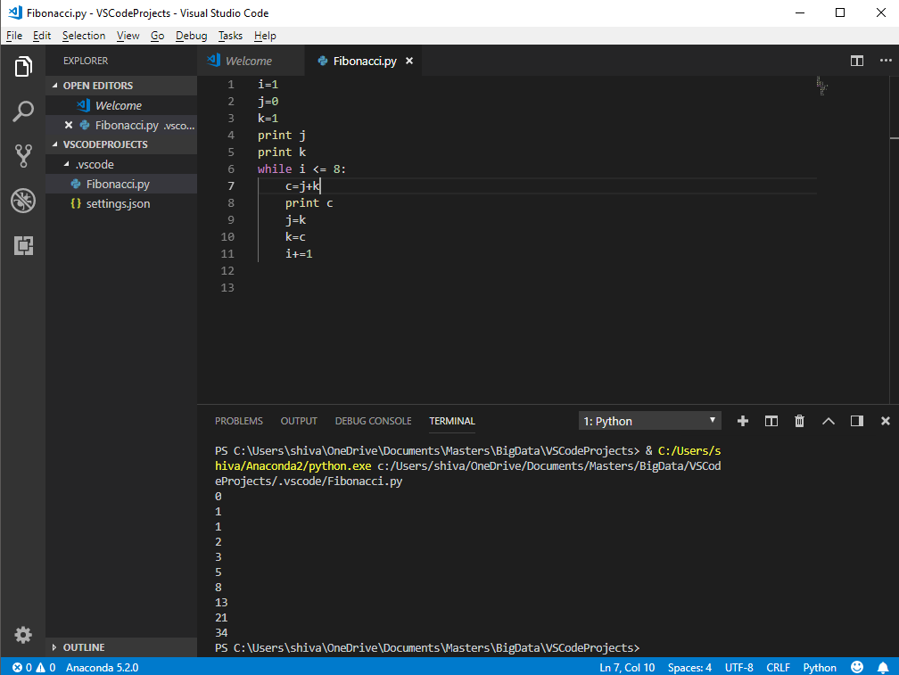

Using jupyter notebook

