**12.A employee_info**

**Query:**

create or replace view employee_info as select a.first_name||' '||a.middle_name||' '||a.last_name as Name_of_employee,a.street_address as address,

a.HOME_PHONE_NUMBER,a.CELL_PHONE_NUMBER,a.ZIP_CODE,a.SSN,a.SALARY,a.BIRTH_DATE, TRUNC(MONTHS_BETWEEN(SYSDATE, a.birth_date))/12 as age,

a.MARITAL_STATUS,a.SPOUSE_NAME,b.name,

a.LAST_DEGREE,a.DATE_DEGREE,c.first_name||' '||c.middle_name||' '||c.last_name as Employee_manager

from project.employee a,project.office b,project.employee c,project.office_employee d,project.office_general_manager e

where a.employee_id=d.employee_id and d.office_id=b.office_id and b.office_id=e.office_id and e.general_mgr_id=c.employee_id;

**Output:**

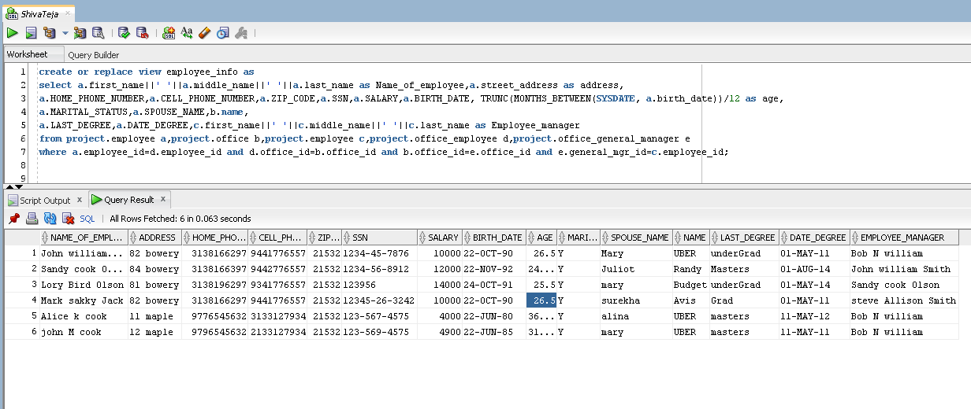

**12.b** **employee_salary Query:**

create or replace view employee_salary as

select first_name,last_name,street_address,ssn,salary,tax_deduction,birth_date,marital_status,branch as branch_name,

max(salary) over (partition by branch) as Highest_sal,avg(salary)over (partition by branch) as Average_sal from

(select a.first_name,a.last_name,a.street_address,a.ssn,a.salary,a.tax_deduction,a.birth_date,a.marital_status,

b.name as branch,c.office_id from project.employee a, project.office b,project.office_employee c

WHERE a.employee_id=c.employee_id and c.office_id=b.office_id);

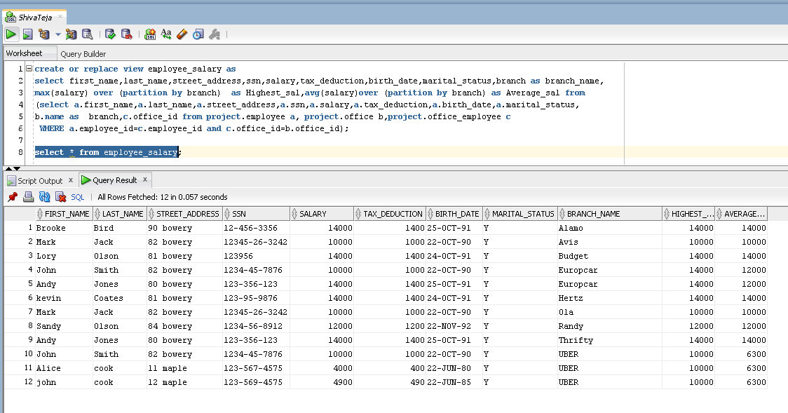

**12.c branch_info**

**Query:**

create or replace view branch_info as

select a.office_id,a.name,a.address,a.phone_number,a.fax_number,b.regular_open_hours,c.business_open_day,d.date_hired,e.first_name||' '||e.last_name as Manager_name from

project.office a,project.office_timings b,project.office_day c,project.office_general_manager d,project.employee e where

a.office_id=b.office_id and a.office_id=c.office_id and a.office_id=d.office_id and d.general_mgr_id=e.employee_id;

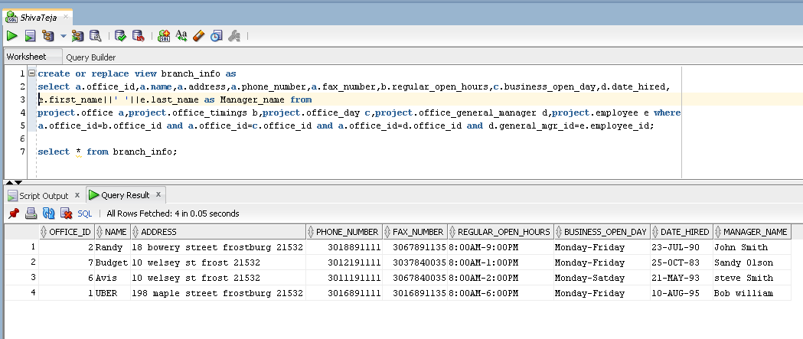

**12.d valued_customers**

**Query:**

create or replace view valued_customers as

select full_name,age,cell_number,address,zipCode,email,License_number,license_issued_state,number_of_times_rented from

(select customer_id,first_name||' '||last_name as full_name,(to_char(sysdate,'yyyy')-to_char(birth_date,'yyyy')) as age,

cell_phone as cell_number,Street_address as address,zip_code as zipcode,email as email,License_number as License_number,

license_issued_state as license_issued_state from project.customer)a join

(select customer_id,count(*) as number_of_times_rented from PROJECT.CAR_CUSTOMER_RENT group by customer_id)b on

a.customer_id=b.customer_id;

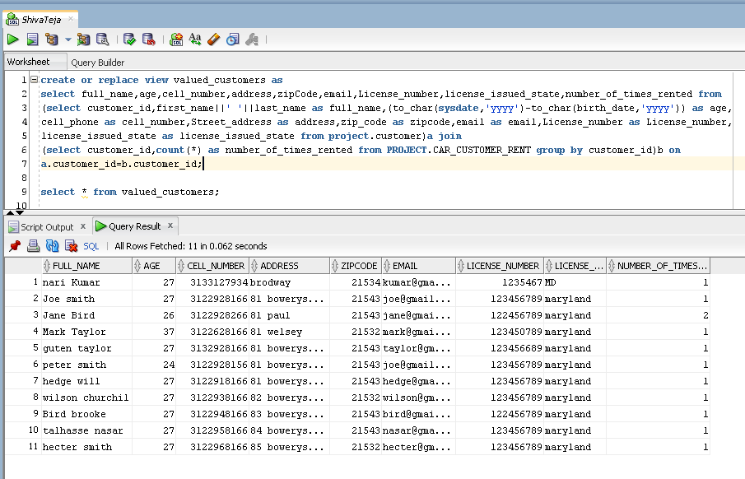

**12.e Query:**

create or replace view list_of_cars as

select VECH.car_id,VECH.car_plate_no,VECH.car_state_registeration,VECH.year,VECH.first_name||' '||VECH.last_name as Owner_name,

VECH.class,VECH.cost_damage,VECH.make,VECH.color,CCR.count_ccr as No_times_car_rented,ACD.count_ACD as No_times_car_accidents from

(select count(*) as count_ccr,car_id from project.car_customer_rent group by CAR_ID) CCR,

(select count(*) as count_ACD,car_id from project.accident group by car_id) ACD,

(select * from project.car CR join project.car_client_list CCL

on CR.car_id=CCL.car_id join project.client CL on CCL.client_id=CL.client_id

join project.accident ACDT on CR.car_id=ACDT.car_id) VECH where VECH.car_id=CCR.car_id and VECH.car_id=ACD.car_id;

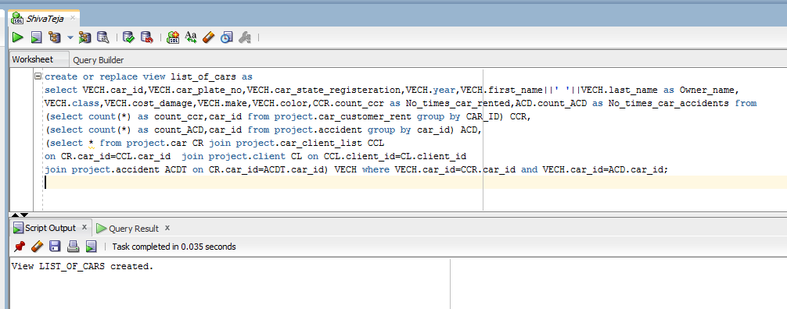

Select * from list_of_cars;

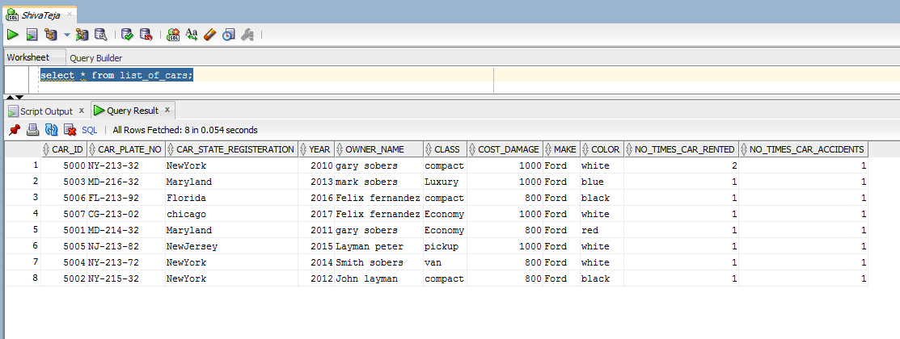

**12.f list_of_transaction**

**Query**

create or replace view list_of_transaction as

select a.car_id,a.payment_amount, 1*a.payment_amount as payment_day,7*a.payment_amount as payment_week,

40*a.payment_amount as payment_month,a.location_return,a.total_mileage,d.first_name||' '||d.last_name as

Employee_name_worked from project.car_customer_rent a,project.car_client_list b,project.employee_client_manage c,

project.employee d where a.car_id=b.car_id and b.client_id=c.client_id and c.employee_id=d.employee_id;

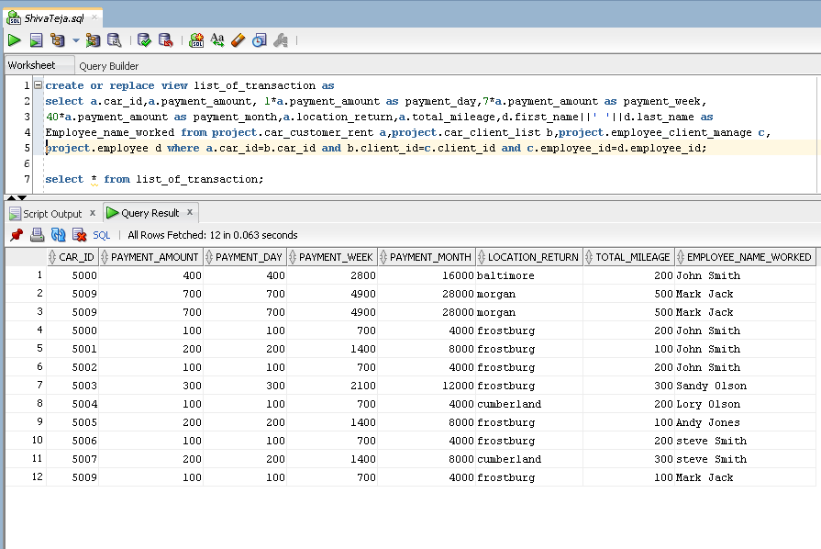

**12.g Query**

create or replace view Statistics_by_Branch as

select office_id,owner_name,customer_name,No_times_car_listed,year,total_amount_received

from

(select ccl.client_id,count(ccr.car_id) as no_times_car_listed,to_char(ccr.date_of_rent,'yyyy') as year,sum(ccr.payment_amount) as total_amount_received

from project.car_customer_rent CCR,project.car_client_list CCL where CCR.car_id=CCL.car_id group by

ccl.client_id,to_char(ccr.date_of_rent,'yyyy'))CCL_CCR

join

(select distinct OFC.office_id as office_id,CCL.client_id,CLT.first_name|| ' ' ||CLT.last_name as owner_name,CST.first_name|| ' ' ||CST.last_name as customer_name

from project.customer CST,project.car_customer_rent CCR,project.car_client_list CCL,project.client CLT,project.employee_client_manage ECM,

project.employee EMP,project.office_employee OFE,project.office OFC

where CST.customer_id=CCR.customer_id and CCL.car_id=CCR.car_id and CLT.client_id=CCL.client_id and

OFE.employee_id=EMP.employee_id and ECM.client_id=CLT.client_id and EMP.employee_id=ECM.employee_id and OFC.office_id=OFE.office_id) OFC_EMP_CST

on CCL_CCR.client_id=OFC_EMP_CST.client_id;

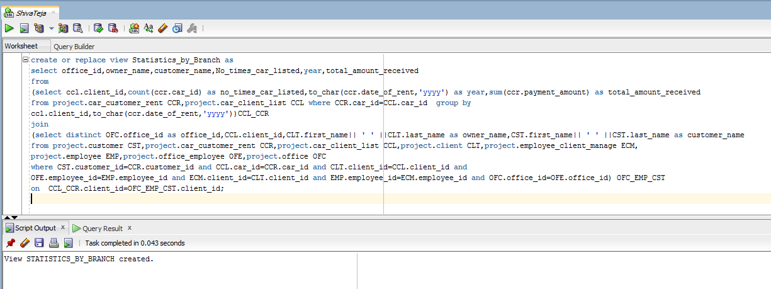

Select * from Statistics_by_Branch;

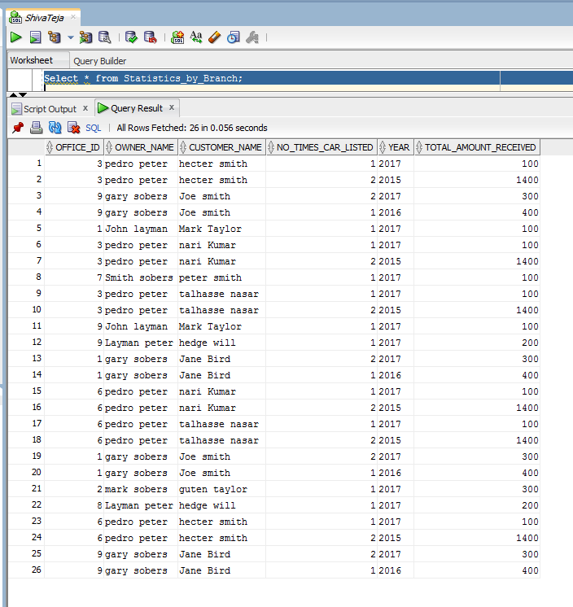

**12.h last_employee_branch**

**Query**

create or replace view last_employee_branch as

select a.first_name||' '||a.last_name as employee_name,b.name as office_name,

c.date_hired as Starting_date,a.salary as salary,to_char(sysdate,'yyyy')-to_char(a.birth_date,'yyyy')

as age from project.employee a,project.office b,project.office_employee c

where a.employee_id=c.employee_id and c.office_id=b.office_id;

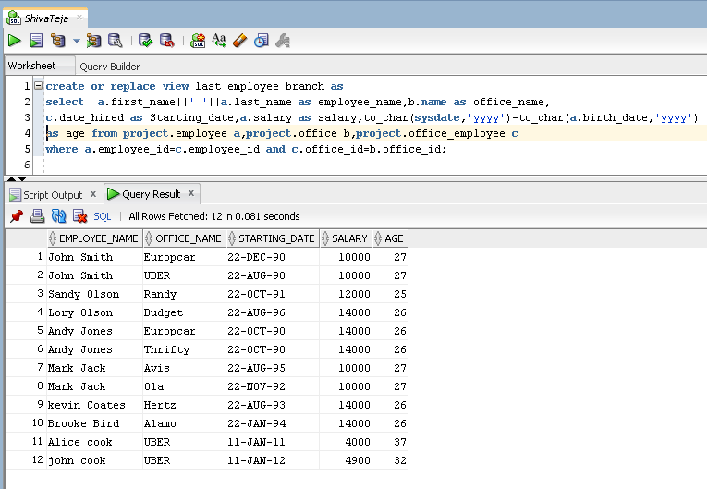

**12.i managers**

**Query:**

create or replace view managers as

select total_employees,starting_date,manager_name from

(select office_id, count(*) as total_employees from project.office_employee group by office_id)a

join

(select x.office_id, x.general_mgr_id,x.date_hired as Starting_date,y.first_name||' '||y.last_name as manager_name

from project.office_general_manager x,project.employee y where x.general_mgr_id=y.employee_id)b

on a.office_id=b.office_id;

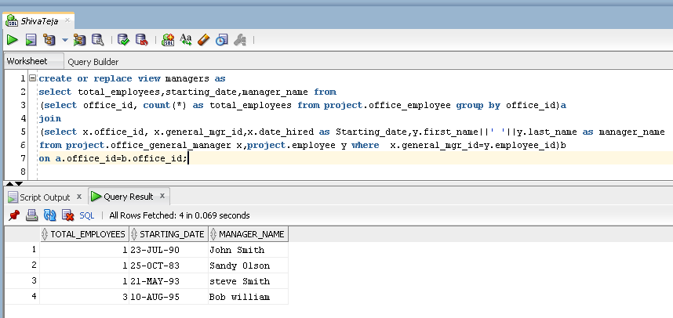

**12.j Customers1**

**Query**

create or replace view customer1 as

select a.current_mileage,a.class,a.make,a.daily_price,a.color,a.year,a.weekly_discount,a.add_cost_per_mile from

project.car a;

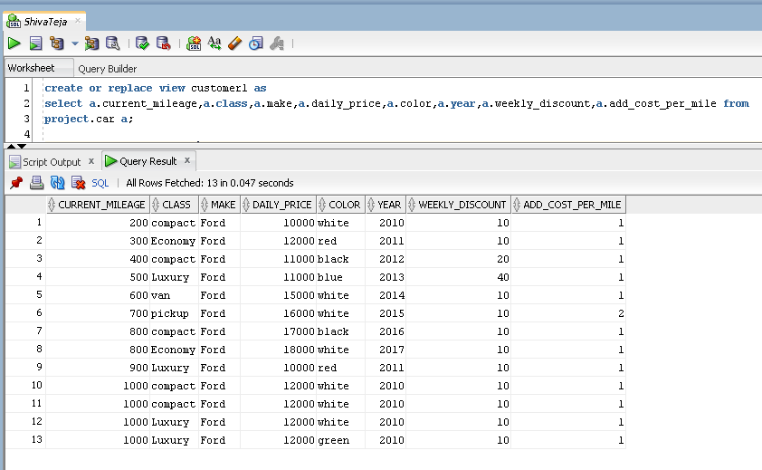

**12.k. customer2**

**Query**

create or replace view car_feedback as

select carid,current_mileage,class,features,make,year,daily_price,car_desc,rating,feedback_given,comments from

(select car_id as carid,current_mileage as current_mileage,class as class,features as features,make as make,year as year,daily_price as daily_price,

car_desc as car_desc from project.car cr) CAR

join

(select cf.car_id,cf.rating as rating,cf.given_by as feedback_given,cf.comments as comments from project.client_customer_feedback cf) CCF

on CCF.car_id=CAR.carid;

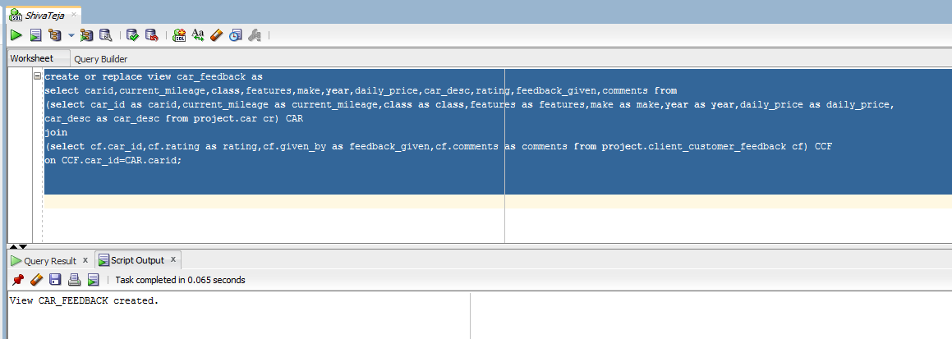

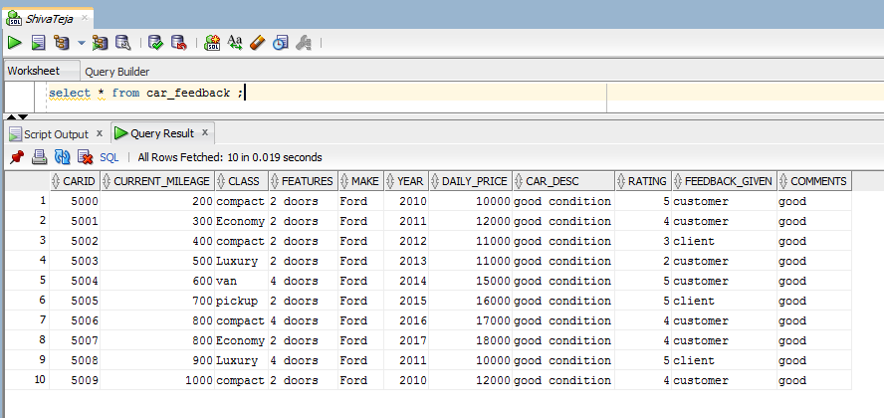

**13.a Index**

**Query:**

create index cus1 on customer_data(first_name,last_name);

select rowid,rownum,first_name,last_name from customer_data;

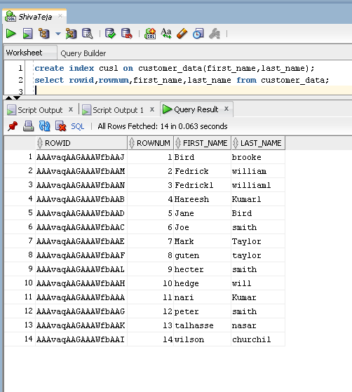

**13.b Index**

**Query**

create index cus2 on customer_data(birth_date);

select rowid,rownum,birth_date from customer_data;

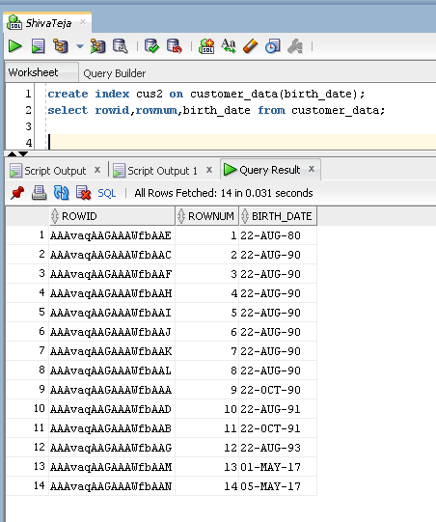

**14.a ID_generator**

**Query**

create sequence id_generator

increment by +2

start with 1000

cache 40;

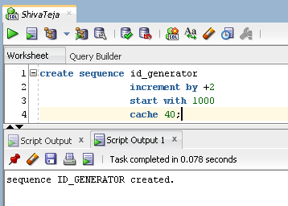

**14.b Transaction id**

**Query**

create sequence trasac_id

increment by +1

start with 1

cache 40;

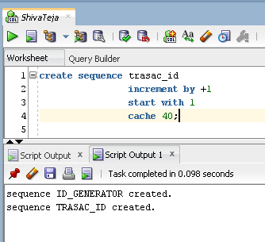

**14.c Tracknumber**

**Query**

create sequence tracknumber

increment by +1

minvalue 0

start with 0

cache 40;

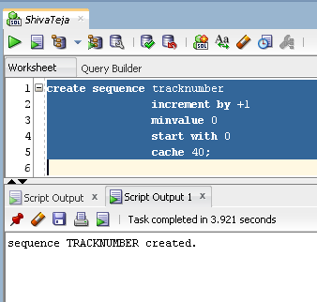

**14.d**

create table inquiries

(Inquiry_Date date default sysdate,

type_of_request varchar2(20),

Full_name varchar2(20),

email varchar2(20),

tracknumber number primary key);

insert into inquiries values(sysdate,'withdraw','tom cruise','tom@gmail.com',tracknumber.NEXTVAL);

insert into inquiries values(sysdate,'deposit','Ben Cutting','Ben@gmail.com',tracknumber.NEXTVAL);

insert into inquiries values(sysdate,'enquiry','chris jordon','chris@gmail.com',tracknumber.NEXTVAL);

insert into inquiries values(sysdate,'confirmation','Steve Smith','Steve@gmail.com',tracknumber.NEXTVAL);

insert into inquiries values(sysdate,'withdraw','Kane williams','Kane@gmail.com',tracknumber.NEXTVAL);

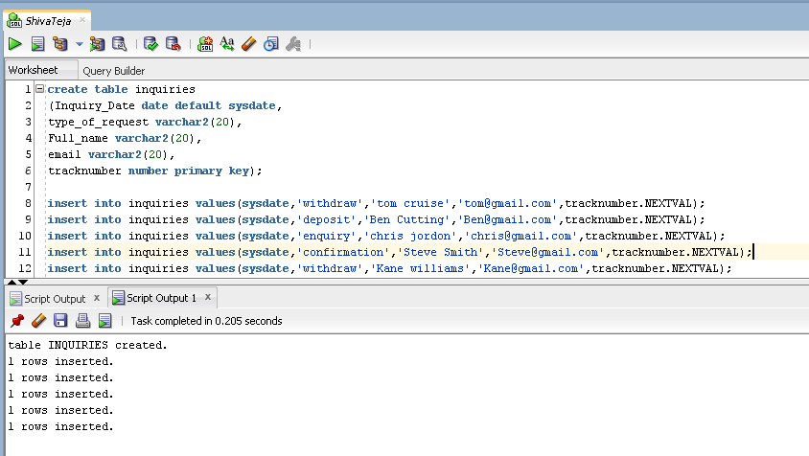

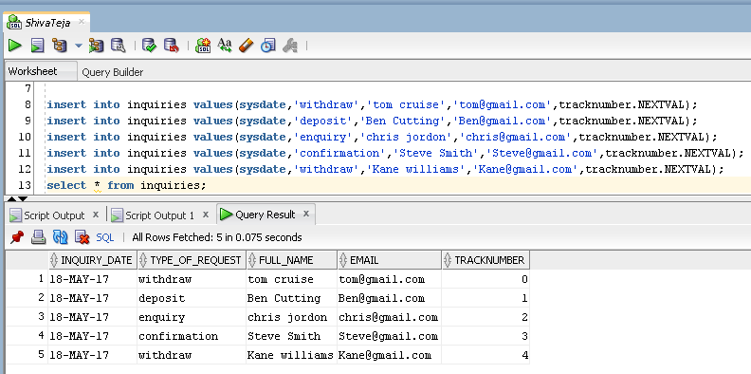

**15.a EmpInsert_pkg**

**Query:**

create or replace package EmpInsert_pkg as

PROCEDURE insert_new_Employee(employee_id IN project.employee.employee_id%TYPE,first_name IN project.employee.first_name%TYPE,

last_name in project.employee.last_name%type,middle_name IN project.employee.middle_name%TYPE,

street_address IN project.employee.street_address%TYPE,city IN project.employee.city%TYPE,state IN project.employee.state%TYPE,

zip_code IN project.employee.zip_code%TYPE,ssn IN project.employee.ssn%TYPE,salary IN project.employee.salary%TYPE,

tax_deduction IN project.employee.tax_deduction%TYPE,birthdate IN project.employee.birth_date%TYPE,

gender IN project.employee.gender%TYPE, marital_status IN project.employee.marital_status%TYPE,

spouse_name IN project.employee.spouse_name%TYPE,last_degree IN project.employee.last_degree%TYPE,

date_degree IN project.employee.date_degree%TYPE,number_of_dependents IN project.employee.NO_OF_DEPENDENTS%TYPE,

home_phone_number IN project.employee.home_phone_number%TYPE,cell_phone_number IN project.employee.cell_phone_number%TYPE,

date_cert_received IN project.employee_certificate_dates.date_cert_received%TYPE,list_of_certificates IN project.employee_certificates.list_of_certificates%TYPE);

PROCEDURE update_marital_statue_employee(employee_id IN project.employee.employee_ID%TYPE,

marital_status IN project.employee.MARITAL_STATUS%TYPE);

PROCEDURE update_last_degree_employee(employee_id IN project.employee.EMPLOYEE_ID%TYPE, last_degree IN project.employee.LAST_DEGREE%TYPE);

PROCEDURE update_certificate_employee(employee_id IN project.employee_certificates.EMPLOYEE_id%TYPE,certificates IN project.employee_certificates.list_of_certificates%TYPE);

PROCEDURE update_manager_employee(manager_id IN project.office_general_manager.general_mgr_id%TYPE,Employee_id IN project.employee.employee_id%TYPE);

end EmpInsert_pkg;

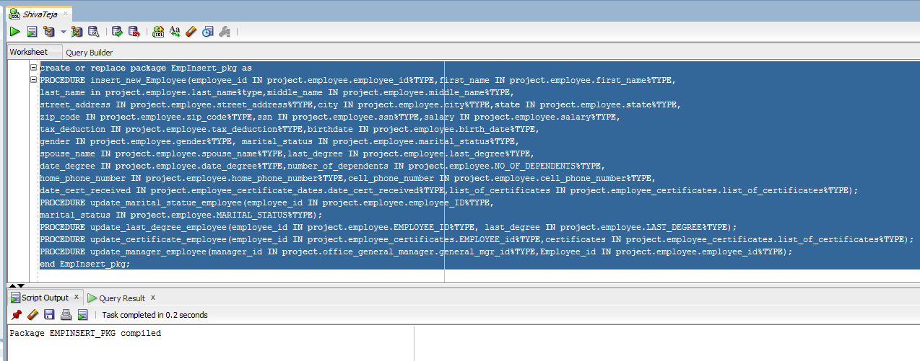

create or replace package body EmpInsert_pkg as

PROCEDURE insert_new_Employee(employee_id IN project.employee.employee_id%TYPE,first_name IN project.employee.first_name%TYPE,

last_name in project.employee.last_name%type,middle_name IN project.employee.middle_name%TYPE,

street_address IN project.employee.street_address%TYPE,city IN project.employee.city%TYPE,state IN project.employee.state%TYPE,

zip_code IN project.employee.zip_code%TYPE,ssn IN project.employee.ssn%TYPE,salary IN project.employee.salary%TYPE,

tax_deduction IN project.employee.tax_deduction%TYPE,birthdate IN project.employee.birth_date%TYPE,

gender IN project.employee.gender%TYPE, marital_status IN project.employee.marital_status%TYPE,

spouse_name IN project.employee.spouse_name%TYPE,last_degree IN project.employee.last_degree%TYPE,

date_degree IN project.employee.date_degree%TYPE,number_of_dependents IN project.employee.NO_OF_DEPENDENTS%TYPE,

home_phone_number IN project.employee.home_phone_number%TYPE,cell_phone_number IN project.employee.cell_phone_number%TYPE,

date_cert_received IN project.employee_certificate_dates.date_cert_received%TYPE,list_of_certificates IN project.employee_certificates.list_of_certificates%TYPE) IS

BEGIN

INSERT INTO employee_temp(employee_id,first_name,last_name, middle_name, street_address, city,state, zip_code, ssn,

salary, tax_deduction, birth_date, gender, marital_status, spouse_name, last_degree, date_degree, NO_OF_DEPENDENTS, home_phone_number, cell_phone_number)

VALUES (employee_id, first_name ,last_name, middle_name ,street_address ,city ,state,zip_code ,ssn ,salary ,

tax_deduction ,birthdate ,gender ,marital_status ,spouse_name ,last_degree ,date_degree ,number_of_dependents ,home_phone_number ,cell_phone_number);

INSERT INTO employee_crtf_dates_temp(employee_id,date_cert_received) values(employee_id,date_cert_received);

INSERT INTO employee_certificates_temp(employee_id,list_of_certificates) values(employee_id,date_cert_received);

exception

when others then

dbms_output.put_line('error: entered invalid values');

end;

PROCEDURE update_marital_statue_employee(employee_id IN project.employee.employee_ID%TYPE,

marital_status IN project.employee.MARITAL_STATUS%TYPE)IS

BEGIN

UPDATE employee_temp SET MARITAL_STATUS = marital_status WHERE employee_ID = employee_id;

exception

when no_data_found then

dbms_output.put_line('error: occured due to entered value employee_id is in-correct');

when others then

dbms_output.put_line('error: invalid data entered');

END;

PROCEDURE update_last_degree_employee(employee_id IN project.employee.EMPLOYEE_ID%TYPE, last_degree IN project.employee.LAST_DEGREE%TYPE)IS

BEGIN

UPDATE employee_temp SET LAST_DEGREE= last_degree WHERE employee_id = employee_id;

exception

when no_data_found then

dbms_output.put_line('error: occured due to entered value employee_id is in correct');

when others then

dbms_output.put_line('error: invalid data entered');

END;

PROCEDURE update_certificate_employee(employee_id IN project.employee_certificates.EMPLOYEE_id%TYPE,

certificates IN project.employee_certificates.list_of_certificates%TYPE) IS

BEGIN

UPDATE employee_certificates_temp SET LIST_OF_CERTIFICATES = certificates

WHERE employee_id = employee_id;

exception

when no_data_found then

dbms_output.put_line('error: occured due to entered value employee_id is in correct');

when others then

dbms_output.put_line('error: invalid data entered');

END;

PROCEDURE update_manager_employee(manager_id IN project.office_general_manager.general_mgr_id%TYPE,Employee_id IN project.employee.employee_id%TYPE) IS

BEGIN

UPDATE manager_temp SET general_mgr_id = Employee_id WHERE general_mgr_id = manager_id;

exception

when no_data_found then

dbms_output.put_line('error: occured due to entered value employee_id is in correct');

when others then

dbms_output.put_line('error: invalid data entered');

END;

end empInsert_pkg;

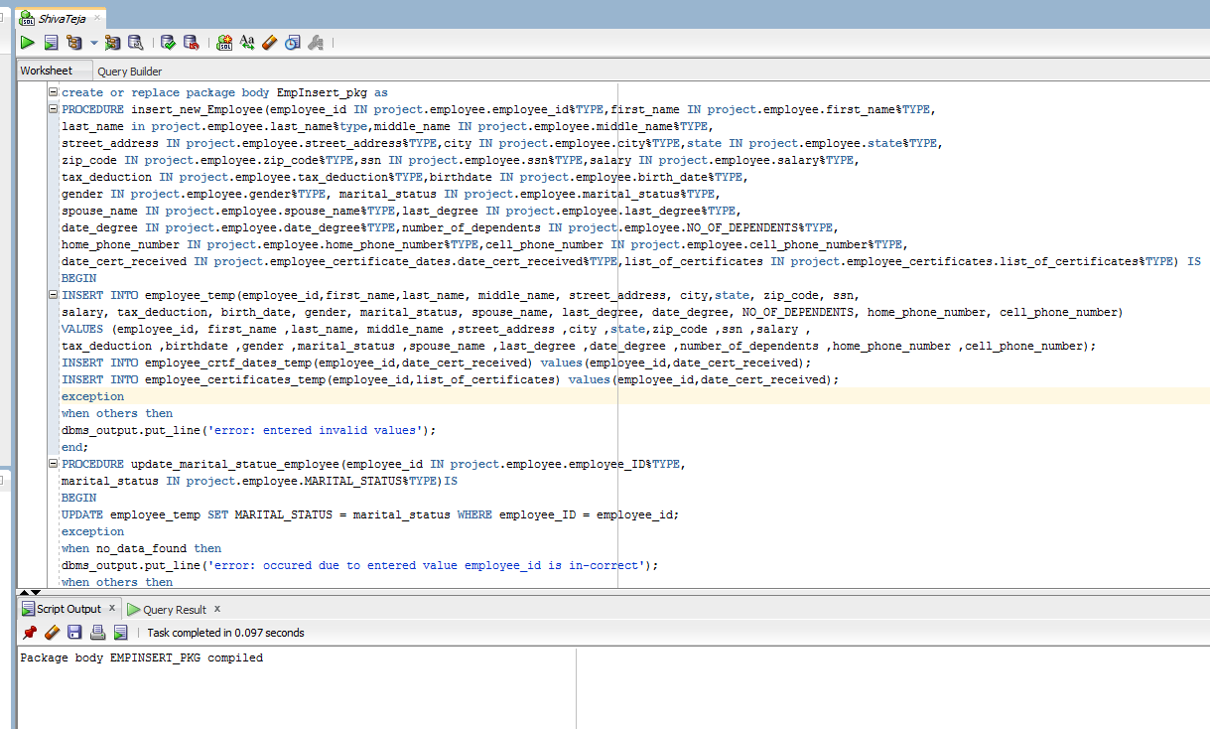

declare

begin

empinsert_pkg.update_certificate_employee(23456,'masters');

empinsert_pkg.update_manager_employee(23456,12345);

end;

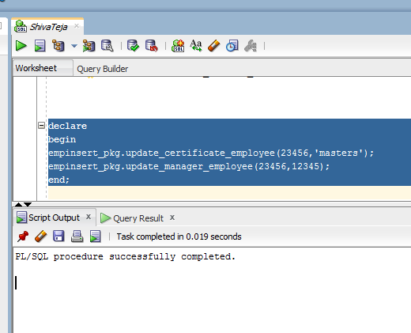

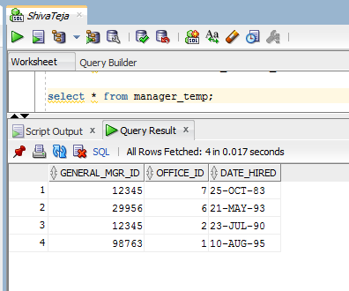

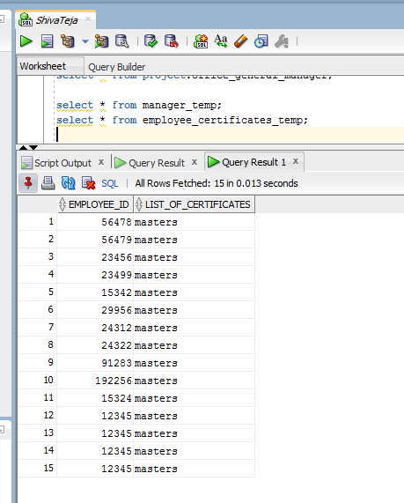

**15.b**

create table customer_temp as select * from project.customer;

create table car_client_list_temp as select * from project.car_client_list;

create table accident_temp as select * from project.accident;

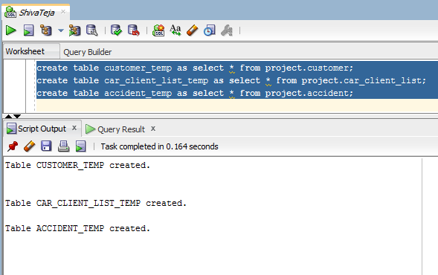

create or replace package insert_pkg as

procedure new_customer_insert(customer_id IN project.customer.CUSTOMER_ID%TYPE,first_name IN project.customer.FIRST_NAME%TYPE,

last_name IN project.customer.LAST_NAME%TYPE,middle_initial IN project.customer.MIDDLE_INITIAL%TYPE,birth_date IN project.customer.BIRTH_DATE%TYPE,

cell_phone IN project.customer.CELL_PHONE%TYPE,street_address IN project.customer.STREET_ADDRESS%TYPE,city IN project.customer.CITY%TYPE,

state1 IN project.customer.STATE%TYPE,zip_code IN project.customer.ZIP_CODE%TYPE,email IN project.customer.EMAIL%TYPE,

license_issued_state IN project.customer.LICENSE_ISSUED_STATE%TYPE,license_number IN project.customer.LICENSE_NUMBER%TYPE,

credit_card_number IN project.customer.CREDIT_CARD_NUMBER%TYPE,expiration_date IN project.customer.EXPIRATION_DATE%TYPE,

ssn1 in project.customer.ssn%type);

procedure insert_new_car_owner(car_id project.car_client_list.car_id%type,client_id project.car_client_list.client_id%type,

available_hrs project.car_client_list.available_hrs%type,start_date project.car_client_list.start_date%type,

end_date project.car_client_list.end_date%type);

procedure info_update_customer(cust_id project.customer.customer_id%type,first_name IN project.customer.FIRST_NAME%TYPE,

last_name IN project.customer.LAST_NAME%TYPE,middle_initial IN project.customer.MIDDLE_INITIAL%TYPE,birth_date IN project.customer.BIRTH_DATE%TYPE,

cell_phone IN project.customer.CELL_PHONE%TYPE,street_address IN project.customer.STREET_ADDRESS%TYPE,city IN project.customer.CITY%TYPE,

state1 IN project.customer.STATE%TYPE,zip_code IN project.customer.ZIP_CODE%TYPE,email IN project.customer.EMAIL%TYPE,

license_issued_state IN project.customer.LICENSE_ISSUED_STATE%TYPE,license_number IN project.customer.LICENSE_NUMBER%TYPE,

credit_card_number IN project.customer.CREDIT_CARD_NUMBER%TYPE,expiration_date IN project.customer.EXPIRATION_DATE%TYPE,

ssn1 in project.customer.ssn%type);

procedure info_update_carowner(existing_car_id project.car_client_list.car_id%type,client_id project.car_client_list.client_id%type,

available_hrs project.car_client_list.available_hrs%type,start_date project.car_client_list.start_date%type,

end_date project.car_client_list.end_date%type);

procedure insert_accident(customer_id project.accident.customer_id%type,car_id project.accident.car_id%type,date_time project.accident.date_time%type,

location1 project.accident.location%type,damage_extent project.accident.damage_extent%type,cost_damage project.accident.cost_damage%type,

police_report project.accident.police_report%type,summary1 project.accident.summary_police_report%type);

end insert_pkg;

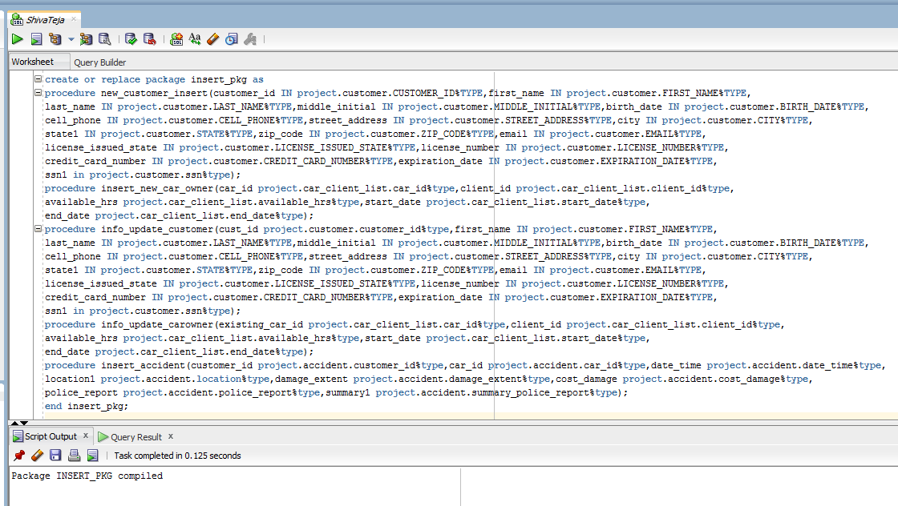

create or replace package body insert_pkg as

procedure new_customer_insert(customer_id IN project.customer.CUSTOMER_ID%TYPE,first_name IN project.customer.FIRST_NAME%TYPE,

last_name IN project.customer.LAST_NAME%TYPE,middle_initial IN project.customer.MIDDLE_INITIAL%TYPE,birth_date IN project.customer.BIRTH_DATE%TYPE,

cell_phone IN project.customer.CELL_PHONE%TYPE,street_address IN project.customer.STREET_ADDRESS%TYPE,city IN project.customer.CITY%TYPE,

state1 IN project.customer.STATE%TYPE,zip_code IN project.customer.ZIP_CODE%TYPE,email IN project.customer.EMAIL%TYPE,

license_issued_state IN project.customer.LICENSE_ISSUED_STATE%TYPE,license_number IN project.customer.LICENSE_NUMBER%TYPE,

credit_card_number IN project.customer.CREDIT_CARD_NUMBER%TYPE,expiration_date IN project.customer.EXPIRATION_DATE%TYPE,

ssn1 in project.customer.ssn%type) as

begin

insert into customer_temp(customer_id,first_name,last_name,middle_initial,birth_date,cell_phone,street_address,city,state,

zip_code,email,license_issued_state,license_Number,credit_card_number,Expiration_date,ssn)

values(customer_id,first_name,last_name,middle_initial,birth_date,cell_phone,street_address,city,state1,zip_code,email,

license_issued_state,license_number,credit_card_number,expiration_date,ssn1);

exception

when others then

dbms_output.put_line('your entered data cannot be inserted into table');

END;

procedure insert_new_car_owner(car_id project.car_client_list.car_id%type,client_id project.car_client_list.client_id%type,

available_hrs project.car_client_list.available_hrs%type,start_date project.car_client_list.start_date%type,

end_date project.car_client_list.end_date%type) as

begin

insert into car_client_list_temp(car_id,client_id,available_hrs,start_date,end_date)

values(car_id,client_id,available_hrs,start_date,end_date);

exception

when others then

dbms_output.put_line('error occured because enter data is invalid');

end;

procedure info_update_customer(cust_id project.customer.customer_id%type,first_name IN project.customer.FIRST_NAME%TYPE,

last_name IN project.customer.LAST_NAME%TYPE,middle_initial IN project.customer.MIDDLE_INITIAL%TYPE,birth_date IN project.customer.BIRTH_DATE%TYPE,

cell_phone IN project.customer.CELL_PHONE%TYPE,street_address IN project.customer.STREET_ADDRESS%TYPE,city IN project.customer.CITY%TYPE,

state1 IN project.customer.STATE%TYPE,zip_code IN project.customer.ZIP_CODE%TYPE,email IN project.customer.EMAIL%TYPE,

license_issued_state IN project.customer.LICENSE_ISSUED_STATE%TYPE,license_number IN project.customer.LICENSE_NUMBER%TYPE,

credit_card_number IN project.customer.CREDIT_CARD_NUMBER%TYPE,expiration_date IN project.customer.EXPIRATION_DATE%TYPE,

ssn1 in project.customer.ssn%type) as

begin

update customer_temp set license_issued_state = license_issued_state where customer_id = cust_id;

exception

when no_data_found then

dbms_output.put_line('error occured due to entered value cust_id is in correct');

when others then

dbms_output.put_line('incorrect data as entered');

end;

procedure info_update_carowner(existing_car_id project.car_client_list.car_id%type,client_id project.car_client_list.client_id%type,

available_hrs project.car_client_list.available_hrs%type,start_date project.car_client_list.start_date%type,

end_date project.car_client_list.end_date%type)

as

begin

update car_client_list_temp set start_date = start_date where car_id = existing_car_id;

exception

when no_data_found then

dbms_output.put_line('error occured due to entered value cust_id is in correct');

when others then

dbms_output.put_line('incorrect data is entered');

end;

procedure insert_accident(customer_id project.accident.customer_id%type,car_id project.accident.car_id%type,date_time project.accident.date_time%type,

location1 project.accident.location%type,damage_extent project.accident.damage_extent%type,cost_damage project.accident.cost_damage%type,

police_report project.accident.police_report%type,summary1 project.accident.summary_police_report%type)

as

begin

insert into accident_temp(customer_id,car_id,date_time,location,damage_extent,cost_damage,police_report,summary_police_report)

values (customer_id,car_id,date_time,location1,damage_extent,cost_damage,police_report,summary1);

exception

when no_data_found then

dbms_output.put_line('error occured due to entered value cust_id is in correct');

when others then

dbms_output.put_line('error occured because enter data is invalid');

end;

end insert_pkg;

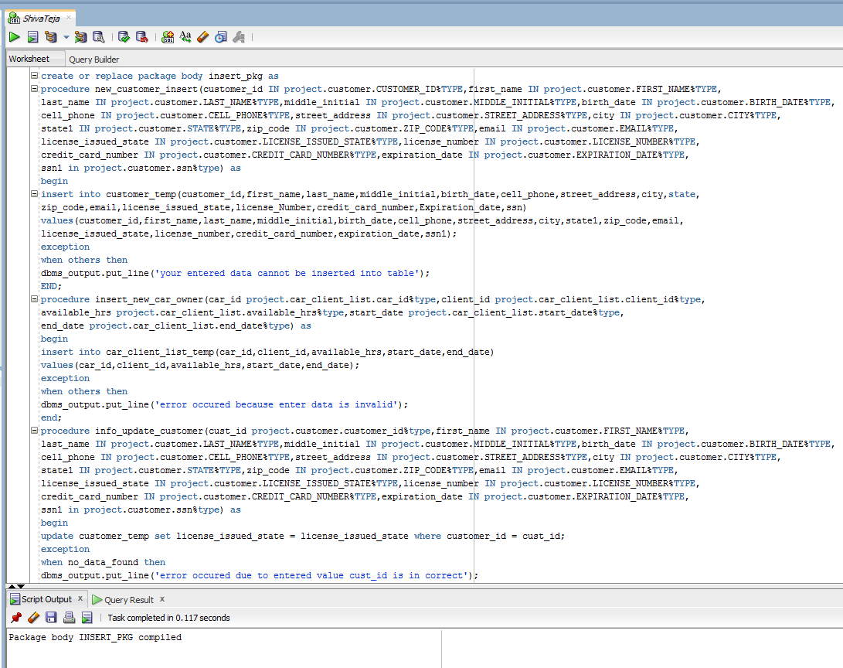

declare

begin

insert_pkg.insert_accident(1000,5004,'07-JAN-17 11.12.45.000000000 AM','frederick',35,2050,'Y','under process');

end;

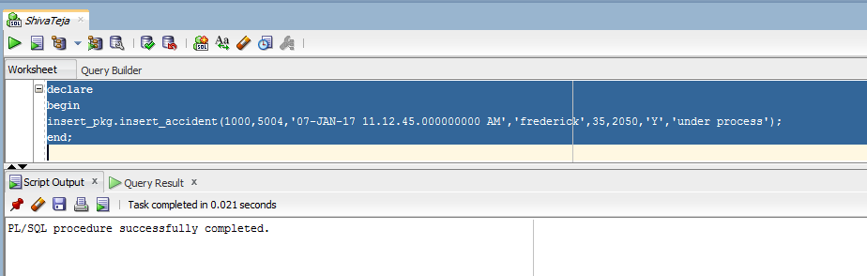

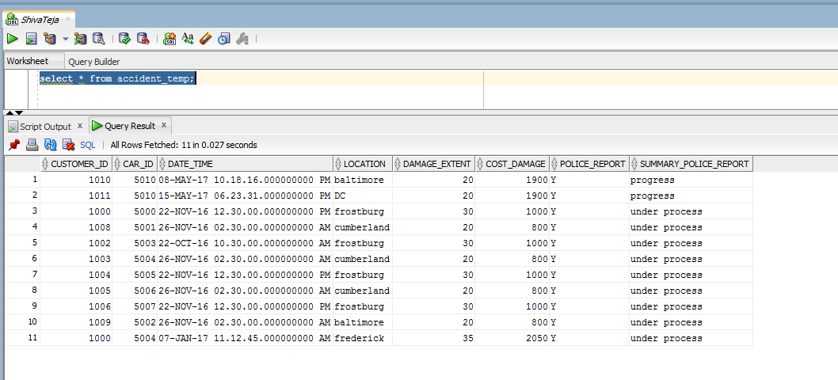

**15.c Vehicle_pkg**

create or replace package Vehicle_pkg as

procedure car_info(vehicle_id in project.car.car_id%type,Plate_no out project.car.car_plate_no%type,state out project.car.car_state_registeration%type,

year out project.car.year%type,current_mileage out project.car.current_mileage%type,class out project.car.class%type, features out project.car.features%type,

make out project.car.make%type, color out project.car.color%type);

procedure car_owner(ssn1 in project.client.ssn%type,carid out project.car.car_id%type,plateno out project.car.car_plate_no%type,

ssn_out out project.client.ssn%type,name_of_owner out project.client.first_name%type,number_of_time_rented out number,number_of_time_accident out number);

procedure carrented(carid in project.car.car_id%type,customers_name out project.client.first_name%type);

procedure carrented(ssn in project.CLIENT.SSN%type,car_id out project.CAR.CAR_ID%type);

end vehicle_pkg;

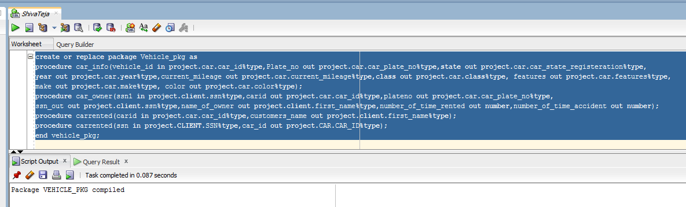

create or replace package body Vehicle_pkg as

procedure car_info(vehicle_id in project.car.car_id%type,Plate_no out project.car.car_plate_no%type,state out project.car.car_state_registeration%type,

year out project.car.year%type,current_mileage out project.car.current_mileage%type,class out project.car.class%type, features out project.car.features%type,

make out project.car.make%type, color out project.car.color%type) as

begin

select car_plate_no,car_state_registeration,year,current_mileage,class,features,make,color into

plate_no,state,year,current_mileage,class,features,make,color from project.car where car_id=vehicle_ID;

exception

when no_data_found then

dbms_output.put_line('error: entered value car_id is incorrect');

when others then

dbms_output.put_line('error: invalid data entered');

end;

procedure car_owner(ssn1 in project.client.ssn%type,carid out project.car.car_id%type,plateno out project.car.car_plate_no%type,

ssn_out out project.client.ssn%type,name_of_owner out project.client.first_name%type,number_of_time_rented out number,number_of_time_accident out number) as

begin

select ccl.car_id,ca.car_plate_no,cl.ssn,cl.first_name|| ' ' || cl.last_name as full_name into carid,plateno,ssn_out,name_of_owner from project.client cl

join project.car_client_list ccl on cl.client_id=ccl.client_id join project.car ca on ca.car_id=ccl.car_id where cl.ssn=ssn1;

select count(*) into number_of_time_rented from project.car_customer_rent ccr join project.car ca on ccr.car_id=ca.car_id group by ca.car_id having ca.car_id=carid;

select count(*) into number_of_time_accident from project.car ca join project.accident pa on pa.car_id=ca.car_id group by ca.car_id having ca.car_id=carid;

exception

when no_data_found then

dbms_output.put_line('error: entered value owner_ssn is incorrect');

when others then

dbms_output.put_line('error: invalid data entered');

end;

procedure carrented(carid in project.car.car_id%type,customers_name out project.client.first_name%type) as

begin

select CST.first_name|| ' ' || CST.last_name as full_name into customers_name from project.car CAR,

project.car_customer_rent CCR, project.customer CST where CAR.car_id=CCR.car_id and CCR.customer_id=CST.customer_id and CAR.car_id=carid;

exception

when no_data_found then

dbms_output.put_line('error: entered invalid car_id ');

when others then

dbms_output.put_line('error: invalid data entered');

end;

procedure carrented(ssn in project.CLIENT.SSN%type,car_id out project.CAR.CAR_ID%type) as

begin

select CCL.car_id into car_id from project.client CLT,project.car_client_list CCL where CLT.client_id=CCL.client_id and CLT.ssn=ssn;

exception

when no_data_found then

dbms_output.put_line('error: entered invalid SSN');

when others then

dbms_output.put_line('error: invalid data entered');

end;

end Vehicle_pkg;

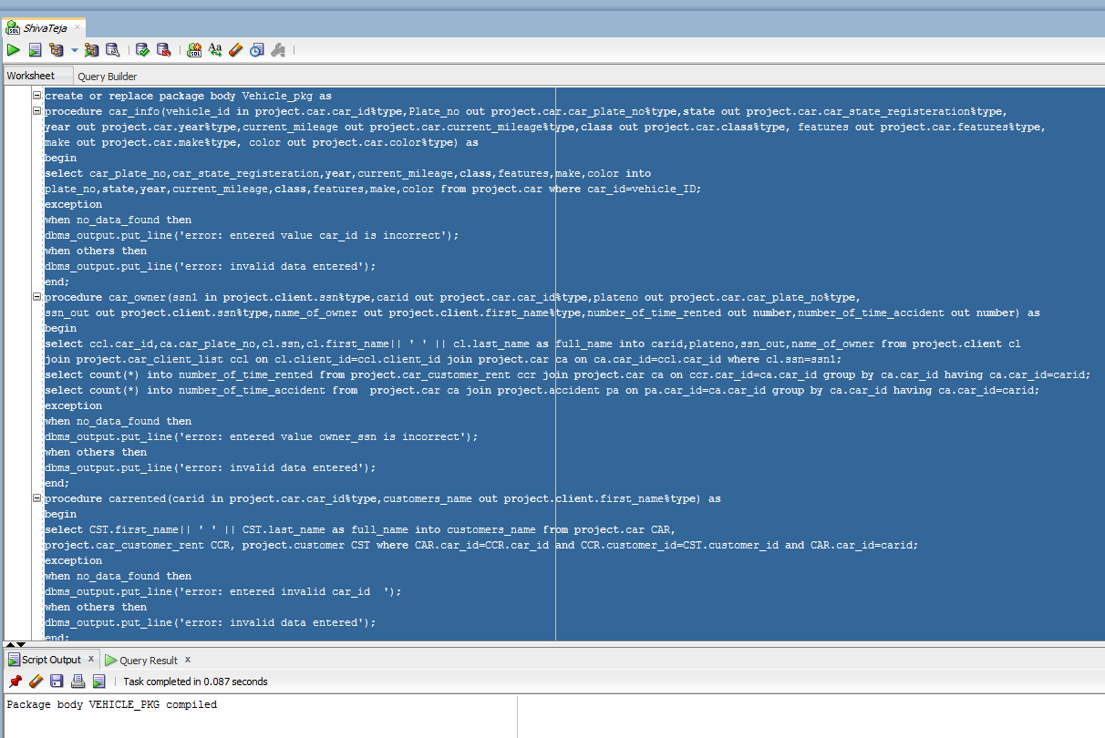

declare

carid project.car.car_id%type;

plateno project.car.car_state_registeration%type;

ssn_out project.client.ssn%type;

name_of_owner project.client.first_name%type;

number_of_time_rented number;

number_of_time_accident number;

begin

vehicle_pkg.car_owner('892-457-3562',carid,plateno,ssn_out,name_of_owner,number_of_time_rented,number_of_time_accident);

dbms_output.put_line(carid||' ' || plateno|| ' ' || ssn_out|| ' ' || name_of_owner|| ' ' || number_of_time_rented|| ' ' || number_of_time_accident);

end;

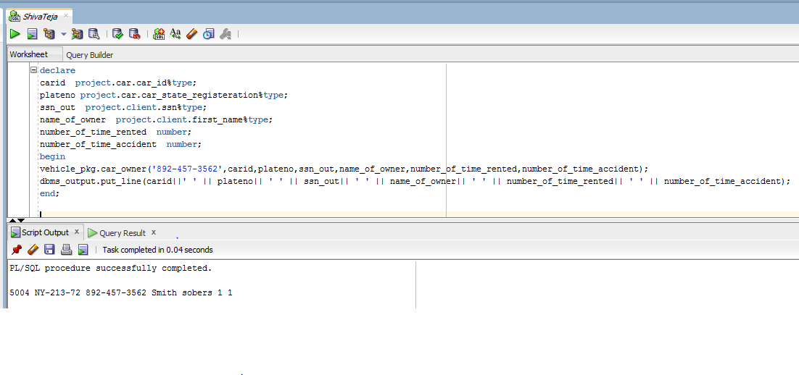

**15.d accident_pkg**

create or replace package accident_pkg as

procedure caraccident(car_id in project.accident.car_id%type, customer_name out varchar2,phone out project.customer.cell_phone%type,

address out project.customer.street_address%type,Date_and_Time out project.accident.date_time%type, place out project.accident.location%type,

extent_of_damage out project.accident.damage_extent%type,cost_of_damage out project.accident.cost_damage%type);

procedure customeraccident(sssn in project.customer.ssn%type,bool out number);

end accident_pkg;

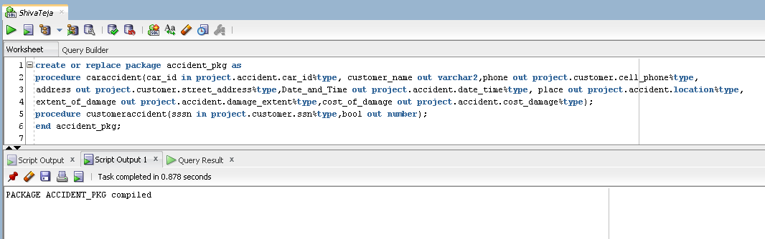

create or replace package body accident_pkg as

procedure caraccident(car_ide in project.accident.car_id%type, customer_name out varchar2,phone out project.customer.cell_phone%type,

address out project.customer.street_address%type,Date_and_Time out project.accident.date_time%type, place out project.accident.location%type,

extent_of_damage out project.accident.damage_extent%type,cost_of_damage out project.accident.cost_damage%type) is

cust_id project.customer.customer_id%type;

begin

select customer_id,date_time,location,damage_extent,cost_damage into cust_id,date_and_time,place,extent_of_damage,cost_of_damage from project.accident where car_id=car_ide;

select first_name||' '||last_name,cell_phone,street_address into customer_name,phone,address from project.customer where customer_id=cust_id;

end;

procedure customeraccident(sssn in project.customer.ssn%type,bool out number) is

cust_id project.customer.customer_id%type;

begin

select customer_id into cust_id from project.customer where ssn=sssn;

select count(*) into bool from project.accident group by cust_id;

end;

end accident_pkg;

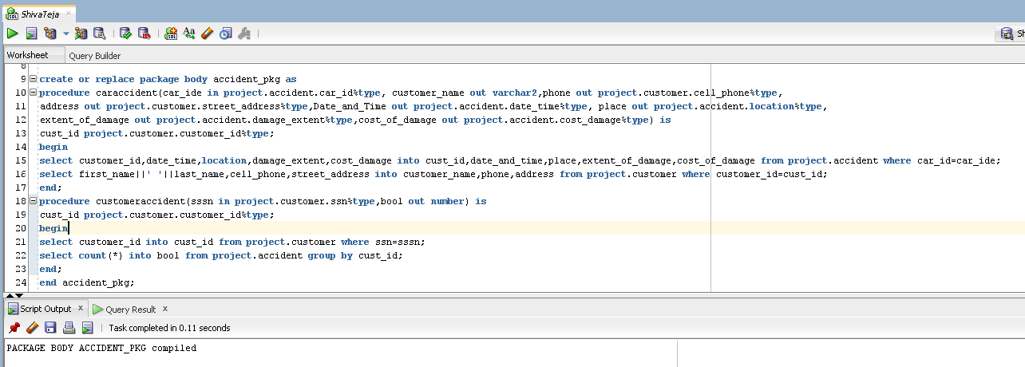

declare

customer_name varchar2(100);phone project.customer.cell_phone%type;

address project.customer.street_address%type;Date_and_Time project.accident.date_time%type; place project.accident.location%type;

extent_of_damage project.accident.damage_extent%type;cost_of_damage project.accident.cost_damage%type;bool number default 0;

begin

accident_pkg.caraccident(5001,customer_name,phone,address,Date_and_Time,place,extent_of_damage,cost_of_damage);

dbms_output.put_line(5001||' '||customer_name||' '||phone||' '||address||' '||Date_and_Time||' '||place||' '||extent_of_damage||' '||cost_of_damage);

accident_pkg.customeraccident('456-89-323',bool);

dbms_output.put_line('456-89-323'||' accidents '||bool);

end;

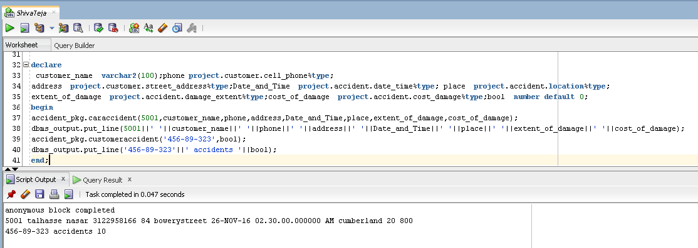

**15.e BirthdaySub:**

**Query:**

create table temp_file

(customer_name varchar2(100),

email varchar2(100),

address varchar2(100));

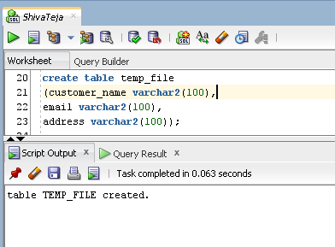

create or replace procedure birthdaysub(today in date,customer_name out varchar2,email out project.customer.email%type,

address out project.customer.street_address%type ) is

birthday project.customer.birth_date%type;

cursor c_temp is

select birth_date,first_name||' '||last_name,email,street_address from project.customer;

begin

open c_temp;

loop fetch c_temp into birthday,customer_name,email,address;

if extract(month from birthday)=extract(month from today) then

if extract(day from birthday)-extract(day from today)<=15 then

execute immediate 'truncate table temp_file';

insert into temp_file values(customer_name,email,address);

end if;

if extract(day from today)-extract(month from birthday)<=15 then

execute immediate 'truncate table temp_file';

insert into temp_file values(customer_name,email,address);

end if;

end if;

exit when c_temp%notfound;

end loop;

close c_temp;

end;

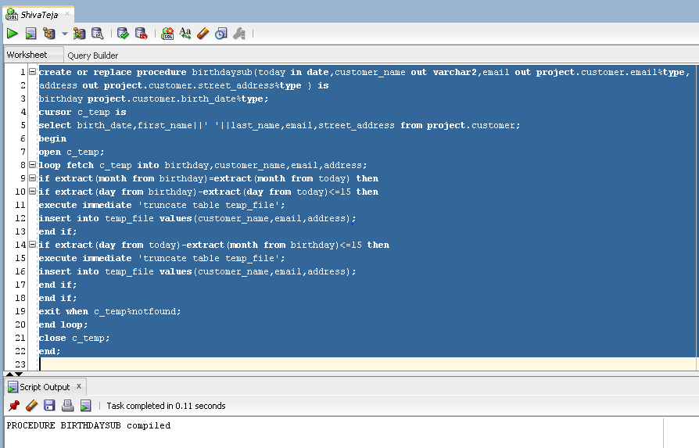

declare

today date default sysdate;

customer_name varchar2(100);

email project.customer.email%type;

address project.customer.street_address%type;

begin

birthdaysub(today,customer_name,email,address);

dbms_output.put_line(customer_name||' '||email||' '||address);

end;

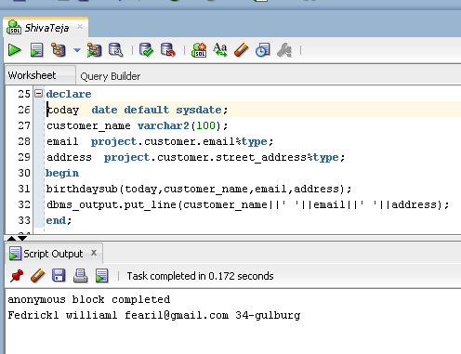

**15.f**

**Query:**

create or replace procedure office_info is

branch_id project.office.office_id%type;

branch_name project.office.name%type;

manager_name varchar2(100);

hired_date project.office_general_manager.date_hired%type;

emp_id project.employee.employee_id%type;

branch_id1 project.office.office_id%type;

cursor c_temp is

select office_id,name from project.office;

cursor c_temp2 is

select general_mgr_id,office_id,date_hired from project.office_general_manager;

begin

open c_temp;

loop fetch c_temp into branch_id,branch_name;

open c_temp2 ;

loop fetch c_temp2 into emp_id,branch_id1,hired_date;

if branch_id1=branch_id then

select first_name||' '||last_name into manager_name from project.employee where employee_id=emp_id;

dbms_output.put_line(branch_id||' '||branch_name||' '||' '||manager_name||' '||hired_date);

end if;

exit when c_temp2%notfound;

end loop;

close c_temp2;

exit when c_temp%notfound;

end loop;

end;

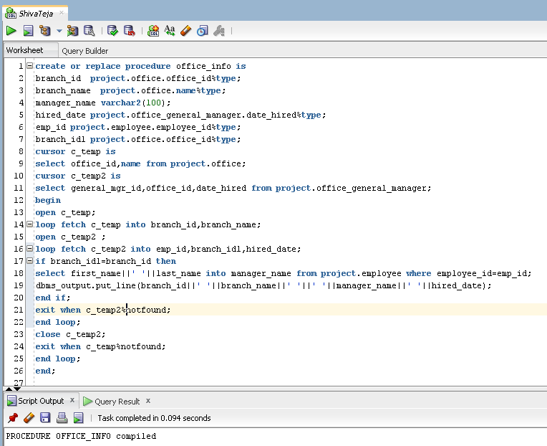

declare

begin

office_info;

end;

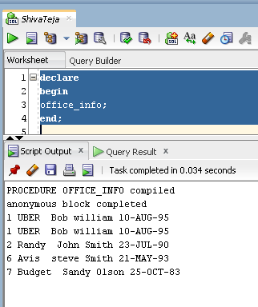

**16.g Employee History**

**Query:**

create table employee_history as (select * from project.employee where 1=0);

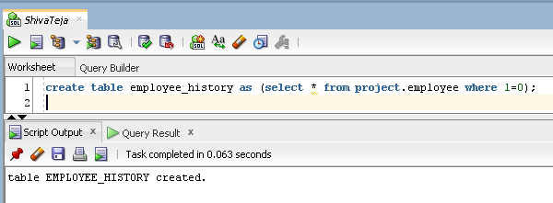

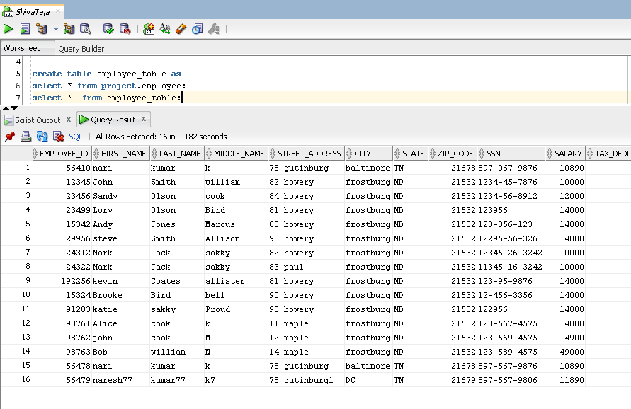

create or replace trigger before_deletion

before delete on employee_table for each row

declare

begin

insert into employee_history values(:old.EMPLOYEE_ID,:old.FIRST_NAME,:old.LAST_NAME,:old.MIDDLE_NAME,:old.STREET_ADDRESS,:old.CITY,

:old.STATE,:old.ZIP_CODE,:old.SSN,:old.SALARY,:old.TAX_DEDUCTION,:old.BIRTH_DATE,:old.GENDER,:old.MARITAL_STATUS,:old.SPOUSE_NAME,

:old.LAST_DEGREE,:old.DATE_DEGREE,:old.NO_OF_DEPENDENTS,:old.HOME_PHONE_NUMBER,:old.CELL_PHONE_NUMBER);

end;

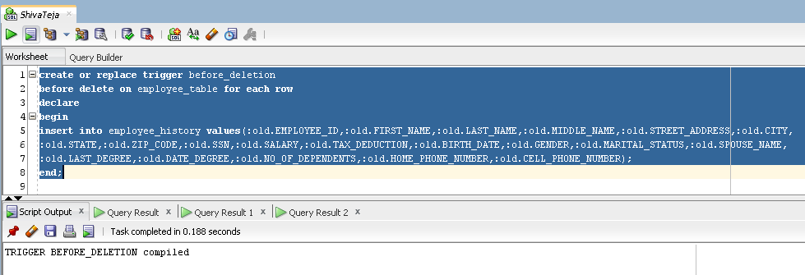

delete from employee_table where employee_id=56410;

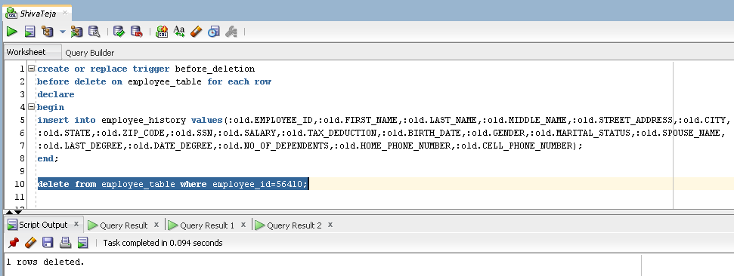

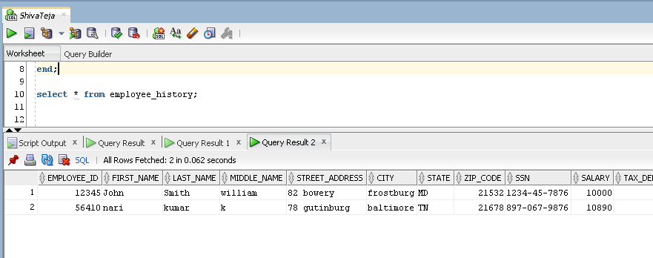

**16.h modifications**

**Query:**

create table CUSTOMER_LOG

(Changed_user varchar2(30),

changed_date date,

Nature varchar2(10));

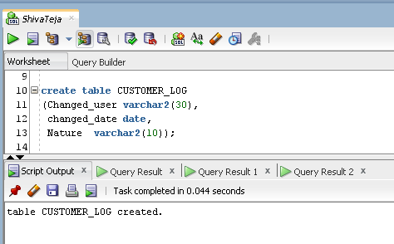

create table customer_table as select * from project.customer ;

select * from customer_table;

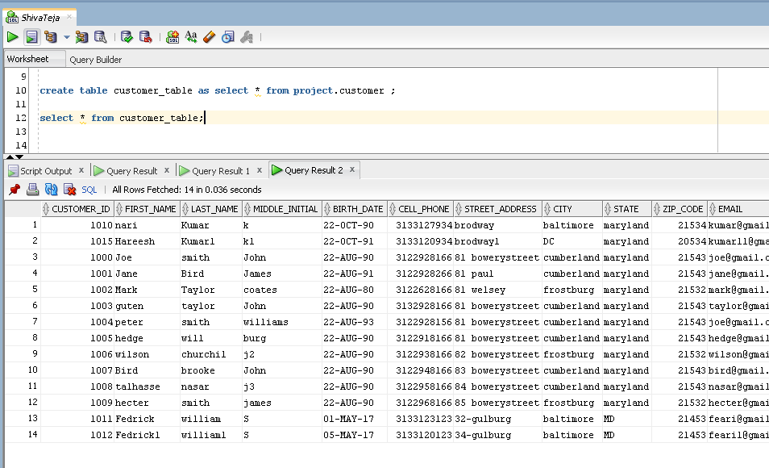

create or replace trigger modification

before update or delete or insert on customer_table for each row

begin

if inserting then

insert into customer_log values(user,sysdate,'I');

elsif deleting then

insert into customer_log values(user,sysdate,'D');

elsif updating then

insert into customer_log values(user,sysdate,'D');

end if;

end;

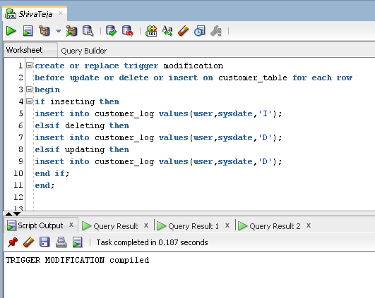

insert into customer_table(first_name,last_name,birth_date,cell_phone,STREET_ADDRESS,CITY,STATE,ZIP_CODE,EMAIL,

LICENSE_ISSUED_STATE,LICENSE_NUMBER,CREDIT_CARD_NUMBER,EXPIRATION_DATE) values('Rish','KAt','22-OCT-90',3133127934,

'brodway','baltimore','maryland',21534,'mark@gmail.com','maryland',123450789,1234467891234568,'12-AUG-21');

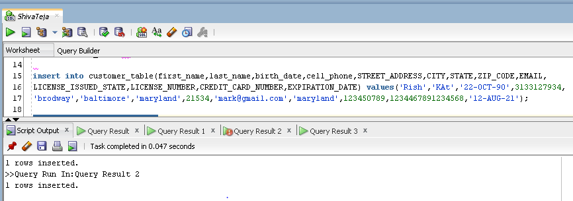

select * from customer_log;

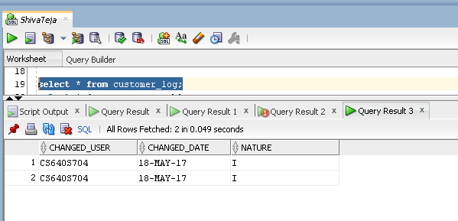

**16.i**

create table accident_table as select * from project.accident;

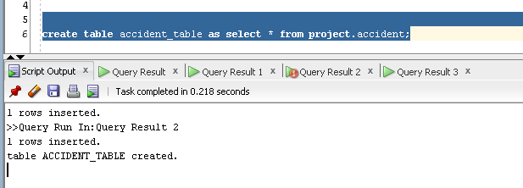

create table accident_log

(Customer_name varchar2(50),

Employee_name varchar2(50),

accident_date date);

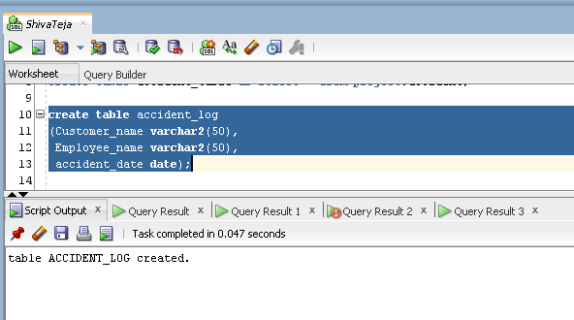

create or replace trigger accident_trigger

after insert on accident_table for each row

declare

customer_name varchar2(50);

Employee_name varchar2(50);

emp_id project.employee.employee_id%type;

begin

select employee_id into emp_id from project.employee_car_list where car_id=:new.car_id;

select first_name||' '||last_name into employee_name from project.employee where employee_id=emp_id;

select first_name||' '||last_name into customer_name from project.customer where customer_id=:new.customer_id;

insert into accident_log values(customer_name,employee_name,:new.Date_Time);

end;

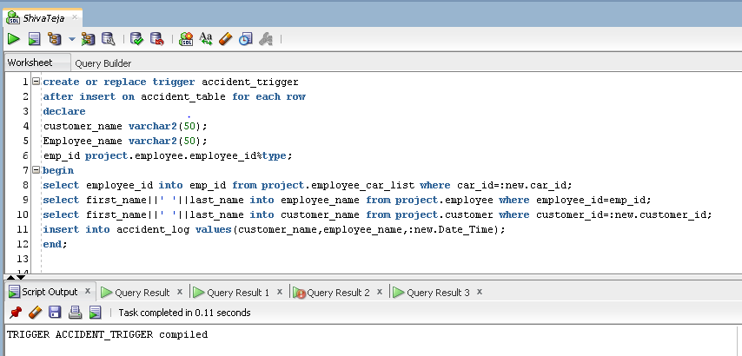

insert into accident_table values(1002,5010,'22-OCT-16 10.30.00.000000000 AM','frostburg',20,1900,'Y','under process');

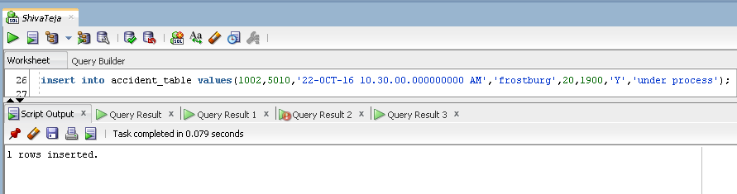

select * from accident_log;

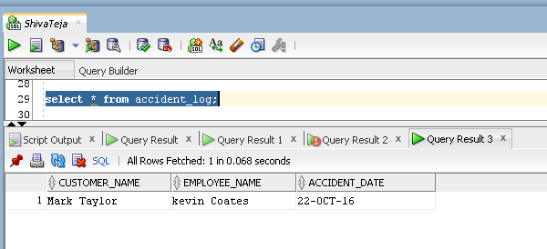

**17**

create table error_log

(name_of_table varchar2(60),

trigger_name varchar2(60),

date_triggered date,

trigger_fired varchar2(60),

trigger_type varchar2(60));

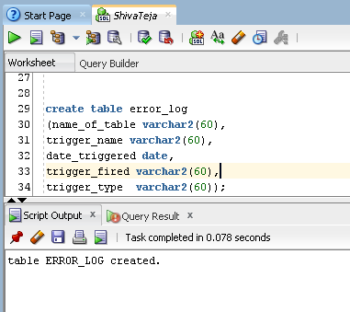

create or replace trigger before_deletion

before delete on employee_table for each row

declare

begin

insert into employee_history values(:old.EMPLOYEE_ID,:old.FIRST_NAME,:new.LAST_NAME,:old.MIDDLE_NAME,:old.STREET_ADDRESS,:old.CITY,

:old.STATE,:old.ZIP_CODE,:old.SSN,:old.SALARY,:old.TAX_DEDUCTION,:old.BIRTH_DATE,:old.GENDER,:old.MARITAL_STATUS,:old.SPOUSE_NAME,

:old.LAST_DEGREE,:old.DATE_DEGREE,:old.NO_OF_DEPENDENTS,:old.HOME_PHONE_NUMBER,:old.CELL_PHONE_NUMBER);

exception

when others then

declare

tri_status user_triggers.status%type;

tri_type user_triggers.trigger_type%type;

begin

select trigger_type,status into tri_type,tri_status from user_triggers where trigger_name like '%before_deletion%';

insert into error_log values('employee_table','before_deletion',sysdate,tri_status,tri_type);

end;

end;

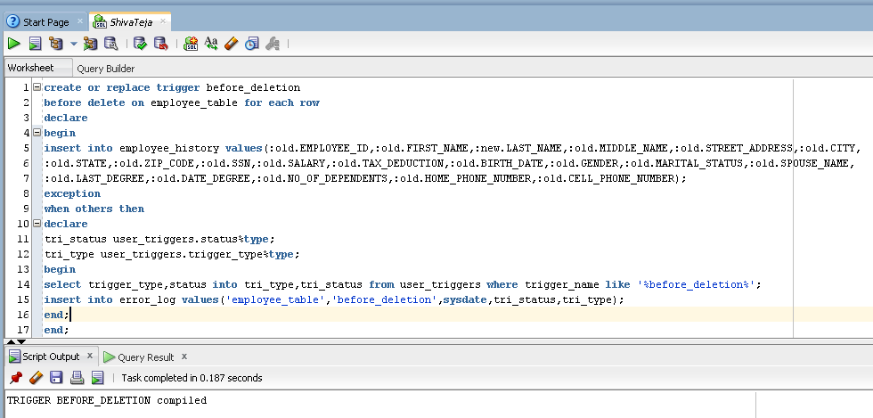

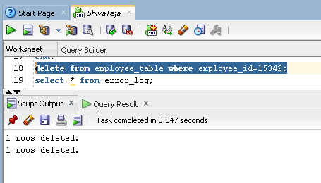

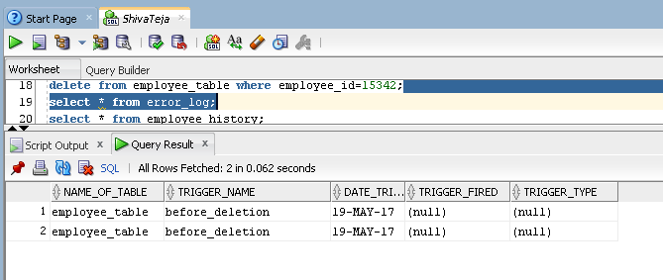

create or replace trigger modification

before update or delete or insert on customer_table for each row

declare

err exception;

tri_status varchar2(100);

tri_type varchar2(100);

begin

select trigger_type,status into tri_type,tri_status from user_triggers where trigger_name like '%MODIFICATION%';

if inserting then

insert into customer_log values(user,sysdate,'jdbkjsdblk');

raise err;

elsif deleting then

insert into customer_log values(user,sysdate,'D');

elsif updating then

insert into customer_log values(user,sysdate,'U');

end if;

exception

when err then

begin

insert into error_log values('customer_table','modification',sysdate,tri_status,tri_type);

end;

end;

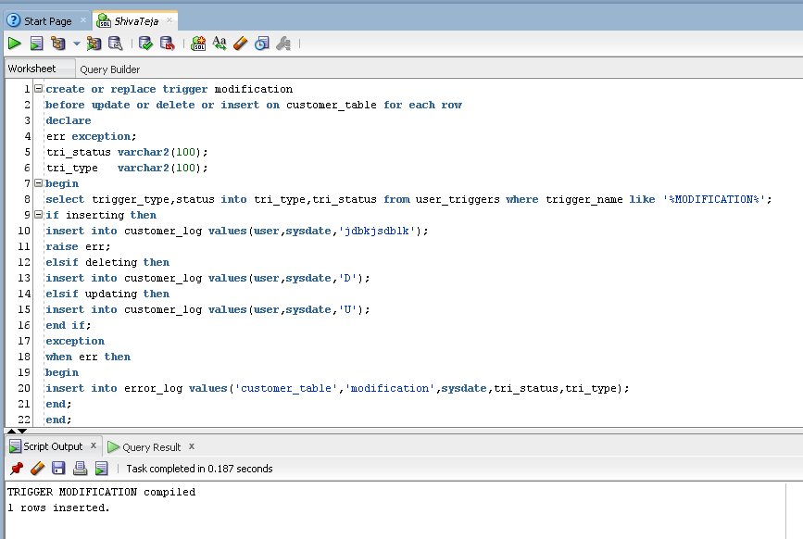

insert into customer_table(first_name,last_name,birth_date,cell_phone,STREET_ADDRESS,CITY,STATE,ZIP_CODE,EMAIL,

LICENSE_ISSUED_STATE,LICENSE_NUMBER,CREDIT_CARD_NUMBER,EXPIRATION_DATE) values('Rish','KAt','22-OCT-90',3133127934,

'brodway','baltimore','maryland',21534,'mark@gmail.com','maryland',123450789,1234467891234568,'12-AUG-21');

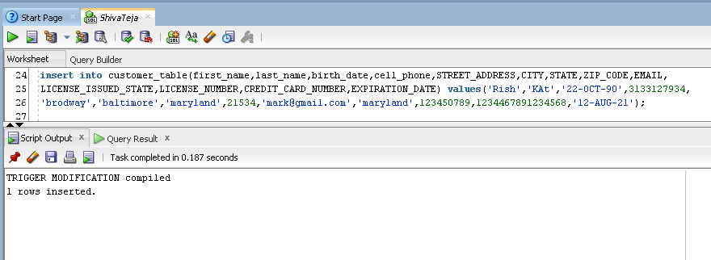

select * from error_log;

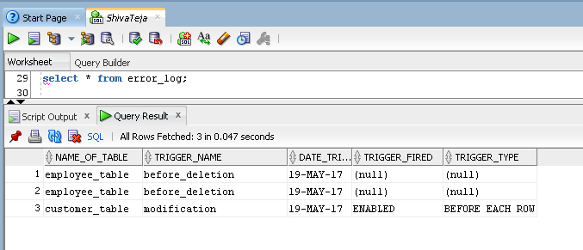

create or replace trigger accident_trigger

after insert on accident_table for each row

declare

customer_name varchar2(50);

Employee_name varchar2(50);

tri_status varchar2(100);

tri_type varchar2(100);

emp_id project.employee.employee_id%type;

begin

select trigger_type,status into tri_type,tri_status from user_triggers where trigger_name like '%ACCIDENT_TRIGGER%';

select employee_id into emp_id from project.employee_car_list where car_id=:old.car_id;

select first_name||' '||last_name into employee_name from project.employee where employee_id=emp_id;

select first_name||' '||last_name into customer_name from project.customer where customer_id=:new.customer_id;

insert into accident_log values(customer_name,employee_name,:new.Date_Time);

exception

when others then

begin

insert into error_log values('accident_table','ACCIDENT_TRIGGER',sysdate,tri_status,tri_type);

end;

end;

