Bellabeat
Smart Device Usage Analysis
A Marketing Strategy Case Study for Bellabeat Time
Prepared using the Ask–Prepare–Process–Analyze–Share–Act framework

1. Business Task
This analysis examines FitBit fitness tracker data to uncover trends in how people use smart devices to track daily activity and sleep. These insights are used to recommend marketing strategies for Bellabeat's Time smart watch, helping position the product based on real-world usage habits.

Guiding Questions
- What are some trends in smart device usage?
- How could these trends apply to Bellabeat customers?
- How could these trends help influence Bellabeat marketing strategy?

Why Bellabeat Time
Time tracks activity, sleep, and stress — the same categories captured in the FitBit dataset — making it the product with the strongest overlap to this data source.

2. Data Sources
The analysis uses the FitBit Fitness Tracker Data (CC0: Public Domain, made available through Mobius on Kaggle). The dataset contains personal fitness tracker data from FitBit users, including activity, steps, heart rate, and sleep information across six tables: dailyActivity_merged, sleepDay_merged, hourlySteps_merged, hourlyCalories_merged, hourlyIntensities_merged, and weightLogInfo_merged.

ROCCC Evaluation
Criteria | Assessment
Reliable | Weak — only 33 users is a small sample, and we don't know if they're representative of the general population (age, fitness level, gender all unknown).
Original | Third-party — collected via an Amazon Mechanical Turk survey, not collected directly by Bellabeat or FitBit.
Comprehensive | Partial — covers activity, steps, sleep, and weight, but is missing demographic data (age, gender) that would help tailor marketing to Bellabeat's audience.
Current | Data was collected April 12 – May 12, 2016 — now roughly a decade old. Device technology and daily routines have likely shifted since then, so findings should be viewed as directional trends.
Cited | Yes — licensed CC0 Public Domain and distributed via Mobius on Kaggle, so it is legally safe to use.

Note: the dataset documentation references 30 users, but 33 unique users were found in dailyActivity_merged — a minor discrepancy worth flagging for transparency.

3. Data Cleaning & Processing
All data was uploaded to Google BigQuery and processed using SQL. The following data quality checks and cleaning steps were performed:

Duplicate Records
- dailyActivity_merged: no duplicate user/date combinations found.
- sleepDay_merged: 3 exact duplicate rows found and removed using SELECT DISTINCT, preserving the original raw table.

Inconsistent Date Formats
Both sleepDay_merged and hourlyIntensities_merged contained two mixed date/time text formats (e.g., "4/23/2016 12:00:00 AM" vs. "05-06-2016 00:00"). These were standardized into proper DATETIME fields using PARSE_DATETIME with fallback logic. All rows converted successfully with zero data loss (410 of 410 sleep rows; 22,099 of 22,099 hourly intensity rows).

Data Completeness Across Tables
Table | Users with Data | % of 33 | Usable for Time Analysis?
dailyActivity_merged | 33 | 100% | Yes
hourlySteps_merged | 33 | 100% | Yes
hourlyCalories_merged | 33 | 100% | Yes
hourlyIntensities_merged | 33 | 100% | Yes
sleepDay_merged | 24 | 73% | Yes (with caveat)
weightLogInfo_merged | 8 | 24% | Excluded — too sparse

Activity, steps, calories, and intensity data are complete across all 33 users. Sleep data covers 73% of users, a usable but smaller subset. Weight data covers only 24% of users and was excluded from the core analysis as too sparse to generalize from — and not a feature offered by the Bellabeat Time product in any case.

4. Analysis & Key Findings

Finding 1: Users Are Highly Sedentary
Across all users, the average day includes about 991 sedentary minutes (~16.5 hours), compared to just 193 lightly active minutes and only 35 combined minutes of fairly and very active movement. Average daily steps were 7,638 — below the commonly cited 10,000-step benchmark.
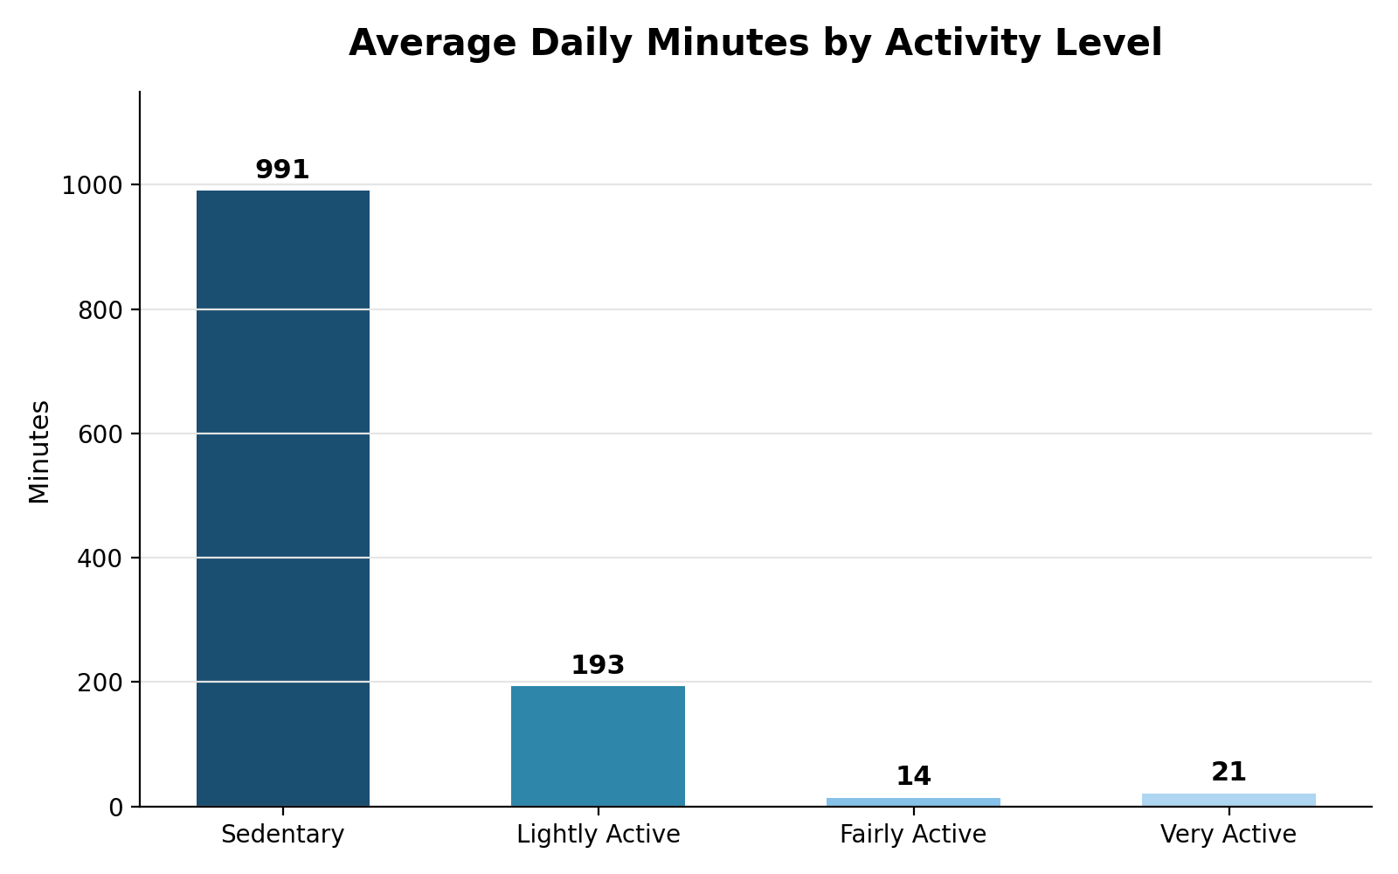
Figure 1. Average daily minutes spent at each activity level.

Finding 2: More Active Users Sleep Less
Grouping days into low (<5,000 steps), moderate (5,000–9,999 steps), and high (10,000+ steps) activity levels shows a clear inverse relationship with sleep: low-activity days average 454 minutes of sleep (~7.6 hrs), while high-activity days average only 396 minutes (~6.6 hrs) — about an hour less.
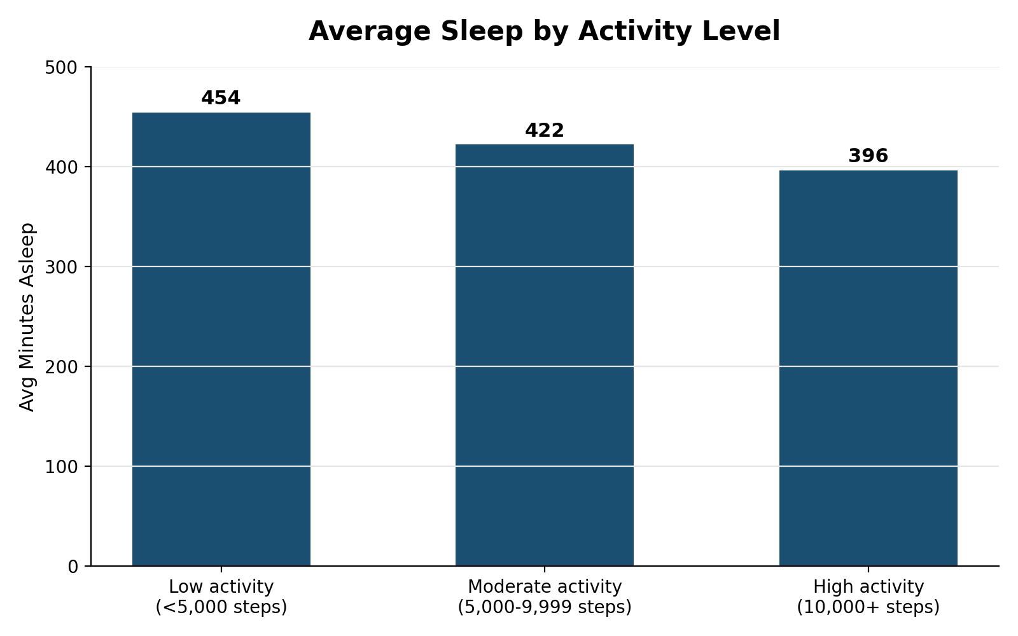
Figure 2. Average minutes asleep by activity level.
This does not necessarily mean activity causes worse sleep — more likely, busier and more active days simply leave less time available for sleep. Either way, it's a meaningful pattern for a wellness brand to address.

Finding 3: Activity Peaks Sharply Between 5–7 PM
Hourly intensity is lowest overnight (3–4 AM), climbs steadily through the morning, plateaus through the workday, and peaks clearly in the early evening — between 5 PM and 7 PM, with the single highest point at 6 PM.
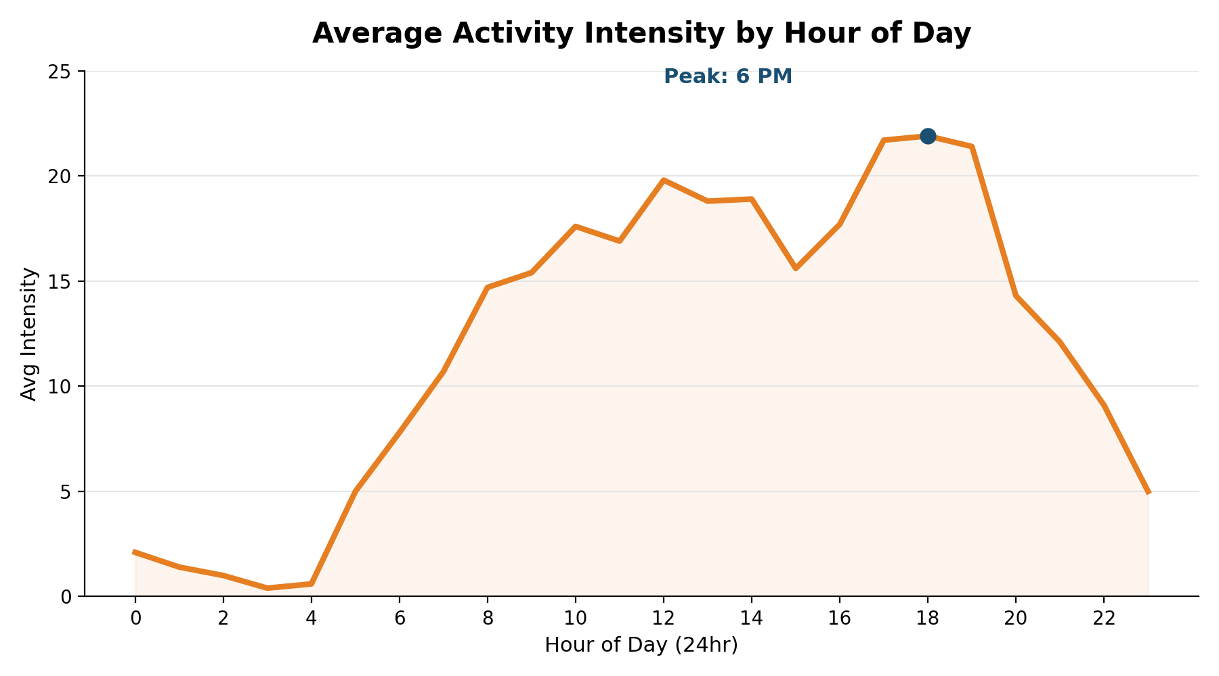
Figure 3. Average activity intensity by hour of day.

5. Recommendations
Based on the findings above, three high-level recommendations are proposed for Bellabeat Time's marketing strategy:

1. Market Time Around Achievable, Everyday Movement
Since most users are sedentary for roughly 16.5 hours a day with limited true exercise time, Bellabeat Time should be positioned around gentle, achievable movement goals — such as hourly "stand up and move" reminders — rather than intense fitness metrics. The data shows most users are everyday people, not athletes.

2. Promote Combined Sleep-and-Activity Tracking as a Balance Tool
Since more active users tend to sleep less, Bellabeat Time should market its combined sleep-and-activity tracking feature to help users understand this trade-off. The app could send gentle notifications on high-activity days, encouraging users to wind down earlier and protect their sleep.

3. Time Engagement Around the 5–7 PM Activity Peak
Since user activity peaks between 5 PM and 7 PM, Bellabeat Time should send a motivational reminder at the start of this window (5 PM) to encourage users to begin their workout, followed by an appreciation or streak notification around 7 PM to reinforce the habit. This peak engagement window is also the ideal time to surface promotional content, such as Bellabeat membership upgrades, when users are most active and receptive.

6. Limitations
- Small sample size (33 users) limits how confidently findings generalize to Bellabeat's broader customer base.
- Data is roughly a decade old (collected April–May 2016); usage habits and device technology have likely changed since.
- No demographic data (age, gender) is available, and Bellabeat's core audience is women, while the FitBit sample's makeup is unknown.
- Sleep data covers only 73% of users and weight data only 24%, limiting confidence in those specific findings.

