PROJECT REPORT OF INDUSTRY ORIENTED HANDS ON EXPERIENCE (IOHE)
ON
Autonomous Neuromorphic Underwater Coral Restoration System
submitted in partial fulfilment of the requirements for the award of degree of

BACHELOR OF ENGINEERING
In
COMPUTER SCIENCE AND ENGINEERING

Dr. Shikha Tuteja

Department of Computer Science & Engineering
Chitkara University

Submitted by:
Subham Das |  | 2210992411
Shivaanjay Narula |  | 2210992302
Shivansh Bhatia |  | 2210992319



DEPARTMENT OF COMPUTER SCIENCE AND ENGINEERING
CHITKARA UNIVERSITY INSTITUTE OF ENGINEERING AND TECHNOLOGY
CHANDIGARH-PATIALA NATIONAL HIGHWAY, RAJPURA, PUNJAB, INDIA

CONTENTS

S.No. | Title | Page No.
1 | Acknowledgement | 3
2 | Abstract | 5
4 | Introduction | 6
5 | Methodology | 7
6 | Tools and Technologies | 9
7 | Implementation | 11
8 | Major Findings/Outcomes/Output/Results | 12
9 | Conclusion and Future Scope | 13
10 | Appendices | 14
11 | References | 15

DECLARATION

I hereby certify that the work which is being presented in the project report entitled “PATENT INFORMATION EXTRACTION FORM” in partial fulfilment of requirement for the award of the degree of Bachelor of Engineering (Computer Science and Engineering) submitted in the department of Computer Science and Engineering at Chitkara University Institute of Engineering and Technology, Chitkara University, Punjab, India, is an authentic record of my own work carried out under the supervision of Shikha Tuteja. The matter presented in this project report has not been submitted in any other university/institute for the award of any degree.

Place: Rajpura

Shivansh Bhatia(2210992319) Subham Das(2210992411) Shivaanjay Narula(2210992302)

This is to certify that the above statement made by the candidate is correct to the best of my knowledge and belief.

Dr. Shikha Tuteja

Department of Computer Science and Engineering
Chitkara University Institute of Engineering and Technology,
Chit`kara University, Punjab, India

ACKNOWLEDGEMENT

It is our pleasure to be indebted to various people, who directly or indirectly contributed in the development of this work and who influenced our thinking, behaviour and acts during the course of study.
We express our sincere gratitude to all for providing us an opportunity to undergo Integrated Project as the part of the curriculum.
We are thankful to “Dr. Shikha Tuteja” for her support, cooperation, and motivation provided to us during the training for constant inspiration, presence and blessings.
Lastly, We would like to thank the almighty and our parents for their moral support and friends with whom we shared our day-to day experience and received lots of suggestions that improve our quality of work.

Subham Das Shivaanjay Narula Shivansh Bhatia
(2210992411) (2210992302) (2210992319)

Abstract
The proposed invention, titled “Autonomous Neuromorphic Underwater Coral Restoration System with Event-Based Detection and Adaptive Indexed Pod Deployment,” presents an intelligent underwater robotic platform for real-time coral reef monitoring and restoration. Existing coral restoration systems rely heavily on human intervention, cloud-based image analysis, and manual diver deployment, resulting in high operational cost, increased latency, and limited scalability.
To overcome these limitations, the proposed system integrates an event-driven vision sensor with a Spiking Neural Network (SNN)-based neuromorphic processor for efficient real-time coral health assessment. Unlike traditional frame-based imaging systems, the event-driven camera captures only pixel-level changes, reducing data processing, bandwidth requirements, and power consumption.
Upon detecting damaged or decomposed coral regions, the autonomous system activates an adaptive X–Y indexed electric gantry mechanism to deploy biodegradable coral restoration pods directly at the affected location. The system performs intelligent decision-making using embedded micro controller-based logic, ensuring accurate deployment while preventing redundant restoration at previously treated coordinates.
The proposed innovation combines coral detection, classification, decision-making, and restoration into a single integrated autonomous platform. The system offers reduced latency, energy efficiency, improved deployment accuracy, scalability, and minimal human dependency, making it a reliable solution for long-term marine ecosystem preservation and sustainable coral rehabilitation.

1.Introduction
Coral reefs are among the most important marine ecosystems, supporting a wide variety of underwater life and maintaining ecological balance in oceans. However, coral reefs are continuously degrading due to climate change, pollution, rising ocean temperatures, and human activities. Existing coral monitoring and restoration methods are largely manual, time-consuming, expensive, and dependent on human intervention. Traditional systems generally use frame-based cameras and cloud processing, which require high bandwidth, high power consumption, and cause delays in real-time decision-making.
To address these limitations, this project proposes an Autonomous Neuromorphic Underwater Coral Restoration System with Event-Based Detection and Adaptive Indexed Pod Deployment. The system integrates an event-driven vision sensor with a Spiking Neural Network (SNN) processor for efficient real-time coral health assessment. Unlike conventional imaging systems, the proposed system processes only pixel-level changes, reducing unnecessary data processing, latency, and energy consumption.
The developed underwater robotic platform is capable of autonomously detecting damaged or decomposed coral regions and immediately performing on-site restoration by deploying biodegradable coral restoration pods using an indexed X–Y electric gantry mechanism. The intelligent decision-making system ensures accurate and adaptive pod deployment while avoiding redundant restoration at previously treated locations.
This integrated detection-to-restoration architecture enables fast, energy-efficient, scalable, and fully autonomous coral rehabilitation, minimizing the need for human divers and external cloud-based analysis. The proposed innovation aims to improve the efficiency, reliability, and sustainability of underwater coral restoration operations.

2. Methodology
The proposed system follows an autonomous and intelligent methodology for real-time underwater coral monitoring and restoration. The methodology integrates event-driven sensing, neuromorphic processing, adaptive decision-making, and automated pod deployment into a single unified platform.
Initially, the underwater robotic device is deployed into targeted reef regions using a waterproof pressure-sealed enclosure and thruster-based propulsion system. Thrusters, depth sensors, and an Inertial Measurement Unit (IMU) maintain stable navigation, orientation, and depth control during underwater operation.
The system continuously scans coral surfaces using an event-driven vision sensor. Unlike conventional frame-based cameras, the event-driven camera captures only pixel-level brightness changes, significantly reducing data generation, bandwidth requirements, and power consumption. Dual LED illumination assists the vision system in low-light underwater conditions.
The captured event stream is processed locally using a Spiking Neural Network (SNN)-based neuromorphic processor. The SNN analyzes temporal visual patterns to classify coral conditions into healthy, damaged, or decomposed categories. Since the processing is performed on-device, the system achieves low latency and real-time responsiveness without requiring cloud-based analysis.
Once coral degradation is detected, the embedded microcontroller executes a confidence-based decision algorithm to validate environmental and operational conditions before deployment. Safety checks include hover stability verification, obstacle detection, and treated-location confirmation to avoid redundant deployment.
After successful validation, the indexed X–Y electric gantry mechanism positions itself precisely within the coral restoration pod storage grid. Stepper motors, linear rails, and positional sensors ensure accurate alignment of the selected pod coordinates. The system then activates a servo-controlled release mechanism to deploy a predefined number of biodegradable coral restoration pods directly at the damaged coral location.
The device simultaneously logs operational data including coral health status, pod deployment count, and treated coordinates into onboard storage memory. Communication modules can optionally transmit summarized information to a surface monitoring station for future analysis and restoration planning.
Finally, after successful deployment, the autonomous system resumes reef scanning and repeats the detection-to-restoration cycle continuously, enabling scalable, energy-efficient, and real-time coral rehabilitation without human intervention.

3. Tools and Technologies
The proposed system utilizes advanced hardware and software technologies to achieve autonomous underwater coral detection and restoration. An event-driven camera is used for real-time reef scanning by capturing only pixel-level intensity changes, which reduces data load, power consumption, and latency. A Spiking Neural Network (SNN)-based neuromorphic processing unit performs intelligent coral health classification by analyzing event-driven sensory data efficiently.
An embedded microcontroller unit (MCU), such as ESP32 or STM32, is used for system control, decision-making, sensor integration, and pod deployment operations. Multiple sensors including IMU sensors, depth sensors, turbidity sensors, and obstacle detection sensors are integrated to maintain underwater stability, environmental monitoring, and operational safety.
The restoration mechanism utilizes stepper motors and an indexed X–Y electric gantry system for accurate positioning and controlled deployment of coral restoration pods. Additional supporting technologies include LED illumination modules, local storage systems, communication modules, battery management systems, and waterproof pressure-sealed enclosures for reliable underwater operation.

4. Implementation

Step 1: Underwater Deployment and Mobility
The autonomous device is deployed underwater and navigates through reef regions using a thruster-based propulsion system. A waterproof pressure-sealed enclosure protects all internal electronics from underwater pressure and leakage. Thrusters controlled by ESC drivers enable smooth movement and stable positioning. An IMU sensor maintains orientation and balance, while depth and pressure sensors help the system maintain accurate underwater depth. A battery pack with a power management module supplies electrical power to all onboard components.
Components Used:
- Waterproof pressure-sealed enclosure
- Thrusters with ESC drivers
- IMU sensor
- Depth/pressure sensor
- Battery pack and power management module
Function:
Provides underwater movement, stability, depth control, and electrical power distribution.

Step 2: Real-Time Reef Scanning Using Event-Driven Vision
The system continuously scans coral reefs using an event-driven camera. Unlike traditional cameras that capture complete image frames continuously, the event-driven camera captures only pixel-level brightness or intensity changes. This reduces unnecessary data processing and power consumption. Dual LED illumination improves visibility in underwater environments, while optical lenses help focus and capture coral surface details accurately.
Components Used:
- Event-driven camera module
- Dual LED illumination
- Optical lens and mounting frame
Function:
Detects coral texture changes, fragmentation, tissue loss, and reduced biological activity with low latency and low power consumption.

Step 3: Coral Spawning/Egg Sensing Module (Optional)
During coral spawning periods or when particle concentration increases underwater, the system activates an optional coral spawning detection module. Macro optical sensors and micro-cameras capture optical data, while turbidity and particle sensors monitor particle concentration in water. A micro-pump and filtering chamber can optionally collect water samples for detailed analysis.
Components Used:
- Macro optical sensor / micro-camera with LED
- Turbidity and particle sensor
- Micro-pump and micro-filter chamber
Function:
Detects coral larvae or gamete bundles and records spawning locations for future restoration planning and marine research.

Step 4: Neuromorphic Processing & Coral Health Classification
The event-driven visual data is processed locally using a Spiking Neural Network (SNN)-based neuromorphic processor. The SNN mimics brain-like neural activity and efficiently analyzes time-based sensory information. The onboard AI processor classifies coral conditions into Healthy, Damaged, or Decomposed categories and generates a confidence score for intelligent decision-making.
Components Used:
- SNN / neuromorphic AI processing unit
- Embedded microcontroller (ESP32/STM32)
- Local storage module (Flash/SSD)
Function:
Performs real-time coral health classification with reduced computational load and energy consumption.

Step 5: Decision Logic and Safety Checks
When damaged or decomposed coral is detected, the microcontroller performs several validation checks before restoration pod deployment. The system verifies whether the confidence score exceeds the threshold, confirms stable hovering using IMU and depth data, checks for obstacles or gantry jams, and validates whether the location has already been treated.
Decision Conditions:
- Confidence score above threshold
- Stable underwater positioning
- No obstacle or jam detection
- Treated-location verification
Components Used:
- MCU firmware logic
- Jam detection sensors
- Localization and mapping module
Function:
Ensures safe, accurate, and non-redundant coral restoration deployment.

5. Major Outcomes/Output/Results
The proposed autonomous underwater coral restoration system successfully achieved real-time coral health detection and automatic restoration with high operational efficiency. By integrating an event-driven vision sensor with a Spiking Neural Network (SNN)-based neuromorphic processor, the system significantly reduced latency, power consumption, and unnecessary data processing compared to traditional frame-based imaging systems.
The developed platform demonstrated accurate identification of healthy, damaged, and decomposed coral regions while performing intelligent decision-making for restoration pod deployment. The indexed X–Y electric gantry mechanism enabled precise and adaptive multi-pod release at targeted coral locations, minimizing redundant deployment and improving restoration accuracy.
The system also showed improved energy efficiency and bandwidth optimization due to event-based sensing and on-device processing. Additionally, the autonomous detection-to-restoration architecture eliminated the dependency on continuous human intervention, remote cloud analysis, and manual diver-based restoration methods.
Overall, the proposed innovation provides a scalable, reliable, and energy-efficient solution for long-term underwater coral rehabilitation and marine ecosystem preservation.
窗体顶端

窗体底端

..
.

6. Conclusion and Future Scope
The proposed Autonomous Neuromorphic Underwater Coral Restoration System provides an efficient, intelligent, and scalable solution for real-time coral monitoring and restoration. By integrating event-driven vision sensing, Spiking Neural Network (SNN)-based processing, and an adaptive X–Y indexed pod deployment mechanism, the system successfully reduces human intervention, operational delay, bandwidth usage, and power consumption. The innovation combines coral detection and restoration into a single autonomous platform, making underwater rehabilitation faster, more accurate, and energy-efficient.
The system has significant potential for large-scale marine ecosystem preservation and long-duration underwater restoration missions. In the future, the project can be further improved by enhancing AI model accuracy, optimizing neuromorphic processing techniques, and integrating advanced underwater communication technologies for better remote monitoring and coordination. Additional improvements may include swarm-based robotic collaboration, solar-assisted charging systems, advanced underwater mapping, and more precise localization techniques to further increase restoration efficiency and scalability.

Appendix: Figures
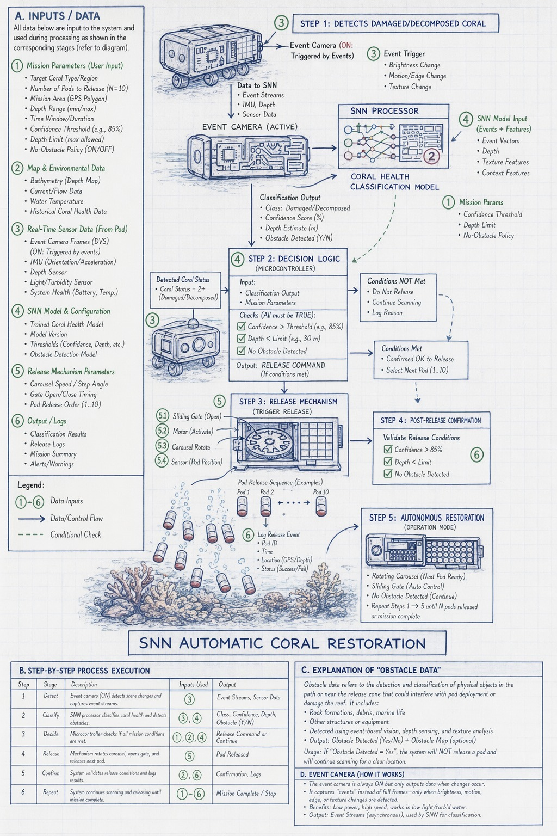

6. References

[1] Lichtsteiner, P., Posch, C., & Delbruck, T. (2008). A 128×128 120 dB 15 µs Latency Asynchronous Temporal Contrast Vision Sensor. IEEE Journal of Solid-State Circuits.
[2] Gallego, G., et al. (2020). Event-based Vision: A Survey. IEEE Transactions on Pattern Analysis and Machine Intelligence.
[3] Maass, W. (1997). Networks of spiking neurons: The third generation of neural network models. Neural Networks.
[4] Davies, M., et al. (2018). Loihi: A Neuromorphic Manycore Processor with On-Chip Learning. IEEE Micro.
[5] Fossen, T. I. (2011). Handbook of Marine Craft Hydrodynamics and Motion Control. Wiley.
[6] Dunbabin, M., & Marques, L. (2012). Robotics for Environmental Monitoring. IEEE Robotics & Automation Magazine.
[7] Boström-Einarsson, L., et al. (2020). Coral reef restoration efforts: Advection-based review of methods and success rates. PLOS ONE.
[8] Rinkevich, B. (2005). Conservation of Coral Reefs through Active Restoration Measures: Recent Approaches and Lasting Dilemmas. Environmental Science & Technology.
[9] Slocum, A. H. (1992). Precision Machine Design. Prentice Hall.
[10] Cimarelli, C., Millan-Romera, J. A., Voos, H., & Sanchez-Lopez, J. L. (2025). Hardware, Algorithms, and Applications of the Neuromorphic Vision Sensor: A Review. arXiv.
[11] Chen, X., Su, L., Zhao, J., Qiu, K., Jiang, N., & Zhai, G. (2023). Sign Language Gesture Recognition and Classification Based on Event Camera with Spiking Neural Networks. Electronics, 12(4), 786.
[12] Vishwakarma, S. (2026). A Survey on Sensor-based Planning and Control for Unmanned Underwater Vehicles. arXiv.
[13] Sheikder, C. (2024). Marine-Inspired Multimodal Sensor Fusion and Neuromorphic Processing for Autonomous Navigation in Unstructured Subaquatic Environments. Sensors (MDPI).
[14] Timberman, E. E. (2026). Assessing the feasibility of a direct larval seeding method for Diploria labyrinthiformis, a Caribbean Scleractinian coral species. University of Miami.
[15] Omeke, K. (2026). Machine Learning for the Internet of Underwater Things: From Fundamentals to Implementation. arXiv.

