PIE
PATENT INFORMATION EXTRACTION FORM
TOPIC : Autonomous Neuromorphic Underwater Coral Restoration System with Event-Based Detection and Adaptive Indexed Pod Deployment
SCHOOL: Chitkara University Institute of Engineering and Technology
INVENTOR’S DETAIL WHO UPLOADED THE PATENT ON CHALKPAD
NAME: Shikha Tuteja
EMPLOYEE CODE: CET1002580 MOBILE NO: 9915369888
MAIL ID (UNIVERSITY): shikha.1290@chitkara.edu.in
MAIL ID (PERSONAL): shikha.1290@chitkara.edu.in
OTHER INVENTORS DETAIL
NAME | EMP CODE/ROLL | ADDRESS WITH EMAIL AND MOBILE NO.
Subham Das | 2210992411 | subham2411.be22@chitkara.edu.in 9002964762
Shivansh Bhatia | 2210992319 | shivansh2319.be22@chitkara.edu.in 9568477210
Shivaanjay Narula | 2210992302 | shivaanjay2302.be22@chitkara.edu.in 8580457634
Shikha Tuteja | CET1002580 | shikha.1290@chitkara.edu.in 9915369888
Prabir Maity | 2250951013 | prabir22013.ccp@chitkara.edu.in 8945527815
Soumarshi Das | 2250951019 | soumarshi22019.ccp@chitkara.edu.in 6297213177

Answer the following questions in brief: (use extra sheets if needed, submit pics/videos etc. which can help us to understand the invention better)

- What was the problem?

- Current coral monitoring systems are not fully automatic, as they depend on humans to analyze data and take action later for coral damage detection and farther deployment .

- There is a delay between detecting coral damage and performing restoration, which reduces effectiveness and increases cost.

- Existing systems use traditional cameras and cloud processing, which require more energy and are not suitable for real-time response.

- There is no single system that can both detect coral damage instantly and perform restoration at the same location without human involvement

- How did you solve it (Inventive Step)?

    - We designed an autonomous underwater system that can both detect coral damage and respond without human involvement using the help of SNN algorithm.

- The system uses an event based sensor instead of a regular camera, which helps in faster detection and lower power usage.

    - It processes the data directly on the device, so there is no need for cloud-based analysis.

    - When damage is detected, the system automatically deploys coral restoration pods at the exact location.

    - A controlled mechanism ensures accurate placement and avoids repeating the process in the same area, making it efficient and scalable.

- What were the other possible solutions and why they could not be done?

- Several alternative solutions were consider for coral monitoring, damage detection and restoration.

- One option was using normal cameras with AI models and sending data to a server but it needs high bandwidth, more power with the help of CNN based algorithm and is not suitable for long underwater use.

- Manual inspection by divers was also considered but it is slow, expensive and not practical for covering large coral areas.

- Some basic under water robots can place coral at fixed intervals but they cannot detect damage properly and may waste resources.

- Hydraulic systems for deployment were another option but they are complex, heavy and have risks like leakage and high maintenance.

- Because of these issues we chose a smarter system that can detect damage and restore coral in real time in an efficient and automatic way.

- What are the advantages of the solution proposed by you?

- Real-Time Autonomous Operation : The system can detect coral damage and immediately take action at the same location without waiting for human input or external analysis.

- Energy Efficiency : It uses an event-based sensor and efficient processing, which helps reduce power consumption compared to traditional camera systems using the help of SNN algorithm.

- Reduced Delay : Since all processing happens on the device itself, there is no need to send data to servers, which makes the response much faster.

- Adaptive Deployment Mechanism: The system can place restoration pods accurately based on how severe the damage is using x-y electric gantry (printer works mechanism ), ensuring better results.

- Scalability : It can work continuously over large coral reef areas without needing divers, making it suitable for large-scale use.

- Improved Accuracy : The system remembers previous locations and avoids placing pods again in the same spot, reducing waste.

- Mechanical Reliability : The electric mechanism is simpler more reliable,and requires less maintenance compared to complex hydraulic systems.

- Bandwidth Optimization : It processes only important changes instead of full images which leads to reduces data usage and communication needs.

- Integrated System : Unlike the conventional systems used before that separate monitoring and restoration the invention combines both into a unified autonomous platform.

- Explain the step wise working of the innovation explaining all the components used in the invention and the specific function they are performing.

- Step 1: Underwater deployment and mobility : The device is deployed underwater and navigates to the targeted reef areas using the thruster based propulsion.
Components used:
- Waterproof pressure sealed enclosure
- Thrusters (vectored fans) and ESC drivers
- IMU (orientation/tilt)
- Depth and pressure sensor
- Battery pack and power management module
Function: It provides stable underwater movement, depth holding and electrical power distribution.

- Step 2: Real time reef scanning using event driven vision : The device continuously scans coral surfaces using an event driven camera. Only pixel level intensity changes are captured thus reducing data load.
Components used:
- Event driven camera module
- Dual LED illumination (fixed)
- Optical lens and mounting frame
Function: It detects coral texture change, loss of living tissue, fragmentation and low biological activity with low power and low latency.

- Step 3: Coral spawning or egg sensing mode : When the system enters a spawning window or detects a local particle increase, it activates the spawning and egg detection module.
Components used (possible solution):
- Macro optical sensor or micro camera and LED
- Turbidity or particle sensor (flow through)
- Micro pump and micro filter sampling chamber
Function: It detects coral gamete bundles and larvae presence through optical classification and particle change confirmation, and logs spawning locations for research and future restoration planning.

- Step 4: Neuromorphic processing and coral health classification :
The event stream and optional egg sensor data is processed by locally using a Spiking Neural Network (SNN) running on the onboard processor.
Components used:
- SNN or neuromorphic processing unit AI chip
- Embedded MCU ESP32 or STM32 for control
- Local storage (Flash or SSD)
Function: It classifies coral health as Healthy, Damaged or Decomposed and generates a confidence score for decision making.

- Step 5: Decision logic and safety checks: When the coral is classified as decomposed or damaged the microcontroller performs control checks before deploying the pods.
Decision conditions include:
- Confidence score above threshold
- Stable hovering (IMU and depth confirmation)
- No obstacle and jam detection
- Treated location verification (memory)
Components used:
- MCU firmware logic
- Jam detection sensor (gate/gantry feedback)
- Localisation/mapping module
Function: It prevents false deployment and duplicate deployment at the same spot, and ensures safe operation.

- Step 6: XY electric gantry indexing to select pods (10×10 grid) :
After confirmation, the indexed electric gantry positions itself to the selected pod coordinates in the 10×10 storage grid.
Components used:
- X axis stepper motor and linear rail
- Y axis stepper motor and linear rail
- Position encoder/limit switches
- Pod storage grid (100 box pods)
Function: It provides accurate positioning for controlled pod selection and avoids mechanical misalignment.

- Step 7: Automatic multi pod release (10 pods) : Once aligned, the system releases exactly 10 pods through the dispensing gate.
Components used:
- Servo actuated release gate
- Pod counter sensor (IR/limit/hall)
- Discharge chute/outlet port
Function: Ensures precise quantity based deployment for coral regeneration while avoiding over release.

- Step 8: Logging, mapping, and communication : The device stores the event data, coral health status, pod count released, and the treated location. If communication is available it transmits summary data to a surface/server.
Components used:
- Storage module (SSD/Flash)
- Communication module (acoustic modem / RF at surface)
- GPS at surface and underwater localisation (as available)
Function: It maintains restoration records, enables revisit planning, and supports long term reef monitoring.

- Step 9: Continue scanning : The device resumes scanning and repeats the above steps for new damaged coral regions.

- Attach drawing hand made/ computer made showing all the components of the
invention.

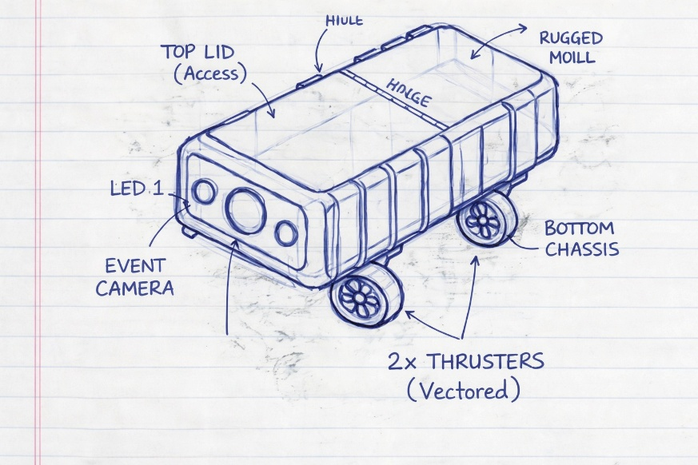

Figure 1: A rugged coral restoration device featuring a top access hinged lid, front mounted event driven camera with dual LEDs, and vectored thrusters for stable navigation and deployment.

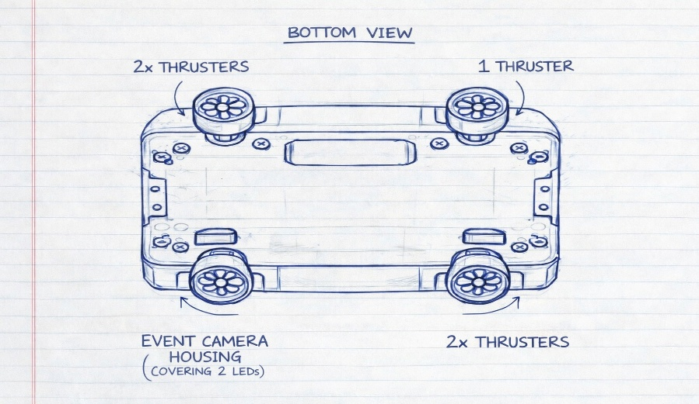

Figure 2: Bottom view showing four vectored thrusters and a protected event camera housing with dual LED coverage for underwater stability and vision.

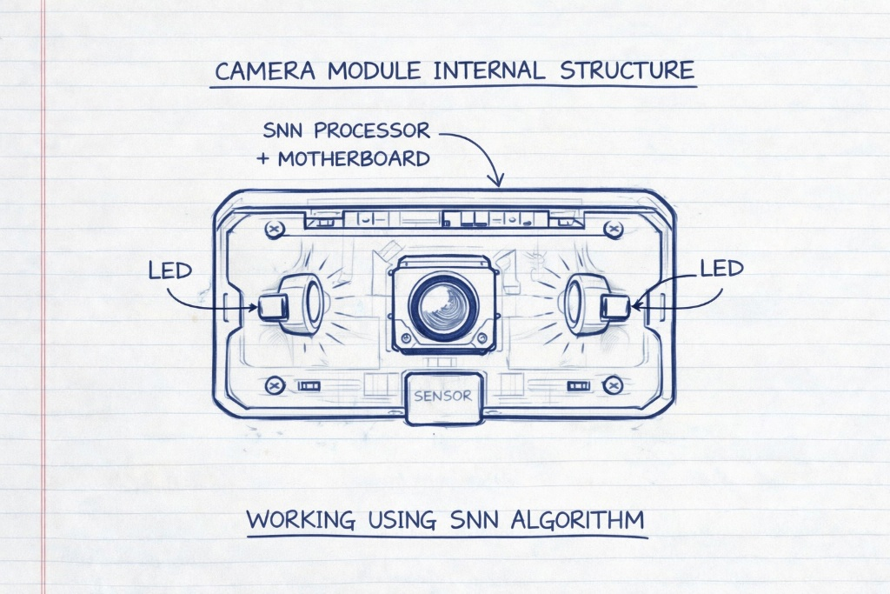

Figure 3: Internal camera module featuring a central event driven sensor with dual LED’s and an integrated SNN processor for real time underwater reef analysis.

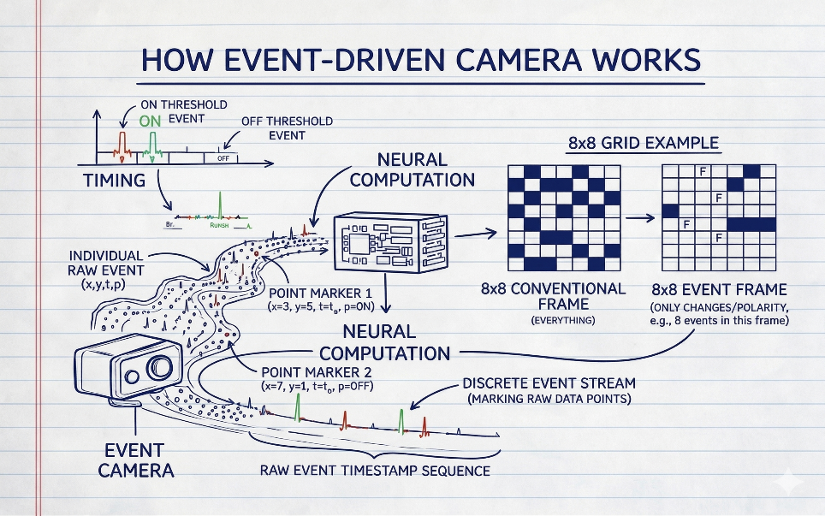

Figure 4: An event driven camera captures only changes in brightness at each pixel and sends them as fast, spike like signals instead of recording full image frames continuously.
.

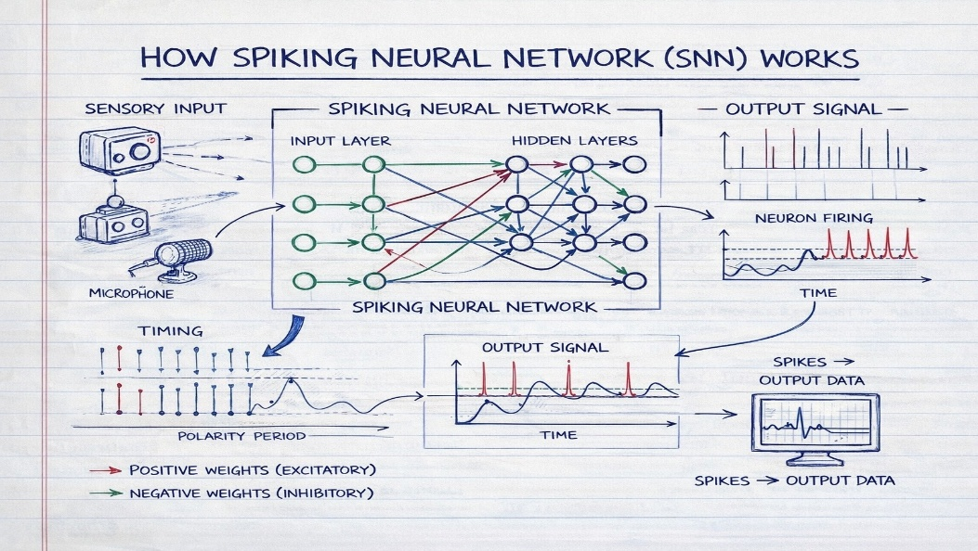

Figure 5: A Spiking Neural Network (SNN) processes time based sensory inputs as discrete spikes, using excitatory and inhibitory neuron firing patterns to generate efficient and event driven output signals.

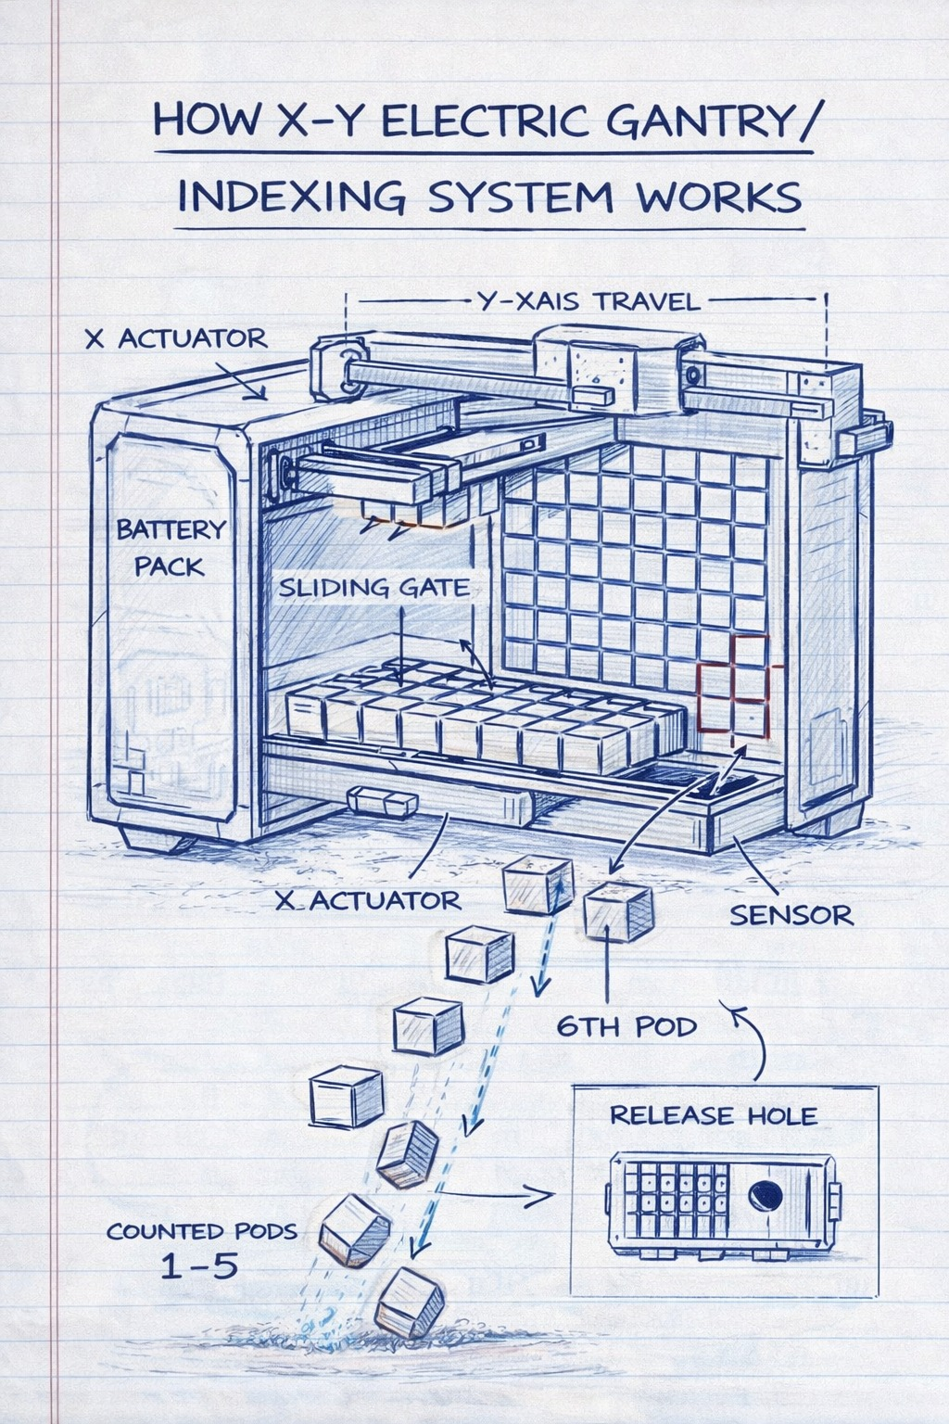

Figure 6: The XY electric gantry indexing system precisely moves across a pod grid using actuators and sensors to align and release selected coral pods through a controlled deployment hole.

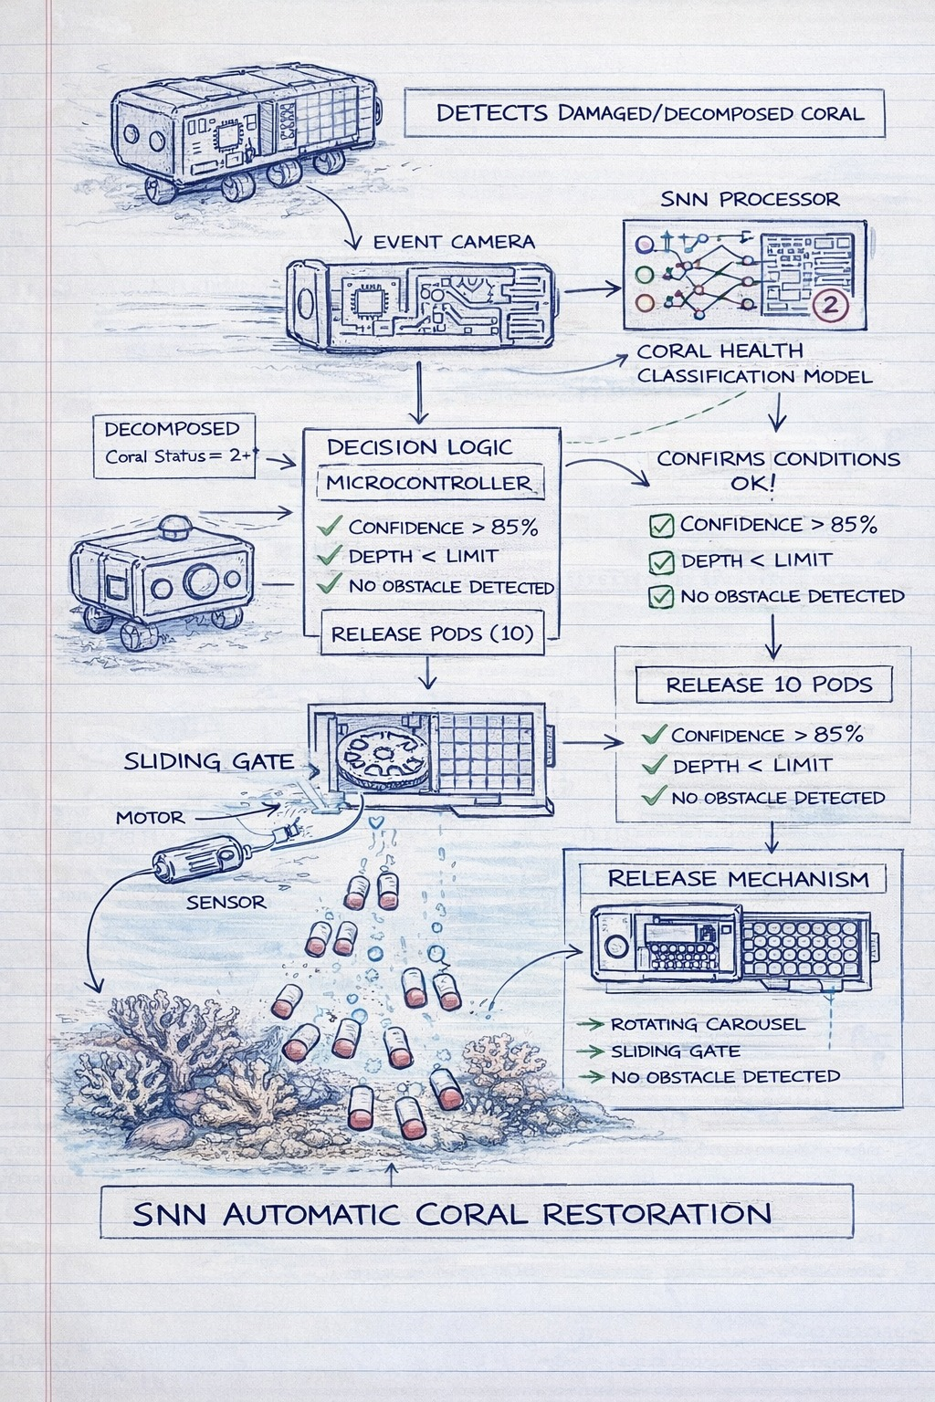
Figure 7 : An SNN based autonomous system detects damaged coral, validates environmental conditions and automatically deploys biodegradable pods through a controlled release mechanism for reef restoration.

Relevant Key phrases relating to your invention

S.NO. | Key phrases
1 | Neuromorphic Event-Based Underwater Coral Detection System
2 | Autonomous SNN-Based Real-Time Coral Health Classification
3 | Adaptive XY Indexed Electric Gantry Pod Deployment Mechanism
4 | Integrated Detection-to-Restoration Autonomous Marine Rehabilitation Platform

