**Data Visualization Tools**

**Tableau**

Tableau is a data visualization tool. You can create graphs, charts, maps, and many other graphics.

Tools of Tableau

Tableau Desktop

Tableau Public

Tableau Online

Tableau Server

Tableau Reader

Data analytics in Tableau is classified into two parts: -

Developer Tools: - The Tableau tools which are used for development such as the creation of charts, dashboards, report generation and visualization are known as developer's tools. Tableau Desktop and the Tableau Public, are the example of this type.

Sharing Tools:- The role of these tools are sharing the reports, visualizations, and dashboards that were created using the developer tools. The Tableau tools that fall into this category are Tableau Server, Tableau Online, and Tableau Reader.

**Tableau Desktop**

Tableau Desktop has a rich feature set and allows us to code and customize reports. Right from creating the reports, charts to blending them all to form a dashboard, all the necessary work is created in Tableau Desktop

1. **Tableau Bar Chart**

In Tableau, there are various types of bar chart that can be created by using the dimensions and measures.

A bar chart represents the data in rectangular bars. Tableau automatically produces a bar chart when you drag a dimension to the Row shelf and measure to the Column shelf.

The bar chart option present in the "Show Me" button. If the data is not appropriate for the bar chart, then this option will be automatically blocked out.

A bar chart can compare the data in different categories. The height of the bar represents the measured value of the category. It can be described as vertical and horizontal type bar charts. The procedure to create a bar chart is given below through an example

For example, consider a data source such as Sample-Superstore and its dimensions and measures.

Step1: First, go to the worksheet and,

Step2: Drag the Category field into the column shelf.

Step3: Drag Profit field into the row shelf.

Step4: By default, it creates the bar chart shown in the below screenshot.

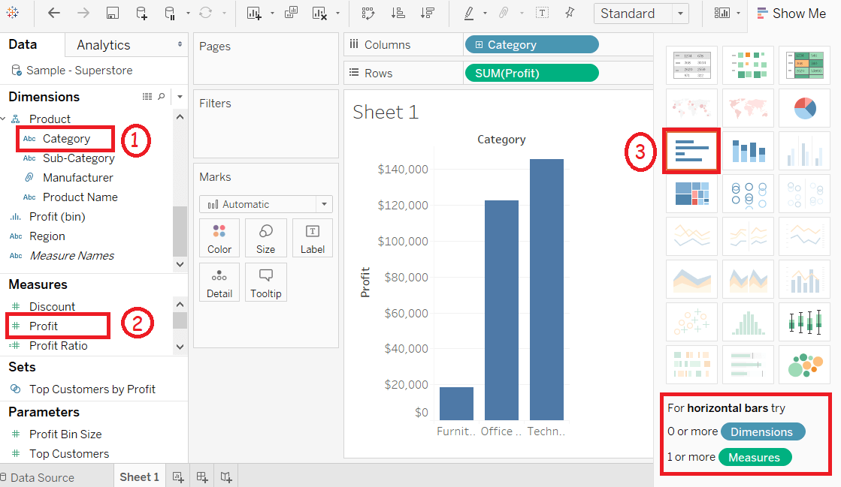

**Bar Chart with Color Range**

You can apply colors to the bars based on their ranges. The longer bars get darker shades, and the smaller bars get the lighter shades. Let's see step by steps,

Step1: Drag the Category field into the column shelf.

Step2: Drag Profit field into the row shelf.

Step3: Also, drag the Profit field to the Color pane under the Marks Pane and, it produces a different color for negative bars.

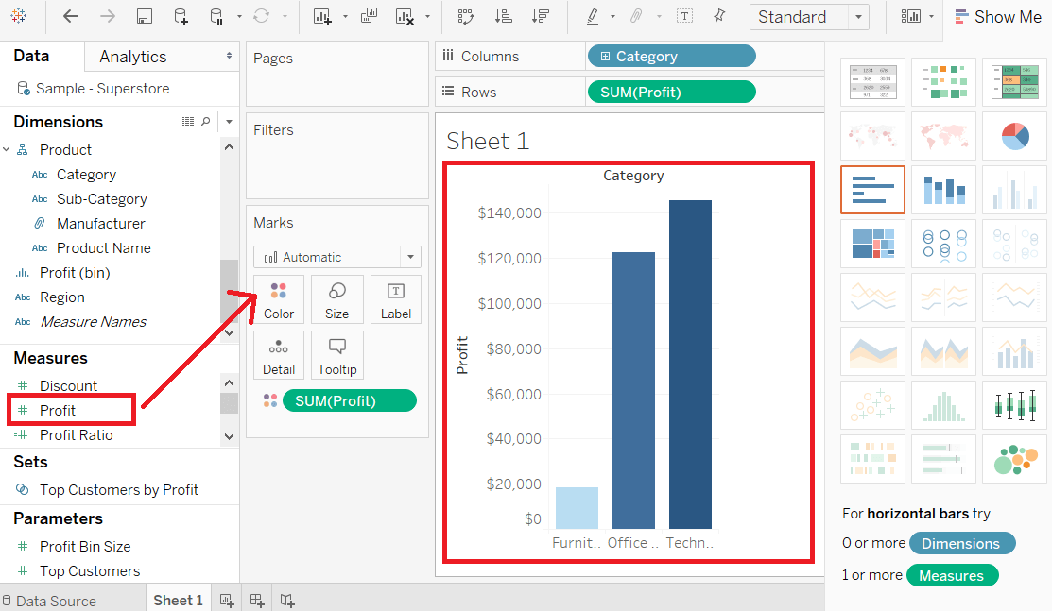

**Stacked Bar Chart**

You can also add one more dimension to the above bar chart to produce a stacked bar chart that shows different colors in each bar.

Step1: Drag the Segment field.

Step2: And drop the Segment field into Color pane.

The below-stacked chart appears that shows the distribution of each segment in each bar.

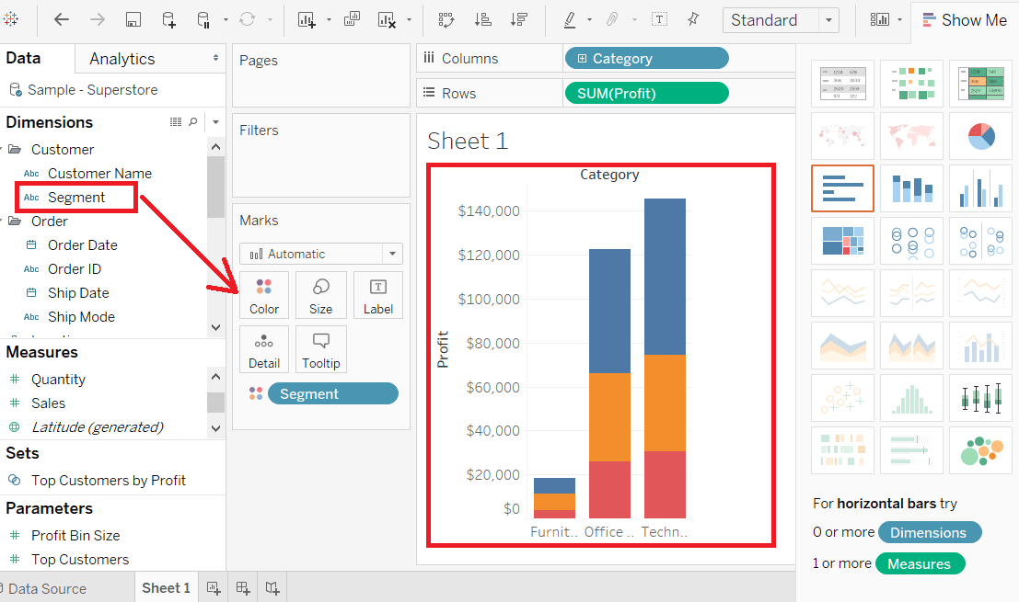

**2. Tableau Line Chart**

For example, consider a data source such as Sample-Superstore and its dimensions and measures.

Step1: Select one dimension and one measure to create a simple line chart.

1) Drag the dimension Order Date into Columns Shelf.

2) And Sales into the Rows shelf.

3) It creates the line chart by default or Chooses the Line chart from the "Show Me" button.

You will view the following line chart that shows the variation of Sales for different Order Date showing in the below screenshot.

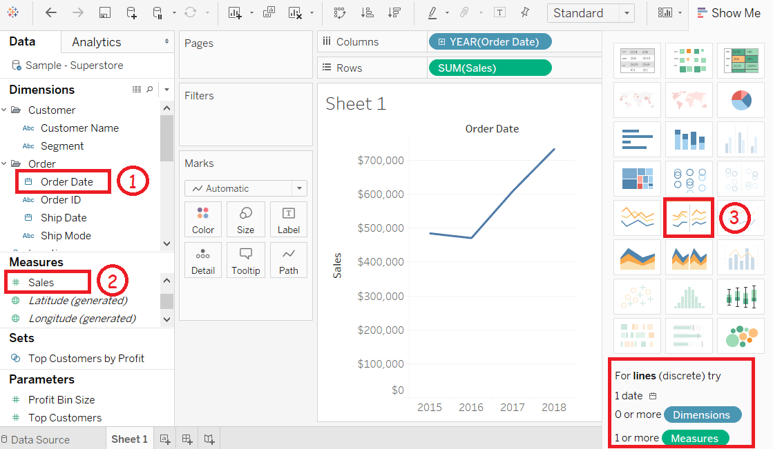

**Multiple Measure Line Chart**

Step1: Drag the dimension Order Date into Columns Shelf.

Step2: Drag measures Sales and Discount into the Rows shelf.

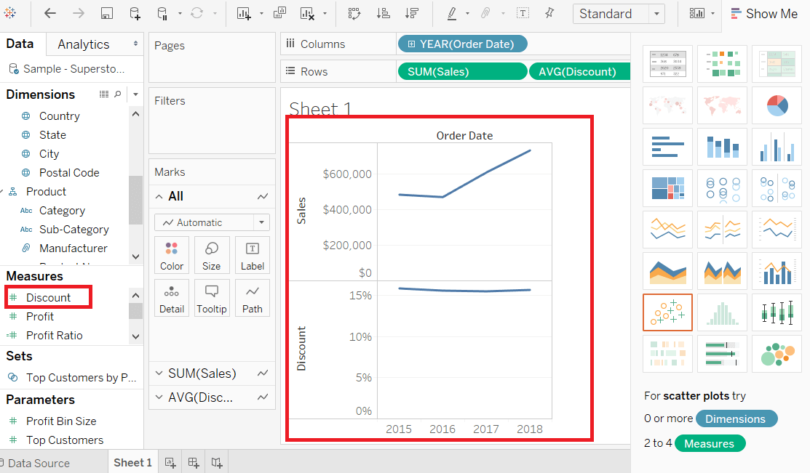

**Line Chart with Label**

Each of the points that creates the line chart are labeled to make the values of the measure visible.

Step1: Drop another measure Profit ratio into the "Labels" pane in the "Marks" card.

Step2: Choose average as the aggregation, and you will view the below chart showing the labels.

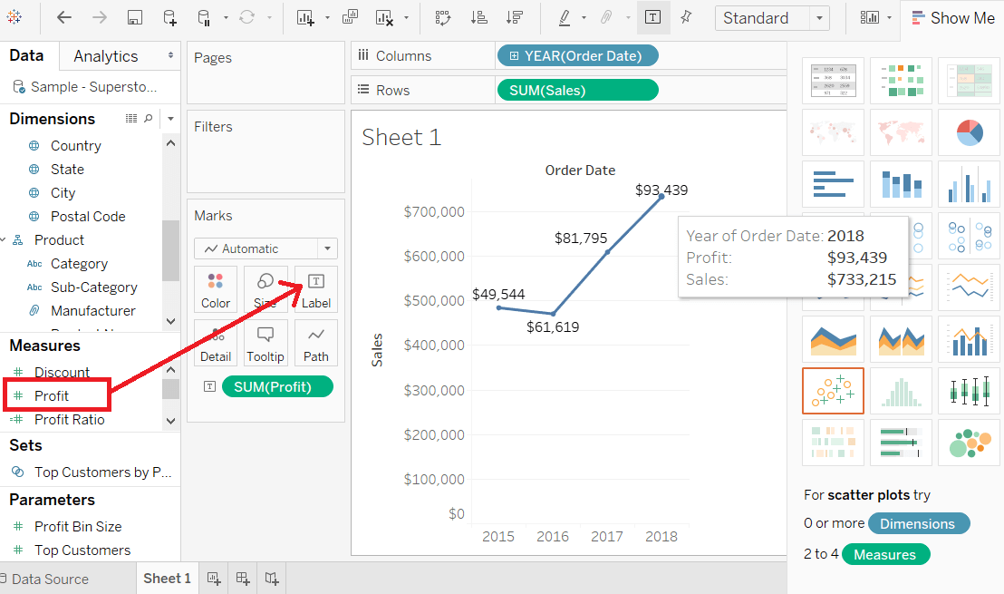

**3.Tableau Pie Chart**

Step1: Go to the worksheet.

Step2: Drag the dimension Segment and drop into the Color and Label pane.

Step3: Drag the measured Profit and drop into the Size pane.

Step4: Choose the chart type from "Show Me" pane.

The following chart will appear that shows the three segments in different colors with labels.

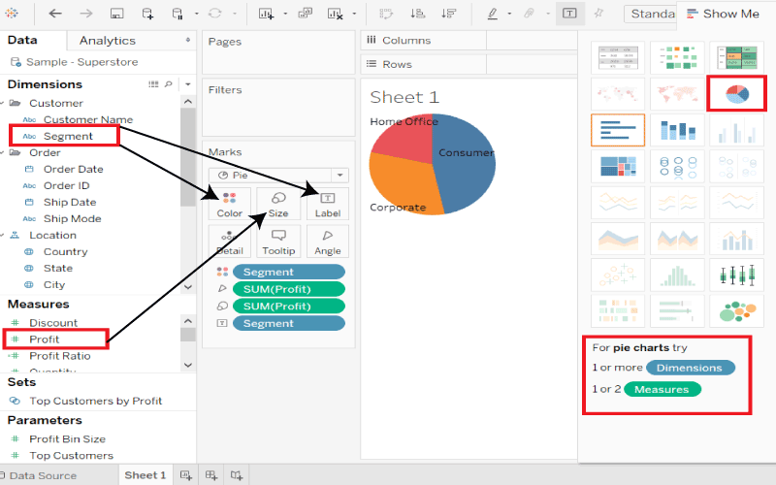

**Drill Down Pie Chart**

For example, consider a data source such as sample-superstore, then take the dimension Product, which has four more levels such as Category, Sub-Category, Manufacturer, and Product Name.

Drag the measured Profit and drop it to the Labels pane. The following pie chart appears that shows the values for each slice.

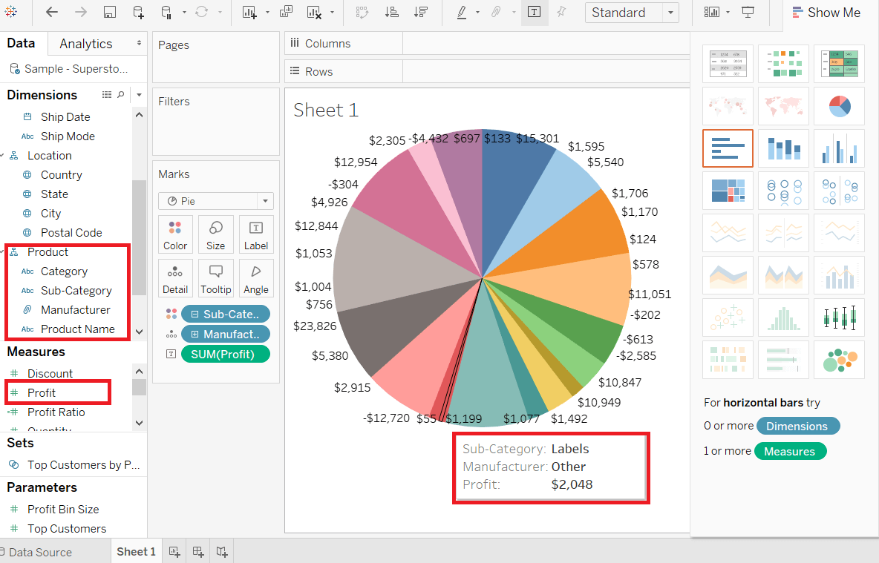

**4. Tableau Bubble Chart**

For example, consider a data source such as sample-superstore, and if you want to find the Profits for different Ship Mode. Then,

Step1: Drag the measures Profit and drop into the "Size" pane.

Step2: Drag the dimensions Ship Mode and drop into the "Labels" pane.

Step3: Also drag the dimension Ship Mode into the "Color pane" under the "Marks" card.

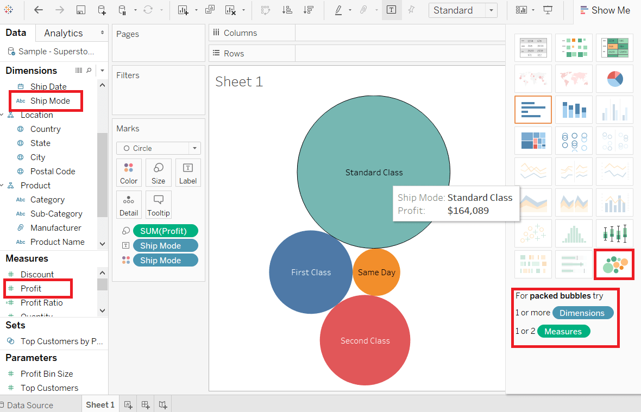

**Bubble Chart with Measure Values**

Also, you can show the value of the measures field that decides the size of the circles.

First, drag the measure Sales into the "Labels" pane. Show the following screenshot.

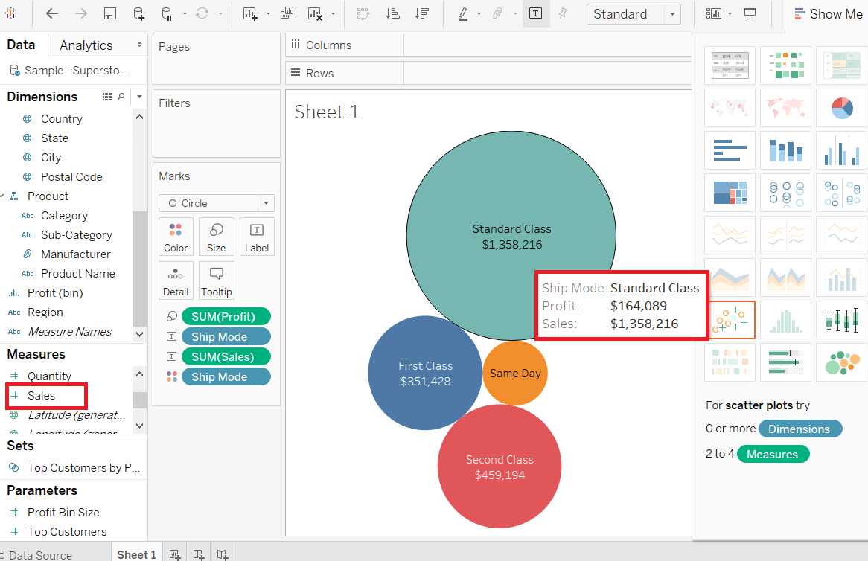

**Bubble Chart with Measure Color**

You can also use the same color with different shades for all the different size circles.

For this, drag the measure Sales into the "Color" pane. The darkest color shows the largest size of the circle and the lighter color shows the smallest size of the circle shown in the below screenshot.

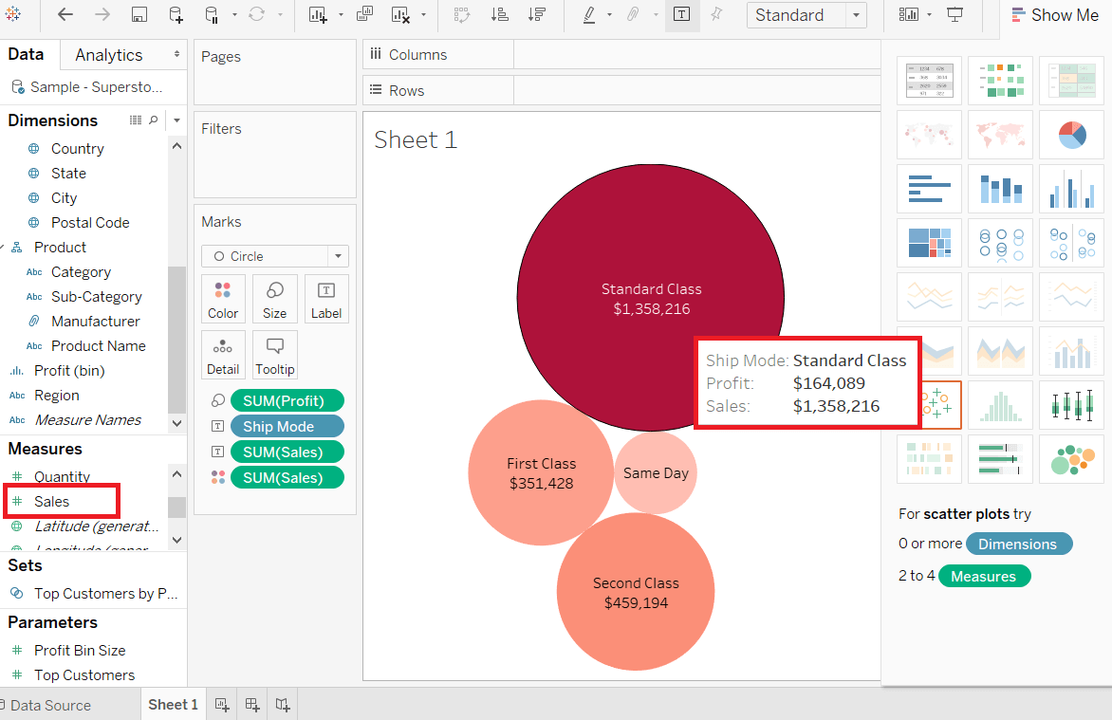

**5. Tableau Box Plot**

The box plot is also called the box-and-whisker plots. They show the distribution of value along an axis.

All box indicates the middle 50 percent of the data where the middle two quartiles of the data's distribution. On both sides, the remaining 50 percent of data represents by lines called whiskers.

To display all points within 1.5 times of interquartile range, which is all aspects within 1.5 times of the width of the adjoining box, or all points at the maximum area of the data.

The Box Plot takes one or more measures with zero or more dimensions.

For example, consider the data source such as Sample-Superstore and find the size of Profits field for the dimension Category for each Ship Mode field values. Below are the steps to create a box plot.

Step 1: Drag the dimension Category and drop into the Columns shelf.

Step 2: Drag the measure Profit and drop into the Rows shelf.

Step 3: Also drag the dimension ShipMode and drop into the right of the Category field in the Columns shelf.

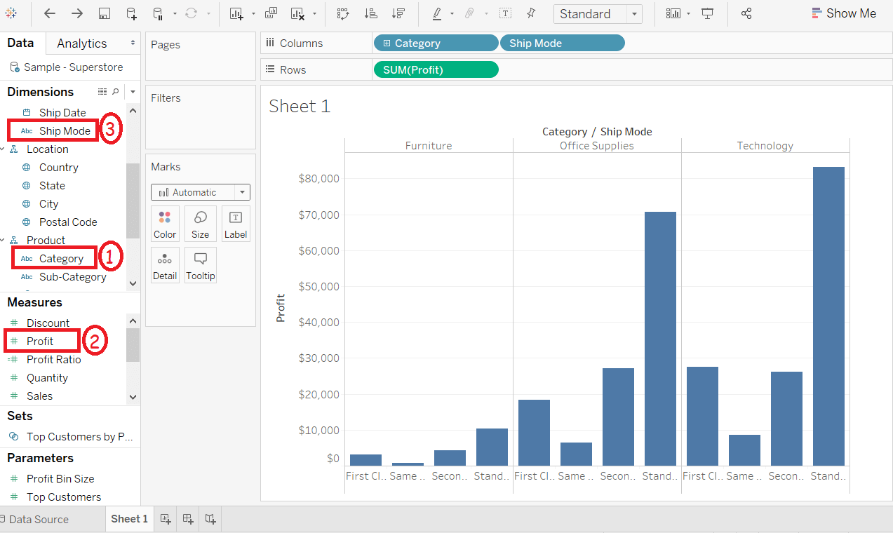

**Step 4: Choose the Box-and-Whisker plot from "Show Me".**

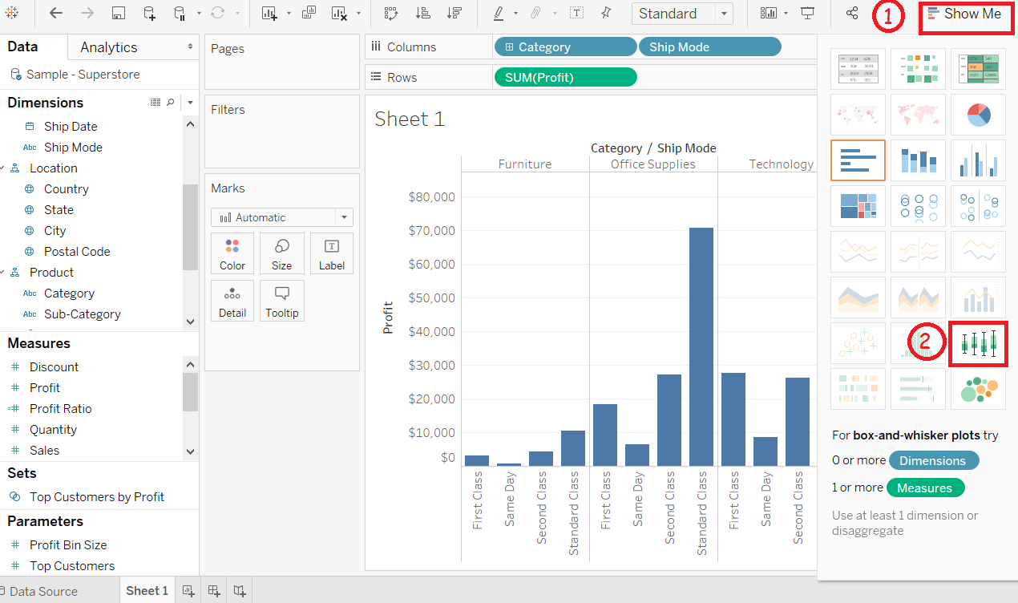

The below chart appears that shows the box-and-whisker plot.Automatically Tableau reassigns the ShipMode to the Marks pane.

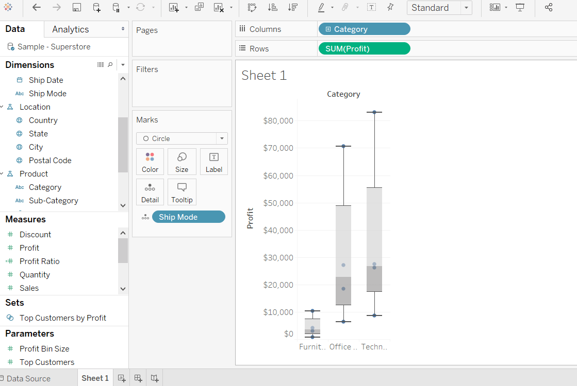

**6. Tableau Heat Map**

The heat map is used to visualize the data in the form of size and color on different measures.

Two different measures are visualized simultaneously using a heat map. One measure is assigned to size, whereas another measure is attached to the color of the heat map.

For example, consider the data source such as the Sample-Superstore and its dimensions and measures.

The procedure to create a heat map is given step by step as follows:

Step 1: First, go to the worksheet.

Step 2: Hold the Ctrl key in the keyboard.

Step 3: Select the dimension Sub-Category and measure Sales as shown in the following screenshot.

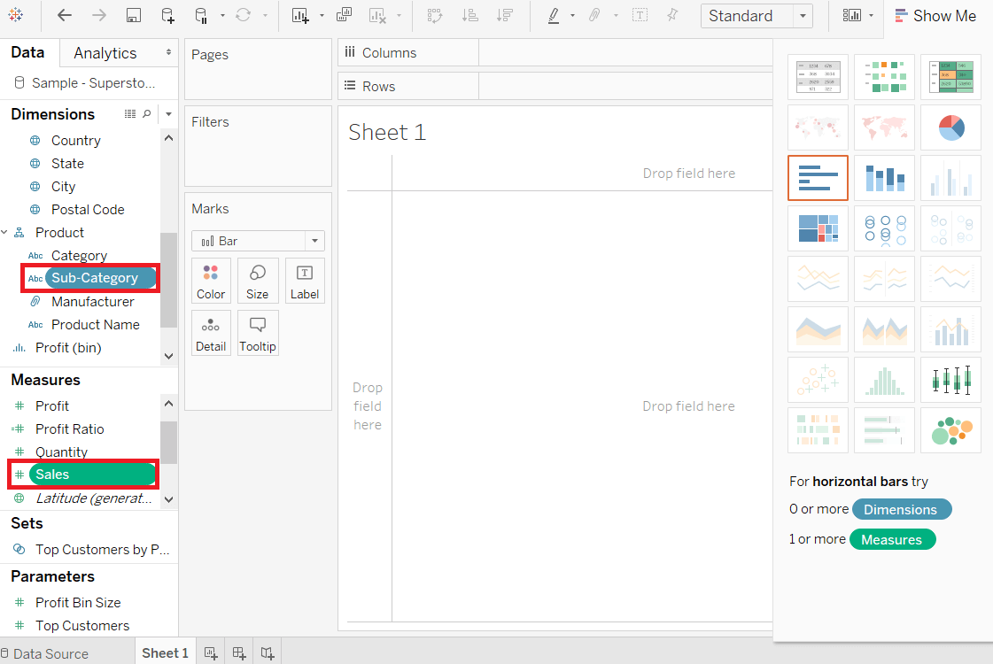

Step 4: Click on the "show me" button of the worksheet.

Step 5: And select the Heatmap icon, as shown in the following screenshot.

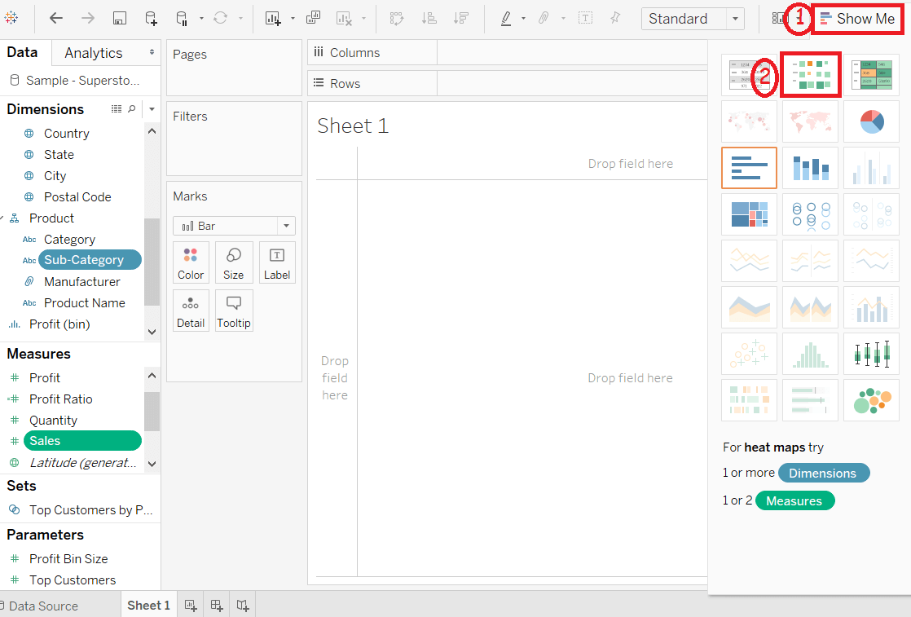

Step 6: Drag measure Profit and drop into the Color shelf under the Marks pane.

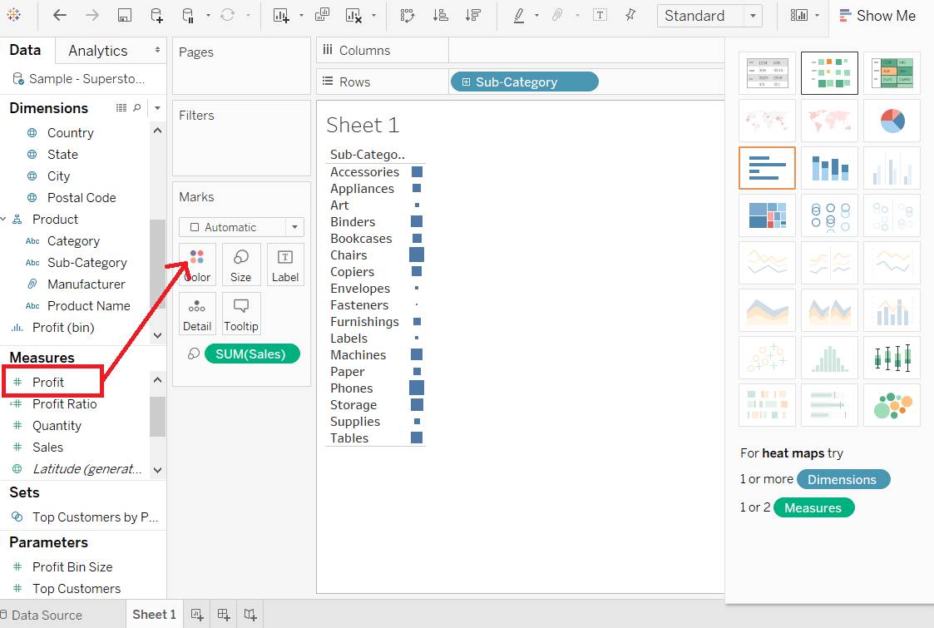

Step 7: Drag the dimension Region and drop into the column shelf.

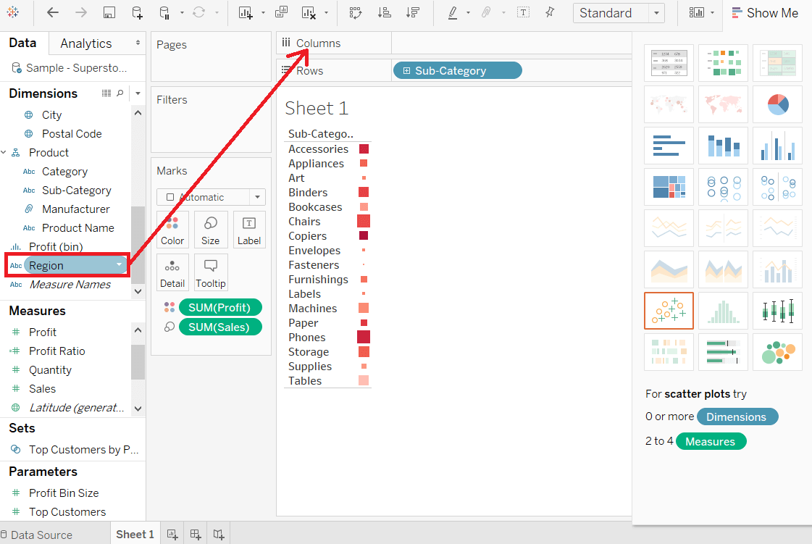

After completing all the above steps, it creates the Heatmap, which is used to visualize the Sales field and Profit field across different the dimension.

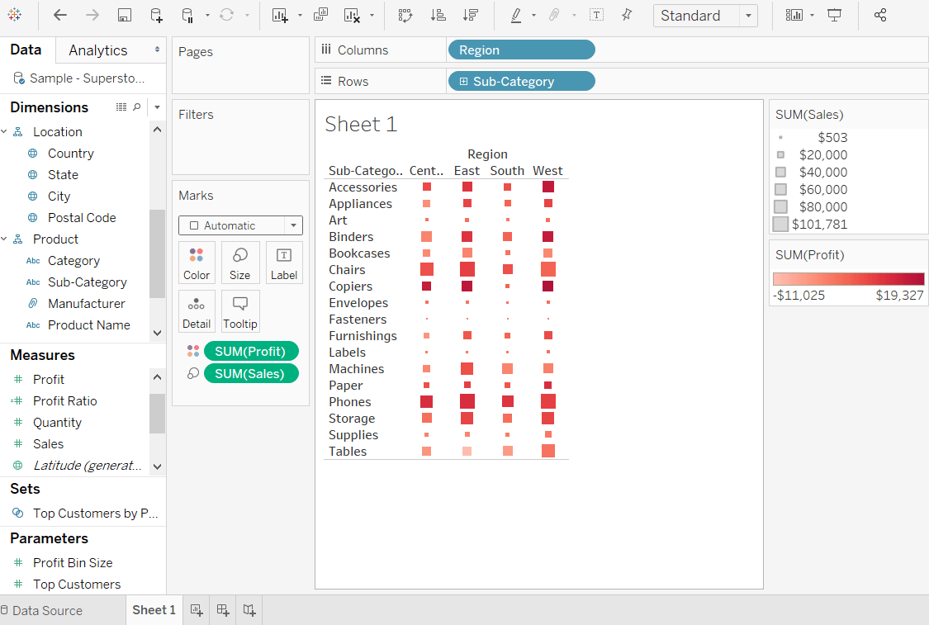

**7. Tableau Tree Maps**

The treemap displays the data in nested rectangles. The dimensions define the structure of the treemap and measures determine the color or size of the individual square.

The squares are easy to visualize as the size and shade of the color of the square reflects the value of the measure.

A Treemap is created using one or more dimension with one or two measures.

For example, consider the data source such as Sample-Superstore, if you want to find the size of Profits for each ShipMode values. Below are the following steps to create a treemap.

Step 1: Drag the measures Profit and drop into the color shelf under Marks pane.

Step 2: Again, drag the measures Profit and drop into the Size shelf.

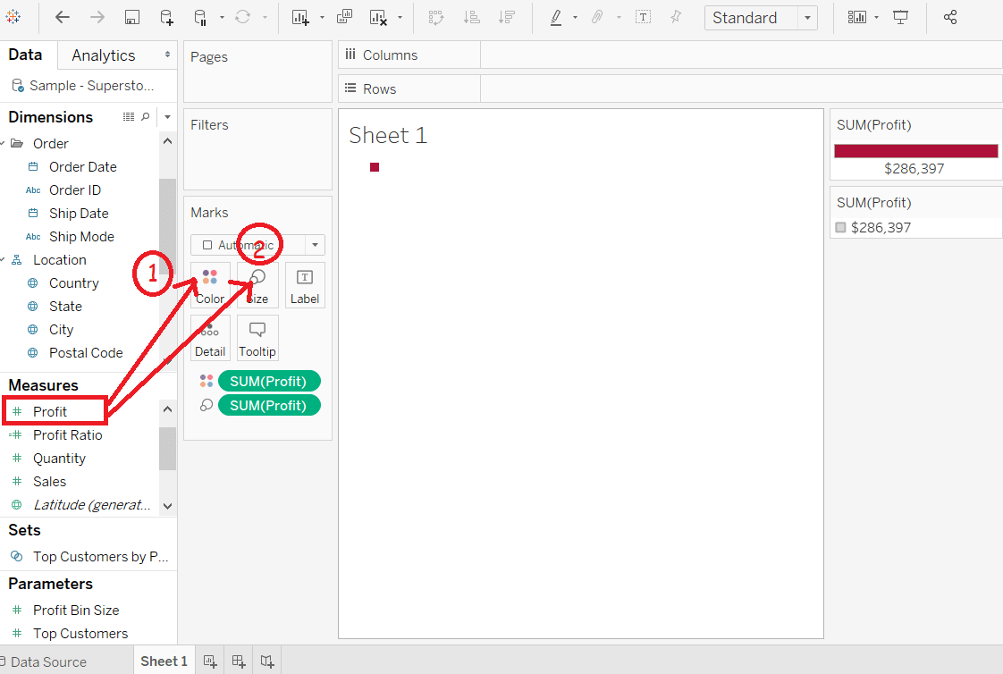

Step 3: Drag the dimension Ship Mode and drop into the Label shelf.

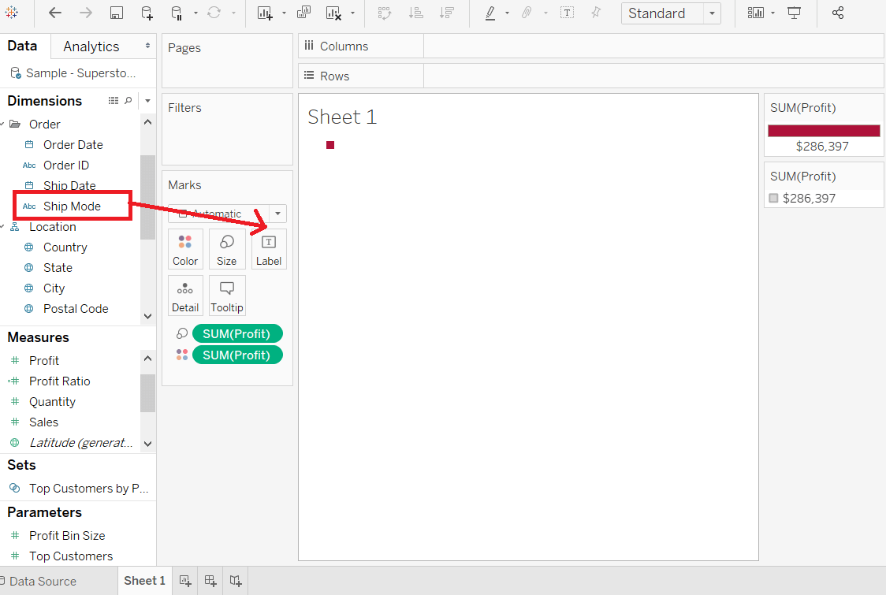

step 4: Choose the treemap option from the "show me".

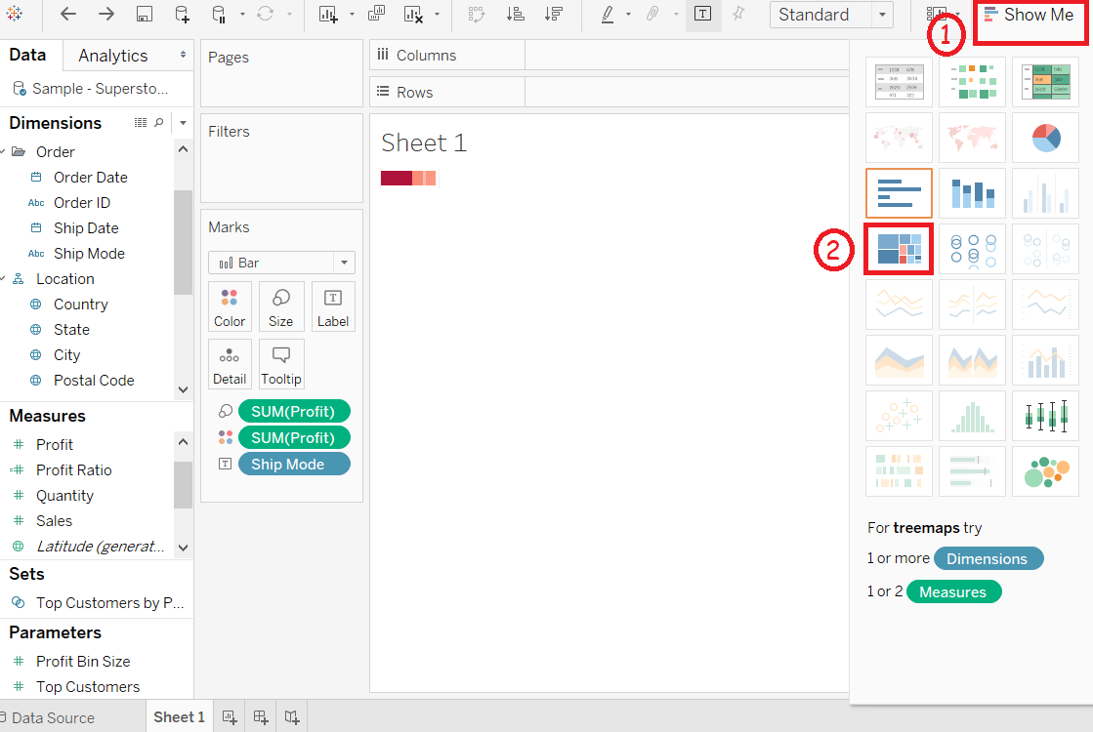

After completing all the above steps, it creates the treemap shown in the below screenshot.

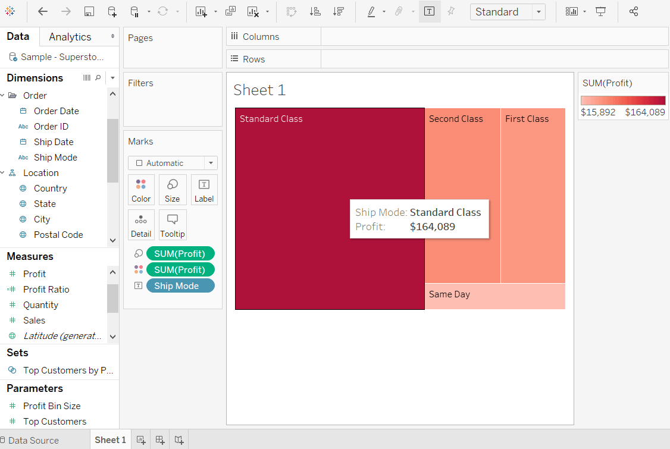

**8. Tableau Scatter Plot**

The scatter plot is used to visualize the relationship between the two measures. It is designed by adding measures in both x-axis and y-axis. This can show the trend or relationship between the measures selected.

To create a scatter plot, you should have at least one measure in the rows shelf and one measure in the columns shelf. However, you can add the dimensions field to the scatter plot that plays a role of different color making for already existing points in the scatter graph.

For example, consider the data source such as Sample-Superstore, if you want to find the variation of Sales field and Profit field as the two axes of the Cartesian plane is distributed according to their Sub-Category field.

To create a scatter plot, there are the following steps, such as:

Step 1: Drag the measure Sales and drop into the columns shelf.

Step 2: Drag the measure Profit and drop into the rows shelf.

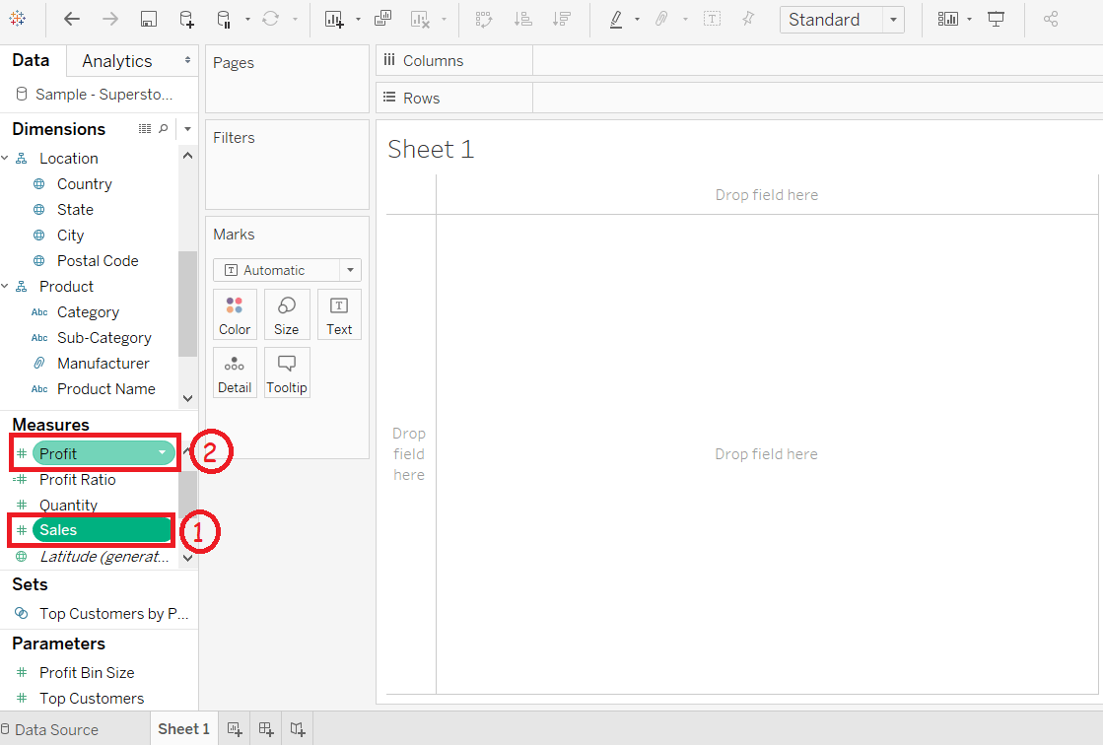

Step 3: Drag the dimension Sub-Category and drop into the Label shelf under the Marks pane.

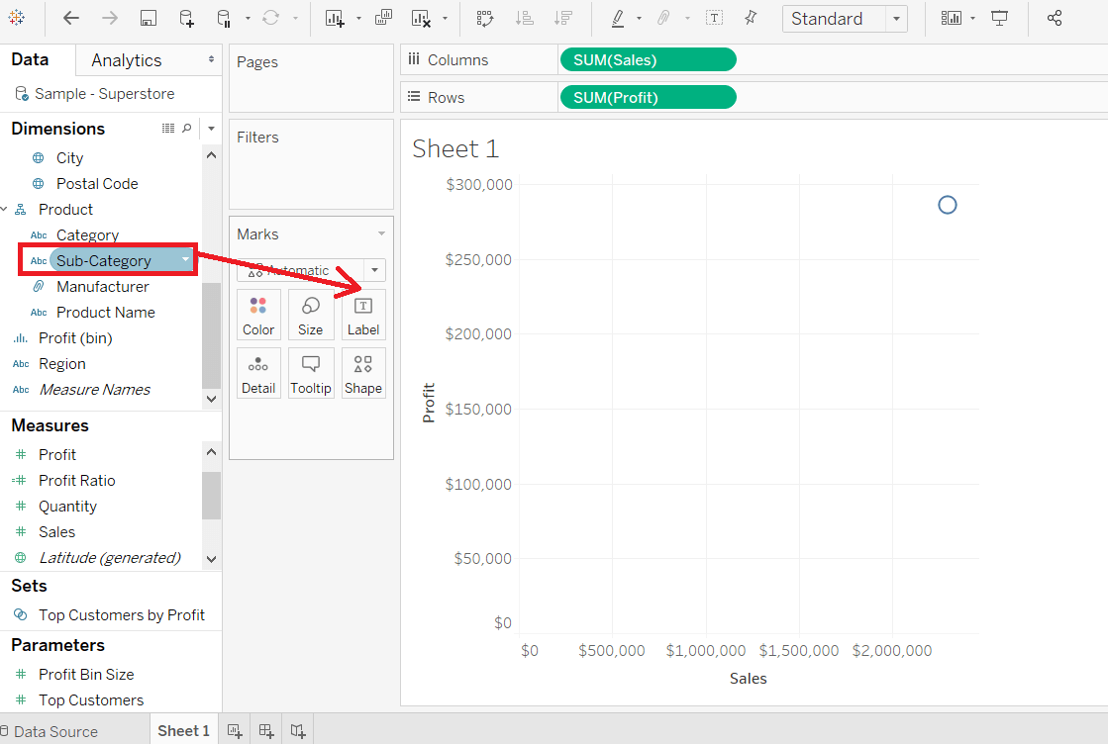

After that, it creates the scatter plot that shows how the Profit field and Sales field is distributed across the dimension Sub-Category of products.

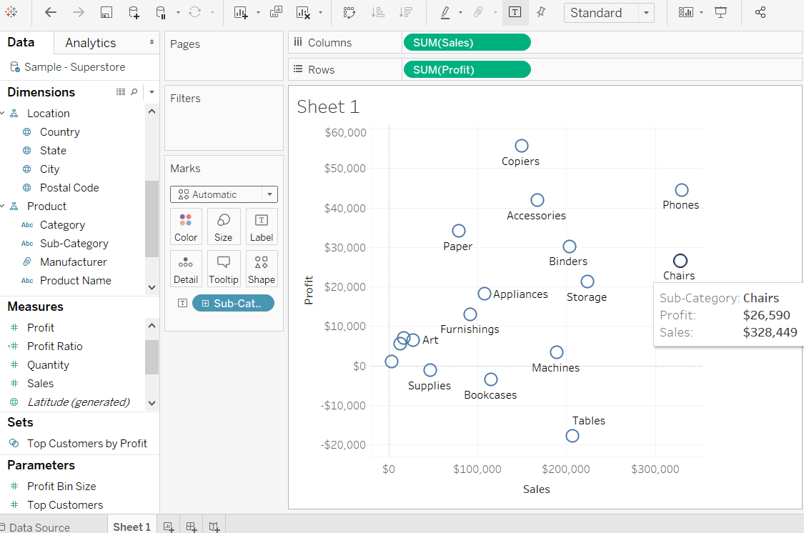

Step 4: You can also get the values color encoded after dragging the Sub-Category field into the Color Shelf.

Below chart appears that show the scatter points with a different color for each point.

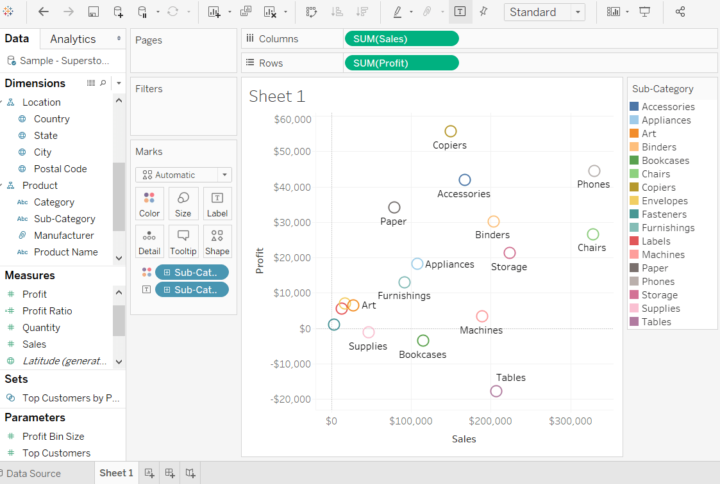

The same scatter plot can show different values when you choose a dimension with hierarchy.

For example, expand the dimension Sub-Category to show the scatter plot values for the Manufacturers field.

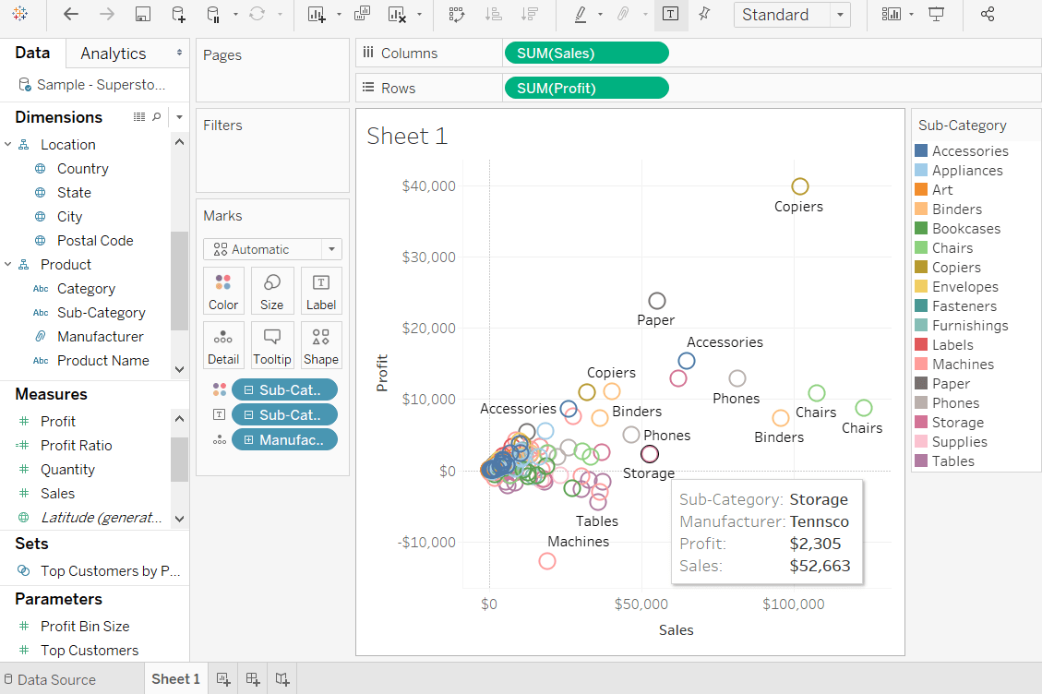

**9. Histogram**

A histogram chart is a chart that displays the shape of the distribution.

A histogram looks like a bar chart but group values for a continuous measure into range. In the histogram, each bar represents the height of the number of values present in that range.

To create a histogram, we need only one measure. It creates the additional bin field for the measure.

For example, consider the data source such as Sample-Superstore, and if you to find the Quantities of sales for different Segment. For this, follow the below procedure step by step, such as:

Step 1: Go to the worksheet.

Step 2: Drag the measure Quantity into the columns shelf.

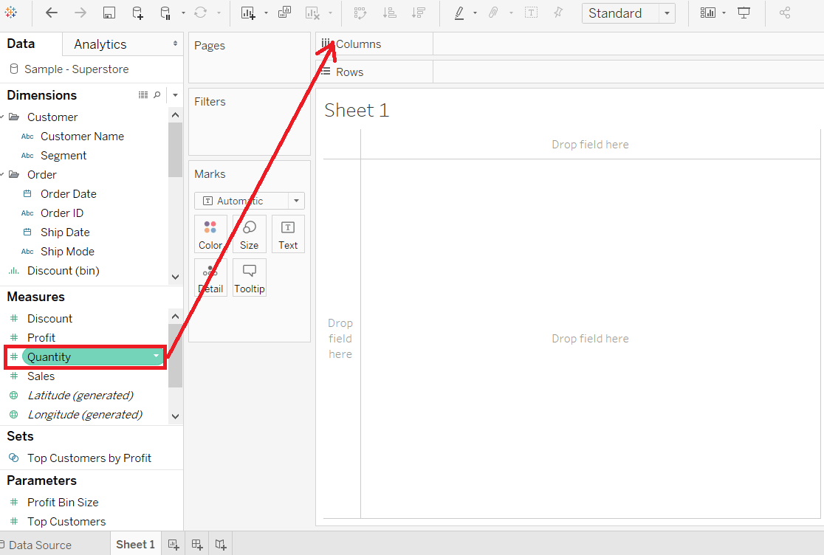

Step 3: Click on the "show me" toolbar and select the histogram chart icon, shown in the below screenshot.

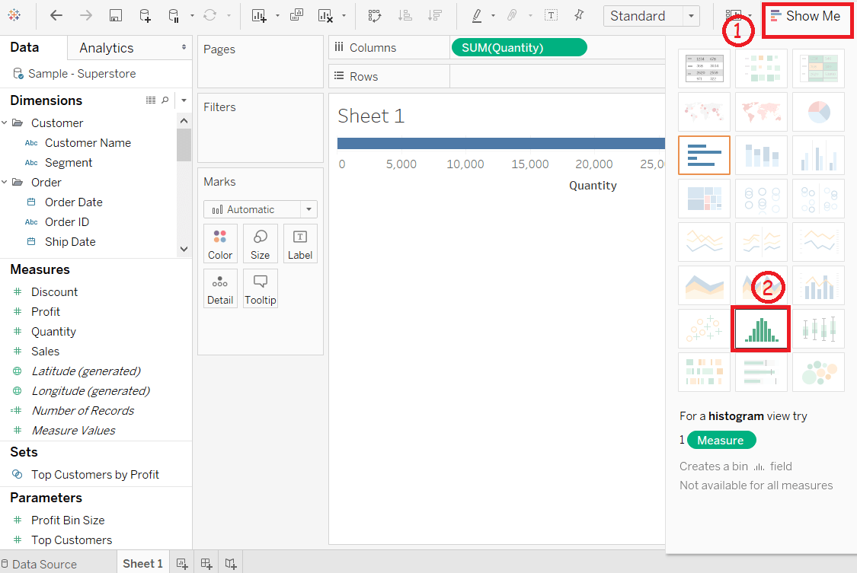

Step 4: After selecting the histogram chart as the chart type. Then,

The view changes and shows vertical bars, with a continuous X-axis and Y-axis.

The measure Quantity with SUM aggregate in columns shelf is replaced by continuous Quantity(bin) dimension.

The Quantity field moves to the rows shelf and aggregation changes from SUM to CNT or (Count).

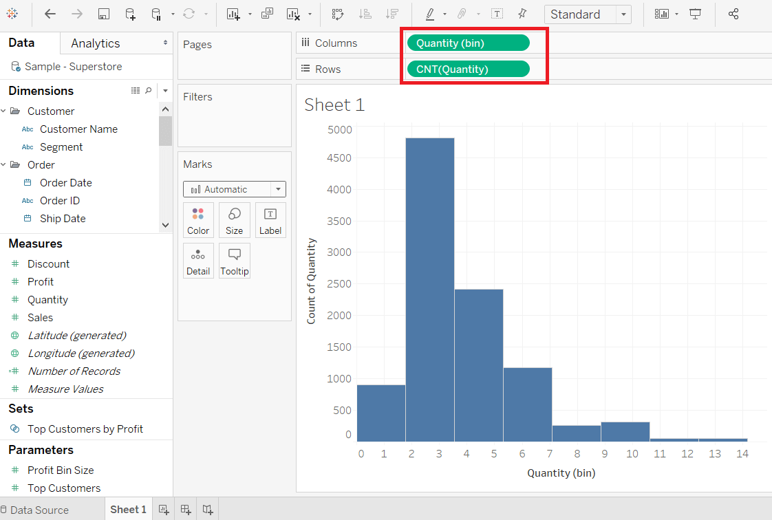

Step 5: Drag the dimension Segment and drop into the Color shelf under the Marks pane.

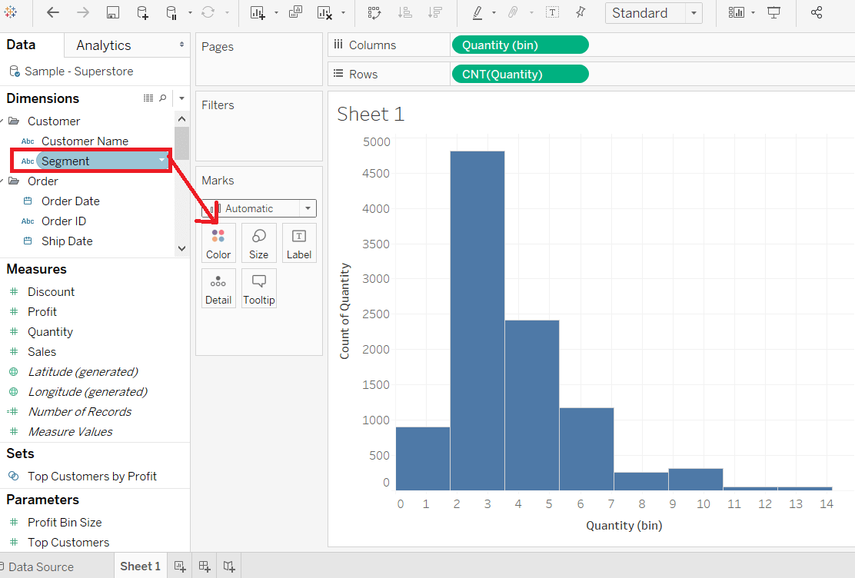

After adding the Segment field to Color shelf, you can see a relationship between the Segment field and the Quantity of item as per order is shown in the below screenshot.

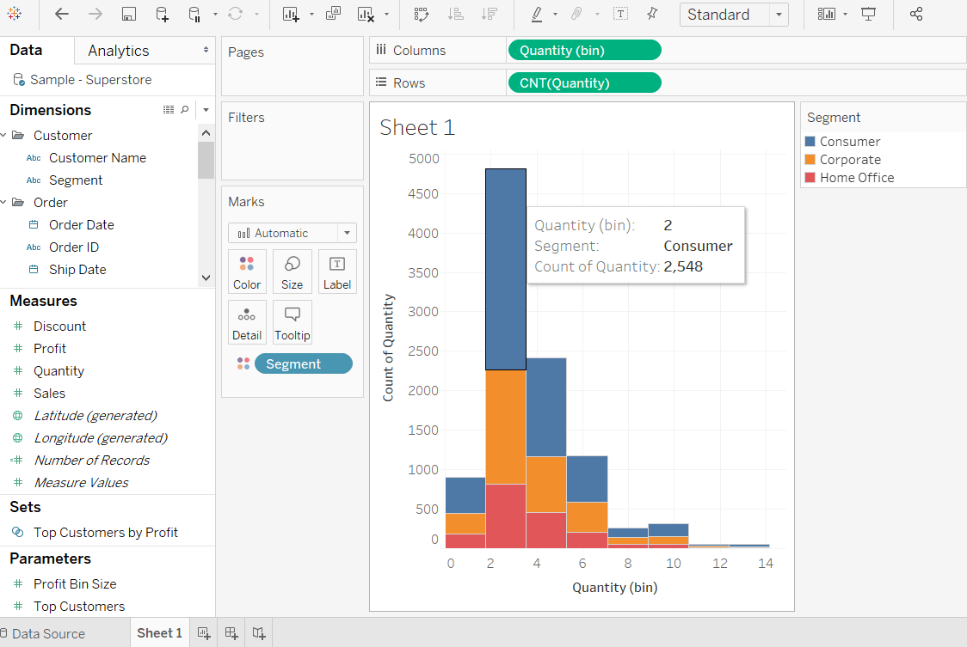

Step 6: Hold the Ctrl key in the keyboard and drag CNT(Quantity) field from the rows shelf Label shelf under the Marks pane.

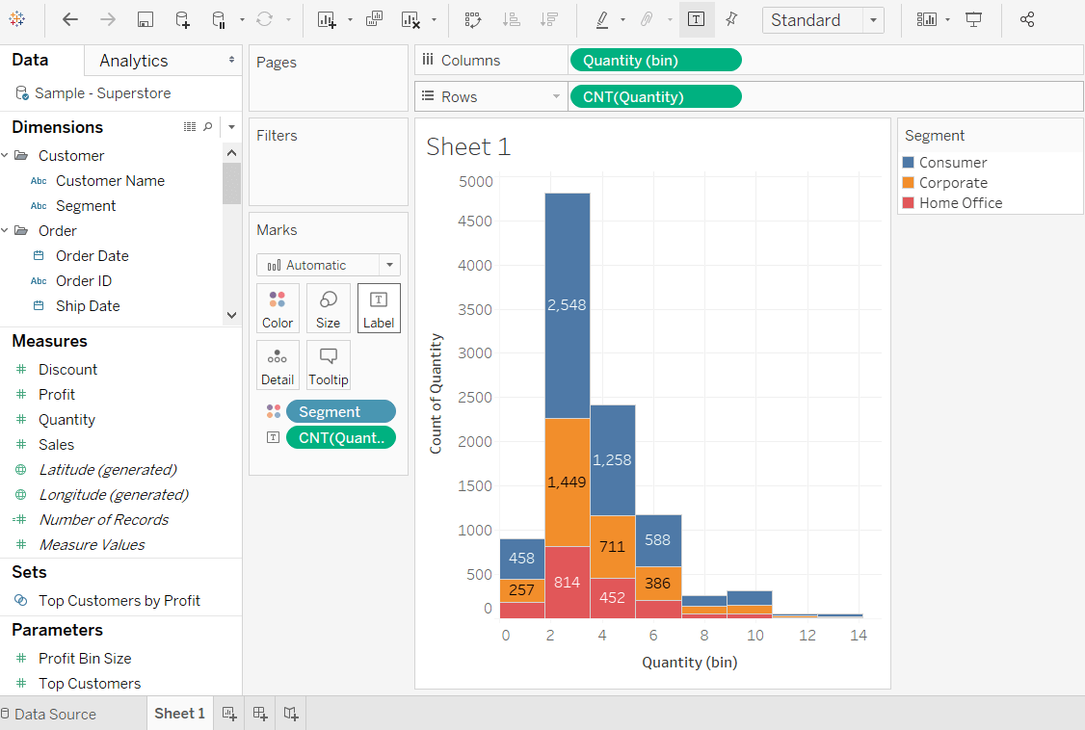

Step 7: Right-click on the CNT(Quantity) field in Marks pane. And

Click on the Quick Table Calculation option from the list.

Select the Percent of Total option.

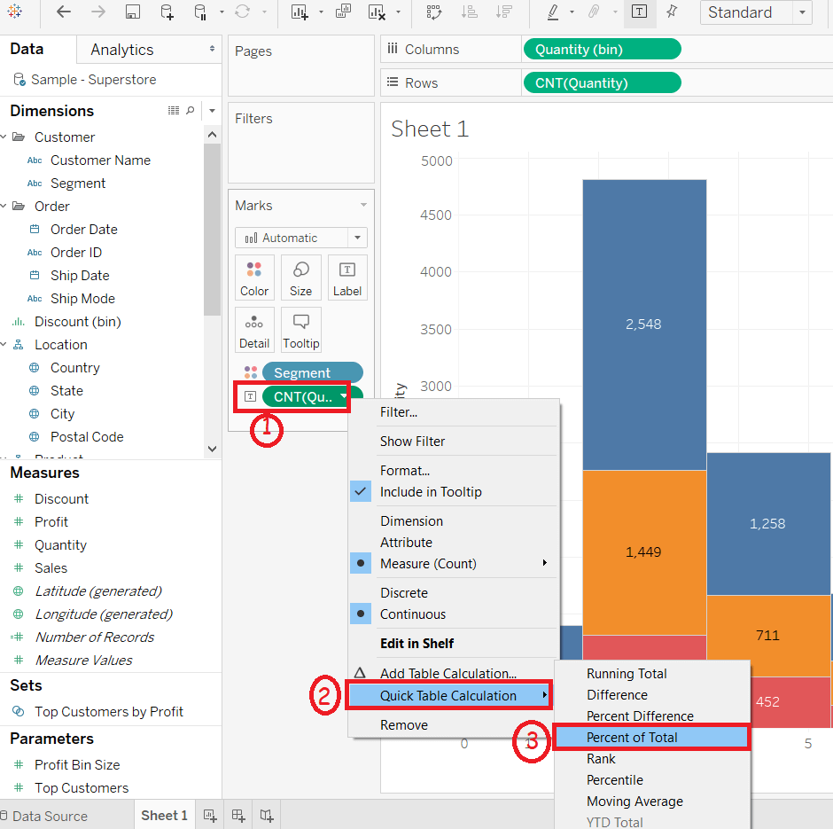

Now each colored section of each bar shows its percentage of total quantity shown in the following screenshot.

