Introduction to ASP.NET (Active Server Pages)
- ASP.NET is a web application framework designed and developed by Microsoft.
- ASP.NET is open source and a subset of the .NET Framework and successor of the classic ASP (Active Server Pages).
- Definition: ASP.NET is a web development framework from Microsoft for building dynamic web applications and websites.
- Platform: Runs on .NET Framework (Windows only).
- Key Features:
  - Web Forms, MVC, Web API
  - Server-side programming using C# or VB.NET
  - Built-in authentication, session management, caching
  - State management and rich controls
Example Use: Building websites, enterprise web apps, or web APIs on Windows servers.

ASP.NET Core
- Definition: ASP.NET Core is a modern, cross-platform, open-source web framework from Microsoft for building cloud-ready and high-performance web apps and APIs.
- Platform: Runs on Windows, Linux, macOS
- Key Features:
  - Unified programming model (MVC + Web API)
  - High performance, lightweight, modular
  - Built-in dependency injection
  - Cross-platform, supports cloud deployment
  - Middleware-based request pipeline
Example Use: Building modern web applications, RESTful APIs, and microservices across platforms.

Building on your table, here are the "Dealbreaker" differences:
Feature | ASP.NET (Legacy) | ASP.NET Core (Modern)
Hosting | Only Windows (IIS) | Windows, Linux, macOS, Docker
Performance | Good | Best-in-class (Top of TechEmpower benchmarks)
Project Setup | Global.asax, Web.config | Program.cs, appsettings.json
Mobile/API | Separate MVC & Web API | Unified (One controller for both)
CLI Support | Minimal (GUI focused) | Full CLI support (dotnet run, dotnet build)

MVC pattern
- The Model-View-Controller (MVC) architectural pattern separates an application into three main groups of components: Models, Views, and Controllers.
- This pattern helps to achieve separation of concerns.
- Using this pattern, user requests are routed to a Controller which is responsible for working with the Model to perform user actions and/or retrieve results of queries.
- The Controller chooses the View to display to the user, and provides it with any Model data it requires.
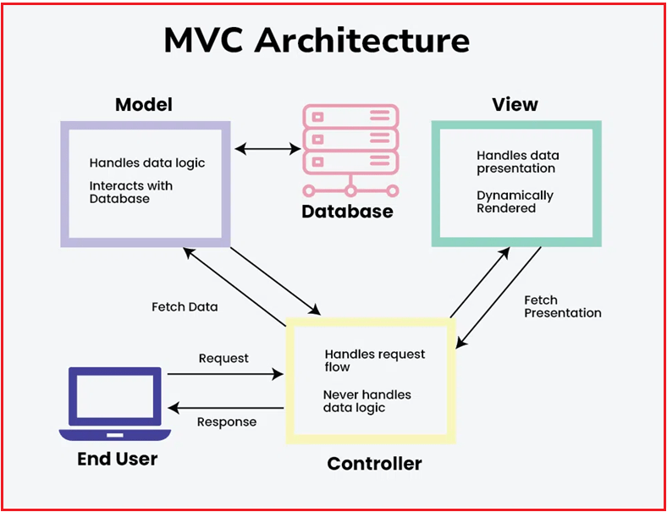

- Model: Manages the data and business logic.
- View: Handles the display and user interface.
- Controller: Handles user requests, interacts with the model, and selects the view to render.

The "Smart TV" Example

1. The Model (The Database/Movie Server)
The Model is the actual movie file and the database of movie titles, ratings, and actors. It doesn’t know what your TV looks like; its only job is to hold the information and provide it when asked.
- In Code: This is your C# Class (e.g., Movie.cs) and your EF Core database context.
- Key Job: To find the right data and make sure it’s accurate.

2. The View (The TV Screen)
The View is the layout you see on your screen—the rows of posters, the "Play" button, and the progress bar. It has no idea where the movie comes from; it just knows how to arrange the images and text on the screen.
- In Code: This is your HTML/Razor (.cshtml) file.
- Key Job: To make the data look pretty and clickable for the user.

3. The Controller (The Remote Control/App Logic)
The Controller is the software in the TV that responds when you click a button. When you click "Watch Now," the Controller sends a request to the server (Model), gets the movie data, and then tells the screen (View) to start playing.
- In Code: This is your Controller Class (e.g., MoviesController.cs).
- Key Job: To listen for clicks, talk to the Model, and decide which View to show next.

Comparison Table: How they talk to each other
Component | Role | What it says
Model | Data | "Here is the movie file you asked for."
View | UI | "I will show this poster in a $200 \times 300$ box."
Controller | Logic | "The user clicked 'Action Movies,' so I'll go get that list."

The "Senior" Insight: Why this matters in an Interview
Interviewer: "Can the View talk directly to the Model?"
The "Senior" Answer:
"In a strict MVC pattern, no. The View should be 'dumb.' If you let the View talk to the Model, your UI code becomes tangled with your database code. By forcing them to talk through a Controller, we achieve 'Loose Coupling.' This means I can completely change my database from SQL to MongoDB (Model) without ever touching my HTML (View)."
In a "Strict MVC" world, you are not allowed to walk behind the counter and look inside the bank vault (The Model) yourself.

Why is this good? (Loose Coupling)
If the bank decides to move the money from a metal vault to a digital server, you—the customer—don't care. You still just stand at the counter and ask the teller for your balance. Your "interface" (the lobby) stays exactly the same.

What happens if the View talks to the Model? (The Mess)
If you did walk into the vault yourself to count your money:
- Security Risk: You might see things you aren't supposed to see.
- Breakage: If the bank changes how the money is organized, you will get lost and won't know how to find your cash.
- Tangled Code: Now, your "customer logic" is stuck inside "vault logic." You can't change one without breaking the other.

