Contents
Introduction to ASP.NET 6
ASP.NET Core 6
MVC pattern 7
Understanding LaunchSettings.json file in ASP.NET Core 8
AppSettings.json File 8
Program Class: 8
Middleware Components 8
Run Method in ASP.NET Core 9
Use Method: 9
Routing in ASP.NET Core 10
Conventional Based Routing 10
Attribute-Based Routing 11
What is Map in ASP.NET Core? 11
11
MapGet 11
MapPost 12
MapPut 12
MapDelete 13
Map (generic) 13
One table (easy to remember) 14
Controller 14
Action Methods: 14
Non-Action Methods 18
View in ASP.NET Core 19
Types of Views 19
Razor Views: 19
Razor Syntax 19
Layout View 19
ViewStart 20
Various ways to pass data from a Controller to a View 21
ViewData 21
Code 21
ViewBag 21
Definition 21
Code 21
TempData 22
Definition 22
Code 22
Strongly Typed View 22
Example 22
Model 23
1. Passing a List from Controller → View 23
Controller 23
View (Strongly Typed List) 23
Model in ASP.NET Core MVC 24
Repository Design Pattern 25
What is a Repository? 25
wwwroot Folder in ASP.NET Core 26
_ViewImports.cshtml 26
Importing Namespaces: 27
Tag Helpers: 27
Tag Helpers in ASP.NET Core MVC 27
Model Binding 29
Model Validations 29
What are Validations? 29
Built-in Data Annotation Attributes in ASP.NET Core MVC: 29
Entity Framework Core 30
Why ORM is used 31
What is Code First Approach? 31
1. Install EF Core Packages 31
2. Configure the Database Context 32
3. Update Program.cs 32
4. Enable Migrations 33
What is the Database First Approach? 34
1. Install EF Core Packages 34
2. Generate the Entity Models 35
3. Update Program.cs 35
Session 36
How many ways for Session storage? 36
1.Enable Session in Program.cs 37
2.Setting / Storing Session Values 37
Syntax 37
Example 37
3.Retrieving Session Values 38
Syntax 38
Example 38
4.Removing a Particular Session Key 38
Syntax 38
Example 38
5.Removing / Clearing All Session Keys 38
Option 1: Clear all session data 38
Option 2: Sign out user and clear authentication cookie 38
Web APIs 39
Restful API 39
What is Swagger in ASP.NET Core Web API? 40
What is ControllerBase? 41
Web API Program 42
CRUD Application by Consuming Web API 44
Identity Framework 46

Introduction to ASP.NET
- ASP.NET is a web application framework designed and developed by Microsoft.
- ASP.NET is open source and a subset of the .NET Framework and successor of the classic ASP(Active Server Pages).
- Definition: ASP.NET is a web development framework from Microsoft for building dynamic web applications and websites.
- Platform: Runs on .NET Framework (Windows only).
- Key Features:
  - Web Forms, MVC, Web API
  - Server-side programming using C# or VB.NET
  - Built-in authentication, session management, caching
  - State management and rich controls
Example Use: Building websites, enterprise web apps, or web APIs on Windows servers.

ASP.NET Core
- Definition: ASP.NET Core is a modern, cross-platform, open-source web framework from Microsoft for building cloud-ready and high-performance web apps and APIs.
- Platform: Runs on Windows, Linux, macOS
- Key Features:
  - Unified programming model (MVC + Web API)
  - High performance, lightweight, modular
  - Built-in dependency injection
  - Cross-platform, supports cloud deployment
  - Middleware-based request pipeline
Example Use: Building modern web applications, RESTful APIs, and microservices across platforms.
Feature | ASP.NET | ASP.NET Core
Open Source? | Partially (most core components under Microsoft Reference Source) | Fully open-source (hosted on GitHub, MIT license)

MVC pattern
- The Model-View-Controller (MVC) architectural pattern separates an application into three main groups of components: Models, Views, and Controllers.
- This pattern helps to achieve separation of concerns.
- Using this pattern, user requests are routed to a Controller which is responsible for working with the Model to perform user actions and/or retrieve results of queries.
- The Controller chooses the View to display to the user, and provides it with any Model data it requires.
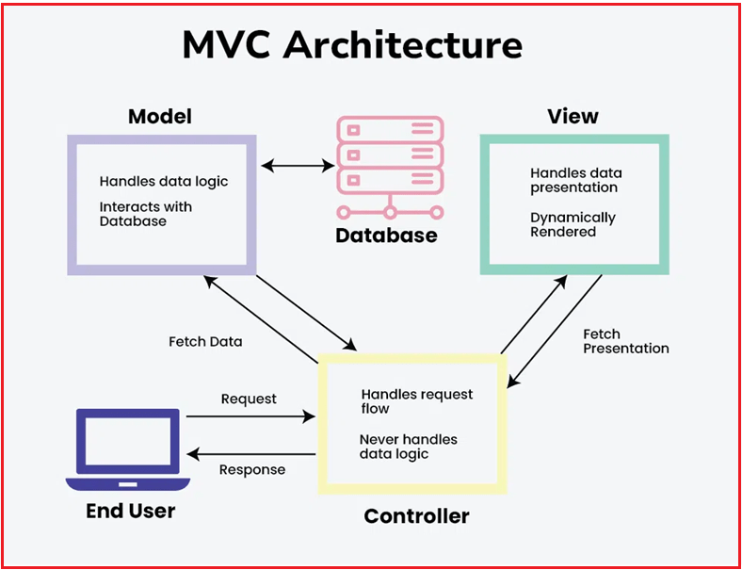

- Model: Manages the data and business logic.
- View: Handles the display and user interface.
- Controller: Handles user requests, interacts with the model, and selects the view to render.

Understanding LaunchSettings.json file in ASP.NET Core
- The most important point you need to remember is that this launchSettings.json file is only used within the local development machine when we run the application using Visual Studio, Visual Studio Code, and .NET CLI.
- This file is not required when we publish our ASP.NET Core Application to the Production Server.
- If you have certain settings and want your application to use such settings when you publish and deploy your Application to the Production Server, then you need to store such settings in the appsettings.json file.
- Generally, in the ASP.NET Core application, the application-level configuration settings will be stored in the appsettings.json file.
- The launchSettings.json file in an ASP.NET Core project defines various profiles (such as HTTP, HTTPS, and IIS Express) for running the application in different environments (like Development, Staging, or Production) with specific configurations.
- It allows developers to define settings like the server type, application URL, environment variables, and more, making it easy to run the application in different contexts during development.

AppSettings.json File
The appsettings.json file is a JSON configuration file in ASP.NET Core for storing application-specific settings that can be easily modified without recompiling the application, making the configuration process more dynamic. It provides a structured way to define configuration settings such as:
- Database connection strings
- Logging configuration
- API keys
- Authentication settings
- External API URLs
- Application-level global variables

Program Class:
- This is the main class of every .NET application that serves as the entry point.
- Creating the Web Host and Configuring the Services
- Building the Application
- Setting Up Endpoints, Routing, and Middleware Components
- Running the Application

Middleware Components
- ASP.NET Core Middleware Components are the basic building blocks of the Request Processing Pipeline in ASP.NET Core Applications.
- The Request Processing Pipeline determines how HTTP Requests and Responses will be processed in the ASP.NET Core Application.
- So, middleware components are used to implement various functionalities like authentication, authorization, error handling, routing, and logging.
- A middleware is nothing but a component(class) which is executed on every request in ASP.NET Core Application

Run Method in ASP.NET Core
- The Run method in ASP.NET Core Application is used to complete the Middleware Execution.
- That means the Run extension method allows us to add the terminating middleware component.
- Terminating middleware means the middleware which will not call the next middleware components in the request processing pipeline.
- The Run method is an extension method on the IApplicationBuilder interface and accepts a parameter of RequestDelegate delegate type which actually handles the request.
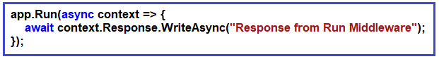

Use Method:
- The Use Extension Method in ASP.NET Core Application allows us to add a new middleware component which may call the next middleware component in the request processing pipeline.
- The Use extension method adds a middleware delegate defined in-line to the application’s request pipeline.
- The Use method is also implemented as an extension method on the IApplicationBuilder interface. Following is the signature of the Use extension method:

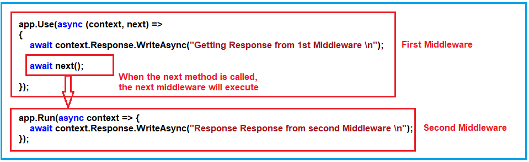

Routing in ASP.NET Core
- Routing in ASP.NET Core MVC is a mechanism that inspects the incoming HTTP request (i.e., URLs) and then maps those HTTP requests to the appropriate controller actions.
- It enables the framework to determine what code to execute based on the URL of the request.
- Routing is an important component of ASP.NET Core MVC applications, providing the ability to define URL patterns and manage how URLs are processed and handled by the application.
- Routes contain information about the Controller name, action method name, method type (Get, Post, Put, Patch, Delete), method parameters, route data, etc.
Types of Routing

Conventional Based Routing
- Conventional-based routing in ASP.NET Core MVC defines URL patterns and maps them to controller actions based on conventions rather than explicitly specifying routes on each action or controller.
- Conventional-based routing follows a set of conventions to map incoming requests to specific controller actions.
- It is configured globally in the Program.cs file using the MapControllerRoute middleware.
- This method allows for centralized route configuration, making it easy to manage and understand how URLs map to controllers and actions.
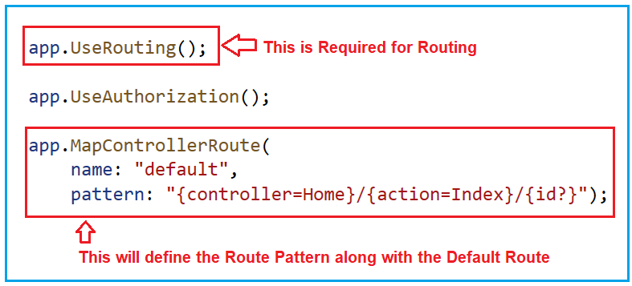

Attribute-Based Routing
- Attribute-based routing in ASP.NET Core MVC allows developers to define routing directly on controller actions or at the controller level using attributes (decorators).
- This approach provides more control and flexibility over how URLs are mapped to actions compared to conventional routing, where routes are configured globally in the Program.cs file.
- This approach is useful for APIs and scenarios where URLs need to be explicitly defined and customized.
- In attribute-based Routing, [Route] attribute is used to define the router
- App.MapController();
- Routes are defined using attributes like [Route], [HttpGet], [HttpPost], [HttpPut], [HttpDelete], [HttpHead], and [HttpPatch].
var builder = WebApplication.CreateBuilder(args);

// Add services for controllers
builder.Services.AddControllers();

var app = builder.Build();

app.UseHttpsRedirection();
app.UseAuthorization();

// Maps attribute-routed controllers
app.MapControllers();

app.Run();

What is Map in ASP.NET Core?
Map methods are used to map HTTP requests (routes + verbs) to code logic in Minimal APIs (without controllers).
They are defined in Program.cs.

MapGet
Handles HTTP GET requests (read data).
app.MapGet("/users", () =>
{
return "Get all users";
});
Used for:
Fetching data
Reading records

MapPost
Handles HTTP POST requests (create data).
app.MapPost("/users", (User user) =>
{
return $"User {user.Name} created";
});
Used for:
Creating new records
Sending data to server

MapPut
Handles HTTP PUT requests (update data).
app.MapPut("/users/{id}", (int id, User user) =>
{
return $"User {id} updated";
});
Used for:
Updating existing data (full update)

MapDelete
Handles HTTP DELETE requests (delete data).
app.MapDelete("/users/{id}", (int id) =>
{
return $"User {id} deleted";
});
Used for:
Removing records

Map (generic)
Used to map any HTTP method or multiple methods.
app.Map("/ping", app =>
{
app.Run(async context =>
{
await context.Response.WriteAsync("Pong");
});
});
Or multiple verbs:
app.MapMethods("/test", new[] { "GET", "POST" }, () => "Hello");

One table (easy to remember)
Method | HTTP Verb | Purpose
MapGet | GET | Read data
MapPost | POST | Create data
MapPut | PUT | Update data
MapDelete | DELETE | Delete data
Map | Any | Custom/multiple verbs

Controller

- A Controller is a special class in the ASP.NET Core Application with .cs (for C# language) extension.
- In the ASP.NET Core MVC Application, the controller class must be inherited from the Controller base class.
- In ASP.NET Core MVC, the Controller base class provides many properties, methods, and features that handle HTTP requests and produce responses in our application.
- It provides Action Result Methods, Model State Management, Validation, TempData, ViewBag, ViewData, etc. A controller is a class that:
- Inherits from the Controller base class.
- Contains action methods that respond to HTTP requests.
- Interacts with models to retrieve or update data.
- Selects views to render HTML or returns data directly.
- Controller manages the flow of the application.
- It is the backbone of MVC

Action Methods:
- Action methods are responsible for handling HTTP requests and returning HTTP responses. They are the methods that perform specific actions in response to user requests.
- These methods are typically associated with URLs and are used to execute specific functionality based on the request type (e.g., GET, POST, PUT, DELETE).
- Action methods are public and typically return an ActionResult or one of its derived types (e.g., ViewResult, JsonResult, RedirectToActionResult) to determine the response to send back to the client.
Example of an action method in a controller:
public ActionResult Index()
{
// Code to handle a GET request and return a view
return View();
}

- ViewResult:
Represents an HTML view template that should be rendered and returned as a response.
Typically used for rendering HTML pages to be displayed in a web browser.
Example:
public IActionResult Index()
{
// Retrieve data and return a view
return View();
}
2. JsonResult:
Represents JSON data that should be serialized and returned as a response.
Useful for serving data to client-side JavaScript applications.
Example:
public IActionResult GetJsonData()
{
// Retrieve data and return as JSON
return Json(new { key1 = "value1", key2 = "value2" });
}
3. RedirectResult:
Redirects the client to a different URL or action method.
Used for performing HTTP redirects.
Example:
public IActionResult RedirectToHomePage()
{
// Redirect to the home page
return Redirect("/Home/Index");
}
4. ContentResult:
Represents plain text, HTML, or any content that doesn’t require view rendering.
Allows you to specify the content and content type directly.
public IActionResult TextContent()
{
return Content("This is plain text content", "text/plain");
}
5. FileResult:
Represents a file download response.
Allows you to send files to the client, such as images, PDFs, or documents.
Example:
public IActionResult DownloadFile()
{
// Return a file for download
byte[] fileBytes = ...; // Load file content
return File(fileBytes, "application/pdf", "document.pdf");
}
These are some of the commonly used Action Results in ASP.NET Core. Depending on the desired response and content type, you can choose the appropriate Action Result type to return from your action methods.

Non-Action Methods
- Non-action methods are regular methods in a controller that are not intended to be used as entry points for handling HTTP requests. They are auxiliary methods used to factor out common functionality or logic to be shared among action methods.
- Non-action methods are typically marked with the [NonAction] attribute to explicitly indicate that they should not be invoked as actions.
These methods cannot be directly accessed via a URL, and they do not return ActionResults.
[NonAction]
public void UtilityMethod()
{
// Code for a utility method that should not be invoked as an action
}

View in ASP.NET Core

- In Model-View-Controller (MVC) Design Pattern, the View is the component that contains logic to represent the model data (the model data provided to it by a controller) as a user interface with which the end-user can interact.
- That means View is used to render the user interface.
- Views are the components in ASP.NET Core MVC that handle the application’s presentation logic.
- They are responsible for rendering HTML markup sent to the client’s browser, typically written using the Razor syntax.
- A view in ASP.NET Core MVC Application is a file with “.cshtml” (for C# language) extension. The meaning of cshtml = CS (C Sharp) + HTML.
- The View combines programming language (C#) and HTML (Hypertext Mark-up Language).
- The Views in the ASP.NET Core MVC Application are generally returned to the client from the Controller Action Method.

Types of Views
Razor Views:
- These are the most common views in ASP.NET Core MVC. They use the Razor syntax (.cshtml files), which is a combination of HTML and C#.

Razor Syntax
The Razor uses the @ symbol to switch from HTML markup to the C# code. The following are the two ways by which you can achieve the transitions.
- Using Razor code expressions
- Using Razor code blocks.

Layout View
- The Layout View is a shared template or master page that can be used across different views within your application to maintain consistent looks and feels.
- It is useful for defining elements that are common across multiple pages, such as headers, footers, navigation bars, and sidebars.
- This helps maintain a consistent look and feel across your web application and also minimizes code duplication.
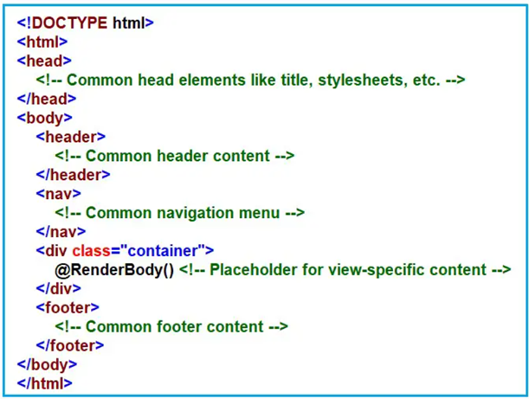

@{
ViewBag.Title = "Home Page";
Layout = "~/Views/Shared/_Layout.cshtml";
}
<h1>Home Page</h1>

ViewStart
- In ASP.NET Core MVC, the _ViewStart.cshtml file is a special view that allows us to set common configuration settings for views in our application.
- This file is typically used to define settings that should apply to all views, such as specifying a layout, setting view-specific data, or configuring view behavior.
- The primary use of _ViewStart.cshtml is to specify a default layout for all views, so we don’t need to set it individually in every view.
- @{
- Layout = "~/Views/Shared/_Layout.cshtml";
- }

Various ways to pass data from a Controller to a View

ViewData
ViewData is a dictionary (key-value) used to pass data from controller to view during the current request.

Code
Controller
public IActionResult Index()
{
ViewData["Msg"] = "Welcome";
return View();
}
Typecasting is required because ViewData stores values as object.
<p>@(int)ViewData["Age"]</p>

ViewBag

Definition
ViewBag is a dynamic property used to pass small amounts of data from controller to view for a single request.

Code
Controller
public IActionResult Index()
{
ViewBag.Message = "Hello World";
return View();
}
View
<p>@ViewBag.Message</p>

TempData

Definition
TempData is used to pass data between actions across requests, especially during redirects.

Code
Controller
public IActionResult Save()
{
TempData["Success"] = "Saved Successfully";
return RedirectToAction("Index");
}
View
<p>@TempData["Success"]</p>

Strongly Typed View
- The View declares the type of model it expects via the @model directive at the top of the Razor view.
- This means you can directly access the model’s properties without casting within the view.
- Strongly typed Views improve code clarity, maintainability, and reduce runtime errors.

Example

Model
public class Student
{
public int Id { get; set; }
public string Name { get; set; }
}

1. Passing a List from Controller → View

Controller
public IActionResult Index()
{
List<Student> students = new List<Student>
{
new Student { Id = 1, Name = "Ram" },
new Student { Id = 2, Name = "Shyam" }
};

return View(students);
}

View (Strongly Typed List)
@model List<Student>

@foreach (var s in Model)
{
<p>@s.Id - @s.Name</p>
}
✔ Strongly typed
✔ No casting
✔ IntelliSense works

Model in ASP.NET Core MVC
- In the ASP.NET Core MVC application, a model is a class with a .cs (for C#) extension that defines the Properties and behaviors of the data entities in your application.
- These are simple classes that represent the objects in your application. For example, a Product model might contain properties such as ID, Name, Price, and methods that define operations related to a product.
- That means the Models in the ASP.NET Core MVC Application contain a set of classes representing the domain data (you can also say the business data) and logic (validation, business, and data access logic) to manage the domain/business data.
- The Model is the component in the MVC Design pattern used to manage the data, i.e., the state of the application in memory.
- 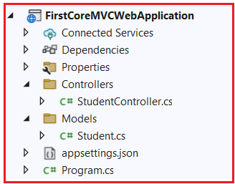
namespace FirstCoreMVCWebApplication.Models
{ public class Student
{
public int StudentId { get; set; }
public string? Name { get; set; }
public string? Branch { get; set; }
public string? Section { get; set; }
public string? Gender { get; set; }
}
}
- Used to manage data
- Controllers are used to manage the overall flow of the application.
- Models are responsible for the data and these data are used on View.

Repository Design Pattern
- The Repository Design Pattern is a software design pattern that facilitates data management by providing a clean separation between the business logic and the data access layers in an application.
- This pattern is widely used in applications that require data persistence, meaning storing data in a database.
- So, it acts as a middleman or middle layer between the rest of the application and the data access logic.
- Abstraction: The repository design pattern acts as a middle layer that abstracts the details of the data access logic from the application’s business logic.
- Decoupling: The repository pattern decouples the data access code from the rest of the application, allowing the business logic to be independent of the underlying database technology.
- Consistency: Repositories can help maintain consistency in data manipulation logic since all data access logic is centralized in one place. This avoids code duplication and makes implementing and changing data handling easier.
- Testing: With repositories, it becomes easier to unit test the business logic without worrying about the integration with the database because repositories can be mocked or stubbed out during testing.
- Aggregation of Data Operations: The repository pattern typically includes standard methods for data operations such as add, remove, update, and find. This standardization supports more robust and consistent development.

What is a Repository?

A repository is a class defined for an entity with all the possible database operations.
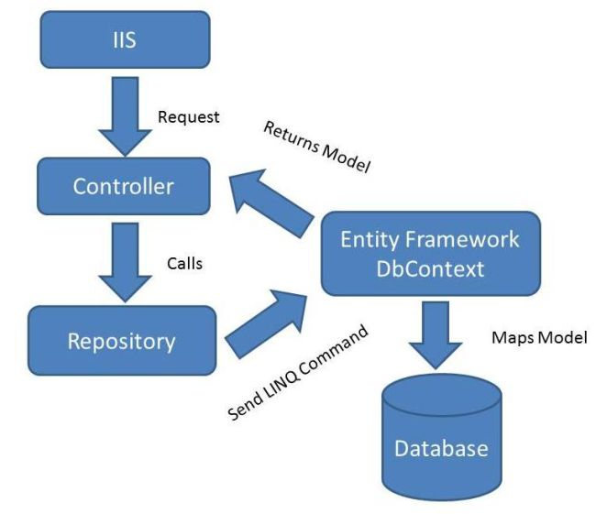

wwwroot Folder in ASP.NET Core
- The wwwroot folder is the designated Web Root directory where static files are stored and served to clients.
- This folder, located in the project root by default, contains static assets like images, CSS, JavaScript, and other resources accessible to clients via direct URLs.
- App.UseStaticFile()
- Libman.json file contains all the configuration for client side libraries.

_ViewImports.cshtml
- The _ViewImports.cshtml file is a special view file that provides a way to include common C# directives and namespaces used across multiple views within an application.
- It helps to keep view files cleaner and more maintainable by allowing to define common settings such as namespaces, services, view components, and tag helpers in a single location.
- These settings are then automatically applied to all Razor views in the same directory or in any subdirectory.

Importing Namespaces:
We can use _ViewImports.cshtml to import namespaces that are used across our Razor views.
This can simplify our view code by allowing us to use types from those namespaces without having to specify @using directives in every view.
@using MyApp.Models
@using MyApp.ViewModels

Tag Helpers:
We can register tag helpers that we want to use in our Razor views. Tag helpers enhance the HTML markup in our views with server-side processing, eliminating the need to declare tag helpers in every view where they are used.
@addTagHelper *, Microsoft.AspNetCore.Mvc.TagHelpers
@namespace
@inject
@model
@using
@add TagHelper
@remove TagHelper
@namespace
@model List<Teacher>

Tag Helpers in ASP.NET Core MVC

- Tag Helpers in ASP.NET Core MVC allow server-side code to participate in creating and rendering HTML elements in Razor views.
- They provide a way to add server-side functionality to HTML elements in a more readable way than traditional HTML helpers.
- Tag Helpers enhance HTML elements with attributes that generate dynamic HTML and allow developers to create cleaner and more maintainable markup.

- Form Tag Helpers: <form> Tag Helper generates HTML forms. They help create forms that post data to actions in your controllers. For example: <form asp-controller=”Account” asp-action=”Login” method=”post”> <!– form fields –> </form>

- Input Tag Helpers: <input>, <label>, <textarea>, <select>, etc, to facilitate form data management and validation. For example, <input asp-for=”Name” /> and <input asp-for=”IsAdmin” type=”checkbox” />.

- Anchor Tag Helper: <a> Tag Helper for generating links using routing information. For example, <a asp-controller=”Home” asp-action=”Details” asp-route-id=”1″>Details</a>

- Image Tag Helper: <img> Tag Helper for rendering images with dynamic sources. For example, <img src=”~/images/pic.jpg” alt=”Picture” asp-append-version=”true”>

- Environment Tag Helper: <environment> Tag Helper for rendering content conditionally based on the current environment, such as Development, Staging, or Production.

- Cache Tag Helper: <cache> Tag Helper for output caching. This can help cache portions of your views to improve performance by reducing the need to recompute content on every request. For example, <cache> <!– Content to be cached –> </cache>
- Partial Tag Helper: <partial> Tag Helper for rendering partial views. This tag helper renders a partial view within another view.
- View Component Tag Helper: <view-component> tag helper renders a view component within a view. View components are similar to partial views but offer more encapsulation and flexibility.
- <span asp-validation-for="UserEmail" class="text-danger"></span>
- @using TagHelpersDemo
@using TagHelpersDemo.Models
@addTagHelper *, Microsoft.AspNetCore.Mvc.TagHelpers

Model Binding
- Model Binding in ASP.NET Core MVC is the process by which HTTP request data (like form data, route data, query strings, and headers) is automatically mapped to action method parameters or model properties.
- The action method parameters can be simple types like integers, strings, etc., or complex types such as Student, Order, Product, etc.
- When a request is made to an MVC application, the data sent from the client is often in a format (such as query strings, form data, and route data) that needs to be converted into .NET objects.
- Model Binding simplifies this process by handling this conversion automatically, allowing developers to work with strongly typed models instead of raw HTTP data.

Model Validations
- Model validations ensure that the data entered by users meets the required criteria before processing or storing it.
- In ASP.NET Core MVC, Data Annotations provide a simple yet powerful way to enforce validation rules on models, ensuring data integrity, enhancing user experience, and safeguarding our web application against malicious inputs.
- In this article, I will explain the concept of validations, the types of validations, and how to implement them effectively using Data Annotations in ASP.NET Core MVC.

What are Validations?
Validations in a web application refer to the processes and techniques used to ensure that the data entered by users is accurate, secure, and appropriate before it is processed or stored.

Built-in Data Annotation Attributes in ASP.NET Core MVC:
- [Required]: Marks a field as required.
- [MinLength(length)] & [MaxLength(length)]: Specifies minimum and maximum lengths for string properties.
- [StringLength(maxLength, MinimumLength = minLength)]: Sets both maximum and optional minimum lengths for string properties.
- [Range(min, max)]: Restricts a numerical property to a specified range.
- [EmailAddress]: Validates that a property contains a valid email format.
- [RegularExpression]: Ensures a property matches a specified regular expression pattern.
- [Compare(“OtherProperty”)]: Compares the value of one property with another, commonly used for password confirmation.
- [DataType(type)]: Specifies the data type, such as Date, Time, and Email Address.
- [Phone]: Validates that a property contains a valid phone number format.
- [Url]: Ensures that a property contains a valid URL.
- [CreditCard]: Validates that a property contains a valid credit card format.

Validation Message Tag Helper: It displays the validation message for a single property of a Model.
<span asp-validation-for="Email"></span>

Validation Summary Tag Helper: It displays a summary of validation messages for all the properties of a Model.
<div asp-validation-summary="All"></div>

Entity Framework Core
- Entity Framework Core is a modern Object-Relational Mapper (ORM) that allows developers to work with databases using .NET objects.
- Instead of writing raw SQL, EF Core lets you interact with the database through LINQ queries and C# classes, simplifying the development process and enhancing maintainability.

What is ORM?
ORM (Object–Relational Mapping) is a technique that allows developers to work with database data using C# objects instead of SQL queries.
In ASP.NET Core MVC, the most commonly used ORM is Entity Framework Core (EF Core).

Why ORM is used
- No need to write raw SQL for most operations
- Database tables ↔ C# classes mapping
- Cleaner, maintainable code
- Less chance of SQL errors

What is Code First Approach?
Definition:
Code First is an Entity Framework (EF) approach where you create C# classes first, and the database is automatically generated from these classes using EF migrations.
- You define your models (entities) in code
- EF Core creates tables, columns, and relationships in the database
- No need to design the database manually

1. Install EF Core Packages
- Microsoft.EntityFrameworkCore: Core functionalities.
- Microsoft.EntityFrameworkCore.SqlServer: Provider for SQL Server.
- Microsoft.EntityFrameworkCore.Tools: Tools for migrations and database updates.

2. Configure the Database Context
The DbContext class acts as a bridge between your application and the database. Let’s create one for our Todo App.
- Create a folder named Data in your project.
- Add a new class file named TodoDbContext.cs inside the Data folder.
using Microsoft.EntityFrameworkCore;
using TodoTutorial.Models;
namespace TodoTutorial.Data
{
public class TodoDbContext : DbContext
{
public TodoDbContext(DbContextOptions<TodoDbContext> options) : base(options) { }
public DbSet<TodoItem> TodoItems { get; set; }
}
}
- The DbSet<T> property represents a table in the database.
- TodoItems will correspond to the TodoItem table.

3. Update Program.cs
In .NET Core 8, database configuration is added directly in Program.cs.
- Open Program.cs.
- Add the EF Core configuration inside the var builder = WebApplication.CreateBuilder(args); block:

using _28_CodeFirstApproach.Models;
using Microsoft.EntityFrameworkCore;

var builder = WebApplication.CreateBuilder(args);

// Add services to the container.
builder.Services.AddControllersWithViews();
var Provider=builder.Services.BuildServiceProvider();
var config = Provider.GetRequiredService<IConfiguration>();
builder.Services.AddDbContext<StudentDbContext>(item=>item.UseSqlServer(config.GetConnectionString("dbcs")));

var app = builder.Build();

- Replace DefaultConnection with the name of your connection string.
- Ensure your appsettings.json file includes the database connection:
"ConnectionStrings": {
"DefaultConnection": "Server=(localdb)\\MSSQLLocalDB;Database=TodoAppDb;Trusted_Connection=True;"
}

4. Enable Migrations
EF Core uses migrations to manage database schema changes.
- Open the Package Manager Console.
- Run the following commands:
- Initialize migrations:
Add-Migration InitialCreate
- Apply migrations to create the database:
Update-Database

What is the Database First Approach?
- In the Database First approach, the development process begins with designing and implementing the database schema.
- After the database is set up, the application code is generated based on the existing database schema.
- This approach contrasts with the Code First approach, where the application code and data models are created first, and the database schema is generated from the code.

Install EF Core Packages
- Microsoft.EntityFrameworkCore: Core functionalities.
- Microsoft.EntityFrameworkCore.SqlServer: Provider for SQL Server.
- Microsoft.EntityFrameworkCore.Tools: Tools for migrations and database updates.

Generate the Entity Models
Use the EF Core tools to scaffold the database schema into entity models. You will need the connection string for your database and the dotnet-ef tool.
Install the dotnet-ef tool (if not already installed).
dotnet tool install --global dotnet-ef

Scaffold the database
dotnet ef dbcontext scaffold "Server=your_server;Database=your_database;Trusted_Connection=True;" Microsoft.EntityFrameworkCore.SqlServer

3. Update Program.cs
In .NET Core 8, database configuration is added directly in Program.cs.
Open Program.cs.
Add the EF Core configuration inside the var builder = WebApplication.CreateBuilder(args); block:

using _28_CodeFirstApproach.Models;
using Microsoft.EntityFrameworkCore;

var builder = WebApplication.CreateBuilder(args);

// Add services to the container.
builder.Services.AddControllersWithViews();
var Provider=builder.Services.BuildServiceProvider();
var config = Provider.GetRequiredService<IConfiguration>();
builder.Services.AddDbContext<StudentDbContext>(item=>item.UseSqlServer(config.GetConnectionString("dbcs")));

var app = builder.Build();

- Replace DefaultConnection with the name of your connection string.
- Ensure your appsettings.json file includes the database connection:
"ConnectionStrings": {
"DefaultConnection": "Server=(localdb)\\MSSQLLocalDB;Database=TodoAppDb;Trusted_Connection=True;"
}

Session
- Sessions solve these problems by storing data on the server, with the browser carrying only a small session ID token (usually via a cookie).
- This approach is more secure and allows storing larger and more complex data compared to client-side cookies.
- This allows web apps to maintain data such as login status, shopping carts, user preferences, and other stateful information securely on the server.
- Session are server-side.
- The session data is backed by a cache and considered (ephemeral) temporary data.

How many ways for Session storage?
In-Memory Cache: Server base storage. Storage capacity is depend upon server’s available memory. Best for single server base environment.
Distributed Cache: Session storage not on one server its store on multiple server. Distributed cache work with Redis, Sql Server etc.

1.Enable Session in Program.cs
var builder = WebApplication.CreateBuilder(args);

// Add services for session
builder.Services.AddSession();

builder.Services.AddControllersWithViews();

var app = builder.Build();

// Enable session middleware
app.UseSession();

// Routing and middleware
app.UseStaticFiles();
app.UseRouting();
app.UseAuthorization();

app.MapControllerRoute(
name: "default",
pattern: "{controller=Home}/{action=Index}/{id?}");

app.Run();

2.Setting / Storing Session Values

Syntax
HttpContext.Session.SetString("KEY", "VALUE");
HttpContext.Session.SetInt32("KEY", VALUE);

Example
HttpContext.Session.SetString("USERNAME", UserName);
HttpContext.Session.SetString("USERID", UserID.ToString());
HttpContext.Session.SetInt32("AGE", 25);

3.Retrieving Session Values

Syntax
HttpContext.Session.GetString("KEY");
HttpContext.Session.GetInt32("KEY");

Example
string username = HttpContext.Session.GetString("USERNAME");
string userId = HttpContext.Session.GetString("USERID");
int? age = HttpContext.Session.GetInt32("AGE");
Note: GetInt32 returns a nullable int?, handle nulls accordingly.

4.Removing a Particular Session Key

Syntax
HttpContext.Session.Remove("KEY");

Example
HttpContext.Session.Remove("USERNAME");

5.Removing / Clearing All Session Keys

Option 1: Clear all session data
HttpContext.Session.Clear();

Option 2: Sign out user and clear authentication cookie
await HttpContext.SignOutAsync();
SignOutAsync ends the current user session and removes the authentication cookie.

Web APIs
Web APIs (Application Programming Interfaces) are essential for allowing different software applications to communicate and exchange data with each other over the Internet. They enable data exchange between various platforms, applications, and devices, regardless of their underlying technologies.

- Web APIs enable systems developed on different technologies (like different programming languages or frameworks) to communicate effectively. For example, a mobile app built with Swift (iOS) can interact with a backend service written in ASP.NET Core (C#) using HTTP-based APIs.
- They facilitate integration between different services and applications. For instance, a weather forecasting service may expose a Web API that other applications can query to get weather data, which they can then integrate into their own functionality.
- Web APIs provide a flexible way to access and manipulate data. They allow developers to create custom client applications that can consume these APIs based on their specific needs.

Examples:
- Social Media Integration: When a website integrates Facebook login, it uses Facebook’s API to authenticate users.
- Payment Gateways: E-commerce sites use APIs from payment processors like PayPal or Stripe to handle transactions.
- Weather Data: Apps that provide weather updates use APIs from weather services to fetch real-time weather data.
- Google Maps API: Allows developers to embed maps and location services into their applications.
- Twilio API: Enables applications to send SMS, make phone calls, and manage communications.

- RESTful Architecture: Web APIs are designed to follow Representational State Transfer (REST) principles. A RESTful API is stateless, uses standard HTTP methods, and organizes resources into a hierarchy with unique URLs for each resource.

Restful API
- Rest API is a kind of web-service which stores and retrieves necessary data for your application in a convenient format (e.g. JSON or XML).
- It provides great flexibility to developers since it does not need any dependent code libraries to access the web-services as it is stateless.

REST APIs can be used to perform different actions. Based on the actions, the relevant method should be used. The following are the 5 methods supported by REST.
GET - This method is used to retrieve a data from database / server.
POST - This method is used to create a new record.
PUT - This method is used to modify / replace the record. It replaces the entire record.
PATCH - This method is used to modify / update the record. It replaces parts of the record.
DELETE - This method is used to delete the record.

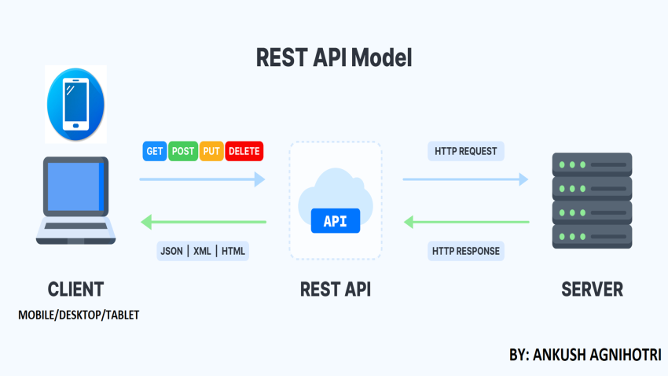

What is Swagger in ASP.NET Core Web API?
- Swagger, often implemented using the Swashbuckle package, is a powerful tool used for documenting RESTful APIs developed with ASP.NET Core Web API.
- It provides a way to help plan, design, and document RESTful APIs. Swagger in ASP.NET Core Web API helps developers create, document, and consume RESTful APIs.

What is ControllerBase?
- ControllerBase is a class in ASP.NET Core that serves as the foundation for building Web APIs.
- It provides the basic functionality needed to handle HTTP requests and return data responses, such as JSON or XML, but does not support rendering HTML views.
Purpose: Building APIs Only
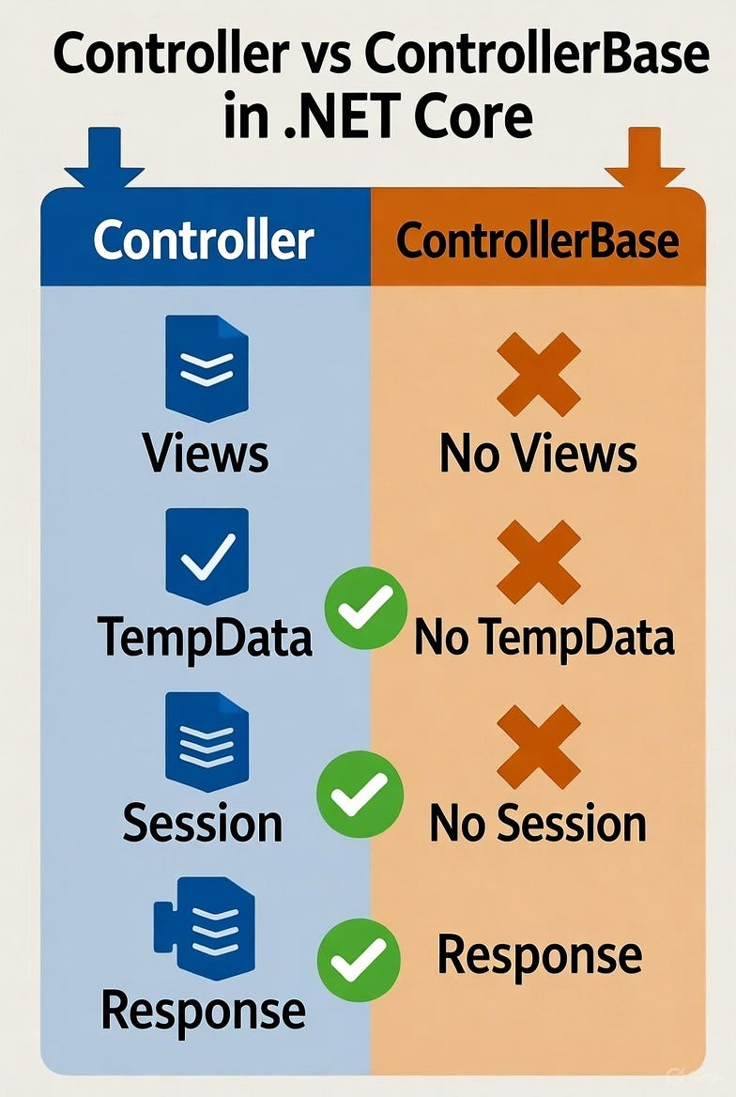

Common Return Types in ControllerBase
Return Method
Ok(object) — Returns HTTP 200 with the provided data.
BadRequest() — Returns HTTP 400 for invalid requests.
NotFound() — Returns HTTP 404 if resource not found.
Created() — Returns HTTP 201 when a resource is created.
NoContent() — Returns HTTP 204 when there’s no data to return.

Web API Program

using _34_WebAPI_CRUD.Models;
using Microsoft.AspNetCore.Http;
using Microsoft.AspNetCore.Mvc;
using Microsoft.EntityFrameworkCore;

namespace _34_WebAPI_CRUD.Controllers
{
[Route("api/[controller]")]
[ApiController]
public class StudentAPIController : ControllerBase
{
private readonly SchoolManagementContext dbcontext;

public StudentAPIController(SchoolManagementContext dbcontext)
{
this.dbcontext = dbcontext;
}
[HttpGet]
public async Task<ActionResult<List<Student>>> GetStudents()
{
var data = await dbcontext.Students.ToListAsync();
return Ok(data);
}
[HttpGet("{id}")]
public async Task<ActionResult<Student>> GetStudentById(int id)
{
var student = await dbcontext.Students.FindAsync(id);
if(student==null)
{
return NotFound();
}
return student;
}
[HttpPost]
public async Task<ActionResult<Student>> Create(Student std)
{
await dbcontext.Students.AddAsync(std);
await dbcontext.SaveChangesAsync();
return Ok(std);
}
[HttpPut("{id}")]
public async Task<ActionResult<Student>> Update(int id,Student std)
{
if (id!=std.Id)
{
return BadRequest();
}
dbcontext.Entry(std).State = EntityState.Modified;
//dbcontext.Students.Update(std);
await dbcontext.SaveChangesAsync();
return Ok(std);
}
[HttpDelete("{id}")]
public async Task<ActionResult<Student>> Delete(int id)
{
var std = await dbcontext.Students.FindAsync(id);
if(std==null)
{
return NotFound();
}
dbcontext.Students.Remove(std);
await dbcontext.SaveChangesAsync();
return Ok();

}
}
}

CRUD Application by Consuming Web API

using _35_CRUDUsingWebAPIandMVC.Models;
using Microsoft.AspNetCore.Mvc;
using Newtonsoft.Json;
using System.Text;

namespace _35_CRUDUsingWebAPIandMVC.Controllers
{
public class StudentController : Controller
{
private string url = "https://localhost:7289/api/StudentAPI/";
private HttpClient client=new HttpClient() ;
[HttpGet]
public IActionResult Index()
{
List<Student> students = new List<Student>();
HttpResponseMessage response= client.GetAsync(url).Result;
if(response.IsSuccessStatusCode)
{
string result=response.Content.ReadAsStringAsync().Result;
var data=JsonConvert.DeserializeObject <List<Student>>(result);
if(data!=null)
{
students = data;
}
}

return View(students);
}
[HttpGet]
public IActionResult Create()
{
return View();

}
[HttpPost]
public IActionResult Create( Student std)
{
if (!ModelState.IsValid)
{
return View(std);
}
string data=JsonConvert.SerializeObject(std);
StringContent content=new StringContent(data,Encoding.UTF8 ,"application/json");
HttpResponseMessage response= client.PostAsync(url, content).Result;
if(response.IsSuccessStatusCode)
{
TempData["InsertMessage"] = "Data Inserted";
return RedirectToAction("Index");
}
return View();

}

[HttpGet]
public IActionResult Edit(int id)
{
Student std = new Student();
HttpResponseMessage response = client.GetAsync(url + id).Result;
if (response.IsSuccessStatusCode)
{

string result = response.Content.ReadAsStringAsync().Result;
var data = JsonConvert.DeserializeObject<Student>(result);
if (data != null)
{
std = data;
}

}
return View(std);

}
[HttpPost]
public IActionResult Edit(Student std)
{
if (!ModelState.IsValid)
{
return View(std);
}
string data = JsonConvert.SerializeObject(std);
StringContent content = new StringContent(data, Encoding.UTF8, "application/json");
HttpResponseMessage response = client.PutAsync(url +std.id, content).Result;
if (response.IsSuccessStatusCode)
{
TempData["UpdateMessage"] = "Data Updated";
return RedirectToAction("Index");
}
return View();

}
[HttpGet]
public IActionResult Details(int id)
{
Student std = new Student();
HttpResponseMessage response = client.GetAsync(url + id).Result;
if (response.IsSuccessStatusCode)
{

string result = response.Content.ReadAsStringAsync().Result;
var data = JsonConvert.DeserializeObject<Student>(result);
if (data != null)
{
std = data;
}

}
return View(std);

}
[HttpGet]
public IActionResult Delete(int id)
{
Student std = new Student();
HttpResponseMessage response = client.GetAsync(url + id).Result;
if (response.IsSuccessStatusCode)
{

string result = response.Content.ReadAsStringAsync().Result;
var data = JsonConvert.DeserializeObject<Student>(result);
if (data != null)
{
std = data;
}

}
return View(std);

}
[HttpPost,ActionName("Delete")]

public IActionResult DeleteConformed(int id)
{

HttpResponseMessage response = client.DeleteAsync(url + id).Result;
if (response.IsSuccessStatusCode)
{
TempData["DeleteMessage"] = "Data Deleted";
return RedirectToAction("Index");

}
return View();
}

}
}

Identity Framework

- ASP.NET Core Identity is a robust and flexible authentication and authorization system built into ASP.NET Core applications.
- It provides everything needed to securely manage user accounts, roles, passwords, and permissions without having to write custom logic from scratch.
- By using ASP.NET Core Identity, developers can easily add essential features like registration, login, password recovery, and social login to their web applications, while ensuring best practices for security.

