INTRODUCTION TO DATA MANAGEMENT
PROJECT REPORT
(Project Semester January-April 2025)

Retail Insights: Coffee Shop Edition
Submitted by:
Shivadan Dogra

Registration No: 12323642

Programme and Section: B. Tech Cse K23-GS
Course Code: -INT217

Under the Guidance of
Baljinder Kaur UID: 27952
Discipline of CSE/IT

Lovely School of Computer Science and Engineering
Lovely Professional University, Phagwara


CERTIFICATE

This is to certify that Shivadan Dogra bearing Registration no. 12323642 has completed Introduction to Data Management INT 217 project titled, “Retail Insights: Coffee Shop Edition” under my guidance and supervision. To the best of my knowledge, the present work is the result of his/her original development, effort and study.

Signature and Name of the Supervisor
Designation of the Supervisor
School of …………………………………………….
Lovely Professional University
Phagwara, Punjab.

Date:

DECLARATION

I, Shivadan Dogra, student of B. Tech Cse (Program name) under CSE/IT Discipline at, Lovely Professional University, Punjab, hereby declare that all the information furnished in this project report is based on my own intensive work and is genuine.

Date: 13-04-2025
Signature:

Registration No: 12323642
Name of the student: Shivadan Dogra

📘 Introduction
In the competitive landscape of the retail coffee industry, data analytics plays a crucial role in driving sales, improving operations, and enhancing customer satisfaction. This project, titled "Retail Insights: Coffee Shop Edition", leverages Power Pivot in Excel to derive actionable insights from a real-world coffee shop transaction dataset. The primary objective is to analyze patterns in sales and customer behavior to guide data-driven decision-making.
Source of Dataset
The dataset used for this project originates from a simulated retail coffee shop environment. It includes detailed records of individual transactions, comprising attributes such as transaction date, time, product category, product name, quantity sold, unit price, and store location. The dataset is structured to support multi-dimensional analysis across time, product, and location dimensions.
https://docs.google.com/spreadsheets/d/1KU9hWAGkf3CUaGUjD_H3FNRb04BPfBCi/edit?usp=sharing&ouid=103188431681357816761&rtpof=true&sd=true
LinkedIn:
https://www.linkedin.com/posts/shivadan-dogra-b1a596231_exceldashboard-dataanalytics-retailinsights-activity-7316847183272558592-UhMI/?utm_source=social_share_send&utm_medium=android_app&rcm=ACoAADnt08YBAzONqoZN3zALeAScSOK8uC7YAOQ&utm_campaign=whatsapp
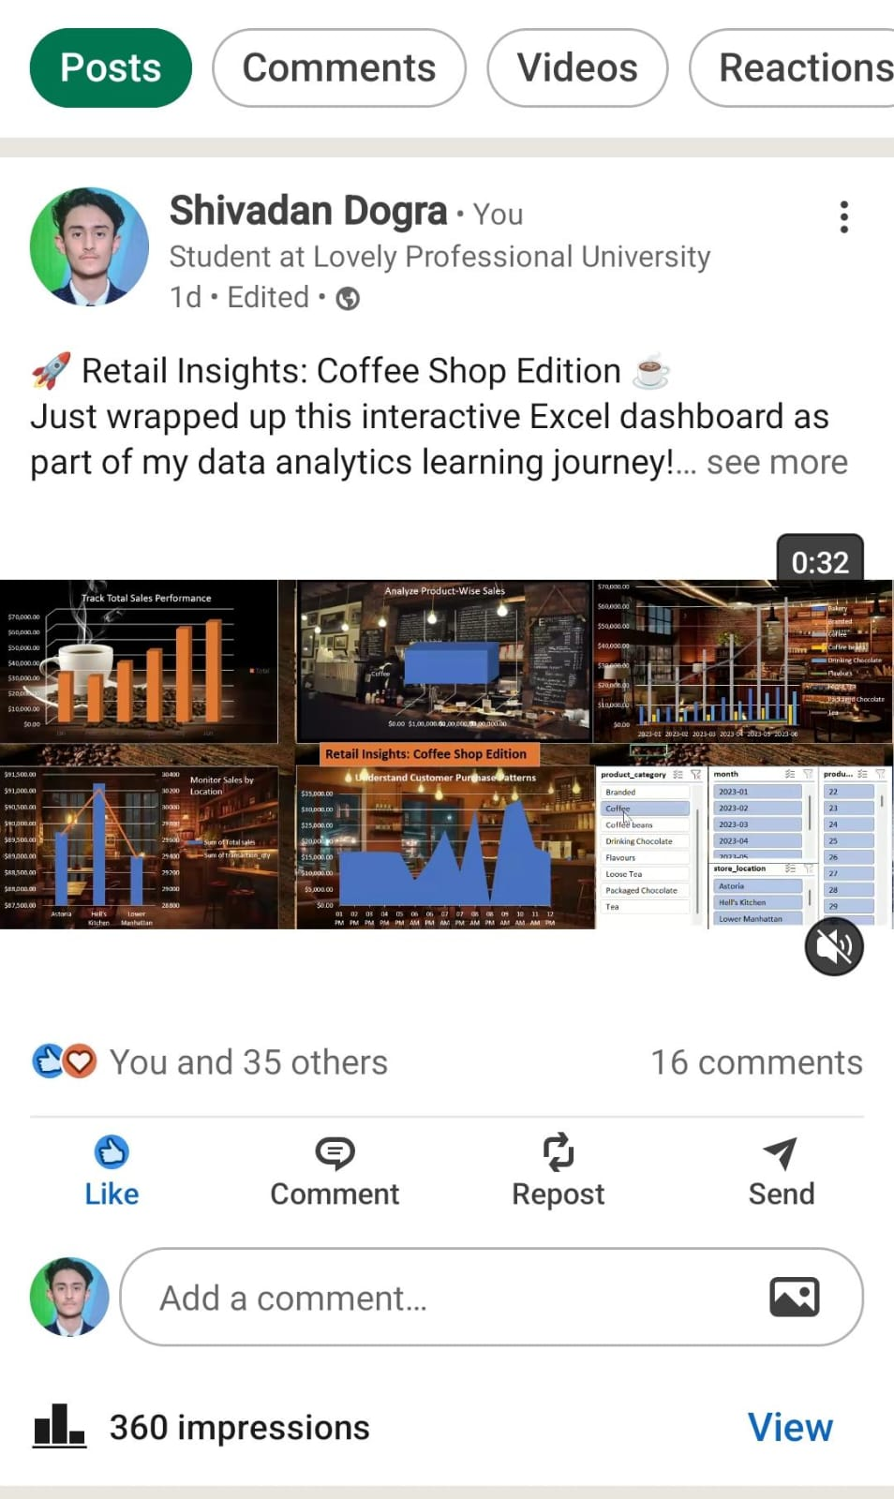
Dataset Preprocessing

Before performing any analysis, the dataset underwent the following preprocessing steps:
- Ensured all date and time fields were in proper format.
- Calculated a new field: Total Sales using the formula:
= [unit_price] * [transaction_qty]
- Created a new column Hour (AM/PM) for time-based grouping using the DAX formula:
= FORMAT([transaction_time], "hh AM/PM")
- Removed any duplicate or incomplete records.
- Date Formatting: The transaction_date was transformed using DAX to extract the month and year:
= FORMAT(transaction_date, "YYYY-MM")
- Data Model: Relationships were created between tables such as Transactions, Products, and Locations.
- Filtering: Data was filtered to focus on the six-month window from January to June 2023.

⌨️ Analysis on Dataset
Objective 1: Summarize Total Sales by Date
General Description: This objective focuses on summarizing the daily sales performance to understand how revenue varies over time.
Specific Requirements: Use PivotTable to aggregate total sales by date.
Formula Used:
- PivotTable setup:
  - Rows: transaction_date
  - Values: Sum of Total Sales
Analysis Results: The daily sales trend exhibited consistency during the weekdays with spikes on weekends. This suggests higher footfall or purchases during leisure time.
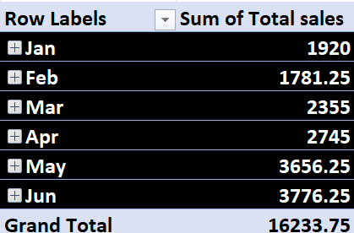
Visualization: Finalised outlook in the dashboard section.

Objective 2: Analyze Product-Wise Sales
General Description: This objective evaluates which products generate the most revenue.
Specific Requirements: Use product category and product name in rows and total sales in values.
Formula Used:
- PivotTable setup:
  - Rows: product_category, product_detail
  - Values: Sum of Total Sales
Analysis Results: Beverages like Coffee and Tea dominated the sales. Specific best-sellers included "Gourmet brewed coffee" and "Spicy Eye Opener Chai".
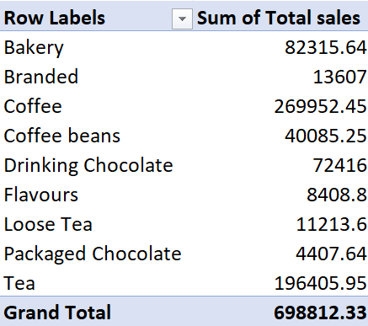
Visualization: Finalised outlook in the dashboard section.

Objective 3: Monitor Sales by Location
General Description: This objective compares sales performance across various store locations.

Specific Requirements: Use store location as rows, total sales and quantity sold as values.

Formula Used:
- PivotTable setup:
  - Rows: store_location
  - Values: Sum of Total Sales, Sum of transaction_qty

Analysis Results: Locations in Lower Manhattan and Downtown Brooklyn performed significantly better, indicating potential target areas for future promotions.
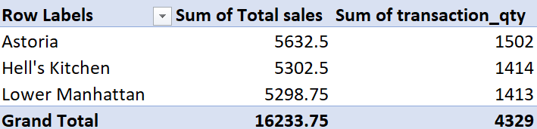
Visualization: Finalised outlook in the dashboard section.

Objective 4: Understand Customer Purchase Patterns
General Description: This objective explores purchasing behavior based on time of day.
Specific Requirements: Use transaction time (AM/PM) as rows and total sales as values.
Formula Used:
- DAX calculated column:
= FORMAT([transaction_time], "hh AM/PM")
- PivotTable setup:
  - Rows: Hour (AM/PM)
  - Values: Sum of Total Sales
Analysis Results: The data showed peak purchase times between 8 AM and 11 AM, aligning with breakfast and commute hours.

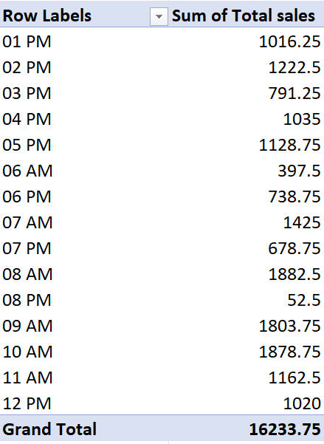
Visualization: Finalised outlook in the dashboard section.

Objective 5: Track Product Mix Over Time
General Description: The goal was to observe how each product category contributes to overall sales over time. This helps the business identify seasonal trends, popularity waves, and opportunities to optimize stock levels and marketing.
Specific Requirements: Use month as Rows, product_category as
Columns, Total sales as Values.
Formula Used:
- PivotTable setup:
  - Rows: month
  - Columns: product_category
  - Values: Total Sales
Analysis Results:
- Coffee, Packaged Chocolate, and Flavours consistently contributed a large share of the monthly revenue.
- A noticeable increase in Coffee Beans and Drinking Chocolate sales during cooler months (January–March).
- Product categories like Tea and Loose Tea had lower but steady demand.
Visualization:
Finalised outlook in the dashboard section.

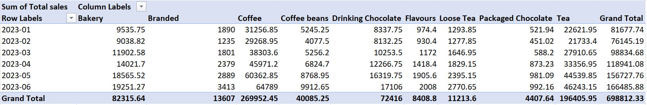
Dashboard:
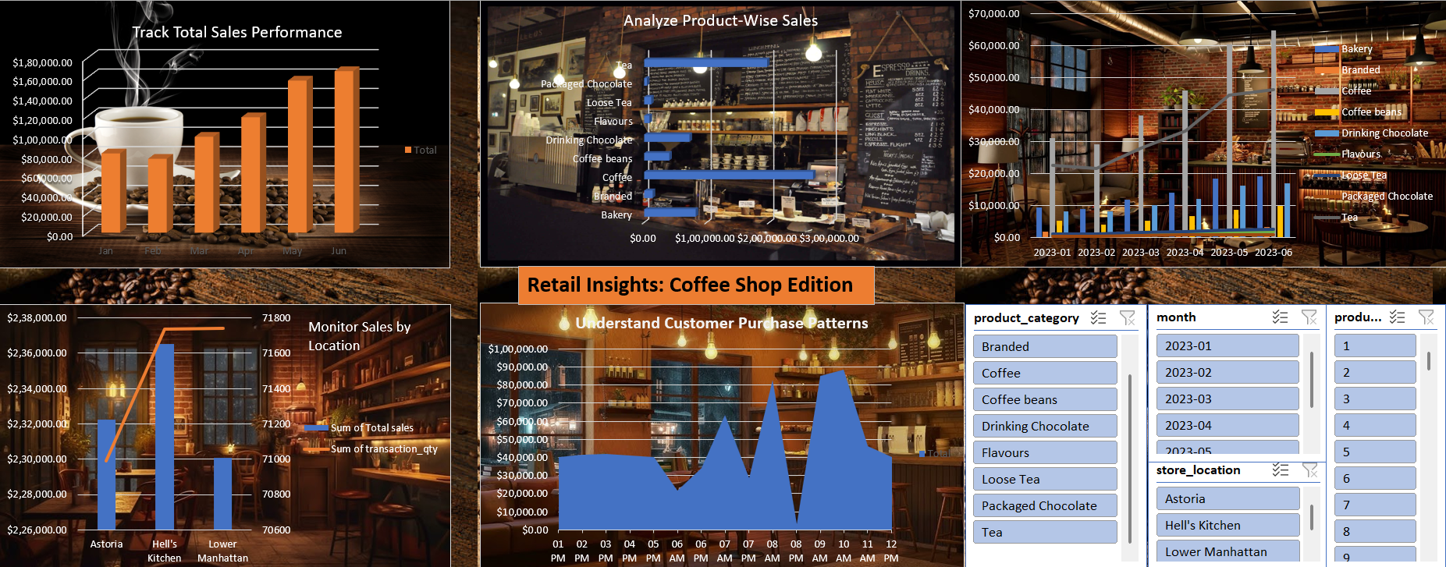
5. Conclusion
The use of Power Pivot enabled multi-faceted insights into coffee shop operations. By visualizing total sales trends, analyzing product performance, comparing store locations, and understanding customer purchase behavior, the business can now make informed decisions regarding inventory management, marketing strategies, and staffing during peak hours.

6. Future Scope
- Introduce customer segmentation to personalize promotions.
- Analyze seasonal trends by expanding the dataset.
- Incorporate weather data to assess external influences on sales.
- Deploy predictive models for demand forecasting.

7. References
[1] Microsoft, “PivotTables in Excel,” [Online]. Available: https://support.microsoft.com/en-us/excel-pivottables
[2] Lovely Professional University, “Minor Project Guidelines,” Internal Document, 2025.
[3] ExcelJet, “TEXT Function,” [Online]. Available: https://exceljet.net/excel-functions/excel-text-function

