**Follow below mentioned procedure to the create the shared folder between the ubuntu and windows**

step1:

install guest additions using below command

$ sudo apt-get install virtualbox-guest-additions-iso

than got to Devices --> insert guest additional CD image press double click, u will get pop up to run additions press run and after completion of run it will show press return to close the window than press enter after that terminal will get closed .

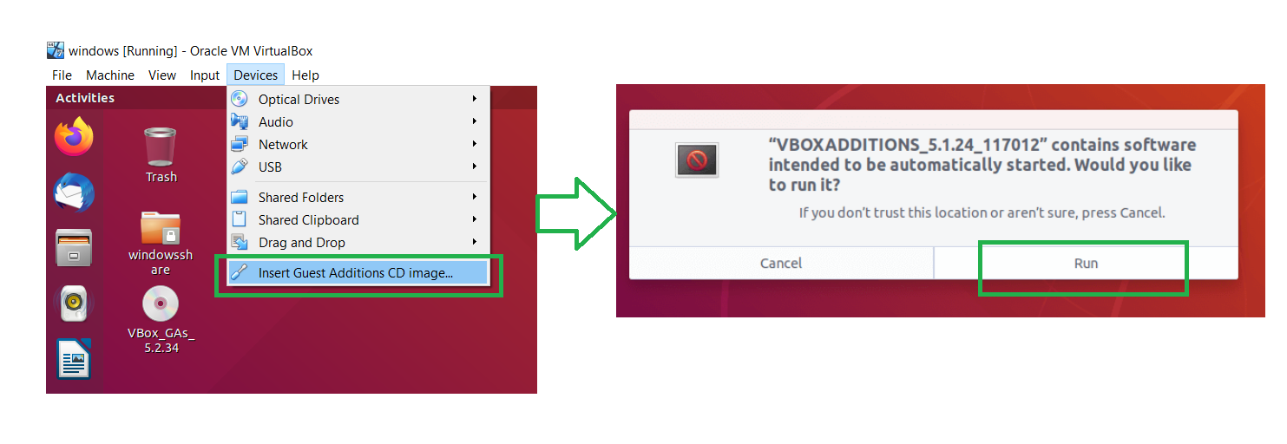

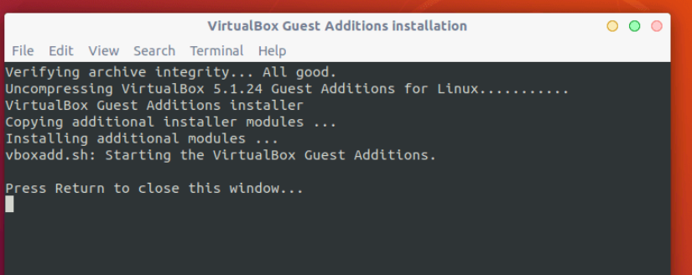

Step 2

Now to enable Shared Clipboard and Drag’n’Drop functionality between Guest and Host Machine. Go to General => Advanced and enable the two options (Shared Clipboard and Drag’n’Drop) as you wish, from the drop-down options. Then click OK to save the settings.

Machine generated alternative text:
Ubuntu_External _full [Running] - Oracle VM VirtualBox 
File Machine View Input Devices Help 
USB 
Ubuntu 18.04 [Running] - Oracle VM VirtualBox 
Act 
O 
Settingsm 
Take Snapshot.„ 
Session Information.„ 
Pause 
Reset 
ACP' Shutdown 
mpor 
6 import paramtko 
7 import argparse 
8 import subprocess 
Host+S 
Host+T 
Host+N 
ig variables.py 
Host+p 
Host+R 
Host+H 
File Machine 
Activities 
View 
Input 
General 
system 
Display 
Storage 
Audio 
Network 
serial ports 
Devices Help 
General 
Basjc Advanced 
Snapshot Folder: 
Shared Clipboard: 
Drag'n'Drop: 
Shared Folders 
user Interface 
Mon 16•.27 
Ubuntu 18.04 - Settings 
Description Encyptjon 
/home/tecmint/VirtualBox VMs,'Ubuntu 18.04/Snapshots 
Bidirectional 
Bidirectional 
Cancel 
enpOs3 
OK 
Right ctrl 

Step3:

Create a shared Directory in Windows: Example -> Make a folder on Windows Desktop with name Ubuntu\_share

create a Shared directory in Ubuntu

$ sudo mkdir ~/Desktop/windows\_share

From Virtual menu go to Devices->Shared Folders->Machine Folders ->then add a new folder in the list, this folder should be the one in windows (Ubuntu\_share) which you want to share with Ubuntu (Guest OS).Make this created folder auto-mount , make permanent as below.

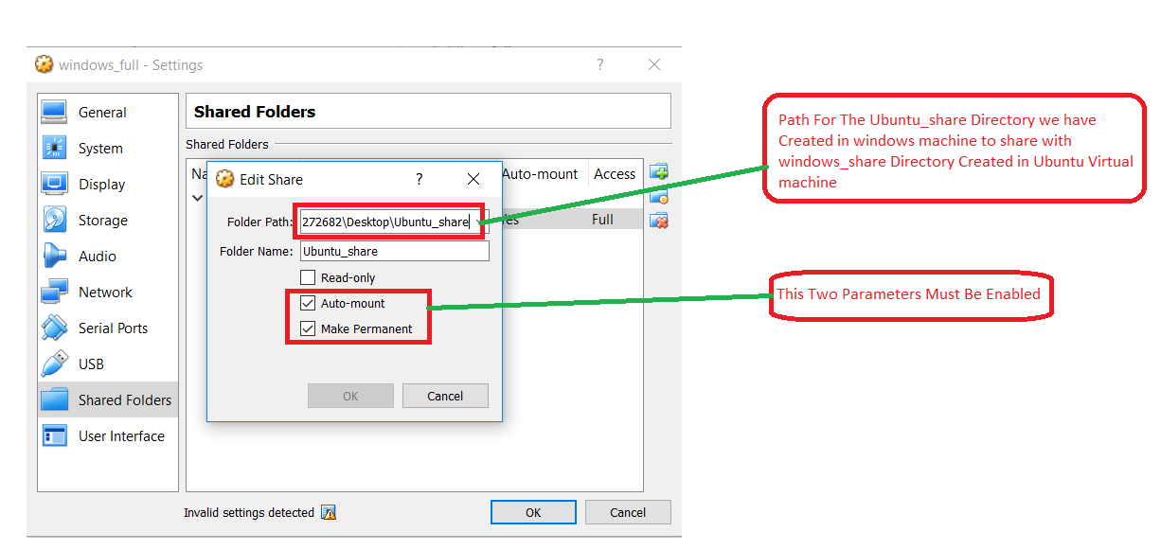

Step 5

With your mountpoint created you can now mount the shared folder.

Run this command to share the folder:

$ sudo mount -t vboxsf Ubuntu\_share ~/Desktop/windows\_share

Ubuntu\_share is the name of folder we created in Windows (Host OS).

~/Desktop/windows\_share is the directory in Ubuntu (Guest OS)

step6:

Run the command: sudo usermod --append --groups vboxsf [yourlinuxVmUsername]

This command calls usermod to modify a user account. The -G specified to modify groups it belongs to. The following ‘vboxsf’ is the user group VirtualBox creates to share folders (I believe vboxsf stands for VirtualBoxSharedFolders). -a is to append, and this expects a username, so [yourusernamehere] should be the name of your user in the VM you want to give access to. Once this command is run, no output (as shown below) means it was success

After all the above steps restart the system , you should be able to see the shared folder mounted properly

+++++++++++++++++++++ shared folder creation Steps Completed ++++++++++++++++++++