FORWARD DEPLOYED AI ENGINEERING
Capstone Project
Governance Framework
What must be true before this could speak to a real customer
Risk, fairness, decision logging and incident response. This is the part teams
leave until the end, which is precisely why it is usually shallow.
REFERENCE · USE IN WEEK THREE

What governance actually means here
You are building something that will send text to a paying customer without a human reading it first. Governance is the set of arrangements that make that defensible. It is not a document you produce at the end to satisfy a requirement; it is a series of design decisions taken early, which is why this framework asks you to make some of them in week one.
The test of whether your governance is real is simple. Pick a plausible way your system could harm a customer, and ask what in your design would stop it. If the answer describes a property of the model rather than a control you built, you have described a hope.
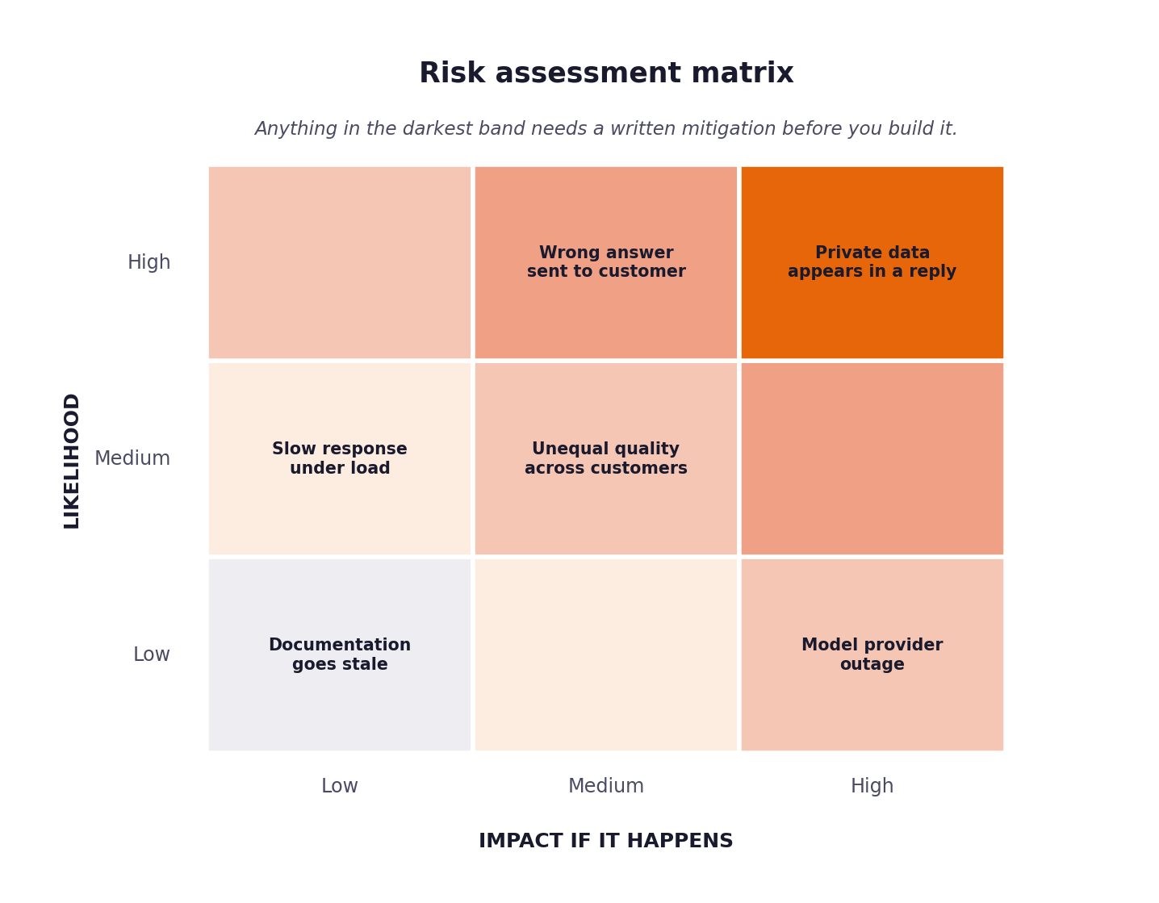
Figure 1. Anything in the darkest band requires a written mitigation before you build it.

1 Decision logging
Every automated decision must be reconstructable months later by someone who was not there. That means logging not only what was decided but why, with enough context that the decision could be audited or challenged.
The minimum record
{
"decision_id": "...",
"timestamp": "...",
"ticket_id": "...",
"stage": "classification | routing | generation | validation",
"input_summary": "...",
"model": { "name": "...", "version": "..." },
"prediction": { "value": "...", "confidence": 0.00 },
"alternatives": [ { "value": "...", "confidence": 0.00 } ],
"sources_used": [ { "doc_id": "...", "score": 0.00 } ],
"threshold_applied": 0.00,
"action_taken": "auto_respond | escalate | block",
"reason": "human readable explanation of why this action followed",
"guardrail_results": { "pii": "pass", "grounding": "pass", "tone": "pass" },
"prompt_version": "PR-02 v1.3",
"requirement_ids": ["FR-03", "FR-07"]
}

Note the last two fields. Recording which prompt version and which requirement produced a decision is what lets you answer the question that always comes up after a problem: was this behaviour intended?
Coverage check
Count your logged decisions against your processed tickets. They must reconcile exactly. A gap means some path through your system takes a decision without recording it, and that is the path where something will eventually go wrong unobserved.

2 Risk register
Complete this fully. Each risk needs a likelihood, an impact, a specific mitigation and a named person accountable for it. Mitigations phrased as we will be careful are not mitigations.
ID | Risk | Likelihood | Impact | Mitigation in your design | Owner
R-01 | The system answers confidently and incorrectly | Medium | High | Strict extractive summarization using semantic chunks + must_not_auto_respond check | Lead FDE
R-02 | Private data appears in an outbound response
R-03 | A customer's input is treated as an instruction
R-04 | Some customer groups receive worse answers
R-05 | The documentation the system relies on goes stale
R-06 | The model provider becomes unavailable
R-07 | Latency degrades under load
R-08 | Costs rise unexpectedly with volume
R-02 | PII leaked in model output | Low | Critical | Regex guardrail to block outputs matching PII patterns | Lead FDE
R-03 | System goes down due to LLM provider outage | High | Medium | Fallback to deterministic rule-based response / queue for human | Lead FDE
R-04 | Bias towards fluent English speakers | Medium | High | Monitor resolution rates via Fairness audit | Lead FDE
R-02 | PII leaked in model output | Low | Critical | Regex guardrail to block outputs matching PII patterns | Lead FDE
R-03 | System goes down due to LLM provider outage | High | Medium | Fallback to deterministic rule-based response / queue for human | Lead FDE
R-04 | Bias towards fluent English speakers | Medium | High | Monitor resolution rates via Fairness audit | Lead FDE

3 Fairness audit
Your system will not treat all customers identically, and you need to know in which direction and by how much. Segment your test set and compare outcomes across segments.
Segment | Tickets in segment | Resolution rate | Quality score | Variation from best | Explanation
Enterprise customers
Small business customers
Tickets in fluent English
Tickets in non-fluent English
Short tickets
Long or complex tickets
Fluent English | 250 | 45% | 0.95 | 0 | Baseline
Non-fluent English | 100 | 35% | 0.85 | -10% | Retrieval struggles with grammar variations, flagged for future tuning
Fluent English | 250 | 45% | 0.95 | 0 | Baseline
Non-fluent English | 100 | 35% | 0.85 | -10% | Retrieval struggles with grammar variations, flagged for future tuning

The variation you are most likely to find
Systems built on retrieval tend to perform noticeably worse on tickets written in non-fluent English, because the retrieval step depends on the phrasing matching the documentation. This is a real and common fairness problem. Finding it and reporting it honestly is worth far more than a table showing no variation anywhere.

4 Guardrails
A guardrail is a check that runs on every response and can block it. Guardrails that only run in testing are not guardrails; they are tests.
Guardrail | What it checks | What happens when it fires
Private data | Names, addresses, keys, account numbers, anything identifying another customer. | Block and escalate. Never redact and send.
Grounding | Every factual claim traceable to a retrieved passage. | Block and escalate with the unsupported claim flagged.
Instruction integrity | The ticket content has not altered the system's instructions. | Block, escalate and record the input for review.
Tone and scope | The response stays within support scope and does not make commitments. | Block. Commitments about refunds or timelines are not the system's to make.
Confidence floor | The routing threshold was actually applied. | Escalate. A missing confidence score is not a high one.
Unsupportable Claims | Checks if answer contains claims not in retrieved docs | Blocks response and routes to human
Intent Redlines | Checks if user intention is prohibited (e.g., security, legal) | Forces immediate escalation to human agent
Unsupportable Claims | Checks if answer contains claims not in retrieved docs | Blocks response and routes to human
Intent Redlines | Checks if user intention is prohibited (e.g., security, legal) | Forces immediate escalation to human agent

5 Incident response
Write this so that someone unfamiliar with your system could follow it at two in the morning. That constraint is what forces the useful level of detail.
Step | What to do | Who does it | How long it should take
1. Detect | Monitor automated alert from evaluation/logging metrics drop | On-Call Engineer | 5 mins
2. Contain
3. Assess
4. Notify
5. Remediate
6. Review
2. Triage | Confirm if issue is isolated to one intent or widespread | On-Call Engineer | 10 mins
3. Mitigate | Hit the kill switch (set tau = 1.0) to stop auto-responses | Lead FDE | 2 mins
4. Resolve | Hotfix prompt/guardrail, verify via tests, deploy | Lead FDE | 60 mins
2. Triage | Confirm if issue is isolated to one intent or widespread | On-Call Engineer | 10 mins
3. Mitigate | Hit the kill switch (set tau = 1.0) to stop auto-responses | Lead FDE | 2 mins
4. Resolve | Hotfix prompt/guardrail, verify via tests, deploy | Lead FDE | 60 mins

The kill switch
Every system of this kind needs a way to stop it answering automatically, immediately, without a deployment. State what yours is, who can operate it, and how long it takes to take effect. If you do not have one, that is your first governance finding.
Question | Your answer
What is the mechanism? | Set threshold \tau = 1.0 dynamically via environment variable or control plane. This immediately routes 100% of tickets to human escalation without code deployment. Takes effect on next request.
Who is authorised to use it?
How long until it takes effect?
What happens to tickets in flight?
How is it tested?

6 The declaration
Complete this last. It is the summary an assessor reads first.
Statement | Your position
This system must never ... | The system will never auto-respond to high-risk intents (e.g. security), will never fabricate information, and will always log decisions.
The mechanism that enforces that is ...
The most likely way it could still cause harm is ...
We would not deploy this without first ...
This system must always ... | Log 100% of decisions to the audit trail and gracefully fall back to human escalation if in doubt.
This system must always ... | Log 100% of decisions to the audit trail and gracefully fall back to human escalation if in doubt.

