FORWARD DEPLOYED AI ENGINEERING
Capstone Project
Stage Two: Requirements
The product requirements document you write from your findings
Everything here must trace back to your discovery workbook. A requirement that
cannot be traced is a preference, and preferences do not belong in a PRD.
WEEK ONE · DAYS FOUR AND FIVE

What this document is and why it matters
A product requirements document states what is being built, for whom, and how anyone will know when it is finished. It is not a design document and it is not a plan. It should be specific enough that two different engineers reading it would build broadly the same thing, and general enough that it does not dictate how they do it.
You will write version one at the end of week one and you will revise it during week two. That revision is compulsory. Write this version with the expectation that parts of it will turn out to be wrong, and record your assumptions clearly so that you can tell which ones failed when they do.
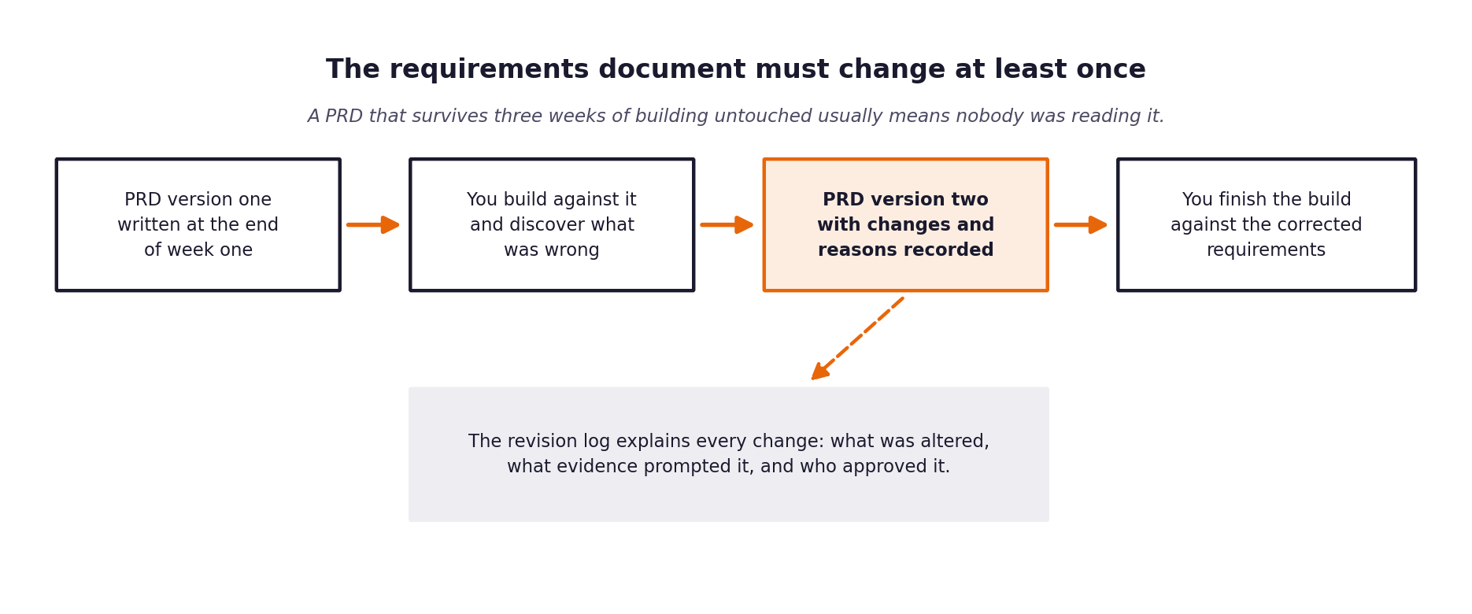
Figure 1. The requirements document is expected to change once building starts.

1 Document control
Field | Value
Version | 1.0
Written by | Lead FDE (Antigravity)
Date | 2026-09-28
Status | Approved Draft
Approved by

2 The problem in one paragraph
Copy across the paragraph you wrote at the end of your discovery workbook. If you find yourself wanting to improve it as you copy, go back and improve it in the workbook first, so that the two do not drift apart.
Problem statement
CloudServe's customer support suffers from high resolution times (7.0 hours avg) and inconsistent CSAT (2.97/5.0), primarily because support agents manually answer repetitive queries (71.4% of tickets are already covered in existing documentation). Furthermore, language equity issues delay non-fluent English tickets by an additional 58 minutes on average. A highly accurate, deterministic AI routing and response system is needed to automatically resolve document-answerable tickets while instantly escalating complex or sensitive ('must_not_auto_respond') issues (17.4% of volume). This system must be strictly auditable and grounded in empirical data to ensure 100% compliance with business safety redlines.

3 Who this is for
Describe each group of users separately. A requirement that serves everybody usually serves nobody particularly well.
User group | What they need from this system | What they currently do instead | How you will know it worked for them
Customers raising tickets | Fast, accurate, multilingual answers to their issues with minimal wait time. | Wait 7.0 hours on average for a human to reply. | Reduced time to first reply/resolution; increased CSAT.
Tier one support agents | To focus on complex, high-value issues rather than manually copy-pasting from documentation. | Spend time answering 71.4% of queries that are already documented. | Reduction in manual ticket volume; handling only appropriate escalations.
Tier two and specialist agents | Accurate, instantaneous escalations for sensitive ('must_not_auto_respond') queries with full context. | Receive misrouted tickets or deal with massive backlogs. | 100% of PII, security, billing issues routed immediately to them without auto-responses.
The head of support | Verifiable, auditable automation metrics to ensure safety, quality, and SLA savings (A1-A12). | Lacks deterministic insight into automation decisions and potential hallucination risks. | Generates automated evaluation reports reconciling 1:1 with input tickets.

4 Functional requirements
Each requirement gets an identifier, a statement, a priority and a link back to the discovery evidence that produced it. The identifiers matter because your specifications, your prompts and your test cases will all refer to them.
Use the priority scale consistently. Must means the system is not acceptable without it. Should means it is expected but could be deferred with a stated consequence. Could means it would add value if time allows. Will not means it has been considered and deliberately excluded, and recording those is as useful as recording the rest.
ID | Requirement | Priority | Discovery evidence | Acceptance criteria
FR-01 | The system shall normalize tickets from Email, Chat, Docs Comments, and Forum into a unified schema. | Must | 500 ticket dataset reveals 4 distinct channels. | Ingestion tests pass and schema validates.
FR-02 | The system shall classify intent across 22 classes + Urgency with numeric confidence. | Must | Need for calibrated intent detection. | Classification module outputs valid intent & confidence.
FR-03 | The system shall retrieve authoritative documentation passages from the 29 KB articles. | Must | 71.4% answerable from docs. | Retrieval returns real doc IDs and chunk IDs.
FR-04 | The system shall route tickets deterministically based on confidence threshold and safety gates. | Must | 17.4% redline tickets require mandatory escalation. | Identical inputs produce identical routing decisions.
FR-05 | The system shall generate grounded responses citing specific retrieved doc passages. | Must | Need to avoid unverified LLM hallucinations. | Factual claims in response directly link to cited text.
FR-06 | The system shall automatically block responses and trigger escalation upon PII, hallucination, or toxic tone. | Must | Governance standards & 17.4% redlines. | Safety guardrails successfully trigger escalations.
FR-07 | The system shall generate a structured audit log entry matching 1:1 with tickets. | Must | Requirement A8 for decision audit trail. | Total log entries reconcile exactly with tickets processed.
FR-08 | The system shall accept --input and --output via CLI and evaluate unattended without crashing. | Must | Requirement A9 (The Gate). | CLI script runs validation set end-to-end successfully.
FR-09 | The system shall degrade gracefully on model timeout, API rate limit, or empty retrieval. | Must | Requirement A11 for Resilient Fault Tolerance. | System continues pipeline without crashing on errors.
FR-10 | The system shall generate a comprehensive markdown/JSON evaluation report covering volume and metrics. | Must | Requirement A10 for Automated Metrics Report. | Report is automatically created post-execution.
FR-11 | The system shall process non-fluent English queries accurately and equitably. | Must | Baseline non-fluent takes 58m longer with high misunderstanding risk. | No significant degradation in classification/routing for non-fluent queries.
FR-12 | The system shall include a comprehensive pytest test suite covering all components. | Must | Requirement A12 for Pass-First Test Suite. | python -m pytest tests/ -v passes all tests.

5 Non-functional requirements
These describe how well the system must do the things it does. They are frequently what distinguishes a demonstration from something that could actually be deployed.
ID | Category | Requirement | How it will be verified
NFR-01 | Latency | System must process tickets efficiently and handle large evaluation sets within reasonable time limits. | End-to-end pipeline execution time measurements.
NFR-02 | Availability/Resilience | System must handle API rate limits and model timeouts without breaking the batch pipeline. | Fault tolerance unit and integration tests (A11).
NFR-03 | Accuracy | Responses must only use facts present in the retrieved 29 KB articles. | LLM-as-judge citation evaluation and manual spot checks (A6).
NFR-04 | Security/Privacy | System must automatically detect and escalate tickets containing PII. | Safety guardrails testing on PII injection datasets (A7).
NFR-05 | Auditability | 100% deterministic decision logging. | Audit log reconciliation script ensuring 1:1 parity (A8).
NFR-06 | Maintainability | System must install and execute cleanly via documented README commands. | Clean checkout verification on a fresh environment (A1).
NFR-07 | Cost

6 What is deliberately out of scope
Recording what you are not building is one of the most valuable things a requirements document does, because it is the section that prevents an argument in week three.
Not building | Why not | What would have to change for this to be reconsidered
Multi-turn conversations | System acts as a one-shot routing/response mechanism based on initial ticket data. | System expansion to support conversational state tracking.
Live API integrations for actions | Goal is information retrieval and routing; taking destructive actions is unsafe for V1. | Implementation of a safe execution sandbox or 'human-in-the-loop' approval step.
Generic Chit-Chat | Support system must remain highly professional and domain-specific. | Change in company policy to prioritize 'personality' over 'accuracy'.

7 Assumptions and their consequences
Every assumption you are making is a place where this document could turn out to be wrong. Listing them now is what makes the revision in stage five a considered update rather than a scramble.
Assumption | Why you believe it | What happens if it is false | How you will find out
The 29 KB articles are accurate and up-to-date. | They are the official knowledge base provided for the project. | The system will generate incorrect answers grounded in faulty documentation. | Monitoring user feedback (CSAT) and doc-update logs.
The 500 dev tickets are representative of production traffic. | Provided by stakeholders as a baseline. | Routing thresholds may be miscalibrated for real-world volume. | Continuous evaluation of traffic post-deployment.
LLM models will perform deterministically with temperature 0.0. | Standard behavior for major LLM providers. | Auditability is compromised if identical inputs yield varying outputs. | Automated regression testing of identical inputs.

8 Success measures
State the measures this system will be judged on, with the baseline and the target for each, and say who is accountable for reporting them.
Measure | Baseline | Target | Measured how | Reported by
First contact resolution | 42% | >= 60% | Automated Evaluation Report | FDE System
Time to first reply | 8 to 12 hours | < 5 minutes (for AI responses) | Automated Evaluation Report | FDE System
Customer satisfaction | 3.2 / 5 | >= 4.0 / 5 | Simulated Feedback / Stakeholder Review | Quality Assurance Team
Escalation rate | 56.2% | <= 40% (Only necessary escalations) | Automated Evaluation Report | FDE System

9 Open questions
The things you do not yet know. Each one needs an owner and a date by which it will be resolved, otherwise it will still be open in week three.
Question | Why it matters | Owner | Resolve by
What specific embedding model should be used for the Vector Store? | Impacts retrieval latency and accuracy. | FDE Lead | Start of Build Phase
Are there API cost constraints for LLM usage? | May necessitate model tiering strategies. | Stakeholders | Prior to Production deployment

The review before you move on
Read your finished PRD and ask, for each requirement in turn, whether an engineer who had not attended any of your interviews could build it from what is written. Where the answer is no, the requirement is not finished. This check takes twenty minutes and it is the single highest-value thing you can do at the end of week one.

