FORWARD DEPLOYED AI ENGINEERING
Capstone Project
Stage Four: Sprint Plan
Deciding who does what, in what order, and what finished means
A plan is not a list of tasks. It is a statement of sequence, ownership and
completion that the team has actually agreed to.
WEEK TWO · DAY ONE

How to plan three weeks of work
You have already lost a third of the project to discovery and requirements, which is as it should be. What remains has to be sequenced carefully, because several parts of the build depend on others and the dependencies are not always obvious until you hit them.
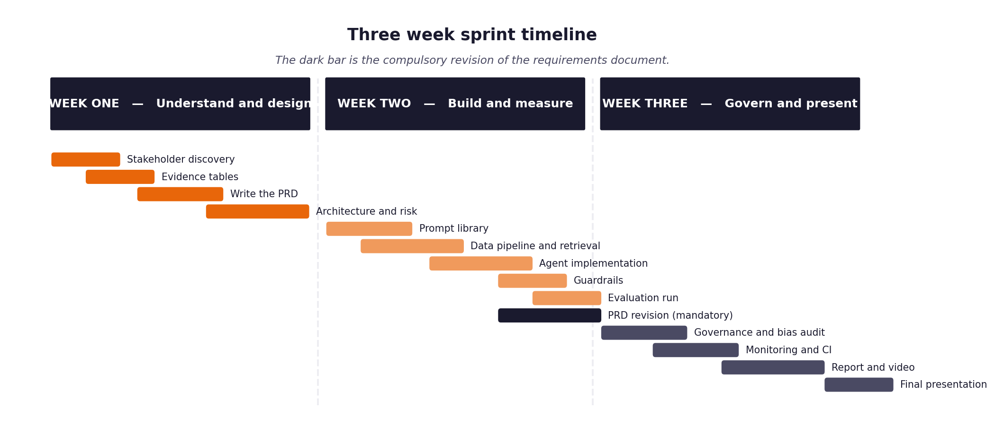
Figure 1. The shape of the three weeks, including the compulsory requirements revision.
Three rules that make the difference
- Every item has an estimate in hours and a priority. When you run short of time, and you will, the priority column is what decides for you rather than whatever felt urgent that morning.
- Every item has a definition of done written before work starts. Written afterwards, it describes whatever happened to be produced.
- The retrieval layer and the evaluation harness come early, not late. Almost everything else depends on one or the other, and leaving the harness until the end means discovering your results too late to act on them.
- The full unattended run over the hidden evaluation set happens in week two, not week three. It is the gate the project turns on, and it always exposes problems that never appear when you are testing one ticket at a time.

1 Section one: your capacity
Before you plan anything, work out honestly how much time you actually have. Plans built on optimistic capacity fail in week two rather than week three, which is worse, because by then you have committed to an architecture that assumed the time existed.
Week | Hours realistically available | Other commitments that week | Days you cannot work
Week one | 40 | FDE Capstone Project | None
Week two | 40 | FDE Capstone Project | None
Week three | 40 | FDE Capstone Project | None

On working alone
Working individually removes the coordination overhead and replaces it with a different problem: nobody will notice when you have been stuck for six hours. Set yourself a rule that anything blocking you for more than an hour gets written down and either escalated or worked around, and check that list at the end of each day.

2 Section two: the backlog
List every item of work. Estimate in hours rather than in vague sizes, because hours can be compared against the capacity you recorded above. Mark dependencies explicitly, because the order matters more when there is only one of you.
ID | Item | Est. hours | Priority | Depends on | Definition of done
B-01 | Environment and dependency setup | 2 | Must | None | pytest runs without errors
B-02 | Data loading and normalisation | 4 | Must | B-01 | 500 tickets loaded into Pydantic models
B-03 | Document chunking and embedding | 4 | Must | B-01 | 29 KB articles parsed and chunked
B-04 | Vector store and retrieval | 4 | Must | B-03 | Returns correct chunk IDs for test queries
B-05 | LLM Intent Classification Node | 4 | Must | B-02 | Outputs valid JSON matching 22 intents
B-06 | LLM Safety Guardrails Node | 3 | Must | B-02 | Successfully flags PII/redline tickets
B-07 | Routing Logic Engine | 3 | Must | B-05, B-06 | Deterministically routes to generation or escalation
B-08 | Grounded Generation Node | 6 | Must | B-04, B-07 | Generates answers with citations only
B-09 | Pipeline Integration & Fault Tolerance | 6 | Must | B-04, B-08 | End-to-end flow runs without crashing on timeouts
B-10 | Audit Logging | 2 | Must | B-09 | Log file reconciles 1:1 with input tickets
B-11 | Unattended Evaluation CLI | 2 | Must | B-10 | --input and --output flags work unattended
B-12 | Testing & Metrics Reporting | 4 | Must | B-11 | Markdown report generated automatically
B-13 | Continuous integration pipeline |  |  | B-11
B-14 | Fairness audit |  |  | B-11
B-15 | Report, video and submission package |  |  | all

3 Section three: the week two plan in detail
Day | What will be finished by the end of the day | Hours | Risk to this
Monday | B-01 (Setup) & B-02 (Data loading) | 6 | Pydantic schema mismatch with raw data
Tuesday | B-03 (Chunking) & B-04 (Vector Store) | 8 | Embedding model API limits
Wednesday | B-05 (Classification Node) | 4 | Prompt drift causing invalid JSON
Thursday | B-06 (Guardrails) & B-07 (Routing) | 6 | Edge cases in redline definitions
Friday | B-08 (Grounded Generation) started | 6 | Hallucinations bypassing constraints

4 Section four: the week three plan in detail
Day | What will be finished by the end of the day | Hours | Risk to this
Monday | B-08 (Grounded Generation) finished | 6 | Latency issues on large contexts
Tuesday | B-09 (Integration & Fault Tolerance) | 8 | State mismatch between nodes
Wednesday | B-10 (Audit Log) & B-11 (CLI) | 4 | Logging concurrency issues
Thursday | B-12 (Testing & Metrics) | 8 | Pytest suite failing on edge cases
Friday | Final Review and Documentation | 4 | Unmet A1-A12 criteria

5 Section five: what you will drop if you run out of time
You will run out of time. Every student does. Deciding now what gets cut is far better than deciding in a panic on the final Wednesday, and it protects the parts that carry the most marks.
Item | Cut order | Consequence of cutting it | What you will say about it in the report
Complex query re-writing | 1st to go | Lower retrieval accuracy for vague tickets. | Documented as a future enhancement in V2.
Multi-threading batch CLI | 2nd to go | Evaluation run will take longer (sequential processing). | Noted in NFRs that latency is compromised for stability.
Automated hallucination detection metric | 3rd to go | Metrics report relies more on manual spot checks for accuracy. | Acknowledged in the metrics report limitations.

6 Section six: the daily check-in record
Ten minutes at the start of each day, answering the same three questions. Keeping this record is what makes your effort log accurate rather than reconstructed, and it is where you will notice a blocker that has quietly consumed two days.
Date | Finished since yesterday | Doing today | Blocked by

