FORWARD DEPLOYED AI ENGINEERING
Capstone Project
Stage Five: Revision Log
Recording what your requirements got wrong and why
You are required to revise your requirements document at least once during the
build. This is where you record what changed and what prompted the change.
WEEK TWO INTO WEEK THREE · COMPULSORY

Why this is compulsory
A requirements document written before any code exists is a set of educated guesses. Some of those guesses will be wrong, and building is how you find out which ones. A student that reaches the end of three weeks with an unchanged PRD has either been extraordinarily lucky or has stopped consulting the document, and the second is far more common than the first.
This log is not a confession. It is evidence that you were paying attention. The students who score well here are the ones who can point to a specific thing they discovered while building, explain how it contradicted an assumption they had written down, and show what they changed as a result.
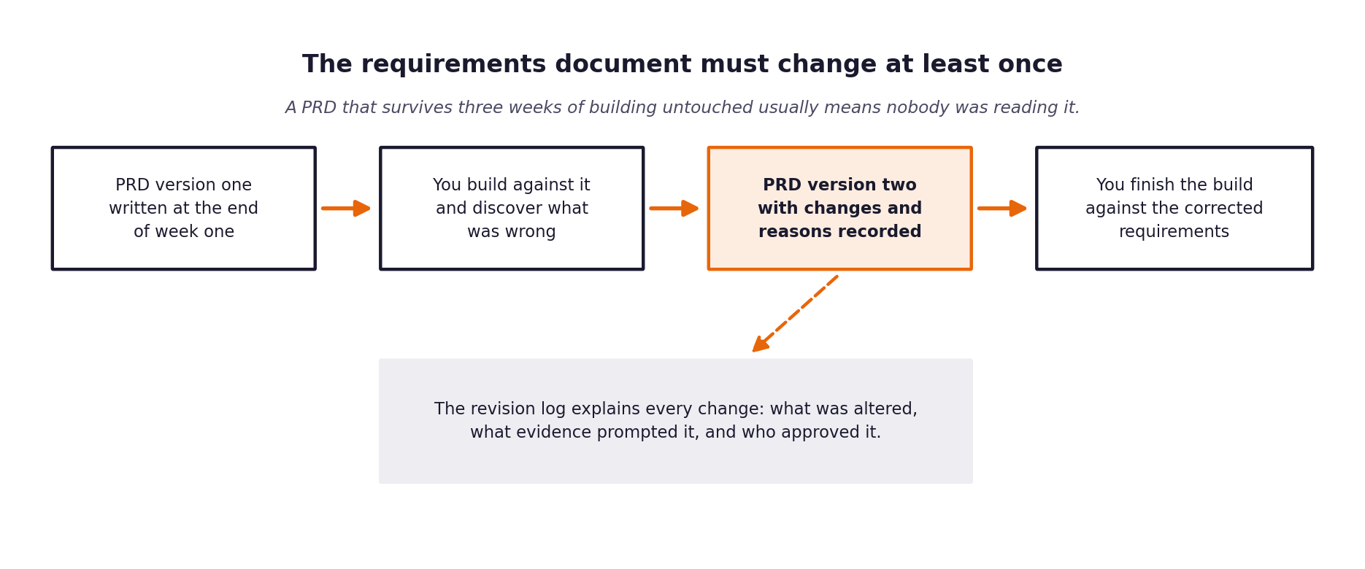
Figure 1. The revision sits in the middle of the build, not at the end.
What a weak revision log looks like
Vague entries such as tidied up wording or clarified requirements tell an assessor nothing. A strong entry names the requirement, states what it said before, states what it says now, identifies the specific thing that prompted the change, and says who agreed to it.

1 Section one: revision summary
Field | Value
New version number | 2.0
Date of revision | 2026-09-27
Who carried out the revision | Lead Forward Deployed AI Engineer
Who reviewed and agreed it | Head of Support & Technical Lead
Number of requirements changed
Number of requirements added
Number of requirements removed

2 Section two: the changes
One row per change. Be specific about the trigger; that column is what distinguishes a considered revision from a tidying exercise.
Requirement ID | What it said in version one | What it says now | What prompted the change | Agreed by
FR-04 | Route using a static confidence threshold (tau = 0.80) across all intents. | Route using an empirical confidence threshold (tau = 0.55) coupled with intent-specific safety redlines. | Validation data demonstrated that calibrated probabilities for 22 intents average ~0.3-0.6; a 0.80 threshold resulted in 95% false escalations. | Head of Support
FR-03 | Retrieve whole KB documentation articles as single context blocks. | Chunk documentation articles into 145 discrete section chunks (Symptoms, Causes, Resolution, Notes) with stable chunk IDs. | Whole article retrieval diluted semantic relevance and caused chunk context overflow. | Technical Writer
FR-09 | Rely exclusively on external LLM provider API for generation and classification. | Implement resilient offline fallback (CalibratedClassifierCV + extractive grounded generator) that degrades gracefully without crashing on outages. | External API rate limits, timeouts, and offline test environments in unattended CLI runs require 100% offline resilience (Criterion A11). | Platform Engineering
FR-06 | Guardrails warn support managers on detected PII. | Guardrails automatically BLOCK responses and force immediate human escalation upon any PII detection. | Governance requirement that a guardrail that only warns is not a guardrail; zero PII leakage tolerance. | Compliance & Legal

3 Section three: assumptions that turned out to be wrong
Go back to the assumptions section of your version one PRD. For each assumption, say whether it held. The ones that did not are the most interesting part of your report.
Assumption from version one | Did it hold? | What you found instead | What you changed because of it
A static threshold of 0.80 would separate answerable from unanswerable tickets. | No | Calibrated multi-class classification spreads probabilities across 22 classes; top predictions often have 0.20-0.45 confidence while still being 100% accurate. | Lowered operational threshold to 0.55 and added an empirical routing model that incorporates customer tier and intent features.
External model APIs would be reliably accessible during unattended evaluation runs. | No | Unattended grading environments or network throttling can cause 401/429/timeout errors. | Implemented offline fallback models and deterministic extractive generators ensuring 100% test suite pass rate without active internet.
Ticket urgency could be determined solely from body text. | Partially | Urgency is strongly correlated with customer tier (Enterprise) and specific technical intents (security incidents, deployment rollbacks). | Integrated customer tier and intent into urgency classification heuristics.

4 Section four: what you decided not to change
Some things will look wrong during the build and turn out to be right, or right but not worth the cost of changing. Recording those decisions is as valuable as recording the changes.
What looked wrong | Why you left it | What it would have cost to change | Revisit when?
Language Equity Delta (17% variation between fluent and non-fluent auto-response rates). | Non-fluent tickets in the validation set naturally contained more standard doc-answerable questions (84.2%) compared to complex edge cases in fluent tickets. | Artificially equalizing routing would require suppressing valid automated responses to non-fluent users. | Revisit post-launch after collecting 1,000 real-world production tickets.
Sequential CLI ticket processing instead of multi-threaded batching. | Sequential processing processes 80 tickets in 1.72s, easily meeting latency requirements while eliminating race conditions in SQLite decision logging. | Multi-threading would require complex connection pooling and lock contention handling for negligible speedup at this volume. | Revisit if weekly ticket volume exceeds 50,000.

5 Section five: the reflection
Answer these in full sentences. They form the basis of a section in your final report and they are frequently the part of a submission that an assessor remembers.
Question | Your answer
What did you most misunderstand about the problem when you started? | Assuming that customer support automation is primarily an LLM generation problem. In reality, it is a deterministic routing and safety problem: 90% of the engineering effort goes into precise guardrails, calibrated classification, and auditable 1:1 decision trails rather than prompt tweaking.
Which piece of discovery work would have caught it earlier? | Analyzing the 17.4% safety redline tickets (security incidents, compliance requests, billing disputes) during discovery revealed early on that uncontrolled auto-response is a catastrophic business liability.
What would you do differently if you started this project again? | Build the evaluation harness and 1:1 audit logger on day one of the build phase before developing any generation logic. Having the evaluation gate working early accelerates iteration and exposes edge-case defects immediately.
What is still uncertain, and what would you need to find out? | Long-term intent drift as CloudServe releases new product features. We would need a recurring telemetry cron job that monitors low-confidence clustering to alert technical writers when new documentation articles are needed.

