1)what is collection in java---::Collections can achieve all the operations that you perform on a data such as searching, sorting, insertion, manipulation, and deletion.
Java Collection means a single unit of objects. Java Collection framework provides many interfaces (Set, List, Queue, Deque) and classes (ArrayList, Vector, LinkedList, PriorityQueue, HashSet, LinkedHashSet, TreeSet).

Collection –mens box etc book libary

2)what is ArrayList in java---:An array is a collection of similar data values with a single name. An array can also be defined as, a special type of variable that holds multiple values of the same data type at a time.

ArrayList<String> cars = new ArrayList<String>(); // Create an ArrayList object
cars.add(“BMW”);
sout(cars);

ArrayList vs. LinkedList
The LinkedList class is a collection which can contain many objects of the same type, just like the ArrayList.
The LinkedList class has all of the same methods as the ArrayList class because they both implement the List interface. This means that you can add items, change items, remove items and clear the list in the same way.

3)what is LinkedList in java---::Linked List is a part of the Collection framework present in java.util package. This class is an implementation of the LinkedList data structure which is a linear data structure where the elements are not stored in contiguous locations and every element is a separate object with a data part and address part. The elements are linked using pointers and addresses. Each element is known as a node.

LinkedList<String> cars = new LinkedList<String>();

4)Difference between ArrayList and LinkedList---:
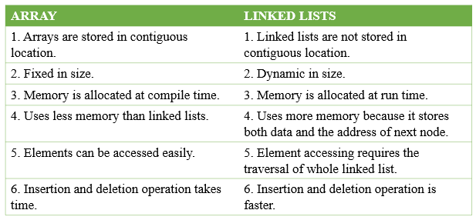

LinkedList is a linear data structure where the elements are not stored in contiguous locations and every element is a separate object with a data part and address part. The elements are linked using pointers and addresses. Each element is known as a node. Due to the dynamicity and ease of insertions and deletions, they are preferred over the arrays. The following is an example to demonstrate the implementation of the LinkedList.

5)what is ListInterface in java----::The List interface in Java provides a way to store the ordered collection. It is a child interface of Collection. It is an ordered collection of objects in which duplicate values can be stored. Since List preserves the insertion order, it allows positional access and insertion of elements.

6)what is vector in java---::The Vector class implements a growable array of objects. Vectors fall in legacy classes, but now it is fully compatible with collections. It is found in java.util package and implement the List interface, so we can use all the methods of the List interface as shown below as follows:

7)Diffenerence between Vector and ArrayList--: The Vector class implements a growable array of objects. Vectors fall in legacy classes, but now it is fully compatible with collections

ArrayList--:An array is a collection of similar data values with a single name. An array can also be defined as, a special type of variable that holds multiple values of the same data type at a time.

8)what is Map--:A Map is an object that maps keys to values. A map cannot contain duplicate keys: Each key can map to at most one value. It models the mathematical function abstraction

9)what is stack---::Stack is a linear data structure that is used to store the collection of objects. It is based on Last-In-First-Out (LIFO). Java collection framework provides many interfaces and classes to store the collection of objects. One of them is the Stack class that provides different operations such as push, pop, search,

10)Difference between List and Stack--:
List---:It contains the index-based methods to insert, update, delete and search the elements.

Stack--:Stack is a linear data structure that is used to store the collection of objects. It is based on Last-In-First-Out (LIFO).

11)Difference between List and Queue
List--:It contains the index-based methods to insert, update, delete and search the elements.
Queue--:Java Queue represents an ordered list of elements. Java Queue follows FIFO order to insert and remove it's elements

12)Difference between Map and List
Map--:A Map is an object that maps keys to values. A map cannot contain duplicate keys: Each key can map to at most one value. It models the mathematical function abstraction
List--:It contains the index-based methods to insert, update, delete and search the elements.

Set--:A Set is a Collection that cannot contain duplicate elements. It models the mathematical set abstraction. The Set interface contains only methods inherited from Collection and adds the restriction that duplicate elements are prohibited.
List--:It contains the index-based methods to insert, update, delete and search the elements.

14)what is HashMap---::The HashMap class of the Java collections framework provides the functionality of the hash table data structure. It stores elements in key/value pairs. Here, keys are unique identifiers used to associate each value on a map. The HashMap class implements the Map interface.

HashMap<String, String> capitalCities = new HashMap<String, String>();

15)what is tree---::TreeSet provides an implementation of the Set interface that uses a tree for storage. Objects are stored in a sorted and ascending order. Access and retrieval times are quite fast, which makes TreeSet an excellent choice when storing large amounts of sorted information that must be found quickly.

16)what is Hashset---:::In Java, HashSet is commonly used if we have to access elements randomly. It is because elements in a hash table are accessed using hash codes. The hashcode of an element is a unique identity that helps to identify the element in a hash table. HashSet cannot contain duplicate elements

HashSet<String> cars = new HashSet<String>();

17)list set queue map
18)what is queue
19) Difference between map and queue
20)Difference between array and arrayList

