Java Logging API was introduced in 1.4 and you can use java logging API to log application messages. In this java logging tutorial, we will learn basic features of Java Logger. We will also look into Java Logger example of different logging levels, Logging Handlers, Formatters, Filters, Log Manager and logging configurations.

Synchronization in Java:-
Ans:-
Synchronization in Java is the capability to control the access of multiple threads to any shared resource.
Java Synchronization is better option where we want to allow only one thread to access the shared resource.

Why use Synchronization?
The synchronization is mainly used to
- To prevent thread interference.
- To prevent consistency problem.

Types of Synchronization
There are two types of synchronization
Play Video
- Process Synchronization
- Thread Synchronization

Thread Synchronization
There are two types of thread synchronization mutual exclusive and inter-thread communication.
- Mutual Exclusive
  - Synchronized method.
  - Synchronized block.
  - Static synchronization.
- Cooperation (Inter-thread communication in java)

Mutual Exclusive
Mutual Exclusive helps keep threads from interfering with one another while sharing data. It can be achieved by using the following three ways:
- By Using Synchronized Method
- By Using Synchronized Block
- By Using Static Synchronization

Concept of Lock in Java
Synchronization is built around an internal entity known as the lock or monitor. Every object has a lock associated with it. By convention, a thread that needs consistent access to an object's fields has to acquire the object's lock before accessing them, and then release the lock when it's done with them.
From Java 5 the package java.util.concurrent.locks contains several lock implementations.
Java Synchronized Method
If you declare any method as synchronized, it is known as synchronized method.
Synchronized method is used to lock an object for any shared resource.
When a thread invokes a synchronized method, it automatically acquires the lock for that object and releases it when the thread completes its task.
Java Thread join() method:-
The join() method of thread class waits for a thread to die. It is used when you want one thread to wait for completion of another. This process is like a relay race where the second runner waits until the first runner comes and hand over the flag to him.

Java String contains():-
The Java String class contains() method searches the sequence of characters in this string. It returns true if the sequence of char values is found in this string otherwise returns false.
SynchronizedList:-
The synchronizedList() method of java.util.Collections class is used to return a synchronized (thread-safe) list backed by the specified list. In order to guarantee serial access, it is critical that all access to the backing list is accomplished through the returned list.

Collection:-
is an in-memory data structure, which holds all the values that the data structure currently has. Every element in the Collection has to be computed before we add it to the Collection. Operations such as searching, sorting, insertion, manipulation, and deletion can be performed on a Collection. It provides many interfaces like (Set, List, Queue, Deque) and Classes like (ArrayList, Vector, LinkedList, PriorityQueue, HashSet).
STREAMS | COLLECTIONS
It doesn’t store data, it operates on the source data structure i.e collection. | It stores/holds all the data that the data structure currently has in a particular data structure like Set, List or Map,
They use functional interfaces like lambda which makes it a good fit for programming language. | They don’t use functional interfaces.
Java Streams are consumable i.e; to traverse the stream, it needs to be created every time. | They are non-consumable i.e; can be traversable multiple times without creating it again.
Java streams support both sequential and parallel processing. | It supports parallel processing and parallel processing can be very helpful in achieving high performance.
All the Java stream API interfaces and classes are in java.util.stream package. | Specific classes for primitive types such as IntStream, LongStream, and DoubleStream are used in collections since primitive data types such as int, long in the collections using auto-boxing and these operations could take a lot of time.
Streams are not modifiable i.e one can’t add or remove elements from streams. | These are modifiable i.e one can easily add to or remove elements from collections.

What is concurrency?
Concurrency is the ability to run several programs or several parts of a program in parallel. If a time consuming task can be performed asynchronously or in parallel, this improves the throughput and the interactivity of the program.

Process vs. threads
A process runs independently and isolated of other processes. It cannot directly access shared data in other processes. The resources of the process, e.g. memory and CPU time, are allocated to it via the operating system.
A thread is a so called lightweight process. It has its own call stack, but can access shared data of other threads in the same process. Every thread has its own memory cache. If a thread reads shared data, it stores this data in its own memory cache.
A thread can re-read the shared data.
A Java application runs by default in one process. Within a Java application you work with several threads to achieve parallel processing or asynchronous behavior.
What is lambda ?
Ans:-A functional interface is an interface that contains only one abstract method. They can have only one functionality to exhibit. From Java 8 onwards, lambda expressions can be used to represent the instance of a functional interface. A functional interface can have any number of default methods. Runnable, ActionListener, Comparable are some of the examples of functional interfaces.

Functional Interface is additionally recognized as Single Abstract Method Interfaces. In short, they are also known as SAM interfaces. Functional interfaces in Java are the new feature that provides users with the approach of fundamental programming.
Functional interfaces are included in Java SE 8 with Lambda expressions and Method references in order to make code more readable, clean, and straightforward. Functional interfaces are interfaces that ensure that they include precisely only one abstract method. Functional interfaces are used and executed by representing the interface with an annotation called @FunctionalInterface. As described earlier, functional interfaces can contain only one abstract method. However, they can include any quantity of default and static methods.

What is stream?
Ans:-Introduced in Java 8, the Stream API is used to process collections of objects. A stream is a sequence of objects that supports various methods which can be pipelined to produce the desired result.
The features of Java stream are –
- A stream is not a data structure instead it takes input from the Collections, Arrays or I/O channels.
- Streams don’t change the original data structure, they only provide the result as per the pipelined methods.
- Each intermediate operation is lazily executed and returns a stream as a result, hence various intermediate operations can be pipelined. Terminal operations mark the end of the stream and return the result.
map: The map method is used to returns a stream consisting of the results of applying the given function to the elements of this stream.
List number = Arrays.asList(2,3,4,5);
List square = number.stream().map(x->x*x).collect(Collectors.toList());
- filter: The filter method is used to select elements as per the Predicate passed as argument.
List names = Arrays.asList("Reflection","Collection","Stream");
List result = names.stream().filter(s->s.startsWith("S")).collect(Collectors.toList());
- sorted: The sorted method is used to sort the stream.
List names = Arrays.asList("Reflection","Collection","Stream");
List result = names.stream().sorted().collect(Collectors.toList());
Terminal Operations:
- collect: The collect method is used to return the result of the intermediate operations performed on the stream.
List number = Arrays.asList(2,3,4,5,3);
Set square = number.stream().map(x->x*x).collect(Collectors.toSet());
- forEach: The forEach method is used to iterate through every element of the stream.
List number = Arrays.asList(2,3,4,5);
number.stream().map(x->x*x).forEach(y->System.out.println(y));
- reduce: The reduce method is used to reduce the elements of a stream to a single value.
The reduce method takes a BinaryOperator as a parameter.
What is consumer interface?
Ans:-The Consumer Interface is a part of the java.util.function package which has been introduced since Java 8, to implement functional programming in Java. It represents a function which takes in one argument and produces a result. However these kind of functions don’t return any value.
Hence this functional interface which takes in one generic namely:-
- T: denotes the type of the input argument to the operation
The lambda expression assigned to an object of Consumer type is used to define its accept() which eventually applies the given operation on its argument. Consumers are useful when it not needed to return any value as they are expected to operate via side-effects.

Functions in Consumer Interface
The Consumer interface consists of the following two functions:
1. accept()

This method accepts one value and performs the operation on the given argument
Syntax:
void accept(T t)
Parameters: This method takes in one parameter:
- t– the input argument
Returns: This method does not return any value.
Below is the code to illustrate accept() method:

what is predicate interface
ans:-A Functional Interface is an Interface which allows only one Abstract method within the Interface scope. There are some predefined functional interface in Java like Predicate, consumer, supplier etc. The return type of a Lambda function (introduced in JDK 1.8) is a also functional interface.
The Functional Interface PREDICATE is defined in the java.util.function package. It improves manageability of code, helps in unit-testing them separately, and contain some methods like:

- isEqual(Object targetRef) : Returns a predicate that tests if two arguments are equal according to Objects.equals(Object, Object).
static Predicate isEqual(Object targetRef)
Returns a predicate that tests if two arguments are
equal according to Objects.equals(Object, Object).
T : the type of arguments to the predicate
Parameters:
targetRef : the object reference with which to
compare for equality, which may be null
Returns: a predicate that tests if two arguments
are equal according to Objects.equals(Object, Object)
- and(Predicate other) : Returns a composed predicate that represents a short-circuiting logical AND of this predicate and another.
default Predicate and(Predicate other)
Returns a composed predicate that represents a
short-circuiting logical AND of this predicate and another.
Parameters:
other: a predicate that will be logically-ANDed with this predicate
Returns : a composed predicate that represents the short-circuiting
logical AND of this predicate and the other predicate
Throws: NullPointerException - if other is null
- negate() : Returns a predicate that represents the logical negation of this predicate.
default Predicate negate()
Returns:a predicate that represents the logical
negation of this predicate
- or(Predicate other) : Returns a composed predicate that represents a short-circuiting logical OR of this predicate and another.
default Predicate or(Predicate other)
Parameters:
other : a predicate that will be logically-ORed with this predicate
Returns:
a composed predicate that represents the short-circuiting
logical OR of this predicate and the other predicate
Throws : NullPointerException - if other is null
- test(T t) : Evaluates this predicate on the given argument.boolean test(T t)
test(T t)
Parameters:
t - the input argument
Returns:
true if the input argument matches the predicate, otherwise false
what is bipredicate interface
ans:-
The BiPredicate<T, V> interface was introduced in JDK 8. This interface is packaged in java.util.function package. It operates on two objects and returns a predicate value based on that condition. It is a functional interface and thus can be used in lambda expression also.
public interface BiPredicate<T, V>
Methods:

- test(): This function evaluates a conditional check on the two objects, and returns a boolean value denoting the outcome.
boolean test(T obj, V obj1)
- and(): This function applies the AND operation on the current object and the object received as argument, and returns the newly formed predicate. This method has a default implementation.
default BiPredicate<T, V> and(BiPredicate<? super T, ? super V> other)
- negate(): This function returns the inverse of the current predicate i.e reverses the test condition. This method has a default implementation.
default BiPredicate<T, V> negate()
- or(): This function applies the OR operation on the current object and the object received as argument, and returns the newly formed predicate. This method has a default implementation.
default BiPredicate<T, V> or(BiPredicate<? super T, ? super V> other)
what is function interface
ans:-The Function Interface is a part of the java.util.function package which has been introduced since Java 8, to implement functional programming in Java. It represents a function which takes in one argument and produces a result. Hence this functional interface takes in 2 generics namely as follows:
- T: denotes the type of the input argument
- R: denotes the return type of the function
The lambda expression assigned to an object of Function type is used to define its apply() which eventually applies the given function on the argument.

Methods in Function Interface
The Function interface consists of the following 4 methods as listed which are later discussed as follows:
- apply()
- andThen()
- compose()
- identity()
what is iterator
ans:-A Java Cursor is an Iterator, which is used to iterate or traverse or retrieve a Collection or Stream object’s elements one by one. There are three cursors in Java.
- Iterator
- Enumeration
- ListIterator
Note: SplitIterator can also be considered as a cursor as it is a type of Iterator only.

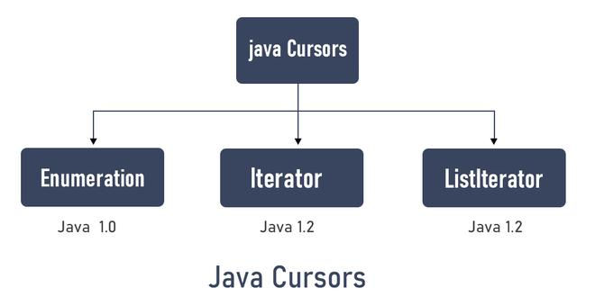

1. Iterator
Iterators in Java are used in the Collection framework to retrieve elements one by one. It is a universal iterator as we can apply it to any Collection object. By using Iterator, we can perform both read and remove operations. It is an improved version of Enumeration with the additional functionality of removing an element.
Syntax:
Iterator itr = c.iterator();
Note: Here “c” is any Collection object. itr is of type Iterator interface and refers to “c”.
Methods of Iterator Interface in Java
Iterator interface defines three methods as listed below:
1. hasNext(): Returns true if the iteration has more elements.
public boolean hasNext();
2. next(): Returns the next element in the iteration. It throws NoSuchElementException if no more element is present.
public Object next();
3. remove(): Removes the next element in the iteration. This method can be called only once per call to next().
public void remove();
Note: remove() method can throw two exceptions namely as follows:
- UnsupportedOperationException : If the remove operation is not supported by this iterator
- IllegalStateException : If the next method has not yet been called, or the remove method has already been called after the last call to the next method.
What is optional class
ans:-
Every Java Programmer is familiar with NullPointerException. It can crash your code. And it is very hard to avoid it without using too many null checks. So, to overcome this, Java 8 has introduced a new class Optional in java.util package. It can help in writing a neat code without using too many null checks. By using Optional, we can specify alternate values to return or alternate code to run. This makes the code more readable because the facts which were hidden are now visible to the developer.
What is functional interface
ans:-An Interface that contains exactly one abstract method is known as functional interface. It can have any number of default, static methods but can contain only one abstract method. It can also declare methods of object class.
Functional Interface is also known as Single Abstract Method Interfaces or SAM Interfaces. It is a new feature in Java, which helps to achieve functional programming approach.
What is reader ?
Ans:-Java Reader is an abstract class for reading character streams. The only methods that a subclass must implement are read(char[], int, int) and close(). Most subclasses, however, will override some of the methods to provide higher efficiency, additional functionality, or both.
Some of the implementation class are BufferedReader, CharArrayReader, FilterReader, InputStreamReader, PipedReader, StringReader
what is BufferedReader class
ans:-Java Reader is an abstract class for reading character streams. The only methods that a subclass must implement are read(char[], int, int) and close(). Most subclasses, however, will override some of the methods to provide higher efficiency, additional functionality, or both.
Some of the implementation class are BufferedReader, CharArrayReader, FilterReader, InputStreamReader, PipedReader, StringReader
what is BufferWriter class
ans:-Java BufferedWriter class is used to provide buffering for Writer instances. It makes the performance fast. It inherits Writer class. The buffering characters are used for providing the efficient writing of single arrays, characters, and strings.

Constructor | Description
BufferedWriter(Writer wrt) | It is used to create a buffered character output stream that uses the default size for an output buffer.
BufferedWriter(Writer wrt, int size) | It is used to create a buffered character output stream that uses the specified size for an output buffer.

Class methods
Method | Description
void newLine() | It is used to add a new line by writing a line separator.
void write(int c) | It is used to write a single character.
void write(char[] cbuf, int off, int len) | It is used to write a portion of an array of characters.
void write(String s, int off, int len) | It is used to write a portion of a string.
void flush() | It is used to flushes the input stream.
void close() | It is used to closes the input stream
What do you mean by Multithreading? Why is it important?
Multithreading means multiple threads and is considered one of the most important features of Java. As the name suggests, it is the ability of a CPU to execute multiple threads independently at the same time but share the process resources simultaneously. Its main purpose is to provide simultaneous execution of multiple threads to utilize the CPU time as much as possible. It is a Java feature where one can subdivide the specific program into two or more threads to make the execution of the program fast and easy.

Multithreading Interview Questions in Java for Freshers

1. What are the benefits of using Multithreading?
There are various benefits of multithreading as given below:
- Allow the program to run continuously even if a part of it is blocked.
- Improve performance as compared to traditional parallel programs that use multiple processes.
- Allows to write effective programs that utilize maximum CPU time
- Improves the responsiveness of complex applications or programs.
- Increase use of CPU resources and reduce costs of maintenance.
- Saves time and parallelism tasks.
- If an exception occurs in a single thread, it will not affect other threads as threads are independent.
- Less resource-intensive than executing multiple processes at the same time.

2. What is Thread in Java?
Threads are basically the lightweight and smallest unit of processing that can be managed independently by a scheduler. Threads are referred to as parts of a process that simply let a program execute efficiently with other parts or threads of the process at the same time. Using threads, one can perform complicated tasks in the easiest way. It is considered the simplest way to take advantage of multiple CPUs available in a machine. They share the common address space and are independent of each other.

3. What are the two ways of implementing thread in Java?
There are basically two ways of implementing thread in java as given below:
- Extending the Thread class
Example:
class MultithreadingDemo extends Thread
{
public void run()
{
System.out.println("My thread is in running state.");
}
public static void main(String args[])
{
MultithreadingDemo obj=new MultithreadingDemo();
obj.start();
}
}
Output:
My thread is in running state.
- Implementing Runnable interface in Java
Example:
class MultithreadingDemo implements Runnable
{
public void run()
{
System.out.println("My thread is in running state.");
}
public static void main(String args[])
{
MultithreadingDemo obj=new MultithreadingDemo();
Threadtobj =new Thread(obj); tobj.start();
}
}

4. What's the difference between thread and process?
Thread: It simply refers to the smallest units of the particular process. It has the ability to execute different parts (referred to as thread) of the program at the same time.
Process: It simply refers to a program that is in execution i.e., an active program. A process can be handled using PCB (Process Control Block).
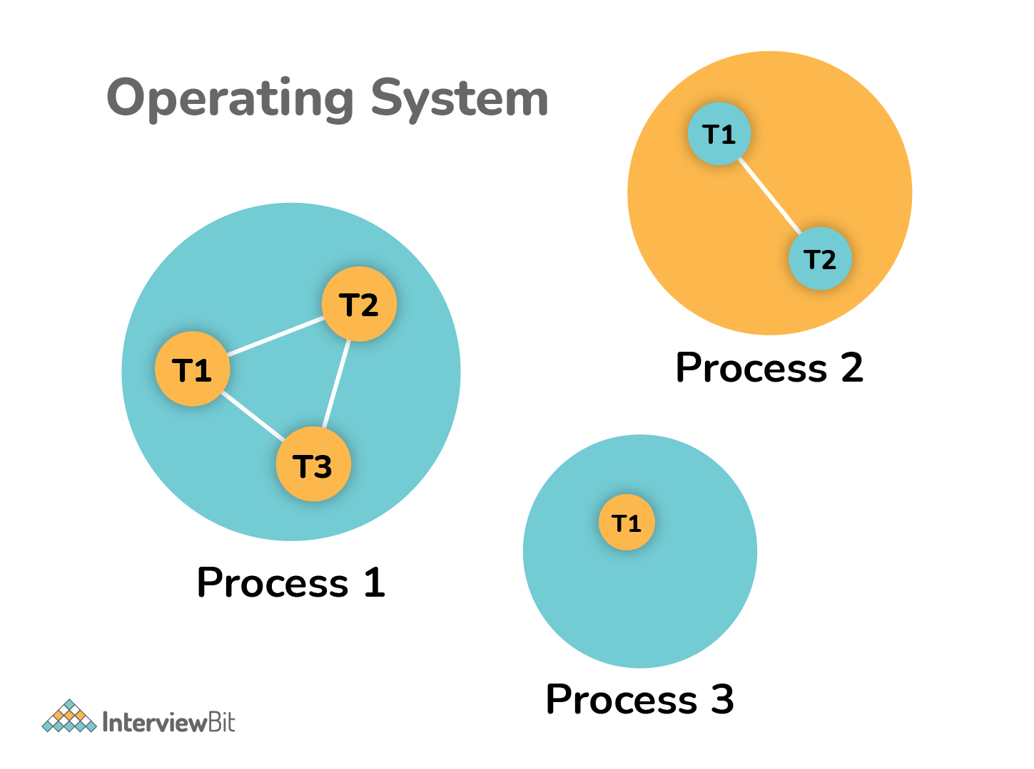
Thread | Process
It is a subset of a subunit of a process. | It is a program in execution containing multiple threads.
In this, inter-thread communication is faster, less expensive, easy and efficient because threads share the same memory address of the process they belong to. | In this, inter-process communication is slower, expensive, and complex because each process has different memory space or address.,
These are easier to create, lightweight, and have less overhead. | These are difficult to create, heavyweight, and have more overhead.
It requires less time for creation, termination, and context switching. | It requires more time for creation, termination, and context switching.
Processes with multiple threads use fewer resources. | Processes without threads use more resources.
Threads are parts of a process, so they are dependent on each other but each thread executes independently. | Processes are independent of each other.
There is a need for synchronization in threads to avoid unexpected scenarios or problems. | There is no need for synchronization in each process.
They share data and information with each other. | They do not share data with each other.

5. What’s the difference between class lock and object lock?
Class Lock: In java, each and every class has a unique lock usually referred to as a class level lock. These locks are achieved using the keyword ‘static synchronized’ and can be used to make static data thread-safe. It is generally used when one wants to prevent multiple threads from entering a synchronized block.
Example:
public class ClassLevelLockExample
{
public void classLevelLockMethod()
{
synchronized (ClassLevelLockExample.class)
{
//DO your stuff here
}
}
}
Object Lock: In java, each and every object has a unique lock usually referred to as an object-level lock. These locks are achieved using the keyword ‘synchronized’ and can be used to protect non-static data. It is generally used when one wants to synchronize a non-static method or block so that only the thread will be able to execute the code block on a given instance of the class.
Example:
public class ObjectLevelLockExample
{
public void objectLevelLockMethod()
{
synchronized (this)
{
//DO your stuff here
}
}
}

6. What's the difference between User thread and Daemon thread?
User and Daemon are basically two types of thread used in Java by using a ‘Thread Class’.
User Thread (Non-Daemon Thread): In Java, user threads have a specific life cycle and its life is independent of any other thread. JVM (Java Virtual Machine) waits for any of the user threads to complete its tasks before terminating it. When user threads are finished, JVM terminates the whole program along with associated daemon threads.
Daemon Thread: In Java, daemon threads are basically referred to as a service provider that provides services and support to user threads. There are basically two methods available in thread class for daemon thread: setDaemon() and isDaemon().
User Thread vs Daemon Thread
User Thread | Daemon Thread
JVM waits for user threads to finish their tasks before termination. | JVM does not wait for daemon threads to finish their tasks before termination.
These threads are normally created by the user for executing tasks concurrently. | These threads are normally created by JVM.
They are used for critical tasks or core work of an application. | They are not used for any critical tasks but to do some supporting tasks.
These threads are referred to as high-priority tasks, therefore are required for running in the foreground. | These threads are referred to as low priority threads, therefore are especially required for supporting background tasks like garbage collection, releasing memory of unused objects, etc.

7. How can we create daemon threads?
We can create daemon threads in java using the thread class setDaemon(true). It is used to mark the current thread as daemon thread or user thread. isDaemon() method is generally used to check whether the current thread is daemon or not. If the thread is a daemon, it will return true otherwise it returns false.
Example:
Program to illustrate the use of setDaemon() and isDaemon() method.
public class DaemonThread extends Thread
{
public DaemonThread(String name){
super(name);
}
public void run()
{
// Checking whether the thread is Daemon or not
if(Thread.currentThread().isDaemon())
{
System.out.println(getName() + " is Daemon thread");
}
else
{
System.out.println(getName() + " is User thread");
}
}
public static void main(String[] args)
{
DaemonThread t1 = new DaemonThread("t1");
DaemonThread t2 = new DaemonThread("t2");
DaemonThread t3 = new DaemonThread("t3");
// Setting user thread t1 to Daemon
t1.setDaemon(true);
// starting first 2 threads
t1.start();
t2.start();
// Setting user thread t3 to Daemon
t3.setDaemon(true);
t3.start();
}
}
But one can only call the setDaemon() method before start() method otherwise it will definitely throw IllegalThreadStateException as shown below:
public class DaemonThread extends Thread
{
public void run()
{
System.out.println("Thread name: " + Thread.currentThread().getName());
System.out.println("Check if its DaemonThread: "
+ Thread.currentThread().isDaemon());
}
public static void main(String[] args)
{
DaemonThread t1 = new DaemonThread();
DaemonThread t2 = new DaemonThread();
t1.start();
// Exception as the thread is already started
t1.setDaemon(true);
t2.start();
}
}
Output:
Thread name: Thread-0
Check if its DaemonThread: false

8. What are the wait() and sleep() methods?
wait(): As the name suggests, it is a non-static method that causes the current thread to wait and go to sleep until some other threads call the notify () or notifyAll() method for the object’s monitor (lock). It simply releases the lock and is mostly used for inter-thread communication. It is defined in the object class, and should only be called from a synchronized context.
Example:
synchronized(monitor)
{
monitor.wait(); Here Lock Is Released by Current Thread
}
sleep(): As the name suggests, it is a static method that pauses or stops the execution of the current thread for some specified period. It doesn’t release the lock while waiting and is mostly used to introduce pause on execution. It is defined in thread class, and no need to call from a synchronized context.
Example:
synchronized(monitor)
{
Thread.sleep(1000); Here Lock Is Held by The Current Thread
//after 1000 milliseconds, the current thread will wake up, or after we call that is interrupt() method
}

9. What’s the difference between notify() and notifyAll()?
notify(): It sends a notification and wakes up only a single thread instead of multiple threads that are waiting on the object’s monitor.
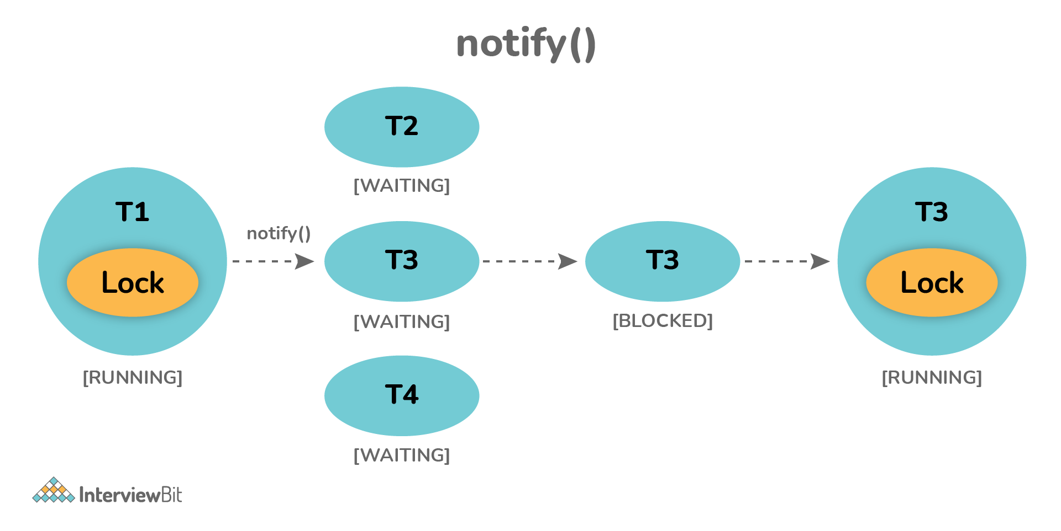
notifyAll(): It sends notifications and wakes up all threads and allows them to compete for the object's monitor instead of a single thread.
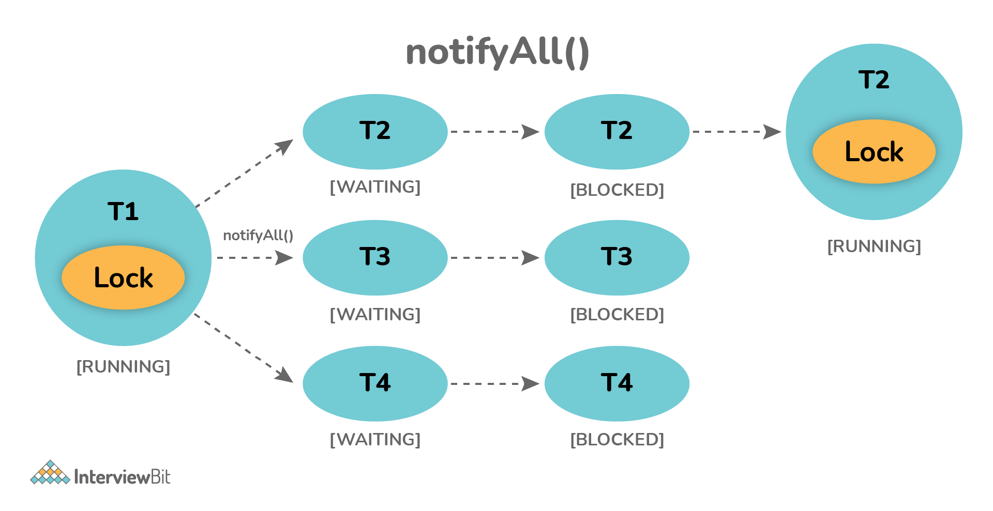

10. Why wait(), notify(), and notifyAll() methods are present in Object class?
We know that every object has a monitor that allows the thread to hold a lock on the object. But the thread class doesn't contain any monitors. Thread usually waits for the object’s monitor (lock) by calling the wait() method on an object, and notify other threads that are waiting for the same lock using notify() or notifyAll() method. Therefore, these three methods are called on objects only and allow all threads to communicate with each that are created on that object.

11. What is Runnable and Callable Interface? Write the difference between them.
Both the interfaces are generally used to encapsulate tasks that are needed to be executed by another thread. But there are some differences between them as given below:
Running Interface: This interface is basically available in Java right from the beginning. It is simply used to execute code on a concurrent thread.
Callable Interface: This interface is basically a new one that was introduced as a part of the concurrency package. It addresses the limitation of runnable interfaces along with some major changes like generics, enum, static imports, variable argument method, etc. It uses generics to define the return type of object.
public interface Runnable
{
public abstract void run();
}
public interface Callable<V>
{
V call() throws Exception;
}
Runnable Interface vs Callable Interface
Runnable Interface | Callable Interface
It does not return any result and therefore, cannot throw a checked exception. | It returns a result and therefore, can throw an exception.
It cannot be passed to invokeAll method. | It can be passed to invokeAll method.
It was introduced in JDK 1.0. | It was introduced in JDK 5.0, so one cannot use it before Java 5.
It simply belongs to Java.lang. | It simply belongs to java.util.concurrent.
It uses the run() method to define a task. | It uses the call() method to define a task.
To use this interface, one needs to override the run() method. | To use this interface, one needs to override the call() method.

12. What is the start() and run() method of Thread class?
start(): In simple words, the start() method is used to start or begin the execution of a newly created thread. When the start() method is called, a new thread is created and this newly created thread executes the task that is kept in the run() method. One can call the start() method only once.
run(): In simple words, the run() method is used to start or begin the execution of the same thread. When the run() method is called, no new thread is created as in the case of the start() method. This method is executed by the current thread. One can call the run() method multiple times.

13. Explain thread pool?
A Thread pool is simply a collection of pre-initialized or worker threads at the start-up that can be used to execute tasks and put back in the pool when completed. It is referred to as pool threads in which a group of fixed-size threads is created. By reducing the number of application threads and managing their lifecycle, one can mitigate the issue of performance using a thread pool. Using threads, performance can be enhanced and better system stability can occur. To create the thread pools, java.util.concurrent.Executors class usually provides factory methods.

14. What’s the purpose of the join() method?
join() method is generally used to pause the execution of a current thread unless and until the specified thread on which join is called is dead or completed. To stop a thread from running until another thread gets ended, this method can be used. It joins the start of a thread execution to the end of another thread’s execution. It is considered the final method of a thread class.

15. What do you mean by garbage collection?
Garbage collection is basically a process of managing memory automatically. It uses several GC algorithms among which the popular one includes Mark and Sweep. The process includes three phases i.e., marking, deletion, and compaction/copying. In simple words, a garbage collector finds objects that are no longer required by the program and then delete or remove these unused objects to free up the memory space.

16. Explain the meaning of the deadlock and when it can occur?
Deadlock, as the name suggests, is a situation where multiple threads are blocked forever. It generally occurs when multiple threads hold locks on different resources and are waiting for other resources to complete their task.
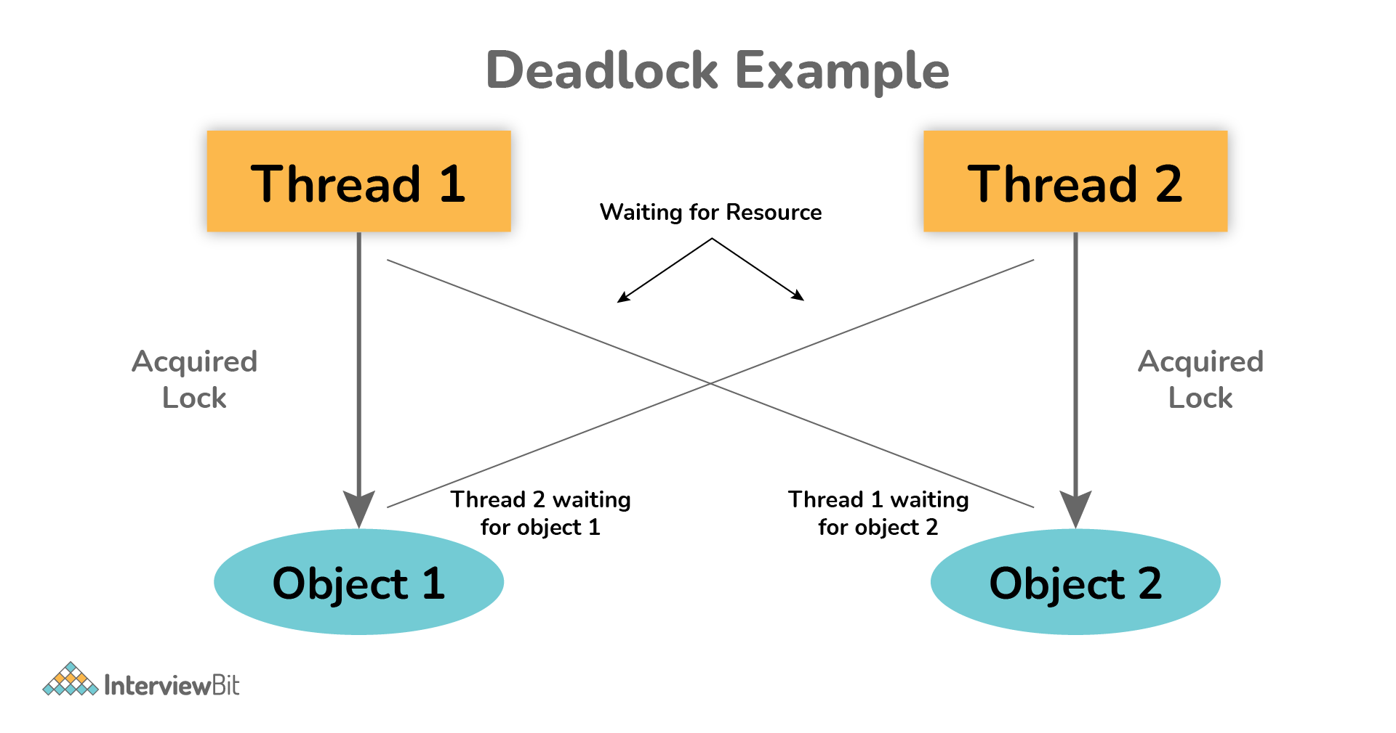
The above diagram shows a deadlock situation where two threads are blocked forever. Thread 1 is holding Object 1 but needs object 2 to complete processing whereas Thread 2 is holding Object 2 but needs object 1 first. In such conditions, both of them will hold lock forever and will never complete tasks.

17. Explain volatile variables in Java?
A volatile variable is basically a keyword that is used to ensure and address the visibility of changes to variables in multithreaded programming. This keyword cannot be used with classes and methods, instead can be used with variables. It is simply used to achieve thread-safety. If you mark any variable as volatile, then all the threads can read its value directly from the main memory rather than CPU cache, so that each thread can get an updated value of the variable.

18. How do threads communicate with each other?
Threads can communicate using three methods i.e., wait(), notify(), and notifyAll().

19. Can two threads execute two methods (static and non-static concurrently)?
Yes, it is possible. If both the threads acquire locks on different objects, then they can execute concurrently without any problem.

20. What is the purpose of the finalize() method?
Finalize() method is basically a method of Object class specially used to perform cleanup operations on unmanaged resources just before garbage collection. It is not at all intended to be called a normal method. After the complete execution of finalize() method, the object gets destroyed automatically.

But one can only call the setDaemon() method before start() method otherwise it will definitely throw IllegalThreadStateException as shown below:
public class DaemonThread extends Thread
{
public void run()
{
System.out.println("Thread name: " + Thread.currentThread().getName());
System.out.println("Check if its DaemonThread: "
+ Thread.currentThread().isDaemon());
}
public static void main(String[] args)
{
DaemonThread t1 = new DaemonThread();
DaemonThread t2 = new DaemonThread();
t1.start();
// Exception as the thread is already started
t1.setDaemon(true);
t2.start();
}
}
Output:
Thread name: Thread-0
Check if its DaemonThread: false

8. What are the wait() and sleep() methods?
wait(): As the name suggests, it is a non-static method that causes the current thread to wait and go to sleep until some other threads call the notify () or notifyAll() method for the object’s monitor (lock). It simply releases the lock and is mostly used for inter-thread communication. It is defined in the object class, and should only be called from a synchronized context.
Example:
synchronized(monitor)
{
monitor.wait(); Here Lock Is Released by Current Thread
}
sleep(): As the name suggests, it is a static method that pauses or stops the execution of the current thread for some specified period. It doesn’t release the lock while waiting and is mostly used to introduce pause on execution. It is defined in thread class, and no need to call from a synchronized context.
Example:
synchronized(monitor)
{
Thread.sleep(1000); Here Lock Is Held by The Current Thread
//after 1000 milliseconds, the current thread will wake up, or after we call that is interrupt() method
}

9. What’s the difference between notify() and notifyAll()?
notify(): It sends a notification and wakes up only a single thread instead of multiple threads that are waiting on the object’s monitor.
notifyAll(): It sends notifications and wakes up all threads and allows them to compete for the object's monitor instead of a single thread.

10. Why wait(), notify(), and notifyAll() methods are present in Object class?
We know that every object has a monitor that allows the thread to hold a lock on the object. But the thread class doesn't contain any monitors. Thread usually waits for the object’s monitor (lock) by calling the wait() method on an object, and notify other threads that are waiting for the same lock using notify() or notifyAll() method. Therefore, these three methods are called on objects only and allow all threads to communicate with each that are created on that object.

11. What is Runnable and Callable Interface? Write the difference between them.
Both the interfaces are generally used to encapsulate tasks that are needed to be executed by another thread. But there are some differences between them as given below:
Running Interface: This interface is basically available in Java right from the beginning. It is simply used to execute code on a concurrent thread.
Callable Interface: This interface is basically a new one that was introduced as a part of the concurrency package. It addresses the limitation of runnable interfaces along with some major changes like generics, enum, static imports, variable argument method, etc. It uses generics to define the return type of object.
public interface Runnable
{
public abstract void run();
}
public interface Callable<V>
{
V call() throws Exception;
}
Runnable Interface vs Callable Interface
Runnable Interface | Callable Interface
It does not return any result and therefore, cannot throw a checked exception. | It returns a result and therefore, can throw an exception.
It cannot be passed to invokeAll method. | It can be passed to invokeAll method.
It was introduced in JDK 1.0. | It was introduced in JDK 5.0, so one cannot use it before Java 5.
It simply belongs to Java.lang. | It simply belongs to java.util.concurrent.
It uses the run() method to define a task. | It uses the call() method to define a task.
To use this interface, one needs to override the run() method. | To use this interface, one needs to override the call() method.

12. What is the start() and run() method of Thread class?
start(): In simple words, the start() method is used to start or begin the execution of a newly created thread. When the start() method is called, a new thread is created and this newly created thread executes the task that is kept in the run() method. One can call the start() method only once.
run(): In simple words, the run() method is used to start or begin the execution of the same thread. When the run() method is called, no new thread is created as in the case of the start() method. This method is executed by the current thread. One can call the run() method multiple times.

13. Explain thread pool?
A Thread pool is simply a collection of pre-initialized or worker threads at the start-up that can be used to execute tasks and put back in the pool when completed. It is referred to as pool threads in which a group of fixed-size threads is created. By reducing the number of application threads and managing their lifecycle, one can mitigate the issue of performance using a thread pool. Using threads, performance can be enhanced and better system stability can occur. To create the thread pools, java.util.concurrent.Executors class usually provides factory methods.

14. What’s the purpose of the join() method?
join() method is generally used to pause the execution of a current thread unless and until the specified thread on which join is called is dead or completed. To stop a thread from running until another thread gets ended, this method can be used. It joins the start of a thread execution to the end of another thread’s execution. It is considered the final method of a thread class.

15. What do you mean by garbage collection?
Garbage collection is basically a process of managing memory automatically. It uses several GC algorithms among which the popular one includes Mark and Sweep. The process includes three phases i.e., marking, deletion, and compaction/copying. In simple words, a garbage collector finds objects that are no longer required by the program and then delete or remove these unused objects to free up the memory space.

16. Explain the meaning of the deadlock and when it can occur?
Deadlock, as the name suggests, is a situation where multiple threads are blocked forever. It generally occurs when multiple threads hold locks on different resources and are waiting for other resources to complete their task.
The above diagram shows a deadlock situation where two threads are blocked forever. Thread 1 is holding Object 1 but needs object 2 to complete processing whereas Thread 2 is holding Object 2 but needs object 1 first. In such conditions, both of them will hold lock forever and will never complete tasks.

17. Explain volatile variables in Java?
A volatile variable is basically a keyword that is used to ensure and address the visibility of changes to variables in multithreaded programming. This keyword cannot be used with classes and methods, instead can be used with variables. It is simply used to achieve thread-safety. If you mark any variable as volatile, then all the threads can read its value directly from the main memory rather than CPU cache, so that each thread can get an updated value of the variable.

18. How do threads communicate with each other?
Threads can communicate using three methods i.e., wait(), notify(), and notifyAll().

19. Can two threads execute two methods (static and non-static concurrently)?
Yes, it is possible. If both the threads acquire locks on different objects, then they can execute concurrently without any problem.

20. What is the purpose of the finalize() method?
Finalize() method is basically a method of Object class specially used to perform cleanup operations on unmanaged resources just before garbage collection. It is not at all intended to be called a normal method. After the complete execution of finalize() method, the object gets destroyed automatically.

Multithreading Interview Questions in Java for Experienced

21. What is the synchronization process? Why use it?
Synchronization is basically a process in java that enables a simple strategy for avoiding thread interference and memory consistency errors. This process makes sure that resource will be only used one thread at a time when one thread tries to access a shared resource. It can be achieved in three different ways as given below:
- By the synchronized method
- By synchronized block
- By static synchronization
Syntax:
synchronized (object)
{
//statement to be synchronized
}

22. What is synchronized method and synchronized block? Which one should be preferred?
Synchronized Method: In this method, the thread acquires a lock on the object when they enter the synchronized method and releases the lock either normally or by throwing an exception when they leave the method. No other thread can use the whole method unless and until the current thread finishes its execution and release the lock. It can be used when one wants to lock on the entire functionality of a particular method.
Synchronized Block: In this method, the thread acquires a lock on the object between parentheses after the synchronized keyword, and releases the lock when they leave the block. No other thread can acquire a lock on the locked object unless and until the synchronized block exists. It can be used when one wants to keep other parts of the programs accessible to other threads.
Synchronized blocks should be preferred more as it boosts the performance of a particular program. It only locks a certain part of the program (critical section) rather than the entire method and therefore leads to less contention.

Multithreading Interview Questions in Java for Experienced

21. What is the synchronization process? Why use it?
Synchronization is basically a process in java that enables a simple strategy for avoiding thread interference and memory consistency errors. This process makes sure that resource will be only used one thread at a time when one thread tries to access a shared resource. It can be achieved in three different ways as given below:
- By the synchronized method
- By synchronized block
- By static synchronization
Syntax:
synchronized (object)
{
//statement to be synchronized
}

22. What is synchronized method and synchronized block? Which one should be preferred?
Synchronized Method: In this method, the thread acquires a lock on the object when they enter the synchronized method and releases the lock either normally or by throwing an exception when they leave the method. No other thread can use the whole method unless and until the current thread finishes its execution and release the lock. It can be used when one wants to lock on the entire functionality of a particular method.
Synchronized Block: In this method, the thread acquires a lock on the object between parentheses after the synchronized keyword, and releases the lock when they leave the block. No other thread can acquire a lock on the locked object unless and until the synchronized block exists. It can be used when one wants to keep other parts of the programs accessible to other threads.
Synchronized blocks should be preferred more as it boosts the performance of a particular program. It only locks a certain part of the program (critical section) rather than the entire method and therefore leads to less contention.

23. What is thr 23. What is thread starvation?
Thread starvation is basically a situation or condition where a thread won’t be able to have regular access to shared resources and therefore is unable to proceed or make progress. This is because other threads have high priority and occupy the resources for too long. This usually happens with low-priority threads that do not get CPU for its execution to carry on.
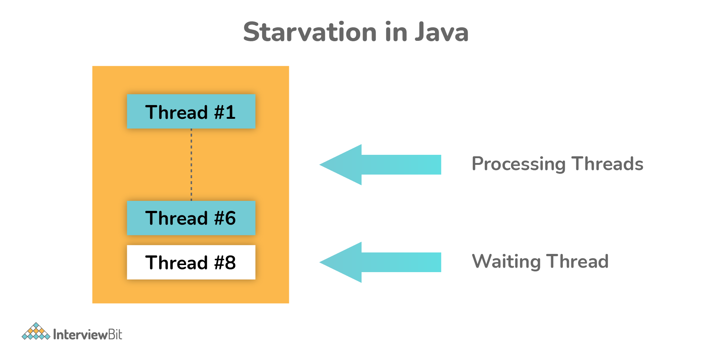

24. What is Livelock? What happens when it occurs?
Similar to deadlock, livelock is also another concurrency problem. In this case, the state of threads changes between one another without making any progress. Threads are not blocked but their execution is stopped due to the unavailability of resources.

25. What is BlockingQueue?
BlockingQueue basically represents a queue that is thread-safe. Producer thread inserts resource/element into the queue using put() method unless it gets full and consumer thread takes resources from the queue using take() method until it gets empty. But if a thread tries to dequeue from an empty queue, then a particular thread will be blocked until some other thread inserts an item into the queue, or if a thread tries to insert an item into a queue that is already full, then a particular thread will be blocked until some threads take away an item from the queue.
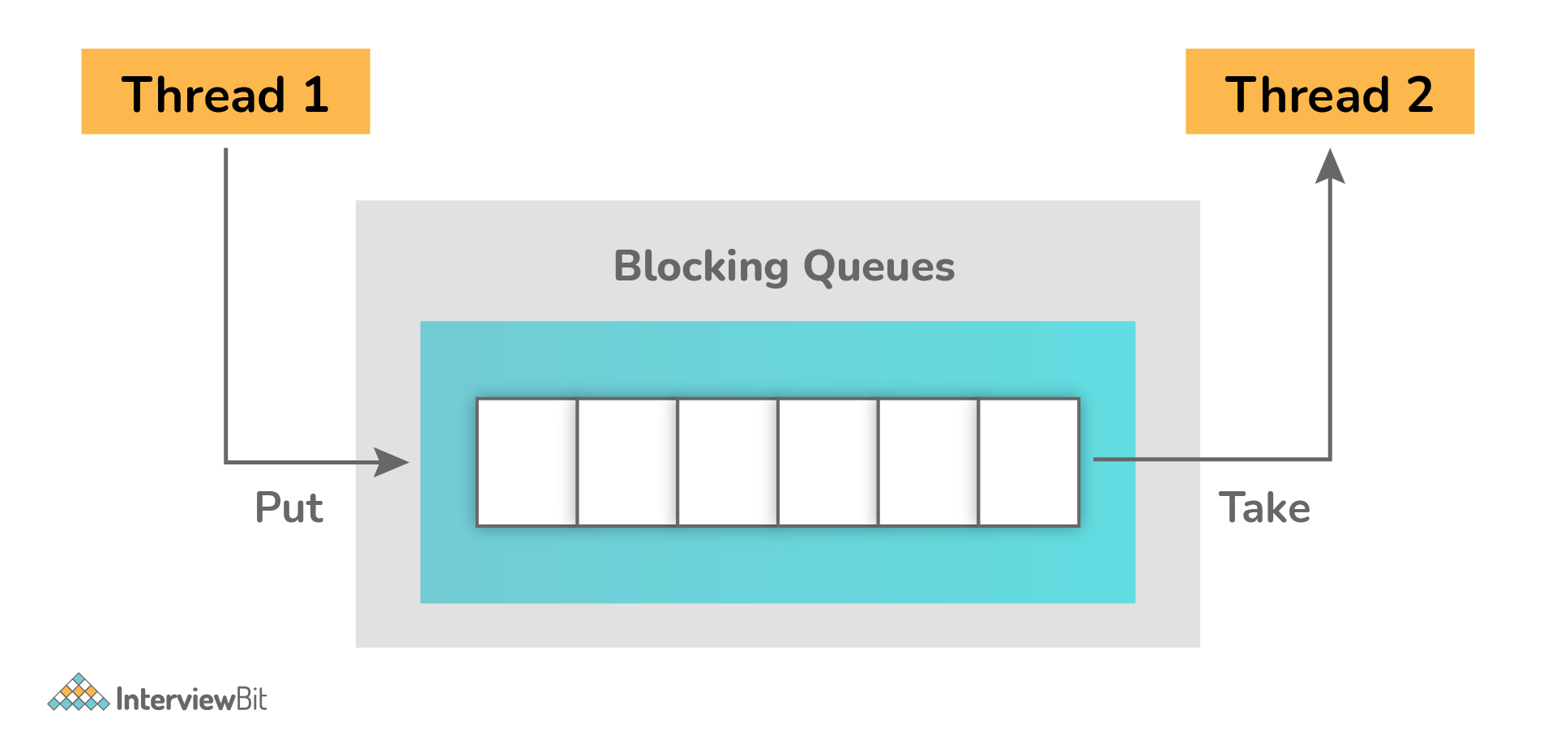
Example:
package org.arpit.java2blog;

import java.util.concurrent.ArrayBlockingQueue;
import java.util.concurrent.BlockingQueue;

public class BlockingQueuePCExample {

public static void main(String[] args) {

BlockingQueue<String> queue=new ArrayBlockingQueue<>(5);
Producer producer=new Producer(queue);
Consumer consumer=new Consumer(queue);
Thread producerThread = new Thread(producer);
Thread consumerThread = new Thread(consumer);

producerThread.start();
consumerThread.start();

}

static class Producer implements Runnable {

BlockingQueue<String> queue=null;

public Producer(BlockingQueue queue) {
super();
this.queue = queue;
}

@Override
public void run() {

try {
System.out.println("Producing element 1");
queue.put("Element 1");
Thread.sleep(1000);
System.out.println("Producing element 2");
queue.put("Element 2");
Thread.sleep(1000);
System.out.println("Producing element 3");
queue.put("Element 3");
} catch (InterruptedException e) {

e.printStackTrace();
}
}
}

static class Consumer implements Runnable {

BlockingQueue<String> queue=null;

public Consumer(BlockingQueue queue) {
super();
this.queue = queue;
}

@Override
public void run() {

while(true)
{
try {
System.out.println("Consumed "+queue.take());
} catch (InterruptedException e) {
e.printStackTrace();
}
}
}

}
}
Output:
Producing element 1
Consumed Element 1
Producing element 2
Consumed Element 2
Producing element 3
Consumed Element 3

26. Can you start a thread twice?
No, it's not at all possible to restart a thread once a thread gets started and completes its execution. Thread only runs once and if you try to run it for a second time, then it will throw a runtime exception i.e., java.lang.IllegalThreadStateException.
Example:
public class TestThreadTwice1 extends Thread{
public void run(){
System.out.println(" thread is executing now........");
}
public static void main(String args[]){
TestThreadTwice1 t1=new TestThreadTwice1();
t1.start();
t1.start();
}
}
Output:
thread is executing now........
Exception in thread "main" java.lang.IllegalThreadStateException

27. Explain context switching.
Context switching is basically an important feature of multithreading. It is referred to as switching of CPU from one thread or process to another one. It allows multiple processes to share the same CPU. In context switching, the state of thread or process is stored so that the execution of the thread can be resumed later if required.

28. What is CyclicBarrier and CountDownLatch?
CyclicBarrier and CountDownLatch, both are required for managing multithreaded programming. But there is some difference between them as given below:
CyclicBarrier: It is a tool to synchronize threads processing using some algorithm. It enables a set of threads to wait for each other till they reach a common execution point or common barrier points, and then let them further continue execution. One can reuse the same CyclicBarrier even if the barrier is broken by setting it.
CountDownLatch: It is a tool that enables main threads to wait until mandatory operations are performed and completed by other threads. In simple words, it makes sure that a thread waits until the execution in another thread completes before it starts its execution. One cannot reuse the same CountDownLatch once the count reaches 0.
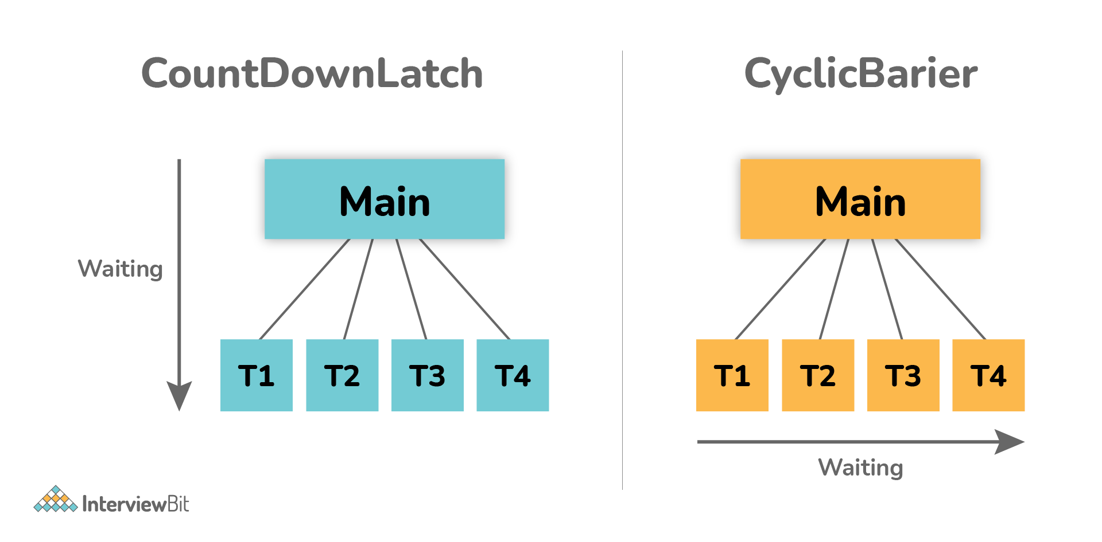

29. What do you mean by inter-thread communication?
Inter-thread communication, as the name suggests, is a process or mechanism using which multiple threads can communicate with each other. It is especially used to avoid thread polling in java and can be obtained using wait(), notify(), and notifyAll() methods.

30. What is Thread Scheduler and Time Slicing?
Thread Scheduler: It is a component of JVM that is used to decide which thread will execute next if multiple threads are waiting to get the chance of execution. By looking at the priority assigned to each thread that is READY, the thread scheduler selects the next run to execute. To schedule the threads, it mainly uses two mechanisms: Preemptive Scheduling and Time slicing scheduling.
Time Slicing: It is especially used to divide CPU time and allocate them to active threads. In this, each thread will get a predefined slice of time to execute. When the time expires, a particular thread has to wait till other threads get their chances to use their time in a round-robin fashion. Every running thread will get executed for a fixed time period.

31. What is a shutdown hook?
A shutdown hook is simply a thread that is invoked implicitly before JVM shuts down. It is one of the most important features of JVM because it provides the capacity to do resource cleanup or save application state JVM shuts down. By calling the halt(int) method of the Runtime class, the shutdown hook can be stopped. Using the following method, one can add a shutdown hook.
public void addShutdownHook(Thread hook){}
Runtime r=Runtime.getRuntime();
r.addShutdownHook(new MyThread());

32. What is busy spinning?
Busy Spinning, also known as Busy-waiting, is a technique in which one thread waits for some condition to happen, without calling wait or sleep methods and releasing the CPU. In this condition, one can pause a thread by making it run an empty loop for a certain time period, and it does not even give CPY control. Therefore, it is used to preserve CPU caches and avoid the cost of rebuilding cache.

33. What is ConcurrentHashMap and Hashtable? In java, why is ConcurrentHashMap considered faster than Hashtable?
ConcurrentHashMap: It was introduced in Java 1.5 to store data using multiple buckets. As the name suggests, it allows concurrent read and writes operations to the map. It only locks a certain portion of the map while doing iteration to provide thread safety so that other readers can still have access to the map without waiting for iteration to complete.
Hashtable: It is a thread-safe legacy class that was introduced in old versions of java to store key or value pairs using a hash table. It does not provide any lock-free read, unlike ConcurrentHashMap. It just locks the entire map while doing iteration.
ConcurrentHashMap and Hashtable, both are thread-safe but ConcurrentHashMap generally avoids read locks and improves performance, unlike Hashtable. ConcurrentHashMap also provides lock-free reads, unlike Hashtable. Therefore, ConcurrentHashMap is considered faster than Hashtable especially when the number of readers is more as compared to the number of writers.

34. Explain thread priority.
Thread priority simply means that threads with the highest priority will get a chance for execution prior to low-priority threads. One can specify the priority but it's not necessary that the highest priority thread will get executed before the lower-priority thread. Thread scheduler assigns processor to thread on the basis of thread priority. The range of priority changes between 1-10 from lowest priority to highest priority.
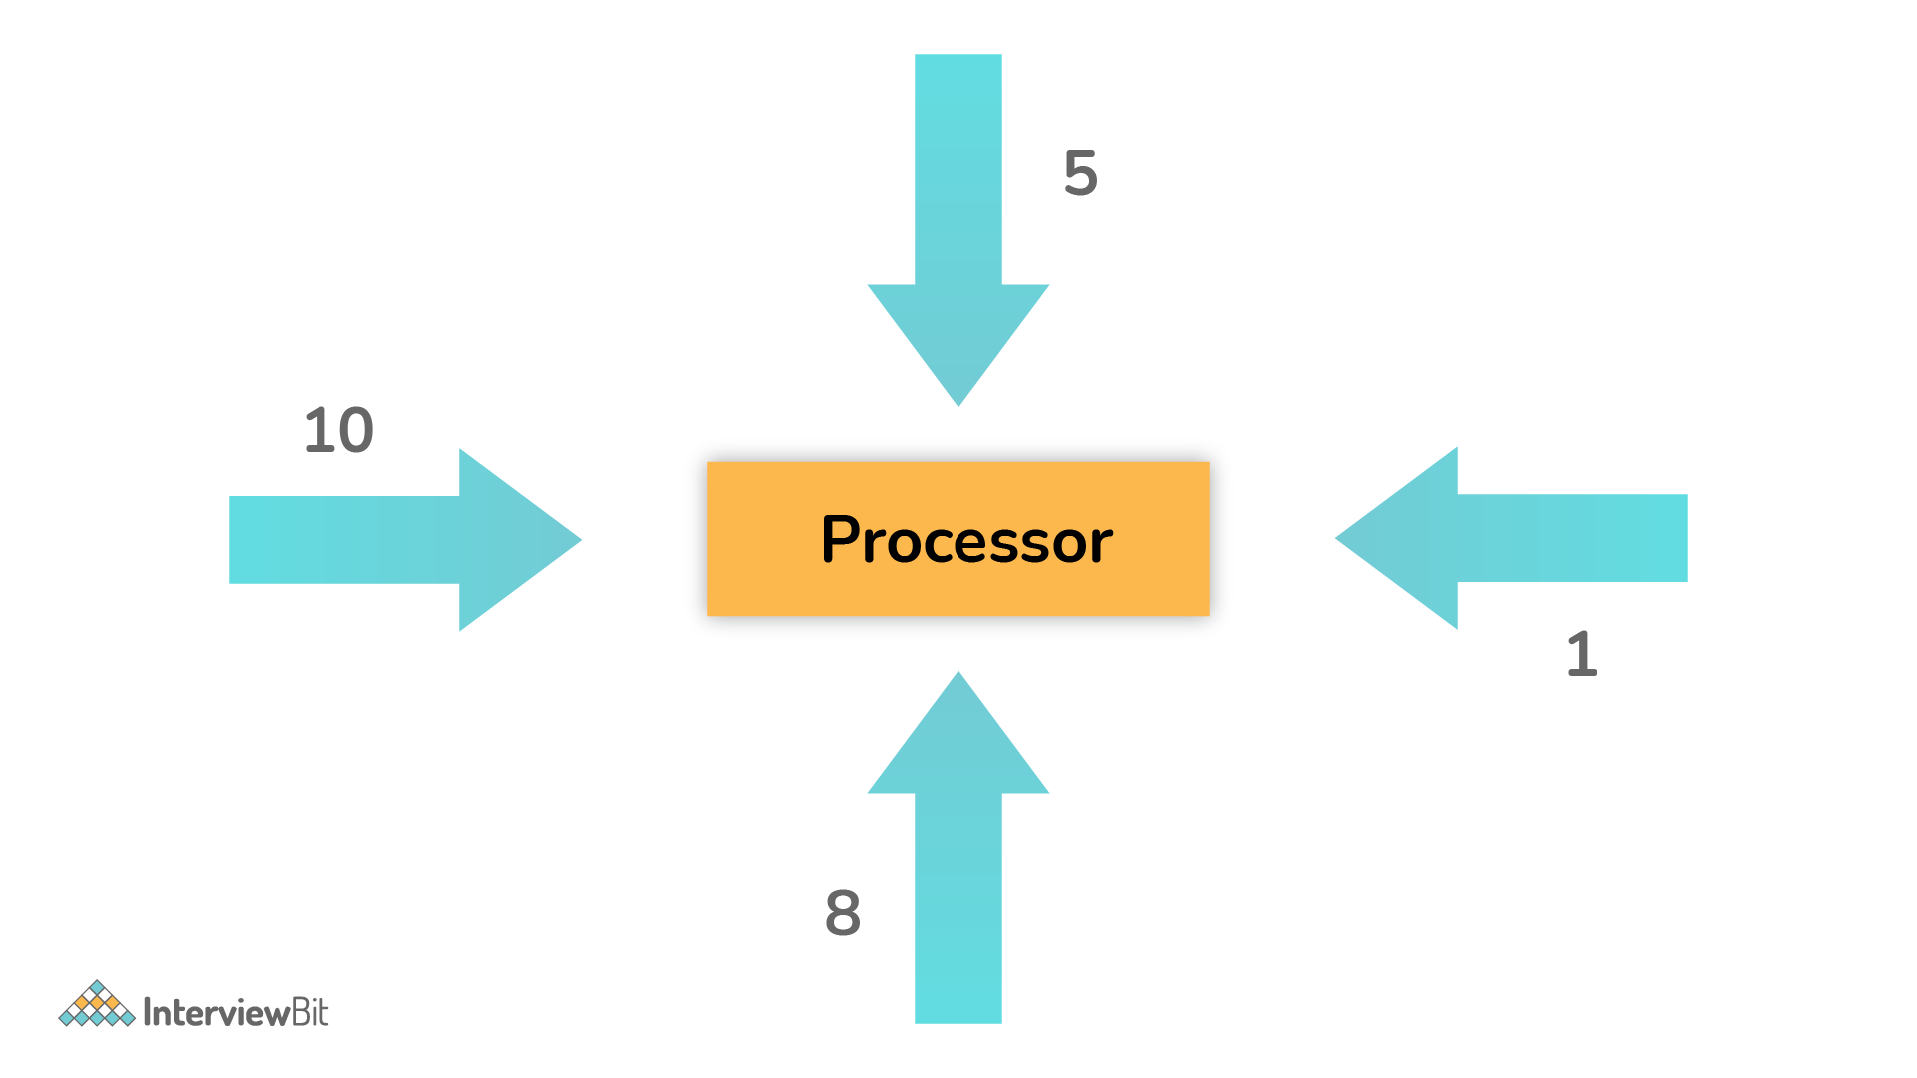

35. What do you mean by the ThreadLocal variable in Java?
ThreadLocal variables are special kinds of variables created and provided by the Java ThreadLocal class. These variables are only allowed to be read and written by the same thread. Two threads cannot be able to see each other’s ThreadLocal variable, so even if they will execute the same code, then there won't be any race condition and the code will be thread-safe.
Example:
public class ThreadLocalExp
{
public static class MyRunnable implements Runnable
{
private ThreadLocal<Integer> threadLocal =
new ThreadLocal<Integer>();
@Override
public void run() {
threadLocal.set( (int) (Math.random() * 50D) );
try
{
Thread.sleep(1000);
} catch (InterruptedException e) {
}
System.out.println(threadLocal.get());
}
}
public static void main(String[] args)
{
MyRunnable runnableInstance = new MyRunnable();
Thread t1 = new Thread(runnableInstance);
Thread t2 = new Thread(runnableInstance);
// this will call run() method
t1.start();
t2.start();
}
}
public void run() { System.out.println("Producing element 2"); this.queue = queue; ead starvation?
threadLocal.set( (int) (Math.random() * 50D) );
try
{
Thread.sleep(1000);
} catch (InterruptedException e) {
}
System.out.println(threadLocal.get());
}
}
public static void main(String[] args)
{
MyRunnable runnableInstance = new MyRunnable();
Thread t1 = new Thread(runnableInstance);
Thread t2 = new Thread(runnableInstance);
// this will call run() method
t1.start();
t2.start();
}
}
queue.put("Element 2");
Thread.sleep(1000);
System.out.println("Producing element 3");
queue.put("Element 3");
} catch (InterruptedException e) {

e.printStackTrace();
}
}
}

static class Consumer implements Runnable {

BlockingQueue<String> queue=null;

public Consumer(BlockingQueue queue) {
super();
this.queue = queue;
}

@Override
public void run() {

while(true)
{
try {
System.out.println("Consumed "+queue.take());
} catch (InterruptedException e) {
e.printStackTrace();
}
}
}

}
}
Output:
Producing element 1
Consumed Element 1
Producing element 2
Consumed Element 2
Producing element 3
Consumed Element 3

26. Can you start a thread twice?
No, it's not at all possible to restart a thread once a thread gets started and completes its execution. Thread only runs once and if you try to run it for a second time, then it will throw a runtime exception i.e., java.lang.IllegalThreadStateException.
Example:
public class TestThreadTwice1 extends Thread{
public void run(){
System.out.println(" thread is executing now........");
}
public static void main(String args[]){
TestThreadTwice1 t1=new TestThreadTwice1();
t1.start();
t1.start();
}
}
Output:
thread is executing now........
Exception in thread "main" java.lang.IllegalThreadStateException

27. Explain context switching.
Context switching is basically an important feature of multithreading. It is referred to as switching of CPU from one thread or process to another one. It allows multiple processes to share the same CPU. In context switching, the state of thread or process is stored so that the execution of the thread can be resumed later if required.

28. What is CyclicBarrier and CountDownLatch?
CyclicBarrier and CountDownLatch, both are required for managing multithreaded programming. But there is some difference between them as given below:
CyclicBarrier: It is a tool to synchronize threads processing using some algorithm. It enables a set of threads to wait for each other till they reach a common execution point or common barrier points, and then let them further continue execution. One can reuse the same CyclicBarrier even if the barrier is broken by setting it.
CountDownLatch: It is a tool that enables main threads to wait until mandatory operations are performed and completed by other threads. In simple words, it makes sure that a thread waits until the execution in another thread completes before it starts its execution. One cannot reuse the same CountDownLatch once the count reaches 0.

29. What do you mean by inter-thread communication?
Inter-thread communication, as the name suggests, is a process or mechanism using which multiple threads can communicate with each other. It is especially used to avoid thread polling in java and can be obtained using wait(), notify(), and notifyAll() methods.

30. What is Thread Scheduler and Time Slicing?
Thread Scheduler: It is a component of JVM that is used to decide which thread will execute next if multiple threads are waiting to get the chance of execution. By looking at the priority assigned to each thread that is READY, the thread scheduler selects the next run to execute. To schedule the threads, it mainly uses two mechanisms: Preemptive Scheduling and Time slicing scheduling.
Time Slicing: It is especially used to divide CPU time and allocate them to active threads. In this, each thread will get a predefined slice of time to execute. When the time expires, a particular thread has to wait till other threads get their chances to use their time in a round-robin fashion. Every running thread will get executed for a fixed time period.

31. What is a shutdown hook?
A shutdown hook is simply a thread that is invoked implicitly before JVM shuts down. It is one of the most important features of JVM because it provides the capacity to do resource cleanup or save application state JVM shuts down. By calling the halt(int) method of the Runtime class, the shutdown hook can be stopped. Using the following method, one can add a shutdown hook.
public void addShutdownHook(Thread hook){}
Runtime r=Runtime.getRuntime();
r.addShutdownHook(new MyThread());

32. What is busy spinning?
Busy Spinning, also known as Busy-waiting, is a technique in which one thread waits for some condition to happen, without calling wait or sleep methods and releasing the CPU. In this condition, one can pause a thread by making it run an empty loop for a certain time period, and it does not even give CPY control. Therefore, it is used to preserve CPU caches and avoid the cost of rebuilding cache.

33. What is ConcurrentHashMap and Hashtable? In java, why is ConcurrentHashMap considered faster than Hashtable?
ConcurrentHashMap: It was introduced in Java 1.5 to store data using multiple buckets. As the name suggests, it allows concurrent read and writes operations to the map. It only locks a certain portion of the map while doing iteration to provide thread safety so that other readers can still have access to the map without waiting for iteration to complete.
Hashtable: It is a thread-safe legacy class that was introduced in old versions of java to store key or value pairs using a hash table. It does not provide any lock-free read, unlike ConcurrentHashMap. It just locks the entire map while doing iteration.
ConcurrentHashMap and Hashtable, both are thread-safe but ConcurrentHashMap generally avoids read locks and improves performance, unlike Hashtable. ConcurrentHashMap also provides lock-free reads, unlike Hashtable. Therefore, ConcurrentHashMap is considered faster than Hashtable especially when the number of readers is more as compared to the number of writers.

34. Explain thread priority.
Thread priority simply means that threads with the highest priority will get a chance for execution prior to low-priority threads. One can specify the priority but it's not necessary that the highest priority thread will get executed before the lower-priority thread. Thread scheduler assigns processor to thread on the basis of thread priority. The range of priority changes between 1-10 from lowest priority to highest priority.

35. What do you mean by the ThreadLocal variable in Java?
ThreadLocal variables are special kinds of variables created and provided by the Java ThreadLocal class. These variables are only allowed to be read and written by the same thread. Two threads cannot be able to see each other’s ThreadLocal variable, so even if they will execute the same code, then there won't be any race condition and the code will be thread-safe.
Example:
public class ThreadLocalExp
{
public static class MyRunnable implements Runnable
{
private ThreadLocal<Integer> threadLocal =
new ThreadLocal<Integer>();
@Override

}

@Override
public void run() {

try {
System.out.println("Producing element 1");
queue.put("Element 1");
Thread.sleep(1000);

Thread starvation is basically a situation or condition where a thread won’t be able to have regular access to shared resources and therefore is unable to proceed or make progress. This is because other threads have high priority and occupy the resources for too long. This usually happens with low-priority threads that do not get CPU for its execution to carry on.

24. What is Livelock? What happens when it occurs?
Similar to deadlock, livelock is also another concurrency problem. In this case, the state of threads changes between one another without making any progress. Threads are not blocked but their execution is stopped due to the unavailability of resources.

25. What is BlockingQueue?
BlockingQueue basically represents a queue that is thread-safe. Producer thread inserts resource/element into the queue using put() method unless it gets full and consumer thread takes resources from the queue using take() method until it gets empty. But if a thread tries to dequeue from an empty queue, then a particular thread will be blocked until some other thread inserts an item into the queue, or if a thread tries to insert an item into a queue that is already full, then a particular thread will be blocked until some threads take away an item from the queue.
Example:
package org.arpit.java2blog;

import java.util.concurrent.ArrayBlockingQueue;
import java.util.concurrent.BlockingQueue;

public class BlockingQueuePCExample {

public static void main(String[] args) {

BlockingQueue<String> queue=new ArrayBlockingQueue<>(5);
Producer producer=new Producer(queue);
Consumer consumer=new Consumer(queue);
Thread producerThread = new Thread(producer);
Thread consumerThread = new Thread(consumer);

producerThread.start();
consumerThread.start();

}

static class Producer implements Runnable {

BlockingQueue<String> queue=null;

public Producer(BlockingQueue queue) {
super();

36. What is semaphore?
Semaphore is regarded as a thread synchronization construct that is usually required to control and manage the access to the shared resource using counters. It simply sets the limit of the thread. The semaphore class is defined within the package java.util.concurrent and can be used to send signals between threads to avoid missed signals or to guard critical sections. It can also be used to implement resource pools or bounded collection.

37. Explain Thread Group. Why should we not use it?
ThreadGroup is a class that is used to create multiple groups of threads in a single object. This group of threads is present in the form of three structures in which every thread group has a parent except the initial thread. Thread groups can contain other thread groups also. A thread is only allowed to have access to information about its own thread group, not other thread groups.
Previously in the old version of Java, the only functionality that did not work without a thread group was uncaughtException( Thread t, Throwable e). But now in Java 5 versions, there is Thread.setUncaughtExceptionHandler(UncaughtExceptionHandler). So now even that works without thread groups and therefore, there is no need to use thread groups.
t1.setUncaughtExceptionHandler(new UncaughtExceptionHandler()
{
@Override
public void uncaughtException(Thread t, Throwable e)
{
System.out.println("exception occured:"+e.getMessage());
}
};

38. What is the ExecutorService interface?
ExecutorService interface is basically a sub-interface of Executor interface with some additional methods or features that help in managing and controlling the execution of threads. It enables us to execute tasks asynchronously on threads.
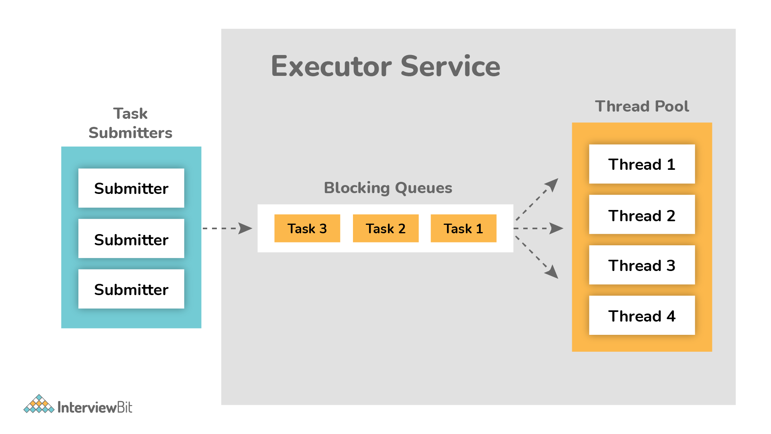
Example:
import java.util.concurrent.ExecutorService;
import java.util.concurrent.Executors;
import java.util.concurrent.TimeUnit;

public class TestThread {
public static void main(final String[] arguments) throws InterruptedException {
ExecutorService e = Executors.newSingleThreadExecutor();

try {
e.submit(new Thread());
System.out.println("Shutdown executor");
e.shutdown();
e.awaitTermination(5, TimeUnit.SECONDS);
} catch (InterruptedException ex) {
System.err.println("tasks interrupted");
} finally {

if (!e.isTerminated()) {
System.err.println("cancel non-finished tasks");
}
e.shutdownNow();
System.out.println("shutdown finished");
}
}

static class Task implements Runnable {

public void run() {

try {
Long duration = (long) (Math.random() * 20);
System.out.println("Running Task!");
TimeUnit.SECONDS.sleep(duration);
} catch (InterruptedException ex) {
ex.printStackTrace();
}
}
}
}
Output:
Shutdown executor
shutdown finished

39. What will happen if we don’t override the thread class run() method?
Nothing will happen as such if we don’t override the run() method. The compiler will not show any error. It will execute the run() method of thread class and we will just don’t get any output because the run() method is with an empty implementation.
Example:
class MyThread extends Thread {
//don't override run() method
}
public class DontOverrideRun {
public static void main(String[] args) {
System.out.println("Started Main.");
MyThread thread1=new MyThread();
thread1.start();
System.out.println("Ended Main.");
}
}
Output:
Started Main.
Ended Main.

40. What is the lock interface? Why is it better to use a lock interface rather than a synchronized block.?
Lock interface was introduced in Java 1.5 and is generally used as a synchronization mechanism to provide important operations for blocking.
Advantages of using Lock interface over Synchronization block:
- Methods of Lock interface i.e., Lock() and Unlock() can be called in different methods. It is the main advantage of a lock interface over a synchronized block because the synchronized block is fully contained in a single method.
- Lock interface is more flexible and makes sure that the longest waiting thread gets a fair chance for execution, unlike the synchronization block.

41. Is it possible to call the run() method directly to start a new thread?
No, it's not possible at all. You need to call the start method to create a new thread otherwise run method won't create a new thread. Instead, it will execute in the current thread.

42. Is it possible that each thread can have its stack in multithreaded programming?
Of course, it is possible. In multithreaded programming, each thread maintains its own separate stack area in memory because of which every thread is independent of each other rather than dependent.

