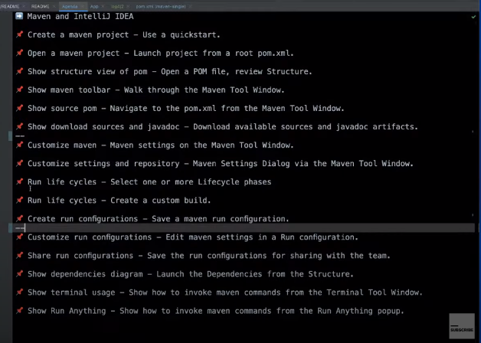
My Frirst task to create a maven project. Go to intellij id and click new project butten.
And click maven archetype butten

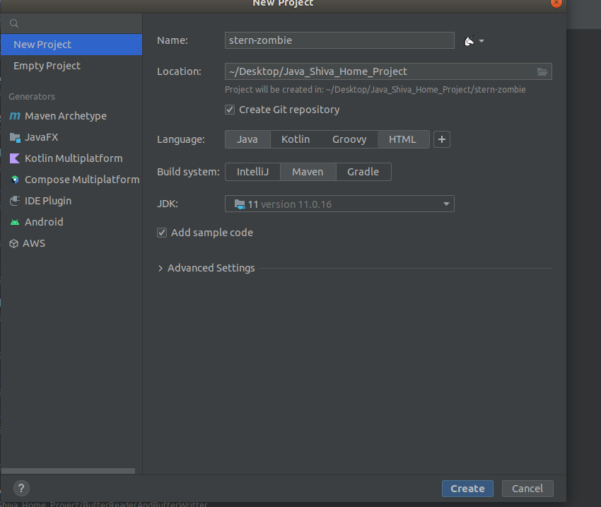

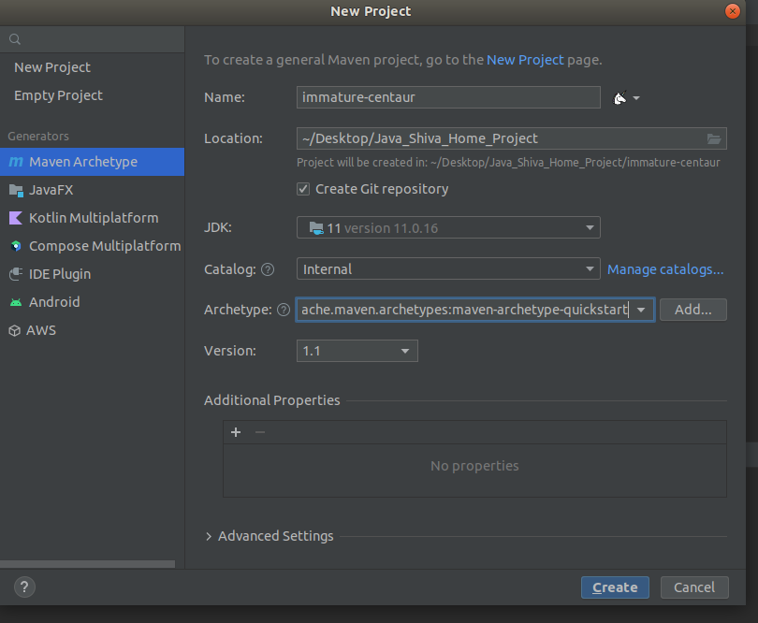
Add maven-archetype-suickstart dependences and version and add jdk version 11 and other or click create butten so your project created successfull

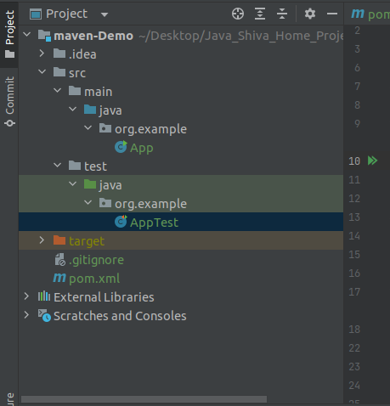
click src ,main,java,org.example folder and click App file so open your App class

and click pom.xml file . You saw your dependences

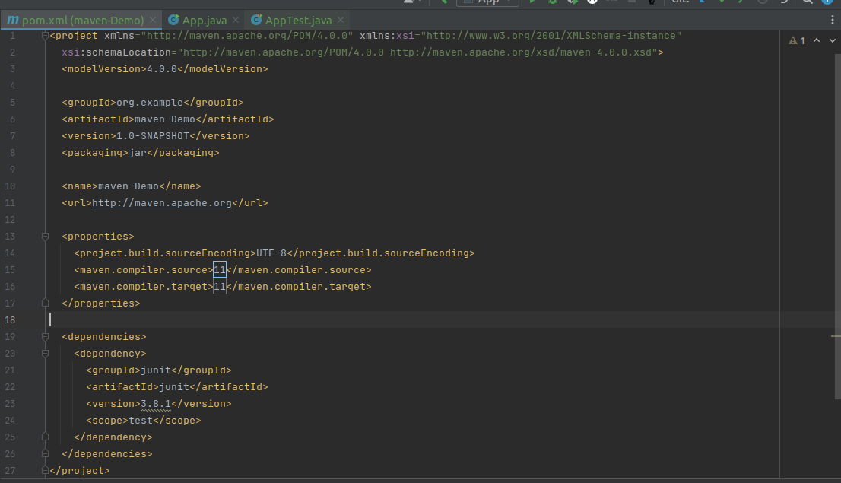
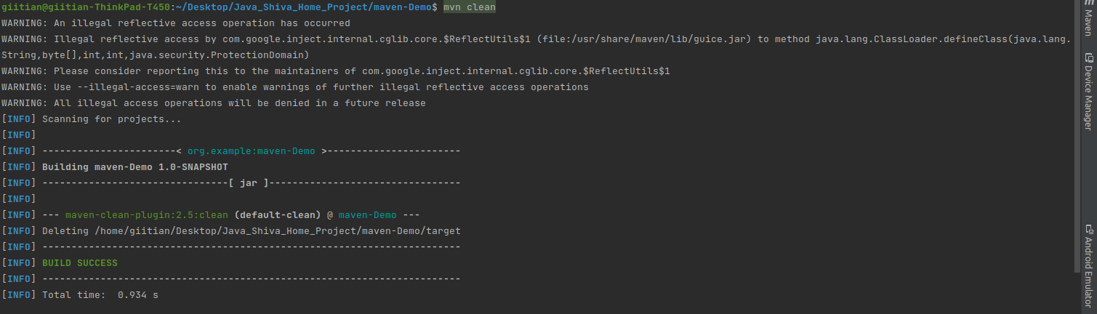
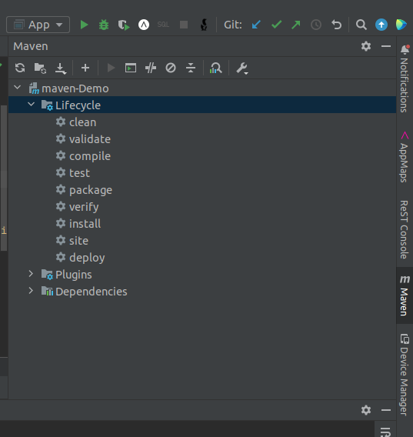
so you click maven and click maven-Demo file so you saw Lifecycle folder youn saw clean,validate,compile ,test,package erc.

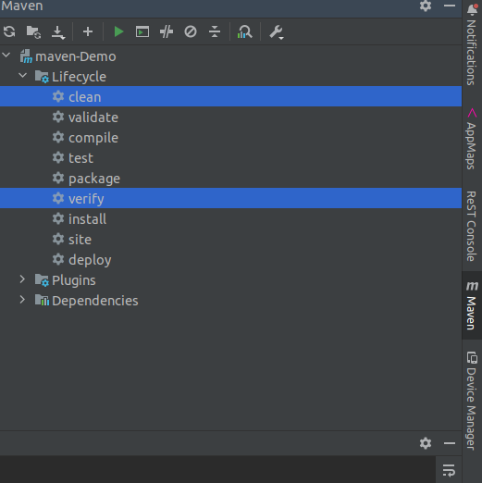
You clicked clean and verify and run

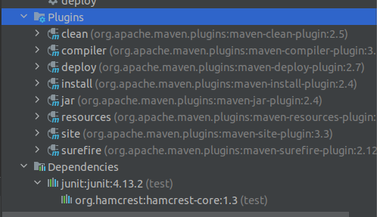
just below you saw plugins folder and so clean plugins ect.
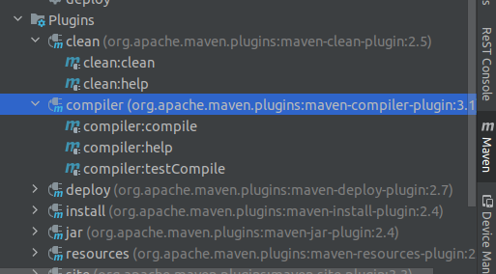
And click compiler plugins and you saw compiler:compile ,help,testCompile.

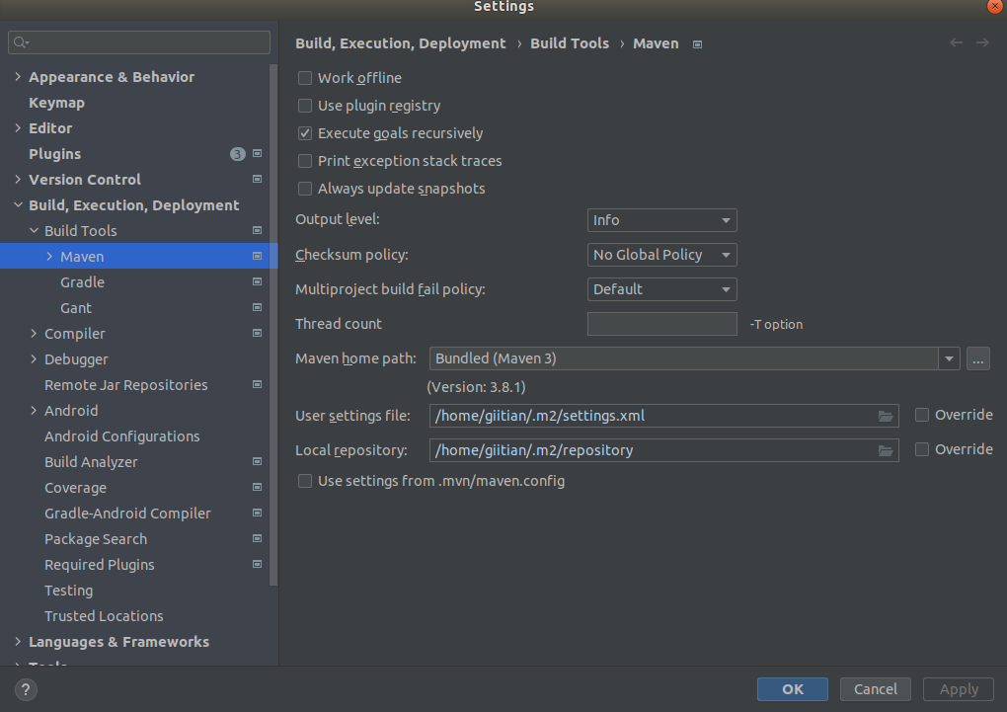
You clicked build tools setting . Open two file Auto reload setting and maven setting . Click maven setting open it

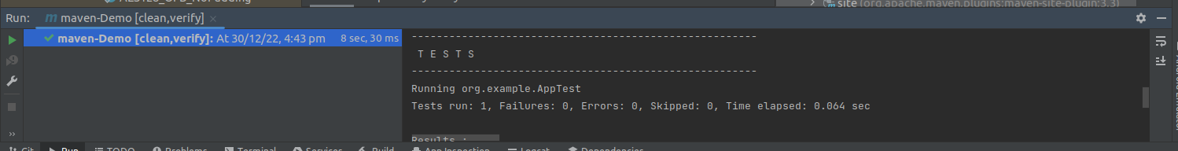
i was run clean and verify .so it build successfully.
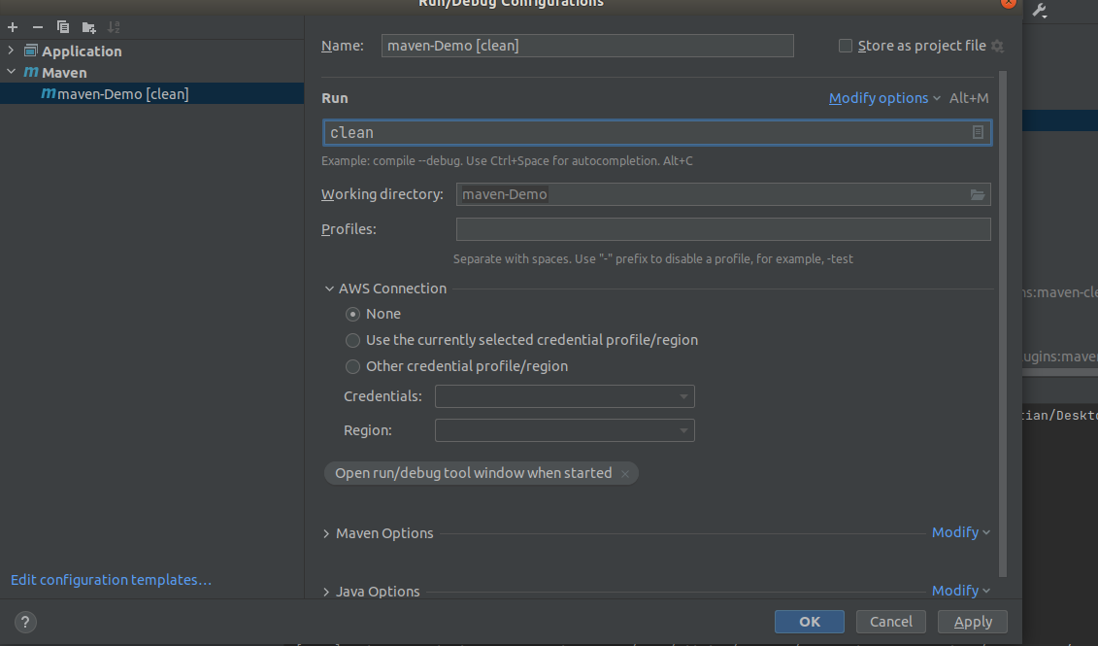
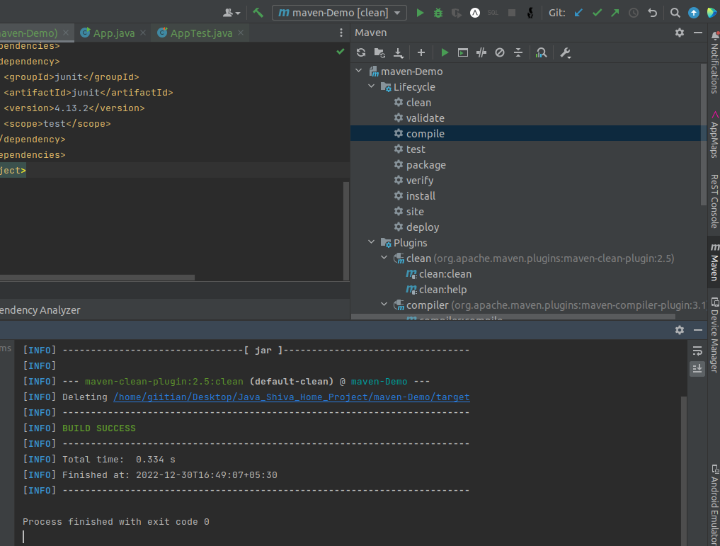
I was click vedio bar butten so run it and build successfully

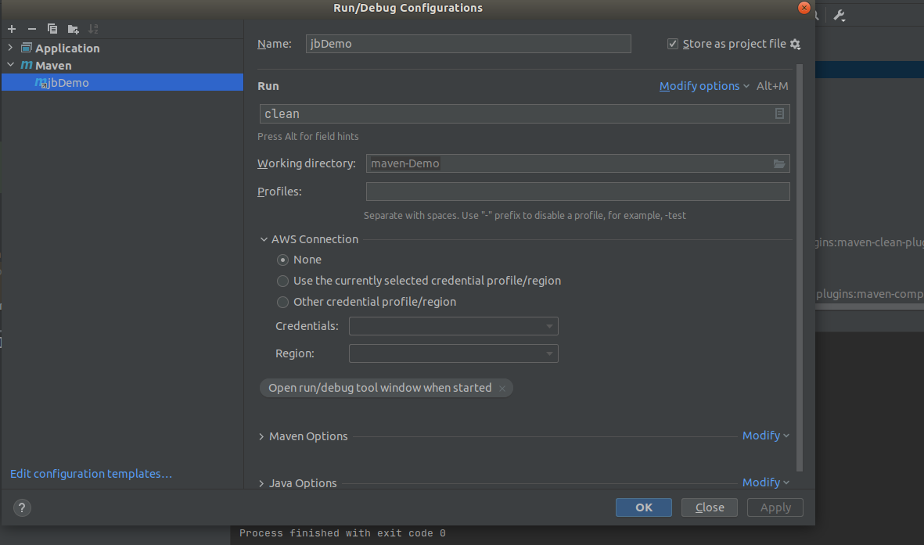
i was click App select run and debug configuration so i clicked Edit configuration show it

