Basic Java Interview Questions for Freshers

Q1. Explain JDK, JRE and JVM?

JDK vs JRE vs JVM
JDK | JRE | JVM
It stands for Java Development Kit. | It stands for Java Runtime Environment. | It stands for Java Virtual Machine.
It is the tool necessary to compile, document and package Java programs. | JRE refers to a runtime environment in which Java bytecode can be executed. | It is an abstract machine. It is a specification that provides a run-time environment in which Java bytecode can be executed.
It contains JRE + development tools. | It’s an implementation of the JVM which physically exists. | JVM follows three notations: Specification, Implementation, and Runtime Instance.

Q2. Explain public static void main(String args[]) in Java.
main() in Java is the entry point for any Java program. It is always written as public static void main(String[] args).
- public: Public is an access modifier, which is used to specify who can access this method. Public means that this Method will be accessible by any Class.
- static: It is a keyword in java which identifies it is class-based. main() is made static in Java so that it can be accessed without creating the instance of a Class. In case, main is not made static then the compiler will throw an error as main() is called by the JVM before any objects are made and only static methods can be directly invoked via the class.
- void: It is the return type of the method. Void defines the method which will not return any value.
- main: It is the name of the method which is searched by JVM as a starting point for an application with a particular signature only. It is the method where the main execution occurs.
- String args[]: It is the parameter passed to the main method.

Q3. Why Java is platform independent?
Java is called platform independent because of its byte codes which can run on any system irrespective of its underlying operating system.

Q4. Why Java is not 100% Object-oriented?
Java is not 100% Object-oriented because it makes use of eight primitive data types such as boolean, byte, char, int, float, double, long, short which are not objects.

Q5. What are wrapper classes in Java?
Wrapper classes convert the Java primitives into the reference types (objects). Every primitive data type has a class dedicated to it. These are known as wrapper classes because they “wrap” the primitive data type into an object of that class. Refer to the below image which displays different primitive type, wrapper class and constructor argument.

Q6. What are constructors in Java?
In Java, constructor refers to a block of code which is used to initialize an object. It must have the same name as that of the class. Also, it has no return type and it is automatically called when an object is created.
There are two types of constructors:
- Default Constructor: In Java, a default constructor is the one which does not take any inputs. In other words, default constructors are the no argument constructors which will be created by default in case you no other constructor is defined by the user. Its main purpose is to initialize the instance variables with the default values. Also, it is majorly used for object creation.
- Parameterized Constructor: The parameterized constructor in Java, is the constructor which is capable of initializing the instance variables with the provided values. In other words, the constructors which take the arguments are called parameterized constructors.

Q7. What is singleton class in Java and how can we make a class singleton?
Singleton class is a class whose only one instance can be created at any given time, in one JVM. A class can be made singleton by making its constructor private.

Q8. What is the difference between Array list and vector in Java?
ArrayList | Vector
Array List is not synchronized. | Vector is synchronized.
Array List is fast as it’s non-synchronized. | Vector is slow as it is thread safe.
If an element is inserted into the Array List, it increases its Array size by 50%. | Vector defaults to doubling size of its array.
Array List does not define the increment size. | Vector defines the increment size.
Array List can only use Iterator for traversing an Array List. | Vector can use both Enumeration and Iterator for traversing.

Q9. What is the difference between equals() and == in Java?
Equals() method is defined in Object class in Java and used for checking equality of two objects defined by business logic.
“==” or equality operator in Java is a binary operator provided by Java programming language and used to compare primitives and objects. public boolean equals(Object o) is the method provided by the Object class. The default implementation uses == operator to compare two objects. For example: method can be overridden like String class. equals() method is used to compare the values of two objects.


Java Certification Training Course
- Instructor-led Sessions
- Real-life Case Studies
- Assignments
- Lifetime Access

Q10. When can you use the super keyword?
In Java, the super keyword is a reference variable that refers to an immediate parent class object.
When you create a subclass instance, you’re also creating an instance of the parent class, which is referenced to by the super reference variable.
The uses of the Java super Keyword are-
- To refer to an immediate parent class instance variable, use super.
- The keyword super can be used to call the method of an immediate parent class.
- Super() can be used to call the constructor of the immediate parent class.

Q11. What makes a HashSet different from a TreeSet?
HashSet | TreeSet
It is implemented through a hash table. | TreeSet implements SortedSet Interface that uses trees for storing data.
It permits the null object. | It does not allow the null object.
It is faster than TreeSet especially for search, insert, and delete operations. | It is slower than HashSet for these operations.
It does not maintain elements in an ordered way. | The elements are maintained in a sorted order.
It uses equals() method to compare two objects. | It uses compareTo() method for comparing two objects.
It does not permit a heterogenous object. | It permits a heterogenous object.

Q12. What are the differences between HashMap and HashTable in Java?

HashMap | Hashtable
It is non synchronized. It cannot be shared between many threads without proper synchronization code. | It is synchronized. It is thread-safe and can be shared with many threads.
It permits one null key and multiple null values. | It does not permit any null key or value.
is a new class introduced in JDK 1.2. | It was present in earlier versions of java as well.
It is faster. | It is slower.
It is traversed through the iterator. | It is traversed through Enumerator and Iterator.
It uses fail fast iterator. | It uses an enumerator which is not fail fast.
It inherits AbstractMap class. | It inherits Dictionary class.

Q13. What is the importance of reflection in Java?
Reflection is a runtime API for inspecting and changing the behavior of methods, classes, and interfaces. Java Reflection is a powerful tool that can be really beneficial. Java Reflection allows you to analyze classes, interfaces, fields, and methods during runtime without knowing what they are called at compile time. Reflection can also be used to create new objects, call methods, and get/set field values. External, user-defined classes can be used by creating instances of extensibility objects with their fully-qualified names. Debuggers can also use reflection to examine private members of classes.
Q14. How to not allow serialization of attributes of a class in Java?
The Non-Serialized attribute can be used to prevent member variables from being serialized.
You should also make an object that potentially contains security-sensitive data non-serializable if possible. Apply the Non-Serialized attribute to certain fields that store sensitive data if the object must be serialized. If you don’t exclude these fields from serialization, the data they store will be visible to any programs with serialization permission.
Q15. Can you call a constructor of a class inside another constructor?
Yes, we can call a constructor of a class inside another constructor. This is also called as constructor chaining. Constructor chaining can be done in 2 ways-
- Within the same class: For constructors in the same class, the this() keyword can be used.
- From the base class: The super() keyword is used to call the constructor from the base class.
The constructor chaining follows the process of inheritance. The constructor of the sub class first calls the constructor of the super class. Due to this, the creation of sub class’s object starts with the initialization of the data members of the super class. The constructor chaining works similarly with any number of classes. Every constructor keeps calling the chain till the top of the chain.

Q16. Contiguous memory locations are usually used for storing actual values in an array but not in ArrayList. Explain.
An array generally contains elements of the primitive data types such as int, float, etc. In such cases, the array directly stores these elements at contiguous memory locations. While an ArrayList does not contain primitive data types. An arrayList contains the reference of the objects at different memory locations instead of the object itself. That is why the objects are not stored at contiguous memory locations.

Q17. How is the creation of a String using new() different from that of a literal?
When we create a string using new(), a new object is created. Whereas, if we create a string using the string literal syntax, it may return an already existing object with the same name.

Q18. Why is synchronization necessary? Explain with the help of a relevant example.
Java allows multiple threads to execute. They may be accessing the same variable or object. Synchronization helps to execute threads one after another.
It is important as it helps to execute all concurrent threads while being in sync. It prevents memory consistency errors due to access to shared memory. An example of synchronization code is-

1  2  3  4 | public synchronized void increment()  {  a++;  }

As we have synchronized this function, this thread can only use the object after the previous thread has used it.
Q19. Explain the term “Double Brace Initialization” in Java?
Double Brace Initialization is a Java term that refers to the combination of two independent processes. There are two braces used in this. The first brace creates an anonymous inner class. The second brace is an initialization block. When these both are used together, it is known as Double Brace Initialization. The inner class has a reference to the enclosing outer class, generally using the ‘this’ pointer. It is used to do both creation and initialization in a single statement. It is generally used to initialize collections. It reduces the code and also makes it more readable.

Q20. Why is it said that the length() method of String class doesn’t return accurate results?
The length() method of String class doesn’t return accurate results because
it simply takes into account the number of characters within in the String. In other words, code points outside of the BMP (Basic Multilingual Plane), that is, code points having a value of U+10000 or above, will be ignored.
The reason for this is historical. One of Java’s original goals was to consider all text as Unicode; yet, Unicode did not define code points outside of the BMP at the time. It was too late to modify char by the time Unicode specified such code points.

Q21. What are the differences between Heap and Stack Memory in Java?
The major difference between Heap and Stack memory are:
Features | Stack | Heap
Memory | Stack memory is used only by one thread of execution. | Heap memory is used by all the parts of the application.
Access | Stack memory can’t be accessed by other threads. | Objects stored in the heap are globally accessible.
Memory Management | Follows LIFO manner to free memory. | Memory management is based on the generation associated with each object.
Lifetime | Exists until the end of execution of the thread. | Heap memory lives from the start till the end of application execution.
Usage | Stack memory only contains local primitive and reference variables to objects in heap space. | Whenever an object is created, it’s always stored in the Heap space.

Q22. What is a package in Java? List down various advantages of packages.
Packages in Java, are the collection of related classes and interfaces which are bundled together. By using packages, developers can easily modularize the code and optimize its reuse. Also, the code within the packages can be imported by other classes and reused. Below I have listed down a few of its advantages:
- Packages help in avoiding name clashes
- They provide easier access control on the code
- Packages can also contain hidden classes which are not visible to the outer classes and only used within the package
- Creates a proper hierarchical structure which makes it easier to locate the related classes

Q23. Why pointers are not used in Java?
Java doesn’t use pointers because they are unsafe and increases the complexity of the program. Since, Java is known for its simplicity of code, adding the concept of pointers will be contradicting. Moreover, since JVM is responsible for implicit memory allocation, thus in order to avoid direct access to memory by the user, pointers are discouraged in Java.

Q24. What is JIT compiler in Java?
JIT stands for Just-In-Time compiler in Java. It is a program that helps in converting the Java bytecode into instructions that are sent directly to the processor. By default, the JIT compiler is enabled in Java and is activated whenever a Java method is invoked. The JIT compiler then compiles the bytecode of the invoked method into native machine code, compiling it “just in time” to execute. Once the method has been compiled, the JVM summons the compiled code of that method directly rather than interpreting it. This is why it is often responsible for the performance optimization of Java applications at the run time.

Q25. What are access modifiers in Java?
In Java, access modifiers are special keywords which are used to restrict the access of a class, constructor, data member and method in another class. Java supports four types of access modifiers:
- Default
- Private
- Protected
- Public
Modifier | Default | Private | Protected | Public
Same class | YES | YES | YES | YES
Same Package subclass | YES | NO | YES | YES
Same Package non-subclass | YES | NO | YES | YES
Different package subclass | NO | NO | YES | YES
Different package non-subclass | NO | NO | NO | YES

Q26. Define a Java Class.
A class in Java is a blueprint which includes all your data. A class contains fields (variables) and methods to describe the behavior of an object. Let’s have a look at the syntax of a class.
1  2  3 | class Abc {  member variables // class body  methods}

Q27. What is an object in Java and how is it created?
An object is a real-world entity that has a state and behavior. An object has three characteristics:
- State
- Behavior
- Identity
An object is created using the ‘new’ keyword. For example:
ClassName obj = new ClassName();

Q28. What is Object Oriented Programming?
Object-oriented programming or popularly known as OOPs is a programming model or approach where the programs are organized around objects rather than logic and functions. In other words, OOP mainly focuses on the objects that are required to be manipulated instead of logic. This approach is ideal for the programs large and complex codes and needs to be actively updated or maintained.

Q29. What are the main concepts of OOPs in Java?
Object-Oriented Programming or OOPs is a programming style that is associated with concepts like:
- Inheritance: Inheritance is a process where one class acquires the properties of another.
- Encapsulation: Encapsulation in Java is a mechanism of wrapping up the data and code together as a single unit.
- Abstraction: Abstraction is the methodology of hiding the implementation details from the user and only providing the functionality to the users.
- Polymorphism: Polymorphism is the ability of a variable, function or object to take multiple forms.

Q30. What is the difference between a local variable and an instance variable?
In Java, a local variable is typically used inside a method, constructor, or a block and has only local scope. Thus, this variable can be used only within the scope of a block. The best benefit of having a local variable is that other methods in the class won’t be even aware of that variable.

Example
1  2  3  4 | if(x > 100)  {  String test = "Edureka";  }

Whereas, an instance variable in Java, is a variable which is bounded to its object itself. These variables are declared within a class, but outside a method. Every object of that class will create it’s own copy of the variable while using it. Thus, any changes made to the variable won’t reflect in any other instances of that class and will be bound to that particular instance only.
1  2  3  4 | class Test{  public String EmpName;  public int empAge;  }

Q31. Differentiate between the constructors and methods in Java?
Methods | Constructors
1. Used to represent the behavior of an object | 1. Used to initialize the state of an object
2. Must have a return type | 2. Do not have any return type
3. Needs to be invoked explicitly | 3. Is invoked implicitly
4. No default method is provided by the compiler | 4. A default constructor is provided by the compiler if the class has none
5. Method name may or may not be same as class name | 5. Constructor name must always be the same as the class name
In case you are facing any challenges with these Core Java interview questions, please comment on your problems in the section below.

Q32. What is final keyword in Java?
final is a special keyword in Java that is used as a non-access modifier. A final variable can be used in different contexts such as:
- final variable
When the final keyword is used with a variable then its value can’t be changed once assigned. In case the no value has been assigned to the final variable then using only the class constructor a value can be assigned to it.


Java Certification Training Course
Weekday / Weekend Batches

final method
When a method is declared final then it can’t be overridden by the inheriting class.

final class
When a class is declared as final in Java, it can’t be extended by any subclass class but it can extend other class.

Q33. What is the difference between break and continue statements?
break | continue
1. Can be used in switch and loop (for, while, do while) statements | 1. Can be only used with loop statements
2. It causes the switch or loop statements to terminate the moment it is executed | 2. It doesn’t terminate the loop but causes the loop to jump to the next iteration
3. It terminates the innermost enclosing loop or switch immediately | 3. A continue within a loop nested with a switch will cause the next loop iteration to execute
Example break:
1  2  3  4  5  6  7  8 | for (int i = 0; i < 5; i++)  {  if (i == 3)  {  break;  }  System.out.println(i);  }

Example continue:
1  2  3  4  5  6  7  8 | for (int i = 0; i < 5; i++)  {  if(i == 2)  {  continue;  }  System.out.println(i);  }

Q34. What is an infinite loop in Java? Explain with an example.
An infinite loop is an instruction sequence in Java that loops endlessly when a functional exit isn’t met. This type of loop can be the result of a programming error or may also be a deliberate action based on the application behavior. An infinite loop will terminate automatically once the application exits.
For example:
1  2  3  4  5  6  7  8 | public class InfiniteForLoopDemo  {  public static void main(String[] arg) {  for(;;)  System.out.println("Welcome to Edureka!");  // To terminate this program press ctrl + c in the console.  }  }

Q35. What is the difference between this() and super() in Java?
In Java, super() and this(), both are special keywords that are used to call the constructor.
this() | super()
1. this() represents the current instance of a class | 1. super() represents the current instance of a parent/base class
2. Used to call the default constructor of the same class | 2. Used to call the default constructor of the parent/base class
3. Used to access methods of the current class | 3. Used to access methods of the base class
4. Used for pointing the current class instance | 4. Used for pointing the superclass instance
5. Must be the first line of a block | 5. Must be the first line of a block

Q36. What is Java String Pool?
Java String pool refers to a collection of Strings which are stored in heap memory. In this, whenever a new object is created, String pool first checks whether the object is already present in the pool or not. If it is present, then the same reference is returned to the variable else new object will be created in the String pool and the respective reference will be returned.
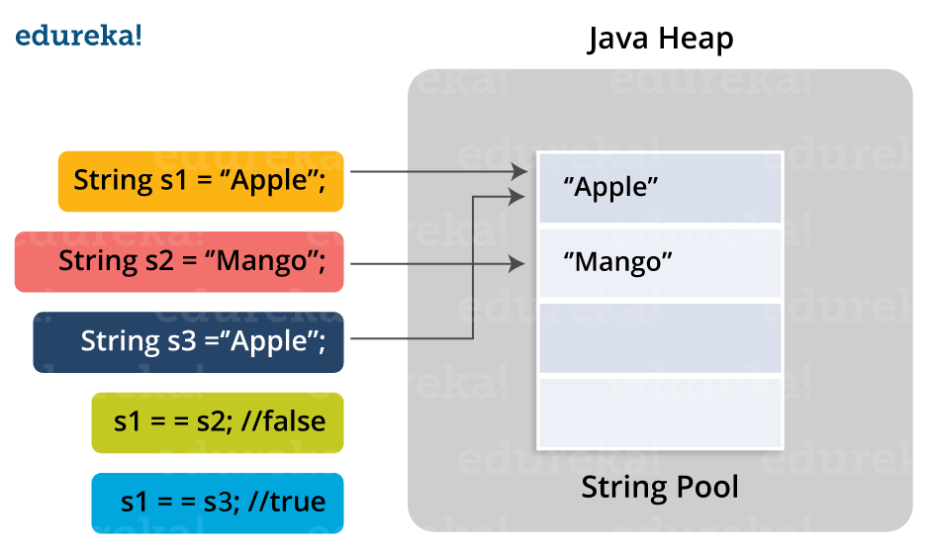

Q37. Differentiate between static and non-static methods in Java.
Static Method | Non-Static Method
1. The static keyword must be used before the method name | 1. No need to use the static keyword before the method name
2. It is called using the class (className.methodName) | 2. It is can be called like any general method
3. They can’t access any non-static instance variables or methods | 3. It can access any static method and any static variable without creating an instance of the class

Q38. Explain the term “Double Brace Initialisation” in Java?
Double Brace Initialization is a Java term that refers to the combination of two independent processes. There are two braces used in this. The first brace creates an anonymous inner class. The second brace is an initialization block. When these both are used together, it is known as Double Brace Initialisation. The inner class has a reference to the enclosing outer class, genertally using the ‘this’ pointer. It is used to do both creation and initialization in a single statement. It is generally used to initialize collections. It reduces the code and also makes it more readable.

Q39. What is constructor chaining in Java?
In Java, constructor chaining is the process of calling one constructor from another with respect to the current object. Constructor chaining is possible only through legacy where a subclass constructor is responsible for invoking the superclass’ constructor first. There could be any number of classes in the constructor chain. Constructor chaining can be achieved in two ways:
- Within the same class using this()
- From base class using super()
Q40. Difference between String, StringBuilder, and StringBuffer.
Factor | String | StringBuilder | StringBuffer
Storage Area | Constant String Pool | Heap Area | Heap Area
Mutability | Immutable | Mutable | Mutable
Thread Safety | Yes | No | Yes
Performance | Fast | More efficient | Less efficient
If you think this article on Java Interview Questions is helpful, you can check out Edureka’s Java Training in Chennai as well.

Q41. What is a classloader in Java?
The Java ClassLoader is a subset of JVM (Java Virtual Machine) that is responsible for loading the class files. Whenever a Java program is executed it is first loaded by the classloader. Java provides three built-in classloaders:
- Bootstrap ClassLoader
- Extension ClassLoader
- System/Application ClassLoader

Q42. Why Java Strings are immutable in nature?
In Java, string objects are immutable in nature which simply means once the String object is created its state cannot be modified. Whenever you try to update the value of that object instead of updating the values of that particular object, Java creates a new string object. Java String objects are immutable as String objects are generally cached in the String pool. Since String literals are usually shared between multiple clients, action from one client might affect the rest. It enhances security, caching, synchronization, and performance of the application.

Q43. What is the difference between an array and an array list?
Array | ArrayList
Cannot contain values of different data types | Can contain values of different data types.
Size must be defined at the time of declaration | Size can be dynamically changed
Need to specify the index in order to add data | No need to specify the index
Arrays are not type parameterized | Arraylists are type
Arrays can contain primitive data types as well as objects | Arraylists can contain only objects, no primitive data types are allowed

Q44. What is a Map in Java?
In Java, Map is an interface of Util package which maps unique keys to values. The Map interface is not a subset of the main Collection interface and thus it behaves little different from the other collection types. Below are a few of the characteristics of Map interface:
- Map doesn’t contain duplicate keys.
- Each key can map at max one value.

Q45. What is collection class in Java? List down its methods and interfaces.
In Java, the collection is a framework that acts as an architecture for storing and manipulating a group of objects. Using Collections you can perform various tasks like searching, sorting, insertion, manipulation, deletion, etc. Java collection framework includes the following:
- Interfaces
- Classes
- Methods
The below image shows the complete hierarchy of the Java Collection.
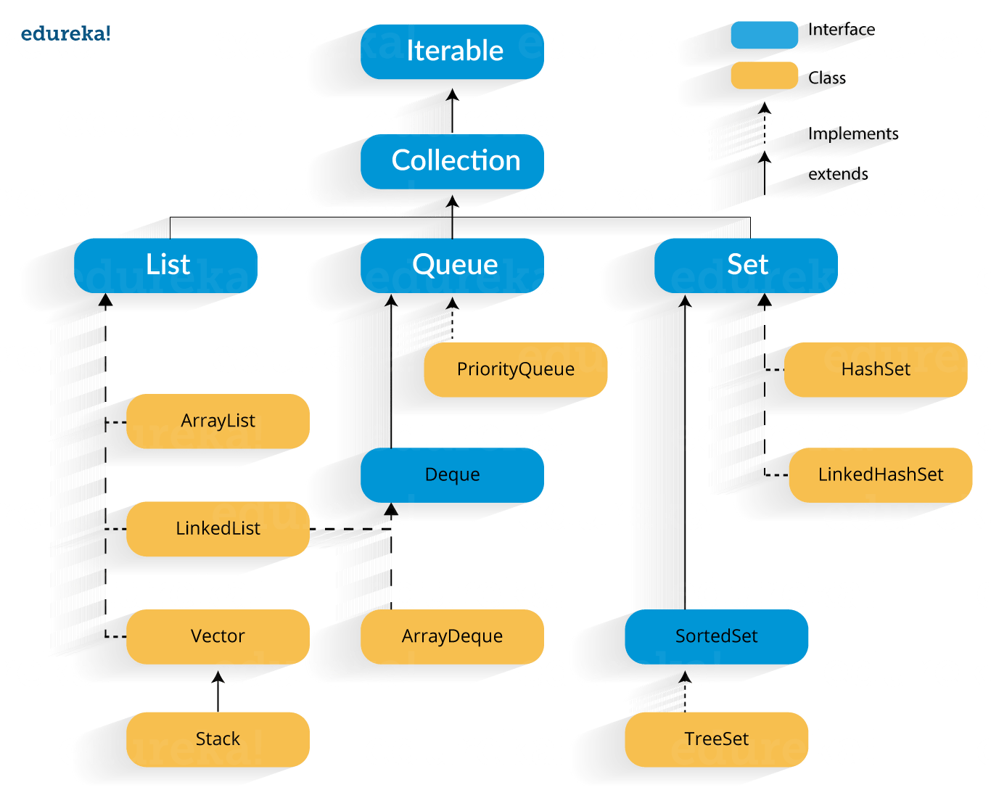

Want to upskill yourself to get ahead in Career? Check out this video
Core Java Interview Quesions And Answers for Freshers and Experienced
This 120+ core java interview question and answer will help freshers and experience to crack the interview in 1st attempt.


OOPS Java Interview Questions

Q1. What is Polymorphism?
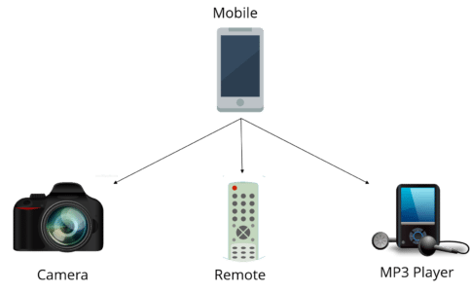
Polymorphism is briefly described as “one interface, many implementations”. Polymorphism is a characteristic of being able to assign a different meaning or usage to something in different contexts – specifically, to allow an entity such as a variable, a function, or an object to have more than one form. There are two types of polymorphism:
- Compile time polymorphism
- Run time polymorphism
Compile time polymorphism is method overloading whereas Runtime time polymorphism is done using inheritance and interface.

Q2. What is runtime polymorphism or dynamic method dispatch?
In Java, runtime polymorphism or dynamic method dispatch is a process in which a call to an overridden method is resolved at runtime rather than at compile-time. In this process, an overridden method is called through the reference variable of a superclass. Let’s take a look at the example below to understand it better.
1  2  3  4  5  6  7  8  9  10  11  12  13  14  15  16  17 | class Car {  void run()  {  System.out.println(&ldquo;car is running&rdquo;);  }  }  class Audi extends Car {  void run()  {  System.out.prinltn(&ldquo;Audi is running safely with 100km&rdquo;);  }  public static void main(String args[])  {  Car b= new Audi(); //upcasting  b.run();  }  }

Q3. What is abstraction in Java?
Abstraction refers to the quality of dealing with ideas rather than events. It basically deals with hiding the details and showing the essential things to the user. Thus you can say that abstraction in Java is the process of hiding the implementation details from the user and revealing only the functionality to them. Abstraction can be achieved in two ways:
- Abstract Classes (0-100% of abstraction can be achieved)
- Interfaces (100% of abstraction can be achieved)

Q4. What do you mean by an interface in Java?
An interface in Java is a blueprint of a class or you can say it is a collection of abstract methods and static constants. In an interface, each method is public and abstract but it does not contain any constructor. Thus, interface basically is a group of related methods with empty bodies. Example:
public interface Animal {
public void eat();
public void sleep();
public void run();
}

Q5. What is the difference between abstract classes and interfaces?
Abstract Class | Interfaces
An abstract class can provide complete, default code and/or just the details that have to be overridden | An interface cannot provide any code at all, just the signature
In the case of an abstract class, a class may extend only one abstract class | A Class may implement several interfaces
An abstract class can have non-abstract methods | All methods of an Interface are abstract
An abstract class can have instance variables | An Interface cannot have instance variables
An abstract class can have any visibility: public, private, protected | An Interface visibility must be public (or) none
If we add a new method to an abstract class then we have the option of providing default implementation and therefore all the existing code might work properly | If we add a new method to an Interface then we have to track down all the implementations of the interface and define implementation for the new method
An abstract class can contain constructors | An Interface cannot contain constructors
Abstract classes are fast | Interfaces are slow as it requires extra indirection to find the corresponding method in the actual class
Q6. What is inheritance in Java?
Inheritance in Java is the concept where the properties of one class can be inherited by the other. It helps to reuse the code and establish a relationship between different classes. Inheritance is performed between two types of classes:
- Parent class (Super or Base class)
- Child class (Subclass or Derived class)
A class which inherits the properties is known as Child Class whereas a class whose properties are inherited is known as Parent class.

Q7. What are the different types of inheritance in Java?
Java supports four types of inheritance which are:
- Single Inheritance: In single inheritance, one class inherits the properties of another i.e there will be only one parent as well as one child class.
- Multilevel Inheritance: When a class is derived from a class which is also derived from another class, i.e. a class having more than one parent class but at different levels, such type of inheritance is called Multilevel Inheritance.
- Hierarchical Inheritance: When a class has more than one child classes (subclasses) or in other words, more than one child classes have the same parent class, then such kind of inheritance is known as hierarchical.
- Hybrid Inheritance: Hybrid inheritance is a combination of two or more types of inheritance.

Q8. What is method overloading and method overriding?

Method Overloading :
- In Method Overloading, Methods of the same class shares the same name but each method must have a different number of parameters or parameters having different types and order.
- Method Overloading is to “add” or “extend” more to the method’s behavior.
- It is a compile-time polymorphism.
- The methods must have a different signature.
- It may or may not need inheritance in Method Overloading.
Let’s take a look at the example below to understand it better.
1  2  3  4  5  6  7  8  9  10  11  12  13  14 | class Adder {  Static int add(int a, int b)  {  return a+b;  }  Static double add( double a, double b)  {  return a+b;  }  public static void main(String args[])  {  System.out.println(Adder.add(11,11));  System.out.println(Adder.add(12.3,12.6));  }}

Method Overriding:
- In Method Overriding, the subclass has the same method with the same name and exactly the same number and type of parameters and same return type as a superclass.
- Method Overriding is to “Change” existing behavior of the method.
- It is a run time polymorphism.
- The methods must have the same signature.
- It always requires inheritance in Method Overriding.
Let’s take a look at the example below to understand it better.
1  2  3  4  5  6  7  8  9  10  11  12  13  14  15 | class Car {  void run(){  System.out.println(&ldquo;car is running&rdquo;);  }  Class Audi extends Car{  void run()  {  System.out.prinltn("Audi is running safely with 100km");  }  public static void main( String args[])  {  Car b=new Audi();  b.run();  }  }

Q9. Can you override a private or static method in Java?
You cannot override a private or static method in Java. If you create a similar method with the same return type and same method arguments in child class then it will hide the superclass method; this is known as method hiding. Similarly, you cannot override a private method in subclass because it’s not accessible there. What you can do is create another private method with the same name in the child class. Let’s take a look at the example below to understand it better.
1  2  3  4  5  6  7  8  9  10  11  12  13  14  15  16  17  18  19  20  21  22 | class Base {  private static void display() {  System.out.println("Static or class method from Base");  }  public void print() {  System.out.println("Non-static or instance method from Base");  }  class Derived extends Base {  private static void display() {  System.out.println("Static or class method from Derived");  }  public void print() {  System.out.println("Non-static or instance method from Derived");  }  public class test {  public static void main(String args[])  {  Base obj= new Derived();  obj1.display();  obj1.print();  }  }

Q10. What is multiple inheritance? Is it supported by Java?
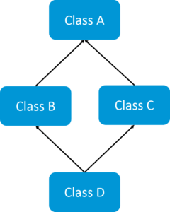
If a child class inherits the property from multiple classes is known as multiple inheritance. Java does not allow to extend multiple classes.
The problem with multiple inheritance is that if multiple parent classes have the same method name, then at runtime it becomes difficult for the compiler to decide which method to execute from the child class.
Therefore, Java doesn’t support multiple inheritance. The problem is commonly referred to as Diamond Problem.
In case you are facing any challenges with these java interview questions, please comment on your problems in the section below.

Q11. What is encapsulation in Java?
Encapsulation is a mechanism where you bind your data(variables) and code(methods) together as a single unit. Here, the data is hidden from the outer world and can be accessed only via current class methods. This helps in protecting the data from any unnecessary modification. We can achieve encapsulation in Java by:
- Declaring the variables of a class as private.
- Providing public setter and getter methods to modify and view the values of the variables.

Q12. What is an association?
Association is a relationship where all object have their own lifecycle and there is no owner. Let’s take the example of Teacher and Student. Multiple students can associate with a single teacher and a single student can associate with multiple teachers but there is no ownership between the objects and both have their own lifecycle. These relationships can be one to one, one to many, many to one and many to many.

Q13. What do you mean by aggregation?
An aggregation is a specialized form of Association where all object has their own lifecycle but there is ownership and child object can not belong to another parent object. Let’s take an example of Department and teacher. A single teacher can not belong to multiple departments, but if we delete the department teacher object will not destroy.

Q14. What is composition in Java?
Composition is again a specialized form of Aggregation and we can call this as a “death” relationship. It is a strong type of Aggregation. Child object does not have their lifecycle and if parent object deletes all child object will also be deleted. Let’s take again an example of a relationship between House and rooms. House can contain multiple rooms there is no independent life of room and any room can not belongs to two different houses if we delete the house room will automatically delete.
Q15. What is a marker interface?
A Marker interface can be defined as the interface having no data member and member functions. In simpler terms, an empty interface is called the Marker interface. The most common examples of Marker interface in Java are Serializable, Cloneable etc. The marker interface can be declared as follows.
1  2 | public interface Serializable{  }

Q16. What is object cloning in Java?
Object cloning in Java is the process of creating an exact copy of an object. It basically means the ability to create an object with a similar state as the original object. To achieve this, Java provides a method clone() to make use of this functionality. This method creates a new instance of the class of the current object and then initializes all its fields with the exact same contents of corresponding fields. To object clone(), the marker interface java.lang.Cloneable must be implemented to avoid any runtime exceptions. One thing you must note is Object clone() is a protected method, thus you need to override it.

Q17. What is a copy constructor in Java?
Copy constructor is a member function that is used to initialize an object using another object of the same class. Though there is no need for copy constructor in Java since all objects are passed by reference. Moreover, Java does not even support automatic pass-by-value.

Q18. What is a constructor overloading in Java?
In Java, constructor overloading is a technique of adding any number of constructors to a class each having a different parameter list. The compiler uses the number of parameters and their types in the list to differentiate the overloaded constructors.
1  2  3  4  5  6  7  8  9  10  11  12 | class Demo  {  int i;  public Demo(int a)  {  i=k;  }  public Demo(int a, int b)  {  //body  }  }

In case you are facing any challenges with these java interview questions, please comment on your problems in the section below. Apart from this Java Interview Questions Blog, if you want to get trained from professionals on this technology, you can opt for a structured training from edureka!

Servlets – Java Interview Questions

Q1. What is a servlet?
- Java Servlet is server-side technologies to extend the capability of web servers by providing support for dynamic response and data persistence.
- The javax.servlet and javax.servlet.http packages provide interfaces and classes for writing our own servlets.
- All servlets must implement the javax.servlet.Servlet interface, which defines servlet lifecycle methods. When implementing a generic service, we can extend the GenericServlet class provided with the Java Servlet API. The HttpServlet class provides methods, such as doGet() and doPost(), for handling HTTP-specific services.
- Most of the times, web applications are accessed using HTTP protocol and thats why we mostly extend HttpServlet class. Servlet API hierarchy is shown in below image.
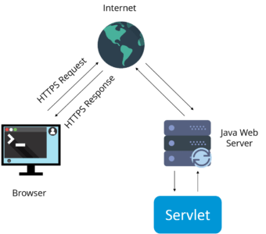

Q2. What are the differences between Get and Post methods?
Get | Post
Limited amount of data can be sent because data is sent in header. | Large amount of data can be sent because data is sent in body.
Not Secured because data is exposed in URL bar. | Secured because data is not exposed in URL bar.
Can be bookmarked | Cannot be bookmarked
Idempotent | Non-Idempotent
It is more efficient and used than Post | It is less efficient and used

Q3. What is Request Dispatcher?
RequestDispatcher interface is used to forward the request to another resource that can be HTML, JSP or another servlet in same application. We can also use this to include the content of another resource to the response.
There are two methods defined in this interface:
1.void forward()
2.void include()

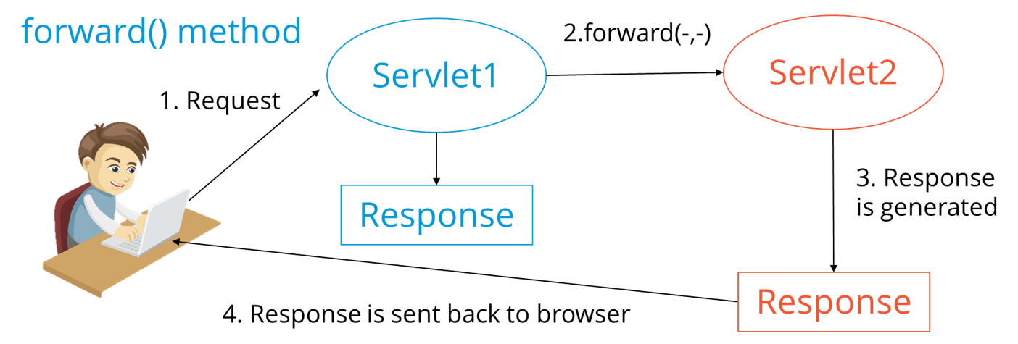

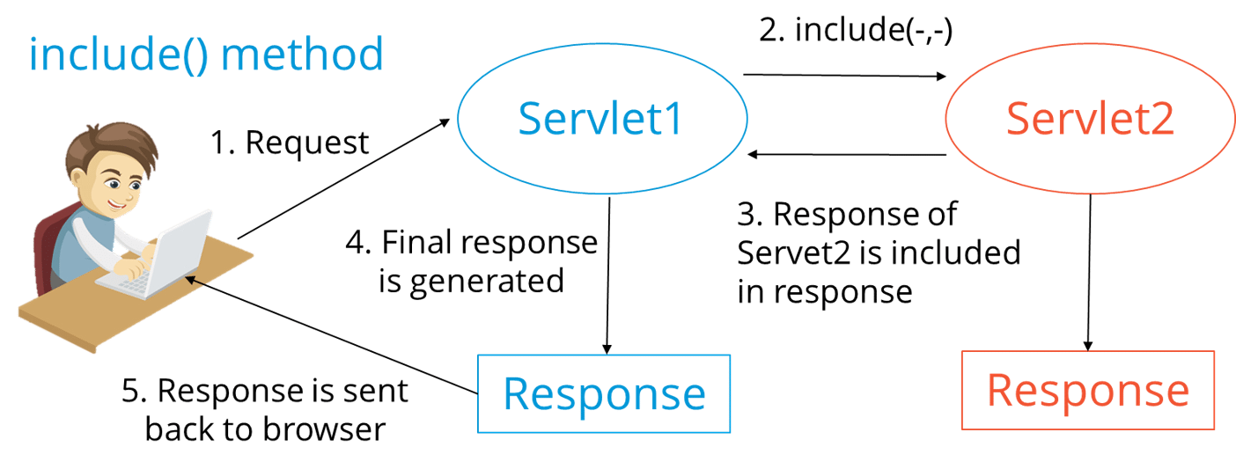

Q4. What are the differences between forward() method and sendRedirect() methods?

forward() method | SendRedirect() method
forward() sends the same request to another resource. | sendRedirect() method sends new request always because it uses the URL bar of the browser.
forward() method works at server side. | sendRedirect() method works at client side.
forward() method works within the server only. | sendRedirect() method works within and outside the server.

Q5. What is the life-cycle of a servlet?
There are 5 stages in the lifecycle of a servlet: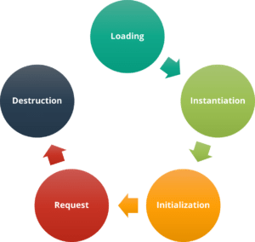
- Servlet is loaded
- Servlet is instantiated
- Servlet is initialized
- Service the request
- Servlet is destroyed

Q6. How does cookies work in Servlets?
- Cookies are text data sent by server to the client and it gets saved at the client local machine.
- Servlet API provides cookies support through javax.servlet.http.Cookie class that implements Serializable and Cloneable interfaces.
- HttpServletRequest getCookies() method is provided to get the array of Cookies from request, since there is no point of adding Cookie to request, there are no methods to set or add cookie to request.
- Similarly HttpServletResponse addCookie(Cookie c) method is provided to attach cookie in response header, there are no getter methods for cookie.

Q7. What are the differences between ServletContext vs ServletConfig?
The difference between ServletContext and ServletConfig in Servlets JSP is in below tabular format.
ServletConfig | ServletContext
Servlet config object represent single servlet | It represent whole web application running on particular JVM and common for all the servlet
Its like local parameter associated with particular servlet | Its like global parameter associated with whole application
It’s a name value pair defined inside the servlet section of web.xml file so it has servlet wide scope | ServletContext has application wide scope so define outside of servlet tag in web.xml file.
getServletConfig() method is used to get the config object | getServletContext() method is used to get the context object.
for example shopping cart of a user is a specific to particular user so here we can use servlet config | To get the MIME type of a file or application session related information is stored using servlet context object.

Q8. What are the different methods of session management in servlets?
Session is a conversational state between client and server and it can consists of multiple request and response between client and server. Since HTTP and Web Server both are stateless, the only way to maintain a session is when some unique information about the session (session id) is passed between server and client in every request and response.
Some of the common ways of session management in servlets are:
- User Authentication
- HTML Hidden Field
- Cookies
- URL Rewriting
- Session Management API

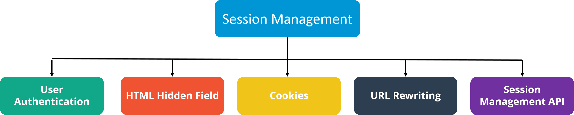
Apart from this blog, if you want to get trained by professionals on this technology, you can opt for structured training from edureka! Click below to know more.

JDBC – Java Interview Questions

1. What is JDBC Driver?
JDBC Driver is a software component that enables java application to interact with the database. There are 4 types of JDBC drivers:
- JDBC-ODBC bridge driver
- Native-API driver (partially java driver)
- Network Protocol driver (fully java driver)
- Thin driver (fully java driver)

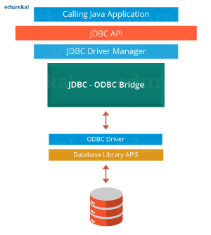2. What are the steps to connect to a database in java?
- Registering the driver class
- Creating connection
- Creating statement
- Executing queries
- Closing connection

3. What are the JDBC API components?
The java.sql package contains interfaces and classes for JDBC API.

Interfaces:
- Connection
- Statement
- PreparedStatement
- ResultSet
- ResultSetMetaData
- DatabaseMetaData
- CallableStatement etc.

Classes:
- DriverManager
- Blob
- Clob
- Types
- SQLException etc.

4. What is the role of JDBC DriverManager class?
The DriverManager class manages the registered drivers. It can be used to register and unregister drivers. It provides factory method that returns the instance of Connection.

5. What is JDBC Connection interface?
The Connection interface maintains a session with the database. It can be used for transaction management. It provides factory methods that returns the instance of Statement, PreparedStatement, CallableStatement and DatabaseMetaData.

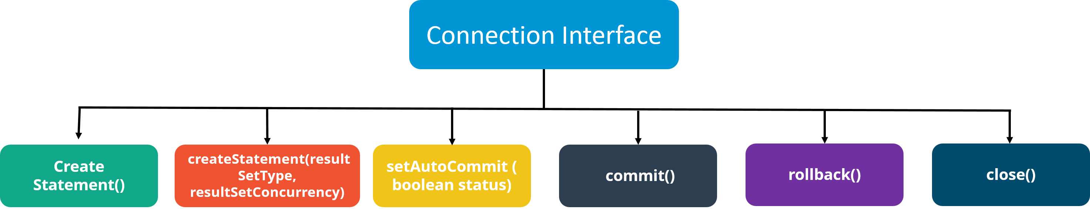
In case you are facing any challenges with these java interview questions, please comment on your problems in the section below.

6. What is the purpose of JDBC ResultSet interface?
The ResultSet object represents a row of a table. It can be used to change the cursor pointer and get the information from the database.

7. What is JDBC ResultSetMetaData interface?
The ResultSetMetaData interface returns the information of table such as total number of columns, column name, column type etc.

8. What is JDBC DatabaseMetaData interface?
The DatabaseMetaData interface returns the information of the database such as username, driver name, driver version, number of tables, number of views etc.

9. What do you mean by batch processing in JDBC?
Batch processing helps you to group related SQL statements into a batch and execute them instead of executing a single query. By using batch processing technique in JDBC, you can execute multiple queries which makes the performance faster.

10. What is the difference between execute, executeQuery, executeUpdate?
Statement execute(String query) is used to execute any SQL query and it returns TRUE if the result is an ResultSet such as running Select queries. The output is FALSE when there is no ResultSet object such as running Insert or Update queries. We can use getResultSet() to get the ResultSet and getUpdateCount() method to retrieve the update count.
Statement executeQuery(String query) is used to execute Select queries and returns the ResultSet. ResultSet returned is never null even if there are no records matching the query. When executing select queries we should use executeQuery method so that if someone tries to execute insert/update statement it will throw java.sql.SQLException with message “executeQuery method can not be used for update”.
Statement executeUpdate(String query) is used to execute Insert/Update/Delete (DML) statements or DDL statements that returns nothing. The output is int and equals to the row count for SQL Data Manipulation Language (DML) statements. For DDL statements, the output is 0.
You should use execute() method only when you are not sure about the type of statement else use executeQuery or executeUpdate method.

Q11. What do you understand by JDBC Statements?
JDBC statements are basically the statements which are used to send SQL commands to the database and retrieve data back from the database. Various methods like execute(), executeUpdate(), executeQuery, etc. are provided by JDBC to interact with the database.
JDBC supports 3 types of statements:
- Statement: Used for general purpose access to the database and executes a static SQL query at runtime.
- PreparedStatement: Used to provide input parameters to the query during execution.
- CallableStatement: Used to access the database stored procedures and helps in accepting runtime parameters.
In case you are facing any challenges with these java interview questions, please comment your problems in the section below. Apart from this Java Interview Questions Blog, if you want to get trained from professionals on this technology, you can opt for a structured training from edureka!

Spring Framework – Java Interview Questions

Q1. What is Spring?
Wikipedia defines the Spring framework as “an application framework and inversion of control container for the Java platform. The framework’s core features can be used by any Java application, but there are extensions for building web applications on top of the Java EE platform.” Spring is essentially a lightweight, integrated framework that can be used for developing enterprise applications in java.

Q2. Name the different modules of the Spring framework.
Some of the important Spring Framework modules are:
- Spring Context – for dependency injection.
- Spring AOP – for aspect oriented programming.
- Spring DAO – for database operations using DAO pattern
- Spring JDBC – for JDBC and DataSource support.
- Spring ORM – for ORM tools support such as Hibernate
- Spring Web Module – for creating web applications.
- Spring MVC – Model-View-Controller implementation for creating web applications, web services etc.

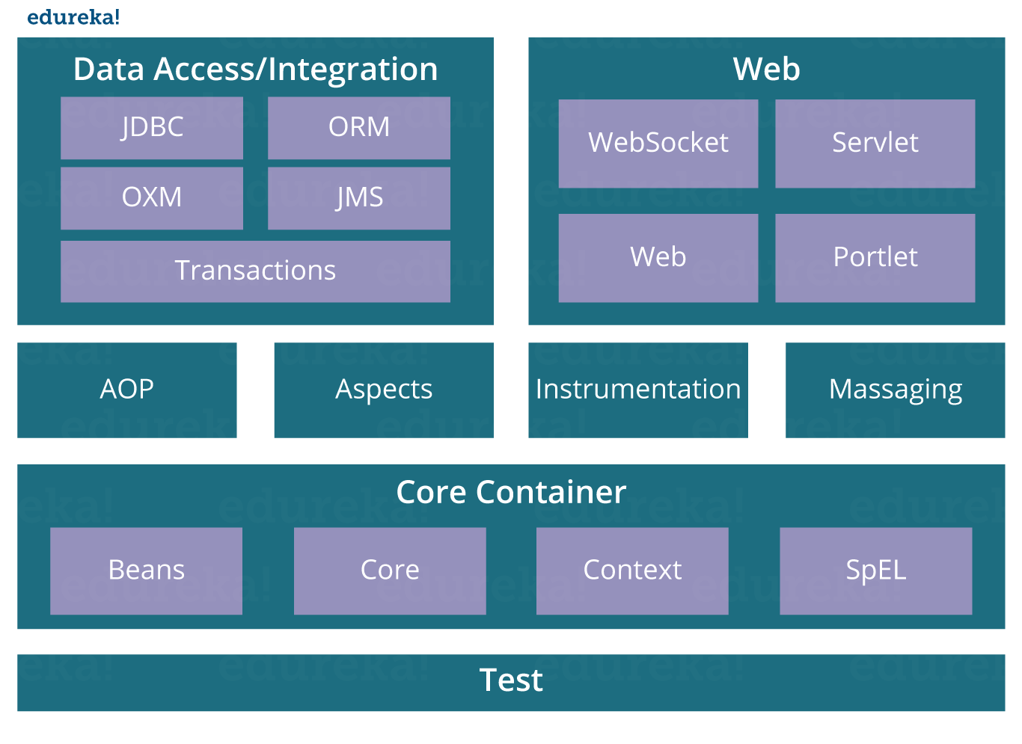Q3. List some of the important annotations in annotation-based Spring configuration.
The important annotations are:
- @Required
- @Autowired
- @Qualifier
- @Resource
- @PostConstruct
- @PreDestroy

Q4. Explain Bean in Spring and List the different Scopes of Spring bean.
Beans are objects that form the backbone of a Spring application. They are managed by the Spring IoC container. In other words, a bean is an object that is instantiated, assembled, and managed by a Spring IoC container.
There are five Scopes defined in Spring beans.
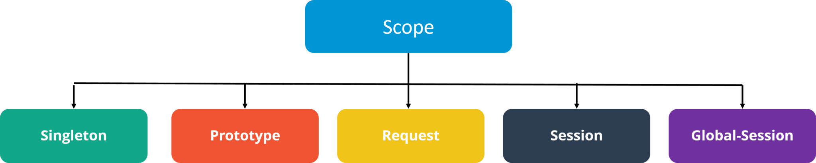
- Singleton: Only one instance of the bean will be created for each container. This is the default scope for the spring beans. While using this scope, make sure spring bean doesn’t have shared instance variables otherwise it might lead to data inconsistency issues because it’s not thread-safe.
- Prototype: A new instance will be created every time the bean is requested.
- Request: This is same as prototype scope, however it’s meant to be used for web applications. A new instance of the bean will be created for each HTTP request.
- Session: A new bean will be created for each HTTP session by the container.
- Global-session: This is used to create global session beans for Portlet applications.
In case you are facing any challenges with these java interview questions, please comment on your problems in the section below.

Q5. Explain the role of DispatcherServlet and ContextLoaderListener.
DispatcherServlet is basically the front controller in the Spring MVC application as it loads the spring bean configuration file and initializes all the beans that have been configured. If annotations are enabled, it also scans the packages to configure any bean annotated with @Component, @Controller, @Repository or @Service annotations.
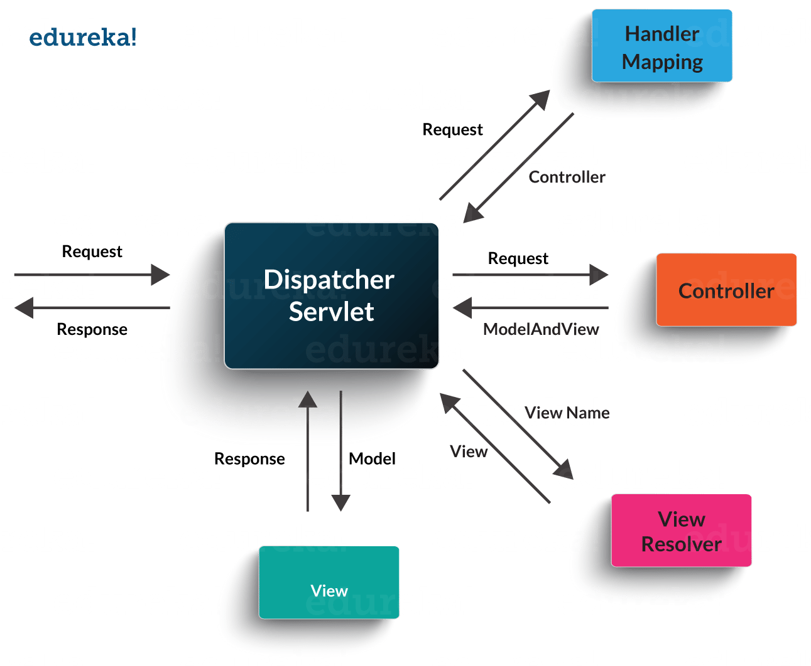ContextLoaderListener, on the other hand, is the listener to start up and shut down the WebApplicationContext in Spring root. Some of its important functions includes tying up the lifecycle of Application Context to the lifecycle of the ServletContext and automating the creation of ApplicationContext.

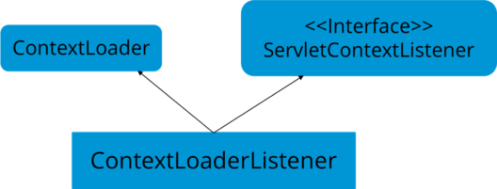

Q6. What are the differences between constructor injection and setter injection?
No. | Constructor Injection | Setter Injection
1) | No Partial Injection | Partial Injection
2) | Doesn’t override the setter property | Overrides the constructor property if both are defined.
3) | Creates a new instance if any modification occurs | Doesn’t create a new instance if you change the property value
4) | Better for too many properties | Better for a few properties.

Q7. What is autowiring in Spring? What are the autowiring modes?
Autowiring enables the programmer to inject the bean automatically. We don’t need to write explicit injection logic. Let’s see the code to inject bean using dependency injection.
- <bean id=“emp” class=“com.javatpoint.Employee” autowire=“byName” />
The autowiring modes are given below:
No. | Mode | Description
1) | no | this is the default mode, it means autowiring is not enabled.
2) | byName | Injects the bean based on the property name. It uses setter method.
3) | byType | Injects the bean based on the property type. It uses setter method.
4) | constructor | It injects the bean using constructor

Q8. How to handle exceptions in Spring MVC Framework?
Spring MVC Framework provides the following ways to help us achieving robust exception handling.

Controller Based:
We can define exception handler methods in our controller classes. All we need is to annotate these methods with @ExceptionHandler annotation.

Global Exception Handler:
Exception Handling is a cross-cutting concern and Spring provides @ControllerAdvice annotation that we can use with any class to define our global exception handler.

HandlerExceptionResolver implementation:
For generic exceptions, most of the times we serve static pages. Spring Framework provides HandlerExceptionResolver interface that we can implement to create global exception handler. The reason behind this additional way to define global exception handler is that Spring framework also provides default implementation classes that we can define in our spring bean configuration file to get spring framework exception handling benefits.

Q9. What are some of the important Spring annotations which you have used?
Some of the Spring annotations that I have used in my project are:
@Controller – for controller classes in Spring MVC project.
@RequestMapping – for configuring URI mapping in controller handler methods. This is a very important annotation, so you should go through Spring MVC RequestMapping Annotation Examples
@ResponseBody – for sending Object as response, usually for sending XML or JSON data as response.
@PathVariable – for mapping dynamic values from the URI to handler method arguments.
@Autowired – for autowiring dependencies in spring beans.
@Qualifier – with @Autowired annotation to avoid confusion when multiple instances of bean type is present.
@Service – for service classes.
@Scope – for configuring the scope of the spring bean.
@Configuration, @ComponentScan and @Bean – for java based configurations.
AspectJ annotations for configuring aspects and advices , @Aspect, @Before, @After, @Around, @Pointcut, etc.

Q10. How to integrate Spring and Hibernate Frameworks?
We can use Spring ORM module to integrate Spring and Hibernate frameworks if you are using Hibernate 3+ where SessionFactory provides current session, then you should avoid using HibernateTemplate or HibernateDaoSupport classes and better to use DAO pattern with dependency injection for the integration.
Also, Spring ORM provides support for using Spring declarative transaction management, so you should utilize that rather than going for hibernate boiler-plate code for transaction management.

Q11. Name the types of transaction management that Spring supports.
Two types of transaction management are supported by Spring. They are:
- Programmatic transaction management: In this, the transaction is managed with the help of programming. It provides you extreme flexibility, but it is very difficult to maintain.
- Declarative transaction management: In this, transaction management is separated from the business code. Only annotations or XML based configurations are used to manage the transactions.
Apart from these Core Java interview questions for experienced professionals, if you want to get trained by professionals on this technology, you can opt for a structured training from edureka!

Hibernate – Java Interview Questions for Experienced Professionals

1. What is Hibernate Framework?
Object-relational mapping or ORM is the programming technique to map application domain model objects to the relational database tables. Hibernate is Java-based ORM tool that provides a framework for mapping application domain objects to the relational database tables and vice versa.
Hibernate provides a reference implementation of Java Persistence API, that makes it a great choice as ORM tool with benefits of loose coupling. We can use the Hibernate persistence API for CRUD operations. Hibernate framework provide option to map plain old java objects to traditional database tables with the use of JPA annotations as well as XML based configuration.
Similarly, hibernate configurations are flexible and can be done from XML configuration file as well as programmatically.

2. What are the important benefits of using Hibernate Framework?
Some of the important benefits of using hibernate framework are:
- Hibernate eliminates all the boiler-plate code that comes with JDBC and takes care of managing resources, so we can focus on business logic.
- Hibernate framework provides support for XML as well as JPA annotations, that makes our code implementation independent.
- Hibernate provides a powerful query language (HQL) that is similar to SQL. However, HQL is fully object-oriented and understands concepts like inheritance, polymorphism, and association.
- Hibernate is an open source project from Red Hat Community and used worldwide. This makes it a better choice than others because learning curve is small and there are tons of online documentation and help is easily available in forums.
- Hibernate is easy to integrate with other Java EE frameworks, it’s so popular that Spring Framework provides built-in support for integrating hibernate with Spring applications.
- Hibernate supports lazy initialization using proxy objects and perform actual database queries only when it’s required.
- Hibernate cache helps us in getting better performance.
- For database vendor specific feature, hibernate is suitable because we can also execute native sql queries.
Overall hibernate is the best choice in current market for ORM tool, it contains all the features that you will ever need in an ORM tool.

3. Explain Hibernate architecture.
Hibernate has a layered architecture which helps the user to operate without having to know the underlying APIs. Hibernate makes use of the database and configuration data to provide persistence services (and persistent objects) to the application. It includes many objects such as persistent object, session factory, transaction factory, connection factory, session, transaction etc.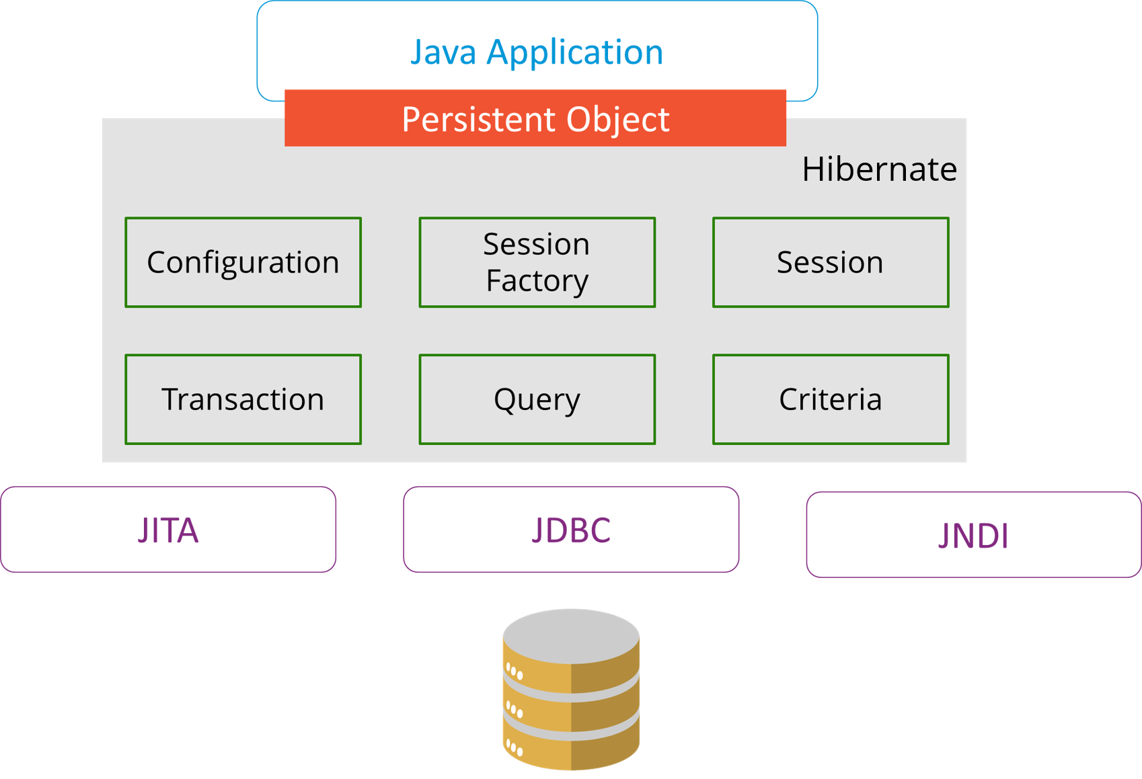
The Hibernate architecture is categorized in four layers.
- Java application layer
- Hibernate framework layer
- Backhand API layer
- Database layer

4. What are the differences between get and load methods?
The differences between get() and load() methods are given below.
No. | get() | load()
1) | Returns null if object is not found. | Throws ObjectNotFoundException if an object is not found.
2) | get() method always hit the database. | load() method doesn’t hit the database.
3) | It returns a real object, not a proxy. | It returns a proxy object.
4) | It should be used if you are not sure about the existence of instance. | It should be used if you are sure that the instance exists.

5. What are the advantages of Hibernate over JDBC?
Some of the important advantages of Hibernate framework over JDBC are:
- Hibernate removes a lot of boiler-plate code that comes with JDBC API, the code looks cleaner and readable.
- Hibernate supports inheritance, associations, and collections. These features are not present with JDBC API.
- Hibernate implicitly provides transaction management, in fact, most of the queries can’t be executed outside transaction. In JDBC API, we need to write code for transaction management using commit and rollback.
- JDBC API throws SQLException that is a checked exception, so we need to write a lot of try-catch block code. Most of the times it’s redundant in every JDBC call and used for transaction management. Hibernate wraps JDBC exceptions and throw JDBCException or HibernateException un-checked exception, so we don’t need to write code to handle it. Hibernate built-in transaction management removes the usage of try-catch blocks.
- Hibernate Query Language (HQL) is more object-oriented and close to Java programming language. For JDBC, we need to write native SQL queries.
- Hibernate supports caching that is better for performance, JDBC queries are not cached hence performance is low.
- Hibernate provides option through which we can create database tables too, for JDBC tables must exist in the database.
- Hibernate configuration helps us in using JDBC like connection as well as JNDI DataSource for the connection pool. This is a very important feature in enterprise application and completely missing in JDBC API.
- Hibernate supports JPA annotations, so the code is independent of the implementation and easily replaceable with other ORM tools. JDBC code is very tightly coupled with the application.
In case you are facing any challenges with these Java interview questions, please comment on your problems in the section below. Apart from this Java Interview Questions Blog, if you want to get trained from professionals on this technology, you can opt for structured training from edureka!

JSP – Java Interview Questions

1. What are the life-cycle methods for a jsp?
Methods | Description
public void jspInit() | It is invoked only once, same as init method of servlet.
public void _jspService(ServletRequest request,ServletResponse)throws ServletException,IOException | It is invoked at each request, same as service() method of servlet.
public void jspDestroy() | It is invoked only once, same as destroy() method of servlet.

2. What are the JSP implicit objects?
JSP provides 9 implicit objects by default. They are as follows:
Object | Type
1) out | JspWriter
2) request | HttpServletRequest
3) response | HttpServletResponse
4) config | ServletConfig
5) session | HttpSession
6) application | ServletContext
7) pageContext | PageContext
8) page | Object
9) exception | Throwable

3. What are the differences between include directive and include action?
include directive | include action
The include directive includes the content at page translation time. | The include action includes the content at request time.
The include directive includes the original content of the page so page size increases at runtime. | The include action doesn’t include the original content rather invokes the include() method of Vendor provided class.
It’s better for static pages. | It’s better for dynamic pages.

4. How to disable caching on back button of the browser?
<%
response.setHeader(“Cache-Control”,”no-store”);
response.setHeader(“Pragma”,”no-cache”);
response.setHeader (“Expires”, “0”); //prevents caching at the proxy server
%>

5. What are the different tags provided in JSTL?
There are 5 type of JSTL tags.
- core tags
- sql tags
- xml tags
- internationalization tags
- functions tags

6. How to disable session in JSP?
- <%@ page session=“false” %>

7. How to delete a Cookie in a JSP?
The following code explains how to delete a Cookie in a JSP :
1  2  3  4  5  6  7  8  9  10  11 | Cookie mycook = new Cookie("name1","value1");  response.addCookie(mycook1);  Cookie killmycook = new Cookie("mycook1","value1");  killmycook . set MaxAge ( 0 );  killmycook . set Path ("/");  killmycook . addCookie ( killmycook 1 );

8. Explain the jspDestroy() method.
jspDestry() method is invoked from javax.servlet.jsp.JspPage interface whenever a JSP page is about to be destroyed. Servlets destroy methods can be easily overridden to perform cleanup, like when closing a database connection.

9. How is JSP better than Servlet technology?
JSP is a technology on the server’s side to make content generation simple. They are document-centric, whereas servlets are programs. A Java server page can contain fragments of Java program, which execute and instantiate Java classes. However, they occur inside an HTML template file. It provides the framework for the development of a Web Application.

10. Why should we not configure JSP standard tags in web.xml?
We don’t need to configure JSP standard tags in web.xml because when container loads the web application and find TLD files, it automatically configures them to be used directly in the application JSP pages. We just need to include it in the JSP page using taglib directive.

11. How will you use JSP EL in order to get the HTTP method name?
Using pageContext JSP EL implicit object you can get the request object reference and make use of the dot operator to retrieve the HTTP method name in the JSP page. The JSP EL code for this purpose will look like ${pageContext.request.method}.
In case you are facing any challenges with these java interview questions, please comment on your problems in the section below. Apart from this Java Interview Questions Blog, if you want to get trained from professionals on this technology, you can opt for structured training from edureka!

Exception and Thread Java Interview Questions

Q1. What is the difference between Error and Exception?
An error is an irrecoverable condition occurring at runtime. Such as OutOfMemory error. These JVM errors you cannot repair them at runtime. Though error can be caught in the catch block but the execution of application will come to a halt and is not recoverable.
While exceptions are conditions that occur because of bad input or human error etc. e.g. FileNotFoundException will be thrown if the specified file does not exist. Or a NullPointerException will take place if you try using a null reference. In most of the cases it is possible to recover from an exception (probably by giving the user feedback for entering proper values etc.

Q2. How can you handle Java exceptions?
There are five keywords used to handle exceptions in Java:
- try
- catch
- finally
- throw
- throws

Q3. What are the differences between Checked Exception and Unchecked Exception?

Checked Exception
- The classes that extend Throwable class except RuntimeException and Error are known as checked exceptions.
- Checked exceptions are checked at compile-time.
- Example: IOException, SQLException etc.

Unchecked Exception
- The classes that extend RuntimeException are known as unchecked exceptions.
- Unchecked exceptions are not checked at compile-time.
- Example: ArithmeticException, NullPointerException etc.

Q4. What are the different ways of thread usage?
There are two ways to create a thread:
- Extending Thread class
This creates a thread by creating an instance of a new class that extends the Thread class. The extending class must override the run() function, which is the thread’s entry point.
- Implementing Runnable interface
This is the easiest way to create a thread, by creating a class that implements the runnable interface. After implementing the runnable interface, the class must implement the public void run() method ()
The run() method creates a parallel thread in your programme. When run() returns, the thread will come to an end.
The run() method creates a parallel thread in your programme. When run() returns, the thread will come to an end.
Within the run() method, you must specify the thread’s code.
Like any other method, the run() method can call other methods, use other classes, and define variables.
Java works as “pass by value” or “pass by reference” phenomenon?
Java is always pass-by-value. This means that it creates a copy of the contents of the parameter in memory. In Java, object variables always refer to the memory heap’s real object.

Q5. Will the finally block get executed when the return statement is written at the end of try block and catch block as shown below?
The finally block always gets executed even hen the return statement is written at the end of the try block and the catch block. It always executes , whether there is an exception or not. There are only a few situations in which the finally block does not execute, such as VM crash, power failure, software crash, etc. If you don’t want to execute the finally block, you need to call the System.exit() method explicitly in the finally block.

Q6. How does an exception propagate in the code?
If an exception is not caught, it is thrown from the top of the stack and falls down the call stack to the previous procedure. If the exception isn’t caught there, it falls back to the previous function, and so on, until it’s caught or the call stack reaches the bottom. The term for this is Exception propagation.

Q7. Can you explain the Java thread lifecycle?
The java thread lifecycle has the following states-
New-
When a thread is created, and before the program starts the thread, it is in the new state. It is also referred to as a born thread.
Runnable
When a thread is started, it is in the Runnable state. In this state, the thread is executing its task.
Waiting
Sometimes, a thread goes to the waiting state, where it remains idle because another thread is executing. When the other thread has finished, the waiting thread again comes into the running state.
Timed Waiting
In timed waiting, the thread goes to waiting state. But, it remains in waiting state for only a specified interval of time after which it starts executing.It remains waiting either till the time interval ends or till the other thread has finished.
Terminated
A thread is said to be in this state once it terminates. It may be because the thread has completed its task or due to any other reason.

Q8. What purpose do the keywords final, finally, and finalize fulfill?

Final:
Final is used to apply restrictions on class, method, and variable. A final class can’t be inherited, final method can’t be overridden and final variable value can’t be changed. Let’s take a look at the example below to understand it better.
1  2  3  4  5  6 | class FinalVarExample {  public static void main( String args[])  {  final int a=10; // Final variable  a=50; //Error as value can't be changed  }

Finally
Finally is used to place important code, it will be executed whether the exception is handled or not. Let’s take a look at the example below to understand it better.
1  2  3  4  5  6  7  8  9  10  11  12 | class FinallyExample {  public static void main(String args[]){  try {  int x=100;  }  catch(Exception e) {  System.out.println(e);  }  finally {  System.out.println("finally block is executing");}  }}  }

Finalize
Finalize is used to perform clean up processing just before the object is garbage collected. Let’s take a look at the example below to understand it better.
1  2  3  4  5  6  7  8  9  10  11  12  13 | class FinalizeExample {  public void finalize() {  System.out.println("Finalize is called");  }  public static void main(String args[])  {  FinalizeExample f1=new FinalizeExample();  FinalizeExample f2=new FinalizeExample();  f1= NULL;  f2=NULL;  System.gc();  }  }

Q9. What are the differences between throw and throws?
throw keyword | throws keyword
Throw is used to explicitly throw an exception. | Throws is used to declare an exception.
Checked exceptions can not be propagated with throw only. | Checked exception can be propagated with throws.
Throw is followed by an instance. | Throws is followed by class.
Throw is used within the method. | Throws is used with the method signature.
You cannot throw multiple exception | You can declare multiple exception e.g. public void method()throws IOException,SQLException.
In case you are facing any challenges with these java interview questions, please comment on your problems in the section below.

Q10. What is exception hierarchy in java?
The hierarchy is as follows:
Throwable is a parent class of all Exception classes. There are two types of Exceptions: Checked exceptions and UncheckedExceptions or RunTimeExceptions. Both type of exceptions extends Exception class whereas errors are further classified into Virtual Machine error and Assertion error.
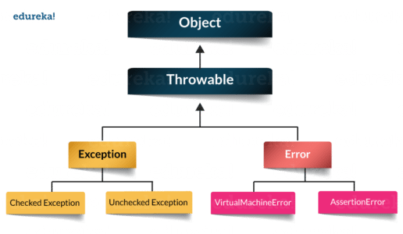

Q11. How to create a custom Exception?
To create you own exception extend the Exception class or any of its subclasses.
- class New1Exception extends Exception { } // this will create Checked Exception
- class NewException extends IOException { } // this will create Checked exception
- class NewException extends NullPonterExcpetion { } // this will create UnChecked exception

Q12. What are the important methods of Java Exception Class?
Exception and all of it’s subclasses doesn’t provide any specific methods and all of the methods are defined in the base class Throwable.
- String getMessage() – This method returns the message String of Throwable and the message can be provided while creating the exception through it’s constructor.
- String getLocalizedMessage() – This method is provided so that subclasses can override it to provide locale specific message to the calling program. Throwable class implementation of this method simply use getMessage() method to return the exception message.
- Synchronized Throwable getCause() – This method returns the cause of the exception or null id the cause is unknown.
- String toString() – This method returns the information about Throwable in String format, the returned String contains the name of Throwable class and localized message.
- void printStackTrace() – This method prints the stack trace information to the standard error stream, this method is overloaded and we can pass PrintStream or PrintWriter as an argument to write the stack trace information to the file or stream.

Q13. What are the differences between processes and threads?
 | Process | Thread
Definition | An executing instance of a program is called a process. | A thread is a subset of the process.
Communication | Processes must use inter-process communication to communicate with sibling processes. | Threads can directly communicate with other threads of its process.
Control | Processes can only exercise control over child processes. | Threads can exercise considerable control over threads of the same process.
Changes | Any change in the parent process does not affect child processes. | Any change in the main thread may affect the behavior of the other threads of the process.
Memory | Run in separate memory spaces. | Run in shared memory spaces.
Controlled by | Process is controlled by the operating system. | Threads are controlled by programmer in a program.
Dependence | Processes are independent. | Threads are dependent.

Q14. What is a finally block? Is there a case when finally will not execute?
Finally block is a block which always executes a set of statements. It is always associated with a try block regardless of any exception that occurs or not.
Yes, finally will not be executed if the program exits either by calling System.exit() or by causing a fatal error that causes the process to abort.

Q15. What is synchronization?
Synchronization refers to multi-threading. A synchronized block of code can be executed by only one thread at a time. As Java supports execution of multiple threads, two or more threads may access the same fields or objects. Synchronization is a process which keeps all concurrent threads in execution to be in sync. Synchronization avoids memory consistency errors caused due to inconsistent view of shared memory. When a method is declared as synchronized the thread holds the monitor for that method’s object. If another thread is executing the synchronized method the thread is blocked until that thread releases the monitor.
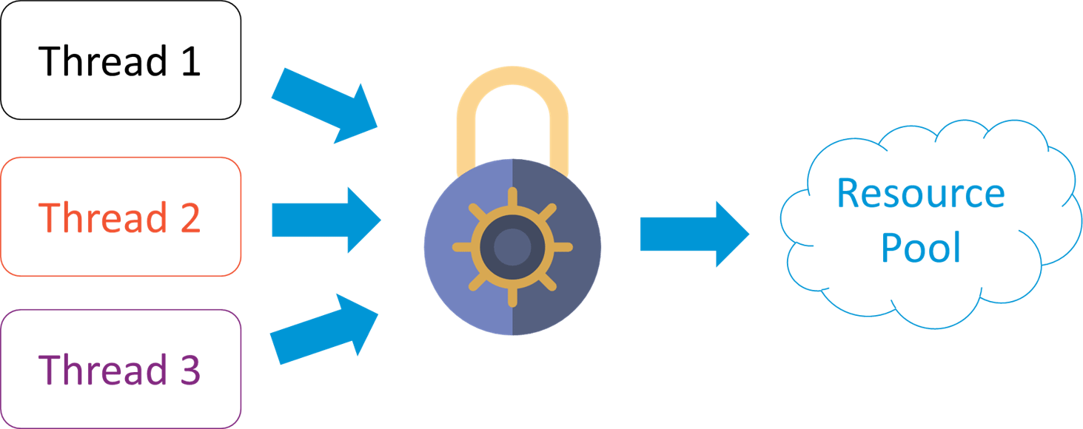

Q16. Can we write multiple catch blocks under single try block?
Yes we can have multiple catch blocks under single try block but the approach should be from specific to general. Let’s understand this with a programmatic example.
1  2  3  4  5  6  7  8  9  10  11  12  13  14  15  16  17  18  19 | public class Example {  public static void main(String args[]) {  try {  int a[]= new int[10];  a[10]= 10/0;  }  catch(ArithmeticException e)  {  System.out.println("Arithmetic exception in first catch block");  }  catch(ArrayIndexOutOfBoundsException e)  {  System.out.println("Array index out of bounds in second catch block");  }  catch(Exception e)  {  System.out.println("Any exception in third catch block");  }  }

Q17. What are the important methods of Java Exception Class?
Methods are defined in the base class Throwable. Some of the important methods of Java exception class are stated below.
- String getMessage() – This method returns the message String about the exception. The message can be provided through its constructor.
- public StackTraceElement[] getStackTrace() – This method returns an array containing each element on the stack trace. The element at index 0 represents the top of the call stack whereas the last element in the array represents the method at the bottom of the call stack.
- Synchronized Throwable getCause() – This method returns the cause of the exception or null id as represented by a Throwable object.
- String toString() – This method returns the information in String format. The returned String contains the name of Throwable class and localized message.
- void printStackTrace() – This method prints the stack trace information to the standard error stream.

Q18. What is OutOfMemoryError in Java?
OutOfMemoryError is the subclass of java.lang.Error which generally occurs when our JVM runs out of memory.

Q19. What is a Thread?
A thread is the smallest piece of programmed instructions which can be executed independently by a scheduler. In Java, all the programs will have at least one thread which is known as the main thread. This main thread is created by the JVM when the program starts its execution. The main thread is used to invoke the main() of the program.

Q20. What are the two ways to create a thread?
In Java, threads can be created in the following two ways:-
- By implementing the Runnable interface.
- By extending the Thread

Q21. What are the different types of garbage collectors in Java?
Garbage collection in Java a program which helps in implicit memory management. Since in Java, using the new keyword you can create objects dynamically, which once created will consume some memory. Once the job is done and there are no more references left to the object, Java using garbage collection destroys the object and relieves the memory occupied by it. Java provides four types of garbage collectors:
- Serial Garbage Collector
- Parallel Garbage Collector
- CMS Garbage Collector
- G1 Garbage Collector

A. Object Oriented Programming (OOP)

1. What is Java?
Java is a computer programming language that is concurrent, class-based and object-oriented. The advantages of object-oriented software development are shown below:
- Modular development of code, which leads to easy maintenance and modification.
- Reusability of code.
- Improved reliability and flexibility of code.
- Increased understanding of code.

2. What are the concepts of OOP?
Object Oriented Programming (OOP) includes:
- Abstraction
- Encapsulation
- Polymorphism
- Inheritance
- Predefined types must be objects
- User defined types must be objects
- Operations must be performed by sending messages to objects

3. Mention some features of Java
Some of the features which play important role in the popularity of java are as follows:
- Object-Oriented
- Platform independent
- High Performance
- Multithreaded
- Portable
- Secure
Sample code for Helloworld in java is shown below:
Hello World
1  2  3  4  5  6  7  8 | public class Helloworld{  public static void main(String args[])  {  System.out.println("Hello World");  }  }

4. Is Java 100% Object-oriented?
Not 100%. Java does not satisfy all the OOP conditions (predefined types must be objects) because it uses eight primitive data types(Boolean, byte, char, int, float, double, long, short) which are not objects.

ADVERTISEMENT



5. What is Abstraction?
Abstraction is the process of separating ideas from specific instances and thus, develop classes in terms of their own functionality, instead of their implementation details. Java supports the creation and existence of abstract classes that expose interfaces, without including the actual implementation of all methods. The abstraction technique aims to separate the implementation details of a class from its behavior.
Abstract class Person is presented below. It has an abstract method getName.Abstract Class Person
1  2  3  4 | public abstract class Person  {  public abstract String getName();  }

Employee class extends the Abstract class Person. The method getName returns the name attribute of the employee.Employee Class
01  02  03  04  05  06  07  08  09  10  11  12  13  14  15  16  17  18  19  20  21  22  23  24  25 | public class Employee extends Person  {  private String name;  public Employee(String name)  {  this.name = name;  }  public String getName()  {  return this.name;  }  public static void main (String args[])  {  Employee employee = new Employee("John Wilson");  System.out.println("Employee's Name "+ employee.getName());  Person person = new Employee("Thomas Smith");  System.out.println("Employee-Person's Name "+ person.getName());  }  }

6. What is Encapsulation?
Encapsulation provides objects with the ability to hide their internal characteristics and behavior. Each object provides a number of methods, which can be accessed by other objects and change its internal data. In Java, there are three access modifiers: public, private and protected. Each modifier imposes different access rights to other classes, either in the same or in external packages. Some of the advantages of using encapsulation are listed below:
- The internal state of every object is protected by hiding its attributes.
- It increases usability and maintenance of code, because the behavior of an object can be independently changed or extended.
- It improves modularity by preventing objects to interact with each other, in an undesired way.
You can refer to our tutorial here for more details and examples on encapsulation.
A sample class Student which has attributes Id and Name is shown as an example for encapsulation.Student Class
01  02  03  04  05  06  07  08  09  10  11  12  13  14  15  16  17  18  19  20  21  22  23  24  25  26  27  28  29  30  31  32  33  34  35  36 | public class Student{  private int id;  private String name;  public void setId(int id)  {  this.id = id;  }  public void setName(String name)  {  this.name = name;  }  public int getId()  {  return this.id;  }  public String getName()  {  return this.name;  }  public static void main(String args[])  {  Student student=new Student();  student.setId(1034);  student.setName("David Smith");  System.out.println("Student id "+ student.getId());  System.out.println("Student name "+ student.getName());  }  }

7. What are the differences between Abstraction and Encapsulation?
Abstraction and encapsulation are complementary concepts. On the one hand, abstraction focuses on the behavior of an object. On the other hand, encapsulation focuses on the implementation of an object’s behavior. Encapsulation is usually achieved by hiding information about the internal state of an object and thus, can be seen as a strategy used in order to provide abstraction.

8. What is Polymorphism?
Polymorphism is the ability of programming languages to present the same interface for differing underlying data types. A polymorphic type is a type whose operations can also be applied to values of some other type.
You can see the example below where Vehicle interface has the method increaseVelocity. Truck, Train and Aeroplane implement the Vehicle Interface and the method increases the velocity to the appropriate velocity related to the vehicle type.

9. What are the types of Polymorphism?
There are two types of Polymorphism in Java:
- Compile-time polymorphism (Static binding) – Method overloading
- Runtime polymorphism (Dynamic binding) – Method overriding
We can perform polymorphism by Method Overloading and Method Overriding.
Compile Time | Runtime
Methods of a class have the same name. Each method has a different number of parameters . It can have parameters with different types and order. | the subclass has method with the name as of a superclass method. It has the number of paramers, type of parameters and the return type as of a superclass method.
Method Overloading is to add to the method behavior. It can be extending to the method’s behavior. | Method Overriding is to modify the method’s behavior .
Overloaded methods will not have same signature. | Overridden methods will have exactly the same signature.
Inheritance is not need in this case. | Inheritance is reuqired.
Sample code for overloading method subtract of Calculator Class is shown below:Calculator Class
01  02  03  04  05  06  07  08  09  10  11  12  13  14  15  16  17 | public class Calculator {  public int subtract(int a, int b)  {  return a-b;  }  public double subtract( double a, double b)  {  return a-b;  }  public static void main(String args[])  {  Calculator calculator = new Calculator();  System.out.println("Difference of 150 and 12 is " +calculator.subtract(150,12));  System.out.println("Difference of 15.5 and 15.4 is " +calculator.subtract(15.50,15.40));  }}

Method overriding is shown below in Shape class. Shape has a method getArea.Shape Class
1  2  3  4 | public class Shape  {  public void getArea(){System.out.println("Shape Area");}  }

Rectangle class overrides getArea method and the implementation of the method is specific to Rectangle. Override annotation is used to indicate to the compiler that the method is overridden. Readability of the code is improved using the annotation.Rectangle Class
01  02  03  04  05  06  07  08  09  10  11  12  13  14  15  16  17  18  19  20  21  22 | public class Rectangle extends Shape{  @Override  public void getArea()  {  System.out.println("Rectangle Area");  }  public static void main(String args[])  {  Shape shape = new Shape();  shape.getArea();  Rectangle rectangle = new Rectangle();  rectangle.getArea();  }  }

10. What is Inheritance?
Inheritance provides an object with the ability to acquire the fields and methods of another class, called base class. Inheritance provides reusability of code and can be used to add additional features to an existing class, without modifying it.
Sample class Mammal is shown below which has a constructor.Mammal Class
1  2  3  4  5  6  7  8 | public class Mammal{  public Mammal()  {  System.out.println("Mammal created");  }  }

Man class extends Mammal which has a default constructor. The sample code is shown below.Man class
1  2  3  4  5  6  7 | public class Man extends Mammal{  public Man()  {  System.out.println("Man is created");  }  }

Inheritance is tested by creating an instance of Man using default constructor. The sample code is shown to demonstrate the inheritance.TestInheritance Class
1  2  3  4  5  6  7 | public class TestInheritance{  public static void main(String args[])  {  Man man = new Man();  }  }

11. What is composition?
Composition is exactly like Aggregation except that the lifetime of the ‘part’ is controlled by the ‘whole’. This control may be direct or transitive. That is, the ‘whole’ may take direct responsibility for creating or destroying the ‘part’, or it may accept an already created part, and later pass it on to some other whole that assumes responsibility for it.
Sample class Car is shown below to demonstrate Composition of tires, doors, windows and steering.Car class
01  02  03  04  05  06  07  08  09  10  11  12  13  14  15  16  17  18  19  20  21  22  23  24  25  26  27  28  29  30 | public class Car  {  private Tire[] tires;  private Door[] doors;  private Steering steering;  private Window[] windows;  }  class Tire  {  }  class Door  {  }  class Steering  {  }  class Window  {  }

12. What is an association?
Association represents the ability of one instance to send a message to another instance. This is typically implemented with a pointer or reference instance variable, although it might also be implemented as a method argument or the creation of a local variable.

13. What is aggregation?
Aggregation is the typical whole/part relationship. This is exactly the same as an association with the exception that instances cannot have cyclic aggregation relationships.
Sample class Person is shown below to demonstrate Aggregation relationship with Address.Person class
01  02  03  04  05  06  07  08  09  10  11  12  13  14  15  16  17  18  19 | public class Person  {  private Address address;  }  class Address  {  private String city;  private String state;  private String country;  private String line1;  private String line2;  }

B.General Questions about Java

14. What is JVM?
A Java virtual machine (JVM) is a process virtual machine that can execute Java bytecode. Each Java source file is compiled into a bytecode file, which is executed by the JVM.

15. Why is Java called the Platform Independent Programming Language?
Java was designed to allow application programs to be built that could be run on any platform, without having to be rewritten or recompiled by the programmer for each separate platform. A Java virtual machine makes this possible because it is aware of the specific instruction lengths and other particularities of the underlying hardware platform.

16. What is the Difference between JDK and JRE?
The Java Runtime Environment (JRE) is basically the Java Virtual Machine (JVM) where your Java programs are being executed. It also includes browser plugins for applet execution. The Java Development Kit (JDK) is the full-featured Software Development Kit for Java, including the JRE, the compilers and tools (like JavaDoc, and Java Debugger), in order for a user to develop, compile and execute Java applications.
JDK | JRE
JDK stands for the term : Java Development Kit. | JRE stands for the term: Java Runtime Environment.
JDK is the tool for compilng, documenting and packaging Java software. | JRE is a runtime environment. JavaByte code gets executed in the environment.
JDK has JRE and development tools. | JRE is a JVM implementation

17. What does the static keyword mean?
The static keyword denotes that a member variable or method can be accessed, without requiring an instantiation of the class to which it belongs.
Sample static method which is shown below:Static method
1  2  3  4  5 | static void printGreeting()  {  }

18. Can you override private or static method in Java?
A user cannot override static methods in Java, because method overriding is based upon dynamic binding at runtime and static methods are statically bound at compile time. A static method is not associated with any instance of a class so the concept is not applicable.

19. Can you access the non-static variable in static context?
A static variable in Java belongs to its class and its value remains the same for all its instances. A static variable is initialized when the class is loaded by the JVM. If your code tries to access a non-static variable, without any instance, the compiler will complain, because those variables are not created yet and they are not associated with any instance.

20. What are the Data Types supported by Java?
The eight primitive data types supported by the Java programming language are:
- byte
- short
- int
- long
- float
- double
- boolean
- char

21. What is Autoboxing and Unboxing?
Autoboxing is the automatic conversion made by the Java compiler between the primitive types and their corresponding object wrapper classes. For example, the compiler converts an int to an Integer, a double to a Double, and so on. If the conversion goes the other way, this operation is called unboxing.

22. What is Function Overriding and Overloading in Java?
Method overloading in Java occurs when two or more methods in the same class have the exact same name, but different parameters. On the other hand, method overriding is defined as the case when a child class redefines the same method as a parent class. Overridden methods must have the same name, argument list, and return type. The overriding method may not limit the access of the method it overrides.

23. What is a Constructor?
A constructor gets invoked when a new object is created. Every class has a constructor. In case the programmer does not provide a constructor for a class, the Java compiler (Javac) creates a default constructor for that class.
A default constructor in java is shown in the example below:Default Constructor
1  2  3  4 | public Man()  {  System.out.println("Man is created");  }

Constructor which takes a parameter is shown in the sample below:Constructor
1  2  3  4  5  6 | private String name;  public Employee(String name)  {  this.name = name;  }

24. What is Constructor Overloading?
The constructor overloading is similar to method overloading in Java. Different constructors can be created for a single class. Each constructor must have its own unique parameter list.

25. What is Copy-Constructor?
Finally, Java does support copy constructors like C++, but the difference lies in the fact that Java does not create a default copy constructor if you do not write your own.
Copy constructor for Employee class is shown below:Copy Constructor
01  02  03  04  05  06  07  08  09  10  11  12  13  14  15 | public class Employee extends Person  {  private String name;  public Employee(String name)  {  this.name = name;  }  public Employee(Employee emp)  {  this.name = emp.name;  }  }

26. Does Java support multiple inheritance?
No, Java does not support multiple inheritance. Each class is able to extend only on one class but is able to implement more than one interfaces.

27. What is the difference between an Interface and an Abstract class?
Java provides and supports the creation of both the abstract classes and interfaces. Both implementations share some common characteristics, but they differ in the following features:
- All methods in an interface are implicitly abstract. On the other hand, an abstract class may contain both abstract and non-abstract methods.
- A class may implement a number of Interfaces but can extend only one abstract class.
- In order for a class to implement an interface, it must implement all its declared methods. However, a class may not implement all declared methods of an abstract class. Though, in this case, the sub-class must also be declared as abstract.
- Abstract classes can implement interfaces without even providing the implementation of interface methods.
- Variables declared in a Java interface is by default final. An abstract class may contain non-final variables.
- Members of a Java interface are public by default. A member of an abstract class can either be private, protected or public.
- An interface is absolutely abstract and cannot be instantiated. An abstract class also cannot be instantiated but can be invoked if it contains the main method.
Also, check out the Abstract class and Interface differences for JDK 8.
Interface | Abstract Class
An interface has the method signatures. It does not have any implementation. | Abstract class has the abstract methods and details to be overridden.
A Class can implement multiple interfaces | In this case, a class can extend just one abstract class
Interface has all abstract methods. | Non abstract methods can be there in an abstract class.
Instance properties cannot be there in an interface. | Instance properties can be there in an abstract class.
An Interface is publicly visible or not visible. | An abstract class can be public, private and protected visibile.
Any change in the interface will impact the classes implementing the interface. | Adding a method to an abstract class and implementing it does not require change in the code for derived classes.
An Interface cannot have constructors | An abstract class can have constructors
Interfaces are slow in terms of performance | Abstract classes are fast in execution of the methods in the derived classes.

28. What are pass by reference and pass by value?
When an object is passed by value, this means that a copy of the object is passed. Thus, even if changes are made to that object, it does not affect the original value. When an object is passed by reference, this means that the actual object is not passed, rather a reference of the object is passed. Thus, any changes made by the external method, are also reflected in all places.
Sample code is presented below which shows pass by value.Pass by Value
01  02  03  04  05  06  07  08  09  10  11  12  13  14 | public class ComputingEngine  {  public static void main(String[] args)  {  int x = 15;  ComputingEngine engine = new ComputingEngine();  engine.modify(x);  System.out.println("The value of x after passing by value "+x);  }  public void modify(int x)  {  x = 12;  }  }

Below example shows pass by reference in the code.Pass by Reference
01  02  03  04  05  06  07  08  09  10  11  12  13  14  15  16  17  18  19  20  21  22  23  24  25  26  27  28  29  30  31 | public class ComputingEngine  {  public static void main(String[] args)  {  ComputingEngine engine = new ComputingEngine();  Computation computation = new Computation(65);  engine.changeComputedValue(computation);  System.out.println("The value of x after passing by reference "+ computation.x);  }  public void changeComputedValue(Computation computation)  {  computation = new Computation();  computation.x = 40;  }  }  class Computation  {  int x;  Computation(int i) { x = i; }  Computation() { x = 1; }  }

29. What is the purpose of a Volatile Variable?
Volatile variable values can be modified by different threads. They will never have the chance to block and hold a lock. Synchronization will happen whenever the variables are accessed. Using volatile may be faster than a lock, but it will not work in some situations. The range of situations in which volatile is effective was expanded in Java 5; in particular, double-checked locking now works correctly.
Sample code for volatile variable is shown below:Volatile Variable
1  2  3  4  5 | public class DistributedObject {  public volatile int count = 0;  }

30. What is the purpose of a Transient variable?
A transient variable would not be serialized even if the class to which it belongs is serialized.
Sample class which has transient variable is shown below:Transitent variable
1  2  3  4  5  6  7  8 | public class Paper implements Serializable  {  private int id;  private String title;  private String author;  private transient int version = 1;  }

31. What is Local Variable and Instance Variable?
Local variable | Instance variable
Local variable is declared inside a method or constructor. It can be declared within a block | Instance variable is declared inside a class.
Local variable need to be initialized before use. The code will not compile. | Instance variable initialization is not necessary. If not initialized, default value is used.

32. What are the different access modifiers available in Java?
There are four types of Access modifiers:
- Public – accessible from everywhere in the application
- Protected – accessible within the package and the subclasses in any package
- Package Private (Default) – accessible strictly within the package
- Private – accessible only within the same class where it is declared

33. Difference between static binding and dynamic binding
Static Binding | Dynamic Binding
Definition of a procedure is related to static binding | An example for dynamic binding is activation of a procedure
Declaration of a name for a variable is done to bind statically the variable. | Binding of a name can be dynamic bound.
The Scope of the declaration is statically bound. | Lifetime of a binding is dynamically bound.
Sample code for static binding is shown below:Static Binding
01  02  03  04  05  06  07  08  09  10  11  12  13  14  15 | public class Shape  {  public void getArea()  {  System.out.println("Shape Area");  }  public static void main(String args[])  {  Shape shape = new Shape();  shape.getArea();  }  }

Sample code for Dynamic binding is shown below:Dynamic Binding
01  02  03  04  05  06  07  08  09  10  11  12  13  14  15  16  17  18  19 | public class Rectangle extends Shape{  public void getArea()  {  System.out.println("Rectangle Area");  }  public static void main(String args[])  {  Shape shape = new Rectangle();  shape.getArea();  }  }

34. What are wrapper classes?
A wrapper class converts java primitives into objects. So a primitive wrapper class is a wrapper class that encapsulates, hides or wraps data types from the eight primitive data types so that these can be used to create instantiated objects with methods in another class or in other classes. The primitive wrapper classes are found in the Java API.

35. What is singleton class and how can we make a class singleton?
In a singleton class we:
- ensure that only one instance of the singleton class ever exists
- provide global access to that instance
To create a singleton class we:
- declare all constructors of the class as private
- provide a static method that returns a reference to the instance
Sample code below shows Double checked Singleton class implementation.Singleton Class
01  02  03  04  05  06  07  08  09  10  11  12  13  14 | public class DoubleCheckedSingleton {  private static volatile DoubleCheckedSingleton instance;  public static DoubleCheckedSingleton getInstance() {  if (instance == null) {  synchronized (DoubleCheckedSingleton .class) {  if (instance == null) {  instance = new DoubleCheckedSingleton();  }  }  }  return instance;  }  }

C.Java Threads

36. What is the difference between processes and threads?
A process is an execution of a program, while a Thread is a single execution sequence within a process. A process can contain multiple threads. A Thread is sometimes called a lightweight process.
Processes | Threads
Process is related to execution of a program . | Process consists of multiple threds.
Processes communicate with each other using inter-process communication . | Threads of a process can communicate with each other.
Processes have control over the child processes. | Threads of a process can have control over other threads.
Any modification in the parent process does not alter child processes | Any modification in the main thread may impact the behavior of the other threads of the process.
Processes get executed in separate memory spaces. | Threads are executed in shared memory spaces.
Operating sytem controls the rocess . | Developer of the software has control over the usage of the threads.
Processes are independent of each other. | Threads are dependent on each other.

37. Explain different ways of creating a thread. Which one would you prefer and why?
There are three ways that can be used in order for a Thread to be created:
- A class may extend the Thread class.
- A class may implement the Runnable interface.
- An application can use the Executor framework, in order to create a thread pool.
The Runnable interface is preferred, as it does not require an object to inherit the Thread class. In case your application design requires multiple inheritance, only interfaces can help you. Also, the thread pool is very efficient and can be implemented and used very easily.

38. Explain the available thread states in a high-level.
During its execution, a thread can reside in one of the following states:
- NEW: The thread becomes ready to run, but does not necessarily start running immediately.
- RUNNABLE: The Java Virtual Machine (JVM) is actively executing the thread’s code.
- BLOCKED: The thread is in a blocked state while waiting for a monitor lock.
- WAITING: The thread waits for another thread to perform a particular action.
- TIMED_WAITING: The thread waits for another thread to perform a particular action up to a specified waiting time.
- TERMINATED: The thread has finished its execution.

39. What is the difference between a method and block that are synchronized?
In Java programming, each object has a lock. A thread can acquire the lock for an object by using the synchronized keyword. The synchronized keyword can be applied in a method level (coarse-grained lock) or block level of code (fine-grained lock).

40. How does thread synchronization occurs inside a monitor?
The JVM uses locks in conjunction with monitors. A monitor is basically a guardian that watches over a sequence of synchronized code and ensuring that only one thread at a time executes a synchronized piece of code. Each monitor is associated with an object reference. The thread is not allowed to execute the code until it obtains the lock.

41. What is a deadlock?
A condition that occurs when two processes are waiting for each other to complete, before proceeding. The result is that both processes wait endlessly.

42. How do you ensure that N threads can access N resources without deadlock?
A very simple way to avoid deadlock while using N threads is to impose an ordering on the locks and force each thread to follow that ordering. Thus, if all threads lock and unlock the mutexes in the same order, no deadlocks can arise.

43. What are the differences between wait and sleep method in Java?
 | Wait | Sleep
Call on | current thread synchronizes on the lock object when there is a call on the object. | Call on a Thread happens on the currently executing thread.
Synchronized | Synchronized is used to access the same Object from multiple threads.. | Synchronized is used to sleep over the Sleeping thread from multiple threads.
Hold lock | release the lock for other objects to have the chance to execute | keep lock for at least t times if timeout specified or somebody interrupt.
Wake up condition | until call notify(), notifyAll() from object | until at least time expire or call interrupt().
Usage | for time-synchronization | for multi-thread-synchronization

D.Java Collections

44. What are the basic interfaces of Java Collections Framework?
Java Collections Framework provides a well-designed set of interfaces and classes that support operations on a collections of objects. The most basic interfaces that reside in the Java Collections Framework are:
- Collection, which represents a group of objects known as its elements.
- Set, which is a collection that cannot contain duplicate elements.
- List, which is an ordered collection and can contain duplicate elements.
- Map, which is an object that maps keys to values and cannot contain duplicate keys.

45. Why Collection does not extend Cloneable and Serializable interfaces?
The Collection interface specifies groups of objects known as elements. Each concrete implementation of a Collection can choose its own way of how to maintain and order its elements. Some collections allow duplicate keys, while some other collections do not. The semantics and the implications of either cloning or serialization come into play when dealing with actual implementations. Thus, the concrete implementations of collections should decide how they can be cloned or serialized.

46. What is an Iterator?
The Iterator interface provides a number of methods that are able to iterate over any Collection. Each Java Collection contains the iterator method that returns an Iterator instance. Iterators are capable of removing elements from the underlying collection during the iteration.

47. What differences exist between Iterator and ListIterator?
The differences of these elements are listed below:
- An Iterator can be used to traverse the Set and List collections, while the ListIterator can be used to iterate only over Lists.
- The Iterator can traverse a collection only in the forward direction, while the ListIterator can traverse a List in both directions.
- The ListIterator implements the Iterator interface and contains extra functionality, such as adding an element, replacing an element, getting the index position for previous and next elements, etc.

48. What is the difference between fail-fast and fail-safe?
The Iterator’s fail-safe property works with the clone of the underlying collection and thus, it is not affected by any modification in the collection. All the collection classes in java.util package are fail-fast, while the collection classes in java.util.concurrent are fail-safe. Fail-fast iterators throw a ConcurrentModificationException, while fail-safe iterator never throws such an exception.

49. How HashMap works in Java?
A HashMap in Java stores key-value pairs. The HashMap requires a hash function and uses hashCode and equals methods, in order to put and retrieve elements to and from the collection respectively. When the put method is invoked, the HashMap calculates the hash value of the key and stores the pair in the appropriate index inside the collection. If the key exists, its value is updated with the new value. Some important characteristics of a HashMap are its capacity, its load factor and the threshold resizing.

50. What is the importance of hashCode() and equals() methods?
In Java, a HashMap uses the hashCode and equals methods to determine the index of the key-value pair and to detect duplicates. More specifically, the hashCode method is used in order to determine where the specified key will be stored. Since different keys may produce the same hash value, the equals method is used, in order to determine whether the specified key actually exists in the collection or not. Therefore, the implementation of both methods is crucial to the accuracy and efficiency of the HashMap.

51. What is the difference between HashMap and Hashtable?
Both the HashMap and Hashtable classes implement the Map interface and thus, have very similar characteristics. However, they differ in the following features:
- A HashMap allows the existence of null keys and values, while a Hashtable does not allow neither null keys, nor null values.
- A Hashtable is synchronized, while a HashMap is not. Thus, HashMap is preferred in single-threaded environments, while a Hashtable is suitable for multi-threaded environments.
- A HashMap provides its set of keys and a Java application can iterate over them. Thus, a HashMap is fail-fast. On the other hand, a Hashtable provides an Enumeration of its keys.
- The Hashtable class is considered to be a legacy class.

52. What is the difference between Array and ArrayList? When will you use Array over ArrayList?
The Array and ArrayList classes differ on the following features:
- Arrays can contain primitive or objects, while an ArrayList can contain only objects.
- Arrays havefixed size, while an ArrayList is dynamic.
- An ArrayList provides more methods and features, such as addAll, removeAll, iterator, etc.
- For a list of primitive data types, the collections use autoboxing to reduce the coding effort. However, this approach makes them slower when working on fixed size primitive data types.
Array | ArrayList
Array should not have values of different data types | Array List can have values of different data types.
Size of the arrray is defined at the time of declaration | Size of the ArrayList can be dynamically changed
You haveto specify the index in order to add data in an array | You do not need to specify the index in an ArrayList
Arrays are not type parameterized | Arraylists can be type paramaterized.
Arrays can have primitive data types as well as objects | Arraylists can have only objects, no primitive data types are allowed

53. What is difference between ArrayList and LinkedList?
Both the ArrayList and LinkedList classes implement the List interface, but they differ on the following features:
- An ArrayList is an index based data structure backed by an Array. It provides random access to its elements with a performance equal to O(1). On the other hand, a LinkedList stores its data as list of elements and every element is linked to its previous and next element. In this case, the search operation for an element has execution time equal to O(n).
- The Insertion, addition and removal operations of an element are faster in a LinkedList compared to an ArrayList, because there is no need of resizing an array or updating the index when an element is added in some arbitrary position inside the collection.
- A LinkedList consumes more memory than an ArrayList, because every node in a LinkedList stores two references, one for its previous element and one for its next element.
Check also our article ArrayList vs. LinkedList.

54. What is the difference between Comparable and Comparator?
- Java provides the Comparable interface, which contains only one method, called compareTo. This method compares two objects, in order to impose an order between them. Specifically, it returns a negative integer, zero, or a positive integer to indicate that the input object is less than, equal or greater than the existing object.
- Java provides the Comparator interface, which contains two methods, called compare and equals. The first method compares its two input arguments and imposes an order between them. It returns a negative integer, zero, or a positive integer to indicate that the first argument is less than, equal to, or greater than the second. The second method requires an object as a parameter and aims to decide whether the input object is equal to the comparator. The method returns true, only if the specified object is also a comparator and it imposes the same ordering as the comparator.

55. What is Java Priority Queue?
The PriorityQueue is an unbounded queue, based on a priority heap and its elements are ordered in their natural order. At the time of its creation, we can provide a Comparator that is responsible for ordering the elements of the PriorityQueue. A PriorityQueue does not allow null values, those objects that do not provide natural ordering or those objects that do not have any comparator associated with them. Finally, the Java PriorityQueue is not thread-safe and it requires O(log(n)) time for its enqueuing and dequeuing operations.

56. What do you know about the big-O notation and can you give some examples with respect to different data structures?
The Big-O notation simply describes how well an algorithm scales or performs in the worst case scenario as the number of elements in a data structure increases. The Big-O notation can also be used to describe other behavior such as memory consumption. Since the collection classes are actually data structures, we usually use the Big-O notation to choose the best implementation to use, based on time, memory and performance. Big-O notation can give a good indication about performance for large amounts of data.

57. What is the trade-off between using an unordered array versus an ordered array?
The major advantage of an ordered array is that the search times have time complexity of O(log n), compared to that of an unordered array, which is O (n). The disadvantage of an ordered array is that the insertion operation has a time complexity of O(n), because the elements with higher values must be moved to make room for the new element. Instead, the insertion operation for an unordered array takes constant time of O(1).

58. What are some of the best practices related to the Java Collection framework?
- Choosing the right type of the collection to use, based on the application’s needs, is very crucial for its performance. For example if the size of the elements is fixed and know a priori, we shall use an Array, instead of an ArrayList.
- Some collection classes allow us to specify their initial capacity. Thus, if we have an estimation on the number of elements that will be stored, we can use it to avoid rehashing or resizing.
- Always use Generics for type-safety, readability, and robustness. Also, by using Generics you avoid the ClassCastException during runtime.
- Use immutable classes provided by the Java Development Kit (JDK) as a key in a Map, in order to avoid the implementation of the hashCode and equals methods for our custom class.
- Program in terms of interface not implementation.
- Return zero-length collections or arrays as opposed to returning a null in case the underlying collection is actually empty.

59. What is the difference between Enumeration and Iterator interfaces?
Enumeration is twice as fast as compared to an Iterator and uses very less memory. However, the Iterator is much safer compared to Enumeration, because other threads are not able to modify the collection object that is currently traversed by the iterator. Also, Iterators allow the caller to remove elements from the underlying collection, something which is not possible with Enumerations.

60. What is the difference between HashSet and TreeSet?
The HashSet is Implemented using a hash table and thus, its elements are not ordered. The add, remove, and contains methods of a HashSet have constant time complexity O(1). On the other hand, a TreeSet is implemented using a tree structure. The elements in a TreeSet are sorted, and thus, the add, remove, and contains methods have time complexity of O(logn).

E.Garbage Collectors

61. What is the purpose of garbage collection in Java, and when is it used?
The purpose of garbage collection is to identify and discard those objects that are no longer needed by the application, in order for the resources to be reclaimed and reused.

62. What does System.gc() and Runtime.gc() methods do?
These methods can be used as a hint to the JVM, in order to start a garbage collection. However, this it is up to the Java Virtual Machine (JVM) to start the garbage collection immediately or later in time.
Sample class ReferenceObject is shown below to demonstrate the usage of System.gc and Runtime.gc methods.
01  02  03  04  05  06  07  08  09  10  11  12  13  14  15  16  17  18 | public class ReferenceObject  {  public void finalize()  {  System.out.println("object is garbage collected");  }  public static void main(String args[]){  ReferenceObject refObj1=new ReferenceObject();  ReferenceObject refObj2=new ReferenceObject();  refObj1=null;  refObj2=null;  System.gc();  Runtime.gc();  }  }

63. When is the finalize() called? What is the purpose of finalization?
The finalize method is called by the garbage collector, just before releasing the object’s memory. It is normally advised to release resources held by the object inside the finalize method.
Finalize method in ReferenceObject class is shown below as an example.Finalize Method
1  2  3  4  5  6  7  8 | public class ReferenceObject  {  public void finalize()  {  System.out.println("object is garbage collected");  }  }

64. If an object reference is set to null, will the Garbage Collector immediately free the memory held by that object?
No, the object will be available for garbage collection in the next cycle of the garbage collector.

65. What is structure of Java Heap?
The JVM has a heap that is the runtime data area from which memory for all class instances and arrays is allocated. It is created at the JVM start-up. Heap memory for objects is reclaimed by an automatic memory management system which is known as a garbage collector. Heap memory consists of live and dead objects. Live objects are accessible by the application and will not be a subject of garbage collection. Dead objects are those which will never be accessible by the application, but have not been collected by the garbage collector yet. Such objects occupy the heap memory space until they are eventually collected by the garbage collector.

66. What is the difference between Serial and Throughput Garbage collector?
The throughput garbage collector uses a parallel version of the young generation collector and is meant to be used with applications that have medium to large data sets. On the other hand, the serial collector is usually adequate for most small applications (those requiring heaps of up to approximately 100MB on modern processors).

67. When does an Object becomes eligible for Garbage collection in Java?
A Java object is subject to garbage collection when it becomes unreachable to the program in which it is currently used.

68. Does Garbage collection occur in permanent generation space in JVM?
Garbage Collection does occur in PermGen space and if PermGen space is full or cross a threshold, it can trigger a full garbage collection. If you look carefully at the output of the garbage collector, you will find that PermGen space is also garbage collected. This is the reason why correct sizing of PermGen space is important to avoid frequent full garbage collections. Also check our article Java 8: PermGen to Metaspace.

F.Exception Handling

69. What are the differences between Checked Exception and Unchecked Exception?
Checked Exception | Unchecked Exception
known as compile time exceptions | known as Runtime exceptions
propagated using throws keyword | automatically propagated
can create custom exception by extending java.lang.Exception class | can create custom exception by extending Runtime exception

70. What is the difference between Exception and Error in java?
Exception and Error classes are both subclasses of the Throwable class. The Exception class is used for exceptional conditions that a user’s program should catch. The Error class defines exceptions that are not expected to be caught by the user program.

71. What is the difference between throw and throws?
The throw keyword is used to explicitly raise a exception within the program. On the contrary, the throws clause is used to indicate those exceptions that are not handled by a method. Each method must explicitly specify which exceptions does not handle, so the callers of that method can guard against possible exceptions. Finally, multiple exceptions are separated by a comma.
Throw | Throws
Throw is used for throwing an exception explicitly. | To declar an exception,throws is used.
Using throw only, Checked exceptions can not be propagated. | Using throws, Checked exception can be propagated.
Throw is always used with an instance. | Throws is always used with a class.
Throw is used inside the method. | Throws is used always with the method signature.
You should not throw multiple exception | You can declare multiple exceptions.

72. What is the importance of finally block in exception handling?
A finally block will always be executed, whether or not an exception is actually thrown. Even in the case where the catch statement is missing and an exception is thrown, the finally block will still be executed. Last thing to mention is that the finally block is used to release resources like I/O buffers, database connections, etc.
Sample code below shows the finally block when exception is thrown.Finally Block
01  02  03  04  05  06  07  08  09  10  11  12  13  14  15  16  17 | public class DivideByZeroException  {  public static void main(String []args){  try{  int a = 1;  System.out.println(a/0);  }  catch(Exception exception)  {  System.out.println("exception is thrown");  }  finally  {  System.out.println("after the exception is handled");  }  }  }

73. What will happen to the Exception object after exception handling?
The Exception object will be garbage collected in the next garbage collection.

74. What purpose does the keywords final, finally, and finalize fulfill?
- Final keyword is used to apply restrictions on class(immutable), method(cannot override) and variable(constant).
- Finally is a block that always executes when the try block exits even if an unexpected exception occurs.
- Finalize is a method called to clean or release the resources by the Garbage Collector before destroying the object.

G.Java Applets

75. What is an Applet?
A java applet is program that can be included in a HTML page and be executed in a java enabled client browser. Applets are used for creating dynamic and interactive web applications.

76. Explain the life cycle of an Applet.
An applet may undergo the following states:
- Init : An applet is initialized each time is loaded.
- Start : Begin the execution of an applet.
- Stop : Stop the execution of an applet.
- Destroy : Perform a final cleanup, before unloading the applet.

77. What happens when an applet is loaded?
First of all, an instance of the applet’s controlling class is created. Then, the applet initializes itself and finally, it starts running.

78. What is the difference between an Applet and a Java Application?
Applets are executed within a java enabled browser, but a Java application is a standalone Java program that can be executed outside of a browser. However, they both require the existence of a Java Virtual Machine (JVM). Furthermore, a Java application requires a main method with a specific signature, in order to start its execution. Java applets do not need such a method to start their execution. Finally, Java applets typically use a restrictive security policy, while Java applications usually use more relaxed security policies.

79. What are the restrictions imposed on Java applets?
Mostly due to security reasons, the following restrictions are imposed on Java applets:
- An applet cannot load libraries or define native methods.
- An applet cannot ordinarily read or write files on the execution host.
- An applet cannot read certain system properties.
- An applet cannot make network connections except to the host that it came from.
- An applet cannot start any program on the host that is executing it.

80. What are untrusted applets?
Untrusted applets are those Java applets that cannot access or execute local system files. By default, all downloaded applets are considered as untrusted.

81. What is the difference between applets loaded over the internet and applets loaded via the file system?
Regarding the case where an applet is loaded over the internet, the applet is loaded by the applet classloader and is subject to the restrictions enforced by the applet security manager. Regarding the case where an applet is loaded from the client’s local disk, the applet is loaded by the file system loader. Applets loaded via the file system are allowed to read files, write files and to load libraries on the client. Also, applets loaded via the file system are allowed to execute processes and finally, applets loaded via the file system are not passed through the byte code verifier.

82. What is the applet class loader, and what does it provide?
When an applet is loaded over the internet, the applet is loaded by the applet classloader. The class loader enforces the Java namespace hierarchy. Also, the class loader guarantees that a unique namespace exists for classes that come from the local file system, and that a unique namespace exists for each network source. When a browser loads an applet over the net, that applet’s classes are placed in a private namespace associated with the applet’s origin. Then, those classes loaded by the class loader are passed through the verifier. The verifier checks that the class file conforms to the Java language specification. Among other things, the verifier ensures that there are no stack overflows or underflows and that the parameters to all bytecode instructions are correct.

83. What is the applet security manager, and what does it provide?
The applet security manager is a mechanism to impose restrictions on Java applets. A browser may only have one security manager. The security manager is established at startup, and it cannot thereafter be replaced, overloaded, overridden, or extended.

H.Swing

84. What is the difference between a Choice and a List?
A Choice is displayed in a compact form that must be pulled down, in order for a user to be able to see the list of all available choices. Only one item may be selected from a Choice. A List may be displayed in such a way that several List items are visible. A List supports the selection of one or more List items.

85. What is a layout manager?
A layout manager is the used to organize the components in a container.

86. What is the difference between a Scrollbar and a JScrollPane?
A Scrollbar is a Component, but not a Container. A ScrollPane is a Container. A ScrollPane handles its own events and performs its own scrolling.

87. Which Swing methods are thread-safe?
There are only three thread-safe methods: repaint, revalidate, and invalidate.

88. Name three Component subclasses that support painting.
The Canvas, Frame, Panel, and Applet classes support painting.

89. What is clipping?
Clipping is defined as the process of confining paint operations to a limited area or shape.

90. What is the difference between a MenuItem and a CheckboxMenuItem?
The CheckboxMenuItem class extends the MenuItem class and supports a menu item that may be either checked or unchecked.

91. How are the elements of a BorderLayout organized?
The elements of a BorderLayout are organized at the borders (North, South, East, and West) and the center of a container.

92. How are the elements of a GridBagLayout organized?
The elements of a GridBagLayout are organized according to a grid. The elements are of different sizes and may occupy more than one row or column of the grid. Thus, the rows and columns may have different sizes.

93. What is the difference between a Window and a Frame?
The Frame class extends the Window class and defines a main application window that can have a menu bar.

94. What is the relationship between clipping and repainting?
When a window is repainted by the AWT painting thread, it sets the clipping regions to the area of the window that requires repainting.

95. What is the relationship between an event-listener interface and an event-adapter class?
An event-listener interface defines the methods that must be implemented by an event handler for a particular event. An event adapter provides a default implementation of an event-listener interface.

96. How can a GUI component handle its own events?
A GUI component can handle its own events, by implementing the corresponding event-listener interface and adding itself as its own event listener.

97. What advantage do Java’s layout managers provide over traditional windowing systems?
Java uses layout managers to lay out components in a consistent manner, across all windowing platforms. Since layout managers are not tied to absolute sizing and positioning, they are able to accomodate platform-specific differences among windowing systems.

98. What is the design pattern that Java uses for all Swing components?
The design pattern used by Java for all Swing components is the Model View Controller (MVC) pattern.

I.JDBC

99. What is JDBC?
JDBC is an abstraction layer that allows users to choose between databases. JDBC enables developers to write database applications in Java, without having to concern themselves with the underlying details of a particular database.

100. What are the JDBC API components?
The java.sql package contains:
Interfaces:
- Driver
- Connection
- Statement
- PreparedStatement
- CallableStatement
- ResultSet
Classes:
- DriverManager
- SQLException

101. Explain the role of Driver in JDBC.
The JDBC Driver provides vendor-specific implementations of the abstract classes provided by the JDBC API. Each driver must provide implementations for the following interfaces of the java.sql package: Connection, Statement, PreparedStatement, CallableStatement, ResultSet and Driver.

102. What is JDBC Connection interface?
Connection interface maintains a session with the database. SQL statements are executed and results are returned within the context of a connection. A Connection object’s database is able to provide information describing its tables, its supported SQL grammar, its stored procedures, the capabilities of this connection, and so on. This information is obtained with the getMetaData method.

103. What does Connection pooling mean?
The interaction with a database can be costly, regarding the opening and closing of database connections. Especially, when the number of database clients increases, this cost is very high and a large number of resources is consumed.A pool of database connections is obtained at start up by the application server and is maintained in a pool. A request for a connection is served by a connection residing in the pool. In the end of the connection, the request is returned to the pool and can be used to satisfy future requests.

104. What is the role of JDBC DriverManager class?
The DriverManager provides the user with a basic service for managing a set of JDBC drivers. It maintains contact with the available drivers and establishes a database connection with an appropriate one.

105. What is the purpose Class.forName method?
This method is used to load the driver that will establish a connection to the database.
Sample Class ClassLoader is shown below to demonstrate the usage of Class.forName() method.Class.forName
01  02  03  04  05  06  07  08  09  10  11  12  13  14  15  16  17  18  19  20  21 | public class ClassLoader  {  public static void main(String[] args) {  try  {  Class cls = Class.forName("BasicClass");  .....  System.out.println("Class = " + cls.getName());  }  catch(ClassNotFoundException exception)  {  System.out.println(exception.toString());  }  }

106. What is the advantage of PreparedStatement over Statement?
PreparedStatement is precompiled and thus, performance is much better. Also, PreparedStatement objects can be reused with different input values to their queries.

107. What is the use of CallableStatement?
A CallableStatement is used to execute stored procedures. Stored procedures are stored and offered by a database. Stored procedures may take input values from the user and may return a result. The usage of stored procedures is highly encouraged, because it offers security and modularity.The method that prepares a CallableStatement is CallableStatement.prepareCall().

108. What do you mean by batch processing in JDBC?
Batch processing groups related SQL statements and execute multiple queries when the batch size reaches a desired threshold. This makes the performance faster.

J.Remote Method Invocation (RMI)

109. What is RMI?
The Java Remote Method Invocation (Java RMI) is a Java API that performs the object-oriented equivalent of remote procedure calls (RPC), with support for direct transfer of serialized Java classes and distributed garbage collection. Remote Method Invocation (RMI) can also be seen as the process of activating a method on a remotely running object. RMI offers location transparency because a user feels that a method is executed on a locally running object. Check some RMI Tips here.

110. What is the basic principle of RMI architecture?
The RMI architecture is based on a very important principle which states that the definition of the behavior and the implementation of that behavior, are separate concepts. RMI allows the code that defines the behavior and the code that implements the behavior to remain separate and to run on separate JVMs.

111. What are the layers of RMI Architecture?
The RMI architecture consists of the following layers:
- Stub and Skeleton layer : This layer lies just beneath the view of the developer. This layer is responsible for intercepting method calls made by the client to the interface and redirect these calls to a remote RMI Service.
- Remote Reference Layer : The second layer of the RMI architecture deals with the interpretation of references made from the client to the server’s remote objects. This layer interprets and manages references made from clients to the remote service objects. The connection is a one-to-one (unicast) link.
- Transport layer : This layer is responsible for connecting the two JVM participating in the service. This layer is based on TCP/IP connections between machines in a network. It provides basic connectivity, as well as some firewall penetration strategies.

112. What is the role of Remote Interface in RMI?
The Remote interface serves to identify interfaces whose methods may be invoked from a non-local virtual machine. Any object that is a remote object must directly or indirectly implement this interface. A class that implements a remote interface should declare the remote interfaces being implemented, define the constructor for each remote object and provide an implementation for each remote method in all remote interfaces.

113. What is the role of the java.rmi.Naming Class?
The java.rmi.Naming class provides methods for storing and obtaining references to remote objects in the remote object registry. Each method of the Naming class takes as one of its arguments a name that is a String in URL format.

114. What is meant by binding in RMI?
Binding is the process of associating or registering a name for a remote object, which can be used at a later time, in order to look up that remote object. A remote object can be associated with a name using the bind or rebind methods of the Naming class.

115. What is the difference between using bind() and rebind() methods of Naming Class?
The bind method bind is responsible for binding the specified name to a remote object, while the rebind method is responsible for rebinding the specified name to a new remote object. In case a binding exists for that name, the binding is replaced.

116. What are the steps involved to make work a RMI program?
The following steps must be involved in order for a RMI program to work properly:
- Compilation of all source files.
- Generation of the stubs using rmic.
- Start the rmiregistry.
- Start the RMIServer.
- Run the client program.

117. What is the role of stub in RMI?
A stub for a remote object acts as a client’s local representative or proxy for the remote object. The caller invokes a method on the local stub, which is responsible for executing the method on the remote object. When a stub’s method is invoked, it undergoes the following steps:
- It initiates a connection to the remote JVM containing the remote object.
- It marshals the parameters to the remote JVM.
- It waits for the result of the method invocation and execution.
- It unmarshals the return value or an exception if the method has not been successfully executed.
- It returns the value to the caller.

118. What is DGC and how does it work?
DGC stands for Distributed Garbage Collection. Remote Method Invocation (RMI) uses DGC for automatic garbage collection. Since RMI involves remote object references across JVMs, garbage collection can be quite difficult. DGC uses a reference counting algorithm to provide automatic memory management for remote objects.

119. What is the purpose of using RMISecurityManager in RMI?
RMISecurityManager provides a security manager that can be used by RMI applications, which use downloaded code. The class loader of RMI will not download any classes from remote locations, if the security manager has not been set.

120. Explain Marshalling and demarshalling.
When an application wants to pass its memory objects across a network to another host or persist it to storage, the in-memory representation must be converted to a suitable format. This process is called marshalling and the revert operation is called demarshalling.

121. Explain Serialization and Deserialization.
Java provides a mechanism, called object serialization where an object can be represented as a sequence of bytes and includes the object’s data, as well as information about the object’s type, and the types of data stored in the object. Thus, serialization can be seen as a way of flattening objects, in order to be stored on disk, and later, read back and reconstituted. Deserialisation is the reverse process of converting an object from its flattened state to a live object.

K.Servlets

122. What is a Servlet?
The servlet is a Java programming language class used to process client requests and generate dynamic web content. Servlets are mostly used to process or store data submitted by an HTML form, provide dynamic content and manage state information that does not exist in the stateless HTTP protocol.

123. Explain the architecture of a Servlet.
The core abstraction that must be implemented by all servlets is the javax.servlet.Servlet interface. Each servlet must implement it either directly or indirectly, either by extending javax.servlet.GenericServlet or javax.servlet.http.HTTPServlet. Finally, each servlet is able to serve multiple requests in parallel using multithreading.

124. What is the difference between an Applet and a Servlet?
An Applet is a client side java program that runs within a Web browser on the client machine. On the other hand, a servlet is a server side component that runs on the web server.An applet can use the user interface classes, while a servlet does not have a user interface. Instead, a servlet waits for client’s HTTP requests and generates a response in every request.

125. What is the difference between GenericServlet and HttpServlet?
GenericServlet is a generalized and protocol-independent servlet that implements the Servlet and ServletConfig interfaces. Those servlets extending the GenericServlet class shall override the service method. Finally, in order to develop an HTTP servlet for use on the Web that serves requests using the HTTP protocol, your servlet must extend the HttpServlet instead. Check Servlet examples here.

126. Explain the life cycle of a Servlet.
On every client’s request, the Servlet Engine loads the servlets and invokes its init methods, in order for the servlet to be initialized. Then, the Servlet object handles all subsequent requests coming from that client, by invoking the service method for each request separately. Finally, the servlet is removed by calling the server’s destroy method.

127. What is the difference between doGet() and doPost()?
doGET: The GET method appends the name-value pairs on the request’s URL. Thus, there is a limit on the number of characters and subsequently on the number of values that can be used in a client’s request. Furthermore, the values of the request are made visible and thus, sensitive information must not be passed in that way. doPOST: The POST method overcomes the limit imposed by the GET request, by sending the values of the request inside its body. Also, there is no limitations on the number of values to be sent across. Finally, the sensitive information passed through a POST request is not visible to an external client.
The code below shows the BasicServlet class which has doGet and doPost methods to be implemented.Get and Post methods
01  02  03  04  05  06  07  08  09  10  11  12  13  14  15  16  17 | public class BasicServlet extends HttpServlet  {  public void doGet(HttpServletRequest request, HttpServletResponse response)  throws ServletException, IOException  {  }  public void doPost(HttpServletRequest request, HttpServletResponse response)  throws ServletException, IOException  {  }  }

128. What is meant by a Web Application?
A Web application is a dynamic extension of a Web or application server. There are two types of web applications: presentation-oriented and service-oriented. A presentation-oriented Web application generates interactive web pages, which contain various types of markup language and dynamic content in response to requests. On the other hand, a service-oriented web application implements the endpoint of a web service. In general, a Web application can be seen as a collection of servlets installed under a specific subset of the server’s URL namespace.

129. What is a Server Side Include (SSI)?
Server Side Includes (SSI) is a simple interpreted server-side scripting language, used almost exclusively for the Web, and is embedded with a servlet tag. The most frequent use of SSI is to include the contents of one or more files into a Web page on a Web server. When a Web page is accessed by a browser, the Web server replaces the servlet tag in that Web page with the hyper text generated by the corresponding servlet.

130. What is Servlet Chaining?
Servlet Chaining is the method where the output of one servlet is sent to a second servlet. The output of the second servlet can be sent to a third servlet, and so on. The last servlet in the chain is responsible for sending the response to the client.

131. How do you find out what client machine is making a request to your servlet?
The ServletRequest class has functions for finding out the IP address or host name of the client machine. getRemoteAddr() gets the IP address of the client machine and getRemoteHost() gets the host name of the client machine. See example here.

132. What is the structure of the HTTP response?
The HTTP response consists of three parts:
- Status Code: describes the status of the response. It can be used to check if the request has been successfully completed. In case the request failed, the status code can be used to find out the reason behind the failure. If your servlet does not return a status code, the success status code, HttpServletResponse.SC_OK, is returned by default.
- HTTP Headers: they contain more information about the response. For example, the headers may specify the date/time after which the response is considered stale, or the form of encoding used to safely transfer the entity to the user. See how to retrieve headers in Servlet here.
- Body: it contains the content of the response. The body may contain HTML code, an image, etc. The body consists of the data bytes transmitted in an HTTP transaction message immediately following the headers.

133. What is a cookie?
A cookie is a bit of information that the Web server sends to the browser. The browser stores the cookies for each Web server in a local file. In a future request, the browser, along with the request, sends all stored cookies for that specific Web server.

134. What is the difference between session and cookie?
The differences between session and a cookie are the following:
- The session should work, regardless of the settings on the client browser. The client may have chosen to disable cookies. However, the sessions still work, as the client has no ability to disable them in the server side.
- The session and cookies also differ in the amount of information the can store. The HTTP session is capable of storing any Java object, while a cookie can only store String objects.

135. Which protocol will be used by browser and servlet to communicate?
The browser communicates with a servlet by using the HTTP protocol.

136. What is HTTP Tunneling?
HTTP Tunneling is a technique by which, communications performed using various network protocols are encapsulated using the HTTP or HTTPS protocols. The HTTP protocol therefore acts as a wrapper for a channel that the network protocol being tunneled uses to communicate. The masking of other protocol requests as HTTP requests is HTTP Tunneling.

137. What’s the difference between sendRedirect and forward methods?
The sendRedirect method creates a new request, while the forward method just forwards a request to a new target. The previous request scope objects are not available after a redirect, because it results in a new request. On the other hand, the previous request scope objects are available after forwarding. FInally, in general, the sendRedirect method is considered to be slower compare to the forward method.
SendRedirect | Forward
This method sends a new request always. Th is because it uses the URL bar of the browser for redirecting. | This method sends the request to another resource by forwarding it.
This method is used at client side. | This method is usead at server side.
This method is used inside and outside the web server. | This method is used inside the web server only.

138. What is URL Encoding and URL Decoding?
The URL encoding procedure is responsible for replacing all the spaces and every other extra special character of a URL, into their corresponding Hex representation. In correspondence, URL decoding is the exact opposite procedure.

139. What is Request Dispatcher?
Servlet Request Dispatcher is an interface whose implementation defines that an object can dispatch requests to any resource (such as HTML, Image, JSP, Servlet etc.) on the server. Another advantage of this interface is that it is used in two cases:
- To include the response of one Servlet into another (i.e. the client gets the response of both Servlets)
- To forward the client request to another Servlet to honor the request (i.e. the client calls a Servlet but the response to client is given by another Servlet)

L.JSP

140. What is a JSP Page?
A Java Server Page (JSP) is a text document that contains two types of text: static data and JSP elements. Static data can be expressed in any text-based format, such as HTML or XML. JSP is a technology that mixes static content with dynamically-generated content. See JSP example here.

141. How are the JSP requests handled?
On the arrival of a JSP request, the browser first requests a page with a .jsp extension. Then, the Web server reads the request and using the JSP compiler, the Web server converts the JSP page into a servlet class. Notice that the JSP file is compiled only on the first request of the page, or if the JSP file has changed.The generated servlet class is invoked, in order to handle the browser’s request. Once the execution of the request is over, the servlet sends a response back to the client. See how to get Request parameters in a JSP.

142. What are the advantages of JSP?
The advantages of using the JSP technology are shown below:
- JSP pages are dynamically compiled into servlets and thus, the developers can easily make updates to presentation code.
- JSP pages can be pre-compiled.
- JSP pages can be easily combined to static templates, including HTML or XML fragments, with code that generates dynamic content.
- Developers can offer customized JSP tag libraries that page authors access using an XML-like syntax.
- Developers can make logic changes at the component level, without editing the individual pages that use the application’s logic.

143. What are Directives?
Directives are instructions that are processed by the JSP engine, when the page is compiled to a servlet. Directives are used to set page-level instructions, insert data from external files, and specify custom tag libraries.

144. What are the different types of Directives available in JSP?
Directives are defined between < %@ and % >.The different types of directives are shown below:
- Include directive: it is used to include a file and merges the content of the file with the current page.
- Page directive: it is used to define specific attributes in the JSP page, like error page and buffer.
- Taglib: it is used to declare a custom tag library which is used in the page.

145. What are JSP actions?
JSP actions use constructs in XML syntax to control the behavior of the servlet engine. They are executed when a JSP page is requested. They can be dynamically inserted into a file, re-use JavaBeans components, forward the user to another page, or generate HTML for the Java plugin.Some of the available actions are listed below:
- jsp:include includes a file, when the JSP page is requested.
- jsp:useBean finds or instantiates a JavaBean.
- jsp:setProperty sets the property of a JavaBean.
- jsp:getProperty gets the property of a JavaBean.
- jsp:forward forwards the requester to a new page.
- jsp:plugin generates browser-specific code.

146. What are Scriptlets?
In Java Server Pages (JSP) technology, a scriptlet is a piece of Java-code embedded in a JSP page. The scriptlet is everything inside the tags. Between these tags, a user can add any valid scriptlet.

147. What are Declarations?
Declarations are similar to variable declarations in Java. Declarations are used to declare variables for subsequent use in expressions or scriptlets. To add a declaration, you must use the sequences to enclose your declarations.
Sample code is added below to show the JSP declarations.Declarations
1  2  3 | <%! int j = 0; %>  <%! int d, e, f; %>  <%! Shape a = new Shape(); %>

148. What are Expressions?
A JSP expression is used to insert the value of a scripting language expression, converted into a string, into the data stream returned to the client, by the web server. Expressions are defined between <% = and %> tags.
JSP Expresssion
1  2  3  4  5  6  7 | <html>  <head><title>My Blog</title></head>  <body>  <p>Today's Date is: <%= (new java.util.Date()).toLocaleString()%></p>  </body>  </html>

149. What is meant by implicit objects and what are they?
JSP implicit objects are those Java objects that the JSP Container makes available to developers in each page. A developer can call them directly, without being explicitly declared. JSP Implicit Objects are also called pre-defined variables.The following objects are considered implicit in a JSP page:
- application
- page
- request
- response
- session
- exception
- out
- config
- pageContext
JSP sample tags for disabling session is shown below:Disabling Session
1 | <%@ page session=“false” %>

150. What are the different tags provided in JSTL?
There are 5 type of JSTL tags:
Core:
- Variable support
- Flow control
- URL management
- Miscellaneous
XML:
- Core
- Flow control
- Transformation
Internationalization:
- Locale
- Message formatting
- Number and date formatting
Database:
- SQL
Functions:
- Collection length
- String manipulation

