stream

1. What is the difference between Collection and Stream? (answer)
The main difference between a Collection and a Stream is that Collection contains its elements, but a Stream doesn't. Stream work on a view where elements are actually stored by Collection or array, but unlike other views, any change made on Stream doesn't reflect on the original Collection.

2. What does the map() function do? why you use it? (answer)
The map() function perform map functional operation in Java. This means it can transform one type of object to others by applying a function.
For example, if you have a List of String and you want to convert that to a List of Integer, you can use map() to do so.
Just supply a function to convert String to Integer e.g., parseInt() to map() and it will apply that to all elements of List and give you a List of Integer. In other words, the map can convert one object to another.
If you want to learn more about these new methods introduced in Java S.E. 8, I suggest you take a look at these best Java Programming courses from Udemy and Coursera. One of the most comprehensive courses which cover everything Java developers need to know.
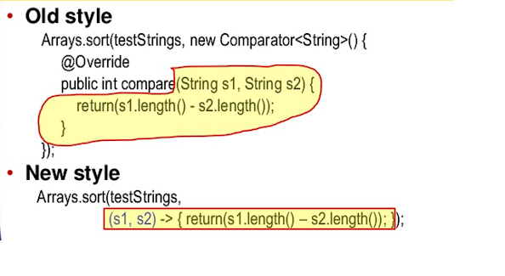

3. What does the filter() method do? when you use it? (answer)
The filter method is used to filter elements that satisfy a certain condition that is specified using a Predicate function.
A predicate function is nothing but a function that takes an Object and returns a boolean. For example, if you have a List of Integer and you want a list of even integers.
In this case, you can use the filter to achieve that. You supply a function to check if a number is even or odd, just like this function, and filter will apply this to stream elements and filter the elements which satisfy the condition and which don't.

4. What does the flatmap() function do? why you need it? (answer)
The flatmap function is an extension of the map function. Apart from transforming one object into another, it can also flatten it.
For example, if you have a list of the list but you want to combine all elements of lists into just one list. In this case, you can use flatMap() for flattening. At the same time, you can also transform an object like you do use map() function.
5. What is the difference between flatMap() and map() functions? (answer)
Even though both map() and flatMap() can be used to transform one object to another by applying a method to each element.
The main difference is that flatMap() can also flatten the Stream. For example, if you have a list of the list, then you can convert it to a big list by using the flatMap() function.
Btw, if you find trouble understanding these functional programming methods like map, flatMap, filter, etc., I suggest you go through From Collections to Streams in Java 8 course on Pluralsight. It's an advanced course but very good.
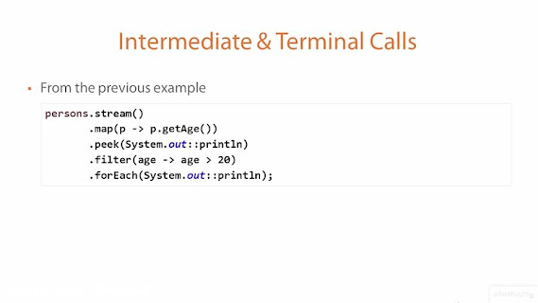

6. What is the difference between intermediate and terminal operations on Stream? (answer)
The intermediate Stream operation returns another Stream, which means you can further call other methods of Stream class to compose a pipeline.
For example after calling map() or flatMap() you can still call filter() method on Stream.
On the other hand, the terminal operation produces a result other than Streams like a value or a Collection.
Once a terminal method like forEach() or collect() is called, you cannot call any other method of Stream or reuse the Stream.
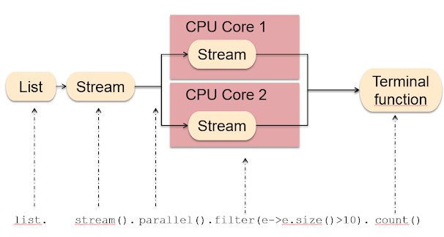

7. What does the peek() method do? When should you use it? (answer)
The peek() method of Stream class allows you to see through a Stream pipeline. You can peek through each step and print meaningful messages on the console. It's generally used for debugging issues related to lambda expression and Stream processing.

8. What do you mean by saying Stream is lazy? (answer)
When we say Stream is lazy, we mean that most of the methods are defined on Java .util.stream.Stream class is lazy i.e. they will not work by just including them on the Stream pipeline.
They only work when you call a terminal method on the Stream and finish as soon as they find the data they are looking for rather than scanning through the whole set of data.

9. What is a functional interface in Java 8? (answer)
As the name suggests, a functional interface is an interface that represents a function. Technically, an interface with just one abstract method is called a functional interface.
You can also use @FunctionalInterface to annotated a functional interface. In that case, the compiler will verify if the interface actually contains just one abstract method or not. It's like the @Override annotation, which prevents you from accidental errors.
Another useful thing to know is that If a method accepts a functional interface, then you can pass a lambda expression to it.
Some examples of the functional interface are Runnable, Callable, Comparator, and Comparable from old API and Supplier, Consumer, and Predicate, etc. from new function API. You can learn more about those interfaces in Java in these Java 8 online courses.


10. What is the difference between a normal and functional interface in Java? (answer)
The normal interface in Java can contain any number of abstract methods, while the functional interface can only contain just one abstract method.
You might be thinking why they are called functional interfaces? Once you know the answer, it might be a little easier for you to remember the concept.
Well, they are called functional interfaces because they wrap a function as an interface. The function is represented by the single abstract method on the interface.
11. What is the difference between the findFirst() and findAny() method? (answer)
The findFirst() method will return the first element meeting the criterion i.e. Predicate, while the findAny() method will return any element meeting the criterion, very useful while working with a parallel stream. You can further see this article for a working example of the findFirst() method in Java 8.
12. What is a Predicate interface? (answer)
A Predicate is a functional interface that represents a function, which takes an Object and returns a boolean. It is used in several Stream methods like filter(), which uses Predicate to filter unwanted elements.
here is how a Predicate function looks like:
public boolean test(T object){
return boolean;
}
You can see it just has one test() method which takes an object and returns a boolean. The method is used to test a condition if it passes; it returns true otherwise false.
13. What are Supplier and Consumer Functional interface? (answer)
The Supplier is a functional interface that returns an object. It's similar to the factory method or new(), which returns an object.
The Supplier has get() functional method, which doesn't take any argument and return an object of type T. This means you can use it anytime you need an object.
Since it is a functional interface, you can also use it as the assignment target for a lambda expression or method reference.
A Consumer is also a functional interface in JDK 8, which represents an operation that accepts a single input argument and returns no result.
Unlike other functional interfaces, Consumer is expected to operate via side-effects. The functional method of Consumer is accept(T t), and because it's a functional interface, you can use it as the assignment target for a lambda expression or method interface in Java 8.
14. Can you convert an array to Stream? How? (answer)
Yes, you can convert an array to Stream in Java. The Stream class provides a factory method to create a Stream from an array, like Stream .of(T ...) which accepts a variable argument, that means you can also pass an array to it as shown in the following example:
String[] languages = {"Java", "Python", "JavaScript"};
Stream numbers = Stream.of(languages);
numbers.forEach(System.out::println);

Output:
Java
Python
JavaScript
So, yes, it's possible to convert an array to Stream in Java 8. You can even convert an ArrayList to Stream, as explained in that article.
15. What is the parallel Stream? How can you get a parallel stream from a List? (answer)
A parallel stream can parallel execute stream processing tasks. For example, if you have a parallel stream of 1 million orders and you are looking for orders worth more than 1 million, then you can use a filter to do that.
Unlike sequential Stream, the parallel Stream can launch multiple threads to search for those orders on the different parts of the Stream and then combine the result.
Read more: https://www.java67.com/2018/10/java-8-stream-and-functional-programming-interview-questions-answers.html#ixzz7pcPz3moF

1) Predicate: What Is It?
A predefined Functional Interface is a predicate. It can be found in java.util.function. Package of predicate. It only takes one argument, which has the form indicated below.

2) Is the following code flawed in any way? Does it compile or does it produce a specific error?
@FunctionalInterface
public interface Test<A, B, C>
public C apply(A a, B b);
default void printString() {
System.out.println("softwaretestinghelp");
}
}
Yess. Because the code adheres to the functional web api of specifying only one abstract method, it will compile. A default method which does not qualify as an abstract method is the second one, printString().
Related Article: Java Stream Tutorial

3) A Stream API: What Is It? Why is the Stream API necessary?
Java 8 now has a new functionality called Stream API. It is a unique class used for handling items from sources like collections.
The Stream API is necessary for us because
- Because it offers aggregate operations, processing is made simple.
- Programming in the functional style is supported.
- It processes data more quickly. It is therefore suitable for greater performance.
- Parallel operations are possible.

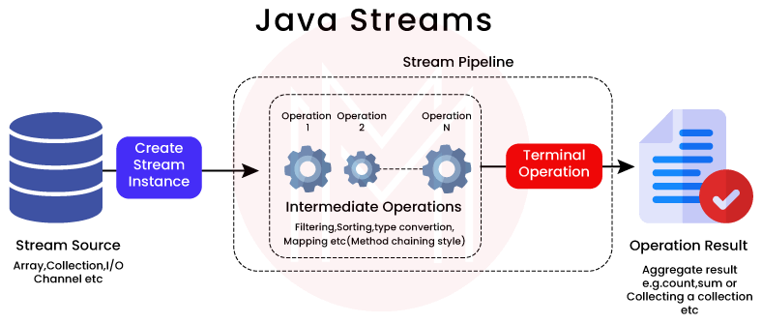

4) What distinguishes a limit from a skip?
The Stream of the desired size is returned using the limit() method. As an illustration, if you mentioned limit(5), there would be 5 output elements.

5) What function does Java 8's limit() method serve?
The limit of the elements is specified via the Stream.limit() function. Limit(X) will return a stream with the size you specified, where X is the value you entered. It belongs to the class java.util.stream.Stream.

6) What distinguishes Stream's Intermediate and Terminal Operations?
All stream operations fall into one of two categories: Terminal or Intermediate. The operations known as intermediate operations are those that release the stream so that subsequent operations can be performed on it. Lazy operations are intermediate operations since they do not analyze the Stream at the call point.
When a terminal operation is performed, these activities (Intermediate Operations) process data. Map and filter are two examples of intermediate operations.
Processing of Streams is started by Terminal Operations. The Stream runs through all of the Intermediate processes during this call. Sum, Collect, and forEach are some examples of terminal operations.

7) What distinguishes findFirst() from findAny() in the Stream object?
The findAny() method is used to determine any element from the stream, but the findFirst() method is employed to discover the first element from the stream, as the name implies.
While the findAny() is non-deterministic, the findFirst() is predestinarian in nature. Deterministic in programming refers to a system where the outcome is determined by the input or beginning state.

8) The Consumer Functional Interface: What Is It?
Like PredicateT> and FunctionT, R>, Consumer Functional Interface also accepts a single argument. It is categorised as java.util.function. Consumer. This has no value returned.

9) The Supplier Functional Interface: What Is It?
There are no input parameters accepted by the Supplier Functional Interface. It is categorised as java.util.function. Supplier. This uses the get function to return the value.

10) What does Java 8's Nashorn mean?
A Java-based engine for running and analysing JavaScript code is called Nashorn in Java 8.

11) What distinguishes map from flatMap stream operation?
While flatMap Stream delivers zero or more output values per input value, Map gives one output value for every input value.

12) What does Java 8's MetaSpace mean?
A new feature to store classes was added in Java 8. In Java 8, there is a place known as MetaSpace where all the classes are kept. MetaSpace has replaced PermGen. The Java Virtual Machine used PermGen to store the classes prior to Java 7. Java 8 substituted MetaSpace for PermGen because MetaSpace is dynamic and has no size restrictions. It can also grow dynamically.

13) Describe JJS.
JavaScript code is run at the console using JJS, a command-line tool. The new JavaScript engine executable in Java 8 is called JJS.



14) What do Java 8's ChronoUnits do?
The enum ChronoUnits was created to take the place of the Integer values which the former API used to indicate the month, day, etc.

15) What does the Java 8 StringJoiner Class mean? How can we use the StringJoiner Class to join several Strings?
StringJoiner is a new class that was added to the java.util package in Java 8. With the help of this class, we may combine numerous strings that have been separated by delimiters and add prefixes and suffixes to them.

16) What distinguishes a collection from a stream?
A Package includes its elements, whereas a Stream does not, and this is the primary distinction between the two types of data structures. Unlike other views, Stream operates on a view whose elements are actually kept in a collection or array, but any changes made to Stream do not affect the original collection.

17) What distinguishes the map() and flatMap() functions?
Despite the fact that each element can have a function applied to it, map() and flatMap() can both be used to convert one object to another. The primary distinction is that flatMap() can flatten the Stream as well. For instance, you may use the flatMap() function to transform a list of lists into a large list.

18) What distinguishes Stream's intermediate and terminal operations?
You can call additional methods of the Stream class to build a pipeline because the intermediary Stream action returns another Stream.

19) What accomplishes the procedure peek()? When ought one to employ it?
You can peek into a Stream pipeline using the peek() function of the Stream type. Each stage can be peeked through, and the terminal can print out messages that imply something. It is typically used to troubleshoot lambda expressions and stream processing problems.

20) What distinguishes a Java functional interface from a conventional interface?
While the functional interface in Java can only contain one abstract method, the normal interface can include any number of abstract methods. They wrap a function in an interface, which is why they are termed functional interfaces. The one abstract method on the interface serves as the function's representation.

Java Stream Interview Questions For Experienced

1) Predicate interface: what is it?
A function that takes an Object and produces a boolean is represented by a Predicate, which is a functional interface. Several Stream methods, like filter(), which employs Predicate to filter out undesirable components, use it.

2) What exactly does an interface's default method do?
The methods that are declared to use the default keyword are the default methods. Prior to Java 8, it is not possible to define methods inside the interface; however, starting with Java 8, you can do so by utilising default methods. Because it enables you to develop the interface after release, this is also known as the "defender technique." By using the default keyword, you may now introduce new methods without disrupting all the clients. JDK 8 has greatly benefited from this, adding several important methods including for Each() and stream() as default methods to already existing types like Iterable and Collection.

3) What distinguishes Period from Duration in Java 8?
There is a small distinction between Period and Duration, despite the fact that both can be used to compute the distinction between dates in Java. In Java 8, Period is the difference between the two LocalDate values while Length is the difference between the two Instant values. Instead of returning a Duration, the LocalDate till() method returns a Period, which may be used to display a number of days, months, and years that have passed between two dates.

4) What are the main features that JDK has added?
The following are some of the key features that JDK 7 introduced:
- A better diamond operator type inference.
- Adding support for strings in switching and case expressions
- Try-with-resource or automatic resource management
- Fourth-Join Framework
- Use an underline in literal numbers
- Capability of using a single catch block to catch numerous exceptions
- Binary literals beginning with "0b"
- The updated File API and Java NIO 2.0
- G1 Garbage Collectors

5) What does Java's ForkJoinPool do?
The ForkJoinPool is a unique thread pool that operates on the idea of work-stealing, meaning that if a post is free, it may grab work from the overloaded queue of another thread. As a result, the remedy is more effective.
Related Article: Java Tutorial

6) What does the Java Diamond Operator do?
With Java, the angle bracket was transformed into the diamond operator, which aids in type inference by preventing the need to repeat the type on the right-hand side of the equation. By doing this, programming effort and clutter are minimised without affecting code readability.

7) What are SAM or functional interfaces?
An interface having a single abstract method is referred to as a functional interface. It is also referred to as the Single Abstract Method (SAM) interface as a result. It encapsulates a function as an interface, or, to put it another way, a function is defined by a dependent upon the type method of the interface, which is why it is known as a reference implementation. The amount of static, overridden and default methods in functional interfaces is infinite. Regarding stating Functional Interfaces

8) What is the standard procedure and why is it necessary?
The default method in an interface is a method with a predetermined body. The word default is used. In Java 8, default methods were added for "Backward Compatibility" in the event that the JDK changed any interfaces. All classes that implement the interface will break if a new abstract method is added, and they will all need to implement the new method. The interface conforming classes won't experience any effects from default methods. In the implementation, default methods can indeed be overridden if necessary. Additionally, it is neither synchronised nor final.

9) What do Interfaces' static methods do?
Static methods, that contain method implementation and are accessed using the identity of the interface, are excellent for defining utility methods because they are controlled by the interface and cannot be overridden.

10) What characteristics distinguish a lambda expression?
The two key characteristics of the procedures that are specified as lambda expressions are listed below:
- Another method may accept lambda expressions as a parameter.
- Lambda expressions are independent of classes and can be used alone.

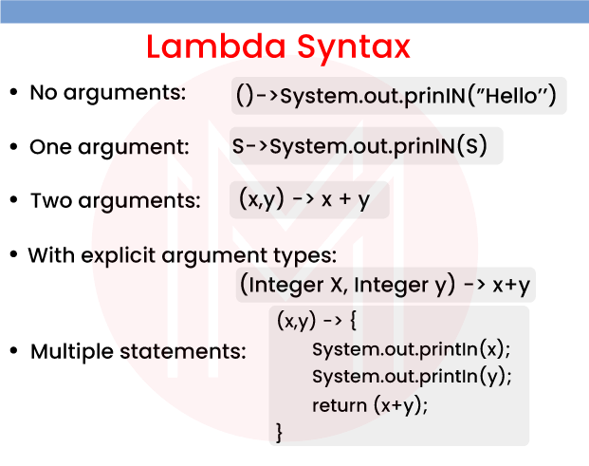

11) A type interface: what is it?
Even previous Java versions had a type interface. The method invocation and accompanying declaration are examined by the compiler at compilation time in order to determine the type of argument.

12) What benefits come with using the Optional class?
The following benefits of using the Optionally class are highlighted:
It avoids null tests by encapsulating optional data, such as null or not-null values, resulting in better, more readable, and more reliable code. It serves as an object wrapper and returns an object rather than a value, which can be utilised to prevent run-time errors. NullPointerExceptions

13) What constitutes a Stream's primary elements?
These are the stream's constituents:
- a source of data
- a group of intermediary operations to handle the data source
- a single terminal operation yields the outcome

14) What types of data objects can a stream process and from what sources?
These types of data can be processed by a stream:
- an assortment of Arrays.
- an input device or I/O channel.
- A source that responds such as comments on social media
- a static factory or a stream generator function.

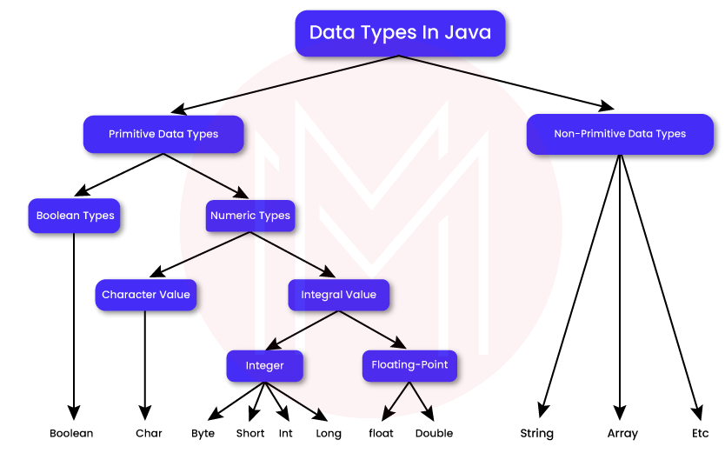

15) Intermediary operations: what are they?
- Analyze the stream's components.
- Usually converts one stream into another
- Are lazy, that is, they wait to execute until a terminal action is called.
- Carries out internal iteration on each component of the source.
- The processing pipeline allows for the chaining of any number of activities.
- The operations are carried out in the prescribed order.
- Lambda functions predominate in intermediate processes.

Most Common Java Stream FAQs

1) What new features does Java 8 have?
The following is a list of the additional features that are included in Java 8:
- References to Methods
- Lambda Expressions
- Default methods
- Optional Class
- Functional Interface
- JavaScript Engine Nashorn
- Stream API
- Date API

2) Functional Interfaces: What Are They?
An interface that just has one abstract method is said to be functional. These interfaces are implemented using a Lambda Expression, therefore in order to utilise it, you must either develop a new task to implement or use an existing functional interface from Java 8.

3) What is an elective course?
Java 8 introduced the optional class, a special wrapping class designed to prevent NullPointerExceptions. This last class can be found in the java.util package. When we don't do the Null checks, NullPointerExceptions happen.

4) What are the standard techniques?
The interface's default methods are those with a body. These techniques make use of the default keywords, as their name suggests. These default methods are used for "Backward Compatibility," which implies that if the JDK alters any interface (without a default method), the classes that implement that interface would stop working. On the other side, you can offer the default implementation if you add the defaults method to an interface. The implementing classes won't be impacted by this.

5) What are the Lambda Function's primary characteristics?
The following are the primary properties of the lambda function:
- It is possible to pass a lambda expression method as an argument to another method.
- A method does not need to be a member of a class to exist.
- Since the compiler can determine the type from the parameter's value, there is no need to declare the type of the parameter.
- When utilising numerous parameters, parentheses can be used, however when using a single parameter, they are not necessary.
- There is little need for curly braces if the expression body only contains one sentence.

6) Why was the previous date and time flawed?
The disadvantages of the previous date and time are outlined below:
Java.util.
- The new Java 8 Date and Time API is thread-safe, whereas Date is changeable and not thread-safe.
- While the previous date and time are badly conceived, Java 8's Date and Time API complies with ISO standards.
- It has added a number of date-related API classes, like LocalDate, LocalTime, LocalDateTime, etc.
- When comparing the two in terms of performance, Java 8 performs better than the previous date and time system.
Related Article: Java Interview Questions

7) How is a functional interface made?
Java can recognise a functional interface, but you can define one by using an annotation.
@FunctionalInterface
There can only be one abstract method once the functional interface has been specified. You can create numerous dynamic methods and default methods because there is only one abstract method.

8) SAM interference: What is it?
FunctionalInterface, a new feature introduced in Java 8, can only have one abstract method. These interfaces are commonly referred to as SAM Interfaces because they only specify one abstract method. The abbreviation "Single Abstract Method" is SAM.

9) How does Method Reference work?
Method Reference is a new feature that was added to Java 8. This phrase is used to describe the functional interface method. When referring to a method, it can take the place of a lambda expression.

10) Describe the ensuing Syntax
String:: ValueOfExpression
It is a reference for the String class' ValueOf method. System.out:: println is a main stage that refers to the println method of the System class's out object. It provides back the provided argument's appropriate string representation. The case may be C.

