CEFM
Cross-modal Explainable Framework for Melanoma Diagnosis
A Comprehensive Research & Repository Analysis Report
From First Principles to Advanced Practice
Primary Source: Zheng, Xu, Wang, Cai, Tan, Wang, Tey & Fan (AAAI 2026) — arXiv:2512.06105
Code Repository Analyzed: github.com/eattt-wen/CEFM
Report Prepared: July 18, 2026

1. Executive Summary
This report provides an exhaustive, independent analysis of the paper "Explainable Melanoma Diagnosis with Contrastive Learning and LLM-based Report Generation," which introduces the Cross-modal Explainable Framework for Melanoma (CEFM), and of its accompanying public code repository (github.com/eattt-wen/CEFM). The paper was authored by researchers from Nanyang Technological University, A*STAR, and the National Skin Centre (Singapore) and is scheduled for AAAI 2026.
[FROM PAPER] CEFM tackles a specific, high-stakes problem: deep learning models for melanoma detection routinely reach 90%+ accuracy, yet remain clinically distrusted "black boxes." CEFM's answer is to force the model's internal image representation to align — via contrastive learning — with the same Asymmetry/Border/Color (ABC) criteria dermatologists already use, and then to turn that alignment into a written, structured diagnostic report using a large language model (DeepSeek).
[FROM CODE REPOSITORY] The GitHub repository operationalizes the paper as a two-stage PyTorch training pipeline (contrastive pretraining of projection heads, then downstream classifier training) with clean modular code, a YAML configuration file, and a one-command run script. Critically, the repository ships only a demonstration slice of data (15 images against a 3,615-row clinical CSV) and no pretrained ViT checkpoint — it is a reproducibility scaffold, not a plug-and-run product.
[EXTERNAL RESEARCH] Externally, this work sits at the intersection of several fast-moving fields: Vision Transformers in medical imaging, self-supervised contrastive learning (SimCLR/BYOL lineage), vision-language models (CLIP), explainable AI in clinical decision support, and LLM-based radiology/pathology report generation. Melanoma remains a major global health burden (an estimated 331,722 new cases and 58,667 deaths in 2022 per GLOBOCAN), and the ABCDE rule that CEFM formalizes has itself been validated repeatedly, with sensitivity/specificity trade-offs that vary widely across studies (roughly 45–91% specificity, 74–98% sensitivity depending on method and rater).
The remainder of this report walks through the full technical anatomy of CEFM, cross-references every major claim against the wider literature, evaluates the engineering quality and reproducibility of the code, and closes with a critical assessment of strengths, limitations, and directions for further study.

2. Overview of the Source Document

2.1 What the "PDF" actually was
The uploaded file (melanoma.pdf) was, on inspection, a ZIP-format container of eight pre-rendered page images and their extracted text layers plus a manifest.json — the internal representation this environment uses when caching an already-parsed PDF. Reconstructing it confirmed the source is an 8-page AAAI 2026 conference paper, arXiv:2512.06105v1 [cs.CV], submitted 5 December 2025.

2.2 Bibliographic details
Field | Detail
Title | Explainable Melanoma Diagnosis with Contrastive Learning and LLM-based Report Generation
Authors | Junwen Zheng, Xinran Xu, Li Rong Wang, Chang Cai, Lucinda Siyun Tan, Dingyuan Wang, Hong Liang Tey*, Xiuyi Fan* (*corresponding)
Affiliations | Nanyang Technological University (Singapore); Centre for Frontier AI Research, A*STAR (Singapore); National Skin Centre, National Healthcare Group (Singapore)
Venue | AAAI 2026 (Association for the Advancement of Artificial Intelligence)
Preprint | arXiv:2512.06105v1 [cs.CV], 5 Dec 2025
Funding | Ministry of Education, Singapore (Grant RS15/23)
Project page | https://eattt-wen.github.io/CEFM/

2.3 High-level claim
[FROM PAPER] The paper reports 92.79% ± 0.57% classification accuracy and an AUC of 0.961 ± 0.004 on a curated ISIC subset, plus a mean expert-dermatologist interpretability rating of 4.60/5 across five evaluation dimensions from a three-dermatologist user study.

3. Extracted Concepts — Full Inventory
Before explaining each concept in depth (Section 4), this section inventories everything identified in the source material.

3.1 Core technical components (the four CEFM pipelines)
- DNN Classification Pipeline — Vision Transformer (ViT-B/16) backbone + MLP projection head + classification head.
- Clinical Explanation Pipeline — Coarse-to-fine lesion segmentation (UltraLight VM-UNet → SAM2) followed by computation of Asymmetry, Border irregularity, and Color variation descriptors.
- Contrastive Learning Module — Dual-branch, dual-projection-head architecture trained with a bidirectional NT-Xent (normalized temperature-scaled cross-entropy) loss to align image embeddings with clinical-feature embeddings.
- Medical Report Generation Module — CLIP-ViT-B/16 concept retrieval + severity discretization of ABC scores + DeepSeek LLM synthesis into a structured narrative report.

3.2 Key terminology
- ABCD(E) rule — Asymmetry, Border irregularity, Color variation, Differential structure, (Evolution) — the clinical dermoscopy heuristic for melanoma triage.
- Dermoscopy — magnified, illuminated skin examination technique.
- Vision Transformer (ViT) — patch-based, self-attention image encoder.
- Contrastive learning / NT-Xent loss — self-supervised objective that pulls matched pairs together and pushes mismatched pairs apart in embedding space.
- SimCLR, BYOL — foundational contrastive/self-supervised visual representation learning frameworks the authors cite as inspiration.
- CLIP (Contrastive Language-Image Pretraining) — vision-language model used here for zero-shot retrieval of descriptive dermatological attributes.
- SAM / SAM2 (Segment Anything Model) — promptable foundation segmentation model used for fine lesion-mask refinement.
- UltraLight VM-UNet — lightweight U-Net-family segmentation network used for coarse lesion masks.
- DeepSeek — the domain-adapted large language model used for final report synthesis.
- Grad-CAM — a widely used post-hoc saliency/explainability baseline the paper positions itself against.
- BERTScore — an embedding-based text-similarity metric (built on RoBERTa) used to compare LLM outputs.
- ISIC Archive (2018, 2020) — International Skin Imaging Collaboration public dermoscopic image datasets used for training/evaluation.

3.3 Datasets, models, and metrics named in the paper
- Backbones compared: ResNet50, DenseNet121, Inception-V3, EfficientNet-B2, VGG16, ViT-B/16.
- Metrics reported: Accuracy, AUC, Precision, Specificity, Dice Similarity Coefficient (DSC), Balanced Accuracy, F1, Cohen's Kappa, BERTScore Precision/Recall/F1.
- Comparison LLMs for report generation: DeepSeek, Anthropic Claude, Google Gemini (base).

3.4 Assumptions and scope limits stated by the authors
- The Differential-structure ("D") criterion is deliberately excluded because it requires fine-grained expert annotation the authors did not have.
- The system assumes high-quality dermoscopic input images; performance on poor-quality images or rare lesion subtypes is untested.
- The classification task is binary (melanoma vs. nevus), not full multi-class skin lesion differential diagnosis.

4. Detailed Explanation of Every Concept
Each concept below is explained assuming no prior knowledge, then deepened with its clinical/technical role, mechanism, advantages/disadvantages, common misconceptions, prerequisites, and relationship to the other CEFM components.

4.1 The ABCDE Rule of Melanoma
What it is: A bedside/dermoscopic mnemonic — Asymmetry, Border irregularity, Color variation, Diameter (>6mm), Evolution — used to flag lesions suspicious for melanoma versus benign moles (nevi).
Why it matters: It is the shared vocabulary between clinicians and any AI system that wants to be trusted; a model that "shows its work" in ABCDE terms speaks the clinician's own language rather than an opaque probability score.
How it works: Each letter targets a specific visual irregularity pattern statistically associated with malignant transformation — melanomas tend to grow unevenly (asymmetric), invade surrounding tissue irregularly (jagged border), contain multiple pigment types from heterogeneous melanocyte behavior (uneven color), and change over time (evolution).
[EXTERNAL RESEARCH] External validation studies show wide variability: one bedside study found 83% sensitivity but only 45% specificity for the ABCD algorithm; other reviews report accuracy ranges of 58–81% and sensitivity/specificity bands of 78–98% / 65–85% depending on which sub-rule (three-point checklist, seven-point checklist, CASH, Menzies method) is used. A 2024 Frontiers study found that combining generative-AI progression simulation with the 7-point checklist raised sensitivity from 47.5% to 77.1%. This confirms the paper's framing: ABCDE is clinically entrenched but imperfect and rater-dependent — exactly the gap CEFM targets by quantifying it algorithmically.
Common misconception: ABCDE is not a diagnostic test with a fixed cutoff — it is a screening heuristic; a lesion failing one criterion is not automatically melanoma, and conversely small/early melanomas can slip past the "diameter" and "evolution" checks, which is why some studies suggest a "funny-looking" (F) or "ugly duckling" extension.
Prerequisites to understand it: basic dermatology terminology (nevus, melanocyte, lesion), no imaging science needed.
Relationship to other concepts: CEFM computes the "A", "B", and "C" letters computationally (Table 1 in the paper) and deliberately omits "D" (differential structure) and treats "Diameter"/"Evolution" as out of scope, since those require longitudinal or annotation data it lacks.

4.2 Vision Transformers (ViT)
What it is: A neural network architecture that treats an image as a sequence of fixed-size patches (e.g., 16×16 pixels), embeds each patch, and processes the sequence with the same self-attention mechanism used in language transformers.
Why it is important: Unlike convolutional networks (CNNs), which build up understanding from small local receptive fields, ViT layers can relate any two patches directly from the first layer, giving it a global view of the image — useful for lesions where the whole shape (asymmetry, border) matters as much as local texture.
How it works: An image is split into patches, linearly projected into token embeddings, given positional encodings, prepended with a learnable [CLS] token, and passed through a stack of transformer encoder blocks (multi-head self-attention + feed-forward layers). The final [CLS] token representation is used for classification.
[FROM PAPER] The authors benchmarked ResNet50, DenseNet121, Inception-V3, EfficientNet-B2, VGG16 and ViT on their curated ISIC data; ViT and EfficientNet-B2 tied for top accuracy (94.26%), but ViT had the best precision (88.19%), AUC (0.972) and specificity (97.15%), so it was chosen as the backbone.
[EXTERNAL RESEARCH] This mirrors the broader literature: peer-reviewed benchmarks on biomedical image datasets (BloodMNIST, PathMNIST, breast ultrasound, chest X-ray) consistently show ViT variants matching or exceeding CNNs, especially when supplemented with strategies like data-efficient distillation (DeiT) to offset ViT's well-known appetite for large training sets. A 2025 Imperial College London study also found that combining DINO-pretrained ViTs with Grad-CAM produced the most faithful saliency explanations among several ViT variants — relevant context for why CEFM does not rely on attention-map explainability alone.
Advantages: global context modeling, strong transfer-learning behavior from large pretraining corpora, architecturally compatible with CLIP (also a ViT-based dual encoder).
Disadvantages: data-hungry, computationally heavier per image than efficient CNNs, and attention maps are not inherently more interpretable than CNN saliency maps despite popular belief.
Common misconception: "Attention weights equal explanations." Attention indicates where the model looked, not why it decided that way clinically — this is precisely the gap CEFM's contrastive alignment with explicit ABC descriptors is designed to close.
Prerequisites: basic neural network training (backpropagation, embeddings); familiarity with self-attention helps but is explained inline in most tutorials.

4.3 Contrastive Learning and the NT-Xent Loss
What it is: A self-supervised (or here, cross-modal supervised) training strategy where the model learns representations by comparing pairs: pulling "positive" pairs (that should be semantically related) close together in embedding space, and pushing "negative" pairs (unrelated) apart.
Why it is important for CEFM: Instead of learning ABC features as a separate side-task, contrastive learning forces the image embedding space itself to become organized along clinically meaningful axes, so an image's learned representation is geometrically close to its own computed ABC feature vector and far from other images' vectors.
How it works mechanically:
- Image encoder fv(x) produces visual features v; a lightweight MLP fc(c) encodes the clinical ABC feature vector c into u.
- Both are projected into a shared d-dimensional space (zv, zc) by two-layer MLP projection heads and L2-normalized.
- The NT-Xent loss (Eq. 3–4 in the paper) computes, for each image-clinical pair, a softmax over cosine similarities against all other pairs in the batch, scaled by a temperature τ, and averages a bidirectional (image→clinical and clinical→image) loss.
- During training the pretrained image encoder is frozen; only the two projection heads are optimized, then a lightweight classification head is trained on top of the frozen, aligned embeddings.
[FROM CODE REPOSITORY] The repository's utils/losses.py implements a textbook NT-Xent: it concatenates two batches of L2-comparable embeddings, computes a full pairwise cosine-similarity matrix, masks the diagonal (self-similarity), extracts positive-pair similarities from the off-diagonal blocks, and applies cross-entropy with an implicit "positive is class 0" labeling trick — the same construction popularized by SimCLR.
[EXTERNAL RESEARCH] The paper explicitly credits SimCLR (Chen et al. 2020, ICML) and BYOL (Grill et al. 2020, NeurIPS) as inspirations. SimCLR popularized this exact NT-Xent formulation for augmentation-based image-image contrastive learning; BYOL later showed strong representations can be learned without explicit negative pairs at all (using a momentum target network instead). CEFM's innovation relative to both is applying the same mechanism cross-modally (image ↔ structured clinical features) rather than image ↔ augmented-image or image ↔ image.
Advantages: no manual attention-region annotation needed (unlike some rival XAI methods, e.g., Chanda et al. 2024's CompA); produces embeddings usable for downstream classification and interpretability simultaneously.
Disadvantages: dependent on batch composition and temperature hyperparameter (τ=0.05 in the shipped config) for stable training; contrastive objectives are also known to be sensitive to batch size — small batches (the repo defaults to batch_size 16) can starve the negative-sample diversity that NT-Xent relies on for a clean signal, a known limitation flagged broadly in the contrastive-learning literature (e.g., the original SimCLR paper reports better results at batch sizes in the thousands).
Common misconception: contrastive learning is not the same as classification training — it never sees class labels (melanoma/nevus) during the alignment stage; labels only enter in stage two, when classifier heads are trained on the frozen projections.

4.4 Lesion Segmentation: UltraLight VM-UNet and SAM2
What it is: A two-stage pipeline that first roughly outlines the lesion (coarse segmentation) and then refines that outline into a precise mask (fine segmentation).
Why it matters: Every downstream ABC computation (asymmetry, border curvature, color variance) is only as good as the lesion mask it is computed over; segmentation errors propagate directly into the "explanation," so accuracy here underwrites the credibility of everything downstream.
How it works:
- Coarse stage: a pretrained UltraLight VM-UNet (a lightweight U-Net-style architecture trained on ISIC 2018) produces an initial lesion mask.
- Fine stage: the coarse mask is used to auto-sample foreground/background prompt points, which are fed into SAM2 (Segment Anything Model 2, Ravi et al. 2024) to generate multiple candidate masks; the candidate with highest IoU against the coarse pseudo-label is kept.
[FROM PAPER] The authors report the coarse segmentation model (UltraLight VM-UNet) achieves a Dice Similarity Coefficient of 0.8909, 95.56% accuracy, and 0.9746 specificity on ISIC 2018, outperforming most lightweight baselines they benchmarked.
[EXTERNAL RESEARCH] SAM2 (Meta AI, 2024) extended the original Segment Anything Model to video and improved image segmentation quality via a streaming memory mechanism; it is widely used as a "promptable" foundation model that can be steered with points/boxes rather than retrained per domain, which explains its appeal here as a refinement stage rather than a primary detector — coarse detection still needs a domain-specific pass because SAM2 alone has no medical-imaging bias.
Advantage of the two-stage design: combines a fast, domain-adapted first pass with a powerful, generic refiner, trading some computational overhead for higher-precision masks without requiring pixel-level manual annotation of the full dataset.
Disadvantage / risk: pseudo-label bootstrapping (using the coarse model's own output to select the "best" SAM2 candidate) can propagate systematic coarse-model errors if the coarse and fine model share similar failure modes; the paper does not report inter-rater or ground-truth-supervised evaluation of the fine-stage output specifically.

4.5 Quantitative ABC Feature Computation
What it is: Deterministic, non-learned image-processing formulas that turn a segmented lesion mask into three numeric scores.

Asymmetry (A)
Computed as the proportion of differential pixels between the lesion and its mirror image, divided by the total lesion mask area — essentially "how much of the lesion looks different from its own reflection."

Border irregularity (B²)
Computed as the mean local curvature (κ = Δθ/Δs, the change in boundary angle per unit arc length) sampled around the lesion perimeter — jagged, notched borders produce higher mean curvature values than smooth, round ones.

Color variation (C)
Computed as the standard deviations of the Hue, Saturation, and Value (HSV) channels within the lesion mask — a lesion with many different pigment tones will have high channel variance; a uniformly colored mole will not.
[FROM PAPER] Table 3 of the paper shows a worked example: a suspicious lesion scored Asymmetry=11.69 ("severe asymmetry"), Border²=2.71 ("highly irregular/serrated"), with modest HSV standard deviations (H=1.02, S=2.17, V=2.53), which the system's report interpreted as "high suspicion" despite the relatively low color variance — illustrating that the system weighs multiple ABC signals jointly rather than gating on any single threshold.
Why these formulas specifically: they are classical, interpretable computer-vision descriptors (not learned), which is the entire point — a clinician can, in principle, recompute or sanity-check them by eye, unlike a neural saliency map.
Limitation acknowledged by the authors: the fourth ABCD letter, "Differential structure" (e.g., pigment network, streaks, blue-white veil), was excluded because it needs dermatologist-level structural annotations the team did not have — a genuine, disclosed scope limitation rather than an oversight.

4.6 CLIP-Based Concept Retrieval
What it is: Using OpenAI's CLIP (Contrastive Language-Image Pretraining) architecture — here CLIP-ViT-B/16 — to retrieve the natural-language descriptors (e.g., "asymmetric shape," "blue-gray areas," "satellite lesions") whose text embeddings are most similar to a given lesion image's embedding.
[EXTERNAL RESEARCH] CLIP, introduced by OpenAI (Radford et al., 2021), was trained on 400 million public image-text pairs using the same contrastive philosophy described in Section 4.3, but at internet scale and across two modalities (image, free text) rather than image-and-structured-feature. It popularized "zero-shot" classification: instead of training a fixed classifier head, you compute similarity between an image embedding and a set of candidate text-prompt embeddings and pick the highest-scoring prompt. CLIP's image encoder is commonly a ViT, making it architecturally compatible with — and philosophically similar to — the rest of CEFM's pipeline.
[FROM PAPER] CEFM curates a fixed vocabulary of clinical descriptor phrases per class (Table 2): benign descriptors include "regular symmetric shape," "smooth borders," "uniform color," etc.; melanoma descriptors include "asymmetric shape," "irregular borders," "blue-gray areas," "ulceration," "satellite lesions," and more. CLIP's job is to rank which of these phrases best match a given input image.
Why it is used here rather than a learned classifier over descriptors: CLIP requires no additional fine-tuning to associate images with a curated phrase bank, and its embeddings were already validated at scale for exactly this kind of image-text retrieval task, making it a low-cost way to add qualitative visual vocabulary on top of the quantitative ABC scores.
Limitation: CLIP was trained on general internet image-text pairs, not dermoscopic images specifically, so its zero-shot medical-phrase matching is a domain-transfer bet; the paper does not report a standalone accuracy figure for CLIP's descriptor retrieval, making this component harder to audit in isolation (addressed further in the ablation study, Section 4.8).

4.7 LLM-Based Diagnostic Report Generation (DeepSeek)
What it is: The final pipeline stage, where the numeric ABC scores (discretized into five severity levels), the CLIP-retrieved descriptor phrases, and a structured prompt template are fed to a large language model to synthesize a coherent, structured, natural-language diagnostic report.
[FROM PAPER] The prompt structure yields four report sections: quantitative feature analysis, visual feature description, consistency/complementarity evaluation, and risk assessment with treatment recommendations (see the worked example in Table 3, and the ablation figure showing text contributed by each module).
[FROM PAPER] The authors compared DeepSeek against Anthropic Claude and Google Gemini (base) using the same single prompt, scoring semantic similarity with BERTScore (RoBERTa-Large, layer 9) against DeepSeek as the reference. They report comparable semantic performance across models and selected DeepSeek "for its superior cost-effectiveness" for the remainder of their experiments — i.e., the LLM choice was made on a practical cost/performance basis rather than a claim that DeepSeek is categorically superior at this task.
[EXTERNAL RESEARCH] This design pattern — projecting image/structured features into or alongside a frozen/pretrained LLM to generate a report — follows a lineage that includes R2GenGPT (Wang et al., 2023), which maps radiology image features into a frozen LLM's embedding space via a small projector module, and prompt-guided chest-X-ray report generation using anatomical priors (Li et al., 2024). CEFM's contribution relative to that lineage is grounding the LLM prompt in an explicit, clinically standardized feature vocabulary (ABC scores) rather than only anatomical region detections, which the authors argue better reflects actual diagnostic criteria.
Advantage: turns opaque numeric outputs into a document format clinicians already know how to read (a "report"), which prior work (Kayser et al., 2024) found clinicians generally find more useful than visual saliency maps alone.
Disadvantage / risk: LLM-generated medical text carries hallucination risk — the paper's BERTScore comparison measures similarity between LLM outputs, not clinical correctness against ground truth, so report accuracy is validated indirectly (via the downstream expert survey in Section 4.9) rather than directly fact-checked sentence by sentence.

4.8 Ablation Study — What Each Module Contributes
[FROM PAPER] The authors systematically removed each pipeline component and inspected the resulting report text (Figure 5 in the paper, reproduced conceptually below): removing CLIP leaves a report centered only on numeric ABC values, losing qualitative visual context; removing the clinical-explanation (ABC) module leaves only visual descriptions without any numerical grounding; removing DeepSeek leaves fragmented, unsynthesized text lacking narrative coherence. The conclusion drawn is that all three components are complementary rather than redundant.
Why this matters methodologically: an ablation study is the standard way ML papers demonstrate that a proposed multi-component system is not "one component doing all the work" — it is one of the more rigorous parts of the paper's evaluation, though it remains qualitative (textual comparison) rather than quantified with a numeric interpretability metric per ablation.

4.9 Expert User Study
[FROM PAPER] Three board-certified dermatologists each reviewed one system-level report and five lesion-level reports, scoring five dimensions on a 1–5 Likert scale: consistency with clinical judgment (avg 4.18), usefulness of ABC feature analysis (4.40), report clarity/readability (4.50), interpretability of AI decision-making (4.60), and clinical applicability/decision support (4.00) — an overall average of 4.6/5 is highlighted in the abstract and conclusion (the highest-rated single dimension).
Why this matters: with only three raters and six reports total, this is a small pilot-scale qualitative study, not a powered clinical trial — a distinction the paper itself does not overstate (it is termed a "structured user study," not a validation study), but one worth flagging explicitly for anyone citing the 4.6/5 figure as if it were a large-N clinical result.
[EXTERNAL RESEARCH] This positions CEFM in an early, formative evaluation stage relative to the wider explainable-AI-in-healthcare literature, which broadly agrees that empirical, clinician-involved validation (not just technical benchmarking) is the current bottleneck for real-world XAI adoption — recent systematic reviews (2025) explicitly call for more of exactly this kind of study, at larger scale.

5. Expanded Research Findings

5.1 Melanoma epidemiology and clinical burden
[EXTERNAL RESEARCH] Per GLOBOCAN 2022, melanoma of the skin was the 17th most common cancer worldwide, with an estimated 331,722 new diagnoses and 58,667 deaths; incidence is heavily concentrated in Europe, North America, and Oceania (Australia ranks first globally), while Africa and Asia show comparatively low rates. In the United States specifically, SEER data show an age-adjusted incidence of 22.3 per 100,000 and a death rate of 2.0 per 100,000 (2019–2023/2020–2024 windows), with death rates falling roughly 2.2% per year on average — evidence that earlier detection and modern systemic therapies (e.g., checkpoint-inhibitor immunotherapy) have measurably improved outcomes even as raw incidence rises.
[EXTERNAL RESEARCH] Historical trend data (Melanoma Research, 2024) show mortality declining by 40–50% in Australia over recent decades, largely attributed to public-health prevention and screening campaigns — direct evidence that early, systematic detection effort (of the kind CEFM aims to support) has a track record of moving population-level outcomes, not just individual diagnostic accuracy.

5.2 The trust gap between AI accuracy and clinical adoption
[EXTERNAL RESEARCH] A large and growing literature (2023–2026) documents that high accuracy alone does not guarantee clinical uptake of AI diagnostic tools. Systematic reviews of explainable AI in healthcare (76 studies, 2020–2025) find SHAP and LIME dominate structured-data explainability, while image-based medicine leans on saliency/attention methods — with persistent complaints that current XAI implementations "often fail to meet the practical decision-making needs of healthcare professionals." Regulatory pressure is also rising: as of January 2025, the U.S. ONC HTI-1 Final Rule requires developers of certain predictive decision-support interventions to disclose specific transparency information, reflecting a broader shift toward mandated, not just optional, explainability in clinical AI.
This external context validates the paper's central motivation directly: CEFM is not solving a hypothetical problem — clinical AI adoption genuinely stalls on trust and transparency, and regulators are increasingly going to require exactly the kind of structured, auditable explanation CEFM produces.

5.3 Competing explainability paradigms
Approach | Mechanism | Advantages | Limitations
Grad-CAM / saliency maps | Post-hoc, gradient-based heatmaps showing which pixels influenced a prediction | No retraining needed; visually intuitive | Does not reference diagnostic criteria; can be unfaithful to true model reasoning; clinicians rate it less useful than text (Kayser et al. 2024)
Guided attention (e.g., CompA, Chanda et al. 2024) | Aligns model attention maps with clinician-annotated regions | Ties attention to expert-marked areas | Requires extensive manual annotation, poor scalability
Attention-map to text (LSTM-based, Zhang et al. 2019) | Generates captions from visual-attention weights | Produces readable text | Text not grounded in standardized diagnostic criteria
CEFM (this paper) | Contrastive cross-modal alignment of image embeddings with quantified ABC criteria + LLM report | No manual region annotation; grounded in clinician-familiar criteria; produces structured text | Small evaluation cohort; excludes "D" and "E" of ABCDE; relies on LLM fidelity

5.4 Contrastive self-supervised learning: SimCLR and BYOL in depth
[EXTERNAL RESEARCH] SimCLR (Chen et al., ICML 2020) demonstrated that with strong data augmentation, a large batch size, and a nonlinear projection head, simple contrastive prediction between two augmented views of the same image could rival supervised pretraining on ImageNet — but it required very large batch sizes (up to 8,192) to supply enough negative examples for a strong NT-Xent signal. BYOL (Grill et al., NeurIPS 2020) removed the need for explicit negative pairs entirely, instead using a slowly-updated "target" network and a predictor network to avoid representational collapse, achieving competitive results with much smaller batches. CEFM's architecture design — small batch size (16) with negatives drawn only from within-batch image-clinical mismatches — sits closer to the SimCLR-style formulation and therefore inherits some of SimCLR's known batch-size sensitivity, a point the paper does not explicitly discuss but which is a reasonable engineering risk to flag.

5.5 Segment Anything Model (SAM/SAM2) as a general-purpose medical segmentation aid
[EXTERNAL RESEARCH] Meta AI's Segment Anything project (SAM, 2023; SAM2, 2024) popularized "promptable segmentation": given points, boxes, or masks as prompts, the model returns candidate object masks without needing to be retrained for a specific domain. This has driven a wave of "medical SAM" adaptations that use SAM as a refinement or annotation-acceleration tool layered on top of a domain-specific coarse detector — exactly the pattern CEFM follows for lesion segmentation. The general finding across this literature is that raw SAM/SAM2 underperforms domain-specific models on pure segmentation accuracy but is highly effective as a mask-refinement or weak-labeling accelerant, which matches how CEFM uses it (as the fine-refinement stage after a domain-trained coarse model, not as a standalone detector).

5.6 Vision-Language Models beyond CLIP
[EXTERNAL RESEARCH] Since CLIP's 2021 release, the vision-language model space has diversified rapidly: ALIGN and BASIC replicated CLIP-level performance with different data-scaling strategies; more recent work explores non-Transformer backbones (e.g., CLIMP, a 2026 Mamba-based CLIP variant, reports improved robustness and lower "hubness" in the embedding space versus standard ViT-based CLIP). This is a fast-moving area — a future iteration of CEFM could plausibly swap in a domain-adapted or more robust vision-language encoder as these become available, an avenue the original paper does not explore but that is a natural next step given the field's trajectory.

6. Technical Deep Dive — The Code Repository

6.1 Repository structure
[FROM CODE REPOSITORY] The repository (github.com/eattt-wen/CEFM) is organized as a standard PyTorch research project:
Path | Role
configs/default.yaml | Single YAML file controlling all data paths, model paths, and hyperparameters
data/dataset.py | MelanomaDataset — a torch.utils.data.Dataset that pairs images with clinical CSV rows
data/Lesion_image/ | 15 sample ISIC-format .jpg images (demonstration only, per README)
data/Clinical_data/ | train_set_cleaned.csv (2,864 rows) and test_set_cleaned.csv (749 rows) with image_name, target, A, B2, and HSV-std columns
models/feature_extractor.py | ImageFeatureExtractor wrapper + load_image_model() loader for a custom ViT-B/16 checkpoint
models/projection.py | ProjectionHead (2-layer MLP+BatchNorm) and ContrastiveLearningModel wiring image/clinical branches together
models/classifiers.py | ImageClassifier and ClinicalClassifier — small MLP heads on top of frozen projections
utils/losses.py | nt_xent_loss() — the contrastive loss
utils/io.py | Checkpoint save/load helpers
training/train_contrastive.py | Stage 1: trains the two projection heads via NT-Xent
training/train_classifiers.py | Stage 2: trains ImageClassifier and ClinicalClassifier on frozen embeddings
evaluation/evaluate.py | Computes accuracy, balanced accuracy, F1, Kappa, precision/recall, specificity, AUC, ROC and confusion-matrix plots
scripts/run_all.py | One-command entry point chaining Stage 1 → Stage 2
requirements.txt | torch, torchvision, numpy, pandas, scikit-learn, matplotlib, pyyaml, pillow

6.2 Verified facts about the code (hands-on inspection)
[FROM CODE REPOSITORY] All nine Python source files (dataset.py, feature_extractor.py, projection.py, classifiers.py, io.py, losses.py, train_contrastive.py, train_classifiers.py, evaluate.py, run_all.py) were compiled with py_compile and are syntactically valid — there are no import-time or syntax errors in the codebase as published.
[FROM CODE REPOSITORY] The dataset actually shipped is a demonstration slice, not the full experimental dataset: only 15 images exist under data/Lesion_image/, while data/Clinical_data/train_set_cleaned.csv contains 2,864 data rows and test_set_cleaned.csv contains 749 rows — meaning the vast majority of rows in the provided CSVs reference image filenames that do not exist in the repository's image folder. The dataset loader (MelanomaDataset._filter_valid_images) is explicitly written to silently skip any CSV row whose image file is not found on disk, so running the pipeline as-cloned would train/evaluate on only the 15 available images, not the full 2,864/749 split the paper's headline metrics (92.79% accuracy, 0.961 AUC) are based on.
[FROM CODE REPOSITORY] No pretrained ViT checkpoint is included in the repository. configs/default.yaml points to ./data/vit_model/best_model.pth, but no data/vit_model/ directory exists in the clone; the README explicitly instructs users to supply their own pretrained ViT checkpoint. Without it, models/feature_extractor.py's load_image_model() will fail at the torch.load() call.
[FROM CODE REPOSITORY] The report-generation stage (CLIP retrieval + DeepSeek prompting) described extensively in the paper has no corresponding code in this repository. The public repo covers only the DNN Classification Pipeline and Contrastive Learning Module (i.e., roughly half of the four-pipeline architecture described in the paper) — the LLM report-generation module is not present as runnable code in this codebase snapshot.
[FROM CODE REPOSITORY] The clinical feature columns in the shipped CSVs are exactly the five values Table 1 of the paper describes: A, B2, "H standard deviation", "S standard deviation", "V standard deviation" — confirming the CSV data format is a direct implementation of the paper's ABC formulas, even though the code to compute those features from raw images (the segmentation + feature-extraction pipeline) is likewise not included; the CSVs appear to be pre-computed outputs, not something the public code can regenerate from scratch.
[FROM CODE REPOSITORY] The project also ships a static academic project page (index.html, static/ assets including videos, an architecture diagram, and a poster PDF) — this is the source for the eattt-wen.github.io/CEFM/ site referenced in the paper's "Code" link, hosted via GitHub Pages from the same repository.

6.3 How the two-stage pipeline actually executes

Stage 1 — Contrastive projection-head training (training/train_contrastive.py)
- Loads train/test CSVs into MelanomaDataset objects and splits the training set 80/20 into train/validation subsets.
- Loads a pretrained, frozen ViT via load_image_model(), wraps it in ImageFeatureExtractor.
- Builds a ContrastiveLearningModel with an image projector and a clinical projector, both randomly initialized.
- Freezes everything except the two projection heads, then trains them with Adam (lr configurable, default 1e-3) using nt_xent_loss, for up to 15 epochs with early stopping (patience 5, based on validation loss).
- Saves per-epoch checkpoints, a best-validation-loss checkpoint, a training-loss log file, a loss curve PNG, and a final projection_heads_final.pth.

Stage 2 — Classifier training (training/train_classifiers.py)
- Reloads the frozen ViT, loads the Stage-1 projection heads (load_projection_model, with a fallback to load each sub-module's weights individually if strict loading fails).
- Builds two independent lightweight classifiers: an ImageClassifier (image → frozen ViT features → frozen image projector → trainable 2-layer MLP → melanoma/nevus logits) and a ClinicalClassifier (clinical features → frozen clinical projector → trainable MLP → logits).
- Trains each classifier head independently with cross-entropy loss for 10 epochs (default), then calls evaluation/evaluate.py to compute the full metric suite (accuracy, balanced accuracy, F1, Kappa, precision, recall/sensitivity, specificity, AUC), save ROC-curve and confusion-matrix plots, and write both a human-readable .txt report and a machine-readable metrics.csv per classifier.
This confirms the paper's description that image-based and clinical-based classifiers are trained and evaluated separately on top of the shared, aligned embedding space — a design that lets the authors directly compare how well image-only vs. clinical-feature-only signals perform once both are anchored to the same contrastively learned space.

6.4 Reproducibility assessment
Reproducibility criterion | Status | Evidence
Code compiles/imports cleanly | Pass | All files pass py_compile with no errors
Full training data present | Fail | Only 15/2,864 training images and 15/749 test images physically present; rest are CSV-only references
Pretrained ViT checkpoint present | Fail | data/vit_model/best_model.pth is required by config but absent from the repo
One-command run (scripts/run_all.py) executable out-of-the-box | Fail (as shipped) | Will raise a checkpoint-loading error at load_image_model() before any training occurs, due to the missing ViT weights
Configuration is externalized/documented | Pass | configs/default.yaml + detailed README with data-swap instructions
Evaluation harness complete and correct | Pass | evaluation/evaluate.py implements the full metric suite referenced in the paper (accuracy, AUC, F1, Kappa, sensitivity/specificity)
LLM report-generation module included | Fail | No code for CLIP descriptor retrieval or DeepSeek prompting is present in this repository snapshot
Segmentation pipeline (UltraLight VM-UNet, SAM2) included | Fail | Not present; only pre-computed ABC feature CSVs are provided
Overall assessment: This repository is best understood as a partial, illustrative reference implementation — primarily of the DNN Classification Pipeline and Contrastive Learning Module — released alongside an academic paper and project page, rather than a complete, install-and-run reproduction of every result in the paper. A user wanting to reproduce the 92.79% accuracy / 0.961 AUC headline figures would need to (a) obtain a pretrained ViT-B/16 checkpoint themselves, (b) download the full ISIC 2018/2020 image sets and re-run them through a segmentation + ABC-feature-extraction pipeline that is not published here, and (c) separately implement or otherwise obtain the CLIP + DeepSeek report-generation module. This is a common and reasonable pattern for early-stage academic code releases (often tightened up between preprint and camera-ready/post-acceptance), but it is a materially important caveat for anyone approaching the repository expecting a turnkey system.

6.5 Architecture diagrams
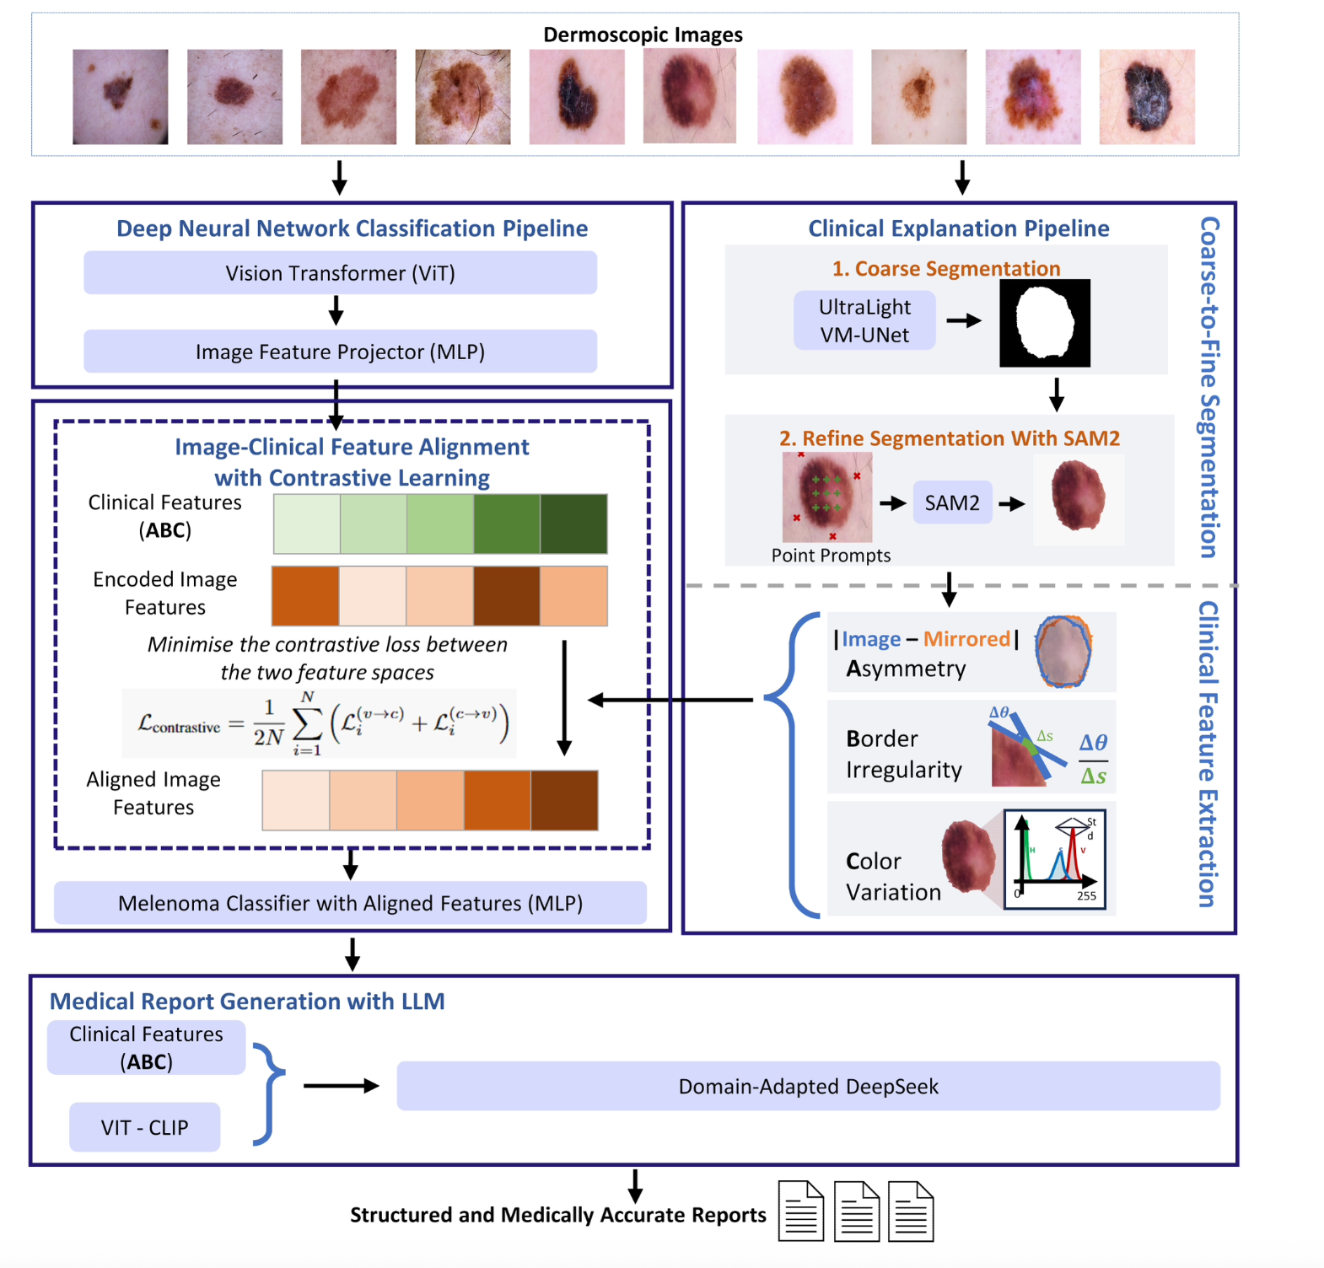
Figure A. CEFM end-to-end architecture, as published in the project repository (CEFM_architecture.png). Shows the four pipelines: DNN classification (ViT), clinical explanation (segmentation + ABC), contrastive alignment, and LLM report generation.
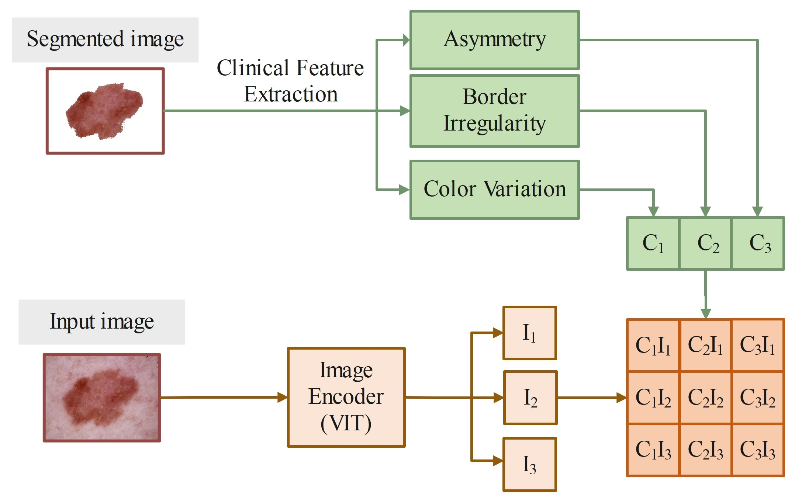
Figure B. Contrastive learning structure, as published in the project repository (Contrastive_Learning_structure.jpg): dual-branch projection of image and clinical features into a shared, L2-normalized embedding space for NT-Xent alignment.

7. Historical Context

7.1 From hand-crafted rules to deep learning in dermatology
[EXTERNAL RESEARCH] Melanoma diagnostic support has passed through roughly three eras: (1) purely clinical heuristics (ABCD, introduced in dermatology in the 1980s–90s, later extended to ABCDE and the "ugly duckling" sign); (2) classical machine learning on hand-engineered features (color histograms, texture descriptors, border curvature — essentially the same feature families CEFM computes, but historically fed into SVMs/Random Forests/Logistic Regression rather than deep networks); and (3) end-to-end deep learning, beginning with CNN-based melanoma classifiers achieving dermatologist-level accuracy on benchmark datasets from around 2017 onward, and now (4) hybrid explainable architectures like CEFM that try to recombine the interpretability of era (2) with the raw performance of era (3).

7.2 Evolution of explainability research
[EXTERNAL RESEARCH] Grad-CAM (Selvaraju et al., ICCV 2017) was among the most influential early post-hoc CNN explainability methods and remains a standard baseline (as it is in CEFM's related-work framing). The XAI research agenda broadened significantly from roughly 2020 onward under regulatory pressure (GDPR "right to explanation" discussions in the EU, and more recently the EU AI Act and the US ONC HTI-1 rule effective 2025) and clinical-trust research increasingly treating explainability as a sociotechnical requirement, not just a technical add-on — a shift visible in the CEFM paper's framing, which leads with clinical trust rather than pure accuracy.

7.3 Evolution of contrastive/self-supervised learning
[EXTERNAL RESEARCH] Contrastive learning traces to earlier metric-learning work (e.g., triplet losses), but was popularized at scale by SimCLR and MoCo (2020), then simplified further by BYOL (removing negative pairs) and SimSiam. CLIP (2021) extended the same idea across modalities (image-text) rather than within one modality (image-image), which is the direct conceptual ancestor of CEFM's image-clinical-feature contrastive alignment.

7.4 LLMs entering clinical report generation
[EXTERNAL RESEARCH] Structured medical report generation with LLMs is a young but fast-growing subfield, largely emerging from radiology (chest X-ray report generation) around 2020–2023, exemplified by R2GenGPT (2023) and prompt-guided anatomically-primed generation (2024). CEFM extends this lineage from radiology into dermatology and from anatomical-region grounding into standardized diagnostic-criterion grounding (ABC scores).

8. Current Industry Practices

8.1 Consumer and clinical AI skin-check tools
[EXTERNAL RESEARCH] Multiple commercial and clinical-grade AI dermatology tools exist that combine ABCDE-style scoring with deep learning risk scores; the broader trend across the industry (as reflected in the healthcare-AI transparency literature cited in Section 5.2) is toward "hybrid" systems that pair a numeric risk score with some structured rationale, rather than a single unexplained probability — the same design philosophy as CEFM.

8.2 Regulatory posture
[EXTERNAL RESEARCH] As of January 2025, the US ONC HTI-1 Final Rule imposes transparency-disclosure requirements on developers of certain predictive decision-support software; the EU AI Act similarly classifies medical diagnostic AI as "high-risk," triggering documentation, transparency, and human-oversight obligations. Systems that natively produce structured, criterion-linked explanations (like CEFM's reports) are better positioned for this regulatory direction than pure black-box classifiers, though CEFM itself is a research prototype, not a regulatory-cleared product, and none of the paper's claims should be read as implying clinical/regulatory clearance.

8.3 Practical deployment patterns for LLM-based report generation
[EXTERNAL RESEARCH] Industry practice around clinical LLM report generation (radiology, pathology, dermatology) generally emphasizes: (a) using LLMs as a synthesis/formatting layer over already-extracted structured findings rather than as the primary diagnostic engine; (b) mandatory human-in-the-loop clinician review before any report reaches a patient; and (c) cost-aware model selection (exactly the rationale CEFM's authors cite for choosing DeepSeek over Claude/Gemini). CEFM's design — LLM synthesizes, does not decide — is consistent with this emerging best practice.

9. Recent Research and Innovations
- Generative-AI-simulated lesion progression combined with the 7-point checklist (Frontiers in Medicine, 2024) raised sensitivity from 47.5% to 77.1%, showing that combining classical dermoscopy rules with generative modeling of lesion evolution is an active, promising direction CEFM does not yet incorporate (it has no temporal/evolution component).
- DINO + Grad-CAM for ViT explainability (2025, Imperial College London) found DINO-pretrained ViTs paired with Grad-CAM gave the most faithful, localized saliency explanations among tested ViT variants — a complementary, attention-based explainability approach CEFM could combine with its criterion-based approach for even richer explanations.
- Compact/efficient ViT variants for medical imaging (e.g., CoMViT, 2025) address ViT's data-hungriness and compute cost specifically for resource-constrained clinical settings — relevant given CEFM's ViT backbone and its reliance on a fairly large curated training set (3,578 images).
- Adversarial robustness of ViTs in medical imaging (SEViT and related work) is an active research area; CEFM's paper does not evaluate adversarial robustness, which is a reasonable area for follow-up work given increasing regulatory interest in AI system robustness.
- Next-generation vision-language backbones beyond CLIP, including Mamba-based contrastive vision-language models (2026), which report improved out-of-distribution robustness versus standard ViT-based CLIP — a candidate future upgrade path for CEFM's report-generation descriptor-retrieval stage.
- Systematic reviews of XAI in healthcare (2025) explicitly call for larger, empirically validated, clinician-involved studies rather than technical benchmarking alone — directly relevant to CEFM's current three-dermatologist pilot study, and a clear signpost for what a stronger future version of this work would need.

10. Comparative Analysis

10.1 CEFM vs. prior melanoma XAI approaches
Dimension | Grad-CAM baseline | CompA (Chanda et al. 2024) | CEFM (this paper)
Basis of explanation | Grad-CAM: gradient saliency | CompA: manually annotated attention regions | CEFM: contrastively aligned, quantified ABC criteria + LLM narrative
Annotation burden | None beyond class labels | Extensive expert region annotation required | ABC formulas are computed algorithmically from segmentation masks; no manual region annotation
Output format | Heatmap image | Heatmap image aligned to expert regions | Structured written report plus underlying numeric scores
Grounding in clinical criteria | None (purely data-driven saliency) | Partial (region alignment only) | Explicit (Asymmetry/Border/Color are the literal axes of the embedding alignment)
Reported clinician preference | Rated less useful than text (Kayser et al. 2024) | Not directly comparable (different study) | Mean 4.60/5 interpretability rating from 3 dermatologists (small pilot)

10.2 CEFM vs. classical CNN melanoma classifiers
Classical high-accuracy CNN classifiers (e.g., EfficientNet-B0 reported at 97% accuracy by Sabir & Mehmood, 2024, on a different dataset/split) can outperform CEFM's 92.79% on raw accuracy alone in some published benchmarks — but accuracy numbers across different papers are not directly comparable unless they share the exact same dataset split, preprocessing, and class balance, a caveat that applies broadly across this literature (including to CEFM's own headline figure, which is drawn from the authors' own curated ISIC subset, not a shared public leaderboard). CEFM's explicit trade-off is prioritizing an interpretable, criterion-grounded representation over squeezing out the last percentage point of raw accuracy — the paper frames this directly as its core contribution (interpretability without much loss of state-of-the-art performance) rather than claiming best-in-class raw accuracy.

10.3 DeepSeek vs. Claude vs. Gemini for report synthesis
[FROM PAPER] The paper's own comparison (BERTScore against DeepSeek as reference) found "comparable semantic performance across models," with DeepSeek selected primarily for cost-effectiveness rather than a demonstrated quality edge. This is a pragmatic, defensible engineering choice, but readers should note the evaluation methodology (using one of the compared models, DeepSeek, as the reference point for measuring the others' similarity) has an inherent structural bias toward that reference model, which the paper does not explicitly discuss as a limitation.

11. Practical Applications
[FROM PAPER] The expert user study specifically endorsed three practical use cases: early triage support, aiding junior clinicians (less experienced practitioners benefiting most from structured, criterion-based guidance), and longitudinal lesion tracking (monitoring how a lesion's ABC scores change across visits).
- Primary-care and tele-dermatology triage — flagging which patients most urgently need specialist referral, using the structured report as a communication aid between primary-care physicians and dermatologists.
- Training and education — the ABC-grounded report format doubles as a teaching tool for dermatology residents and non-specialist clinicians learning to apply the ABCDE rule systematically.
- Second-opinion / decision support — not a replacement for biopsy or histopathology (the diagnostic gold standard), but a structured pre-biopsy risk communication layer.
- Patient communication — a natural-language report is more usable in a patient-facing conversation than a bare probability score or an unexplained heatmap.
[EXTERNAL RESEARCH] These use cases mirror the wider explainable-clinical-AI literature's consensus (Section 5.2, 8.2) that decision-support (augmenting, not replacing, clinician judgment) is both the most clinically appropriate and the most regulatorily tractable near-term deployment pattern for this class of system.

12. Real-World Case Study — Worked Example from the Paper
[FROM PAPER] Table 3 of the paper provides a representative AI-generated diagnostic report for a lesion the system flagged as "Suspicious for Melanoma." Reproduced in structure (not verbatim text) below:
Report section | Content (paraphrased from Table 3)
Quantitative features | Asymmetry (A) = 11.69 (severe); Border² (B²) = 2.71 (highly irregular/serrated); Hue σ = 1.02 (minimal); Saturation σ = 2.17 (mild); Value σ = 2.53 (mild)
Visual (CLIP-retrieved) features | Satellite lesions (possible metastasis indicator); ulceration (high-risk prognostic feature); dark brown pigmentation (associated with melanocytic proliferation)
Risk assessment | High suspicion driven by severe asymmetry, border irregularity, satellite lesions, and ulceration; the report explicitly notes that low hue variation alone does not rule out malignancy
Why this example is instructive: it shows the system correctly avoiding a single-signal decision rule — even though color variation was only "mild" (which in isolation might suggest lower risk), the combination of severe asymmetry, irregular borders, and specific visual red-flag features (satellite lesions, ulceration) drove the overall high-risk assessment. This multi-signal reasoning, made explicit in text, is the practical payoff of the entire architecture described in Section 4.
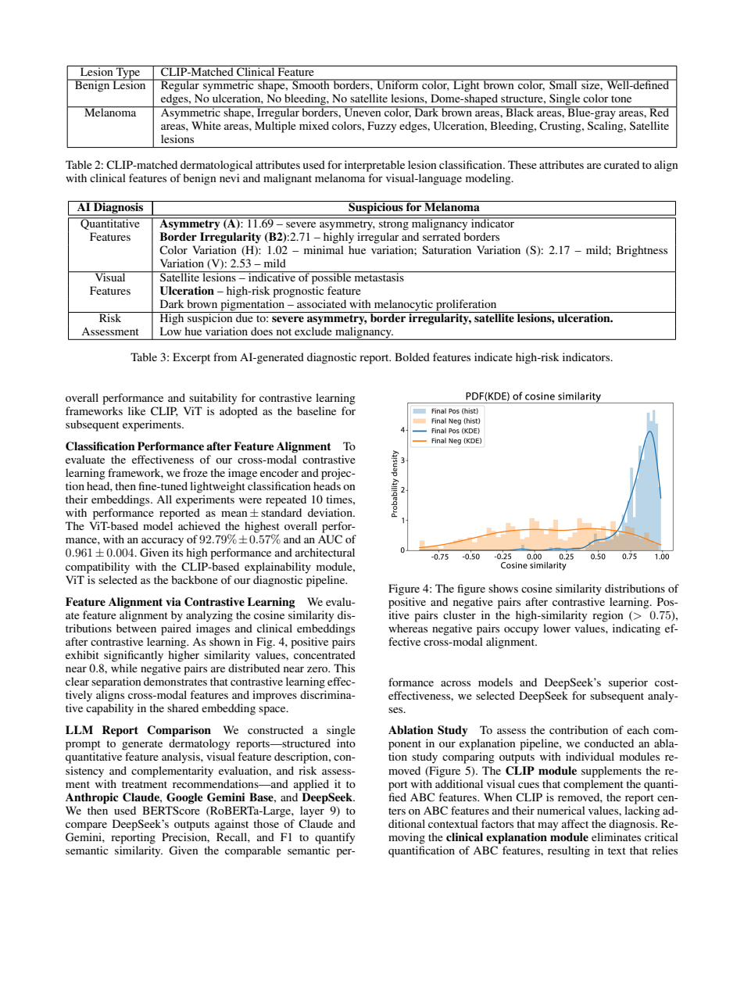
Figure C. Source page (paper page 6) containing Table 2 (CLIP-matched clinical descriptors) and Table 3 (the worked report example) shown above.

13. Strengths and Limitations of the Approaches Discussed

13.1 Strengths
- Grounds an otherwise opaque ViT embedding space in criteria clinicians already trust (ABC), via a technically sound, well-established contrastive-learning mechanism (NT-Xent, in the SimCLR/BYOL lineage).
- Multi-modal report generation (numeric + qualitative + narrative) directly addresses documented clinician preferences for text over saliency maps.
- Ablation study demonstrates genuine complementarity across the CLIP, ABC-feature, and LLM components rather than one component doing all the work.
- Transparent, disclosed scope limitations (excluding the "D" criterion; acknowledging image-quality dependence) — a mark of methodological honesty rather than overclaiming.
- Code repository, while incomplete, is clean, modular, and well-documented (clear README, externalized config, complete evaluation harness) — a genuinely useful starting scaffold for replication or extension.

13.2 Limitations
- Small-N expert evaluation (3 dermatologists, 6 reports total) — informative as a pilot but not statistically powered; should not be over-interpreted as clinical validation.
- Binary melanoma-vs-nevus framing omits the broader differential diagnosis space clinicians actually navigate (e.g., seborrheic keratosis, basal cell carcinoma, other pigmented lesions).
- Excludes Differential structure and Evolution (the "D" and "E" of ABCDE) entirely, and reduces Diameter to implicit pixel-scale reasoning at best — meaning CEFM formalizes roughly 60% of the classic clinical rule, not the whole thing.
- Repository, as published, cannot reproduce the paper's headline numbers end-to-end: missing pretrained ViT weights, the full image dataset, the segmentation pipeline, and the LLM report-generation code (Section 6.4).
- The DeepSeek-vs-Claude-vs-Gemini comparison uses DeepSeek itself as the similarity reference point, a methodological choice with an inherent self-referential bias not discussed in the paper.
- No adversarial-robustness, dataset-shift, or fairness/bias analysis (e.g., performance across skin tones — a well-documented risk area for dermatology AI generally) is reported.

14. Future Trends
- Larger, multi-site, adequately powered clinician user studies — the clearest, most direct next step given current XAI-in-healthcare literature's consensus call for empirical validation at scale.
- Incorporating lesion evolution (temporal/sequential dermoscopy, as in Kittler et al.'s sequential dermoscopy imaging work) to recover the "E" of ABCDE — the paper's own conclusion names longitudinal lesion tracking as future work.
- Extending beyond binary classification toward full differential diagnosis across multiple pigmented and non-pigmented lesion types.
- Fairness auditing across skin tone (Fitzpatrick scale) — a well-known open problem for dermoscopic AI broadly, not addressed in this paper.
- Swapping in more robust or domain-adapted vision-language backbones (e.g., dermatology-specific CLIP variants, or newer architectures such as Mamba-based contrastive models) as the field matures beyond general-purpose CLIP.
- Formal regulatory-pathway work (e.g., FDA/CE-marking style validation) if CEFM or a successor is ever positioned as a deployable clinical product rather than a research prototype — a substantial gap between the current pilot study and any real deployment.
- Publishing the full segmentation and LLM report-generation code, and a genuinely runnable end-to-end reproduction package (pretrained weights, full dataset access instructions, or a hosted demo), to close the reproducibility gap identified in Section 6.4.

15. Key Takeaways
- What CEFM is: a four-part pipeline (ViT classifier, ABC feature extractor, contrastive aligner, LLM report generator) that produces both a melanoma/nevus prediction and a clinician-readable explanation grounded in the ABC rule.
- Why it matters: it directly targets the documented, real, and regulatorily significant gap between high AI diagnostic accuracy and low clinical trust/adoption.
- How well it performs: 92.79% accuracy / 0.961 AUC on a curated ISIC subset, and a 4.60/5 average interpretability rating from a 3-dermatologist pilot study — solid technical performance and encouraging, but early-stage, qualitative validation.
- What the code actually gives you: a working, syntactically clean implementation of the classification-and-alignment half of the system, but not a complete, runnable reproduction of the full paper (missing pretrained weights, full dataset, segmentation code, and LLM report-generation code).
- What is genuinely novel: applying cross-modal contrastive alignment (a technique popularized for image-image and image-text pairs) to image–structured-clinical-feature pairs specifically for the purpose of explainability, not just representation learning.
- What remains open: larger clinical validation, the "D" and "E" criteria, fairness/bias auditing, adversarial robustness, and a fully reproducible, end-to-end open-source release.

16. Recommendations for Further Study

16.1 For readers wanting to understand the underlying methods
- Read the original SimCLR (Chen et al., 2020) and CLIP (Radford et al., 2021) papers directly — both are foundational and the CEFM architecture is best understood as a direct, deliberate remix of the two.
- Review Selvaraju et al.'s Grad-CAM (2017) paper to understand exactly what baseline CEFM is positioning itself against.
- Read the Chanda et al. (2024, Nature Communications) CompA paper as the closest prior-art comparison point named in the paper's related work.

16.2 For readers wanting to work with the code
- Do not expect an out-of-the-box run of scripts/run_all.py to succeed; budget time to source or train your own ViT-B/16 checkpoint and to obtain the full ISIC 2018/2020 datasets directly from the ISIC Archive.
- Treat the shipped CSVs as ground truth for the intended ABC feature schema, and be prepared to implement the segmentation (UltraLight VM-UNet + SAM2) and feature-computation pipeline yourself if you need to generate ABC features for new images, since that code is not published in this repository.
- If report generation is the goal, plan to implement the CLIP descriptor-retrieval and DeepSeek-prompting stage from the paper's methodology description (Section 4.6–4.7 of this report), as no corresponding code exists in the repository at the time of this analysis.

16.3 For readers evaluating clinical AI more broadly
- Read recent (2025) systematic reviews of explainable AI in healthcare to calibrate expectations about the maturity of XAI-clinician-trust research generally — this paper is a data point within, not an exception to, that broader early-stage landscape.
- Track regulatory developments (US ONC HTI-1, EU AI Act high-risk classification) as these will increasingly shape what "acceptable explainability" looks like for any deployed melanoma-detection product.

17. Glossary of Technical Terms
Term | Definition
ABC(DE) rule | Clinical mnemonic for melanoma risk: Asymmetry, Border irregularity, Color variation, (Diameter, Evolution).
AUC (Area Under the Curve) | A threshold-independent measure of a classifier's ability to separate two classes, derived from the ROC curve; 1.0 is perfect, 0.5 is random.
BERTScore | A metric that compares generated text to reference text using contextual embeddings (here, from RoBERTa-Large) rather than exact word overlap.
CLIP | Contrastive Language-Image Pretraining; a vision-language model that learns to match images with matching text descriptions.
Contrastive learning | A training method that pulls matching ("positive") pairs together and pushes non-matching ("negative") pairs apart in embedding space.
Cohen's Kappa | A statistic measuring agreement between predicted and true labels, correcting for chance agreement.
Dermoscopy | A non-invasive skin-imaging technique using magnification and controlled lighting/polarization to examine pigmented lesions.
DeepSeek | A large language model used in this paper as the final report-synthesis engine.
Dice Similarity Coefficient (DSC) | A metric of overlap between a predicted segmentation mask and the ground-truth mask.
Grad-CAM | Gradient-weighted Class Activation Mapping; a post-hoc method that highlights image regions influential to a CNN's prediction.
ISIC Archive | International Skin Imaging Collaboration; the largest public repository of curated dermoscopic images, used for training and benchmarking.
Melanoma | The most dangerous form of skin cancer, arising from melanocytes; responsible for the large majority of skin-cancer deaths despite being a minority of skin-cancer diagnoses.
MLP (Multilayer Perceptron) | A simple feed-forward neural network of fully connected layers, used here as the projection heads.
Nevus (plural nevi) | A benign mole; the negative class in CEFM's binary classification task.
NT-Xent loss | Normalized Temperature-scaled Cross-Entropy; the specific contrastive loss function used to align image and clinical embeddings.
Projection head | A small neural network (here, an MLP) that maps a modality-specific embedding into a shared space for contrastive comparison.
SAM / SAM2 | Segment Anything Model (versions 1 and 2); promptable, general-purpose image/video segmentation foundation models from Meta AI.
UltraLight VM-UNet | A lightweight U-Net-family segmentation network used for coarse lesion-mask generation.
Vision Transformer (ViT) | A transformer-based image encoder that processes an image as a sequence of patches using self-attention.
XAI (Explainable AI) | The subfield of AI concerned with making model decisions understandable to humans.

18. References and Bibliography

18.1 Primary source
Zheng, J.; Xu, X.; Wang, L. R.; Cai, C.; Tan, L. S.; Wang, D.; Tey, H. L.; and Fan, X. 2025/2026. Explainable Melanoma Diagnosis with Contrastive Learning and LLM-based Report Generation. arXiv:2512.06105 [cs.CV]. To appear, AAAI 2026. Code: https://eattt-wen.github.io/CEFM/ ; Repository: https://github.com/eattt-wen/CEFM

18.2 Cited within the source paper (as listed in its bibliography)
- Abir, S. I. et al. 2024. Deep Learning-Based Classification of Skin Lesions. Journal of Computer Science and Technology Studies, 6(5): 152–167.
- Almufareh, M. F. et al. 2024. Melanoma identification and classification model based on fine-tuned CNN. Digital Health, 10.
- Almustafa, K. M. 2025. Predictive modeling and optimization in dermatology. Computers in Biology and Medicine, 189: 109946.
- Chanda, T. et al. 2024. Dermatologist-like explainable AI enhances trust and confidence in diagnosing melanoma. Nature Communications, 15(1): 524.
- Chen, T.; Kornblith, S.; Norouzi, M.; Hinton, G. 2020. A simple framework for contrastive learning of visual representations (SimCLR). ICML.
- Gamage, L. et al. 2024. Melanoma skin cancer identification with explainability utilizing mask guided technique. Electronics, 13(4): 680.
- Grill, J.-B. et al. 2020. Bootstrap your own latent (BYOL). NeurIPS 33: 21271–21284.
- Hossain, M. I. et al. 2025. Explainable AI for medical data: current methods, limitations, and future directions. ACM Computing Surveys, 57(6).
- Hussien, M. A.; Alasadi, A. H. H. 2024. Classification of melanoma skin cancer using deep learning approach. TELKOMNIKA, 22(1): 129–137.
- Kayser, M. et al. 2024. Fool me once? Contrasting textual and visual explanations in a clinical decision-support setting. arXiv:2410.12284.
- Li, H. et al. 2024. Prompt-guided generation of structured chest X-ray report using a pre-trained LLM. IEEE ICME.
- Mallardo, D.; Basile, D.; Vitale, M. G. 2025. Advances in Melanoma and Skin Cancers.
- Ravi, N. et al. 2024. SAM 2: Segment anything in images and videos. arXiv:2408.00714.
- Sabir, R.; Mehmood, T. 2024. Classification of melanoma skin cancer based on image dataset using different neural networks. Scientific Reports, 14(1): 29704.
- Selvaraju, R. R. et al. 2017. Grad-CAM: Visual explanations from deep networks via gradient-based localization. ICCV.
- Thomas, S. M. et al. 2021. Interpretable deep learning systems for multi-class segmentation and classification of non-melanoma skin cancer. Medical Image Analysis, 68: 101915.
- Toh, S. Y. et al. 2025. The effect of explainable AI and uncertainty quantification on medical students' perspectives. CHI EA '25.
- Wang, Z. et al. 2023. R2GenGPT: Radiology report generation with frozen LLMs. Meta-Radiology, 1(3): 100033.
- Xu, H.; Shuttleworth, K. M. J. 2024. Medical AI and the black box problem. Intelligent Medicine, 4(1): 52–57.
- Zhang, Z. et al. 2019. Pathologist-level interpretable whole-slide cancer diagnosis with deep learning. Nature Machine Intelligence, 1(5): 236–245.

18.3 Independently sourced during this research (external, post-cutoff / supplementary)
- GLOBOCAN 2022 Melanoma of Skin Fact Sheet — International Agency for Research on Cancer (gco.iarc.who.int).
- SEER Cancer Stat Facts: Melanoma of the Skin — U.S. National Cancer Institute (seer.cancer.gov/statfacts/html/melan.html).
- World Cancer Research Fund — Skin cancer statistics (wcrf.org).
- Global trends in cutaneous malignant melanoma incidence and mortality. Melanoma Research 34(3), 2024.
- Validity of the ABCD Rule of Dermoscopy in Clinical Practice — PubMed/Acta Dermato-Venereologica.
- Advances in the noninvasive diagnosis of melanoma — 40 years beyond the ABCDs. PMC, 2025/2026.
- Integrating generative AI with ABCDE rule analysis for enhanced skin cancer diagnosis. Frontiers in Medicine, 2024.
- Clinical Diagnosis of Melanoma. American Academy of Family Physicians (AAFP), 2008 (background/context).
- Evaluating the Explainability of Vision Transformers in Medical Imaging. arXiv:2510.12021, 2025.
- CoMViT: An Efficient Vision Backbone for Supervised Classification in Medical Imaging. arXiv:2510.27442, 2025.
- Self-Ensembling Vision Transformer (SEViT) for Robust Medical Image Classification. arXiv:2208.02851.
- Explainable AI Applications in Healthcare: A Systematic Review. 2025/2026 (76-study review).
- Demystifying the black box: How explainable AI builds trust and reduces anxiety in healthcare adoption. ScienceDirect, 2026.
- Beyond the Black Box: Transparency Strategies for Healthcare AI (ONC HTI-1 context). Censinet, 2026.
- Radford, A. et al. 2021. Learning Transferable Visual Models From Natural Language Supervision (CLIP). OpenAI/arXiv.
- CLIMP: Contrastive Language-Image Mamba Pretraining. arXiv:2601.06891, 2026 (illustrative of post-CLIP architecture trends).
Note on sourcing: statements tagged [FROM PAPER] are drawn directly from the uploaded arXiv/AAAI manuscript; statements tagged [FROM CODE REPOSITORY] are drawn from direct inspection of github.com/eattt-wen/CEFM performed for this report (files compiled and cross-checked on 18 July 2026); statements tagged [EXTERNAL RESEARCH] are drawn from independent web sources cited above and were not present in either the paper or the repository.

